UNITED STATES
SECURITIES AND EXCHANGE COMMISSION
Washington, D.C. 20549
FORM 10-K

☒ |  |  | ANNUAL REPORT PURSUANT TO SECTION 13 OR 15(d) OF THE SECURITIES EXCHANGE ACT OF 1934

For the fiscal year ended December 31, 2024

OR

☐ |  |  | TRANSITION REPORT PURSUANT TO SECTION 13 OR 15(d) OF THE SECURITIES EXCHANGE ACT OF 1934

For the transition period from _______ to _______
Commission File Number 001-39614

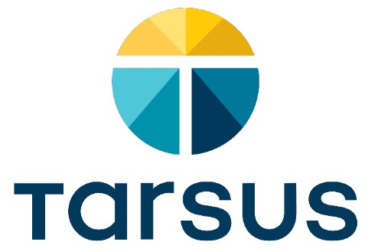
TARSUS PHARMACEUTICALS, INC.
(Exact name of Registrant as specified in its charter)
Delaware |  |  |  |  |  | 81-4717861
(State or other jurisdiction of  incorporation or organization) |  |  |  |  |  | (I.R.S. Employer  Identification No.)

15440 Laguna Canyon Road, Suite 160
Irvine, California |  |  |  |  |  | 92618
(Address of principal executive offices) |  |  |  |  |  | (Zip Code)

(949) 418-1801
(Registrant's telephone number, including area code)
Securities registered pursuant to Section 12(b) of the Act:
Title of each class |  |  | Trading Symbol |  |  | Name of each exchange on which registered
Common Stock, $0.0001 par value per share |  |  | TARS |  |  | The Nasdaq Global Market LLC  (Nasdaq Global Select Market)
Securities registered pursuant to Section 12(g) of the Act: None.
Indicate by check mark if the registrant is a well-known seasoned issuer, as defined in Rule 405 of the Securities Act. Yes ☒ No ☐
Indicate by check mark if the registrant is not required to file reports pursuant to Section 13 or Section 15(d) of the Act. Yes ☐ No ☒
Indicate by check mark whether the registrant (1) has filed all reports required to be filed by Section 13 or 15(d) of the Securities Exchange Act of 1934 during the preceding 12 months (or for such shorter period that the registrant was required to file such reports), and (2) has been subject to such filing requirements for the past 90 days. Yes ☒ No ☐

Indicate by check mark whether the registrant has submitted electronically every Interactive Data File required to be submitted pursuant to Rule 405 of Regulation S-T (§ 232.405 of this chapter) during the preceding 12 months (or for such shorter period that the registrant was required to submit such files). Yes ☒ No ☐
Indicate by check mark whether the registrant is a large accelerated filer, an accelerated filer, a non-accelerated filer, a smaller reporting company, or an emerging growth company. See the definitions of “large accelerated filer,” “accelerated filer,” “smaller reporting company,” and "emerging growth company" in Rule 12b-2 of the Exchange Act.
Large accelerated filer |  |  | ☒ |  |  |  |  |  | Accelerated filer |  |  | ☐
Non-accelerated filer |  |  | ☐ |  |  |  |  |  | Smaller reporting company |  |  | ☐
 |  |  |  |  |  |  |  |  | Emerging growth company |  |  | ☐

If an emerging growth company, indicate by check mark if the registrant has elected not to use the extended transition period for complying with any new or revised financial accounting standards provided pursuant to Section 13(a) of the Exchange Act. ☐
Indicate by check mark whether the registrant has filed a report on and attestation to its management’s assessment of the effectiveness of its internal control over financial reporting under Section 404(b) of the Sarbanes-Oxley Act (15 U.S.C. 7262(b)) by the registered public accounting firm that prepared or issued its audit report. ☒

If securities are registered pursuant to Section 12(b) of the Act, indicate by check mark whether the financial statements of the registrant included in the filing reflect the correction of an error to previously issued financial statements. ☐

Indicate by check mark whether any of those error corrections are restatements that required a recovery analysis of incentive-based compensation received by an of the registrant's executive officers during the relevant recovery period pursuant to §240.10D-1(b).☐
Indicate by check mark whether the registrant is a shell company (as defined in Rule 12b-2 of the Act). Yes ☐ No ☒
The aggregate market value of the registrant’s voting and non-voting common equity held by non-affiliates of the registrant, based on the closing price of the registrant’s common stock as reported by the Nasdaq Global Select Market on June 30, 2024, was approximately $996.0 million. Shares of common stock held by each executive officer, director, and holder of 10% or more of the outstanding common stock have been excluded in that such persons may be deemed to be affiliates. This determination of affiliate status is not necessarily a conclusive determination for other purposes.
As of February 19, 2025, the number of outstanding shares of the registrant’s common stock, par value $0.0001 per share, was 38,377,178.
DOCUMENTS INCORPORATED BY REFERENCE

Portions of the information called for by Part III of this Annual Report on Form 10-K is hereby incorporated by reference to portions of the registrant’s definitive proxy statement for its 2025 annual meeting of stockholders, which will be filed with the Securities and Exchange Commission not later than 120 days after the registrant’s fiscal year ended December 31, 2024.

TABLE OF CONTENTS

Part I |  |  | 1
Item 1. Business |  |  | 5
Item 1A. Risk Factors |  |  | 36
Item 1B. Unresolved Staff Comments |  |  | 93
Item 2. Properties |  |  | 94
Item 3. Legal Proceedings |  |  | 94
Item 4. Mine Safety Disclosures |  |  | 95
Part II |  |  | 96
Item 5. Market for Registrant's Common Equity, Related Stockholder Matters and Issuer Purchases of Equity Securities |  |  | 96
Item 6. [Reserved.] |  |  | 97
Item 7. Management's Discussion and Analysis of Financial Condition and Results of Operations |  |  | 98
Item 7A. Quantitative and Qualitative Disclosures About Market Risk |  |  | 113
Item 8. Financial Statements and Supplementary Data |  |  | 114
Item 9. Changes in and Disagreements With Accountants on Accounting and Financial Disclosures |  |  | 151
Item 9A. Controls and Procedures |  |  | 151
Item 9B. Other Information |  |  | 154
Item 9C. Disclosure Regarding Foreign Jurisdictions that Prevent Inspections |  |  | 154
Part III |  |  | 155
Item 10. Directors, Executive Officers and Corporate Governance |  |  | 155
Item 11. Executive Compensation |  |  | 155
Item 12. Security Ownership of Certain Beneficial Owners and Management and Related Stockholder Matters |  |  | 155
Item 13. Certain Relationships and Related Transactions, and Director Independence |  |  | 155
Item 14. Principal Accounting Fees and Services |  |  | 155
Part IV |  |  | 156
Item 15. Exhibits, Financial Statement Schedules |  |  | 156
Item 16. Form 10-K Summary |  |  | 158
Signatures |  |  | 160

NOTE REGARDING FORWARD-LOOKING STATEMENTS

This Annual Report on Form 10-K contains forward-looking statements within the meaning of Section 21E of the Securities Exchange Act of 1934, as amended ("Exchange Act"). All statements other than statements of historical facts contained in this Annual Report on Form 10-K, including statements regarding our future results of operations and financial position, business strategy, product candidates, planned preclinical studies and clinical trials, results of clinical trials, research and development costs, regulatory approvals, timing and likelihood of success, as well as plans and objectives of management for future operations, are forward-looking statements. These statements involve known and unknown risks, uncertainties and other important factors that are in some cases beyond our control and may cause our actual results, performance or achievements to be materially different from any future results, performance or achievements expressed or implied by the forward-looking statements. Factors that may cause actual results to differ from expected results include, among others:
•our ability to continue to successfully commercialize XDEMVY®, formerly known as TP-03, for the treatment of Demodex blepharitis;

•the prevalence of Demodex blepharitis and the size of the market opportunity for XDEMVY;

•our plans to continue commercializing XDEMVY and our product candidates, if approved, including commercialization timelines and sales strategy;

•any statements regarding our ability to achieve distribution and patient access for our products including XDEMVY and timing and breadth of payer coverage; our expectations of the potential market size, pricing, gross-to-net yields, eye care provider and patient acceptance of our product and product candidates, opportunity and patient populations for our product and product candidates, including XDEMVY;

•the rate and degree of market acceptance and clinical utility of XDEMVY and our product candidates;

•the likelihood of our clinical trials demonstrating safety and efficacy of our product candidates, and other positive results;
•the timing and progress of our current clinical trials and timing of initiation of our future clinical trials, and the reporting of data from our current and future trials;
•the timing or likelihood of regulatory filings and approval for our product candidates and our ability to meet existing or future regulatory standards or comply with post-approval requirements;
•our plans relating to the clinical development of our current and future product candidates, including the size, number and disease areas to be evaluated;
•the impact of health epidemics on our business and operations;
•the impact of unfavorable global and geopolitical economic conditions on our business and operations;
•the success of competing therapies that are or may become available;
•our estimates of the number of patients in the United States ("U.S.") or globally, as applicable, who suffer from Demodex blepharitis, Ocular Rosacea, Lyme disease and malaria and the number of patients that will enroll in our clinical trials;
•the beneficial characteristics, safety, efficacy, therapeutic effects and potential advantages of our product and product candidates;
•our ability to obtain and maintain regulatory approval of our product and our product candidates to meet existing or future regulatory standards;
•our plans relating to the further development and manufacturing of our product and product candidates, including additional indications for which we may pursue;
1

•our ability to identify additional products, product candidates or technologies with significant commercial potential that are consistent with our commercial objectives;
•the expected potential benefits of strategic collaborations with third parties (including, for example, the receipt of payments, achievement and timing of milestones under license agreements, and the ability of our third party collaborators to commercialize our product candidates in the territories under license) and our ability to attract collaborators with development, regulatory and commercialization expertise;
•existing regulations and regulatory developments in the U.S. and other jurisdictions;
•our plans and ability to obtain, maintain, and/or protect intellectual property rights, including extensions of existing patent terms where available;
•our continued reliance on third parties to conduct additional clinical trials of our product candidates, and for the manufacture of our product candidates for preclinical studies and clinical trials;
•the need to hire additional personnel and our ability to attract and retain such personnel;
•the accuracy of our estimates regarding expenses, future revenue, capital requirements and needs for additional financing;
•our financial performance;
•the sufficiency of our existing capital resources to fund our future operating expenses and capital expenditure requirements;
•our competitive position; and
•our anticipated use of our existing resources and the proceeds from our Initial Public Offering ("IPO"), our subsequent follow-on public offerings in May 2022 (the "May 2022 Public Offering"), August 2023 (the "August 2023 Public Offering"), and March 2024 (the "March 2024 Public Offering"), collectively the "Follow-On Public Offerings," as well as proceeds from our sales agreement prospectus (the "2023 ATM Prospectus"), and drawdowns from our loan and security agreement (the "2024 Credit Facility") with funds associated with Pharmakon Advisors, LP ("Pharmakon").
We have based these forward-looking statements largely on our current expectations and projections about our business, the industry in which we operate and financial trends that we believe may affect our business, financial condition, results of operations and growth prospects, and these forward-looking statements are not guarantees of future performance or development. These forward-looking statements speak only as of the date of this Annual Report on Form 10-K and are subject to a number of risks, uncertainties and assumptions, including those described in the section titled “Risk Factors” elsewhere in this Annual Report on Form 10-K. Moreover, we operate in a very competitive and rapidly changing environment. New risks emerge from time to time. It is not possible for our management to predict all risks, nor can we assess the impact of all factors on our business or the extent to which any factor, or combination of factors, may cause actual results to differ materially from those contained in any forward-looking statements we may make. In light of these risks, uncertainties and assumptions, the forward-looking events and circumstances discussed in this report may not occur and actual results could differ materially and adversely from those anticipated or implied in the forward-looking statements. Except as required by applicable law, we do not plan to publicly update or revise any forward-looking statements after the date of this Annual Report on Form 10-K, whether as a result of any new information, future events or otherwise.
You should not rely upon forward-looking statements as predictions of future events. Although we believe that the expectations reflected in the forward-looking statements are reasonable, we cannot guarantee that the future results, advancements, discoveries, levels of activity, performance or events and circumstances reflected in the forward-looking statements will be achieved or occur. Moreover, except as required by law, neither we nor any other person assumes responsibility for the accuracy and completeness of the forward-looking statements. We undertake no obligation to update publicly any forward-looking statements for any reason after the date of this report to conform these statements to actual results or to changes in our expectations.
2

You should read this report and the documents that we reference in this report and have filed with the Securities Exchange Commission ("SEC") as exhibits to this report with the understanding that our actual future results, levels of activity, performance and events and circumstances may be materially different from what we expect.
Unless the context otherwise requires, all references in this Annual Report on Form 10-K to the “Company,” “we,” “us,” “our,” “Tarsus,” and “Tarsus Pharmaceuticals” refer to Tarsus Pharmaceuticals, Inc. We primarily conduct our business activities as Tarsus Pharmaceuticals.
Tarsus Pharmaceuticals, Tarsus, and Tarsus Pharmaceuticals, Inc., our logo, XDEMVY, and other registered or common law trade names, trademarks or service marks of Tarsus appearing in this report are the property of the Company. This report contains additional trade names, trademarks and service marks of other companies that are the property of their respective owners. We do not intend our use or display of other companies’ trade names, trademarks or service marks to imply a relationship with, or endorsement or sponsorship of us by, these other companies. Solely for convenience, our trade names, trademarks and service marks referred to in this report appear without the ®, ™ or SM symbols, but such references are not intended to indicate, in any way, that we will not assert, to the fullest extent under applicable law, our rights or the right of the applicable licensor to these trade names, trademarks and service marks.

SUMMARY OF RISKS ASSOCIATED WITH OUR BUSINESS
We face risks and uncertainties associated with our business, many of which are beyond our control. Some of the more significant risks associated with our business include the following:
•We are a commercial stage biopharmaceutical company with a limited operating history and a single product approved for commercial sale. While we have generated revenues from the launch of XDEMVY, we have continued to incur significant losses and negative cash flows from operations since our inception and anticipate that we will continue to incur significant expenses and potential losses for the foreseeable future.
•Due to the recently initiated commercialization of XDEMVY and our continued development of our pipeline of product candidates through clinical trials and other indications, our capital requirements are difficult to predict and may change. We may need to obtain substantial additional funding to achieve our goals and a failure to obtain this necessary capital when needed on acceptable terms, or at all, could force us to delay, reduce or eliminate our product development programs, commercialization efforts or other operations.
•We obtained regulatory approval for XDEMVY in the U.S. in July 2023 and have limited experience as a commercial company generating revenue from product sales. If the commercialization of XDEMVY becomes unsuccessful or any future approved product launches are unsuccessful, we may never be profitable.
•We are heavily dependent on the successful commercialization of XDEMVY and the development, regulatory approval, and commercialization of our current and future product candidates. XDEMVY remains subject to ongoing post-marketing review and extensive regulation.
•We may not be successful in educating eye care providers ("ECPs"), and the market about the need for treatments specifically for Demodex blepharitis and other diseases or conditions targeted by XDEMVY or our product candidates. XDEMVY or other product candidates that we may develop may fail to achieve market acceptance by ECPs, other healthcare providers and patients, or adequate formulary coverage, pricing or reimbursement by third-party payers and others in the medical community, and the market opportunity for these products may be smaller than we estimate. XDEMVY and any product candidates for which we obtain marketing approval may become subject to unfavorable pricing regulations, third-party coverage or reimbursement practices or healthcare reform initiatives, which could harm our business.
•The sizes of the market opportunity for XDEMVY for the treatment of Demodex blepharitis, as well as our other product or product candidates, have not been established with precision and may be smaller than we estimate, possibly materially. If our estimates of the sizes overestimate these markets, our sales growth may be adversely affected. We may also not be able to grow the markets for our product candidates as intended or at all.
•The development and commercialization of our products, including XDEMVY, for the treatment of Demodex blepharitis, TP-04 for the potential treatment of Ocular Rosacea and TP-05 for potential Lyme disease prophylaxis and
3

community malaria reduction, is dependent on intellectual property we license from Elanco Tiergesundheit AG ("Elanco").
•We expect to expand our development, regulatory and operational capabilities, and, as a result, we may encounter difficulties in managing our growth, which could disrupt our operations.
•We contract with third parties for the commercial manufacture of XDEMVY and for the manufacture of our product candidates for preclinical studies, clinical trials and for eventual commercialization. In some instances, we or our third party contract manufacturers rely on single source suppliers for certain of the materials for our product and product candidates. This reliance on third parties and single source suppliers increases the risk that we will not have sufficient quantities of XDEMVY or our product candidates or compounds or that such supply will not be available to us at an acceptable cost, which could delay, prevent or impair our commercialization or development efforts, as we expect that XDEMVY and each of our product candidates will only be covered by single source suppliers for the foreseeable future.
•Clinical drug development is a lengthy, expensive and risky process with uncertain timelines and uncertain outcomes, and results of earlier studies and trials may not be predictive of future results. If clinical trials of our product candidates do not meet safety or efficacy endpoints or are prolonged or delayed, we may be unable to obtain required regulatory approvals, and therefore be unable to commercialize our product candidates on a timely basis or at all.
•Any termination or suspension of, or delays in the commencement or completion of, our planned clinical trials could result in increased costs to us, delay or limit our ability to generate revenue and adversely affect our commercial prospects.
•We rely on third parties to conduct our clinical trials and perform some of our research and preclinical studies. If these third parties do not satisfactorily carry out their contractual duties or fail to meet expected deadlines, our development programs may be delayed or subject to increased costs, each of which may have an adverse effect on our business and prospects.
•If we are unable to obtain and maintain sufficient intellectual property protection for XDEMVY or our product candidates, or if the scope of the intellectual property protection is not sufficiently broad, our competitors could develop and commercialize products similar or identical to ours, and our ability to successfully commercialize our products may be adversely affected.
•Patent terms may be inadequate to protect our competitive position on our product candidates and preclinical programs for an adequate amount of time.
•The concentration of our stock ownership will likely limit your ability to influence corporate matters, including the ability to influence the outcome of director elections and other matters requiring stockholder approval.
4

PART I

Item 1. Business
Overview
We are a commercial stage biopharmaceutical company focused on the development and commercialization of therapeutics, starting with eye care. We launched XDEMVY® (lotilaner ophthalmic solution) 0.25%, formerly known as TP-03, for the treatment of Demodex blepharitis, in August 2023 after receiving U.S. Food and Drug Administration ("FDA") approval in July 2023. Demodex blepharitis is caused by the infestation of Demodex mites. Blepharitis ("Blephar" is a reference to eyelid and "itis" is a reference to inflammation) is an ophthalmic lid margin disease characterized by inflammation of the eyelid margin, redness and ocular irritation, including a specific type of eyelash dandruff called collarettes, which are pathognomonic for Demodex blepharitis. Chronic and progressive blepharitis can lead to corneal damage over time and, in extreme cases, blindness. There may be as many as approximately 25 million people in the U.S. who suffer from Demodex blepharitis. XDEMVY is the first and only therapeutic approved by the FDA and we believe is the definitive standard of care for the treatment of Demodex blepharitis.
XDEMVY targets and eradicates the root cause of Demodex blepharitis — Demodex mite infestation. The active pharmaceutical ingredient ("API") of XDEMVY, lotilaner, paralyzes and eradicates mites and other parasites through the inhibition of parasite-specific gamma-aminobutyric acid-gated chloride ("GABA-Cl") channels with no GABA-Cl inhibition in humans.
To date, we have completed seven clinical trials that include a Phase 3 trial (the "Saturn-2 trial"), a Phase 2b/3 trial (the "Saturn-1 trial"), four Phase 2 trials, and a Phase 1 trial (the "Hyperion trial") for XDEMVY in Demodex blepharitis, all of which met their primary, secondary and/or certain exploratory endpoints, with the drug generally safe and well tolerated throughout each trial. We have also completed, and/or have ongoing clinical trials for the potential treatment of Demodex blepharitis in patients with Meibomian Gland Disease ("MGD"), including a Phase 2a clinical trial (the "Ersa trial") that evaluated XDEMVY for the treatment of MGD in patients with Demodex blepharitis, and a pilot clinical trial that evaluated an XDEMVY vehicle for the potential treatment of MGD in patients with Demodex mites (the "Rhea trial"), TP-04 for the potential treatment of Ocular Rosacea, and TP-05 for potential Lyme disease prophylaxis, among others.
We intend to further advance our pipeline with the lotilaner API to address several diseases in human medicine, including eye care and infectious disease prevention. We are investigating the development of our product candidates to address targeted diseases with high unmet medical needs, which currently include TP-04, a novel ophthalmic gel formulation of lotilaner for the potential treatment of Ocular Rosacea, and TP-05, a novel investigational oral formulation of lotilaner, for potential Lyme disease prophylaxis and community malaria reduction.
TP-03 Demodex blepharitis in patients with Meibomian Gland Disease (MGD)
MGD is commonly characterized by functional and structural dysfunction of the meibomian glands within the eyelid margin, which then results in blockage and/or thickened and decreased production of meibum. If left untreated, MGD can lead to permanent changes to the tear film and progressive gland loss. Approximately 30-40 million Americans are impacted by MGD. Currently, there are no FDA-approved pharmacologic therapies for MGD patients without Demodex blepharitis. Demodex mites are key contributors to MGD in patients with Demodex blepharitis, causing eyelid inflammation and reduced meibomian gland function.

In August 2022, we announced the enrollment of our first patient in the Ersa trial. In December 2023, we announced positive topline results from the Ersa trial evaluating XDEMVY administered twice daily ("BID") or three times a day ("TID") for six weeks and twelve weeks. XDEMVY demonstrated statistically significant and clinically meaningful improvements compared to baseline in two objective measures of the disease: the presence and quality of liquid secretion as measured by the Meibomian Gland Secretion Score; and the number of glands secreting normal or clear liquid. In November 2024, additional positive data was presented from the Ersa trial as well as data from the Rhea trial, at the American Academy of Optometry ("AAOpt") Annual Meeting 2024. The Rhea trial enrolled a similar patient population as the Ersa trial, and evaluated the same outcomes, with the same dosing regimens with XDEMVY vehicle. Both the Ersa and Rhea trials also assessed patient reported outcomes for some of the most commonly reported patient symptoms in Demodex blepharitis and MGD, namely fluctuating vision, itching, redness, and burning.
The combined data from the Ersa and Rhea trials showed in a pooled analysis presented at the AAOpt Annual Meeting 2024 that XDEMVY could be the first pharmacologic treatment for MGD in patients with Demodex blepharitis to
5

demonstrate statistically significant and clinically meaningful improvements from baseline, as well as when compared to XDEMVY vehicle. These improvements were shown across three objective measures of MGD: (i) the presence and quality of liquid secretion as measured by the Meibomian Gland Secretion Score; (ii) the number of glands secreting normal or clear liquid; and (iii) the number of glands yielding any liquid. Improvements were also demonstrated across some of the most reported patient outcomes, including fluctuating vision, itching and redness. Further, XDEMVY demonstrated statistically significant rates of collarette cure and lid margin erythema cure that are consistent with previous XDEMVY studies. No statistically significant differences were observed between the BID and TID treatment arms in both the Ersa and Rhea trials, respectively, and XDEMVY and the XDEMVY vehicle were well tolerated. Given the positive results of these trials, and the FDA’s feedback that these patients are already included in XDEMVY’s label for the treatment of Demodex blepharitis, we are moving forward with sharing this data with eye care providers ("ECPs") to further educate them on the disease and the potential benefits of treating these patients with XDEMVY.
TP-04 for the Potential Treatment of Ocular Rosacea
We are exploring the therapeutic potential of TP-04 as a novel topical ophthalmic gel formulation of lotilaner for the treatment of Ocular Rosacea, a chronic eyelid disease characterized by redness, flushing and inflammation of the eyelid margin, visible blood vessels, and surrounding peri-ocular skin. Ocular Rosacea, like Demodex blepharitis, is believed to be caused by Demodex mites. Approximately 15-18 million Americans are impacted by Ocular Rosacea and there are currently no FDA-approved therapeutics to treat this disease.
TP-04 is designed to eradicate Demodex mites, a potential root cause of Ocular Rosacea. In March 2023, we announced positive topline results from the Phase 1 Galatea trial (the "Galatea Phase 1 trial”) and initiated a Phase 2a trial (the "Galatea trial") for the potential treatment of rosacea. The Galatea trial was a multicenter, randomized, vehicle-controlled trial evaluating the safety, tolerability and efficacy of TP-04. In February 2024, we announced positive topline results from the Galatea trial which demonstrated statistically significant improvements (p<0.05) in inflammatory lesions and Investigator's Global Assessment ("IGA") score (change in baseline and success rate) compared to vehicle at Week 12. After review of this data with the FDA and Key Opinion Leaders ("KOLs"), we decided to pursue development of TP-04 for the potential treatment for Ocular Rosacea. In January 2025, we announced plans to initiate a Phase 2 trial in the second half of 2025 for the potential treatment of Ocular Rosacea.
TP-05 for the Potential Prevention of Lyme Disease
We are exploring the therapeutic potential of TP-05 as an oral, systematic prophylactic for Lyme disease designed to eradicate the tick before it can transmit the Borrelia burgdorferi infection that causes Lyme disease. There are approximately 80 million people in the U.S. at risk of Lyme disease exposure with nearly 30 million of which are moderate to high risk. Further, there are approximately 400,000 reported cases of Lyme disease in the U.S. each year, but it is believed that the actual number of cases could be much higher.
Lyme disease can potentially cause severe, often debilitating symptoms with permanent and irreversible damage. The disease can result in inflammation, nerve, joint and muscle pain or swelling, numbness, shortness of breath and, in severe cases, neurological complications such as facial palsy, vision issues and meningitis, including severe headaches and neck stiffness. Lyme disease can often go undetected and untreated because the ticks are not always noticed before they transmit the disease. People who are in high-risk areas and/or spend extended amounts of time outdoors in wooded, grassy areas are at higher risk of contracting the infection. Data from the Centers for Disease Control and Prevention ("CDC") show that the risk of Lyme disease is spreading to new geographic areas, resulting in a significant need for prophylactic solutions.
Currently, there are no FDA-approved pharmacological prophylactic options for Lyme disease. We believe TP-05 is currently the only non-vaccine, drug-based, preventive therapeutic in clinical development that targets the ticks, and potentially prevents Lyme disease transmission. It is designed to rapidly provide systemic blood levels of lotilaner, a well-characterized anti-parasitic agent that paralyzes and kills infected ticks attached to the human body through selective targeting of parasite-specific GABA-CI channels, before they can transmit the Borrelia burgdorferi infection.
In December 2022, we announced positive topline results from the completed Phase 1 Callisto trial (the "Callisto trial") and enrollment of the first patient in the Phase 2a clinical trial (the "Carpo trial"). The Carpo trial was designed to evaluate TP-05, for the potential prevention of Lyme disease in humans. The Carpo trial was a randomized, double-blind, placebo-controlled trial that evaluated the efficacy of TP-05 in killing lab grown, non-disease carrying ticks after they have attached to the skin of healthy volunteers, as well as confirm the safety, tolerability, and blood concentration of TP-05. Sterile, non-pathogenic nymphal ticks were placed on the skin of healthy human volunteers at two separate instances (one day prior to dosing and 30 days after dosing). Tick mortality was evaluated within 24 hours of attachment after each placement. In most
6

cases, ticks must be attached for 36-48 hours or more before Lyme disease can be transmitted, so killing ticks within 24 hours of attachment can greatly increase the probability of disease prevention.
In February 2024, we announced positive topline results from the Carpo trial which demonstrated a statistically significant benefit in killing ticks compared to vehicle (p < 0.0001). Specifically, after the Day 1 tick challenge, mean tick mortality was 97.0% (± 1.4 standard error, SE) and 92.0% (± 6.3 SE) for the high and low doses of TP-05, respectively, compared to only 5.0% (± 2.5 SE) for placebo. Similarly, at the 30-day challenge, mean tick mortality at 24 hours after placement was 89.0% (± 11.1 SE) and 91.0% (± 6.1 SE) for the high and low doses of TP-05, respectively, compared to only 9.0% (± 8.0 SE) for placebo (p<0.001). No statistically significant differences in tick mortality were observed between the two TP-05 treatment arms, and TP-05 was generally well tolerated.
In December 2024, we met with the FDA about our Lyme disease program. The FDA agreed to our proposed approach for a Phase 2b clinical trial, which plans to include several hundred subjects. Additionally, the FDA confirmed that a Phase 3 clinical study would require a disease prevention field study that would likely require the enrollment of thousands of patients. We continue to believe that the best approach to potentially deliver this potential prophylactic therapy to patients is to enter into discussions to partner this program either prior to the initiation of the Phase 2b study or after the completion of the study.
The following chart presents our wholly owned product candidates and clinical development status:

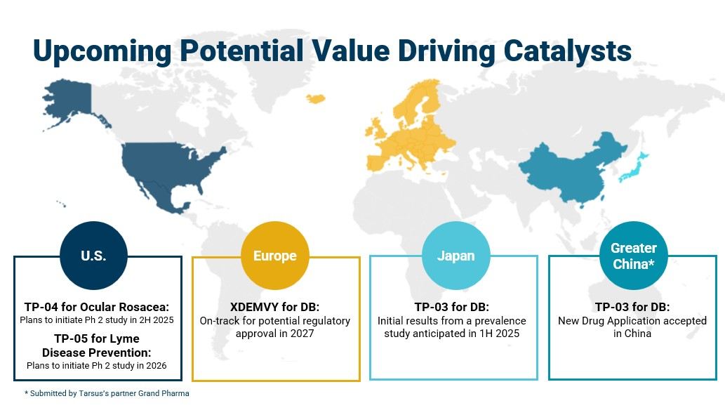
Our Strategy
Our ambition is to become a leader in eye care. We have been intentional about charting a new course in eye care that is grounded in addressing the root cause of disease and we intend to achieve this ambition by pursuing the following key strategic objectives:
•Continue to accelerate the launch trajectory of our first marketed product, XDEMVY. We launched XDEMVY for the treatment of Demodex blepharitis in August 2023 after receiving FDA approval in July 2023. XDEMVY has delivered remarkable results for patients and ECPs, and offers a compelling value proposition for payers.
•Continue to pursue a potentially transformative opportunity in Ocular Rosacea. OR is our next opportunity to create another potential blockbuster market in eye care. Ocular Rosacea is another common
7

eye disease that has been underdiagnosed and undertreated for years because there are no FDA-approved therapeutics. In January 2025, we announced plans to initiate a Phase 2 study in the second half of 2025.
•Continue to advance and expand our pipeline, bringing novel products utilizing lotilaner to unmet needs across human medicine, including Lyme disease prophylaxis. The mechanism of lotilaner coupled with our insights into disease where it can demonstrate clinical benefit, provides an opportunity to expand into new indications for treatment or prevention. In December 2024, we met with the FDA about our Lyme disease prevention program. The FDA agreed to our proposed approach for a Phase 2b clinical trial, which would include several hundred subjects. We continue to believe that the best approach to potentially deliver this potential prophylactic therapy to patients is to enter into discussions to partner this program either prior to the initiation of the Phase 2b study or after the completion of the study.
•Evaluate and strategically enter collaborations to maximize the potential of our pipeline and the scope of our eye care product offerings. Apart from the development and license agreement (the "China Out-License") with Xi An Grand Chang An Pharmaceutical Co., Ltd. ("GrandPharma") of TP-03 for the potential treatment of Demodex blepharitis and MGD within the China Territory, as described below within License Agreements: GrandPharma Agreement, we have retained our rights globally to all of our indications for use in humans, including for XDEMVY for the treatment of Demodex blepharitis, TP-04 for the potential treatment of Ocular Rosacea and TP-05 for potential Lyme disease prophylaxis and community malaria reduction. Given the potential to treat patients worldwide we may opportunistically enter into additional strategic collaborations around certain product candidates, disease and/or geographic regions.
•Continue innovating and planning for growth. We have assembled an exceptional management team with decades of deep and expansive strategic expertise building new markets across eye care and biotechnology. This team, coupled with their strong execution capabilities and financial discipline will potentially enable further innovation and growth.

Additional Potential Growth Drivers in 2025 and Beyond

We are on track for potential European regulatory approval of a preservative-free formulation of XDEMVY for the potential treatment of Demodex blepharitis in 2027. We have initiated market development work, including Key Opinion Leader engagement, disease education and scientific presentations at major conferences.

In Japan, we expect to share results from a Demodex blepharitis prevalence study in the first half of 2025 and meet with Japanese regulatory authorities to help determine a regulatory path forward.

The Chinese regulatory agency, National Medical Products Administration, accepted the New Drug Application ("NDA") submitted by our partner, Grand Pharmaceutical Group Ltd., for TP-03 for Demodex blepharitis.
Commercial Strategy for Demodex Blepharitis
In August 2023 we launched XDEMVY in the U.S. with a specialty sales force, social and digital media, and ECP education campaigns and targeted prescribing ophthalmologists and optometrists.
During 2024, we continued to work with KOLs and various associations to increase Demodex blepharitis awareness and education, and we have highlighted prevalence, impact, and simplicity of diagnosis of Demodex blepharitis. Our goal is to continue to educate ECPs about the prevalence of Demodex blepharitis, simplicity and efficiency of diagnosis, and the positive profile of XDEMVY. Consistent with our goal to educate ECPs, we expanded our sales force by approximately 50 new representatives and leaders in 2024. In addition to educating ECPs, we activated our first Direct-to-Consumer ("DTC") campaign in streaming television in the fourth quarter of 2024 that leverages creative and memorable visuals to illustrate the damaging impact of the disease, with the goal of supporting patients in their journey and encouraging them to consult with ECPs to see whether XDEMVY is right for them.
In 2024, the first full year XDEMVY was available on the market, XDEMVY generated $180.1 million in net product sales, more than 163,000 bottles were dispensed to patients, and we secured broad commercial and Medicare coverage. The success of XDEMVY was built on a very core set of fundamentals and a reflection of our strategic approach to an unwavering focus on evidence generation, education, ease of access and execution, which we believe will drive continued success in 2025 and beyond.
8

Blepharitis: Market Overview
Blepharitis is a common, chronic ophthalmic lid margin disease characterized by inflammation of the eyelid margin, redness and ocular irritation. It is also a progressive disease that often manifests with more severe symptoms if left untreated, such as blurring of vision, missing eyelashes, MGD, corneal damage and potentially, in extreme cases, blindness. Demodex blepharitis may affect approximately 25 million Americans based on an extrapolation from the Titan study (as defined below) indicating 58% of patients presenting to U.S. eye care clinics have collarettes, a pathognomonic sign of Demodex infestation, and that at least 45 million people annually visit an eye care clinic. In addition, there is growing awareness among ECPs of the pathognomonic sign of Demodex infestation, called collarettes or cylindrical dandruff, which is a specific type of debris found at the base of the eyelashes. Collarettes are composed of partially digested epithelial cells, mite waste products and eggs among other things and can be easily diagnosed by ECPs as part of a standard eye examination. The prevalence of Demodex blepharitis increases progressively with aging, which is one main risk factor for the disease, though other frequently presenting patients can also suffer from dry eye, contact lens intolerance, and cataracts. These patients commonly present to the offices of ECPs for other ophthalmic diseases besides blepharitis, such as cataract surgery evaluation and contact lens discomfort. Accordingly, we believe that there is significant opportunity to increase the diagnosis rate of Demodex blepharitis through ECP and patient education that encourages examination of the disease in standard practice.
Despite the high prevalence of patients with Demodex blepharitis and growing awareness of the disease among ECPs, there were no FDA-approved therapeutics for the treatment of blepharitis, let alone Demodex blepharitis, until XDEMVY was approved in July 2023. Although we believe blepharitis and Demodex blepharitis are significantly under-diagnosed diseases with limited treatment alternatives, there are already approximately 1.5 million Demodex blepharitis diagnoses in the U.S. based on findings from the Titan study and data that show blepharitis classified per the International Classification of Diseases, Tenth Revision, Clinical Modification ("ICD-10-CM").
We have conducted epidemiology and market research on the prevalence of blepharitis and potential adoption of XDEMVY. Our research indicates approximately 58% of patients presenting to ECP offices have collarettes and, based on the Gao et al 2005 study (the "Gao study"), all patients with collarettes were also found to have Demodex mites. In addition, our market research suggests the potential for a high level of adoption of XDEMVY. We believe there is a significant opportunity to increase the diagnosis rate of Demodex blepharitis and build a significant new market with XDEMVY, a therapy that addresses the underlying root cause of the disease.
Further, patients continue to have underlying risk of Demodex infestation, as there could be a recurrence or reinfestation based on the presence of Demodex mites in the facial pores even after eradication of Demodex mites from the eyelid, that may potentially necessitate retreatment. The Saturn-2 trial enrolled 412 adults having, among other things, more than ten collarettes per lid and at least mild lid erythema. All pre-specified primary and secondary endpoints were met, XDEMVY was well tolerated, and improvement in lids (reduction of collarettes to no more than 2 collarettes per upper lid) was demonstrated in 55% of patients treated with XDEMVY. The Saturn-1 trial enrolled 421 adult patients having more than ten collarettes on the upper lid and at least mild erythema of the upper eyelid margin. The Saturn-1 trial results showed the pre-specified primary and secondary endpoints were met, and improvement in lids (reduction of collarettes to no more than 2 collarettes per upper lid) was demonstrated in 44% of patients treated with XDEMVY by day 43.
Blepharitis Overview
Blepharitis
Blepharitis is a common, chronic ophthalmic lid margin disease, which may lead to or exacerbate ocular surface disease. Blepharitis is primarily diagnosed and treated by ECPs, including ophthalmologists and optometrists. Typical signs and symptoms of blepharitis include debris on the eyelashes, redness of the eye and eyelid, missing or misdirected eyelashes, blurring of vision, irritation, lid itchiness and ocular discomfort. Blepharitis can be challenging to manage, recurs frequently, and its progression can lead to scarring of the eyelid, loss of proper eyelid and tear-film function, eyelid and lash abnormalities, inflammation of the conjunctiva and surrounding skin, MGD, suboptimal surgical outcomes, corneal damage, and potentially in extreme cases, blindness.
Multiple factors can cause blepharitis, including infestation by Demodex mites, bacterial infection, clogging of the meibomian glands and seborrheic dermatitis.
The following images illustrate representative eyelids with Demodex blepharitis demonstrating the characteristic sign of collarettes:
9

Figure 2: Eyelids With Demodex Blepharitis
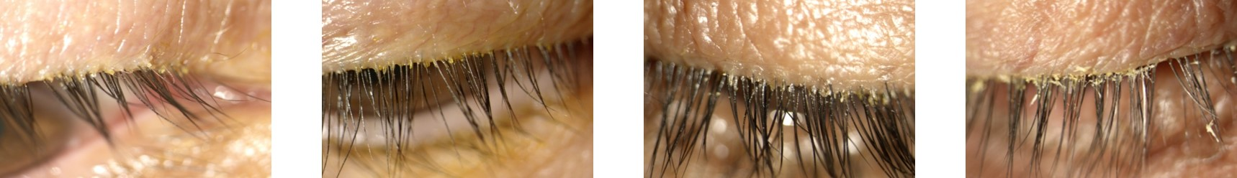
Demodex Blepharitis
Demodex infestation is a major cause of blepharitis, and we estimate that the number of Demodex blepharitis patients in the U.S. may be as many as approximately 25 million. Although we believe blepharitis and Demodex blepharitis are significantly under-diagnosed diseases, with limited treatment options, there are already an estimated 1.5 million Demodex blepharitis diagnoses in the U.S. based on the Titan study and coding for blepharitis classified per the ICD-10-CM. Demodex mites are the most common ectoparasite found on humans and are more likely to cause infestation and disease with aging. Demodex blepharitis typically presents bilaterally in patients with the disease. There are two species of Demodex mites, folliculorum and brevis, that live on the skin of the face and eyelids. Demodex folliculorum, which is commonly found in the follicle, is the more common sub-species of mite that causes Demodex blepharitis.
The pathognomonic sign of Demodex blepharitis is a specific type of eyelid debris known as the collarette, which is also sometimes referred to as cylindrical dandruff, sleeves, or waxy scurf. Collarettes are composed of partially digested epithelial cells, mite waste products and eggs among other things and can be easily diagnosed by ECPs with a standard eye examination known as the slit lamp examination. Other bothersome signs and symptoms of Demodex blepharitis that can lead to further disease progression include missing or misdirected eyelashes, crusting, redness of the lid margin, inflammation of the lid margin, inflammation of the conjunctiva and/or inflammation of the cornea, also known as blepharoconjunctivitis and blepharokeratitis. Demodex blepharitis is a progressive disease that often manifests with more severe signs and symptoms if left untreated, such as blurring of vision, missing eyelashes, MGD, corneal damage and potentially, in extreme cases, blindness. Furthermore, Demodex blepharitis can negatively impact daily activities and create an emotional burden for individuals with the disease. According to studies we have conducted, approximately 56% of cataract patients have Demodex infestation, which may increase the risk for infection after cataract and refractive surgery. Therefore, treating Demodex blepharitis may potentially improve patient satisfaction with cataract and refractive surgery. Additionally, the primary reason people stop wearing contact lenses is due to discomfort; blepharitis has been shown to cause contact lens intolerance. Therefore, treating Demodex blepharitis may reduce contact lens intolerance. We believe these benefits may lead to better vision and improved activities of daily living for patients.
10

The following figures illustrate how Demodex folliculorum mites enter and reside in the eyelash follicles:
Figure 3: Demodex folliculorum Mites Entering and Residing in Eyelash Follicles
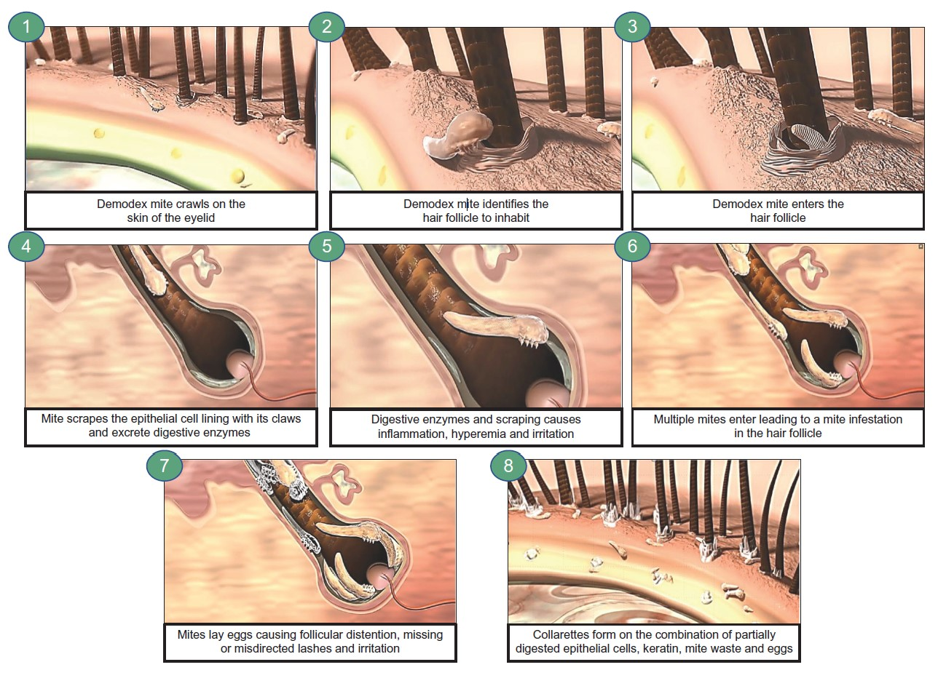
Demodex infestation can lead to Demodex blepharitis in three main ways:
 |  |  | 1) |  |  | Mechanical: Overcrowded mites scrape the epithelial cell lining of the eyelash follicles with their claws and lay eggs, causing follicular distention, misdirected lashes, eyelash loss and irritation. Dead mites and collarettes also obstruct the hair follicle opening, leading to inflammation.
 |  |  | 2) |  |  | Chemical: Mites excrete digestive enzymes as they feed and exude digestive waste when they die, resulting in inflammation, redness, irritation and epithelial hyperplasia.
 |  |  | 3) |  |  | Bacterial: Bacteria living on the mite surface or in its gut may cause inflammation of the surrounding ocular tissues.
11

As mites scratch and feed on the skin, the partially digested epithelial cells, keratin, mite waste and eggs combine to form collarettes. These collarettes are typically found at the base of the lash but can migrate away as the hair shaft grows.
The following figure illustrates collarettes at the base of an eyelash:
Figure 4: Collarettes Are the Pathognomonic Sign of Demodex Blepharitis
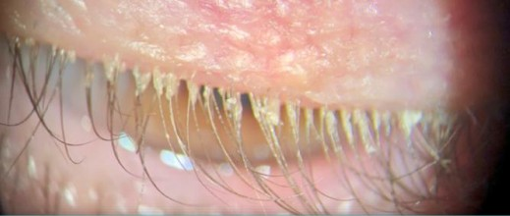
The Gao study confirmed the pathognomonic relationship of the collarette to Demodex infestation. The study included 55 patients seen at the Ocular Surface Center in Miami, Florida to determine the prevalence of Demodex in eyelashes with collarettes. All patients underwent a routine, complete eye examination and photography. Patients were divided into three main groups: (i) those with collarettes; (ii) those without collarettes and those who had been using daily lid scrubs for a full year; and (iii) those without collarettes who were not using daily lid scrubs. Of the 32 patients in the study, 100% of patients with at least one collarette had Demodex present. Those patients without collarettes were divided into two groups; patients who were using lid scrubs for a full year and those who were not. Only 7% (n=15) of patients without collarettes and who were not performing the daily lid scrubs had Demodex, while 50% (n=8) of those subjects without collarettes, but who were using daily lid scrubs with shampoo for a full year, had Demodex infestation, implying that hygiene alone did not eradicate the mites. All 55 patients were seen at one location and may not be representative of the U.S. population. However, subsequent studies, including the XDEMVY pivotal Saturn-1 and Saturn-2 trials, that had >800 patients, consistently demonstrated a correlation between the presence of collarettes and Demodex mites.
Demodex blepharitis can be diagnosed by ECPs with a slit lamp examination, by confirming the presence of collarettes. The slit lamp examination is routinely performed by ECPs as part of standard practice during a customary eye examination, so diagnosing Demodex blepharitis via presence of collarettes would not involve any additional equipment or workflow alterations on the part of the ECP.
Treatment Options Before Approval of XDEMVY and Their Limitations
Other than the use of XDEMVY, the first ever FDA-approved pharmaceutical therapy for the treatment of Demodex blepharitis, Demodex blepharitis has been generally managed with a variety of over-the-counter remedies such as tea tree oil, lid wipes and artificial tears, as well as off-label prescription products for dry eye.
These approaches have significant limitations, including:
 |  |  | • |  |  |  |  |  | limited efficacy of over-the-counter and off-label treatments as well as device-based treatments administered in clinic by ECPs;
 |  |  | • |  |  |  |  |  | insufficient definitive knowledge of diagnostic criteria to guide treatment decisions;
 |  |  | • |  |  |  |  |  | prohibitive side effects (significant burning and stinging) from treatments that target Demodex mites (e.g. tea tree oil);
 |  |  | • |  |  |  |  |  | current treatments do not typically eradicate the Demodex mites, leading to a chronic and progressive disease; and
 |  |  | • |  |  |  |  |  | some treatments may be harmful (e.g. to meibomian gland epithelial cells).
12

According to the Titan real-world prevalence study, 75% of patients using tea tree oils and 57% of those using lid wipes were found to have a high prevalence of collarettes, indicating that current management tools for this disease are ineffective. The Titan study was an Institutional Review Board ("IRB") -approved, retrospective chart review of 1,032 patients across six U.S.-based ophthalmology and optometry practices conducted by seven investigators. The study was designed to better understand the prevalence of Demodex blepharitis via collarettes in U.S. eye care clinics.
Our Approach: Treating Demodex Mites, a Root Cause of Disease
To address these limitations and high unmet need for effectively treating Demodex blepharitis, we developed and are in the process of commercializing XDEMVY, which is the definitive standard of care for the treatment of Demodex blepharitis. XDEMVY is a novel therapeutic based on the drug lotilaner, which is designed to paralyze and eradicate mites and other parasites through the inhibition of parasite-specific GABA-Cl channels. XDEMVY met all endpoints in its clinical trials and was generally well tolerated throughout each of these trials. As a result, XDEMVY was approved by the FDA in July 2023 for the treatment of Demodex blepharitis and we began commercializing XDEMVY in August 2023.
XDEMVY Eye Drops – Mechanism of Action
The active ingredient in XDEMVY is lotilaner, a member of a class of anti-parasitic molecules called isoxazolines. It is a potent non-competitive antagonist of insect and arachnid GABA-Cl channels. Lotilaner is designed to eradicate Demodex mites by selectively inhibiting GABA-Cl channels, causing mite paralysis and eventual death. It has demonstrated no binding to human GABA-Cl and other ion channels (e.g. hERG) and thus likely has no impact on the human nervous system. Lotilaner is a lipophilic molecule, which may promote its uptake in the oily sebum of the hair follicle, where the mites reside. In clinical trials, XDEMVY was topically applied to the eye BID to better ensure delivery of the drug to the eyelid margin. Following mite eradication, collarettes eventually clear from the eyelid since they are composed of mite-related waste.
The following figures illustrate the intended paralysis of mites in the hair follicle by XDEMVY administration:
Figure 5: Progression of XDEMVY Application, Mite Paralysis and Eradication
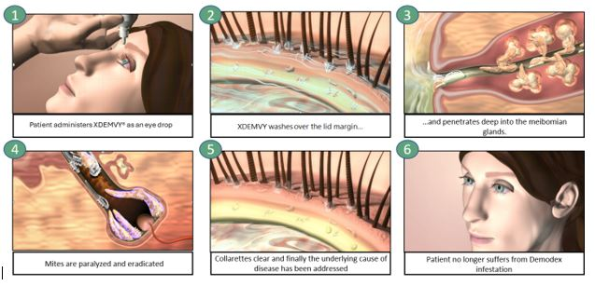
Clinical Development Program
To date we have completed seven clinical trials that include one Phase 3 trial, one Phase 2b/3 trial, four Phase 2 trials, and one Phase 1 trial for XDEMVY in Demodex blepharitis, all of which met primary, secondary and/or certain exploratory endpoints, while demonstrating XDEMVY was well tolerated. These pivotal trial results (Phase 2b/3 and Phase 3) supported the FDA approval of XDEMVY in July 2023.
13

We have also completed, and/or have ongoing clinical trials for the potential treatment of Demodex blepharitis in patients with MGD including the Ersa trial involving XDEMVY, and the Rhea trial involving a XDEMVY vehicle; TP-04 for the potential treatment of Ocular Rosacea, and TP-05 for potential Lyme disease prophylaxis, among others.
The Saturn-2 Trial
In May 2021, we initiated the Saturn-2 trial; a randomized, controlled, multicenter, double-masked trial studying the safety and efficacy of XDEMVY for the treatment of Demodex blepharitis. The Saturn-2 trial was similar in design and size to the Saturn-1 trial, which met the primary and all secondary endpoints. The Saturn-2 trial's primary endpoint was the proportion of patients achieving collarette cure, defined as zero to two collarettes per lid. Secondary endpoints included the eradication of Demodex mites and the proportion of patients achieving a cure based on a composite of collarette cure and erythema cure (eyelid redness). A statistically significant outcome for primary efficacy endpoints is typically one of the requirements for FDA approval of a product. A statistically significant outcome indicates that the probability of the outcome occurring at random is less than the pre-established allowed error level, frequently set at 0.05 (or 1 in 20).
In May 2022, we announced positive topline results of the Saturn-2 trial, our second XDEMVY pivotal trial. The Saturn-2 trial enrolled 412 adults having, among other things, more than ten collarettes per lid and at least mild lid erythema. All pre-specified primary and secondary endpoints were met, XDEMVY was well tolerated and improvement in lids (reduction of collarettes to no more than 2 collarettes per upper lid) was demonstrated in 55% of patients treated with XDEMVY.
Primary Endpoint:
•55% of patients on XDEMVY achieved complete collarette cure, defined as zero to two collarettes per lid at day 43, compared to 12% on vehicle (p<0.0001).
Secondary Endpoints:
•50% of patients on XDEMVY achieved mite eradication defined as zero mites per lash at day 43, compared to 14% on vehicle (p<0.0001).
•30% of patients on XDEMVY compared to 9% of patients on vehicle (p<0.0001) achieved complete lid erythema cure at day 43.
•19% of patients on XDEMVY achieved a complete composite cure, based on achieving both complete collarette cure and complete lid erythema cure, compared to 4% on vehicle (p<0.0001) at day 43.
Safety Profile:
•Consistent with the results from the Saturn-1 trial, the Saturn-2 trial demonstrated that XDEMVY was well tolerated with a safety profile similar to the vehicle group.
▪91% of XDEMVY patients reported that the drop comfort was neutral to very comfortable.
▪There were no serious treatment-related adverse events nor any treatment-related adverse events leading to treatment discontinuation.
Additional Analysis:
•89% of patients on XDEMVY achieved a clinically meaningful collarette reduction, defined as zero to ten collarettes per lid at day 43 compared to 33% of those on vehicle (p<0.0001).
The Saturn-1 Trial
In September 2020, we commenced the Saturn-1 trial; a randomized, controlled, multicenter, double-masked Phase 2b/3 trial that evaluated the safety and efficacy of XDEMVY in adults with Demodex blepharitis. The Saturn-1 trial enrolled 421 adult patients having more than ten collarettes on the upper lid and at least mild erythema of the upper eyelid margin. Each
14

patient had at least 1.5 mites per lash on the upper and lower eyelids combined. One drop of XDEMVY was self-administered twice per day in each eye for six weeks. Enrolled patients received no treatment for blepharitis symptoms (i.e. lid hygiene) during the trial or 14 days prior to enrollment. The primary endpoint was complete collarette cure (grade zero defined as - zero to two collarettes per lid) and the secondary endpoints included complete mite eradication (mite density of zero mites per lash) and composite cure (the presence of zero to two collarettes on the upper eyelid and the absence of erythema (redness).
In June 2021, we announced positive results of the Saturn-1 trial. The pre-specified primary and secondary endpoints were met, and improvement in lids (reduction of collarettes to no more than 2 collarettes per upper lid) was demonstrated in 44% of patients treated with XDEMVY.
44% of patients on XDEMVY achieved the primary endpoint of complete collarette reduction at day 43 compared to 7% on vehicle (p<0.0001). 81% of patients achieved a significant, clinically meaningful collarette count reduction defined as zero to ten collarettes per lid at day 43 compared to 23% of those on vehicle (p<0.0001). Additionally, a significant, clinically meaningful collarette reduction was seen in 23% of patients on XDEMVY compared to 11% on vehicle as early as day 8 (p=0.03).
The secondary endpoint of complete mite eradication achieved statistically significant results by day 15, and 68% of patients on XDEMVY achieved mite eradication compared to 17% on vehicle (p<0.0001) at day 43.
For composite cure, 13.4% of patients on TP-03 achieved a complete cure based on a composite endpoint of collarette cure and erythema cure compared to 1.0% on vehicle (p<0.0001) at day 43. Results for complete erythema cure (19% of patients on XDEMVY compared to 7% of patients on vehicle, p<0.0001) and one grade or more erythema improvement (45% of patients on XDEMVY compared to 28% of patients on vehicle, p=0.0002) were also statistically significant. Additionally, 92% of XDEMVY patients reported that the drop comfort was neutral to very comfortable. There were no serious treatment-related adverse events nor any treatment-related adverse events leading to treatment discontinuation.
In July 2021, we presented additional data from the Saturn-1 trial at the American Society of Cataract and Refractive Surgery 2021 Annual Meeting demonstrating high treatment response rates, and reinforcing the potential of XDEMVY to be the standard of care for Demodex blepharitis patients.
•95% of XDEMVY patients showed a significant improvement in mite count, achieving ≤0.5 mites per lash
•93% of XDEMVY patients improved by at least one collarette grade
We also announced results from an additional Saturn-1 trial safety analysis, which reinforced XDEMVY’s positive profile, revealing that XDEMVY had no clinically significant adverse effect on multiple safety measures including Corrected Distance Visual Acuity ("CDVA"), corneal staining, and intraocular pressure ("IOP"), and no significant findings from slit lamp biomicroscopy or fundus exam in the study. In addition, no impact to endothelial cell density ("ECD") was demonstrated in a subset of 21 patients. ECD was further evaluated as part of the Saturn-2 trial plan and also demonstrated no impact.
Phase 2 Clinical Trials
We completed four Phase 2 clinical trials for XDEMVY, along with one additional ex vivo study, which included our Mars, Jupiter, Io, and Europa clinical trials. Key efficacy endpoints for our Mars and Jupiter clinical trials included collarette grade and mite density and key efficacy endpoints for our Io and Europa clinical trials included collarette cure rate based on collarette grade, which we refer to herein as collarette cure rate, and mite eradication rate. The primary, secondary and/or certain exploratory endpoints were met, as applicable, in such trials, and showed statistically significant cure and eradication rates in Io and Europa. XDEMVY was generally well tolerated throughout these trials.
Our Additional Product Candidates
TP-04 Topical Formulation for the Treatment of Ocular Rosacea
Rosacea
Rosacea is a chronic skin disease characterized by facial redness, inflammatory lesions, burning and stinging, which can flare up in response to certain triggers such as sun exposure or emotional stress. Approximately 10% of people in the U.S., or nearly 30 million Americans, are affected by rosacea and a study estimates rosacea prevalence can represent up to 5.4%
15

of the global population. . More than half of all rosacea patients present with ocular manifestations. Hallmarks of Ocular Rosacea include telangiectasias and erythema (flushing or redness). Clinical symptoms can range from bloodshot appearance, foreign body sensation, burning or stinging, light sensitivity and blurred vision. Ocular rosacea can also lead to inflammatory MGD, conjunctivitis, and decreased visual acuity caused by corneal complications.
The cause of rosacea remains multifactorial but there is increasing evidence that Demodex mites play a role in the disease. Studies have found a correlation between Demodex infestation and rosacea, with a higher density of Demodex mites found in the skin of rosacea patients. A proposed theory suggests that the Bacillus oleronius bacteria has a pathogenic role, contributing to skin inflammation and the signs and symptoms of rosacea; these bacteria are also known to be sensitive to the antibiotics typically prescribed to treat rosacea. Meanwhile, Demodex mites have been shown to carry Bacillus oleronius in their digestive tracts, suggesting that Demodex may contribute to rosacea by being a transporter for the bacteria that causes the disease. Furthering that point, there is evidence to suggest that Bacillus oleronius forms a symbiotic relationship with Demodex, and that both species must be present in order to cause the signs and symptoms of rosacea. Other bacteria such as Staphylococcus epidermidis, also potentially carried by Demodex mites, may play a role in the disease as well.
Our Approach: TP-04 Topical Formulation for Ocular Rosacea
There are no FDA-approved therapeutics for Ocular Rosacea available today. Treatment options include topical anti-inflammatories including steroids for acute flares, and topical and/or oral antibiotics (e.g. tetracyclines, azithromycin). To address this unmet need in the rosacea market, we are developing lotilaner as a topical sterile ophthalmic product, TP-04. TP-04 is designed to be active after topical administration with no systemic activity. Lotilaner’s mechanism of targeting and killing Demodex mites has been established through our preclinical study and clinical trials evaluating XDEMVY in Demodex blepharitis, which is why we believe it may be effective in another Demodex driven disease. We believe we can improve upon existing treatments with an API that is potentially more effective (longer half-life, more lipophilic, greater therapeutic window). We believe a longer half-life leads to a more durable and long-lasting treatment and that more lipophilicity is expected to provide better bioavailability in the sebum in the follicle and sebaceous glands where mites reside, thus increasing the opportunity to target and eradicate mites and a greater therapeutic window.
We have completed the initial preclinical studies and a Phase 1 trial for TP-04 and have selected a topical ophthalmic formulation for early clinical studies. We intend to leverage systemic preclinical data from our XDEMVY program such as embryofetal development studies, genotoxicity studies and safety pharmacology studies, and augment with the dermal toxicology studies. In March 2023, we initiated the Galatea trial evaluating TP-04, a novel gel formulation of lotilaner, for the treatment of rosacea. In February 2024, we announced positive topline results from the Galatea trial, which demonstrated statistically significant improvements (p<0.05) in inflammatory lesions and IGA score (change in baseline and success rate) were observed compared to vehicle at week 12. TP-04 was generally well tolerated. After review of this data with the FDA and KOLs, we decided to pursue development of TP-04 for the potential treatment of Ocular Rosacea. In January 2025, we announced plans to initiate a Phase 2 study in the second half of 2025 for the potential treatment of Ocular Rosacea.
TP-05 Oral Formulation for Prophylactic Protection against Lyme Disease
Lyme Disease
Lyme disease is the most common vector-borne disease in the U.S., caused by infection of Borrelia bacteria following a bite by a tick vector, predominantly ticks of the Ixodes genus (namely Ixodes scapularis in the U.S.). There are approximately 80 million people in the U.S. at risk of Lyme disease exposure with more than 30 million of which are moderate to high risk, according to a report commissioned by the Company. Further, there are approximately 400,000 reported cases in the U.S. each year, but it is believed that the actual number of cases could be more. We estimate a greater than $1.3 billion impact to the U.S. healthcare system as a result of Lyme disease. Lyme disease occurs most commonly in geographical areas where the Ixodes scapularis tick is prevalent, namely in the Northeast and Mid-Atlantic regions of the U.S., but also in other regions of the U.S. Lyme disease also occurs in certain parts of Europe, typically resulting from a different Ixodes species vector.
The mechanism of Lyme disease infection is well understood. Borrelia bacteria colonizes the salivary glands of the ticks, and the infected saliva is transmitted to the human host when a tick attaches to a person for feeding. The transfer usually occurs at the conclusion of the feeding and therefore, the probability of Borrelia transmission, and thus the risk of Lyme disease, increases with the duration of the tick’s attachment. Borrelia is rarely transferred during the first or even second day of feeding but transfers quite efficiently during and after the third day of feeding (greater than 48 hours). This window from the time of bite to the time of transmission offers an opportunity for intervention to prevent Lyme disease if the tick can be killed prior to the transfer of the Borrelia bacteria.
16

Lyme disease can be a serious condition that may affect multiple organ systems and produce a broad range of symptoms. Early symptoms include a localized rash, fever and fatigue. More severe, sometimes chronic, symptoms may evolve as the infection spreads, including fever, muscle and joint pain, peripheral and central neurological deficits and lymphocytic meningitis. Lyme disease can be successfully treated with oral antibiotics when diagnosed sufficiently early, but chronic symptoms can commonly persist beyond antibiotic treatment. Because many people are either undiagnosed or misdiagnosed, the treatment of Lyme disease with antibiotics may be commonly delayed or absent.
Current Lyme Disease Prophylaxis Options and Their Limitations
Lyme disease is currently prevented through behavior modification – avoiding areas where ticks are prevalent, wearing clothing which minimizes tick exposure, using insect repellants, and physically removing ticks that have attached. With the exception of removing attached ticks, none of these approaches prevents the transmission of Borrelia post-bite.
Moreover, there are currently no FDA-approved small molecules or biologics for the prevention of Lyme disease. A vaccine for Lyme disease, LYMERix, was developed and launched by SmithKline Beecham in 1999. Approximately 1.5 million doses of the vaccine were sold in 1999, but the product was quickly removed from the market following negative press and a class-action litigation claiming a dangerous side effect profile. We are aware of vaccines currently under development including a multivalent recombinant protein vaccine, VLA-15, being developed by Valneva in partnership with Pfizer for Lyme disease; mRNA-based vaccine mRNA-1982/1975, being developed by Moderna and eliciting high levels of anti-OspA antibodies; and a pre-exposure prophylaxis injectable therapy being developed by MassBiologics involving a human anti-Lyme monoclonal antibody.
Our Approach: TP-05 Oral Formulation for the Prophylactic Protection against Lyme Disease
Since Borrelia is usually transferred during the second or third day following a tick bite, our approach is to eradicate the tick before it can transmit the bacteria. To do this, we are developing TP-05 as an oral tablet formulation of lotilaner. We are targeting potentially at least 30 days of prophylactic protection against Lyme disease with a simple oral regimen of TP-05. Given that lotilaner was developed specifically, in part, to eradicate ticks with systemic administration to domesticated animals such as dogs or cats, the pharmacology of lotilaner for Lyme disease prophylaxis is well understood. Similar to its mechanism against Demodex mites, lotilaner is a potent non-competitive antagonist of tick GABA-Cl channels. Antagonism of these channels in ticks induces paralysis and eventual death. While lotilaner results in the paralysis and eventual death of the I. scapularis vector, it does also result in the death of Borrelia burgdorferi, a non-free-living bacterium whose entire survival is conditional upon its living host. The high selectivity for insect and arachnid GABA-Cl channels over human channels where there has been no demonstrated binding, is a highly advantageous part of the profile of the molecule. Extensive preclinical systemic toxicology and safety pharmacology studies have been performed by third parties to date and support advancing TP-05 into clinical development. Lotilaner has a long, approximately 30-day systemic half-life in dogs, which we believe could provide for a convenient oral tablet administration.
In December 2022, we announced positive topline results from the Phase 1 Callisto trial for TP-05, a novel, oral, non-vaccine therapeutic for the potential prevention of Lyme disease. The Callisto trial was a randomized, double-blind, single and multiple-ascending dose trial that evaluated the safety, tolerability, and pharmacokinetic ("PK") of TP-05 in healthy subjects. Results from the trial showed that TP-05 was well tolerated with no dose-related or drug-related serious adverse events. PK data from the trial demonstrated rapid absorption and an extended half-life of TP-05 that potentially supports a convenient oral regiment supporting its potential as a rapid onset, prophylactic therapy for Lyme disease. Additionally, exploratory ex-vivo tick kill modeling that utilized serum from TP-05 treated subjects demonstrated potent, rapid killing of adult and nymph ticks. In December 2022, we also announced the initiation of the Phase 2a Carpo trial, evaluating TP-05 for the potential prevention of Lyme disease in humans. The Carpo trial is a randomized, double-blind, placebo-controlled trial that evaluated the efficacy of TP-05 in killing lab grown, non-disease carrying ticks after they have attached to the skin of healthy volunteers, as well as confirm the safety, tolerability, and blood concentration of TP-05. In February 2024 we announced positive topline results from the Carpo trial.
In December 2024, we met with the FDA about our Lyme disease program. The FDA agreed to our proposed approach for a Phase 2b clinical trial, which plans to include several hundred subjects. Additionally, the FDA confirmed that a Phase 3 clinical study would require a disease prevention field study that would likely require the enrollment of thousands of patients. We continue to believe that the best approach to get this potential prophylactic therapy to patients is to partner this program either prior to the initiation of the Phase 2b study or after the completion of the study.
We believe TP-05 is currently the only non-vaccine, drug-based prophylaxis in development designed to target ticks, and potentially prevent Lyme disease transmission. It is designed to rapidly and durably provide systemic blood levels of
17

lotilaner potentially sufficient to kill infected ticks attached to the human body before they can transmit the Borrelia bacteria that causes Lyme disease.
Chemistry, Manufacturing and Controls ("CMC")
We do not currently own or operate and currently have no plans to establish facilities for manufacturing, storing, distributing or testing our product or product candidates. We rely and expect to continue to rely for the foreseeable future on contract manufacturing organizations ("CMOs") to manufacture and supply our preclinical and clinical materials to be used during the development of our product candidates. We have assembled a team of employees and consultants to oversee our technical quality and CMOs.
Our lead product, XDEMVY, is a presentation of lotilaner, the API, formulated into a topical eye drop formulation. We believe that the existing capacity of our current API supplier is sufficient to support commercial scale-up, validation and commercial launch activities. Our current supplier currently manufactures current good manufacturing practice ("cGMP") lotilaner at multiple geographically distinct facilities.
Although we have relied on a single supplier for both non-clinical and clinical supply for lotilaner under cGMP protocols and a single CMO to manufacture XDEMVY and to perform analytical testing services, we have identified and are in the process of qualifying an additional manufacturer to provide lotilaner and drug product manufacturing and analytical testing services. The drug product manufacturing is a compounding and aseptic filling operation that we believe could be transferred to additional CMOs as necessary. We have suppliers for TP-04 topical formulation for Ocular Rosacea and TP-05 oral formulation for our Phase 1/2 trials.
Our third-party service providers, our third-party supply chain providers, their facilities and XDEMVY used in our clinical trials or for commercial sale are required to be in compliance with the requirements of cGMP. The cGMP regulations govern manufacturing processes and procedures, including requirements relating to organization of personnel, buildings and facilities, equipment, control of components and packaging containers and closures, production and process controls, packaging and labeling controls, holding and distribution, laboratory controls, records and reports, and returned or salvaged products. Product candidates used in late-stage clinical trials must be manufactured in accordance with cGMP requirements and manufacturing specifications and processes must satisfy FDA or other authorities’ requirements before any product is approved and before we can manufacture commercial products. Our third-party manufacturers are also subject to periodic inspections of facilities by the FDA and other authorities, including procedures and operations used in the testing and manufacture of XDEMVY to assess compliance with applicable regulations. Our failure, or the failure of our third-party providers and supply chain providers, to comply with such statutory and regulatory requirements could subject us to possible legal or regulatory action, including clinical holds, fines, injunctions, civil penalties, delays, suspension or withdrawal of approvals, license revocation, suspension of production, warning letters, the seizure or recall of products, operating restrictions and criminal prosecutions. Any of these actions could have a material impact on commercial supplies of XDEMVY, clinical supplies of TP-03 or our other product candidates. Contract manufacturers at times encounter difficulties involving production yields, quality control and quality assurance, as well as shortages of qualified personnel.
Competition
The biotechnology and pharmaceutical industries are characterized by rapid technological advancement, significant competition and an emphasis on intellectual property. We face potential competition from many different sources, including major and specialty pharmaceutical and biotechnology companies, academic research institutions, governmental agencies and public and private research institutions. Any products or product candidates that we successfully develop and commercialize will compete with existing approaches and new therapies that may become available in the future. We believe that the key competitive factors affecting the success of any of our products or product candidates will include efficacy, combinability, safety profile, convenience, cost, level of promotional activity devoted to them and intellectual property protection.
Other than XDEMVY, there are currently no other on-label prescription pharmaceutical treatments available for the treatment of blepharitis or Demodex blepharitis specifically, in the U.S. Other than XDEMVY, current treatments for blepharitis in the U.S. include over the counter and off-label remedies such as tea tree oil, lid wipes and artificial tears. We are aware of other companies developing potential prescription therapies for blepharitis, including Azura Ophthalmics, Aperta Biosciences, LLC, Formosa Pharmaceuticals, Inc., Glaukos Corp., Hovione Scientia, Nicox, Premark Pharma, Quorum Innovations, and Viatris. To our knowledge, Azura Ophthalmics, Aperta Biosciences, LLC, Atticus Medical, and Glaukos Corp. are the only companies currently focused on Demodex blepharitis and are in pre-clinical stage for the Demodex blepharitis indication (Aperta, Atticus, and Glaukos have publicly disclosed plans to initiate Phase 2 trials in 2025), and Premark Pharma, Azura Ophthalmics, Nicox, and Viatris are the only companies with blepharitis programs that have completed Phase 2 trials.
18

Many of the companies against which we may compete have significantly greater financial resources and expertise in research and development, manufacturing, preclinical testing, conducting clinical trials, obtaining regulatory approvals and marketing approved products than we do. Smaller or early-stage companies may also prove to be significant competitors, particularly through collaborative arrangements with large and established companies. These competitors also compete with us in recruiting and retaining qualified scientific and management personnel and establishing clinical trial sites and patient registration for clinical trials, as well as in acquiring technologies complementary to, or necessary for, our programs.
Sales and Marketing
We launched XDEMVY in the U.S. in August 2023. In 2024, XDEMVY generated $180.1 million of net product sales driven by the following:
•More than 163,000 bottles have been dispensed to patients;
•More than 15,000 ECPs have prescribed XDEMVY;
•Broad commercial, Medicare, and Medicaid reimbursement has extended to more than 90% of covered lives, as of February 25, 2025; and
•Gross to net discounts of approximately 45%.

There are approximately 25 million people in the U.S. who suffer from Demodex blepharitis, however, we are initially targeting the approximately 9 million people who are proactively seeking treatment for Demodex blepharitis or seeking treatment for complementary eye conditions or treatments.

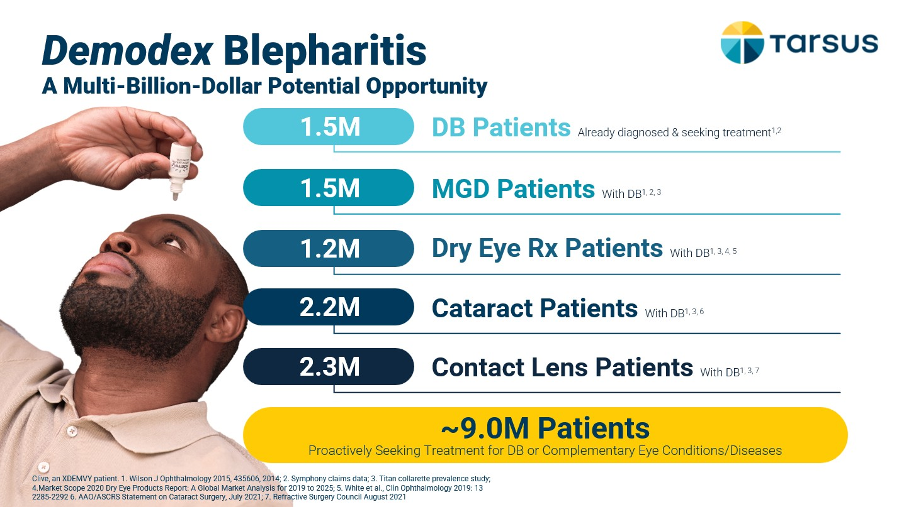
To date, we have observed increased adoption and utilization in the additional Demodex blepharitis patient segments noted above, which was further validated by our latest market research detailing that even at this early stage in the launch, approximately 40% of ECPs surveyed are already prescribing XDEMVY across each of these additional patient segments. And over 90% of the ECPs indicated they plan to increase utilization across these segments.
Outside the U.S., we intend to further develop commercialization strategies for TP-03, which may include collaborations with other companies. In March 2021, we entered into the China Out-License with LianBio Ophthalmology Limited ("LianBio"), granting exclusive commercial rights of TP-03 for the treatment of Demodex blepharitis and MGD within the China Territory. In March 2024, we executed an agreement with GrandPharma and LianBio to transition these rights to
19

GrandPharma. The terms of this agreement are further described below in the section "License Agreements: GrandPharma Agreement." We are also exploring development and commercialization opportunities in other markets, including Europe and Japan.
Intellectual Property
We protect our intellectual property rights and proprietary technology with a combination of patent rights that we own or license in certain fields of use, trademark rights, confidentiality procedures and contractual provisions. We seek not only to protect our intellectual property rights and proprietary technology in select key global markets, but also to supplement our intellectual property portfolio with new filings and applications to enhance such protection and support commercialization of current and future product candidates. To that end, we continue to seek protection for our technological innovations and branding efforts by filing new patent and trademark applications when and where appropriate. In the normal course of business, we intend to pursue, when possible, composition, method of use, dosing and formulation patent protection, as well as manufacturing and drug development processes and technology.
Our patent portfolio includes a combination of issued patents and pending patent applications licensed from third parties, as well as those assigned solely to us based on our ongoing development activities. The patents and applications in our portfolio can be categorized as related to XDEMVY, TP-03, TP-04, TP-05 or future pipeline product candidates and alternative technologies. Some of our issued patents and patent applications are exclusively licensed to us in therapeutic fields of use from Elanco.
As of December 31, 2024, the material licensed-in portfolio includes approximately 38 issued patents and approximately 17 pending patent applications from Elanco. These patents and patent applications relate to lotilaner and are issued or pending in, for example, the U.S., Argentina, Australia, Brazil, Canada, Chile, China, Columbia, several European territories, India, Japan, South Korea, Mexico, New Zealand, the Russian Federation, South Africa and Taiwan. The issued patents include composition of matter claims. The estimated natural expiration dates of the issued material in-licensed patents is approximately 2029 or 2030 with a potential extension until 2032.
Approximately 76 of our owned material patents and pending patent applications include treatment and composition of matter claims which relate to XDEMVY or TP-03 with respect to our lead indication (e.g., isoxazoline parasiticides for the treatment of Demodex blepharitis), as well as other conditions. These pending material patent applications include applications in the U.S., Australia, Brazil, Canada, China, several European territories, Hong Kong, Israel, India, Japan, South Korea, Mexico, New Zealand, the Russian Federation, and South Africa. We have a total of 38 material XDEMVY or TP-03-related issued patents worldwide. The estimated natural expiration dates of these issued patents are in 2038, and if additional patents issue on the material XDEMVY or TP-03-related pending applications of ours, the estimated natural expiration dates are between approximately 2038 and 2040.
Our continuing research and development activities, technical expertise and contractual arrangements supplement our existing intellectual property protection and help us maintain our competitive position, and we rely on trade secrets to protect our proprietary information and technologies, especially where we do not believe patent protection is appropriate or obtainable, or where such patents would be difficult to enforce. In order to maintain such trade secrets and other proprietary information, we rely in part on confidentiality agreements with our employees, consultants, contractors, outside scientific collaborators and other advisors.
We also protect our brand through trademark rights. As of December 31, 2024, we own: i) approximately 7 trademark registrations in the U.S., ii) approximately 3 pending trademark applications in the U.S., iii) approximately 34 trademark registrations in foreign countries, and iv) approximately 50 pending trademark applications in foreign countries. In order to supplement the protection of our brand, we also own at least 6 registered internet domain names.
Cybersecurity Risk Management and Strategy
We continue to make substantial investments to augment the capabilities of our people, processes, and technologies in order to address our cybersecurity risks. Our cybersecurity risks, and the controls designed to mitigate those risks, are integrated into our overall risk management governance and are reviewed quarterly by our Board of Directors (the "Board").
As of December 31, 2024, we've implemented a set of comprehensive cybersecurity and data protection policies and procedures. Our employees and contractors receive regular cybersecurity awareness trainings, including specific topics related to social engineering and email fraud. We have capable employees and consultants with significant expertise and certifications in cybersecurity related to our industry, as well as access to additional resources and other third parties as needed.
20

We invest in advanced technologies for continuous cybersecurity monitoring across our information technology environment which are designed to prevent, detect, and minimize cybersecurity attacks, as well as alert management of such attacks.
Our Information Technology General Controls ("ITGCs") are established based on recognized industry standards and cover areas such as risk management, data backup, and disaster recovery. We have implemented processes to monitor security threats and vulnerabilities and respond to all cybersecurity incidents affecting us, including prompt escalation and communication of major security incidents to senior business leadership and our Board. We conduct cybersecurity penetration testing annually to identify and remediate cybersecurity gaps. We also perform cybersecurity assessments of all our third-party providers who have access to our information technology systems and data.
License Agreements
Elanco In-License Agreement for Skin and Eye Diseases or Conditions in Humans
In January 2019, we entered into an agreement with Elanco granting us exclusive, worldwide, sublicensable license rights to certain intellectual property for the development, marketing, and commercialization of lotilaner for the treatment, palliation, prevention or cure of any eye or skin disease or condition in humans (as amended and restated in June 2022, the "Eye and Derm Elanco Agreement"). We are obligated to use commercially reasonable efforts to develop and commercialize products comprising lotilaner and must achieve certain developmental milestones within specified achievement deadlines. If we fail to meet these obligations, Elanco has the right to terminate the Eye and Derm Elanco Agreement. We utilize the intellectual property licensed under the Eye and Derm Elanco Agreement in our TP-03 and TP-04 product candidates. We are permitted to have certain third parties manufacture lotilaner for us and, upon Elanco's consent, additional third parties.
Under the Eye and Derm Elanco Agreement, we have made cash payments to Elanco totaling $14.0 million for clinical milestone achievements, including: a $1.0 million upfront payment at execution in 2019, and a total of $4.0 million for three specified clinical milestone achievements in September 2020, April 2021, and March 2023, which were recorded as research and development expense in the accompanying Statements of Operations and Comprehensive Loss in the respective periods incurred. Additionally, a sales-based milestone of $5.0 million and a commercial milestone of $4.0 million were achieved and paid to Elanco during the years ended December 31, 2024 and 2023, respectively. These milestones were recorded to intangible assets and cash and cash equivalents in the accompanying Balance Sheets as of December 31, 2024 and 2023 (see Note 9).
In accordance with the terms of the Eye and Derm Elanco Agreement, we are obligated to make further cash payments to Elanco upon our achievement of various clinical milestones up to an aggregate maximum of $2.0 million and various sales milestones up to an aggregate maximum of $70.0 million. If we receive certain types of payments from sublicensees, we are obligated to pay Elanco a variable percentage in the mid to high single digits of such proceeds and decreasing after certain milestones are met, except for sublicense revenue. We owe Elanco tiered royalties during the royalty term in the mid-to-high single digits on our future net sales and those of our sublicensees. The royalty term for any licensed product in a given country commences on the date of first commercial sale of such licensed product and ends on the latest of (i) expiration of the last-to-expire of the licensed patents which has at least one valid claim, (ii) the expiration of regulatory exclusivity and (iii) ten years after the first commercial sale of such licensed product in such country. As a result of the commercialization of XDEMVY in August 2023, we began accruing royalties payable, which were recorded to cost of sales in the accompanying Statements of Operations and Comprehensive Loss for the years ended December 31, 2024 and 2023.
The Eye and Derm Elanco Agreement shall expire on a licensed product-by-licensed product and country-by-country basis upon the expiration of the applicable royalty term with respect to such licensed product in such country. The achievement deadlines for eye-related diligence milestones range between 18 months after contract execution to six years after contract execution. The achievement deadlines for dermatological diligence milestones range between 24 months after contract execution to nine years after contract execution. All eye-related and dermatological diligence milestones have been achieved.
Either party may terminate the Eye and Derm Elanco Agreement upon a material breach by the other party, solely in the country pertaining to such breach, that is not cured within 60 days after receiving written notice thereof. If we fail to comply with our development obligations under the Eye and Derm Elanco Agreement, and fail to remedy such failure or cure such breach within 60 days, Elanco will have the right to terminate the Eye and Derm Elanco Agreement. If we fail to meet any diligence milestones by the achievement deadlines set forth in the Eye and Derm Elanco Agreement for any reason other than those outside of our reasonable control, and such milestones remain unmet for 120 days after Elanco notifies us thereof, Elanco may terminate the Eye and Derm Elanco Agreement. If we fail to meet certain dermatological milestones by the achievement deadlines set forth in the Eye and Derm Elanco Agreement for any reasons other than those outside of our reasonable control, and such milestones remain unmet for 120 days after Elanco notifies us thereof, Elanco may limit our field of use under the Eye
21

and Derm Elanco Agreement to the treatment, palliation, prevention or cure of eye diseases or conditions in humans only. If Elanco terminates the Eye and Derm Elanco Agreement for our failure to achieve a development milestone by the specified achievement deadline, then we must grant Elanco a non-exclusive, sublicensable, royalty free license to our patents and know-how relating to lotilaner to develop, manufacture and commercialize lotilaner and any licensed products for the treatment, palliation, prevention or cure of any eye or skin disease or condition in humans. Elanco may also terminate the Eye and Derm Elanco Agreement if we, our affiliates or sublicensees initiate proceedings to oppose Elanco’s licensed patents and such proceeding is not withdrawn within 30 days of Elanco providing notice to us; provided that Elanco may not terminate the Eye and Derm Elanco Agreement for a challenge by a sublicensee if we terminate the sublicense with such sublicensee within such 30 day period.
Under the terms of the Eye and Derm Elanco Agreement, we granted Elanco a worldwide, sublicensable, royalty-free, perpetual license to our patents related to lotilaner and the licensed products and to our know-how to research, develop, make and commercialize lotilaner and the licensed products for all applications in non-human animals, agricultural application, seed treatment applications and urban pest applications related to structural, turf, lawns and gardens. We also granted Elanco an exclusive royalty-free, perpetual license to any intellectual property we conceive from our use of lotilaner applications in non-human animals, agricultural applications, seed treatment applications and urban pest applications related to structural, turf, lawns and gardens.
Elanco retains the sole responsibility to prosecute the patents they license to us and has the first right to enforce the licensed intellectual property against third parties in the licensed field of use but cannot settle or dispose of any such action without our written consent.
Elanco In-License Agreement for All Other Diseases or Conditions in Humans
In September 2020, we entered into a license agreement with Elanco (the "All Human Uses Elanco Agreement") granting us an exclusive, worldwide, sublicensable license to certain intellectual property for the development, marketing, and commercialization of lotilaner for all applications in humans other than the treatment, palliation, prevention or cure of any eye or skin disease or condition. We are obligated to use commercially reasonable efforts to develop and commercialize products comprising lotilaner and must achieve certain developmental milestones within specified achievement deadlines. If we fail to meet these obligations, Elanco has the right to terminate the All Human Uses Elanco Agreement. We utilize the intellectual property licensed under the All Human Uses Elanco Agreement in our TP-05 product candidates. We are permitted to have certain third parties manufacture lotilaner for us and, upon Elanco's consent, additional third parties.
Under the terms of the All Human Uses Elanco Agreement, we issued 222,460 shares of our common stock to Elanco at the execution of the agreement in September 2020, with an estimated fair value of $3.1 million.
In March 2021, we issued 187,500 shares of our common stock to Elanco, with an estimated fair value of $5.5 million, to maintain the All Human Uses Elanco Agreement. In December 2022, we achieved a clinical milestone of $0.5 million related to the initiation of our Phase 2a Carpo trial for the potential treatment of Lyme disease.
Under the All Human Uses Elanco Agreement, we have made cash payments to Elanco totaling $0.5 million for clinical milestone achievements. We are required to make additional cash payments to Elanco upon the achievement of various clinical milestones for an aggregate maximum of $4.0 million and various commercial and sales threshold milestones for an aggregate maximum of $77.0 million. In addition, we are obligated to pay contractual royalties to Elanco for sales in certain countries. If we receive payments from sublicensees, we are obligated to pay Elanco a variable percentage beginning in the low to mid double-digits of such proceeds and decreasing after certain milestones are met, except for sublicense revenue generated after achieving regulatory approval for the use of lotilaner to applications in humans other than to treat or cure any eye or skin disease or condition. We owe Elanco tiered royalties during the royalty term in the mid-to-high single digits on our future net sales and those of our sublicensees. The royalty term for any licensed product in a given country commences on the date of first commercial sale of such licensed product and ends on the latest of (a) expiration of the last-to-expire of the licensed patents which has at least one valid claim, (b) the expiration of regulatory exclusivity, or (c) ten years after the first commercial sale of such licensed product in such country. The All Human Uses Elanco Agreement shall expire on a licensed product-by-licensed product and country-by-country basis upon the expiration of the applicable royalty term with respect to such licensed product in such country. The achievement deadlines for diligence milestones range between 24 months after contract execution to six years after contract execution.
Either party may terminate the All Human Uses Elanco Agreement upon a material breach by the other party, solely in the country pertaining to such breach, that is not cured within 60 days after receiving written notice from the other party. If we fail to comply with our development obligations under the All Human Uses Elanco Agreement, and fail to remedy
22

such failure or cure such breach within 60 days, Elanco will have the right to terminate the All Human Uses Elanco Agreement. If we fail to meet any diligence milestones by the achievement deadlines set forth in the All Human Uses Elanco Agreement for any reason other than those outside of our reasonable control, and such milestones remain unmet for 120 days after Elanco notifies us of the failure to meet such diligence milestone, Elanco may terminate the All Human Uses Elanco Agreement. If Elanco terminates the All Human Uses Elanco Agreement for our failure to achieve a development milestone by the specified achievement deadline, then we must grant Elanco a non-exclusive, sublicensable, royalty free license to our patents and know-how relating to lotilaner to develop, manufacture and commercialize lotilaner and any licensed products for all applications in humans other than the treatment, palliation, prevention or cure of any eye or skin disease or condition. Elanco may also terminate the All Human Uses Elanco Agreement if we, our affiliates or sublicensees initiate proceedings to oppose Elanco’s licensed patents and such proceeding is not withdrawn within 30 days of Elanco providing notice to us; provided that Elanco may not terminate the All Human Uses Elanco Agreement for a challenge by a sublicensee if we terminate the sublicense with such sublicensee within such 30-day period.
Under the terms of the All Human Uses Elanco Agreement, we granted to Elanco a non-exclusive worldwide, sublicensable, royalty-free, perpetual license to our patents related to lotilaner and the licensed products and to our know-how to research, develop, make and commercialize lotilaner and the licensed products for all applications in non-human animals and other non-human-use applications, agricultural applications, seed treatment applications and urban pest applications related to structural, turf, lawns and gardens. We also grant to Elanco an exclusive, royalty-free, perpetual license to any intellectual property we conceive from our use of lotilaner for all applications in non-human animals and other non-human applications.
Elanco retains the sole responsibility to prosecute the patents they license to us and has the first right to enforce the licensed intellectual property against third parties in the licensed field of use but cannot settle or dispose of any such action without our written consent.
GrandPharma Agreement
In March 2021, we entered into the China Out-License with LianBio (the "China Out-License") for its exclusive development and commercialization rights of TP-03 (lotilaner ophthalmic solution) 0.25% in The People's Republic of China, Macau, Hong Kong, and Taiwan (the "China Territory") for the treatment of Demodex blepharitis and MGD.
In February 2024, LianBio announced its plan to wind down its operations and in March 2024 made a special cash dividend payment to the Company of $0.7 million (equivalent to $4.80 per share - see Note 3). In March 2024, the Company executed an agreement assigning the China Out-License from LianBio to GrandPharma (the "Novation Agreement") and LianBio made a one-time payment of $2.5 million (the "Termination Payment") to the Company in April 2024. The Termination Payment was recorded as license fees and collaboration revenue in the accompanying Statement of Operations and Comprehensive Loss for the twelve months ended December 31, 2024. The Novation Agreement amended the $15.0 million future development milestone payable on China regulatory approval of the China Out-License with a combined condition of patent issuance related to TP-03 in China.
Simultaneous with the execution of the Novation Agreement, the Company entered into a warrant termination agreement (the "Warrant Termination Agreement) for a total cancellation payment received by us of $0.4 million (the "Warrant Cancellation Payment"). This Warrant Cancellation Payment was recorded as license fees and collaboration revenue in the accompanying Statement of Operations and Comprehensive Loss for the twelve months ended December 31, 2024 and cash and cash equivalents in the accompanying Balance Sheet as of December 31, 2024.
Through December 31, 2024, we received aggregate payments from LianBio totaling $86.1 million comprised of: (i) initial consideration of $15.0 million; (ii) $67.5 million for the achievement of specified milestone events; (iii) $2.5 million upon execution of the Novation Agreement; (iv) $0.4 million upon execution of the Warrant Termination Agreement; and (v) $0.7 million related to a special cash dividend.
As of December 31, 2024, we will be eligible to receive further consideration from GrandPharma upon the achievement of additional TP-03 events, including: (i) additional regulatory and/or patent milestones of up to an aggregate of $20.0 million; (ii) China-based TP-03 sales threshold milestone payments of up to an aggregate of $100.0 million and (iii) tiered low-to-high-teen royalties for China Territory TP-03 product sales. The variable consideration related to the remaining milestone payments was fully constrained as of December 31, 2024.
23

Government Regulation
Government authorities in the U.S. at the federal, state and local level and in other countries extensively regulate, among other things, the research, development, testing, manufacture, quality control, approval, labeling, packaging, storage, record-keeping, promotion, advertising, distribution, post-approval monitoring and reporting, marketing and export and import of drug products such as those we are developing. Generally, before a new drug can be marketed, considerable data demonstrating its quality, safety and efficacy must be obtained, organized into a format specific for each regulatory authority, submitted for review and approved by the regulatory authority. We will be required to navigate the various preclinical, clinical and commercial approval requirements of the governing regulatory agencies of the countries in which we wish to conduct studies or trials or seek approval of our product candidates. The processes for obtaining regulatory approvals in the U.S. and other countries, as appropriate, along with subsequent compliance with appropriate federal, state, local and foreign statutes and regulations, require the expenditure of substantial time and resources.
U.S. Drug Regulation
In the U.S., we are subject to extensive regulation by the FDA, which regulates drugs under the Federal Food, Drug, and Cosmetic Act (the "FDCA"), and its implementing regulations. FDA approval is required before any new unapproved drug or dosage form, including a new use of a previously approved drug, can be marketed in the U.S. Drugs also are subject to other federal, state and local statutes and regulations. The process of obtaining regulatory approvals and the subsequent compliance with appropriate federal, state, local and foreign statutes and regulations requires the expenditure of substantial time and financial resources. Failure to comply with the applicable U.S. or foreign requirements at any time during the product development process, approval process or post-marketing may subject an applicant to a variety of administrative or judicial sanctions, such as the FDA’s refusal to approve pending NDAs, withdrawal of an approval, imposition of a clinical hold, issuance of warning or untitled letters, product recalls, product seizures, total or partial suspension of production or distribution, injunctions, fines, refusals of government contracts, restitution, disgorgement or civil or criminal penalties. Any agency or judicial enforcement action could have a material adverse effect on our business, market acceptance of our products, and our reputation.
Our product candidates are considered small molecule drugs and must be approved by the FDA through the NDA process before they may be legally marketed in the U.S. The process generally involves the following:
 |  |  | • |  |  |  |  |  | completion of extensive preclinical studies in accordance with applicable regulations, including studies conducted in accordance with good laboratory practice ("GLP") requirements;
 |  |  | • |  |  |  |  |  | submission to the FDA of an IND, which must become effective before human clinical trials may begin in the U.S. and must be updated annually or when significant changes are made;
 |  |  | • |  |  |  |  |  | approval by an independent IRB or independent ethics committee at each clinical trial site before each trial may be initiated;
 |  |  | • |  |  |  |  |  | performance of adequate and well-controlled human clinical trials in accordance with applicable IND regulations, good clinical practices ("GCP"), requirements and other clinical trial-related regulations to establish substantial evidence of the safety and efficacy of the investigational product for each proposed indication;
 |  |  | • |  |  |  |  |  | submission to the FDA of an NDA;
 |  |  | • |  |  |  |  |  | a determination by the FDA within 60 days of its receipt of an NDA to accept the submission for review;
 |  |  | • |  |  |  |  |  | satisfactory completion of an FDA pre-approval inspection of the manufacturing facility or facilities where the drug will be produced to assess compliance with cGMP requirements, and of selected clinical investigational sites to assess compliance with GCP;
 |  |  | • |  |  |  |  |  | potential FDA audit of the preclinical study and/or clinical trial sites that generated the data in support of the NDA filing;
 |  |  | • |  |  |  |  |  | payment of user fees for FDA review of the NDA as well as annual fees after NDA approval;
 |  |  | • |  |  |  |  |  | FDA review and approval of the NDA, including consideration of the views of any FDA advisory committee, prior to any commercial marketing or sale of the drug in the U.S.; and
 |  |  | • |  |  |  |  |  | compliance with any post-approval requirements, including the potential requirement to implement a Risk Evaluation and Migration Strategy ("REMS") and the potential requirement to conduct post-approval studies.
24

The data required to support an NDA are generated in two distinct developmental stages: preclinical and clinical. The preclinical and clinical testing and approval process can take many years and the actual time required to obtain approval, if any, may vary substantially based upon the type, complexity and novelty of the product or condition being treated.
Preclinical Studies and IND Submission
Before testing any drug product candidate in humans, the product candidate must undergo rigorous preclinical testing. The preclinical developmental stage generally involves laboratory evaluations of drug chemistry, formulation and stability, as well as in vitro and animal studies to assess the potential for adverse events and in some cases to establish a rationale for therapeutic use. The conduct of preclinical studies is subject to federal regulations and requirements, including GLP regulations for certain safety/toxicology studies. An IND is a request for authorization from the FDA to administer an investigational product to humans, and must become effective before human clinical trials may begin in the U.S.
An IND sponsor must submit the results of the preclinical tests, together with manufacturing information, analytical data, any available clinical data or literature and plans for clinical studies, among other things, to the FDA as part of an IND. Some long-term preclinical testing, such as animal tests of reproductive adverse events and carcinogenicity, may continue after the IND is submitted. An IND automatically becomes effective 30 days after receipt by the FDA and clinical trials may proceed under such IND at such time, unless before that time the FDA raises concerns or questions related to one or more proposed clinical trials and places the trial on clinical hold. In such a case, the IND sponsor and the FDA must resolve any outstanding concerns before the clinical trial can begin. As a result, submission of an IND may not result in the FDA allowing clinical trials to commence. A separate submission to an existing IND must also be made for each successive clinical trial conducted during product development along with any subsequent changes to the investigational plan.
Clinical Trials
The clinical stage of development involves the administration of the investigational product to healthy volunteers or patients under the supervision of qualified investigators, generally physicians not employed by or under the trial sponsor’s control, in accordance with GCP requirements, which include the requirement that all research subjects provide their informed consent for their participation in any clinical trial. Clinical trials are conducted under protocols detailing, among other things, the objectives of the clinical trial, dosing procedures, subject selection and exclusion criteria and the parameters to be used to monitor subject safety and assess efficacy. Each protocol, and any subsequent amendments to the protocol, must be submitted to the FDA as part of the IND. Furthermore, each clinical trial must be reviewed and approved by an IRB for each institution at which the clinical trial will be conducted to ensure that the risks to individuals participating in the clinical trials are minimized and are reasonable in relation to anticipated benefits. The IRB also approves the informed consent form that must be provided to each clinical trial subject or his or her legal representative, and must monitor the clinical trial until completed. There also are requirements governing the reporting of ongoing clinical trials and completed clinical trial results to public registries, including the website maintained by the U.S. National Institutes of Health, ClinicalTrials.gov.
A sponsor who wishes to conduct a clinical trial outside of the U.S. may, but need not, obtain FDA authorization to conduct the clinical trial under an IND. If a foreign clinical trial is not conducted under an IND, the sponsor may still submit data from the clinical trial to the FDA in support of an NDA. The FDA may agree to accept a well-designed and well-conducted foreign clinical trial not conducted under an IND if the trial was conducted in accordance with GCP requirements and the FDA is able to validate the data through an onsite inspection, if deemed necessary.
Clinical trials in the U.S. generally are conducted in three sequential phases, known as Phase 1, Phase 2 and Phase 3. Although the phases are usually conducted sequentially, they may overlap or be combined.
 |  |  | • |  |  |  |  |  | Phase 1 clinical trials generally involve a small number of healthy volunteers or disease-affected patients who are initially exposed to a single dose and then multiple doses of the product candidate. The primary purpose of these clinical trials is to assess the metabolism, pharmacologic action, tolerability and safety of the drug in humans, the side effects associated with increasing doses, and if possible, to gain early evidence on effectiveness.
 |  |  | • |  |  |  |  |  | Phase 2 clinical trials generally involve studies in disease-affected patients to determine the dose and dosing schedule required to produce the desired benefits. At the same time, safety and further pharmacokinetic and pharmacodynamic information is collected, possible adverse effects and safety risks are identified and a preliminary evaluation of efficacy is conducted.
25

 |  |  | • |  |  |  |  |  | Phase 3 clinical trials generally involve a large number of patients at multiple sites and are designed to provide the data necessary to demonstrate the safety and effectiveness of the product for its intended use and to establish the overall benefit/risk relationship of the product to provide an adequate basis for product approval. These trials may include comparisons with placebo and/or other comparator treatments. The duration of treatment is often extended to mimic the actual use of a product during marketing.
 |  |  | • |  |  |  |  |  | A Phase 1/2 clinical trial has elements of a Phase 1 trial and a Phase 2 trial. We have designated our TP-04 and TP-05 trials as Phase 1/2 trials since we intend to go beyond the typical safety and tolerability assessments of a Phase 1 trial and intend to have these trials include additional efficacy assessments as well.
 |  |  | • |  |  |  |  |  | A Phase 2b/3 clinical trial has elements of a late Phase 2 trial and a Phase 3 trial. We have designated the Saturn-1 trial as a Phase 2b/3 trial as it is both our first multi-center trial based in the U.S., and also a pivotal trial for the U.S.
Post-approval trials, sometimes referred to as Phase 4 clinical trials, may be conducted after initial marketing approval. These trials are used to gain additional experience from the treatment of patients in the intended therapeutic indication. In certain instances, the FDA may mandate the performance of Phase 4 clinical trials as a condition of approval of an NDA.
Progress reports detailing the results of the clinical trials, among other information, must be submitted at least annually to the FDA and written IND safety reports must be submitted to the FDA and the investigators for serious and unexpected suspected adverse events, findings from other studies suggesting a significant risk to humans exposed to the drug, findings from animal or in vitro testing that suggest a significant risk for human subjects and any clinically important increase in the rate of a serious suspected adverse reaction over that listed in the protocol.
Phase 1, Phase 2 and Phase 3 clinical trials may not be completed successfully within any specified period, if at all. The FDA or the sponsor may suspend or terminate a clinical trial at any time on various grounds, including a finding that the research subjects or patients are being exposed to an unacceptable health risk. Similarly, an IRB can suspend or terminate approval of a clinical trial at its institution if the clinical trial is not being conducted in accordance with the IRB’s requirements or if the drug has been associated with unexpected serious harm to patients.
Equivalent, and similarly detailed, obligations will apply to the conduct of clinical trials in third countries including the European Union (“EU”).
NDA Review and Marketing Approval
Following completion of clinical trials, data are analyzed to assess whether the investigational product is safe and effective for the proposed indicated use or uses. The results of preclinical studies and clinical trials are then submitted to the FDA as part of an NDA, along with proposed labeling, chemistry and manufacturing information, and other information in a request for approval to market the drug for one or more specified indications. The application must include both negative and ambiguous results of preclinical studies and clinical trials, as well as positive findings. Data may come from company-sponsored clinical trials intended to test the safety and efficacy of a product’s use or from a number of alternative sources, including studies initiated by investigators. To support marketing approval, the data submitted must be sufficient in quality and quantity to establish the safety and efficacy of the investigational product to the satisfaction of FDA. FDA approval of an NDA must be obtained before a drug may be marketed in the U.S.
Under the Prescription Drug User Fee Act (the "PDUFA"), as amended, each NDA must be accompanied by an application user fee. FDA adjusts the PDUFA user fees on an annual basis. PDUFA also imposes an annual program fee for each marketed human drug. Fee waivers or reductions are available in certain circumstances, including a waiver of the application fee for the first application filed by a qualifying small business. Additionally, no user fees are assessed on NDAs for products designated as orphan drugs, unless the product NDA also includes a non-orphan indication.
The FDA conducts a preliminary review of all submitted NDAs before it accepts them for filing to determine if they are sufficiently complete to permit a substantive review, and the FDA may request additional information rather than accepting the NDA for filing. In this event, the application must be resubmitted with the additional information. The resubmitted application is also subject to review before the FDA accepts it for filing. The FDA must make a decision on accepting an NDA for filing within 60 days of receipt. Once the submission is accepted for filing, the FDA begins an in-depth review of the NDA to determine, among other things, whether the drug is safe and effective and whether the facility in which it
26

is manufactured, processed, packaged or held meets standards designed to assure the product’s continued safety, quality and purity.
Under PDUFA, the FDA has agreed to certain performance goals in the review of NDAs through a two-tiered classification system, (i) standard review; and (ii) priority review. According to PDUFA performance goals, the FDA endeavors to review applications subject to standard review within ten months, whereas the FDA’s goal is to review priority review applications within six months, depending on whether the drug is a new molecular entity. The FDA does not always meet its PDUFA goal dates for standard and priority NDAs, and the review process is often extended by FDA requests for additional information or clarification.
In addition, under the Pediatric Research Equity Act of 2003 as amended and reauthorized, certain NDAs or supplements to an NDA must contain data that are adequate to assess the safety and effectiveness of the drug for the claimed indications in all relevant pediatric subpopulations, and to support dosing and administration for each pediatric subpopulation for which the product is safe and effective. The FDA may, on its own initiative or at the request of the applicant, grant deferrals for submission of some or all pediatric data until after approval of the product for use in adults, or full or partial waivers from the pediatric data requirements.
Before approving an NDA, the FDA will conduct a pre-approval inspection of the manufacturing facilities for the new product to determine whether they comply with cGMP requirements. The FDA will not approve the product unless it determines that the manufacturing processes and facilities are in compliance with cGMP requirements and adequate to assure consistent production of the product within required specifications. The FDA may also audit data from clinical trials to ensure compliance with GCP requirements.
The FDA generally accepts data from foreign clinical trials in support of an NDA if the trials were conducted under an IND. If a foreign clinical trial is not conducted under an IND, the FDA nevertheless may accept the data in support of an NDA if the study was conducted in accordance with GCP requirements and the FDA is able to validate the data through an on-site inspection, if deemed necessary. Although the FDA generally requests that marketing applications be supported by some data from domestic clinical studies, the FDA may accept foreign data as the sole basis for marketing approval if (1) the foreign data are applicable to the U.S. population and U.S. medical practice, (2) the studies were performed by clinical investigators with recognized competence, and (3) the data may be considered valid without the need for an on-site inspection or, if the FDA considers the inspection to be necessary, the FDA is able to validate the data through an on-site inspection or other appropriate means.
Additionally, the FDA may refer applications for novel drug products or drug products which present difficult questions of safety or efficacy to an advisory committee, typically a panel that includes clinicians and other experts, for review, evaluation and a recommendation as to whether the application should be approved and under what conditions, if any. The FDA is not bound by recommendations of an advisory committee, but it considers such recommendations when making decisions on approval. The FDA also closely analyzes the clinical trial data, which could result in extensive discussions between the FDA and the applicant during the review process.
After the FDA evaluates an NDA, it will issue an approval letter or a Complete Response Letter. An approval letter authorizes commercial marketing of the drug with specific prescribing information for specific indications and potentially subject to other requirements. A Complete Response Letter indicates that the review cycle of the application is complete and the application will not be approved in its present form. A Complete Response Letter usually describes all of the specific deficiencies in the NDA identified by the FDA. The Complete Response Letter may require additional clinical data, including the potential requirement to conduct additional pivotal Phase 3 clinical trial(s) and/or other significant and time-consuming requirements related to clinical trials, or to conduct additional preclinical studies or manufacturing changes. If a Complete Response Letter is issued, the applicant may either resubmit the NDA, addressing all of the deficiencies identified in the letter, or withdraw the application. Even if such data and information are submitted, the FDA may decide that the NDA does not satisfy the criteria for approval. Data obtained from clinical trials are not always conclusive and the FDA may interpret data differently than we interpret the same data.
Post-Approval Requirements
Following approval of a new product, the product is subject to continuing regulation by the FDA, including, among other things, requirements relating to facility registration and drug listing monitoring and record keeping, periodic reporting, product sampling and distribution, advertising and promotion, and reporting of adverse experiences with the product. After approval, most changes to the approved product, such as adding new indications or other labeling claims, are subject to prior FDA review and approval. There also are continuing, annual user fee requirements for any marketed products and the
27

establishments at which such products are manufactured, as well as new application fees for supplemental applications with clinical data. The FDA strictly regulates marketing, labeling, advertising and promotion of drugs, including after they are placed on the market. Drugs may be promoted only for the approved indications and in accordance with the provisions of the approved label.
Although physicians may prescribe legally available drugs for off-label uses, manufacturers may not market or promote such uses. Prescription drug promotional materials must be submitted to the FDA in conjunction with their first use or first publication.
The FDA may also place other conditions on approvals including the requirement for a Risk Evaluation and Mitigation Strategy ("REMS"), to assure the safe use of the product. If the FDA concludes that a REMS is needed, the NDA sponsor must submit a proposed REMS. The FDA will not approve the FDA without an approved REMS, if required. Any of these limitations on approval or marketing could restrict the commercial promotion, distribution, prescription or dispensing of products. Product approvals may be withdrawn for non-compliance with regulatory standards or if problems occur following initial marketing.
FDA regulations require that products be manufactured in specific approved facilities and in accordance with cGMP regulations. We rely, and expect to continue to rely, on third parties for the production of clinical and commercial quantities of our products in accordance with cGMP regulations. These manufacturers must comply with cGMP regulations that require, among other things, quality control and quality assurance, the maintenance of records and documentation, and the obligation to investigate and correct any deviations from cGMP. Manufacturers and other entities involved in the manufacture and distribution of approved drugs are required to register their establishments with the FDA and certain state agencies, and are subject to periodic unannounced inspections by the FDA and certain state agencies for compliance with cGMP requirements and other laws. Accordingly, manufacturers must continue to expend time, money and effort in the area of production and quality control to maintain cGMP compliance. The discovery of violative conditions, including failure to conform to cGMP regulations, could result in enforcement actions, and the discovery of problems with a product after approval may result in restrictions on a product, its manufacturer or the NDA holder, including recalls.
The FDA may withdraw approval of a product if compliance with regulatory requirements and standards is not maintained or if problems occur after the product reaches the market. Corrective action could delay drug distribution and require significant time and financial expenditures. Later discovery of previously unknown problems with a product, including adverse events of unanticipated severity or frequency, or with manufacturing processes, or failure to comply with regulatory requirements, may result in revisions to the approved labeling to add new safety information; imposition of post-market studies or clinical studies to assess new safety risks or imposition of distribution restrictions or other restrictions under a REMS program. Other potential consequences include, among other things:
 |  |  | • |  |  |  |  |  | restrictions on the marketing or manufacturing of the product, suspension of the approval, complete withdrawal of the product from the market, or product recalls;
 |  |  | • |  |  |  |  |  | fines, warning letters, or holds on post-approval clinical trials;
 |  |  | • |  |  |  |  |  | refusal of the FDA to approve pending applications or supplements to approved applications;
 |  |  | • |  |  |  |  |  | suspension or revocation of product approvals;
 |  |  | • |  |  |  |  |  | product seizure or detention, or refusal to permit the import or export of products; or
 |  |  | • |  |  |  |  |  | injunctions or the imposition of civil or criminal penalties.
Other Regulatory Matters
Pharmaceutical companies are subject to additional healthcare regulation and enforcement by the federal government and by authorities in the states and foreign jurisdictions in which they conduct their business. For example, in the U.S., sales, marketing and scientific and educational programs also must comply with state and federal fraud and abuse laws, false claims laws, transparency laws, government price reporting, and health information privacy and security laws. These laws include the following:
28

 |  |  | • |  |  |  |  |  | the federal Anti-Kickback Statute (“AKS”) which prohibits, among other things, knowingly and willfully offering, paying, soliciting or receiving remuneration (i.e., anything of value), directly or indirectly, in cash or in kind, to induce or in return either for the referral of an individual for, or for purchasing, leasing, ordering or arranging for the purchase, lease or order of any healthcare item or service reimbursable under Medicare, Medicaid or other federally financed healthcare programs. This statute has been interpreted to apply to arrangements between pharmaceutical manufacturers on one hand and prescribers, purchasers, and formulary managers on the other. Although there are a number of statutory exceptions and regulatory safe harbors protecting certain common business arrangements and activities from prosecution or regulatory sanctions, the exceptions and safe harbors are drawn narrowly and practices that involve remuneration intended to induce prescribing, purchasing or recommending may be subject to scrutiny if they do not fit squarely within an exception or safe harbor. Our practices may not in all cases meet all of the criteria for safe harbor protection from AKS liability. Moreover, there are no safe harbors for many common practices, such as educational and research grants, charitable donations, product support and patient assistance programs. The regulatory safe harbors also are subject to regulatory revision and interpretation by a number of government agencies. Liability under the AKS may be established without proving actual knowledge of the statute or specific intent to violate it. In addition, the government may assert that a claim including items or services resulting from a violation of the AKS constitutes a false or fraudulent claim for purposes of the federal civil False Claims Act (discussed below). Violations of the AKS are punishable by imprisonment, criminal fines, damages, civil monetary penalties, and exclusion from participation in federal healthcare programs;
 |  |  | • |  |  |  |  |  | the federal civil False Claims Act (“FCA”) which prohibits any person from, among other things, knowingly presenting, or causing to be presented, a false or fraudulent claim for payment of government funds, or knowingly making, using, or causing to be made or used a false record or statement material to an obligation to pay money to the government, or knowingly concealing or knowingly and improperly avoiding, decreasing, or concealing an obligation to pay money to the federal government. Actions under the FCA may be brought by the Attorney General or as a qui tam action by a private individual in the name of the government. Such private individuals may share in amounts paid by the entity to the government in recovery or settlement. Recently, several pharmaceutical and other healthcare companies have been prosecuted under these laws for allegedly providing free product to customers with the expectation that the customers would bill federal programs for the product. Other companies have been prosecuted for causing false claims to be submitted because of the companies’ marketing of the product for unapproved, and thus non-reimbursable, uses. FCA liability is potentially significant in the healthcare industry because the statute provides for treble damages and significant mandatory penalties per false or fraudulent claim or statement for violations, as well as exclusion from participation in federal healthcare programs. Pharmaceutical and other healthcare companies also are subject to other federal false claims laws, including, among others, federal criminal healthcare fraud and false statement statutes that extend to non-government health benefit programs;
 |  |  | • |  |  |  |  |  | the federal Health Insurance Portability and Accountability Act ("HIPAA"), which imposes criminal liability for, among other things, knowingly and willfully executing or attempting to execute a scheme to defraud any healthcare benefit program, knowingly and willfully embezzling or stealing from a health care benefit program, willfully obstructing a criminal investigation of a health care offense, or knowingly and willfully making false statements relating to healthcare matters;
 |  |  | • |  |  |  |  |  | HIPAA and its implementing regulations, also imposes obligations, on certain covered entity health care providers, health plans and health care clearinghouses as well as their business associates that perform certain services involving the use or disclosure of individually identifiable health information, including mandatory contractual terms, with respect to safeguarding the privacy, security and transmission of individually identifiable health information;
 |  |  | • |  |  |  |  |  | federal consumer protection and unfair competition laws, which broadly regulate marketplace activities and activities that potentially harm consumers;
 |  |  | • |  |  |  |  |  | the FDCA, which prohibits, among other things, the adulteration or misbranding of drugs, biologics and medical devices, including off-label or pre-approval promotion;
29

 |  |  | • |  |  |  |  |  | the federal Physician Payments Sunshine Act, which requires applicable manufacturers of covered drugs, devices, biologics and medical supplies for which payment is available under Medicare, Medicaid or the Children’s Health Insurance Program, with specific exceptions, to annually report to Centers for Medicare & Medicaid Services ("CMS") information regarding direct or indirect payments and other transfers of value to physicians and teaching hospitals (and certain other practitioners as of 2022), as well as information regarding ownership and investment interests held by physicians and their immediate family members; and
 |  |  | • |  |  |  |  |  | analogous state and foreign laws and regulations, such as state anti-kickback and false claims laws which may apply to sales or marketing arrangements and claims involving healthcare items or services reimbursed by non- governmental third-party payers, including private insurers, state laws that require pharmaceutical manufacturers to comply with the industry’s voluntary compliance guidelines and the relevant compliance guidance promulgated by the federal government and may require drug manufacturers to report information related to payments and other transfers of value to physicians and other healthcare providers or marketing expenditures, state laws that require pharmaceutical manufacturers to report information on the pricing of certain drug products, state and local laws that require the licensure and registration of pharmaceutical sales representatives, and state and foreign laws that govern the privacy and security of health information in some circumstances, many of which differ from each other in significant ways and often are not preempted by HIPAA, thus complicating compliance efforts.
Furthermore, states are constantly adopting new laws or amending existing laws, requiring attention to frequently changing regulatory requirements. For example, California has enacted the California Consumer Privacy Act ("CCPA"), as amended by the California Privacy Rights Act ("CPRA"). The CCPA created new transparency requirements, granted California consumers (as that word is broadly defined in the law) several new rights with regard their personal information, and places increased privacy and security obligations on entities handling personal data of consumers or households. The CCPA requires covered companies to provide new disclosures to California consumers, provide such consumers new ways to opt-out of certain sales of personal information, and allow for a new cause of action for data breaches. In addition, the CPRA introduced significant amendments to the CCPA and established and funded a dedicated California privacy regulator, the California Privacy Protection Agency (“CPPA”). The amendments introduced by the CPRA went into effect on January 1, 2023, and implementing regulations continue to be introduced by the CPPA. In addition, California residents have the right to bring a private right of action in connection with certain types of incidents. These claims may result in significant liability and potential damages. Other states, including Virginia, Colorado, Utah, Indiana, Iowa, Tennessee, Montana, Texas, and Connecticut, have enacted privacy laws similar to the CCPA that impose new obligations or limitations in areas affecting our business and we continue to assess the impact of these state legislations on our business as additional information and guidance becomes available. Similarly, there are a number of legislative proposals in the United States, at both the federal and state level, that could impose new obligations or limitations in areas affecting our business. Failure to comply with the CCPA and other state law may result in, among other things, significant civil penalties and injunctive relief, or potential statutory or actual damages. These laws could impact our business activities depending on how they are interpreted and exemplify the vulnerability of our business to not only cyber threats but also the evolving regulatory environment related to personal data and protected health information. We have implemented processes to manage compliance with the CCPA and other state laws and we continue to assess their impact on our business as additional information and guidance becomes available.
Products must meet applicable child-resistant packaging requirements under the U.S. Poison Prevention Packaging Act. Manufacturing, sales, promotion and other activities also are potentially subject to federal and state consumer protection and unfair competition laws.
The distribution of pharmaceutical products is subject to additional requirements and regulations, including extensive record-keeping, licensing, storage and security requirements intended to prevent the unauthorized sale of pharmaceutical products.
The failure to comply with any of these laws or regulatory requirements subjects firms to possible legal or regulatory action. Depending on the circumstances, failure to meet applicable regulatory requirements can result in significant civil, criminal and administrative penalties, including damages, fines, disgorgement, individual imprisonment, exclusion from participation in government funded healthcare programs, such as Medicare and Medicaid, compliance oversight and reporting obligations, contractual damages, reputational harm, diminished profits and future earnings, injunctions, requests for recall, seizure of products, total or partial suspension of production, denial or withdrawal of product approvals or refusal to allow a firm to enter into supply contracts, including government contracts.
30

U.S. Patent-Term Restoration and Marketing Exclusivity
Depending upon the timing, duration and specifics of FDA approval of any future product candidates, some of our U.S. patents may be eligible for limited patent term extension under the Drug Price Competition and Patent Term Restoration Act of 1984, also known as the Hatch-Waxman Act. The Hatch-Waxman Act permits restoration of the patent term of up to five years as compensation for patent term lost during product development and FDA regulatory review process. Patent-term restoration, however, cannot extend the remaining term of a patent beyond a total of 14 years from the product’s approval date. The patent-term restoration period is generally one-half the time between the effective date of an IND or the issue date of the patent, whichever is later, and the submission date of an NDA plus the time between the submission date of an NDA or the issue date of the patent, whichever is later, and the approval of that application, except that the review period is reduced by any time during which the applicant failed to exercise due diligence. Only one patent applicable to an approved drug is eligible for the extension and the application for the extension must be submitted prior to the expiration of the patent. The U.S. Patent and Trademark Office ("USPTO"), in consultation with the FDA, reviews and approves the application for any patent term extension or restoration. In the future, we may apply for restoration of patent term for our currently owned or licensed patents to add patent life beyond its current expiration date, depending on the expected length of the clinical trials and other factors involved in the filing of the relevant NDA.
Market exclusivity provisions under the FDCA also can delay the submission or the approval of certain applications. The FDCA provides a five-year period of non-patent marketing exclusivity within the U.S. to the first applicant to gain approval of an NDA for a new chemical entity. A drug is a new chemical entity if the FDA has not previously approved any other new drug containing the same active moiety, which is the molecule or ion responsible for the action of the drug substance. During the exclusivity period, the FDA may not accept for review an abbreviated new drug application ("ANDA") or a 505(b)(2) NDA submitted by another company for another version of such drug where the applicant does not own or have a legal right of reference to all the data required for approval. However, an application may be submitted after four years if it contains a certification of patent invalidity or non-infringement. The FDCA also provides three years of marketing exclusivity for an NDA, 505(b)(2) NDA or supplement to an existing NDA if new clinical investigations, other than bioavailability studies, that were conducted or sponsored by the applicant are deemed by the FDA to be essential to the approval of the application, for example, new indications, dosages or strengths of an existing drug. This three-year exclusivity covers only the conditions of use associated with the new clinical investigations and does not prohibit the FDA from approving ANDAs for drugs containing the original active agent. Five-year and three-year exclusivity will not delay the submission or approval of a full 505(b)(1) NDA. However, an applicant submitting a full NDA would be required to conduct or obtain a right of reference to all of the preclinical studies and adequate and well-controlled clinical trials necessary to demonstrate safety and effectiveness.
European Union Drug Development
Similar to the U.S., the various phases of preclinical and clinical research in the European Union are subject to significant regulatory controls. Although the European Union Clinical Trials Directive 2001/20/EC has sought to harmonize the EU clinical trials regulatory framework, setting out common rules for the control and authorization of clinical trials in the EU, the 27 member states of the EU (the "EU Member States") have transposed and applied the provisions of the Directive differently. This has led to significant variations in the member state regimes. Under the regime of the Clinical Trials Directive, before a clinical trial can be initiated it must be approved in each of the EU countries where the trial is to be conducted by two distinct bodies: the National Competent Authority ("NCA"), and one or more ethics committees. Under the regime of the Clinical Trials Directive all suspected unexpected serious adverse reactions to the investigated drug that occur during the clinical trial have to be reported to the NCA and ECs of the Member State where they occurred.
In order to streamline the regulation of clinical trials across the EU, the EU legislator has adopted Regulation (EU) No 536/2014 (the "EU Clinical Trials Regulation"). The new EU Clinical Trials Regulation, which has repealed and replaced the EU Clinical Trials Directive, introduced a complete overhaul of the former regulation of clinical trials for medicinal products in the EU. The main characteristics of the regulation include: a streamlined application procedure through a single entry point, the “EU portal”; a single set of documents to be prepared and submitted for the application as well as simplified reporting procedures for clinical trial sponsors; and a harmonized procedure for the assessment of applications for clinical trials, which is divided in two parts. The EU Clinical Trials Regulation is applicable as of January 31, 2022 and is applicable directly in all countries of the European Economic Area ("EEA") (which is comprised of 27 Member States of the EU plus Norway, Iceland and Liechtenstein). Clinical trials that were authorized under the Clinical Trials Directive before January 31, 2023 can continue to be conducted under the Clinical Trials Directive until January 31, 2025. An application to transition ongoing trials from the current Clinical Trials Directive to the new EU Clinical Trials Regulation will need to be submitted and authorized in time before the end of the transitional period. From January 31, 2023 onwards, the application for new clinical trials must be
31

done in accordance with the new EU Clinical Trials Regulation. The EU Clinical Trials Regulation is intended to simplify and streamline the approval of clinical trials in the EEA.
European Union Drug Review and Approval
In order to market any product outside of the U.S., a company must also comply with numerous and varying regulatory requirements of other countries and jurisdictions regarding quality, safety, and efficacy, and governing, among other things, clinical trials, marketing authorization, commercial sales, and distribution of products. Whether or not it obtains FDA approval for a product, an applicant will need to obtain the necessary approvals by the comparable foreign regulatory authorities before it can commence clinical trial or marketing of the product in those countries or jurisdictions.
Marketing Authorization
In the EEA, medicinal products can only be commercialized after obtaining a Marketing Authorization ("MA"). There are a number of types of marketing authorizations.
 |  |  | • |  |  |  |  |  | The Community MA is adopted by the European Commission in the form of a decision through the Centralized Procedure (the "Centralized Procedure"). The decision, which is based on the opinion of the Committee for Medicinal Products for Human Use ("CHMP") of the European Medicine Agency ("EMA"), is valid throughout the entire territory of the EEA. The Centralized Procedure is mandatory for certain types of products, such as biotechnology medicinal products, orphan medicinal products, advanced-therapy medicines such as gene-therapy, somatic cell-therapy or tissue-engineered medicines and medicinal products containing a new active substance indicated for the treatment of HIV, AIDS, cancer, neurodegenerative disorders, diabetes, auto-immune and other immune dysfunctions and viral diseases. The Centralized Procedure is optional, on approval by the EMA for products containing a new active substance not yet authorized in the EEA, or for products that constitute a significant therapeutic, scientific or technical innovation or which are in the interest of public health in the European Union.
Under the Centralized Procedure, the CHMP established at the EMA is responsible for conducting an initial scientific assessment of a product. The maximum timeframe for the evaluation of an MA under the Centralized Procedure is 210 days, excluding clock stops when additional information or written or oral explanation is to be provided by the applicant in response to questions of the CHMP.
Accelerated evaluation may be granted by the CHMP in exceptional cases, when a medicinal product is of major interest from the point of view of public health and, in particular, from the viewpoint of therapeutic innovation. If the CHMP accepts such a request, the time limit of 210 days will be reduced to 150 days, but it is possible that the CHMP may revert to the standard time limit for the Centralized Procedure if it determines that it is no longer appropriate to conduct an accelerated assessment.
 |  |  | • |  |  |  |  |  | MAs based on the Mutual Recognition Procedure or the Decentralized Procedure are available for products not falling within the mandatory scope of the Centralized Procedure. Where a product is first authorized by a Reference Member State this may be recognized by other Concerned Member States through the Mutual Recognition Procedure. Alternatively, a product can be approved simultaneously in various EU Member States through the Decentralized Procedure. Under the Decentralized Procedure an identical dossier is submitted to the competent authorities of each of the EU Member States in which the MA is sought, one of which is selected by the applicant as the Reference Member State. The competent authority of the Reference Member State prepares a draft assessment report, a draft Summary of Product Characteristics ("SmPC") and a draft of the labeling and package leaflet, which are sent to the other Member States (referred to as the "Concerned Member States") for their approval. If the Concerned Member States raise no objections, based on a potential serious risk to public health, to the assessment, SmPC, labeling or packaging proposed by the Reference Member State, the product is subsequently granted a national MA in all the Member States (i.e., in the Reference Member State and the Concerned Member States).
Regulatory data protection and market exclusivity in the EU
In the EU, new medicinal products are granted a protection period of 8 years of data exclusivity and an additional 2 years of market exclusivity. As such, for a period of 8 years, generics cannot use the data of the innovator to obtain a marketing authorization. Only after 8 years have lapsed, other parties that apply for a marketing authorization (generics or biosimilars) may make reference to the dossier of the originator product. Only after another 2 years (i.e. a total of 10 years) may such
32

generic or biosimilar medicinal product be placed on the market. In April 2023, the European Commission published a proposal to reform this system. In this proposal, the current standard period of regulatory data protection will be reduced from eight years to six years. The legislative process for this reform is expected to take several years. It is currently uncertain if the proposal will be adopted in its current form and it is uncertain if and when the revised legislation would enter into force.
Coverage and Reimbursement
Sales of our products will depend, in part, on the extent to which our products will be covered by third-party payers, such as government health programs, commercial insurance, and managed healthcare organizations. In the U.S., for example, principal decisions about reimbursement for new products are typically made by CMS, the agency that administers the Medicare program through regional contractors, state Medicaid programs, third-party payers, and insurance plans. These entities decide whether and to what extent a new product will be covered and reimbursed based on clinical needs and economic impact. To date, no uniform policy of coverage and reimbursement for drug products exists. Accordingly, decisions regarding the extent of coverage and amount of reimbursement to be provided for any of our products will be made on a payer-by-payer basis.
Increasingly, third-party payers are requiring that drug companies provide them with discounts usually in the form of rebates from list prices and are challenging the prices charged for medical products. Further, such payers are examining the medical necessity and reviewing the cost effectiveness of newly launched drugs. There may be especially significant delays in obtaining coverage and reimbursement for newly approved drugs or new indications for products as several large payers have implemented new to market blocks that can last anywhere between six to twelve months. Third-party payers may limit coverage to specific product candidates on an approved list, known as a formulary, which might not include all FDA-approved drugs for a particular indication. We may need to conduct additional expensive pharmaco-economic Phase 4 real-world studies to demonstrate the medical necessity and cost effectiveness of our products. As a result, the coverage determination process is often a time-consuming and costly process that will require us to provide scientific and clinical support for the use of our products, with no assurance that coverage and adequate reimbursement will be obtained. Additionally, maintaining coverage for a product is often evaluated annually by payers and additional barriers may be placed impacting access. We are committed to partnering with payers to ensure broad access and affordability.
Pharmaceutical Pricing
We participate in the Medicaid Drug Rebate Program and Medicare Part D Coverage Gap Discounts Program ("Medicare Part D"). Participation is required for federal funds to be available for our covered outpatient drugs under Medicaid and Medicare Part B ("Medicare Part B"), and under Medicare Part D, respectively. Under the Medicaid Drug Rebate Program, we are required to pay a mandatory rebate to each state Medicaid program for our covered outpatient drugs that are dispensed to Medicaid beneficiaries and paid for by a state Medicaid program as a condition of having federal funds being made available to the states for our drugs under Medicaid. Those rebates are based on pricing data reported by the manufacturer on a monthly and quarterly basis to CMS. These data include the average manufacturer price and, in the case of innovator products, the best price for each drug, which, in general, represents the lowest price available from the manufacturer to any wholesaler, retailer, provider, health maintenance organization, nonprofit entity, or governmental entity in the U.S. in any pricing structure, calculated to include all sales and associated rebates, discounts, and other price concessions. Under the Medicare Part D Coverage Gap Discount Program, manufacturers, including us, are currently required to provide to CMS a 70% discount on brand name prescription drugs utilized by Medicare Part D beneficiaries when those beneficiaries are in the coverage gap phase of the Medicare Part D benefit design. The IRA sunsets the coverage gap discount program starting in 2025 and replaces it with a new manufacturer discount program.
The Affordable Care Act (“ACA”) (addressed further in the section on “Healthcare Reform”) made significant changes to the Medicaid Drug Rebate Program, and CMS issued a final regulation to implement the changes to the Medicaid Drug Rebate Program under the ACA. CMS also issued a final regulation that modified prior Medicaid Drug Rebate Program regulations to permit reporting multiple best price figures with regard to value based purchasing arrangements; and provide definitions for “line extension,” “new formulation,” and related terms, with the practical effect of expanding the scope of drugs considered to be line extensions that are subject to an alternative rebate formula.
Federal law requires that any company that participates in the Medicaid Drug Rebate Program also participate in the Public Health Service’s 340B drug pricing program in order for federal funds to be available for the manufacturer’s drugs under Medicaid and Medicare Part B. The 340B drug pricing program requires participating manufacturers to agree to charge statutorily defined covered entities no more than the 340B ceiling price for the manufacturer’s covered outpatient drugs. These 340B covered entities include a variety of community health clinics and other entities that receive health services grants from the Public Health Service, as well as hospitals that serve a disproportionate share of low-income patients. The 340B ceiling
33

price is calculated using a statutory formula, which is based on the average manufacturer price and rebate amount for the covered outpatient drug as calculated under the Medicaid Drug Rebate Program.
Further, the Inflation Reduction Act ("IRA") of 2022 (addressed further in the section on “Healthcare Reform”) establishes a Medicare Part D inflation rebate schemes (the first rebate period is in fourth quarter 2022 through third quarter 2023) and a drug price negotiation program, with the first negotiated prices to take effect in 2026. It also makes several changes to the Medicare Part D benefit, including the creation of a new manufacturer discount program in place of the current coverage gap discount program (beginning in 2025).
In addition, to be eligible to have its products paid for with federal funds under the Medicaid and Medicare Part B programs and purchased by certain federal agencies and grantees, a manufacturer also must participate in the U.S. Department of Veterans Affairs ("VA") Federal Supply Schedule ("FSS") pricing program. Under this program, the manufacturer is obligated to make its innovator and single source products available for procurement on an FSS contract and charge a price to four federal agencies, the VA, U.S. Department of Defense ("DoD"), Public Health Service and U.S. Coast Guard - that is no higher than the statutory Federal Ceiling Price ("FCP"). Manufacturers also are obligated to calculate and submit to the VA on a quarterly and annual basis, their Non-Federal Average Manufacturer Price (“Non-FAMP”), which the VA uses to calculate the FCP. Moreover, pursuant to regulations issued by the DoD Defense Health Agency to implement Section 703 of the National Defense Authorization Act for Fiscal Year 2008, manufacturers are required to provide rebates on utilization of their innovator and single source products that are dispensed to TRICARE beneficiaries by TRICARE network retail pharmacies.
The requirements under the Medicaid, 340B, FSS, and TRICARE programs could reduce the revenue we may generate from any products that are commercialized in the future and could adversely affect our business and operating results. If we fail to comply with any applicable obligations under governmental pricing programs that we participate in, we could be subject to additional reimbursement requirements, significant civil monetary penalties, sanctions and fines, and those could negatively impact our business, financial condition, results of operations and growth prospects.
In addition, in most foreign countries, the proposed pricing for a drug must be approved before it may be lawfully marketed. The requirements governing drug pricing and reimbursement vary widely from country to country. For example, the European Union provides options for its member states to restrict the range of medicinal products for which their national health insurance systems provide reimbursement and to control the prices of medicinal products for human use. A member state may approve a specific price for the medicinal product or it may instead adopt a system of direct or indirect controls on the profitability of the company placing the medicinal product on the market. Pharmaceutical products may face competition from lower-priced products in foreign countries that have placed price controls on pharmaceutical products and may also compete with imported foreign products. There can be no assurance that any country that has price controls or reimbursement limitations for pharmaceutical products will allow favorable reimbursement and pricing.
Healthcare Reform
The U.S. government, state legislatures, and foreign governments have shown significant interest in implementing cost containment programs to limit the growth of government-paid healthcare costs, including price-controls, restrictions on reimbursement, and requirements for substitution of generic products and/or lower cost over the counter alternatives for branded prescription drugs. For example, the ACA substantially changed the way healthcare is financed by both the government and private insurers, and significantly impacts the U.S. pharmaceutical industry. The ACA contains provisions that may reduce the profitability of drug products through increased rebates for drugs reimbursed by Medicaid programs, extension of Medicaid rebates to Medicaid managed care plans, mandatory discounts for certain Medicare Part D beneficiaries and annual fees based on pharmaceutical companies’ share of sales to federal health care programs. The ACA made several changes to the Medicaid Drug Rebate Program, including increasing pharmaceutical manufacturers’ rebate liability by raising the minimum basic Medicaid rebate. The ACA also expanded the universe of Medicaid utilization subject to drug rebates by requiring pharmaceutical manufacturers to pay rebates on Medicaid managed care utilization and by enlarging the population potentially eligible for Medicaid drug benefits.
There have been judicial challenges to certain aspects of the ACA, as well as efforts by Congress to modify, and by agencies to alter the implementation of, certain aspects of the ACA. For example, Congress eliminated the tax penalty for not complying with the ACA’s individual mandate to carry health insurance. Further, the Bipartisan Budget Act of 2018, among other things, amended the ACA to increase from 50 percent to 70 percent the point-of-sale discount that is owed by pharmaceutical manufacturers who participate in Medicare Part D to close the coverage gap in most Medicare drug plans, commonly referred to as the "donut hole" (the IRA sunsets the coverage gap discount program and replaces it with a new manufacturer discount, beginning in 2025).
34

It is possible that the ACA, as currently enacted or may be amended in the future, as well as other healthcare reform measures including those that may be adopted in the future, may result in more rigorous coverage criteria, and less favorable payment methodologies, or other downward pressure on coverage and payment and the price that we receive for any approved product. Any reduction in reimbursement or restriction on coverage under Medicare or other government programs may result in a similar reduction or restriction by private payers.
Other legislative changes have been proposed and adopted in the U.S. since the ACA was enacted. These changes included aggregate reductions to Medicare payments to providers of 2% per fiscal year required by the Budget Control Act of 2021, as amended by the American Taxpayer Relief Act of 2012 (“ATRA”). Subsequent legislation extended the 2% reduction, generally to 2031. Sequestration is currently set at 2% and will increase to 2.25% for the first half of fiscal year 2030, to 3% for the second half of fiscal year 2030, and to 4% for the remainder of the sequestration period that lasts through the first six months of fiscal year 2031. ATRA, among other things, also reduced Medicare payments to several types of providers, and increased the statute of limitations period for the government to recover overpayments to providers from three to five years. Other new laws may result in additional reductions in Medicare and other healthcare funding, which could have a material adverse effect on customers for our drugs, if approved, and accordingly, our financial operations.
Moreover, the Medicare Prescription Drug, Improvement, and Modernization Act of 2003 ("MMA") established the Medicare Part D program to provide a voluntary prescription drug benefit to Medicare beneficiaries. Under Part D, Medicare beneficiaries may enroll in prescription drug plans offered by private entities that provide coverage of outpatient prescription drugs. Unlike Medicare Part A and B, Part D coverage is not standardized. While all Medicare drug plans must give at least a standard level of coverage set by Medicare, Part D prescription drug plan sponsors are not required to pay for all covered Part D drugs, and each drug plan can develop its own drug formulary that identifies which drugs it will cover and at what tier or level. However, Part D prescription drug formularies must include drugs within each therapeutic category and class of covered Part D drugs, though not necessarily all the drugs in each category or class. Any formulary used by a Part D prescription drug plan must be developed and reviewed by a pharmacy and therapeutic committee. Government payment for some of the costs of prescription drugs may increase demand for products for which we receive marketing approval. However, any negotiated prices for our products covered by a Part D prescription drug plan likely will be lower than the prices we might otherwise obtain. Moreover, while the MMA applies only to drug benefits for Medicare beneficiaries, private third-party payers often follow Medicare coverage policy and payment limitations in setting their own payment rates and in establishing their formulary placement.
Further, the IRA introduces several changes to the Medicare Part D benefit, including a limit on annual out-of-pocket costs and a change in manufacturer liability under the program which could negatively affect the profitability of our product candidates. The IRA sunsets the current Part D coverage gap discount program starting in 2025 and replaces it with a new manufacturer discount program. Failure to pay a discount under this new program will be subject to a civil monetary penalty. In addition, the IRA established a Medicare Part B inflation rebate scheme effective January 2023 and a Medicare Part D inflation rebate scheme effective October 2022, under which, generally speaking, manufacturers will owe rebates if the price of a Part B or Part D drug increases faster than the pace of inflation. Failure to timely pay a Part B or D inflation rebate is subject to a civil monetary penalty. The IRA also creates a drug price negotiation program under which the prices for Medicare units of certain high Medicare spend drugs and biologicals without generic or biosimilar competition will be capped by reference to, among other things, a specified non-federal average manufacturer price starting in 2026. Failure to comply with requirements under the drug price negotiation program is subject to an excise tax and/or a civil monetary penalty. Congress continues to examine various policy proposals that may result in pressure on the prices of prescription drugs with respect to the government health benefit programs and otherwise. The IRA or other legislative changes could impact the market conditions for our product candidates.
Additionally, there has been heightened governmental scrutiny over the manner in which drug manufacturers set prices for their marketed products, which has resulted in several Congressional inquiries and proposed and enacted federal and state legislation designed to, among other things, bring more transparency to product pricing, review the relationship between pricing and manufacturer patient programs, and reform government program reimbursement methodologies for drug products. At the state level, legislatures have increasingly passed legislation and implemented regulations designed to control pharmaceutical and biological product pricing, including price or patient reimbursement constraints, discounts, restrictions on certain product access and marketing cost disclosure and transparency measures, and, in some cases, designed to encourage importation from other countries and bulk purchasing. Finally, some states have established Prescription Drug Affordability Boards (or similar entities) to review high-cost drugs and, in some cases, set upper payment limits.
Human Capital Resources

35

Human Capital

As of December 31, 2024, we had 323 employees, all of which were full-time employees. None of our employees are represented by a labor union or covered under a collective bargaining agreement.

Our human capital resources objectives include, as applicable, identifying, recruiting, retaining, incentivizing and integrating our existing and new employees, advisors and consultants. The principal purposes of our equity and cash incentive plans are to attract, retain and reward personnel through the granting of stock-based and cash-based compensation awards, in order to increase stockholder value and the success of our company by motivating such individuals to perform to the best of their abilities and achieve our objectives.

Employee Development and Training

Our values-based culture and our employees are a critical component of our success. We strive to create a supportive and professional environment for our employees. We expend considerable management time and attention, and financial resources, to attracting, retaining, and motivating exceptional individuals at our company.

Diversity, Equity, and Inclusion

We are committed to creating and maintaining a workplace free from discrimination or harassment on the basis of race, color, citizenship, religion, creed, national origin, ancestry, gender, sexual orientation, age, marital status, veteran status, disability, medical condition, or any other status protected by applicable law. Our employment policies and compliance trainings prohibit such discrimination and harassment. Our management team and employees are also expected to exhibit and promote honest, ethical, and respectful conduct in the workplace. All of our employees must adhere to a code of business conduct and ethics that sets standards for appropriate behavior and are required to attend annual training on the code of business conduct and ethics.

Corporate Information
We were incorporated under the laws of the State of Delaware in November 2016. Our principal executive offices are located at 15440 Laguna Canyon Road, Suite 160, Irvine, California 92618. Our telephone number is (949) 418-1801. Our website address is www.tarsusrx.com. Information contained on the website is not incorporated by reference into this Annual Report.

Our annual reports on Form 10-K, quarterly reports on Form 10-Q and current reports on Form 8-K, and amendments to those reports filed or furnished pursuant to Sections 13(a) and 15(d) of the Securities Exchange Act of 1934, as amended, may be obtained free of charge at the Investor & News section of our website, www.tarsusrx.com, as soon as reasonably practicable after we electronically file such material with, or furnish it to, the SEC. Additionally, the SEC maintains an internet site that contains reports, proxy and information statements and other information. The address of the SEC’s website is www.sec.gov. The contents of these websites are not incorporated into this Annual Report on Form 10-K. Further, references to the URLs for these websites are intended to be inactive textual references only.

Facilities
We currently lease approximately 39,181 square feet of office and laboratory space in Irvine, California under certain leases that last expire in January 2027. In December 2024, we entered into a lease agreement for 59,626 square feet of new office space located in Irvine, California for a 10-year lease term. The lease payments for the new office space are expected to commence in late 2025 following the earlier of: (i) eleven months following the lease execution date; or (ii) the date the Company commences its regular business activities at the premises following completion of tenant improvements, at which time we plan to terminate our current leases without penalty. We believe that these spaces will be sufficient to meet our needs for the foreseeable future and that any additional space we may require will be available on commercially reasonable terms.

Legal Proceedings

We are not currently a party to any material legal proceedings. From time to time, we may become involved in legal proceedings arising in the ordinary course of our business. Regardless of outcome, litigation can have an adverse impact on us due to defense and settlement costs, diversion of management resources, negative publicity, reputational harm and other factors.

Item 1A. Risk Factors
36

Investing in our common stock is speculative and involves a high degree of risk. Before investing in our common stock, you should consider carefully the risks described below, together with the other information contained in this Annual Report on Form 10-K, including our financial statements and the related notes appearing at the end of this Annual Report on Form 10-K. If any of the following risks occur, our business, financial condition, results of operations and future growth prospects could be materially and adversely affected. In these circumstances, the market price of our common stock could decline, and you may lose all or part of your investment. The risks described below are not the only ones we face. Additional risks that we are unaware of, or that we currently believe are not material, may also become important factors that affect us. This Annual Report on Form 10-K also contains forward-looking statements that involve risks and uncertainties. Our actual results could differ materially from those anticipated in the forward-looking statements as a result of a number of factors, including the risks described below. See “Note Regarding Forward-Looking Statements.”
Risks Related to our Business and Operations
We are an early commercial stage biopharmaceutical company with a limited operating history and a single product approved for commercial sale. We have incurred significant losses and negative cash flows from operations since our inception and could continue to incur significant expenses and losses for the foreseeable future.

We have one product, XDEMVY®, formerly known as TP-03, which obtained Food Drug and Administration ("FDA") approval for the treatment of Demodex blepharitis in the U.S. in July 2023. We have incurred net losses each year since our company’s formation in 2016. We have funded our operations primarily from the sale and issuance of redeemable convertible preferred stock, convertible promissory notes and the sale of our common stock in our IPO, subsequent Follow-On Public Offerings, and under our Open Market Sale AgreementTM (the "2023 ATM Prospectus"), as well as proceeds from product sales, net, our China Out-License and draws from our Credit Facilities (as defined below). For the years ended December 31, 2024, 2023, and 2022, our net losses were $115.6 million, $135.9 million, and $62.1 million, respectively. As of December 31, 2024 and December 31, 2023, we had an accumulated deficit of $360.2 million and $244.7 million, respectively. Additionally, the net losses we incur may fluctuate significantly from quarter to quarter such that a period-to-period comparison of our results of operations may not be a good indicator of our future performance. The size of our future net losses will depend, in part, on the rate of future growth of our expenses and our ability to generate revenue. We initiated sales and marketing activities to commercialize XDEMVY in August 2023. We could potentially incur operating losses over the next several years and for the foreseeable future until our revenue from product sales from XDEMVY and any other approved products exceeds expenses, which may never occur. We may never achieve profitability and, even if we do, we may not be able to sustain or increase our profitability. Our prior losses, combined with expected future losses, have had and will continue to have an adverse effect on our accumulated deficit and working capital.

We expect to continue incurring significant expenses and increasing operating losses for the foreseeable future. We expect that our expenses will increase substantially as we:
•continue to commercialize XDEMVY and any other products for which we may obtain marketing approval;
•enhance our product development and planned future commercialization efforts of our product candidates, including through hiring additional clinical, regulatory, quality control and scientific personnel;
•seek marketing approvals and reimbursement for our product candidates;
•prepare for and initiate additional preclinical, clinical and other studies for our product candidates;
•change or add additional manufacturers or suppliers, some of which may require additional permits or other governmental approvals;
•create additional infrastructure to support our operations as a public company, including adding operational, financial and management information systems and personnel;
•seek to identify, assess, acquire or develop additional product candidates;
•acquire or in-license other product candidates and technologies;
•make milestone or other payments in connection with the development or approval of our product candidates;
•maintain, protect, enforce and expand our intellectual property portfolio; and
37

•experience any delays or encounter issues with any of the above.
Because of the numerous risks and uncertainties associated with biopharmaceutical product development, we are unable to accurately predict the timing or amount of increased expenses or when, or if, we will be able to achieve profitability. Our expenses could increase beyond our expectations if, among other things:
•there are any delays in establishing appropriate manufacturing arrangements for or completing the development of any of our product candidates;
•we are required by regulatory authorities to perform clinical trials or studies in addition to, or different than, those that we currently expect; or
•there are any third-party challenges to our intellectual property or we need to defend against any intellectual property-related claim.

We expect to continue to expend substantial resources in connection with our commercialization efforts. If we are successful in commercializing more product candidates, we expect to incur substantial additional research and development and other expenditures to develop and market additional product candidates or to expand the approved indications of any marketed product. We may encounter unforeseen expenses, difficulties, complications, delays and other unknown factors that may adversely affect our business.

We expect to expand our development, regulatory, operational, sales, marketing, and distribution capabilities and, as a result, we may encounter difficulties in managing our growth, which could disrupt our operations.

As we advance our research and development programs and commercialization efforts, we expect to experience continued growth in the number of our employees and the scope of our operations, particularly in the areas of clinical development, quality, regulatory affairs, manufacturing, quality control, sales, marketing, and distribution. To manage our anticipated future growth, we must:
•identify, recruit, integrate, maintain and motivate additional qualified personnel;
•manage our development efforts effectively, including the initiation and execution of clinical trials for our product candidates; and
•improve our operational, financial and management controls, reporting systems and procedures.

Our future financial performance and our ability to develop, manufacture and commercialize our product candidates will depend, in part, on our ability to effectively manage any future growth, and our management may also have to divert financial and other resources, and a disproportionate amount of its attention away from day-to-day activities in order to devote a substantial amount of time, to managing these growth activities. If we do not effectively manage the expansion of our operations, we could experience weaknesses in our infrastructure, operational mistakes, loss of business opportunities, loss of employees and reduced productivity among remaining employees. The expansion of our operations also could lead to significant costs and may divert our management and business development resources. Any inability to manage growth could delay the execution of our business plans or disrupt our operations.

We currently rely, and for the foreseeable future will continue to rely, in substantial part on certain third-party contract organizations, advisors and consultants to provide certain services, including assuming substantial responsibilities for the conduct of our clinical trials and the manufacture of our product candidates. We cannot assure you that the services of such third-party contract organizations, advisors and consultants will continue to be available to us on a timely basis when needed, or that we can find qualified replacements. In addition, if we are unable to effectively manage our outsourced activities or if the quality or accuracy of the services provided by our vendors or consultants is compromised for any reason, our clinical trials may be extended, delayed or terminated, and we may not be able to successfully commercialize XDEMVY, obtain marketing approval of our product candidates or otherwise advance our business. We cannot assure you that we will be able to properly manage our existing vendors or consultants or find other competent outside vendors and consultants on economically reasonable terms, or at all.

Many of the biotechnology and pharmaceutical companies that we compete against for qualified personnel and consultants have greater financial and other resources, different risk profiles and a longer history in the industry than we do. If we are unable to continue to attract and retain high quality personnel and consultants, the rate and success at which we can
38

discover and develop product candidates and operate our business will be limited. If we are not able to effectively expand our organization by hiring new employees and expanding our groups of consultants and contractors, we may not be able to successfully implement the tasks necessary to further develop and commercialize our product candidates and, accordingly, may not achieve our research, development and commercialization goals.

Our future success depends on our ability to retain key employees, consultants and advisors and to attract, retain and motivate qualified personnel.

We are highly dependent on the expertise of our executive officers, as well as the other members of our scientific and clinical teams and certain advisors to develop and soundly execute our business strategy. Although we have employment offer letters with each of our executive officers, each of them may terminate their employment with us at any time. We do not maintain key person insurance for any of our executives or employees.

Recruiting and retaining qualified scientific, clinical, and sales and marketing personnel, are critical to our success. The loss of the services of our executive officers or other key employees could impede the achievement of our research, development and commercialization objectives and seriously harm our ability to successfully implement our business strategy. Furthermore, replacing executive officers and key employees may be difficult and may take an extended period of time because of the limited number of individuals in our industry with the breadth of skills and experience required to successfully develop, gain regulatory approval for and commercialize our product candidates. Competition to hire qualified personnel in our industry is intense, and we may be unable to hire, train, retain or motivate these key personnel on acceptable terms given the competition among numerous pharmaceutical and biotechnology companies for similar personnel.

Furthermore, to the extent we hire personnel from competitors, we may be subject to allegations that they have been improperly solicited or that they have divulged proprietary or other confidential information, or that their former employers own their research output. We also experience competition for the hiring of scientific and clinical personnel from universities and research institutions. In addition, we rely on consultants and advisors, including scientific and clinical advisors, to assist us in formulating our research and development and commercialization strategy. Our consultants and advisors may be employed by employers other than us and may have commitments under consulting or advisory contracts with other entities that may limit their availability to us. If we are unable to continue to attract and retain high quality personnel, our ability to pursue our growth strategy will be limited, and our business, prospects, financial condition and results of operations may be adversely affected.

Many of our employees have become or will become vested in a substantial amount of our common stock or a number of common stock options. Our employees may be more likely to leave us if the shares they own have significantly appreciated in value relative to the original purchase prices of the shares, or if the exercise prices of the options that they hold are significantly below the market price of our common stock. Our future success also depends on our ability to continue to attract and retain additional executive officers and other key employees.

Our information technology systems, or those of our third-party contract research organizations ("CROs") or other contractors or consultants, may fail or suffer security breaches, loss or leakage of data, and other disruptions, which could result in a material disruption of XDEMVY and our product candidates’ development programs, compromise sensitive information related to our business or prevent us from accessing critical information, potentially exposing us to liability or otherwise adversely affecting our business.

We are increasingly dependent upon information technology systems, infrastructure and data to operate our business. In the ordinary course of business, we collect, store and transmit confidential information (including but not limited to intellectual property, proprietary business information and personal information). It is critical that we do so in a secure manner to maintain the confidentiality, availability and integrity of such confidential information. We also have outsourced elements of our operations to third parties, and as a result we manage a number of third-party contractors who have access to our confidential information.
Despite the implementation of security measures, given their size and complexity and the increasing amounts of confidential information that they maintain, our internal information technology systems and those of our third-party CROs, contract manufacturing organizations ("CMO"), and other contractors and consultants are potentially vulnerable to breakdown or other damage or interruption from service interruptions, system malfunction, natural disasters, interruptions or cyber incidents resulting from the conflict between Russia and Ukraine, conflict in the Middle East, terrorism, war and telecommunication and electrical failures, as well as security breaches from inadvertent or intentional actions by our employees, contractors, consultants, business partners, and/or other third parties, or from cyber-attacks by malicious third parties (including the deployment of harmful malware, ransomware, denial-of-service attacks, social engineering and other means to affect service reliability and threaten the confidentiality, integrity and availability of information), which may compromise our system
39

infrastructure or lead to data leakage. Further, due to the political uncertainty involving Russia and Ukraine and conflict in the Middle East, there is an increased likelihood that escalation of tensions could result in cyber attacks that could either directly or indirectly impact our operations. To the extent that any disruption or security breach were to result in a loss of, or damage to, our data or applications, or inappropriate disclosure of confidential or proprietary information, we could incur liability and reputational damage and the commercial operations of XDEMVY and further development of our product candidates could be delayed.

While we have not experienced any such system failure, accident or security breach to date, we cannot assure you that our data protection efforts and our investment in information technology and cybersecurity will prevent significant breakdowns, data leakages, breaches in our systems or other cyber incidents that could have a material adverse effect upon our reputation, business, operations or financial condition, whether due to a loss of our trade secrets or other proprietary information or other similar disruptions. Our inability to use or access our information systems at critical points in time could adversely affect the timely and efficient operation of our business. Any delayed sales, significant costs or lost customers resulting from these technology failures could adversely affect our business, operations, and financial results. For example, if such an event were to occur and cause interruptions in our operations, it could result in a material disruption to our commercial operations of XDEMVY and further development of our product candidates could be delayed. In addition, the loss of clinical trial data for our product candidates could result in delays in our marketing approval efforts and significantly increase our costs to recover or reproduce the data. Furthermore, significant disruptions of our information technology systems or security breaches could result in the loss, misappropriation, and/or unauthorized access, use, or disclosure of, or the prevention of access to, confidential information (including trade secrets or other intellectual property, proprietary business information, and personal information), which could result in financial, legal, business, and reputational harm to us. For example, any such event that leads to unauthorized access, use, or disclosure of personal information, including personal information regarding our clinical trial subjects or employees, could harm our reputation directly, compel us to comply with federal and/or state breach notification laws and foreign law equivalents, subject us to mandatory corrective action, and otherwise subject us to liability under laws and regulations that protect the privacy and security of personal information, including private lawsuits or class actions under the California Consumer Privacy Act "CCPA"), which could result in significant legal and financial exposure and reputational damages that could potentially have an adverse effect on our business.
We maintain specific coverage to mitigate losses associated with certain cybersecurity incidents that impact our or our third parties’ systems, networks, and technologies.
Product liability lawsuits against us could cause us to incur substantial liabilities, could divert our resources and could limit or delay our commercialization of XDEMVY or any product candidates that we may develop.

We face an inherent risk of product liability exposure related to the commercialization of XDEMVY and the testing of our product candidates in human clinical trials and will continue to face risk if we commercially sell any future products we may develop. The sale of XDEMVY and any approved products in the future as well as the use of product candidates by us in clinical trials may expose us to liability claims. These claims might be made by patients that use the product, healthcare providers, pharmaceutical companies or others selling such products. On occasion, large judgments have been awarded in class action lawsuits based on products that had unanticipated adverse effects. If we cannot successfully defend ourselves against claims that XDEMVY or our product candidates caused injuries, we could incur substantial liabilities. Regardless of merit or eventual outcome, product liability claims may result in:
•the inability or delay of our efforts to commercialize XDEMVY or any products that we may develop;
•decreased demand for XDEMVY or any product candidates or products that we may develop;
•withdrawal of regulatory approval, recall, restriction on the approval or a black box warning or contraindication for XDEMVY or any future product candidates, if approved;
•delay, variation or termination of clinical trials;
•injury to our reputation and significant negative media attention;
•withdrawal of clinical trial subjects or challenges with clinical trial enrollment;
•initiation of investigations by regulators;
•significant costs to defend the related litigation and diversion of management’s time and our resources;
40

•substantial monetary awards to study subjects or patients;
•product recalls, withdrawals or new labeling requirements, marketing or promotional restrictions; or
•loss of revenue.

Although we maintain product liability insurance coverage, it may not be adequate to cover all liabilities that we may incur. We anticipate that we will need to increase our insurance coverage as our product candidates advance through clinical trials. Insurance coverage is increasingly expensive, thus we may not be able to maintain insurance coverage at a reasonable cost or in an amount adequate to satisfy any liability that may arise. If a successful product or clinical trial liability claim or series of claims is brought against us for uninsured liabilities or in excess of insured liabilities, our assets may not be sufficient to cover such claims and our business operations could be impaired.

Our employees, independent contractors, including our CROs and CMOs, commercial partners, consultants, suppliers, service providers, and other vendors may engage in misconduct or other improper activities, including noncompliance with regulatory standards and requirements, which could have an adverse effect on our results of operations.

We are exposed to the risk that our employees, independent contractors, including our CROs and CMOs, commercial partners, consultants, suppliers, service providers, and other vendors may engage in misconduct or other illegal activity. Misconduct by these parties could include intentional, reckless and/or negligent conduct or other unauthorized activities that violate the laws and regulations of the FDA and other similar foreign regulatory authorities, including those laws that require the reporting of true, complete, and accurate information to such foreign regulatory authorities; manufacturing standards; U.S. federal and state healthcare fraud and abuse, data privacy laws and other similar non-U.S. laws; or laws that require the true, complete, and accurate reporting of financial information or data. Activities subject to these laws also involve the improper use or misrepresentation of information obtained in the course of clinical trials, the creation of fraudulent data in our nonclinical studies or clinical trials, or illegal misappropriation of product, which could result in regulatory sanctions and cause serious harm to our reputation. It is not always possible to identify and deter misconduct by employees and other third parties, and the precautions we take to detect and prevent this activity may not be effective in controlling unknown or unmanaged risks or losses or in protecting us from governmental investigations or other actions or lawsuits stemming from a failure to be in compliance with such laws or regulations. In addition, we are subject to the risk that a person or government could allege such fraud or other misconduct, even if none occurred. If any such actions are instituted against us, and we are not successful in defending ourselves or asserting our rights, those actions could have a significant impact on our business and financial results, including, without limitation, the imposition of significant civil, criminal and administrative penalties, damages, monetary fines, disgorgements, possible exclusion from participation in Medicare, Medicaid and other U.S. healthcare programs, imprisonment, other sanctions, contractual damages, reputational harm, future earnings and curtailment of our operations, any of which could adversely affect our ability to operate our business and our results of operations.

Health epidemics may affect our ability to initiate and complete preclinical studies and clinical trials, disrupt regulatory activities, disrupt our manufacturing and supply chain or have other adverse effects on our business and operations. In addition, health epidemics could cause substantial disruption in the financial markets and may adversely impact economies worldwide, both of which could result in adverse effects on our business and operations.

Our business, operations and clinical development timelines could be adversely affected by health epidemics in regions where we have concentrations of clinical trial sites or other business operations, and could cause significant disruption in the operations of CROs upon whom we rely. Moreover, our clinical development timelines and plans could be affected by health epidemics as we and the third-party manufacturers and clinical research organizations that we engage may face disruptions. Site initiation and patient enrollment could be delayed or suspended due to prioritization of hospital resources toward the health epidemics or patients not having a desire to enroll in clinical trials due to concerns. In addition, some patients may not be able to comply with clinical trial protocols and the ability to conduct follow up visits with treated patients may be limited if patients do not want to participate in follow up visits due to concerns regarding health epidemics or if quarantines impede patient movement or interrupt healthcare services. There may be shortages in the raw materials used in the manufacturing of our product candidates or laboratory supplies for our preclinical studies and clinical trials, in each case, because of ongoing efforts to address the outbreak.

We cannot assure that the inability to collect such clinical data would not have an adverse impact on our clinical trial results. Similarly, our ability to recruit and retain patients and principal investigators and site staff who, as healthcare providers, may have heightened exposure to health epidemics could be adversely impacted.

We may experience disruptions that could severely impact our business, preclinical studies, and clinical trials, including:
41

•delays in receiving approval from local regulatory authorities to initiate our planned clinical trials, including receiving any required investigational new drug ("IND");
•delays or difficulties in enrolling and retaining patients in our clinical trials;
•delays or difficulties in clinical site initiation, including difficulties in recruiting clinical site investigators and clinical site staff;
•manufacturing and supply chain disruptions;
•delays in clinical sites receiving the supplies and materials needed to conduct our clinical trials;
•delays in the transport of clinical trial materials;
•changes in local regulations as part of a response to a health epidemic which may require us to change the ways in which our clinical trials are conducted, which may result in unexpected costs, or to discontinue the clinical trials altogether;
•diversion of healthcare resources away from the conduct of clinical trials, including the diversion of hospitals serving as our clinical trial sites and hospital staff supporting the conduct of our clinical trials;
•difficulties recruiting or retaining patients for our planned clinical trials if patients are affected by the virus or are fearful of visiting or traveling to clinical trial sites because of the outbreak;
•interruption of or changes in key clinical trial activities, such as clinical trial site monitoring, implementation of virtual monitoring, use of local testing labs, or home delivery of study drugs, due to limitations on travel imposed or recommended by federal or state governments, employers and others, use of new digital technologies for subject visits or interruption of clinical trial subject visits and study procedures, the occurrence of which could affect the integrity of clinical trial data;
•risk that participants enrolled in our clinical trials will acquire a particular disease related to a health epidemic while the clinical trial is ongoing, which could impact the results of the clinical trial, including by increasing the number of observed adverse events;
•delays in necessary interactions with local regulators, ethics committees and other important agencies and contractors due to limitations in employee resources or forced furlough of government employees;
•limitations in employee resources that would otherwise be focused on the conduct of our clinical trials, including because of sickness of employees or their families or the desire of employees to avoid contact with large groups of people;
•interruption or delays in the operations of the FDA which may impact review and approval timelines;
•delays in regulatory approvals for our product candidates due to the FDA focusing on clinical trials related to therapies and vaccines targeting health epidemics;
•refusal of the FDA to accept data, including from clinical trials in affected geographies or failure to comply with updated FDA guidance and expectations related to the conduct of clinical trials during a health epidemic; and
•interruption or delays to our sourced discovery and clinical activities.

The response to a health epidemic may redirect resources with respect to regulatory matters in a way that would adversely impact our ability to pursue marketing approvals. In addition, we may face impediments to regulatory meetings and potential approvals due to measures intended to limit in-person interactions. Furthermore, third parties, including manufacturers, medical institutions, clinical investigators, CROs and consultants with whom we conduct business, are similarly adjusting their operations and assessing their capacity in light of a health epidemic. If these third parties continue to experience shutdowns or business disruptions, our ability to conduct our business in the manner and on the timelines presently planned could be materially and negatively impacted.

42

The extent to which the health epidemic impacts our business, clinical trials, results of operations and financial condition will depend on future developments, which are highly uncertain and cannot be predicted, including, but not limited to, the duration of the pandemic, its severity, the actions to contain the virus or address its impact, and how quickly and to what extent government orders and mandates are lifted and normal economic and operating activities can resume. Further, while the potential economic impact of any health epidemic may be difficult to assess or predict, it could result in significant disruptions of global financial markets, which could reduce our ability to access capital, which could in the future negatively affect our liquidity. To the extent a health epidemic adversely affects our business, clinical trials, results of operations and financial condition, it may also have the effect of heightening many of the other risks described in this “Risk Factors” section. The ultimate impact of a health epidemic is highly uncertain and subject to change.
We or the third parties upon whom we depend on may be adversely affected by earthquakes, fires or other natural disasters, or geopolitical events and our business continuity and disaster recovery plans may not adequately protect us from a serious disaster.

Any unplanned event, such as earthquakes, fires, flood, explosion, extreme weather, health epidemics, pandemics, power outages, telecommunication failures, war or other military conflict, terrorist activities or other natural or manmade accidents or incidents could severely disrupt our operations, and have a material adverse effect on our business, results of operations, financial condition and prospects. If a natural disaster, power outage or other event occurred that prevented us from using all or a significant portion of our headquarters, that damaged critical infrastructure, such as the manufacturing facilities of our third-party contract manufacturers, or that otherwise disrupted operations, it may be difficult or, in certain cases, impossible for us to continue our business for a substantial period of time. The disaster recovery and business continuity plans we have in place currently are limited and are unlikely to prove adequate in the event of a serious disaster or similar event. We may incur substantial expenses as a result of the limited nature of our disaster recovery and business continuity plans, which, particularly when taken together with our lack of earthquake insurance, could have a material adverse effect on our business.

Unfavorable global and geopolitical economic conditions could adversely affect our business, financial condition or results of operations.

Our results of operations could be adversely affected by general conditions in the global and geopolitical economy and in the global financial markets. Financial pressures may cause government or other third-party payers to more aggressively seek cost containment measures in healthcare and other settings. As a result of global economic conditions, some third-party payers may delay or be unable to satisfy their reimbursement obligations. Job losses or other economic hardships (including inflation) may also affect patients’ ability to afford healthcare as a result of increased co-pay or deductible obligations, greater cost sensitivity to existing co-pay or deductible obligations, lost healthcare insurance coverage or for other reasons. We believe such conditions have led and could continue to lead to reduced demand for our products, which could have a material adverse effect on our product sales, net, business and results of operations. The current inflationary environment related to increased aggregate demand, supply chain constraints and the effects from the armed conflict in Ukraine (including the effects of the sanctions that were implemented in response to the conflict and the resulting impacts on the commodity market and supply chains), and the current conflict in the Middle East, have also increased our operating expenses and may continue to affect our operating expenses. Our operational costs, including the cost of energy, materials, labor, distribution and our other operational and facilities costs are subject to market conditions and are being adversely affected by inflationary pressures. Global and geopolitical economic conditions may also adversely affect the ability of our distributors, customers and suppliers to obtain the liquidity required to buy inventory or raw materials and to perform their obligations under agreements with us, which could disrupt our operations. Although we monitor our distributors’, customers’ and suppliers’ financial condition and their liquidity to mitigate our business risks, some of our distributors, customers and suppliers may become insolvent, which could have a material adverse effect on our product sales, business and results of operations. A significant worsening of global and geopolitical economic conditions could precipitate or materially amplify the other risks described herein.

We maintain a significant portfolio of investments disclosed as cash equivalents and marketable securities in our accompanying Balance Sheets. The value of our investments may be adversely affected by interest rate fluctuations, inflation, downgrades in credit ratings, illiquidity in the capital markets, health epidemics and other factors that may result in other-than-temporary declines in the value of our investments. Any of those events could cause us to record impairment charges with respect to our investment portfolio or to realize losses on sales of investments.
Risks Related to Development and Commercialization

We obtained regulatory approval for XDEMVY in the U.S. in July 2023 and commenced the commercial launch of XDEMVY in August 2023. We have limited experience as a commercial company and generating revenue from product sales. If the commercial launch of XDEMVY is unsuccessful or any future approved products are unsuccessful, we may never be profitable.

43

We received approval by the FDA for XDEMVY for the treatment of Demodex blepharitis in the U.S. and began generating revenue from product sales during the third quarter of 2023. Our ability to become and remain profitable is heavily dependent on our ability to continue to generate revenue from XDEMVY. The success of our commercialization will depend on a number of factors, including, among others, the continued development of our commercial organization, including our internal sales and marketing team and distribution capabilities, our ability to navigate the significant expenses and risks involved with the development and management of such capabilities, satisfying any post-marketing regulatory requirements, our ability to secure and maintain adequate healthcare coverage and the acceptance of XDEMVY by patients, eye care providers ("ECPs") and third-party payers. Further, our commercial success is dependent on our ability to educate ECPs, patients and others in the medical community about Demodex blepharitis. If XDEMVY, or any other future approved product, does not achieve an adequate level of acceptance, coverage, pricing or reimbursement, we may not generate significant revenue from product sales and we may not be profitable. Even if we successfully commercialize XDEMVY in the U.S., we may be unable to achieve or maintain profitability, unless XDEMVY is approved in other jurisdictions or for additional indications. Because of the uncertainties and risks associated with these activities, we are unable to accurately and precisely predict the timing and amount of revenues from product sales of XDEMVY, or any future approved products, or if or when we might achieve profitability.

If we are unsuccessful in accomplishing our objectives, or if our commercialization efforts do not develop as planned, we may not be able to successfully commercialize XDEMVY or any future approved products, we may require significant additional capital and financial resources, we may not become profitable, and we may not be able to compete against more established companies in our industry. Even if we do achieve profitability, we may not be able to sustain or increase profitability on a quarterly or annual basis.
We are heavily dependent on the successful commercialization of XDEMVY and the development, regulatory approval, and commercialization of our current and future product candidates.

We currently have one product approved for commercial sale, XDEMVY, which was approved by the FDA in July 2023 for the treatment of Demodex blepharitis in the U.S. The success of our business, including our ability to generate revenue from product sales in the future, will primarily depend on the continued successful commercialization of XDEMVY and the successful development, regulatory approvals and commercialization of our product candidates in one or more jurisdictions. Our ability to generate revenue and achieve profitability depends significantly on our ability, or any future collaborator’s ability, to achieve a number of challenging objectives, including:
•timely receipt of regulatory approvals from applicable regulatory authorities for our product candidates for which we successfully complete clinical development;
•successful and timely completion of preclinical and clinical development of our product candidates;
•successfully educating ECPs about Demodex blepharitis and related diagnosis;
•successful commercial launch following any regulatory approval, including leveraging our commercial infrastructure in-house or with one or more collaborators;
•commercial acceptance of XDEMVY and any of our other product candidates by patients, the medical community and third-party payers, including our planned direct-to-consumer television advertising campaign;
•establishing and maintaining relationships with CROs and clinical sites for the clinical development, both in the U.S. and internationally, of our product candidates;
•making any required post-marketing approval commitments to applicable regulatory authorities;
•establishing and maintaining commercially viable supply and manufacturing relationships with third parties that can provide adequate, in both amount and quality, products and services to support clinical development and meet the market demand for product candidates that we develop, if approved;
•obtaining an IND prior to commencing clinical trials in the U.S. for drug for a particular indication, such as TP-04 for the potential treatment of Ocular Rosacea and TP-05 for potential Lyme disease prophylaxis and community malaria reduction;
•a continued acceptable safety and efficacy profile both prior to and following any marketing approval of our product candidates;
44

•identifying, assessing and developing new product candidates;
•obtaining, maintaining and expanding patent protection, trade secret protection and regulatory exclusivity, both in the U.S. and internationally;
•protecting our rights in our intellectual property portfolio;
•defending against third-party interference or infringement claims, if any;
•obtaining favorable terms in any collaboration, licensing or other arrangements that may be necessary or desirable to develop, manufacture or commercialize our existing or acquired product candidates;
•obtaining coverage and adequate reimbursement for customers and patients from government and third-party payers for XDEMVY and other potential product candidates that we develop;
•addressing any competing therapies and technological and market developments; and
•attracting, hiring and retaining qualified personnel.

We may never be successful in achieving our objectives and, even if we do, may never generate significant revenue that is large enough to achieve profitability. If we do achieve profitability, we may not be able to sustain or increase profitability on a quarterly or annual basis and we will continue to incur substantial research and development and other expenditures to develop and market additional product candidates. In addition, as a young business, we may encounter unforeseen expenses, difficulties, complications, delays and other known and unknown challenges. Our failure to become and remain profitable would decrease the value of our company and could impair our ability to maintain or further our research and development efforts, raise additional necessary capital, grow our business, retain key employees and continue our operations.

We may not be successful in educating ECPs and the market about the need for treatments specifically for Demodex blepharitis and other diseases or conditions targeted by XDEMVY or our product candidates. XDEMVY or other product candidates that we may develop may fail to achieve market acceptance by ECPs, other healthcare providers and patients, or adequate formulary coverage, pricing or reimbursement by third-party payers and others in the medical community, and the market opportunity for these products may be smaller than we estimate.

XDEMVY, or any current or future product candidate that receives marketing approval, may fail to gain sufficient market acceptance by ECPs or other healthcare providers, patients, third-party payers and others in the medical community. Before the approval of XDEMVY, there was no FDA-approved prescription therapeutic for Demodex blepharitis and the only other current treatments include over-the-counter and off-label remedies such as tea tree oil, lid wipes and artificial tears, as well as off-label prescription products. Efforts to educate the medical community, patients and third-party payers on the benefits of XDEMVY and our other product candidates has required and may continue to require significant resources and we may not be successful.

Although XDEMVY is approved for the treatment of Demodex blepharitis, ECPs and potential patients may not have sufficient information about, or recognize the need for a treatment specifically targeting Demodex blepharitis. It is possible that ECPs may continue to rely on other treatments for treating symptoms consistent with Demodex blepharitis. A key tenet of our continued commercialization strategy is to educate ECPs on Demodex blepharitis and how to diagnose it with a simple slit lamp examination as well as raise patient awareness of Demodex blepharitis. However, our efforts may prove to be unsuccessful, and we may not be able to develop this new market for XDEMVY. We may still not achieve success in promotional efforts for XDEMVY, and ECPs may continue to use existing treatments rather than XDEMVY or any other product candidate and potential patients may not inquire as to XDEMVY. It is also possible that ECPs and patients may not be willing to adopt XDEMVY for the treatment of Demodex blepharitis because of the possibility that the disease will recur despite mite eradication, or after adoption fail to continue to use XDEMVY for the treatment of Demodex blepharitis.

In addition, if generic versions of any products that compete with XDEMVY or any of our product candidates are approved for marketing by the FDA or comparable foreign regulatory authorities, they could be offered at a substantially lower price than we expect to offer for XDEMVY or our other product candidates, if approved. As a result, ECPs, patients and third-party payers may choose to rely on such products rather than XDEMVY or our product candidates, if approved.

If XDEMVY or any other product candidate that we develop does not achieve an adequate level of acceptance, formulary coverage, pricing or reimbursement we may not generate significant product revenues and we may not become
45

profitable. The degree of market acceptance of XDEMVY or any other product candidate that we develop, if approved for commercial sale, will depend on a number of factors, including:
•the efficacy, safety and potential advantages of XDEMVY, or our product candidates, if approved, compared to alternative treatments, including the existing standard-of-care, and the perceptions by members of the healthcare community of the same;
•our ability to offer our products for sale at competitive prices, particularly in light of the lower cost of alternative treatments;
•the clinical indications for which the product is approved;
•the convenience and ease of administration compared to alternative treatments;
•the willingness of the target patient population to try new therapies and of ECPs to prescribe these therapies;
•the strength and effectiveness of our marketing and distribution support, which may be adversely impacted by health epidemics;
•publicity concerning our products or competing products and treatments;
•the timing of market introduction of competitive products;
•the perception by patients or physicians that the diseases we are targeting, including Demodex blepharitis, are not burdensome;
•the potential for our competitors to limit our access to the market through anti-competitive contracts or other arrangements;
•the availability of third-party formulary coverage and adequate reimbursement;
•product labeling or product insert requirements of the FDA or other regulatory authorities;
•the prevalence and severity of any side effects; and
•any restrictions on the use of our products, if approved, together with other medications.
The sales, marketing, and distribution of XDEMVY or any future approved products may be unsuccessful or less successful than anticipated. If we are unable to establish sales and marketing capabilities for any of our future approved products or enter into agreements with third parties to sell and market XDEMVY or any future approved products on acceptable terms, we may be unable to successfully commercialize XDEMVY or any future approved products.

We began commercializing our first product, XDEMVY, in the U.S. in July 2023. The success of our commercialization efforts for XDEMVY and any future approved products is subject to the effective execution of our business plan, including, among others, the continued development of our internal sales, marketing and distribution capabilities. For example, we have established an internal infrastructure as well as an ECP-focused sales and distribution infrastructure to market XDEMVY and our product candidates in the U.S., and have completed hiring in areas to support commercialization, including sales management, sales representatives, marketing, access and reimbursement, sales support and distribution. There are significant risks involved with establishing our own sales, marketing, and distribution capabilities, including our ability to hire, retain and appropriately incentivize qualified individuals, provide adequate training to sales and marketing personnel, and effectively manage geographically dispersed sales and marketing teams to generate sufficient demand. Any failure or delay in the development of these capabilities could or negatively affect the success of our commercialization efforts and business. For example, the commercialization of XDEMVY may not develop as planned or anticipated, which may require us to, among other items, adjust or amend our business plan and strategies and incur significant expenses.
Further, given our limited experience commercializing products, we do not have a track record of successfully executing on the commercialization of an approved product. If we are unsuccessful in accomplishing our objectives and executing on our business plan, or if the commercialization of XDEMVY or any future approved products does not develop as
46

planned, we may require significant additional capital and financial resources, we may not become profitable, and we may not be able to compete against more established companies in our industry.

Additionally, if we choose to collaborate, either globally or on a territory-by-territory basis, with third parties that have direct sales forces and established distribution systems, either to augment our own sales force and distribution systems or in lieu of our own sales force and distribution systems, we will be required to negotiate and enter into arrangements with such third parties relating to the proposed collaboration. If we are unable to enter into such arrangements when needed, on acceptable terms, or at all, we may not be able to successfully commercialize any of our product candidates that receive regulatory approval or any such commercialization may experience delays or limitations. If we are unable to successfully commercialize our approved product candidates, either on our own or through collaborations with one or more third parties, our future product revenue will suffer and we may incur significant additional losses.
Further, in order to continue to commercialize XDEMVY or commercialize any product candidates, if approved, we must continue to build marketing, sales, distribution, managerial and other non-technical capabilities or make arrangements with third parties to perform these services for each of the territories in which we may have approval to sell and market our product candidates. We may not be successful in accomplishing these required tasks.

The sizes of the market opportunities for our product or product candidates, particularly XDEMVY for the treatment of Demodex blepharitis, may be smaller than we estimate, possibly materially. If we overestimate the size of these markets, our sales growth may be adversely affected. We may also not be able to grow the markets for our product candidates as intended or at all.

Our assessment of the potential market opportunity for XDEMVY and other product candidates that we develop is based on industry and market data that we obtained from industry publications and research, surveys and studies conducted by third parties and our own internal epidemiology and market research studies. Industry publications and third-party research, surveys and studies generally indicate that their information has been obtained from sources believed to be reliable, although they do not guarantee the accuracy or completeness of such information. While we believe these industry publications and third-party research, surveys and studies are reliable, we have not independently verified such data. Similarly, although the studies we have conducted are based on information that we believe to be complete and reliable, we cannot guarantee that such information is accurate or complete. The potential market opportunities for the treatment of Demodex blepharitis is difficult to precisely estimate, because patients often have multiple ocular surface diseases and the symptoms have significant overlap, leading to frequent misdiagnosis of the various conditions. Therefore, our estimates of the potential market opportunities for our product candidates include several key assumptions based on our industry knowledge, industry publications, third-party research and our own epidemiology studies and market research, which may be based on a small sample size and fail to accurately reflect market opportunities. While we believe that our internal assumptions and the bases of the studies and research we have conducted are reasonable, no independent source has verified such assumptions or bases. If any of our assumptions or estimates, or these publications, research, surveys or studies prove to be inaccurate, then the actual market for XDEMVY or any of our other product candidates may be smaller than we expect, and as a result our revenue from product sales may be limited and it may be more difficult for us to achieve or maintain profitability.

We may face significant potential competition in the future, and if our competitors develop and market technologies or products more rapidly than we do or that are more effective, safer or less expensive than the product candidates we develop, our commercial opportunities will be negatively impacted. XDEMVY and our product candidates, if approved, will also compete with existing branded, generic and off-label products.

The development and commercialization of new drug products is highly competitive. We face potential competition with respect to XDEMVY and our product candidates that we may seek to develop or commercialize in the future, from many different sources, including major pharmaceutical companies, specialty pharmaceutical companies and biotechnology companies worldwide and existing treatments. Potential competitors also include academic institutions, government agencies and other public and private research organizations that conduct research, seek patent protection and establish collaborative arrangements for research, development, manufacturing and commercialization.

Our commercial opportunity could be reduced or eliminated if our competitors develop and commercialize products that are safer, more effective, have fewer or less severe side effects, are more convenient or are less expensive than our products. Our competitors may obtain FDA approval or other regulatory authority approval for their products more rapidly than we may obtain approval for our product candidates, which could result in our competitors establishing a strong market position before we are able to enter the market.

47

In addition, our ability to compete may be affected in many cases by insurers or other third-party payers, particularly Medicare and other comparable foreign regulatory authorities, seeking to encourage the use of generic products. Generic products are currently being used for certain of the indications that we are pursuing, and additional products are expected to become available on a generic basis over the coming years.

Many of the companies against which we are competing or against which we may compete in the future have significantly greater financial resources and expertise in research and development, manufacturing, preclinical testing, conducting clinical trials, obtaining regulatory approvals and marketing approved products than we do. Mergers and acquisitions in the pharmaceutical and biotechnology industries may result in even more resources being concentrated among a smaller number of our competitors. Smaller and early stage companies may also prove to be significant competitors, particularly through collaborative arrangements with large and established companies. These third parties compete with us in recruiting and retaining qualified scientific and management personnel, establishing clinical trial sites and patient registration for clinical trials, as well as in acquiring technologies complementary to, or necessary for, our programs.

Additionally, while XDEMVY is approved for the treatment of blepharitis or Demodex blepharitis specifically, a number of other treatments are currently available for blepharitis in the U.S. Current treatments for blepharitis in the U.S. include over the counter remedies such as tea tree oil, lid wipes and artificial tears, as well as off-label prescription products. If ECPs were to continue to prescribe these other existing treatments instead of XDEMVY, our business would be adversely affected.
Although we obtained FDA approval of XDEMVY, and even if we obtain FDA approval of any of our product candidates, we may never obtain approval or authorization for such product candidates, including XDEMVY, in any other jurisdiction or commercialize such product candidates in the U.S. or in any other jurisdiction, which would limit our ability to realize their full market potential.

In order to market any products, including XDEMVY, outside of the U.S., we will need to comply with additional onerous and varying regulatory requirements of other countries regarding safety and efficacy on a country-by-country basis. Approval by the FDA in the U.S. does not ensure approval by comparable regulatory authorities in other countries or jurisdictions nor does it ensure that we will be able to successfully commercialize XDEMVY or any other approved products in the U.S. or in other jurisdictions. In addition, clinical trials conducted in one country may not be accepted by regulatory authorities in other countries, and regulatory approval in one country does not mean that regulatory approval will be obtained in any other country. Further, successful commercialization in the U.S. does not guarantee successful commercialization in other jurisdictions. Approval procedures vary among countries and can involve additional product testing and validation and additional administrative review periods. Seeking foreign regulatory approvals could result in significant delays, difficulties and costs for us and may require additional preclinical studies or clinical trials which would be costly and time consuming. Regulatory requirements can vary widely from country to country and could delay or prevent the introduction of our products in those countries. Satisfying these and other regulatory requirements is costly, time consuming, uncertain and subject to unanticipated delays. In addition, our failure to obtain regulatory approval in any country may delay or have negative effects on the process for regulatory approval in other countries. We do not have any product candidates approved for sale in international markets, and we do not have experience in obtaining regulatory approval in international markets. If we, or our collaboration partners, fail to comply with regulatory requirements in international markets or to obtain and maintain required approvals, or if regulatory approvals in international markets are delayed, our ability to realize the full market potential of our products will be harmed.
Our future product candidates may cause significant adverse events, toxicities or other undesirable side effects which may delay or prevent marketing approval or cause us to abandon or limit further clinical development or commercialization of those product candidates. In addition, significant adverse events, toxicities or other undesirable side effects may be identified during post-marketing surveillance for XDEMVY, or future approved products, which could result in regulatory action or negatively affect our ability to market the product.

Adverse events or other undesirable side effects caused by our product candidates could cause us or regulatory authorities to interrupt, delay or halt clinical trials and could result in a more restrictive label or the delay or denial of regulatory approval by the FDA, the European Commission or other comparable foreign regulatory authorities.

During the conduct of clinical trials, subjects report changes in their health, including illnesses, injuries, and discomforts, to their study doctor. Often, it is not possible to determine whether or not the product candidate being studied caused these conditions. It is possible that as we test our product candidates in larger, longer and more extensive clinical trials, or as use of these product candidates becomes more widespread if they receive regulatory approval, illnesses, injuries, discomforts and other adverse events that were not observed in earlier trials, as well as conditions that did not occur or went undetected in previous trials, will be reported by subjects. Many times, side effects are only detectable after investigational
48

products are tested in large-scale, Phase 3 clinical trials or, in some cases, after they are made available to patients on a commercial scale after approval.

Our understanding of the relationship between our product candidates and these adverse events may change as we gather more information, and additional unexpected adverse events or an increase in adverse event rates may occur. If additional clinical experience indicates that any of our product candidates have side effects or causes serious or life-threatening side effects, participant recruitment for trials and the ability of enrolled subjects to complete trials could be negatively impacted, and the development of the product candidate may fail or be delayed, which would severely harm our business, prospects, operating results and financial condition.

Additionally, if we or others later identify undesirable side effects or adverse events caused by XDEMVY or one of our product candidates that receives marketing approval, a number of potentially significant negative consequences could result, including, but not limited to:
•regulatory authorities may withdraw approvals of such product or require additional warnings on the label such as a black box warning, a contraindication or other limitations on the product's approved use, or issue safety alerts, Dear Healthcare Provider letters, press releases or other communications containing warnings or other safety information about the product;
•the product may be seized by regulatory authorities;
•there may be a recall of the product;
•we may be required to change the way the product is administered or conduct additional clinical trials or post-approval studies;
•we may be required to create and implement a Risk Evaluation Mitigation Strategy ("REMS") plan, which could include a medication guide outlining the risks of such side effects for distribution to patients, a communication plan for healthcare providers, including ECPs, and/or other elements to assure safe use;
•the product may become less competitive;
•we could be sued and held liable for harm caused to patients; and
•our reputation may suffer and there may be resulting harm to physician or patient acceptance of our product.

Any of these events could prevent us from achieving or maintaining market acceptance of the particular product candidate, if approved, and could significantly harm our business, results of operations, and prospects.
As we participate in the Medicaid Drug Rebate Program and other governmental pricing programs, failure to comply with obligations under these programs could result in additional reimbursement requirements, penalties, sanctions and fines, which could have a material adverse effect on our business, financial condition, results of operations and growth prospects.
Under the Medicaid Drug Rebate Program, a participating manufacturer is required to pay a rebate to each state Medicaid program for its covered outpatient drugs that are dispensed to Medicaid beneficiaries and paid for by the state Medicaid program as a condition of having federal funds being made available for drugs under Medicaid and Medicare Part B ("Medicare Part B"). Those rebates are based on pricing data reported by the manufacturer on a monthly and quarterly basis to to the Centers for Medicare and Medicaid Services ("CMS"). These data include the average manufacturer price and, in the case of innovator products, the best price for each drug, which, in general, represents the lowest price available from the manufacturer to any wholesaler, retailer, provider, health maintenance organization, nonprofit entity, or governmental entity in the U.S. in any pricing structure, calculated to include all sales and associated rebates, discounts, and other price concessions. If we fail to pay the required rebate amount or report pricing data on a timely basis, we may be subject to civil monetary penalties and/or termination from the Medicaid Drug Rebate Program. Additionally, civil monetary penalties can be applied if we are found to have knowingly submitted any false price or product information to the government, if we fail to submit the required price data on a timely basis, or if we misclassify or misreport product information. CMS could also decide to terminate our Medicaid Drug Rebate Program, in which case federal payments may not be available under Medicaid or Medicare Part B for our covered outpatient drugs.
49

The ACA (addressed further above in the section on “Business – Government Regulatory – Coverage and Reimbursement”) made significant changes to the Medicaid Drug Rebate Program, and CMS issued a final regulation to implement the changes to the Medicaid Drug Rebate Program under the ACA. CMS also issued a final regulation that modified prior Medicaid Drug Rebate Program regulations to permit reporting multiple best price figures with regard to value based purchasing arrangements; and provide definitions for “line extension,” “new formulation,” and related terms, with the practical effect of expanding the scope of drugs considered to be line extensions that are subject to an alternative rebate formula. While the regulatory provisions that purported to affect the applicability of the best price and average manufacturer price exclusions of manufacturer-sponsored patient benefit programs, in the context of pharmacy benefit managers ("PBM") “accumulator” and "maximizer" programs were invalidated by a court, such programs may continue to negatively affect us in other ways. Our failure to comply with these price reporting and rebate payment options, as well as PBM “accumulator” and "maximizer" programs, could negatively impact our financial results.
Federal law requires that a manufacturer also participate in the 340B Drug Pricing program "(340B program") in order for federal funds to be available for the manufacturer’s drugs under Medicaid and Medicare Part B. The 340B program requires participating manufacturers to agree to charge no more than the 340B “ceiling price” ("340B ceiling price) for the manufacturer’s covered outpatient drugs to a specified “covered entities,” including community health centers and other entities that receive certain federal grants, as well as hospitals that serve a disproportionate share of low-income patients. The 340B ceiling price is calculated using a statutory formula, which is based on the average manufacturer price and rebate amount for the covered outpatient drug as calculated under the Medicaid Drug Rebate Program. If we are found to have knowingly and intentionally charged 340B program covered entities more than the statutorily mandated ceiling price, we could be subject to significant civil monetary penalties and/or such failure also could be grounds for Health Resources and Services to terminate our agreement to participate in the 340B program, in which case our covered outpatient drugs would no longer be eligible for federal payment under the Medicaid or Medicare Part B program.
Further, the IRA established a Medicare Part D Prescription Drug Program ("Medicare Part D") inflation rebate scheme, (with the first rebate period taking place in the fourth quarter of 2022 through the third quarter of 2023, and a drug price negotiation program, with the first negotiated prices to take effect in 2026. It also makes several changes to the Medicare Part D benefit, including the creation of a new manufacturer discount program in place of the current coverage gap discount program (beginning in 2025). Manufacturers may be subject to civil monetary penalties for certain violations of the negotiation and inflation rebate provisions and an excise tax during a noncompliance period under the negotiation program. Drug manufacturers may also be subject to civil monetary penalties with respect to their compliance with the new Medicare Part D manufacturer drug discount program.
Pricing and rebate calculations are complex, vary across products and programs, and are often subject to interpretation by the manufacturer, governmental agencies, and courts. A manufacturer that becomes aware that its Medicaid reporting for a prior quarter was incorrect, or has changed as a result of recalculation of the pricing data, is obligated to resubmit corrected data up to three years after those data originally were due. Restatements and recalculations increase the costs for complying with the laws and policies governing the Medicaid Drug Rebate program and could result in an overage or underage in our rebate liability for past quarters. They also may affect the 340B ceiling price and therefore liability under the 340B program.
We accrue rebates for contractually agreed-upon discounts with commercial insurance companies and mandated discounts under government programs such as the Medicaid Drug Rebate Program, Medicare Part D, and other government health care programs in the U.S. Our estimates for expected utilization of commercial insurance rebates are based on data received from its customers. The Company's estimates for rebates under government programs are based on statutory discount rates and expected utilization as well as historical data it has accumulated since product launch. Our rebate calculations may require estimates, including estimates of customer mix, to determine which product sales will be subject to rebates and the amount of such rebates. We updates our estimates and assumptions on a quarterly basis and records any necessary adjustments to revenue in the period identified. Rebates are generally invoiced and paid in arrears so that the accrual balance consists of an estimate of the amount expected to be incurred for the current quarter’s activity, plus an accrual balance for known prior quarters’ unpaid rebates. If actual rebates vary from estimates, due to government invoicing delays or otherwise, we may need to adjust accruals, potentially adversely, which would affect product sales, net in the period of adjustment. An accrued liability is recorded for unpaid rebates related to product for which control has transferred to the customer.
Finally, in order to be eligible to have its products paid for with federal funds under the Medicaid and Medicare programs and purchased by the Department of Veterans Affairs (“VA”), Department of Defense (“DoD”), Public Health Service, and Coast Guard (collectively, the “Big Four agencies”) and certain federal grantees, a manufacturer is required to participate in the VA Federal Supply Schedule (“FSS”) pricing program, established under Section 603 of the Veterans Health Care Act of 1992. Under this program, the manufacturer is obligated to make its covered drugs available for procurement on an
50

FSS contract and charge a price to the Big Four agencies that is no higher than the Federal Ceiling Price (“FCP”), which is a price calculated pursuant to a statutory formula. The FCP is derived from a calculated price point called the “non-federal average manufacturer price” (“Non FAMP”), which the manufacturer calculates and reports to the VA on a quarterly and annual basis. Pursuant to applicable law, knowing provision of false information in connection with a Non FAMP filing can subject a manufacturer to significant penalties for each item of false information. The FSS contract also contains extensive disclosure and certification requirements. If we overcharge the government in connection with the FSS contract or Tricare Retail Pharmacy Rebate Program, whether due to a misstated FCP or otherwise, we will be required to refund the difference to the government. Failure to make necessary disclosures and/or to identify contract overcharges can result in allegations against us under the False Claims Act and other laws and regulations. Unexpected refunds to the government, and any response to government investigation or enforcement action, would be expensive and time-consuming, and could have a material adverse effect on our business, financial condition, results of operations and growth prospects.
Under Section 703 of the National Defense Authorization Act for Fiscal Year 2008, the manufacturer is required to pay quarterly rebates to DoD on utilization of its innovator products that are dispensed through DoD’s Tricare network pharmacies to Tricare beneficiaries. The rebates are calculated as the difference between the annual Non FAMP and FCP for the calendar year that the product was dispensed. A manufacturer that overcharges the government in connection with the FSS contract or Tricare Retail Pharmacy Rebate Program, whether due to a misstated FCP or otherwise, is required to refund the difference to the government. Failure to make necessary disclosures and/or to identify contract overcharges can result in allegations against us under the False Claims Act and other laws and regulations.
We may expend our limited resources on the commercialization of XDEMVY for the treatment of Demodex blepharitis and fail to capitalize on product candidates or indications that may be more profitable or for which there is a greater likelihood of success.

Because we have limited financial and managerial resources, we must prioritize our research programs and will need to focus our product candidates on the potential treatment of certain indications. We are currently focused on the commercialization, of XDEMVY for the treatment of Demodex blepharitis. As a result, we may forego or delay pursuit of opportunities with other product candidates or for other indications that later prove to have greater commercial potential. Our resource allocation decisions may cause us to fail to capitalize on the most viable commercial products or profitable market opportunities. Our spending on current and future research and development programs for XDEMVY and other product candidates may not yield any commercially viable products. If we do not accurately evaluate the commercial potential or target market for XDEMVY for other indications and other product candidates, we may also relinquish valuable rights to that product candidate through collaboration, licensing or other royalty arrangements in cases in which it would have been more advantageous for us to retain sole development and commercialization rights to such product candidate.

The terms of approvals and ongoing regulation of XDEMVY and any other current product candidates or product candidates we develop could require substantial expenditure of resources and may limit how we manufacture and market our products, which could materially impair our ability to generate revenue from product sales.

XDEMVY, and any other product candidate for which we obtain regulatory approval, along with the manufacturing processes, post-approval clinical data, labeling, advertising, and promotional activities for such product, will be subject to continual requirements of and review by the FDA, the European Medical Agency ("EMA") and other regulatory authorities. These requirements include submissions of safety and other post-marketing information and reports, registration and listing requirements, current good manufacturing practice ("cGMP") requirements relating to quality control, quality assurance and corresponding maintenance of records and documents, and requirements regarding the distribution of samples to physicians and recordkeeping. Even if regulatory approval of a product candidate is granted, the approval may be subject to limitations on the indicated uses for which the product may be marketed or to the conditions of approval, or contain requirements for costly post-marketing testing and surveillance to monitor the safety or efficacy of the product.

Accordingly, we and our contract manufacturers will continue to expend time, money, and effort in all areas of regulatory compliance, including manufacturing, production, product surveillance, and quality control for XDEMVY and any other approved products. If we are not able to comply with post-approval regulatory requirements, we could have the regulatory approvals for our products, including XDEMVY, withdrawn by regulatory authorities and our ability to market XDEMVY or any future products could be limited, which could adversely affect our ability to achieve or sustain profitability. Further, the cost of compliance with post-approval regulations may have a negative effect on our business, operating results, financial condition, and prospects.
If XDEMVY or any of our product candidates that are approved for marketing are found to have been improperly promoted for off-label uses by us, or if ECPs misuse our products or use our products off-label, we may become subject to prohibitions
51

on the sale or marketing of our products, product liability claims and significant fines, penalties and sanctions, and our brand and reputation could be harmed.

The FDA and other foreign regulatory authorities strictly regulate the marketing of and promotional claims that are made about drug products. In particular, a product may not be promoted for uses or indications that are not approved by the FDA or such other foreign regulatory authorities as reflected in the product’s approved labeling. Any regulatory approval that the FDA or a foreign regulatory authority grants is limited to those specific diseases and indications for which a product is deemed to be safe and effective. For example, the FDA-approved label for XDEMVY is limited to the treatment of Demodex blepharitis, and we are not permitted to promote XDEMVY for any other uses, unless and until such uses are approved.

In addition, although we believe XDEMVY and our product candidates may exhibit a lower risk of side effects or more favorable tolerability profile or better symptomatic improvement than other products for the indications we are studying, without head-to-head data, we will be unable to make comparative claims for XDEMVY or our product candidates, if approved. If we receive regulatory approval for any of our products and are found to have promoted XDEMVY or any of our products or product candidates, if approved, for off-label uses, we may become subject to significant liability, which would materially harm our business. Both federal and state governments have levied large civil and criminal fines against companies for alleged improper promotion and have enjoined several companies from engaging in off-label promotion. If we become the target of such an investigation or prosecution based on our marketing and promotional practices, we could face similar sanctions, which would materially harm our business. In addition, our management’s attention could be diverted from our business operations, significant legal expenses could be incurred, and our brand and reputation could be damaged. The FDA has also previously requested that companies enter into consent decrees or permanent injunctions under which specified promotional conduct is changed or curtailed. If we are deemed by the FDA to have engaged in the promotion of our products for off-label use, we could be subject to FDA regulatory or enforcement actions, including the issuance of an untitled letter, a warning letter, injunction, seizure, civil fine, or criminal penalties. It is also possible that other federal, state, or foreign enforcement authorities might take action if they determine our business activities constitute promotion of an off-label use, which could result in significant penalties, including criminal, civil or administrative penalties, damages, fines, disgorgement, exclusion from participation in government healthcare programs and the curtailment or restructuring of our operations. We cannot, however, prevent an ECP from using XDEMVY or our product candidates in ways that fall outside the scope of the approved indications, as he or she may deem appropriate in his or her medical judgment. ECPs may also misuse XDEMVY or our product candidates, if approved, or use improper techniques, which may lead to adverse results, side effects or injury and, potentially, subsequent product liability claims. Furthermore, the use of XDEMVY or our product candidates, if approved, for indications other than those approved by the FDA and/or other regulatory authorities may not effectively treat such conditions, which could harm our brand and reputation among ECPs and patients.
Clinical drug development is a lengthy, expensive and risky process with uncertain timelines and uncertain outcomes, and results of earlier studies and trials may not be predictive of future results. If clinical trials of our product candidates do not meet safety or efficacy endpoints or are prolonged or delayed, we may be unable to obtain required regulatory approvals, and therefore be unable to commercialize our product candidates on a timely basis or at all.

Before obtaining marketing approval from regulatory authorities for the sale of our product candidates, we must conduct extensive clinical trials to demonstrate the safety and efficacy of the product candidates in humans. The research and development of drugs is an extremely risky industry. Only a small percentage of product candidates that enter the development process ever receive marketing approval. Failure or delay can occur at any time during the clinical trial process. To date, we have focused substantially all of our efforts and financial resources on identifying, acquiring, and developing our product candidates, including conducting preclinical studies and clinical trials. Clinical testing is expensive and can take many years to complete, and we cannot be certain that any clinical trials will be conducted as planned or completed on schedule, if at all. Furthermore, product candidates are subject to continued preclinical safety studies, which may be conducted concurrently with our clinical testing. The outcomes of these safety studies may delay the launch of or enrollment in future clinical trials and could impact our ability to continue to conduct our clinical trials. Our inability to successfully complete preclinical and clinical development could result in additional costs to us and negatively impact our ability to generate revenue. Our future success is dependent on our ability to successfully develop, obtain regulatory approval for, and then successfully commercialize product candidates. We currently generate revenue from product sales for one product, and we may never be able to develop or commercialize additional marketable products.

The results of preclinical and early clinical trials of our product candidates and other products with the same mechanism of action may not be predictive of the results of later-stage clinical trials. For example, we may not be able to replicate the safety and efficacy results of our Phase 2b/3 clinical trials for Demodex blepharitis in clinical trials for other indications in the future. Clinical trial failure may result from a multitude of factors including flaws in trial design, dose selection, placebo effect, patient enrollment criteria and other challenges with enrolling and maintaining trial subjects, relatively smaller sample size in earlier trials, and failure to demonstrate favorable safety or efficacy traits. As such, failure in clinical
52

trials can occur at any stage of testing. A number of companies in the biopharmaceutical industry have suffered setbacks in the advancement of clinical trials due to lack of efficacy or adverse safety profiles, notwithstanding promising results in earlier trials, and we cannot be certain that we will not face similar setbacks. Based upon negative or inconclusive results, we may decide, or regulators may require us, to conduct additional clinical trials or preclinical studies. In addition, data obtained from clinical trials are susceptible to varying interpretations, and regulators may not interpret our data as favorably as we do, which may further delay, limit or prevent marketing approval. Furthermore, as more product candidates within a particular class of drugs proceed through clinical development to regulatory review and approval, the amount and type of clinical data that may be required by regulatory authorities may increase or change. The outcome of preclinical testing and early clinical trials may not be predictive of the success of later clinical trials, and preliminary or interim results of a clinical trial do not necessarily predict final results. For example, our product candidates may fail to show the desired safety and efficacy in clinical development despite positive results in preclinical studies or having successfully advanced through initial clinical trials. The failure of any of our product candidates to demonstrate safety and efficacy in any clinical trial could negatively impact the perception of our other product candidates or cause regulatory authorities to require additional testing before approving any of our product candidates.

If we are unable to complete preclinical or clinical trials of current or future product candidates, due to safety concerns, or if the results of these trials are not satisfactory to convince regulatory authorities of their safety or efficacy, we will not be able to obtain marketing approval for commercialization. Even if we are able to obtain marketing approvals for any of our product candidates, those approvals may be for indications that are not as broad as desired or may contain other limitations that would adversely affect our ability to generate revenue from sales of those products. Moreover, if we are not able to differentiate our product against other approved products within the same class of drugs, or if any of the other circumstances described above occur, our business would be materially harmed and our ability to generate revenue from that class of drugs would be severely impaired.

Each of our product candidates will require additional clinical development, management of clinical, preclinical (for some of our product candidates) and/or manufacturing activities, regulatory approval in multiple jurisdictions, achieving and maintaining commercial-scale supply, building of a commercial organization, substantial investment and significant marketing efforts before we generate any revenues from product sales. We are not permitted to market or promote any of our product candidates before we receive regulatory approval from the FDA or comparable foreign regulatory authorities, and we may never receive such regulatory approval for any of our product candidates. We may experience delays in our ongoing clinical trials, and we do not know whether planned clinical trials will begin on time, need to be redesigned, enroll patients on time or be completed on schedule, if at all. Any recommendations by the FDA regarding our applications or clinical trials could cause delay of any regulatory approval by the FDA and cause our expenses to increase. We may experience numerous unforeseen events during, or as a result of, clinical trials that could delay or prevent our ability to receive marketing approval or commercialize our product candidates, or any other product candidates that we may develop, including:
•we may experience delays in or failure to reach agreement on acceptable terms with prospective CROs, vendors and clinical sites, the terms of which can be subject to extensive negotiation and may vary significantly among different CROs, vendors and trial sites;
•we may fail to obtain sufficient enrollment in our clinical trials, our enrollment needs may grow larger than we anticipate, or participants may fail to complete our clinical trials at a higher rate than we anticipate;
•clinical trials of our product candidates may produce negative or inconclusive results, and we may decide, or regulators may require us, to conduct additional clinical trials or abandon product development programs;
•we may decide, or regulators or Institutional Review Boards ("IRBs") or ethics committees may require us, to suspend or terminate clinical research for various reasons, including noncompliance with regulatory requirements or a finding that the participants are being exposed to unacceptable health risks;
•regulators or IRBs or ethics committees may not authorize us or our investigators to commence a clinical trial at a prospective clinical trial site or at all or may require us to perform additional or unanticipated clinical trials to obtain approval or we may be subject to additional post-marketing testing requirements to maintain regulatory approval;
•regulators may revise the requirements for approving our product candidates, or such requirements may not be as we anticipate;
53

•the cost of clinical trials of our product candidates may be greater than we anticipate, and we may need to delay or suspend one or more trials until we complete additional financing transactions or otherwise receive adequate funding;
•the supply or quality of our product candidates or other materials necessary to conduct clinical trials of our product candidates may be insufficient or inadequate or may be delayed;
•our product candidates may have undesirable side effects or other unexpected characteristics, causing us or our investigators, regulators or IRBs or ethics committees to suspend or terminate trials;
•regulatory authorities may determine that the planned design of our clinical trials is flawed or inadequate;
•regulatory authorities may suspend or withdraw their approval of a product or impose restrictions on its distribution;
•we may not be able to timely or at all obtain INDs for a product candidate;
•we may modify a preclinical study or clinical trial protocol;
•third-party contractors may fail to comply with regulatory requirements or meet their contractual obligations to us in a timely manner, or at all;
•we may be unable to establish clinical endpoints that applicable regulatory authorities consider clinically meaningful, or, if we seek accelerated approval, biomarker efficacy endpoints that applicable regulatory authorities consider likely to predict clinical benefit;
•we may experience delays due to the outbreak of health epidemics, including with respect to the conduct of ongoing clinical trials, receipt of product candidates or other materials, submission of NDAs, filing of INDs, and starting any clinical trials for other indications or programs; and
•we may experience manufacturing delays due to health epidemics in our supply chain caused by a shortage of raw materials, a lack of employees on site at our suppliers due to illness, or a lack of productivity at our suppliers due to local or national government quarantine restrictions on coming to the workplace.

If we are required to conduct additional clinical trials or other testing of our product candidates beyond those that we currently contemplate, if we are unable to successfully complete clinical trials of our product candidates or other testing, if the results of these trials or tests are not positive or are only modestly positive, if there are safety concerns or if we determine that the observed safety or efficacy profile would not be competitive in the marketplace, we may:
•incur unplanned costs;
•be delayed in obtaining marketing approval for our product candidates;
•not obtain marketing approval at all;
•obtain marketing approval in some countries and not in others;
•obtain approval for indications or patient populations that are not as broad as intended or desired;
•obtain approval with labeling that includes significant use or distribution restrictions or safety warnings;
•be subject to additional post-marketing testing requirements; or
•have the product removed from the market after obtaining marketing approval.

We cannot be certain whether any of our planned clinical trials will begin on schedule or any preclinical studies we plan to initiate will begin on our intended schedule, or whether any such studies or clinical trials will need to be restructured or will be completed on schedule, or at all. If we experience delays in the completion of, or termination of, any clinical trial of our product candidates, or are unable to achieve clinical endpoints due to unforeseen events, such as health epidemics, the
54

commercial prospects of our product candidates will be harmed, and our ability to generate product revenues from any of these product candidates will be delayed. In addition, any delays in completing our clinical trials will increase our costs, slow down our product candidate development and approval process and jeopardize our ability to generate additional revenue from product sales. Significant clinical trial delays could also allow our competitors to bring products to market before we do or shorten any periods during which we have the exclusive right to commercialize our product candidates and impair our ability to commercialize our product candidates and may harm our business and results of operations.

Our product candidates still require significant testing. We only recently began clinical trials to test TP-04 and TP-05 in humans and, as a company, we have limited experience in this area.

We are early in our development efforts for our product candidates and indications, including TP-04 for the treatment of Ocular Rosacea and TP-05 for potential Lyme disease prophylaxis and community malaria reduction. The risk of failure for product candidates in early development is high. Extensive clinical trials are necessary to demonstrate the safety and efficacy of such product candidates in humans. Clinical trials may fail to demonstrate that such product candidates are safe for humans and effective for indicated uses. Further, we intend to leverage data from the TP-03 preclinical studies and clinical safety assessments for the treatment of Demodex blepharitis to satisfy the preclinical study requirements for TP-04 and TP-05 and other indications. For rosacea, we conducted the Phase 1 Galatea trial with TP-04 and initiated the Phase 2a Galatea trial, for the treatment of rosacea in March 2023. In February 2024, we announced positive topline results and in January 2025, we announced plans to initiate a Phase 2 study in the second half of 2025. With respect to Lyme disease, in December 2022 we announced positive topline results from the completed Callisto trial and enrollment of the first patient in the Carpo trial. The Carpo trial, evaluating TP-05, a novel investigational oral, non-vaccine pharmacological prophylactic for the potential prevention of Lyme disease in humans is a randomized, double-blind, placebo-controlled trial that evaluated the efficacy of TP-05 in killing lab grown, non-disease carrying ticks after they have attached to the skin of healthy volunteers, as well as confirm the safety, tolerability, and blood concentration of TP-05. In February 2024, we announced positive topline results from the Carpo trial. In December 2024, we met with the FDA about our Lyme disease program. The FDA agreed to our proposed approach for a Phase 2b clinical trial, which would include several hundred subjects. Additionally, the FDA confirmed that a Phase 3 clinical study would require a disease prevention field study that would likely require the enrollment of thousands of patients.
The FDA may reject our use of data from TP-03 preclinical studies for the treatment of Demodex blepharitis for other indications or require additional studies to augment the data to advance for clinical development. The FDA may also reject our use of data from preclinical studies conducted by third parties for Lyme disease and require us to conduct additional preclinical studies before advancing to additional clinical trials. In addition, data from preclinical studies conducted by third parties may not be as reliable as data from studies conducted by us and since we did not conduct the studies, there may be weaknesses in the studies design or results that we may not be aware of.

In part because of our limited infrastructure, experience conducting clinical trials as a company and regulatory interactions, we cannot be certain that our clinical trials will be completed on time, that our planned clinical trials will be initiated on time, if at all, that our planned development programs would be acceptable to the FDA or other comparable foreign regulatory authorities, or that, if approval is obtained, such product candidates can be successfully commercialized.

We have and may continue to encounter difficulties or delays enrolling patients in our clinical trials, which could cause delays in or adverse effects of our clinical development activities.

We have and may continue to experience difficulties in patient enrollment in our clinical trials for a variety of reasons. The timely completion of clinical trials in accordance with their protocols depends, among other things, on our ability to enroll a sufficient number of patients who remain in the study until its conclusion. We have and may continue to experience difficulties in patient enrollment in our clinical trials for a variety of reasons. For example, we experienced delays related to our Carpo trial with topline results pushing to February 2024 as a result of patient enrollment delays. The enrollment of patients depends on many factors, including:
•the patient eligibility criteria defined in the protocol;
•size of the patient population required for analysis of the trial’s primary endpoints;
•the proximity of patients to study sites;
•the design of the trial;
•our ability to recruit clinical trial investigators with the appropriate competencies and experience;
55

•clinicians’ and patients’ perceptions as to the potential advantages of the product candidate being studied in relation to other available therapies, including any new drugs that may be approved for the indications we are investigating;
•our ability to obtain and maintain patient consents;
•costs to, or lack of adequate compensation for, prospective patients;
•difficulties of enrolling patients or patients continuing to participate in follow-up visits due to ongoing or new health epidemics; and
•the risk that patients enrolled in clinical trials will drop out of the trials before completion.

In addition, our clinical trials may compete with other clinical trials for product candidates that are in the same therapeutic areas as our product candidates, and this competition would reduce the number and types of patients available to us, because some patients who might have opted to enroll in our trials may instead opt to enroll in a trial being conducted by one of our competitors. Since the number of qualified clinical investigators is limited, we expect to conduct some of our clinical trials at the same clinical trial sites that some of our competitors use, which will reduce the number of patients who are available for our clinical trials in such clinical trial site. Moreover, potential patients and their doctors may be inclined to use existing therapies rather than enroll patients in any future clinical trial.

Delays in patient enrollment may result in increased costs or may affect the timing or outcome of the planned clinical trials, which could prevent completion of these trials and adversely affect our ability to advance the development of our product candidates.

Any termination or suspension of, or delays in the commencement or completion of, our planned clinical trials could result in increased costs to us, delay or limit our ability to generate revenue from product sales and adversely affect our commercial prospects.

Before we can initiate clinical trials in the U.S. for our product candidates, we must submit the results of preclinical testing and any previous clinical studies to the FDA along with other information, including information about product candidate chemistry, manufacturing and controls and our proposed clinical trial protocol, as part of an IND. The initiation of clinical trials in the EU Member States will be subject to similar requirements concerning approval by competent national authorities and the receipt of a positive opinion from the relevant ethics committees. We do not know whether our planned trials will begin on time or be completed on schedule, if at all. The commencement and completion of clinical trials can be delayed for a number of reasons, including delays related to:
•the FDA or comparable foreign regulatory authorities placing the clinical trial on hold;
•subjects failing to enroll or remain in our trial at the rate we expect;
•subjects choosing an alternative treatment or other product candidates, or participating in competing clinical trials;
•lack of adequate funding to continue the clinical trial;
•subjects experiencing severe or unexpected drug-related adverse effects;
•failure to demonstrate efficacy of the product;
•any interruptions or delays in the supply of our product candidates for our clinical trials;
•a facility manufacturing any of our product candidates or any of their components being ordered by the FDA or comparable foreign regulatory authorities to temporarily or permanently shut down due to violations of cGMP regulations or other applicable requirements, or infections or cross-contaminations of product candidates in the manufacturing process;
•any changes to our manufacturing process that may be necessary or desired;
56

•any failure or delay in reaching an agreement with CROs, vendors and clinical trial sites;
•third-party clinical investigators losing the licenses or permits necessary to perform our clinical trials, not performing our clinical trials on our anticipated schedule or consistent with the clinical trial protocol, good clinical practices ("GCP") or regulatory requirements or other third parties not performing data collection or analysis in a timely or accurate manner;
•third-party contractors becoming debarred, disqualified or suspended or otherwise penalized by the FDA or other comparable foreign regulatory authorities for violations of applicable regulatory requirements, in which case we may need to find a substitute contractor, and we may not be able to use some or all of the data produced by such contractors in support of our marketing applications;
•one or more IRBs, other ethics committees refusing to approve, suspending or terminating the trial at an investigational site, precluding enrollment of additional subjects, or withdrawing its approval of the trial; or
•changes in regulatory requirements and policies, which may require us to amend clinical trial protocols to comply with these changes and resubmit our clinical trial protocols to IRBs or ethics committees for reexamination.

Any delays in completing our clinical trials will increase our costs, slow down our product candidate development and approval process and jeopardize the commercial prospects of our product candidates and our ability to generate revenue from product sales.

In addition, many of the factors that cause, or lead to, termination or suspension of, or a delay in the commencement or completion of, clinical trials may also ultimately lead to the denial of regulatory approval of a product candidate. For example, if we make manufacturing or formulation changes to our product candidates, we may need to conduct additional studies to bridge our modified product candidates to earlier versions. Further, if one or more clinical trials are delayed, our competitors may be able to bring products to market before we do, and the commercial viability of our product candidates could be significantly reduced. Any of these occurrences may harm our business, financial condition and prospects significantly. Any termination of any clinical trial of our product candidates will harm our commercial prospects and our ability to generate revenue from product sales.

Our future growth may depend, in part, on our ability to penetrate foreign markets, where we would be subject to additional regulatory burdens and other risks and uncertainties.

Our future profitability may depend, in part, on our ability to commercialize our product candidates in foreign markets for which we may rely on collaboration with third parties, such as our China Out-License. We are evaluating the opportunities for the development and commercialization of our product candidates in other foreign markets. We are not permitted to market or promote any of our product candidates before we receive regulatory approval from the applicable regulatory authority in that foreign market, and we may never receive such regulatory approval for any of our product candidates. To obtain separate regulatory approvals in other countries we may be required to comply with numerous and varying regulatory requirements of such countries regarding the safety and efficacy of our product candidates and governing, among other things, clinical trials and commercial sales, pricing and distribution of our product candidates, and we cannot predict success in these jurisdictions. If we obtain approval of our product candidates and ultimately commercialize our product candidates in foreign markets, we would be subject to additional risks and uncertainties, including:
•our customers’ ability to obtain reimbursement for our product candidates in foreign markets;
•our inability to directly control commercial activities if we are relying on third parties;
•the burden of complying with complex and changing foreign regulatory, tax, accounting and legal requirements;
•different medical practices and customs in foreign countries affecting acceptance in the marketplace;
•import or export licensing requirements;
•longer accounts receivable collection times;
•longer lead times for shipping;
57

•language barriers for technical training and the need for language translations;
•reduced protection of intellectual property rights in some foreign countries;
•the existence of additional potentially relevant third-party intellectual property rights;
•foreign currency exchange rate fluctuations; and
•the interpretation of contractual provisions governed by foreign laws in the event of a contract dispute.

For example, the pharmaceutical industry in the China Territory is subject to comprehensive government regulation and supervision, encompassing the approval, registration, manufacturing, packaging, licensing and marketing of new drugs. In recent years, the regulatory framework in the China Territory regarding the pharmaceutical industry has undergone significant changes, and we expect that it will continue to undergo significant changes. Any such changes or amendments may result in increased compliance costs on our business or cause delays in or prevent the successful development of TP-03 by GrandPharma under the China Out-License and reduce the current benefits we believe are available to us. The China Territory authorities have become increasingly vigilant in enforcing laws in the pharmaceutical industry and any failure by GrandPharma or our other partners to maintain compliance with applicable laws and regulations or obtain and maintain required licenses and permits may result in the suspension or termination of our partner’s business activities in the China Territory. Additionally, to the extent that we enter into collaborations with third parties for development and/or commercialization of our products or product candidates in foreign markets, we will be unable to directly control development and commercial activities or whether such third parties continue to develop or commercialize such products or product candidates. For example, in February 2024, LianBio announced its completion of a comprehensive strategic review and determined to initiate the wind down of its operations, including the sale of remaining pipeline assets, the delisting of its American Depositary Shares, deregistration under Section 12(b) of the Exchange Act, and workforce reductions. In March 2024, we executed the Novation Agreement with GrandPharma and LianBio to transition the rights to develop and commercialize TP-03 in China for the treatment of Demodex blepharitis and MGD. As of the date of this filing, it is uncertain if and when we will receive any future milestone consideration under the China Out-License.
Another example of the changing regulatory requirements is that in the European Union ("EU"), the European Commission has presented a proposal to reform the current EU pharmaceutical legislation. The proposal intends to reduce the regulatory data protection period and orphan market exclusivity period for new medicinal products. It is currently uncertain if the proposal will be adopted in its current form and it is uncertain if and when the revised legislation would enter into force.
Foreign sales of our product candidates could also be adversely affected by the imposition of governmental controls, political and economic instability, trade restrictions and changes in tariffs. In some countries, particularly the countries in Europe, the pricing of prescription pharmaceuticals is subject to governmental control. In these countries, pricing negotiations with governmental authorities can take considerable time after the receipt of marketing approval for a drug. To obtain reimbursement or pricing approval in some countries, we may be required to conduct a clinical trial that compares the cost-effectiveness of our product candidate to other available therapies. If reimbursement of our products is unavailable or limited in scope or amount, or if pricing is set at unsatisfactory levels, our business could be harmed, possibly materially.

We have conducted a number of our completed clinical trials and may conduct ongoing clinical trials for our product candidates at sites outside the U.S., and the FDA may not accept data from trials conducted in such locations.
Although the FDA may accept data from clinical trials conducted outside the U.S., acceptance of this data is subject to conditions imposed by the FDA. For example, the clinical trial must be well designed and conducted and be performed by qualified investigators in accordance with certain ethical and policy principles, including GCP standards. Among other requirements, the trial data must be applicable to the U.S. population and U.S. medical practice in ways that the FDA deems clinically meaningful. In addition, while these clinical trials are subject to the applicable local laws, FDA acceptance of the data will depend on its determination that the trials also complied with certain U.S. laws and regulations. There can be no assurance the FDA will accept data from clinical trials conducted outside of the U.S. There can also be no assurance that the comparable foreign regulatory authority in any jurisdiction in which we seek regulatory approval for our product candidates will accept data from clinical trials conducted outside such jurisdiction. If the FDA or any such foreign regulatory authority does not accept the data from any trial that we have conducted outside the U.S., it would likely result in the need for additional trials, which would be costly and time-consuming and could delay or permanently halt our development of the applicable product candidates.

In addition, there are risks inherent in conducting clinical trials in multiple jurisdictions, inside and outside of the U.S. and if we conduct trials outside of the U.S., we may face risks, such as:
58

•regulatory and administrative requirements of the jurisdiction where the trial is conducted that could burden or limit our ability to conduct our clinical trials;
•foreign exchange rate fluctuations;
•manufacturing, customs, shipment and storage requirements;
•cultural or legal differences in the standards for medical practice and clinical research;
•diminished protection of intellectual property in some countries;
•different cultural attitudes to self-reported adverse events (such as burning, stinging, blurry vision) leading to a different safety profile; and
•the risk that the patient populations in such trials are not considered representative as compared to the patient population in the target markets where approval is being sought.

Managing our obligations under our in-license and out-license agreements and other strategic agreements may divert management time and attention, causing delays or disruptions to our business.

We have entered into two license agreements with Elanco Tiergesundheit AG "(Elanco"): (i) a license agreement for exclusive worldwide rights to certain intellectual property for the development and commercialization of lotilaner in the treatment or cure of any eye or skin disease or condition in humans, as amended in June 2022 ("Eye and Derm Elanco Agreement") and (ii) a license agreement with Elanco granting it a worldwide license to certain intellectual property for the development and commercialization of lotilaner for the treatment, palliation, prevention, or cure of all other diseases and conditions in humans (i.e., beyond that of the eye or skin), as amended in June 2022 (the "the All Human Uses Elanco Agreement" and with the Eye and Derm Elanco Agreement, the "Elanco Agreements"), and have also entered into the China Out-License as discussed elsewhere herein. We also may in the future enter into in-license or out-license agreements with multiple licensors and strategic agreements, which, subject us to various obligations, including diligence obligations, reporting and notification obligations, payment obligations for achievement of certain milestone as well as other material obligations. We may need to devote substantial time and attention to ensuring that we successfully integrate these transactions into our existing operations and are compliant with our obligations under these agreements, which may divert management’s time and attention away from our research and development programs or other day-to-day activities.

Our in-license, out-license, and strategic agreements are also complex and certain provisions in those agreements may be susceptible to multiple interpretations. In the event of any disagreement about the interpretation of these provisions, our management may need to devote a disproportionate amount of its attention to resolving these disagreements. Such disruptions may cause delays in our research and development programs and other business objectives.

Our operating activities may be restricted by certain covenants in our license and other strategic agreements, which could limit our development and commercial opportunities.

In connection with our in-license, out-license, or other collaborations or strategic alliances, we may agree to and be bound by negative covenants which may limit our development and commercial opportunities. For example, pursuant to the Elanco Agreements, we made certain covenants to only engage with third party suppliers previously approved by Elanco, and only under certain circumstances. These provisions may inhibit our development efforts, prevent us from forming strategic collaborations to develop and potentially commercialize any other product candidates and may materially harm our business, financial condition, results of operations and prospects.

Interim top-line and preliminary results from our clinical trials that we announce or publish from time to time may change as more participant data become available and are subject to audit and verification procedures, which could result in material changes in the final data.
From time to time, we may publish interim top-line or preliminary results from our clinical trials. Interim results from clinical trials that we may complete are subject to the risk that one or more of the clinical outcomes may materially change as participant enrollment continues and more participant data become available. We also make assumptions, estimations, calculations, and conclusions as part of our analyses of data, and we may not have received or had the opportunity to fully evaluate all data. Preliminary or top-line results also remain subject to audit and verification procedures that may result in the final data being materially different from the preliminary data we previously published. As a result, interim and preliminary
59

data should be viewed with caution until the final data are available. Adverse differences between preliminary or interim data and final data could be material and could significantly harm our reputation and business prospects and may cause the trading price of our common stock to fluctuate significantly.
Risks Related to our Financial Position and Need for Additional Capital
Our limited operating history may make it difficult for you to evaluate the success of our business to date and to assess our future viability.

We commenced activities in 2016. Our limited operating history may make it difficult to evaluate the success of our business to date and to assess our future viability. Our operations to date have been limited to organizing our company, raising capital, identifying and developing product candidates, establishing licensing arrangements and/or acquiring necessary technology, undertaking research, preclinical studies and clinical trials of our product candidates, establishing arrangements for the manufacture of XDEMVY and other product candidates and longer-term planning for commercialization efforts of XDEMVY and our other potential product candidates. Our prospects must be considered in light of the uncertainties, risks, expenses and difficulties frequently encountered by companies in their early stages of operations. We have limited experience in obtaining marketing approvals, manufacturing commercial scale product or arranging for a third party to do so on our behalf, or conducting sales, marketing and distribution activities necessary for successful product commercialization. Consequently, any predictions made about our future success or viability may not be as accurate as they could be if we had a longer operating history or a history of successfully developing, obtaining marketing approval for and commercializing products. In addition, as our business grows, we may encounter unforeseen expenses, difficulties, complications, delays and other known and unknown obstacles. We may not be successful as we transition from a company with a research and development focus to a company capable of supporting commercial activities.

Due to the ongoing commercialization of XDEMVY and our continued development of our pipeline of product candidates through clinical trials and other indications, our capital requirements are difficult to predict and may change. We may need to obtain substantial additional funding to achieve our goals and a failure to obtain this necessary capital when needed on acceptable terms, or at all, could force us to delay, reduce or eliminate our product development programs, commercialization efforts or other operations.

Since our inception, we have funded our operations through private placements of preferred stock, convertible promissory notes, the sale of our common stock in our IPO and the Follow-On Public Offerings, and the 2023 ATM Prospectus, as well as proceeds from product sales, net, our China Out-License, and draws on our Credit Facilities. We expect our expenses to increase substantially and we will require a larger amount of capital to fund our commercialization efforts, the development of our product candidates and the maintenance and expansion of our operations and capabilities. These expenditures will include costs associated with marketing and selling any products approved for sale, including XDEMVY, conducting non-clinical studies and clinical trials, obtaining regulatory approvals, securing manufacturing and supply of product candidates, costs associated with in-licensing assets consistent with our core strategy and other unanticipated costs. Further, as a public company, we incur significant legal, accounting and other costs associated with operating as a public company.
We believe that our cash, cash equivalents and marketable securities of $291.4 million as of December 31, 2024 and expected sales of XDEMVY is sufficient to fund our current and planned operations for at least the next twelve months from the date of filing this Annual Report on Form 10-K.
We will need to raise substantial additional capital to complete the development and commercialization of XDEMVY and our other product candidates through one or more of: equity offerings, draws from our Credit Facilities, marketing and distribution arrangements and other collaborations, strategic alliances and licensing arrangements or other sources.
Due to the complexities of our transition to a commercial stage company, it is challenging to estimate the actual amounts necessary to successfully commercialize any products approved for sale. We may need to raise additional funds earlier than currently anticipated if we choose to pursue additional indications for our product candidates, acquire new product candidates or otherwise expand our business more rapidly than we presently planned. We have based these estimates on assumptions that may prove to be incorrect or require adjustment because of our ongoing business decisions, and we could utilize our available capital resources sooner than we currently expect. Our future capital requirements will depend on many factors, including:
•the cost and timing, receipt and amount of sales and marketing capabilities of any current and future products, including the success of our commercialization efforts involving XDEMVY;
60

•market acceptance of our current and future products, including XDEMVY, and the impact of any competing products;
•the ability of patients or healthcare providers to obtain coverage of or sufficient reimbursement for any current or future products;
•the scope and costs of manufacturing development and commercial manufacturing activities and our ability to scale them up;
•the scope, rate of progress, costs and results of our drug discovery, preclinical development activities, laboratory testing and clinical trials for our product candidates;
•the number and scope of clinical programs we decide to pursue;
•the extent to which we acquire or in-license other product candidates and technologies;
•the cost, timing and outcome of regulatory review of our product candidates, including the potential for regulatory authorities to require that we conduct more studies and trials than those that we currently expect to conduct and the costs of post-marketing studies or REMS that could be required by regulatory authorities;
•suspensions or delays in enrollment of our ongoing and future clinical trials, issues with data collection, or changes to the number of subjects we decide to enroll in clinical trials, including as a result of health pandemics, competing trials, or otherwise;
•the costs of commercialization activities for any current or future products that are approved for sale, including marketing, sales, and distribution costs, and any discounts or rebates to obtain access;
•potential changes in the regulatory environment and enforcement rules;
•the costs of preparing, filing and prosecuting patent applications, maintaining and enforcing our intellectual property rights and defending intellectual property-related claims;
•our ability to establish and maintain collaborations on favorable terms, if at all;
•our ability to satisfy our outstanding debt obligations;
•our efforts to enhance operational systems and our ability to attract, hire and retain qualified personnel, including personnel to support the sales and marketing activities associated with the commercialization of our products, including XDEMVY, and the development of our product candidates;
•potential changes in pharmaceutical pricing and reimbursement infrastructure;
•the costs related to any future collaboration or licensing partners upon the achievement of negotiated milestones;
•the costs associated with any product liability or other lawsuits related to our products;
•the expense needed to attract and retain skilled personnel; and
•the costs associated with being a public company.
Commercialization efforts of any current or future products, including our commercialization efforts involving XDEMVY, identifying potential product candidates and conducting preclinical studies and clinical trials is a time consuming, expensive and uncertain process that takes years to complete, and we may never generate the necessary data or results required to obtain marketing approval for our product candidates. In addition, our product candidates, if approved, may not achieve adequate product sales or commercial success. Although we initiated commercialization of XDEMVY for the treatment of Demodex blepharitis in August 2023, we will need to continue to sustain our existing capital resources to fund our future operating expenses and capital expenditure requirements. Adequate additional financing may not be available to us on acceptable terms, or at all, and may be impacted by the economic climate and market conditions. If we are unable to raise capital when needed or on attractive terms, we would be forced to delay, limit, reduce or eliminate our research and
61

development programs or future commercialization efforts or grant rights to develop and market product candidates that we would otherwise prefer to develop and market ourselves. In addition, attempting to secure additional financing may divert the time and attention of management from day-to-day activities and distract from our research and development efforts. Alternatively, we may seek additional capital due to favorable market conditions or strategic considerations, even if we believe we have sufficient funds for our current or future operating plans.

Raising additional capital may cause dilution to our stockholders, restrict our operations or require us to relinquish rights to our technologies or product candidates.

Until such time as we can generate substantial revenue from product sales, including from XDEMVY, our only approved product, we expect to finance our cash needs through possible combinations of equity offerings, debt financings, collaborations, strategic alliances and licensing arrangements. To the extent that we raise additional capital through the sale of equity or convertible debt securities, your ownership interest will be diluted and the terms of these securities may include liquidation or other preferences that adversely affect your rights as a common stockholder. For example, in May 2022, August 2023, and March 2024, we completed the Follow-On Public Offerings, in which we received total net proceeds of $74.2 million, $99.3 million, and $107.7 million, respectively, (after deducting underwriting discounts, commissions and other estimated offering-related expenses) through the issuance of 5,889,832 shares of our common stock in the May 2022 Public Offering, 6,069,449 shares of our common stock in the August 2023 Public Offering, and 3,281,250 shares of our common stock and, in lieu of common stock to a certain investor, pre-funded warrants to purchase 312,500 shares of our common stock in the March 2024 Public Offering. Debt financing, if available, may involve agreements that include covenants limiting or restricting our ability to take specific actions. For example, the 2024 Credit Facility restricts our ability to pursue certain transactions that we may believe to be in our best interests without the prior written consent of Pharmakon, including but not limited to: disposing of certain properties or assets, incurring additional indebtedness, granting liens, making investments, paying dividends or making distributions or certain other restricted payments in respect of equity, prepaying other indebtedness, entering into restrictive agreements, undertaking fundamental changes or amending certain material contracts, in each case subject to certain customary exceptions and negotiated carve outs.

If we raise funds through collaborations, strategic alliances or licensing arrangements with third parties, we may have to relinquish valuable rights to our technologies, future revenue streams, research programs or product candidates or grant licenses on terms that may not be favorable to us. If we raise funds through research grants, we may be subject to certain requirements, which may limit our ability to use the funds or require us to share information from our research and development. Raising additional capital through any of these or other means could adversely affect our business and the holdings or rights of our stockholders, and may cause the market price of our shares to decline. If we are unable to raise additional funds through equity or debt financings when needed, we may be required to delay, limit, reduce or terminate our product development or continued and future commercialization efforts or grant rights to develop and market product candidates that we would otherwise prefer to develop and market ourselves.
Adverse developments affecting the financial services industry, such as actual events or concerns involving liquidity, defaults or non-performance by financial institutions or transactional counterparties, could adversely affect our business and our financial condition and results of operations.

Actual events involving limited liquidity, defaults, non-performance or other adverse developments that affect financial institutions, transactional counterparties or other companies in the financial services industry or the financial services industry generally, or concerns or rumors about any events of these kinds or other similar risks, have in the past and may in the future lead to market-wide liquidity problems. For example, in March 2023, Silicon Valley Bank ("SVB") was closed by the California Department of Financial Protection and Innovation, which appointed the Federal Deposit Insurance Corporation ("FDIC"), as receiver, and SVB was subsequently transferred into a new entity, Silicon Valley Bridge Bank ("SVBB"). In March 2023, First Citizens Bank assumed all of SVBB’s obligations and commitments, and SVBB began operating as SVB, a division of First Citizens Bank. Unless otherwise noted herein, all references to SVB or Silicon Valley Bank shall refer to Silicon Valley Bank, a division of First Citizens Bank. In light of the foregoing, the Company does not believe it has exposure to loss as a result of SVB’s receivership.
We currently maintain cash held on deposit at financial institutions in the U.S., including at SVB. These deposits are insured by the FDIC in an amount up to $250,000 for any depositor. To the extent we hold cash deposits in amounts that exceed the FDIC insurance limitation, we may incur a loss in the event of a failure of any of the financial institutions where we maintain deposits, to the extent such loss exceeds the FDIC insurance limitation, and such a failure could have a material adverse effect upon our liquidity, operations and our results of operations.
Additionally, we and other parties with whom we conduct business may be unable to access funds in such deposit account or other accounts, including money market funds, held with a financial institution or lending arrangements with such a
62

financial institution. Our ability and any of our counter-party’s ability to pay their obligations to us or to enter into new commercial arrangements requiring additional payments to us could be adversely affected. In this regard, counterparties to SVB credit agreements and arrangements, and third parties such as beneficiaries of letters of credit (among others), may experience direct impacts from financial institutions in the future and uncertainty remains over liquidity concerns in the broader financial services industry.
Inflation and rapid increases in interest rates have led to a decline in the trading value of previously issued government securities with interest rates below current market interest rates. Although the U.S. Department of Treasury, FDIC and Federal Reserve Board have announced a program to provide up to $25 billion of loans to financial institutions secured by certain of such government securities held by financial institutions to mitigate the risk of potential losses on the sale of such instruments, widespread demands for customer withdrawals or other liquidity needs of financial institutions for immediately liquidity may exceed the capacity of such program. There is no guarantee that the U.S. Department of Treasury, FDIC and Federal Reserve Board will provide access to uninsured funds in the future in the event of the closure of other banks or financial institutions, or that they would do so in a timely fashion.
Our existing indebtedness may limit our flexibility in financing and operating our business and adversely affect our business, financial condition and results of operations.

In April 2024 we entered into the 2024 Credit Facility with Pharmakon. The 2024 Credit Facility provides a $75.0 million initial term loan which was drawn in April 2024, a portion of which was utilized to repay all outstanding indebtedness, for total net proceeds of $39.6 million. The 2024 Credit Facility provides for three potential additional term loan tranches in principal amounts up to $25.0 million, $50.0 million, and $50.0 million, respectively, subject to customary conditions to funding and, in the case of the last two tranches, achieving minimum net sales milestones, which may be requested on or prior to December 31, 2024, June 30, 2025 and December 31, 2025, respectively. We did not draw on the related $25.0 million first tranche prior to December 31, 2024. The 2024 Credit Facility contains representations and warranties, affirmative and negative covenants in each case, which is customary for financings of this type. Certain of the customary negative covenants limit our ability to, among other things, dispose of certain properties or assets, incur additional indebtedness, grant liens, make investments, pay dividends or make distributions or certain other restricted payments in respect of equity, prepay other indebtedness, enter into restrictive agreements, undertake fundamental changes or amend certain material contracts, in each case subject to certain customary exceptions and negotiated carve outs. However, there are no financial covenants.

Such restrictions could limit our ability to take certain actions and could reduce our flexibility to run and manage our business which could have an adverse effect on our results of operations. Our obligations under the 2024 Credit Facility are secured by a lien in substantially all of our assets, subject to certain exclusions. If we were unable to repay amounts due under the 2024 Credit Facility, Pharmakon could proceed against such assets. Any declaration by Pharmakon of an event of default could significantly harm our business and prospects and could cause the price of our common stock to decline.

We may engage in acquisitions or strategic partnerships that could disrupt our business, cause dilution to our stockholders, reduce our financial resources, cause us to incur debt or assume contingent liabilities, and subject us to other risks.

In the future, we may enter into transactions to acquire other businesses, product candidates, products or technologies or enter into strategic partnerships, including licensing. If we do identify suitable acquisition or partnership candidates, we may not be able to make such acquisitions or partnerships on favorable terms, or at all. Any acquisitions or partnerships we make may not strengthen our competitive position, and these transactions may be viewed negatively by customers or investors. We may decide to incur debt in connection with an acquisition or issue our common stock or other equity securities to the stockholders of the acquired company, which would reduce the percentage ownership of our existing stockholders.

We could incur losses resulting from undiscovered liabilities of the acquired business or partnership that are not covered by the indemnification we may obtain from the seller or our partner. In addition, we may not be able to successfully integrate any acquired personnel, technologies and operations into our existing business in an effective, timely and non-disruptive manner. Acquisitions or partnerships may also divert management attention from day-to-day responsibilities, lead to a loss of key personnel, increase our expenses and reduce our cash available for operations and other uses. We cannot predict the number, timing or size of future acquisitions or partnerships or the effect that any such transactions might have on our operating results.
Our ability to use our net operating loss carryforwards and certain other tax attributes may be limited.

63

We have incurred substantial losses during our history which we expect to continue, we do not expect to become profitable in the near future, and we may never achieve profitability. Under Sections 382 and 383 of the Internal Revenue Code of 1986, as amended, if a corporation undergoes an “ownership change,” generally defined as a greater than 50 percentage point change (by value) in its equity ownership by certain stockholders over a three-year period, the corporation’s ability to use its pre-change NOL carryforwards, and other pre-change tax attributes (such as research tax credits) to offset its post-change income or taxes may be limited. We have not yet completed an ownership change analysis. If a requisite ownership change occurs, the amount of remaining tax attribute carryforwards available to offset taxable income and reduce income tax expense in future years may be restricted or eliminated. Similar provisions of state tax law may also apply to limit our use of accumulated state tax attributes. In addition, at the state level, there may be periods during which the use of NOLs is suspended or otherwise limited, which could accelerate or permanently increase state taxes owed. As a result, even if we attain profitability, we may be unable to use a material portion of our NOLs and other tax attributes, which could adversely affect our future cash flows.
We may be subject to adverse legislative or regulatory tax changes that could negatively impact our financial condition.
The rules dealing with U.S. federal, state, and local income taxation are complex and are constantly under review by legislators, the U.S. Department of Treasury, and the Internal Revenue Service. Changes to tax laws (which may have retroactive application) have occurred and are likely to continue to occur in the future, which could adversely affect our shareholders.

Risks Related to Reliance on Third Parties

We rely on third parties to conduct our clinical trials and perform some of our research and preclinical studies. If these third parties do not satisfactorily carry out their contractual duties or fail to meet expected deadlines, our development programs may be delayed or subject to increased costs, each of which may have an adverse effect on our business and prospects.

We do not have the ability to independently conduct our clinical trials. We currently rely on third parties, such as CROs, clinical data management organizations, medical institutions and clinical investigators, to conduct our current and planned clinical trials of TP-03, TP-04 and TP-05 and other product candidates, and we expect to continue to rely upon third parties to conduct additional clinical trials of potential future product candidates. Third parties have a significant role in the conduct of our clinical trials and the subsequent collection and analysis of data. These third parties are not our employees, and except for remedies available to us under our agreements with such third party, we have limited ability to control the amount or timing of resources that any such third party will devote to our clinical trials. Some of these third parties may terminate their engagements with us at any time. If we need to enter into alternative arrangements with a third party, it would delay our development activities.

Our reliance on these third parties for such development activities will reduce our control over these activities but will not relieve us of our regulatory responsibilities. For example, we will remain responsible for ensuring that each of our clinical trials is conducted in accordance with the general investigational plan and protocols for the trial. Moreover, the FDA requires us to comply with GCP standards, regulations for conducting, recording and reporting the results of clinical trials to assure that data and reported results are credible and accurate and that the rights, integrity and confidentiality of trial participants are protected. The EC also requires us to comply with similar standards. Regulatory authorities enforce these GCP requirements through periodic inspections of trial sponsors, principal investigators and trial sites. If we or any of our CROs fail to comply with applicable GCP requirements, the clinical data generated in our clinical trials may be deemed unreliable and the FDA, EC or comparable foreign regulatory authorities may require us to perform additional clinical trials before approving our marketing applications. We cannot assure you that upon inspection by a given regulatory authority, such regulatory authority will determine that any of our clinical trials comply with GCP or other applicable regulations. In addition, our clinical trials must be conducted with product produced under current applicable cGMP regulations. Our failure to comply with these regulations may require us to repeat clinical trials, which would delay the marketing approval process. We also are required to register certain ongoing clinical trials and post the results of certain completed clinical trials on a government-sponsored database, ClinicalTrials.gov, within certain timeframes. Failure to do so can result in fines, adverse publicity and civil and criminal sanctions.

The third parties we rely on for these services may also have relationships with other entities, some of which may be our competitors. In addition, the operations of our CROs and other third-party service providers may be constrained or disrupted by health epidemics. If these third parties do not successfully carry out their contractual duties, meet expected deadlines or conduct our clinical trials in accordance with regulatory requirements or our stated protocols, we will not be able to obtain, or may be delayed in obtaining, marketing approvals for our product candidates and will not be able to, or may be delayed in our efforts to, successfully commercialize our product candidates.

64

If any of our relationships with these third parties terminate, we may not be able to enter into arrangements with alternative third parties or do so on commercially reasonable terms. Switching or adding additional CROs, investigators and other third parties involves additional cost and requires management time and focus. In addition, there is a natural transition period when a new CRO commences work. As a result, delays can occur, which could materially impact our ability to meet our desired clinical development timelines. Although we plan to carefully manage our relationships with our CROs, investigators and other third parties, we may nonetheless encounter challenges or delays in the future, which could have a material and adverse impact on our business, financial condition and prospects.

In addition, principal investigators for our clinical trials may serve as scientific advisors or consultants to us from time to time and receive compensation in connection with such services. Under certain circumstances, we may be required to report some of these relationships to the FDA. The FDA may conclude that a financial relationship between us and a principal investigator has created a conflict of interest or otherwise affected interpretation of the trial. The FDA may therefore question the integrity of the data generated at the applicable clinical trial site and the utility of the clinical trial itself may be jeopardized. This could result in a delay in approval, or rejection, of our marketing applications by the FDA and may ultimately lead to the denial of marketing approval of any product candidates.

We contract with third parties for the commercial manufacture of XDEMVY and for the manufacture of our product candidates for preclinical studies, clinical trials and eventual commercialization. In some instances, we or our third party contract manufacturers rely on single source suppliers for certain of the materials for our product and product candidates. This reliance on third parties and single source suppliers increases the risk that we will not have sufficient quantities of XDEMVY or our product candidates or compounds or that such supply will not be available to us at an acceptable cost, which could delay, prevent or impair our commercialization or development efforts.

We do not have any, and have no plans to acquire any, manufacturing facilities. We produce in our laboratory relatively small quantities of compounds for evaluation in our research programs. We rely, and expect to continue to rely, on third parties for the commercial manufacture of XDEMVY and the manufacture of our product candidates for preclinical and clinical testing, as well as for commercial manufacture of our product candidates, if approved. If the third parties we engage with are unable to supply us with sufficient quantities of XDEMVY or our product candidates, and we are unable to timely establish an alternate supply from one or more third-party manufacturers, we will experience delays in our commercialization and development efforts as we seek to locate and qualify new manufacturers. In particular, any replacement of our third-party manufacturers could require significant effort and expertise because there may be a limited number of qualified replacements or capacity could be limited at each of the qualified replacements. We currently have limited manufacturing arrangements and expect that XDEMVY and each of our product candidates will only be covered by third party manufacturers, which exacerbates these and other related risks for us. Additionally, we and our third party contract manufacturers rely and we expect that we will continue to rely on single-source suppliers for certain of the materials for our products and product candidates for the foreseeable future. For example, we purchase our API for XDEMVY, lotilaner, from Elanco, who sources through a single source supplier. This reliance on third parties, including single source suppliers, increases the risk that we will not have sufficient quantities of XDEMVY or our product candidates or any future approved products, or such quantities at an acceptable cost or quality, which could delay, prevent or impair our commercialization or development efforts. If current or future suppliers are delayed or unable to supply sufficient materials to manufacture our products and product candidates, we may experience delays in our commercialization and development efforts, which would have an adverse affect on our business and results of operations.

Furthermore, all entities involved in the preparation of XDEMVY for commercial sale or other therapeutics for clinical trials or commercial sale, including our existing contract manufacturers for XDEMVY and our product candidates, are subject to extensive regulation. Components of a finished therapeutic product approved for commercial sale or used in clinical trials must be manufactured in accordance with cGMP requirements. These regulations govern manufacturing processes and procedures, including record keeping, and the implementation and operation of quality systems to control and assure the quality of XDEMVY, investigational products and future products approved for sale. Poor control of production processes can lead to the introduction of contaminants, or to inadvertent changes in the properties or stability of XDEMVY or our product candidates that may not be detectable in final product testing. We or our contract manufacturers must supply all necessary documentation in support of an NDA on a timely basis and must adhere to the FDA’s Good Laboratory Practice regulations and cGMP regulations enforced by the FDA through its facilities inspection program. Foreign regulatory authorities, including the European Commission and the competent authorities of the EU Member States, may require compliance with similar requirements. The facilities and quality systems of our third-party contractor manufacturers must pass a pre-approval inspection for compliance with the applicable regulations as a condition of marketing approval of our product candidates. We do not control the manufacturing process of, and are completely dependent on, our contract manufacturing partners for compliance with cGMP regulations. We have little or no control over the production processes of third-party manufacturers, CMOs or other suppliers. The third-party manufacturing facilities used in the production of API and our drug products are located outside of the U.S. and require FDA approval, which our third-party manufacturers may have limited experience with obtaining. Our
65

CMOs and other suppliers are subject to inspection by the FDA and may receive observations that they may not be able to resolve in a timely or effective manner, which could impact whether our products can be approved on a timely basis, if at all.

In the event that any of our manufacturers fails to comply with such requirements or to perform its obligations to us in relation to quality, timing or otherwise, or if our supply of XDEMVY, components or other materials becomes limited or interrupted for other reasons, we may be forced to manufacture XDEMVY or other materials ourselves, for which we currently do not have the capabilities or resources, or enter into an agreement with another third party, which we may not be able to do on commercially reasonable terms, if at all. In particular, any replacement of our manufacturers could require significant effort and expertise because there may be a limited number of qualified replacements. In some cases, the technical skills or technology required to manufacture XDEMVY or our product candidates may be unique or proprietary to the original manufacturer and we may have difficulty transferring such skills or technology to another third party and a feasible alternative may not exist. These factors would increase our reliance on such manufacturer or require us to obtain a license from such manufacturer in order to have another third party manufacture XDEMVY or our product candidates. If we elect to or are required to change manufacturers for any reason, we will be required to verify that the new manufacturer maintains facilities and procedures that comply with quality standards and with all applicable regulations and guidelines. If any of our current contract manufacturers cannot perform as agreed, we may be required to replace such manufacturers. Although we believe that there are several potential alternative manufacturers who could manufacture XDEMVY or our product candidates, we may incur added costs and delays in identifying and qualifying any such replacement or be unable to reach agreement with an alternative manufacturer.

Our or a third party’s failure to execute on our manufacturing requirements, to do so on commercially reasonable terms and comply with cGMP could adversely affect our business in a number of ways, including:
•an inability to meet commercial demands for XDEMVY or any other future product that is approved;
•requirements to cease development or to recall batches of XDEMVY or our product candidates;
•an inability to initiate or continue clinical trials of our product candidates under development;
•delay in submitting regulatory applications, or receiving marketing approvals, for our product candidates;
•loss of the cooperation of an existing or future collaborator, including by Elanco and under the Elanco Agreements; and
•subjecting third-party manufacturing facilities or our manufacturing facilities to additional inspections by regulatory authorities.

XDEMVY, our product candidates and any future products that we may develop may compete with other products and product candidates for access to manufacturing facilities. As a result, we may not obtain access to these facilities on a priority basis or at all. There are a limited number of manufacturers that operate under cGMP regulations and that might be capable of manufacturing for us. Any performance failure on the part of our existing or future manufacturers could prevent or delay commercialization efforts of XDEMVY or any future products, if approved, clinical development of product candidates or marketing approval of current or future product candidates.
We or our third-party manufacturers may encounter shortages in the raw materials or API necessary to produce XDEMVY or our product candidates in the quantities needed in sufficient quantities for our commercialization or to meet an increase in demand, or for our clinical trials, as a result of capacity constraints or delays or disruptions in the market for the raw materials or APIs, including shortages caused by the purchase of such raw materials or APIs by our competitors or others. The failure of us or our third-party manufacturers to obtain the raw materials or APIs necessary to manufacture sufficient quantities of XDEMVY or our product candidates, may have a material adverse effect on our business.

We, or our third-party manufacturers, may be unable to successfully scale-up manufacturing of XDEMVY or our product candidates in sufficient quality and quantity, which would delay or prevent us from commercializing, conducting clinical trials and developing our product candidates.

In order to successfully commercialize XDEMVY and to conduct clinical trials of our product candidates, we will need to manufacture XDEMVY and our product candidates in large quantities. We, or our manufacturing partners, may be unable to maintain or successfully increase the manufacturing capacity for XDEMVY or any of our product candidates in a timely or cost-effective manner, or at all. In addition, quality issues may arise during scale-up activities. If we, or our manufacturing partners, are unable to successfully scale up the manufacture of XDEMVY or our product candidates in sufficient quality and quantity, the commercialization of XDEMVY or the development, testing and clinical trials of that
66

product candidate may be delayed or become infeasible, and commercialization of XDEMVY or marketing approval or commercial launch of any resulting product may be delayed or not obtained, which could significantly harm our business.

Changes in methods of product candidate manufacturing or formulation may result in additional costs or delay.

As product candidates progress through preclinical to late stage clinical trials to marketing approval and commercialization, it is common that various aspects of the development program, such as manufacturing methods and formulation, are altered along the way in an effort to optimize yield, manufacturing batch size, minimize costs and achieve consistent quality and results. Such changes carry the risk that they will not achieve these intended objectives. Any of these changes could cause our product candidates to perform differently and affect the results of planned clinical trials or other future clinical trials conducted with the altered materials. This could delay completion of clinical trials, require the conduct of bridging clinical trials or the repetition of one or more clinical trials, increase clinical trial costs, delay approval of our product candidates and jeopardize our ability to commercialize our product candidates and generate revenue.

Risks Related to Intellectual Property

Changes in patent law in the U.S. and other jurisdictions could diminish the value of patents in general, thereby impairing our ability to protect XDEMVY or our product candidates.

As is the case with other biopharmaceutical companies, our success is heavily dependent on intellectual property, particularly patents. Obtaining and enforcing patents in the biopharmaceutical industry involves both technological and legal complexity and is therefore costly, time-consuming and inherently uncertain. Changes in either the patent laws or interpretation of the patent laws in the U.S. could increase the uncertainties and costs. Patent reform legislation in the U.S. and other countries, including the Leahy-Smith America Invents Act (the “Leahy-Smith Act”), signed into law on September 16, 2011, could increase those uncertainties and costs surrounding the prosecution of our patent applications and the enforcement or defense of our issued patents. The Leahy-Smith Act includes a number of significant changes to U.S. patent law. These include provisions that affect the way patent applications are prosecuted, redefine prior art and provide more efficient and cost-effective avenues for competitors to challenge the validity of patents. These include allowing third-party submission of prior art to the U.S. Patent and Trademark Office (“USPTO”) during patent prosecution and additional procedures to attack the validity of a patent by USPTO administered post-grant proceedings, including post-grant review, inter partes review, and derivation proceedings. After March 2013, under the Leahy-Smith Act, the U.S. transitioned to a first inventor to file system in which, assuming that the other statutory requirements are met, the first inventor to file a patent application will be entitled to the patent on an invention regardless of whether a third party was the first to invent the claimed invention. However, the Leahy-Smith Act and its implementation could increase the uncertainties and costs surrounding the prosecution of our patent applications and the enforcement or defense of our issued patents, all of which could have a material adverse effect on our business, financial condition, results of operations and prospects.

The U.S. Supreme Court has ruled on several patent cases in recent years, either narrowing the scope of patent protection available in certain circumstances or weakening the rights of patent owners in certain situations. Depending on future actions by the U.S. Congress, the U.S. courts, the USPTO and the relevant law-making bodies in other countries, the laws and regulations governing patents could change in unpredictable ways that would weaken our ability to obtain new patents or to enforce our existing patents and patents that we might obtain in the future.

The U.S. federal government retains certain rights in inventions produced with its financial assistance under the Bayh-Dole Act of 1980 (the "Bayh-Dole Act"). The federal government retains a nonexclusive, nontransferable, irrevocable, paid-up license for its own benefit. The Bayh-Dole Act also provides federal agencies with “march-in rights.” March-in rights allow the government, in specified circumstances, to require the contractor or successors in title to the patent to grant a nonexclusive, partially exclusive, or exclusive license to a responsible applicant or applicants. If the patent owner refuses to do so, the government may grant the license itself. If, in the future, we co-own or license in technology that is critical to our business that is developed in whole or in part with federal funds subject to the Bayh-Dole Act, our ability to enforce or otherwise exploit patents covering such technology may be adversely affected.

Additionally, the new unitary patent system that came into effect in Europe in June 2023 has increased the complexity and uncertainty of European patent laws and would significantly impact European patents, including those granted before the introduction of such a system. Under the unitary patent system, European applications will have the option, upon grant of a patent, of becoming a Unitary Patent which will be subject to the jurisdiction of the Unitary Patent Court (“UPC”). As the UPC is a new court system, there is no precedent for the court, increasing the uncertainty of any litigation. Patents granted before the implementation of the UPC will have the option of opting out of the jurisdiction of the UPC and remaining as national patents in the UPC countries. Patents that remain under the jurisdiction of the UPC will be potentially vulnerable to a single UPC-based revocation challenge that, if successful, could invalidate the patent in all countries who are signatories to the UPC. We cannot predict with certainty the long-term effects of any potential changes.
67

The development and commercialization of our products, including our lead product XDEMVY, for the treatment of Demodex blepharitis, TP-04 for the potential treatment of Ocular Rosacea and TP-05 for potential Lyme disease prophylaxis and community malaria reduction, is dependent on intellectual property we license from Elanco. If we breach our agreements with Elanco or the agreements are terminated, we could lose license rights that are important to our business.

Pursuant to the Elanco Agreements we acquired exclusive, worldwide, sublicensable licenses to certain intellectual property of Elanco for the development, marketing and commercialization of lotilaner for (i) the treatment, prevention, palliation or cure of any eye or skin disease or condition in humans and (b) all other applications in humans, respectively. The Elanco Agreements impose various development, regulatory, commercial diligence, financial and other obligations on us. If we fail to comply with our obligations under the Elanco Agreements, or otherwise materially breach either Elanco Agreement, and fail to remedy such failure or cure such breach within 60 days, Elanco will have the right to terminate the applicable Elanco Agreement. If we fail to meet any milestones by the achievement deadlines set forth in either Elanco Agreement for any reason other than those outside of our reasonable control, and such milestones remain unmet for 120 days after Elanco notifies us thereof, Elanco may terminate the applicable Elanco Agreement.

If either Elanco Agreement is terminated or if our field of use in the Eye and Derm Elanco Agreement is reduced to eye and skin conditions only by Elanco, we would lose our applicable license in the country where such license was terminated and all rights therein to the licensed intellectual property would revert to Elanco. The loss of the license from Elanco would prevent us from developing and commercializing XDEMVY, TP-03, TP-04 and TP-05 in any country where the license is terminated and could subject us to claims of breach of contract and patent infringement by Elanco if any continued research, development, manufacture or commercialization of XDEMVY, TP-03, TP-04 or TP-05 is covered by the affected patents. If Elanco terminates the Eye and Derm Elanco Agreement for our failure to achieve a development milestone by the specified achievement deadline, then we must grant Elanco a non-exclusive, sublicensable, royalty-free license to our patents and know-how relating to lotilaner to develop, manufacture and commercialize lotilaner and any licensed products for the treatment, palliation, prevention or cure of any eye or skin disease or condition in humans. If Elanco terminates the All Human Uses Elanco Agreement for our failure to achieve a development milestone by the specified achievement deadline, then we must grant Elanco a non-exclusive, sublicensable, royalty-free license to our patents and know-how relating to lotilaner to develop, manufacture and commercialize lotilaner and any licensed products for all applications in humans other than the treatment, palliation, prevention or cure of any eye or skin disease or condition. Accordingly, the loss of our license or the termination of our license for skin diseases and conditions or of our license for other use in humans with Elanco would materially harm our business.

If we are unable to obtain and maintain sufficient intellectual property protection for XDEMVY or our product candidates, or if the scope of the intellectual property protection is not sufficiently broad, our competitors could develop and commercialize products similar or identical to ours, and our ability to successfully commercialize our products may be adversely affected.

We rely upon a combination of patents, trademarks, trade secret protection, and confidentiality agreements to protect the intellectual property related to XDEMVY, our development programs and product candidates. Our success depends in large part on our ability to obtain and maintain patent protection in the U.S. and other countries with respect to XDEMVY, our product candidates and research programs. We seek to protect our proprietary position by filing patent applications in the U.S. and abroad related to our novel discoveries and technologies that are important to our business. Our pending and future patent applications may not result in patents being issued that protect XDEMVY or our product candidates or their intended uses or that effectively prevent others from commercializing competitive technologies, products or product candidates.

Obtaining and enforcing patents is expensive and time-consuming, and we may not be able to file and prosecute all necessary or desirable patent applications, or maintain and/or enforce patents that may issue based on our patent applications, at a reasonable cost or in a timely manner. Moreover, in some circumstances, we do not have the right to control the preparation, filing and prosecution of patent applications, or to maintain, enforce and defend the patents, covering technology that we license from third parties. It is also possible that we will fail to identify patentable aspects of our research and development results before it is too late to obtain patent protection. Although we enter into non-disclosure and confidentiality agreements with parties who have access to patentable aspects of our research and development output, such as our employees, corporate collaborators, outside scientific collaborators, CROs, CMOs, consultants, advisors and other third parties, any of these parties may breach these agreements and disclose such results before a patent application is filed, thereby jeopardizing our ability to seek patent protection.

The patent position of biotechnology and pharmaceutical companies generally is highly uncertain, involves complex legal and factual questions and has in recent years been the subject of much litigation, resulting in court decisions, including U.S. Supreme Court decisions, which have increased uncertainties as to the ability to enforce patent rights in the future. In addition, the scope of patent protection outside of the U.S. is uncertain and laws of foreign countries may not protect
68

our rights to the same extent as the laws of the U.S., or vice versa. For example, European patent law restricts the patentability of methods of treatment of the human body more than U.S. law does. With respect to both owned and in-licensed patent rights, we cannot predict whether the patent applications we and our licensors are currently pursuing or will pursue will issue as patents in any particular jurisdiction or whether the claims of any issued patents will provide sufficient protection from competitors. As noted above, the Novation Agreement amended the $15.0 million future development milestone payable on China regulatory approval of the China Out-License agreement with a combined condition of patent issuance related to TP-03 in China. If we are not able to obtain the aforementioned patent issuance in China, the likelihood we achieve the associated milestone, as well as commercialization in the China Territory, would be substantially decreased.

Further, we may not be aware of all third-party intellectual property rights potentially relating to XDEMVY or our product candidates or their intended uses, and as a result the impact of such third-party intellectual property rights upon the patentability of our own patents and patent applications, as well as the impact of such third-party intellectual property upon our ability to commercialize our products, is highly uncertain. Because we have not yet conducted a formal patent landscape analysis related to XDEMVY or our product candidates, we may not be aware of issued patents that a third party might assert are infringed by XDEMVY or one of our current or future product candidates, which could materially impair our ability to commercialize XDEMVY or our product candidates. Even if we diligently search third-party patents for potential infringement by our products or product candidates, including XDEMVY, TP-03, TP-04 or TP-05, we may not successfully find patents that our products or product candidates, including XDEMVY, TP-03, TP-04 or TP-05, may infringe. If we are unable to confirm that our products do not infringe third-party patents, others could preclude us from commercializing XDEMVY or our product candidates. In addition, publications of discoveries in the scientific literature often lag behind the actual discoveries and patent applications in the U.S. and other jurisdictions are typically not published until 18 months after filing or, in some cases, not published at all. Therefore, we cannot know with certainty whether we were the first to make the inventions claimed in our patents or pending patent applications, or that we were the first to file for patent protection of such inventions. As a result, the issuance, scope, validity, enforceability and commercial value of our patent rights are highly uncertain. Our patents or pending patent applications may be challenged in the courts or patent offices in the U.S. and abroad. For example, we may be subject to a third party pre-issuance submission of prior art to the USPTO, or become involved in post-grant review or interference procedures, oppositions, derivations, revocations, reexaminations, or inter partes review proceedings, in the U.S. or elsewhere, challenging our patent rights or the patent rights of others. An adverse determination in any such submission, proceeding or litigation could reduce the scope of, or invalidate, our patent rights, allow third parties to commercialize our technology or product candidates and compete directly with us, without payment to us, or result in our inability to manufacture or commercialize drugs without infringing third-party patent rights. If the breadth or strength of protection provided by our patents and patent applications is threatened, regardless of the outcome, it could dissuade companies from collaborating with us to license, develop or commercialize XDEMVY or our current or future product candidates.

Our owned and licensed patent estate includes patent applications, many of which are at an early stage of prosecution. The coverage claimed in a patent application can be significantly reduced before the patent is issued, and its scope can be reinterpreted after issuance. Even if our owned and in-licensed patent applications issue as patents, they may not issue in a form that will provide us with any meaningful protection, prevent competitors from competing with us or otherwise provide us with any competitive advantage. The issuance of a patent is not conclusive as to its inventorship, scope, validity or enforceability, and our owned and in-licensed patents may be challenged in the courts or patent offices in the U.S. and abroad. Such challenges may result in loss of exclusivity or ability to sell our products without infringing third-party patents or patent claims being narrowed, invalidated, or held unenforceable, in whole or in part, which could limit our ability to stop others from using or commercializing similar or identical technology and products, or limit the duration of the patent protection of our technology and products. In addition, given the amount of time required for the development, testing and regulatory review of new product candidates, patents protecting such candidates might expire before or shortly after such candidates are commercialized. Furthermore, our competitors may be able to circumvent our patents by developing similar or alternative technologies or products in a non-infringing manner. As a result, our owned and in-licensed patent portfolio may not provide us with sufficient rights to exclude others from commercializing technology and products similar or identical to any of our technology and product candidates.

Furthermore, while we seek to protect the trademarks we use in the U.S. and in other countries, we may be unsuccessful in obtaining registrations and/or otherwise protecting these trademarks. If that were to happen, we may be prevented from using our names, brands and trademarks unless we enter into appropriate royalty, license or coexistence agreements, which may not be available or may not be available on commercially reasonable terms. Over the long term, if we are unable to establish name recognition based on our trademarks, trade names, service marks and domain names, then we may not be able to compete effectively, resulting in a material adverse effect on our business. Our registered or unregistered trademarks or trade names may be challenged, infringed, diluted or declared generic, or determined to be infringing on other marks. We rely on both registration and common law protection for our trademarks. We may not be able to protect our rights to these trademarks and trade names or may be forced to stop using these names, which we need to build name recognition among potential partners or customers in our markets of interest. At times, competitors may adopt trademarks and trade names similar to ours, thereby impeding our ability to build brand identity and possibly leading to market confusion. During trademark registration proceedings, we may receive rejections. Although we would be given an opportunity to respond to those rejections,
69

we may be unable to overcome such rejections. In addition, in the USPTO and in comparable agencies in many foreign jurisdictions, third parties are given an opportunity to oppose pending trademark applications and to seek to cancel registered trademarks. Opposition or cancellation proceedings may be filed against our trademarks, and our trademarks may not survive such proceedings. Effective trademark protection may not be available or may not be sought in every country in which our products are made available. Any name we propose to use for our products in the U.S. must be approved by the FDA, regardless of whether we have registered it, or applied to register it, as a trademark. The FDA typically conducts a review of proposed product names, including an evaluation of potential for confusion with other product names. If the FDA objects to any of our proposed product names, we may be required to expend significant additional resources in an effort to identify a usable substitute name that would qualify under applicable trademark laws, that does not infringe the existing rights of third parties and that is acceptable to the FDA. If we are unable to establish name recognition based on our trademarks and trade names, we may not be able to compete effectively and our business may be adversely affected.

Obtaining and maintaining our patent protection depends on compliance with various procedural, document submission, fee payment and other requirements imposed by governmental patent agencies, and our patent protection could be reduced or eliminated for non-compliance with these requirements.

Periodic maintenance fees, renewal fees, annuities fees and various other governmental fees on patents and/or patent applications are due to be paid to the USPTO and foreign patent agencies in several stages over the lifetime of the patent and/or patent application. The USPTO and various foreign governmental patent agencies also require compliance with a number of procedural, documentary, fee payment and other similar provisions during the patent application process. In certain circumstances, we rely on our licensing partners to pay these fees to, or comply with the procedural and documentary rules of, the relevant patent agency While an inadvertent lapse can in many cases be cured by payment of a late fee or by other means in accordance with the applicable rules, there are situations in which noncompliance can result in abandonment or lapse of the patent or patent application, resulting in partial or complete loss of patent rights in the relevant jurisdiction. Non-compliance events that could result in abandonment or lapse of a patent or patent application include, but are not limited to, failure to respond to official actions within prescribed time limits, non-payment of fees and failure to properly legalize and submit formal documents. In such an event, potential competitors might be able to enter the market with similar or identical products or technology. If we or our licensors fail to maintain the patents and patent applications relating to XDEMVY or our product candidates, our competitive position, business, financial condition, results of operations and prospects would be adversely affected.

We may not identify relevant third-party patents or may incorrectly interpret the relevance, scope or expiration of a third-party patent which might adversely affect our ability to develop and market our products.

We cannot guarantee that any of our patent searches or analyses, including the identification of relevant patents, the scope of patent claims or the expiration of relevant patents, are complete or thorough, nor can we be certain that we have identified each and every third party patent and pending application in the U.S. and abroad that is relevant to or necessary for the commercialization of XDEMVY or our product candidates in any jurisdiction. Because we have not yet conducted a formal patent landscape analysis related to XDEMVY or our product candidates, we may not be aware of issued patents that a third party might assert are infringed by one of XDEMVY or our current or future product candidates, which could materially impair our ability to commercialize XDEMVY or our product candidates. Even if we diligently search third-party patents for potential infringement by our products, including XDEMVY, or product candidates, we may not successfully find patents that our products or product candidates may infringe. If we are unable to confirm that our products, including XDEMVY, do not infringe third-party patents, others could preclude us from commercializing XDEMVY or our product candidates.

The scope of a patent claim is determined by an interpretation of the law, the written disclosure in a patent and the patent’s prosecution history. Our interpretation of the relevance or the scope of a patent or a pending application may be incorrect, which may negatively impact our ability to market our products. We may incorrectly determine that our products are not covered by a third-party patent or may incorrectly predict whether a third party’s pending application will issue with claims of relevant scope. Our determination of the expiration date of any patent in the U.S. or abroad that we consider relevant may be incorrect, which may negatively impact our ability to develop and market XDEMVY or our product candidates. Our failure to identify and correctly interpret relevant patents may negatively impact our ability to develop and market our products, including XDEMVY.

We may wish to acquire rights to future assets through in-licensing or may attempt to form collaborations in the future with respect to XDEMVY or our product candidates, but may not be able to do so, which may cause us to alter or delay our commercialization or development plans.

The commercialization of XDEMVY and the development and potential commercialization of our product candidates will require substantial additional capital to fund expenses. In 2019 and 2020, we entered into the Eye and Derm Elanco Agreement and the All Human Uses Elanco Agreement, respectively. We have utilized these license rights in
70

developing and marketing XDEMVY, and our TP-03, TP-04 and TP-05 product candidates. We may, in the future, decide to collaborate with other biopharmaceutical companies for the development and potential commercialization of XDEMVY in other jurisdictions or our product candidates. We will face significant competition in seeking appropriate collaborators. We may not be successful in our efforts to establish a strategic partnership or other alternative arrangements for our product candidates because they may be deemed to be at too early of a stage of development for collaborative effort and third parties may not view our product candidates as having the requisite potential to demonstrate safety and efficacy. If and when we collaborate with a third party for the commercialization of XDEMVY in other jurisdictions or the development and commercialization of a product candidate, we can expect to relinquish some or all of the control over the future success of XDEMVY or that product candidate to the third party. Our ability to reach a definitive agreement for a collaboration will depend, among other things, upon our assessment of the collaborator’s resources and expertise, the terms and conditions of the proposed collaboration and the proposed collaborator’s evaluation of a number of factors. Those factors may include the following:
•the potential market for the product candidate;
•the costs and complexities of manufacturing and delivering such product candidate to patients;
•the design or results of clinical trials;
•the likelihood of approval by the FDA or comparable foreign regulatory authorities;
•the potential of competing products;
•the existence of uncertainty with respect to our ownership of technology or other rights, which can exist if there is a challenge to such ownership without regard to the merits of the challenge; and
•industry and market conditions generally.

The collaborator may also consider alternative product candidates or technologies for similar indications that may be available to collaborate on and whether such a collaboration could be more attractive than the one with us for XDEMVY or our product candidate. We may also be restricted under any license agreements from entering into agreements on certain terms or at all with potential collaborators. Collaborations are complex and time-consuming to negotiate and document. In addition, there have been a significant number of recent business combinations among large pharmaceutical companies that have resulted in a reduced number of potential future collaborators and changes to the strategies of the combined company. As a result, we may not be able to negotiate collaborations on a timely basis, on acceptable terms, or at all. If we are unable to do so, we may have to curtail the development of such product candidate, reduce or delay one or more of our other development programs, delay the commercialization or reduce the scope of any planned sales or marketing activities for such product candidate, or increase our expenditures and undertake development, manufacturing or commercialization activities at our own expense. If we elect to increase our expenditures to fund development, manufacturing or commercialization activities on our own, we may need to obtain additional capital, which may not be available to us on acceptable terms or at all. If we do not have sufficient funds, we may not be able to further develop our product candidates or bring them to market and generate product revenue.

Collaborations that we have entered into and may enter in the future may not be successful, and any success will depend heavily on the efforts and activities of such collaborators. Collaborations pose a number of risks, including the following:
•collaborators have significant discretion in determining the amount and timing of efforts and resources that they will apply to these collaborations;
•collaborators may not perform their obligations as expected;
•collaborators may not pursue development of our product candidates or may elect not to continue or renew development programs based on results of clinical trials or other studies, changes in the collaborators’ strategic focus or available funding, or external factors, such as an acquisition or business combination, that divert resources or create competing priorities;
•collaborators may not pursue commercialization of any product or product candidates that achieve marketing approval or may elect not to continue or renew commercialization programs based on results of clinical trials or other studies, changes in the collaborators’ strategic focus or available funding, or external factors, such as an acquisition or business combination, that may divert resources or create competing priorities;
71

•collaborators may delay clinical trials, provide insufficient funding for a clinical trial program, stop a clinical trial or abandon a product candidate, repeat or conduct new clinical trials or require a new formulation of a product candidate for clinical testing;
•we may not have access to, or may be restricted from disclosing, certain information regarding product candidates being developed or commercialized under a collaboration and, consequently, may have limited ability to inform our stockholders about the status of such product candidates on a discretionary basis;
•collaborators could independently develop, or develop with third parties, products that compete directly or indirectly with XDEMVY or our product candidates and products if the collaborators believe that the competitive products are more likely to be successfully developed or can be commercialized under terms that are more economically attractive than ours;
•product candidates discovered in collaboration with us may be viewed by our collaborators as competitive with their own product candidates or products, which may cause collaborators to cease to devote resources to the commercialization of our product candidates;
•a collaborator may fail to comply with applicable regulatory requirements regarding the development, manufacture, distribution or marketing of a product candidate or product;
•a collaborator may seek to renegotiate or terminate their relationship with us due to unsatisfactory clinical results, manufacturing issues, a change in business strategy, a change of control or other reasons;
•a collaborator with marketing and distribution rights to one or more of our product candidates that achieve marketing approval may not commit sufficient resources to the marketing and distribution of such product or products;
•disagreements with collaborators, including disagreements over intellectual property or proprietary rights, contract interpretation or the preferred course of development, might cause delays or terminations of the research, development or commercialization of product candidates, might lead to additional responsibilities for us with respect to product candidates, or might result in litigation or arbitration, any of which would be time-consuming and expensive;
•collaborators may not properly obtain, maintain, enforce, defend or protect our intellectual property or proprietary rights or may use our proprietary information in such a way as to potentially lead to disputes or legal proceedings that could jeopardize or invalidate our intellectual property or proprietary information or expose us to potential litigation;
•disputes may arise with respect to the ownership of intellectual property developed pursuant to our collaborations;
•collaborators may infringe, misappropriate or otherwise violate the intellectual property or proprietary rights of third parties, which may expose us to litigation and potential liability; and
•collaborations may be terminated for the convenience of the collaborator, and, if terminated, we could be required to raise additional capital to pursue further development or commercialization of the applicable product candidates.

Collaboration agreements may not lead to development or commercialization of our products or product candidates in the most efficient manner, or at all. If any collaborations that we enter into do not result in the successful development and commercialization of products or if one of our collaborators terminates its agreement with us, we may not receive any future research funding or milestone or royalty payments under the collaboration. If we do not receive the funding we expect under these agreements, our development of our product candidates could be delayed and we may need additional resources to develop our product candidates. All of the risks relating to product development, regulatory approval and commercialization described in this report also apply to the activities of our collaborators.

In the future, we may need to obtain additional licenses of third-party technology that may not be available to us or are available only on commercially unreasonable terms or we may fail to comply with our obligations under such agreements and our business could be harmed.

72

In addition to the Elanco Agreements, from time to time we may be required to license technology from additional third parties to further develop or commercialize our product candidates. Should we be required to obtain licenses to any third-party technology, including any such patents required to manufacture, use or sell our product candidates, such licenses may not be available to us on commercially reasonable terms, or at all.

If we are unable to license such technology, or if we are forced to license such technology on unfavorable terms, our business could be materially harmed. If we are unable to obtain a necessary license, we may be unable to develop or commercialize the affected product candidates, which could materially harm our business and the third parties owning such intellectual property rights could seek either an injunction prohibiting our sales or an obligation on our part to pay royalties and/or other forms of compensation. Even if we are able to obtain a license, it may be non-exclusive, thereby giving our competitors access to the same technologies licensed to us.

If we are unable to obtain rights to required third-party intellectual property rights or maintain the existing intellectual property rights we have, we may be required to expend significant time and resources to redesign our technology, product candidates, or the methods for manufacturing them or to develop or license replacement technology, all of which may not be feasible on a technical or commercial basis. If we are unable to do so, we may be unable to develop or commercialize the affected technology and product candidates, which could harm our business, financial condition, results of operations and prospects significantly.

Additionally, if we fail to comply with our obligations under any license agreements, our counterparties may have the right to terminate these agreements, in which event we might not be able to develop, manufacture or market, or may be forced to cease developing, manufacturing or marketing, any product that is covered by these agreements or may face other penalties under such agreements. Such an occurrence could materially adversely affect the value of the product candidate being developed under any such agreement. Termination of these agreements or reduction or elimination of our rights under these agreements, or restrictions on our ability to freely assign or sublicense our rights under such agreements when it is in the interest of our business to do so, may result in our having to negotiate new or reinstated agreements with less favorable terms, cause us to lose our rights under these agreements, including our rights to important intellectual property or technology or impede, or delay or prohibit the further development or commercialization of one or more product candidates that rely on such agreements.

If we enter into in-bound intellectual property license agreements, we may not be able to fully protect the licensed intellectual property rights or maintain those licenses. In each of the Elanco Agreements, Elanco retains, and future licensors could retain, the right to prosecute and defend the intellectual property rights licensed to us, in which case we would depend on the ability of our licensors to obtain, maintain and enforce such licensed intellectual property. These licensors may determine not to pursue litigation against other companies or may pursue such litigation less aggressively than we would. If our licensors do not adequately protect such licensed intellectual property, competitors may be able to use such intellectual property and erode or negate any competitive advantage we may have, which could materially harm our business, negatively affect our position in the marketplace, limit our ability to commercialize our products and product candidates and delay or render impossible our achievement of profitability. Further, entering into such license agreements could impose various diligence, commercialization, royalty or other obligations on us. Future licensors may allege that we have breached our license agreement with them, and accordingly seek to terminate our license, which could adversely affect our competitive business position and harm our business prospects.

In addition to the above risks, intellectual property rights that we license in the future may include sublicenses under intellectual property owned by third parties, in some cases through multiple tiers. The actions of our licensors may therefore affect our rights to use our sublicensed intellectual property, even if we are in compliance with all of the obligations under our license agreements. Should our licensors or any of the upstream licensors fail to comply with their obligations under the agreements pursuant to which they obtain the rights that are sublicensed to us, or should such agreements be terminated or amended, our ability to develop and commercialize our product candidates may be materially harmed.

Disputes may arise regarding intellectual property subject to a licensing agreement, including:
•the scope of rights granted under the license agreement and other interpretation related issues;
•the extent to which our technology and processes infringe intellectual property of the licensor that is not subject to the licensing agreement;
•the sublicensing of patent and other rights;
•our diligence obligations under the license agreement and what activities satisfy those diligence obligations;
73

•the inventorship and ownership of inventions and know-how resulting from the joint creation or use of intellectual property by our licensors and us and our partners; and
•the priority of invention of patented technology.

In addition, the agreements under which we currently license intellectual property or technology from third parties are complex, and certain provisions in such agreements may be susceptible to multiple interpretations. The resolution of any contract interpretation disagreement that may arise could narrow what we believe to be the scope of our rights to the relevant intellectual property or technology, or increase what we believe to be our financial or other obligations under the relevant agreement, either of which could have a material adverse effect on our business, financial condition, results of operations and prospects. Moreover, if disputes over intellectual property that we have licensed prevent or impair our ability to maintain our current licensing arrangements on commercially acceptable terms, we may be unable to successfully develop and commercialize the affected technology and product candidates, which could have a material adverse effect on our business, financial conditions, results of operations and prospects.

We cannot ensure that patent rights relating to inventions described and claimed in our pending patent applications will issue or that our patents or patents based on our patent applications will not be challenged and rendered invalid and/or unenforceable.

Although we have pending U.S. and foreign patent applications in our portfolio, we cannot predict:
•if and when patents may issue based on our patent applications;
•the scope of protection of any patent issuing based on our patent applications;
•whether the claims of any patent issuing based on our patent applications will provide protection against competitors;
•whether or not third parties will find ways to invalidate or circumvent our patent rights;
•whether or not others will obtain patents claiming aspects similar to those claimed in our patents and patent applications;
•whether we will need to initiate litigation or administrative proceedings to enforce and/or defend our patent rights which will be costly whether we win or lose; and/or
•whether the patent applications that we own or in-license will result in issued patents with claims that cover our products or product candidates or uses thereof in the U.S. or in other foreign countries.

We cannot be certain that the claims in our pending patent applications directed to our products or product candidates and/or technologies will be considered patentable by the USPTO or by patent offices in foreign countries. One aspect of the determination of patentability of our inventions depends on the scope and content of the “prior art,” information that was or is deemed available to a person of skill in the relevant art prior to the priority date of the claimed invention. There may be prior art of which we are not aware that may affect the patentability of our patent claims or, if issued, affect the validity or enforceability of a patent claim. Even if the patents do issue based on our patent applications, third parties may challenge the validity, enforceability or scope thereof, which may result in such patents being narrowed, invalidated or held unenforceable. Furthermore, even if they are unchallenged, patents in our portfolio may not adequately exclude third parties from practicing relevant technology or prevent others from designing around our claims. If the breadth or strength of our intellectual property position with respect to our product candidates is threatened, it could dissuade companies from collaborating with us to develop and threaten our ability to commercialize our product candidates. In the event of litigation or administrative proceedings, we cannot be certain that the claims in any of our issued patents will be considered valid by courts in the U.S. or foreign countries.

If we are sued for infringing, misappropriating or otherwise violating intellectual property rights of third parties, such litigation could be costly and time consuming and could prevent or delay us from developing or commercializing our product candidates.

Our commercial success depends, in part, on our ability to develop, manufacture, market and sell our product candidates without infringing, misappropriating or otherwise violating the intellectual property and other proprietary rights of third parties. Third parties may allege that we have infringed or misappropriated their intellectual property. Litigation or other
74

legal proceedings relating to intellectual property claims, with or without merit, are unpredictable and generally expensive and time consuming and, even if resolved in our favor, are likely to divert significant resources from our core business, including distracting our technical and management personnel from their normal responsibilities. In addition, there could be public announcements of the results of hearings, motions or other interim proceedings or developments and if securities analysts or investors perceive these results to be negative, it could have a substantial adverse effect on the market price of our common stock.

Such litigation or proceedings could substantially increase our operating losses and reduce the resources available for development activities or any future sales, marketing or distribution activities. We may not have sufficient financial or other resources to adequately conduct such litigation or proceedings. Some of our competitors may be able to sustain the costs of such litigation or proceedings more effectively than we can because of their greater financial resources and more mature and developed intellectual property portfolios. Uncertainties resulting from the initiation and continuation of patent litigation or other proceedings could have a material adverse effect on our ability to compete in the marketplace.

There is a substantial amount of intellectual property litigation in the biotechnology and biopharmaceutical industries, and we may become party to, or threatened with, litigation or other adversarial proceedings regarding intellectual property rights with respect to our product candidates. Third parties may assert infringement claims against us based on existing or future intellectual property rights, regardless of merit. The pharmaceutical and biotechnology industries have produced a significant number of patents, and it may not always be clear to industry participants, including us, which patents are directed to various types of products or methods of use. As the pharmaceutical and biotechnology industries expand and more patents are issued, the risk increases that our technologies or product candidates that we may identify may be subject to claims of infringement of the patent rights of third parties. The scope of patents is subject to interpretation by the courts, and the interpretation is not always uniform. The legal threshold for initiating litigation or contested proceedings is low, so even lawsuits or proceedings with a low probability of success might be initiated and require significant resources to defend. If we were sued for patent infringement, we would need to demonstrate that our product candidates, products or methods either do not infringe the patent claims of the relevant patent or that the patent claims are invalid or unenforceable, and we may not be able to do this. Proving invalidity may be difficult. For example, in the U.S., proving invalidity in court requires a showing of clear and convincing evidence to overcome the presumption of validity enjoyed by issued patents. Even if we are successful in these proceedings, we may incur substantial costs and the time and attention of our management and scientific personnel could be diverted in pursuing these proceedings, which could have a material adverse effect on our business and operations. In addition, we may not have sufficient resources to bring these actions to a successful conclusion.

If we are found to infringe a third party’s intellectual property rights, we could be forced, including by court order, to cease developing, manufacturing or commercializing the infringing product candidate or product. Alternatively, we may be required to obtain a license from such third party in order to use the infringing technology and continue developing, manufacturing or marketing the infringing product candidate. However, we may not be able to obtain any required license on commercially reasonable terms or at all. Even if we were able to obtain a license, it could be non-exclusive, thereby giving our competitors access to the same technologies licensed to us and could require us to make substantial licensing and royalty payments. We could be forced, including by court order, to cease developing, manufacturing and commercializing the infringing technology or product. In addition, we could be found liable for monetary damages, including treble damages and attorneys’ fees if we are found to have willfully infringed a patent. A finding of infringement could prevent us from commercializing our product candidates or force us to cease some of our business operations, which could materially harm our business. Claims that we have misappropriated the confidential information or trade secrets of third parties could have a similar negative impact on our business, financial condition, results of operations and prospects.

If we do not obtain patent term extension for any product candidates we may develop, our business may be materially harmed.

In the U.S., the term of a patent that covers an FDA-approved drug may be eligible for limited patent term extension, which permits patent term restoration as compensation for the patent term lost during the FDA regulatory review process. The Drug Price Competition and Patent Term Restoration Act of 1984, also known as the Hatch-Waxman Act, permits a patent term extension of up to five years beyond the expiration of the patent. The length of the patent term extension is related to the length of time the drug is under regulatory review. Patent extension cannot extend the remaining term of a patent beyond a total of 14 years from the date of product approval, and only one patent applicable to an approved drug may be extended and only those claims covering the approved drug, a method for using it, or a method for manufacturing it may be extended. Similar provisions are available in Europe and certain other non-U.S. jurisdictions to extend the term of a patent that covers an approved drug. While we may apply for patent term extensions on patents covering XDEMVY and other product candidates that may receive FDA approval, there is no guarantee that the applicable authorities will agree with our assessment of whether such extensions should be granted, and even if granted, the length of such extensions. We may not be granted patent term extension either in the U.S. or in any foreign country because of, for example, failing to exercise due diligence during the
75

testing phase or regulatory review process, failing to apply within applicable deadlines, failing to apply prior to expiration of relevant patents or otherwise failing to satisfy applicable requirements. Moreover, the term of extension, as well as the scope of patent protection during any such extension, afforded by the governmental authority could be less than we request. If we are unable to obtain any patent term extension or the term of any such extension is less than we request, our competitors may obtain approval of competing products following the expiration of our patent rights, and our business, financial condition, results of operations and prospects could be materially harmed.

We may become involved in lawsuits to protect or enforce our patents and other intellectual property rights, which could be expensive, time-consuming and unsuccessful.

Competitors may infringe, misappropriate or otherwise violate our patents, trademarks, copyrights or other intellectual property. It may be difficult to detect infringers who do not advertise the components that are used in their products. Moreover, it may be difficult or impossible to obtain evidence of infringement in a competitor’s or potential competitor’s product. To counter infringement or unauthorized use, we may be required to file infringement or other intellectual property-related claims, which can be expensive and time consuming and divert the time and attention of our management and scientific personnel. There can be no assurance that we will have sufficient financial or other resources to file and pursue such infringement claims, which typically last for years before they are concluded. Any claims we assert against perceived infringers could provoke these parties to assert counterclaims against us alleging that we infringe their patents, in addition to counterclaims asserting that our patents are invalid or unenforceable, or both. In any patent infringement proceeding, there is a risk that a court will decide that a patent of ours is invalid or unenforceable, in whole or in part, and that we do not have the right to stop the other party from making, using, or selling the invention at issue. In patent litigation in the U.S., defendant counterclaims alleging invalidity or unenforceability are commonplace. Grounds for a validity challenge could be an alleged failure to meet any of several statutory requirements, including lack of novelty, obviousness, or non-enablement. Grounds for an unenforceability assertion could be an allegation that someone connected with prosecution of the patent withheld material information from the USPTO, or made a misleading statement, during prosecution. Third parties may institute such claims before administrative bodies in the U.S. or abroad, even outside the context of litigation. Such mechanisms include re-examination, post-grant review, inter partes review, interference proceedings, derivation proceedings, and equivalent proceedings in foreign jurisdictions (e.g., opposition proceedings). The outcome following legal assertions of invalidity and unenforceability is unpredictable. There is also a risk that, even if the validity of such patents is upheld, the court will construe the patent’s claims narrowly or decide that we do not have the right to stop the other party from making, using or selling the invention at issue on the grounds that our patent claims do not cover the invention. An adverse outcome in a litigation or proceeding involving our patents could limit our ability to assert our patents against those parties or other competitors, and may curtail or preclude our ability to exclude third parties from making, using and selling similar or competitive products. Any of these occurrences could adversely affect our competitive business position, business prospects and financial condition. Similarly, if we assert trademark infringement claims, a court may determine that the marks we have asserted are invalid or unenforceable, or that the party against whom we have asserted trademark infringement has superior rights to the marks in question. In this case, we could ultimately be forced to cease use of such trademarks, which could materially harm our business and negatively affect our position in the marketplace.

Even if we establish infringement, the court may decide not to grant an injunction against further infringing activity and instead award only monetary damages, which may or may not be an adequate remedy. Furthermore, because of the substantial amount of discovery required in connection with intellectual property litigation, there is a risk that some of our confidential information could be compromised by disclosure during litigation. There also could be public announcements of the results of hearings, motions or other interim proceedings or developments. If securities analysts or investors perceive these results to be negative, it could have a material adverse effect on the price of shares of our common stock. Moreover, we cannot assure you that we will have sufficient financial or other resources to file and pursue such infringement claims, which typically last for years before they are concluded. Even if we ultimately prevail in such claims, the monetary cost of such litigation and the diversion of the attention of our management and scientific personnel could outweigh any benefit we receive as a result of the proceedings.

Because of the expense and uncertainty of litigation, we may not be in a position to enforce our intellectual property rights against third parties.

Because of the expense and uncertainty of litigation, we may conclude that even if a third party is infringing our issued patent, any patents that may be issued as a result of our pending or future patent applications or other intellectual property rights, the risk-adjusted cost of bringing and enforcing such a claim or action may be too high or not in the best interest of our company or our stockholders. In such cases, we may decide that the more prudent course of action is to simply monitor the situation or initiate or seek some other non-litigious action or solution.

76

Changes in patent law in the U.S. and other jurisdictions could diminish the value of patents in general, thereby impairing our ability to protect our product candidates.

As is the case with other biopharmaceutical companies, our success is heavily dependent on intellectual property, particularly patents. Obtaining and enforcing patents in the biopharmaceutical industry involves both technological and legal complexity and is therefore costly, time-consuming and inherently uncertain. Changes in either the patent laws or interpretation of the patent laws in the U.S. could increase the uncertainties and costs. Recent patent reform legislation in the U.S. and other countries, including the Leahy-Smith Act signed into law on September 16, 2011, could increase those uncertainties and costs surrounding the prosecution of our patent applications and the enforcement or defense of our issued patents. The Leahy-Smith Act includes a number of significant changes to U.S. patent law. These include provisions that affect the way patent applications are prosecuted, redefine prior art and provide more efficient and cost-effective avenues for competitors to challenge the validity of patents. These include allowing third-party submission of prior art to the USPTO during patent prosecution and additional procedures to attack the validity of a patent by USPTO administered post-grant proceedings, including post-grant review, inter partes review, and derivation proceedings. After March 2013, under the Leahy-Smith Act, the U.S. transitioned to a first inventor to file system in which, assuming that the other statutory requirements are met, the first inventor to file a patent application will be entitled to the patent on an invention regardless of whether a third party was the first to invent the claimed invention. However, the Leahy-Smith Act and its implementation could increase the uncertainties and costs surrounding the prosecution of our patent applications and the enforcement or defense of our issued patents, all of which could have a material adverse effect on our business, financial condition, results of operations and prospects.

The U.S. Supreme Court has ruled on several patent cases in recent years, either narrowing the scope of patent protection available in certain circumstances or weakening the rights of patent owners in certain situations. Depending on future actions by the U.S. Congress, the U.S. courts, the USPTO and the relevant law-making bodies in other countries, the laws and regulations governing patents could change in unpredictable ways that would weaken our ability to obtain new patents or to enforce our existing patents and patents that we might obtain in the future.

The U.S. federal government retains certain rights in inventions produced with its financial assistance under the Bayh-Dole Act. The federal government retains a nonexclusive, nontransferable, irrevocable, paid-up license for its own benefit. The Bayh-Dole Act also provides federal agencies with “march-in rights”. March-in rights allow the government, in specified circumstances, to require the contractor or successors in title to the patent to grant a nonexclusive, partially exclusive, or exclusive license to a responsible applicant or applicants. If the patent owner refuses to do so, the government may grant the license itself. If, in the future, we co-own or license in technology that is critical to our business that is developed in whole or in part with federal funds subject to the Bayh-Dole Act, our ability to enforce or otherwise exploit patents covering such technology may be adversely affected.

We may not be able to protect our intellectual property rights throughout the world.

Patents are of national or regional effect, and filing, prosecuting and defending patents on all of our product candidates throughout the world would be prohibitively expensive, and the laws of foreign countries may not protect our rights to the same extent as the laws of the U.S. As such, we may not be able to prevent third parties from practicing our inventions in all countries outside the U.S., or from selling or importing products made using our inventions in and into the U.S. or other jurisdictions. Further, the legal systems of certain countries, particularly certain developing countries, do not favor the enforcement of patents, trade secrets and other intellectual property protection, particularly those relating to pharmaceuticals or biologics, which could make it difficult for us to stop the infringement of our patents or marketing of competing products in violation of our proprietary rights generally. In addition, certain jurisdictions do not protect to the same extent or at all inventions that constitute new methods of treatment. As such, we may not be able to prevent third parties from practicing our inventions in all countries outside the U.S., or from selling or importing products made using our inventions in and into the U.S. or other jurisdictions. Furthermore, certain foreign and developing countries, including China and India, have compulsory licensing laws under which a patent owner may be compelled to grant licenses to third parties. In those countries, we and our licensors may have limited remedies if patents are infringed or if we or our licensors are compelled to grant a license to a third party, which could materially diminish the value of those patents. This could limit our potential revenue opportunities. Accordingly, our efforts to enforce our intellectual property rights around the world may be inadequate to obtain a significant commercial advantage from the intellectual property that we develop or license.

We may rely on trade secret and proprietary know how which can be difficult to trace and enforce, and if we are unable to protect the confidentiality of our trade secrets, our business and competitive position would be harmed.

In addition to seeking patents for some of our technology and product candidates, we may also rely on trade secrets, including unpatented know-how, technology and other proprietary information, to maintain our competitive position. Elements of our product candidate, including processes for their preparation and manufacture, may involve proprietary know-how,
77

information, or technology that is not covered by patents, and thus for these aspects we may consider trade secrets and know-how to be our primary intellectual property. Any disclosure, either intentional or unintentional, by our employees, the employees of third parties with whom we share our facilities or third party consultants and vendors that we engage to perform research, clinical trials or manufacturing activities, or misappropriation by third parties (such as through a cybersecurity breach) of our trade secrets or proprietary information could enable competitors to duplicate or surpass our technological achievements, thus eroding our competitive position in our market.

Trade secrets and know-how can be difficult to protect. We require our employees to enter into written employment agreements containing provisions of confidentiality and obligations to assign to us any inventions generated in the course of their employment. We further seek to protect our potential trade secrets, proprietary know-how, and information in part, by entering into non-disclosure and confidentiality agreements with parties who are given access to them, such as our corporate collaborators, outside scientific collaborators, CROs, CMOs, consultants, advisors and other third parties. With our consultants, contractors, and outside scientific collaborators, these agreements typically include invention assignment obligations. While it is our policy to require our employees and contractors who may be involved in the conception or development of intellectual property to execute agreements assigning such intellectual property to us, we may be unsuccessful in executing an enforceable agreement with each party who in fact conceives or develops intellectual property that we regard as our own. Despite these efforts, our assignment agreements may not be self-executing and any of these parties may breach the agreements and disclose our proprietary information, including our trade secrets, and we may not be able to obtain adequate remedies for such breaches. Enforcing a claim that a party illegally disclosed or misappropriated a trade secret is difficult, expensive and time-consuming, and the outcome is unpredictable. If we fail in bringing or defending any such claims, in addition to paying monetary damages, we may lose valuable intellectual property rights. Such an outcome could materially, and adversely affect our business, financial condition, results of operations, and growth prospects. Even if we are successful in defending against such claims, litigation could result in substantial costs and distraction to management and other employees. The assignment risks of this paragraph could also pertain to any intellectual property licensed-in to us. In addition, some courts inside and outside the U.S. are less willing or unwilling to protect trade secrets. If any of our trade secrets were to be lawfully obtained or independently developed by a competitor or other third party, we would have no right to prevent them from using that technology or information to compete with us. If any of our trade secrets were to be disclosed to or independently developed by a competitor or other third party, our competitive position would be harmed.

We may be subject to claims that our employees, consultants or independent contractors have wrongfully used or disclosed confidential information of third parties.

We employ individuals who were previously employed at other biotechnology or biopharmaceutical companies, or at research institutions. Although we seek to protect our ownership of intellectual property rights by ensuring that our agreements with our employees, collaborators, and other third parties with whom we do business include provisions requiring such parties to assign rights in inventions to us, we may be subject to claims that we or our employees, consultants or independent contractors have inadvertently or otherwise used or disclosed confidential information of our employees’ former employers or other third parties. We or our licensors may also be subject to claims that former employers or other third parties have an ownership interest in our patents. Litigation may be necessary to defend against these claims. There is no guarantee of success in defending these claims, and if we or our licensors fail in defending any such claims, in addition to paying monetary damages, we may lose valuable intellectual property rights, such as exclusive ownership of, or right to use, valuable intellectual property. Even if we are successful, litigation could result in substantial cost and be a distraction to our management and other employees.

Intellectual property rights do not necessarily address all potential threats to our competitive advantage.

The degree of future protection afforded by our intellectual property rights is uncertain because intellectual property rights have limitations, and may not adequately protect our business or permit us to maintain our competitive advantage. For example:
•others may be able to make product candidates that are similar to ours but that are not covered by the claims of the patents that we own or have exclusively licensed;
•we or our licensors or future collaborators might not have been the first to make the inventions covered by the issued patent or pending patent application that we own or have exclusively licensed;
•we or our licensors or future collaborators might not have been the first to file patent applications covering certain of our inventions;
78

•others may independently develop similar or alternative technologies or duplicate any of our technologies without infringing our intellectual property rights;
•it is possible that our pending patent applications will not lead to issued patents;
•issued patents that we own or have exclusively licensed may be held invalid or unenforceable, as a result of legal challenges by our competitors;
•our competitors might conduct research and development activities in countries where we do not have patent rights and then use the information learned from such activities to develop competitive products for sale in our major commercial markets;
•we cannot ensure that any of our patents, or any of our pending patent applications, if issued, or those of our licensors, will include claims having a scope sufficient to protect our product candidates;
•we cannot ensure that any patents issued to us or our licensors will provide a basis for an exclusive market for our commercially viable product candidates or will provide us with any competitive advantages;
•the U.S. Supreme Court, other U.S. federal courts, U.S. Congress, the USPTO or similar foreign authorities may change the standards of patentability and any such changes could narrow or invalidate, or change the scope of, our or our licensors’ patents;
•patent terms may be inadequate to protect our competitive position on our product candidates for an adequate amount of time;
•we cannot ensure that our commercial activities or product candidates will not infringe upon the patents of others;
•we cannot ensure that we will be able to successfully commercialize our product candidates on a substantial scale, if approved, before the relevant patents that we own or license expire;
•we may choose not to file a patent in order to maintain certain trade secrets or know-how, and a third party may subsequently file a patent covering such intellectual property;
•we may not develop additional proprietary technologies that are patentable; and
•the patents of others may have an adverse effect on our business.
Should any of these events occur, they could significantly harm our business, results of operations and prospects.

Patent terms may be inadequate to protect our competitive position on our product candidates and preclinical programs for an adequate amount of time.

Patent rights are of limited duration. In the U.S., if all maintenance fees are timely paid, the natural expiration of a patent is generally 20 years from its earliest U.S. non-provisional filing date. Various extensions may be available, but the life of a patent, and the protection it affords, is limited. A patent term extension based on regulatory delay may be available in the U.S. However, only a single patent can be extended for each marketing approval, and any patent can be extended only once, for a single product. Moreover, the scope of protection during the period of the patent term extension does not extend to the full scope of the claim, but instead only to the scope of the product as approved. Laws governing analogous patent term extensions in foreign jurisdictions vary widely, as do laws governing the ability to obtain multiple patents from a single patent family. Given the amount of time required for the development, testing and regulatory review of new product candidates, patents protecting such candidates might expire before or shortly after such product candidates are commercialized. Even if patents covering our product candidates are obtained, once the patent life has expired for a product, we may be open to competition from biosimilar or generic products. Additionally, we may not receive an extension if we fail to apply within applicable deadlines, fail to apply prior to expiration of relevant patents or otherwise fail to satisfy applicable requirements. If we are unable to obtain patent term extension or restoration, or the term of any such extension is less than we request, the period during which we will have the right to exclusively market our product will be shortened and our competitors may obtain approval of competing products following our patent expiration, and our revenue could be reduced, possibly materially.

79

Risks Related to Government Regulation

Our industry is highly regulated by the FDA and comparable foreign regulatory authorities. We must comply with extensive, strictly enforced regulatory requirements to develop, obtain, and maintain marketing approval for XDEMVY or any of our product candidates, if approved.

XDEMVY and any product candidates we develop and the activities associated with their development and commercialization, including their design, testing, manufacturing, safety, efficacy, recordkeeping, labeling, storage, approval, advertising, promotion, sale, and distribution are very heavily regulated. We have not received approval to market any product candidates from regulatory authorities in any jurisdiction. We have only limited experience in filing and supporting the applications necessary to gain marketing approvals and have relied and expect to continue to rely on third-party CROs to assist us in this process. Securing FDA or comparable foreign regulatory approval such as a marketing authorization from the European Commission or the competent authorities of the individual EU Member States requires the submission of extensive preclinical and clinical data and supporting information for each therapeutic indication to establish the product candidate’s safety and efficacy for its intended use. Securing regulatory approval also requires the submission of information about the product manufacturing process to, and inspection of manufacturing facilities by, the relevant regulatory authority. It takes years to complete the testing of a new drug and development delays and/or failure can occur at any stage of testing. Any of our present and future clinical trials may be delayed, halted, not authorized, or approval of any of our products may be delayed or may not be obtained due to any of the following:
•any preclinical study or clinical trial may fail to produce safety and efficacy results satisfactory to the FDA or comparable foreign regulatory authorities;
•preclinical and clinical data can be interpreted in different ways, which could delay, limit or prevent marketing approval;
•negative or inconclusive results from a preclinical study or clinical trial or adverse events during a clinical trial could cause a preclinical study or clinical trial to be repeated or a development program to be terminated, even if other studies or trials relating to the development program are ongoing or have been completed and were successful;
•the FDA or comparable foreign regulatory authorities can place a clinical hold on a trial if, among other reasons, it finds that subjects enrolled in the trial are or would be exposed to an unreasonable and significant risk of illness or injury;
•the facilities that we utilize, or the processes or facilities of third-party vendors, including without limitation the contract manufacturers who are or will be manufacturing drug substance and drug product for us or any potential collaborators, may not satisfactorily complete inspections by the FDA or comparable foreign regulatory authorities; and
•we may encounter delays or rejections based on changes in FDA regulations, standards or policies or the regulations, standards or policies of comparable foreign regulatory authorities during the period in which we develop a product candidate or the period required for review of any final marketing approval before we are able to market any product candidate.

In addition, information generated during the clinical trial process is susceptible to varying interpretations that could delay, limit, or prevent marketing approval at any stage of the approval process.

Moreover, early positive preclinical or clinical trial results may not be replicated in later clinical trials. As more product candidates within a particular class of drugs proceed through clinical development to regulatory review and approval, the amount and type of clinical data that may be required by regulatory authorities may increase or change. Failure to demonstrate adequately the quality, safety and efficacy of any of our product candidates would delay or prevent marketing approval of the applicable product candidate. We cannot assure you that if clinical trials are completed, either we or our potential collaborators will submit applications for required authorizations to manufacture or market potential products or that any such application will be reviewed and approved by appropriate regulatory authorities in a timely manner, if at all. Changes in marketing approval policies during the development period, changes in or the enactment of additional statutes or regulations, or changes in regulatory review for each submitted product application, may cause delays in the approval or rejection of an application.

80

Changes in healthcare law and implementing regulations, as well as changes in healthcare policy, may impact our business in ways that we cannot currently predict, and may have a significant adverse effect on our business and results of operations.

In the U.S. and some foreign jurisdictions, there have been, and continue to be, several legislative and regulatory changes and proposed changes regarding the healthcare system that could restrict or regulate post-approval activities, impact pricing and reimbursement and affect our ability to profitably sell XDEMVY or any other product candidates for which we obtain marketing approval and prevent or delay marketing approval of product candidates. Among policy makers and payers both federally and on the state level in the U.S. and elsewhere, including in the EU, there is significant interest in promoting changes in healthcare systems with the stated goals of containing healthcare costs, improving quality and/or expanding access. In the U.S., the pharmaceutical industry has been a particular focus of these efforts and has been significantly affected by major legislative initiatives.

The ACA substantially changed the way healthcare is financed by both the government and private insurers, and significantly impacted the U.S. pharmaceutical industry. The ACA, among other things: (i) introduced a new average manufacturer price definition for drugs and biologics that are inhaled, infused, instilled, implanted or injected and not generally dispensed through retail community pharmacies; (ii) increased the minimum Medicaid rebates owed by manufacturers under the Medicaid Drug Rebate Program and expanded rebate liability from fee-for-service Medicaid utilization to include the utilization of Medicaid managed care organizations as well; (iii) established a branded prescription drug fee that pharmaceutical manufacturers of branded prescription drugs must pay to the federal government; (iv) expanded the list of covered entities eligible to participate in the 340B program; (v) established a new Medicare Part D coverage gap discount program, in which manufacturers must agree to offer 70% (increased from 50% in 2019) point-of-sale discounts off negotiated prices of applicable brand drugs to eligible beneficiaries during their coverage gap period, as a condition for the manufacturer’s outpatient drugs to be covered under Medicare Part D (which, under the IRA, will be replaced by a new manufacturer discount program starting in 2025); (vi) expanded eligibility criteria for Medicaid programs by, among other things, allowing states to offer Medicaid coverage to additional individuals and by adding new mandatory eligibility categories for individuals with income at or below 133% of the federal poverty level, thereby potentially increasing manufacturers’ Medicaid rebate liability; (vii) created a licensure framework for follow on biologic products; and (viii) established a Center for Medicare & Medicaid Innovation, at the CMS to test innovative payment and service delivery models to lower Medicare and Medicaid spending, potentially including prescription drug spending.

Since its enactment, there have been judicial challenges to certain aspects of the ACA, as well as efforts by Congress to modify, and agencies to alter the implementation of, certain aspects of the ACA. For example, Congress eliminated the tax penalty for not complying with the ACA’s individual mandate to carry health insurance. Further, the Bipartisan Budget Act of 2018, among other things, amended the ACA, effective January 1, 2019, to increase from 50% to 70% the point-of-sale discount that is owed by pharmaceutical manufacturers who participate in Medicare Part D to close the coverage gap in most Medicare drug plans, commonly referred to as the "donut hole" (which, under the IRA, will be replaced by a new manufacturer discount program starting in 2025). In the future, Congress may consider other legislation to modify elements of the ACA or other health care reform measures, agencies may further alter their implementation of elements of the ACA or other such measures, and other judicial challenges to elements of the ACA or other such measures may be brought. The extent to which any such changes may impact our business or financial condition is uncertain.
It is possible that the ACA, as currently enacted or may be amended in the future, as well as other healthcare reform measures including those that may be adopted in the future, may result in more rigorous coverage criteria, and less favorable payment methodologies, or other downward pressure on coverage and payment and the price that we receive for any approved product. Any reduction in reimbursement or restriction on coverage under Medicare or other government programs may result in a similar reduction or restriction by private payers.

Other legislative changes have been proposed and adopted since the ACA was enacted. These changes include aggregate reductions to Medicare payments to providers of up to 2% per fiscal year pursuant to the Budget Control Act of 2011 and subsequent laws. Subsequent legislation extended the 2% reduction, generally to 2031. Sequestration is currently set at 2% and will increase to 2.25% for the first half of fiscal year 2030, to 3% for the second half of fiscal year 2030, and to 4% for the remainder of the sequestration period that lasts through the first six months of fiscal year 2031. The American Taxpayer Relief Act of 2012 among other things, also reduced Medicare payments to several types of providers, including hospitals, imaging centers and cancer treatment centers, and increased the statute of limitations period for the government to recover overpayments to providers from three to five years. New laws may result in additional reductions in Medicare and other healthcare funding, which may materially adversely affect customer demand and affordability for our products and related services and, accordingly, the results of our financial operations. Additional changes that may affect our business include the expansion of new programs such as Medicare payment for performance initiatives for physicians under the Medicare Access and CHIP
81

Reauthorization Act of 2015 which first affected physician payment in 2019. It is unclear how the introduction of the Medicare quality payment program will impact our business.
The IRA introduces several changes to the Medicare Part D benefit, including a limit on annual out-of-pocket costs and a change in manufacturer liability under the program which could negatively affect the profitability of our product candidates. The IRA sunsets the current Medicare Part D coverage gap discount program starting in 2025 and replaces it with a new manufacturer discount program. Failure to pay a discount under this new program will be subject to a civil monetary penalty. In addition, the IRA establishes a Medicare Part B inflation rebate scheme and a Medicare Part D inflation rebate scheme, under which, generally speaking, manufacturers will owe rebates if the price of a Medicare Part B or Part D drug increases faster than the pace of inflation. Failure to timely pay a Medicare Part B or Part D inflation rebate is subject to a civil monetary penalty. The IRA also creates a drug price negotiation program under which the prices for Medicare units of certain high Medicare spend drugs and biologics without generic or biosimilar competition will be capped by reference to, among other things, a specified Non-FAMP starting in 2026. Failure to comply with requirements under the drug price negotiation program is subject to an excise tax and/or a civil monetary penalty. This or any other legislative change could impact the market conditions for our products.
In the EU, the European Commission has published a proposal that intends to reduce the regulatory data protection period and orphan market exclusivity period for new medicinal products. Although it is currently uncertain if the proposal will be adopted in its current form and it is uncertain if and when the revised legislation would enter into force, this reform can impact our product candidates in the EU.
There has been heightened governmental scrutiny over the manner in which drug manufacturers set prices for their marketed products, which have resulted in several Congressional inquiries and proposed bills and initiatives, as well as state efforts, designed to, among other things, bring more transparency to product pricing, review the relationship between pricing and manufacturer patient programs, and reform government program reimbursement methodologies for drug products. Individual states in the U.S. have become increasingly active in passing legislation and implementing regulations designed to control pharmaceutical and biological product pricing, including price or patient reimbursement constraints, discounts, restrictions on certain product access and marketing cost disclosure and transparency measures. Additionally, states have established Prescription Drug Affordability Boards (or similar entities) to review high-cost drugs and, in some cases, set upper payment limits.

We expect that these and other healthcare reform measures in the future, may result in more rigorous coverage criteria and lower reimbursement, and in additional downward pressure on the price that we receive for any approved product. Any reduction in reimbursement from Medicare or other government-funded programs may result in a similar reduction in payments from private payers. The implementation of cost containment measures or other healthcare reforms may hinder us in generating revenue, attaining profitability or commercializing our drugs, once marketing approval is obtained.

In the EU, the European Commission has published a proposal that intends to reduce the regulatory data protection period for new medicinal products, which would allow generic competitors to obtain marketing authorization for generic products relying on our data earlier than under the current laws and we may be faced with earlier generic competition and lower prices for our product on the EU market. The legislative process for this reform is expected to take several years. Although it is currently uncertain if the proposal will be adopted in its current form and it is uncertain if and when the revised legislation would enter into force, this reform could impact our product candidates in the EU.

In the EU, coverage and reimbursement status of any product candidates for which we obtain regulatory approval are provided for by the national laws of EU Member States. The requirements may differ across the EU Member States. In markets outside of the U.S. and the EU, reimbursement and healthcare payment systems vary significantly by country, and many countries have instituted price ceilings on specific products and therapies. Also, at the national level, actions have been taken to enact transparency laws regarding payments between pharmaceutical companies and health care professionals.

We cannot predict the likelihood, nature or extent of government regulation that may arise from future legislation or administrative action in the U.S., the EU or any other jurisdiction. If we or any third parties we may engage with are slow or unable to adapt to changes in existing requirements or the adoption of new requirements or policies, or if we or such third parties are not able to maintain regulatory compliance, our product candidates may lose any regulatory approval that may have been obtained and we may not achieve or sustain profitability.

Our employees, independent contractors, clinical trial investigators, CROs, consultants, vendors and any potential commercial partners may engage in misconduct or other improper activities, including non-compliance with regulatory standards and requirements and insider trading.
82

We are exposed to the risk of fraud or other misconduct by our employees, clinical trial investigators, CROs, consultants, vendors and any potential commercial partners. Misconduct by these parties could include intentional, reckless and/or negligent conduct or disclosure of unauthorized activities to us that violates: (i) FDA laws and regulations or those of comparable foreign regulatory authorities, including those laws that require the reporting of true, complete and accurate information, (ii) manufacturing standards, (iii) federal and state health and data privacy, security, fraud and abuse, government price reporting, transparency reporting requirements, and other healthcare laws and regulations in the U.S. and abroad or (iv) laws that require the true, complete and accurate reporting of financial information or data. Specifically, sales, marketing and business arrangements in the healthcare industry are subject to extensive laws and regulations intended to prevent fraud, misconduct, kickbacks, self-dealing and other abusive practices. These laws and regulations may restrict or prohibit a wide range of pricing, discounting, marketing and promotion, sales commission, customer incentive programs and other business arrangements. Activities subject to these laws could also involve the improper use or misrepresentation of information obtained in the course of clinical trials, creation of fraudulent data in preclinical studies or clinical trials or illegal misappropriation of drug product, which could result in regulatory sanctions and cause serious harm to our reputation. It is not always possible to identify and deter misconduct by employees and other third parties, and the precautions we take to detect and prevent this activity may not be effective in controlling unknown or unmanaged risks or losses or in protecting us from governmental investigations or other actions or lawsuits stemming from a failure to comply with such laws or regulations. We adopted a code of conduct applicable to all of our employees immediately following the completion of our IPO, as well as a disclosure program and other applicable policies and procedures, but it is not always possible to identify and deter employee misconduct, and the precautions we take to detect and prevent this activity may not be effective in controlling unknown or unmanaged risks or losses or in protecting us from governmental investigations or other actions or lawsuits stemming from a failure to comply with these laws or regulations. Additionally, we are subject to the risk that a person or government could allege such fraud or other misconduct, even if none occurred. If any such actions are instituted against us, and we are not successful in defending ourselves or asserting our rights, those actions could have a significant impact on our business, including the imposition of significant civil, criminal and administrative penalties, damages, monetary fines, disgorgements, possible exclusion from participation in Medicare, Medicaid, other U.S. federal healthcare programs or healthcare programs in other jurisdictions, integrity oversight and reporting obligations to resolve allegations of non-compliance, individual imprisonment, other sanctions, contractual damages, reputational harm, diminished profits and future earnings, and curtailment of our operations.

If we fail to comply with environmental, health and safety laws and regulations, we could become subject to fines or penalties or incur costs that could have a material adverse effect on the success of our business.

We, and the third parties with whom we share our facilities, are subject to numerous environmental, health and safety laws and regulations, including those governing laboratory procedures and the handling, use, storage, treatment and disposal of hazardous materials and wastes. Each of our operations involve the use of hazardous and flammable materials, including chemicals and biological and radioactive materials. Each of our operations also produce hazardous waste products. We generally contract with third parties for the disposal of these materials and wastes. We cannot eliminate the risk of contamination or injury from these materials. We could be held liable for any resulting damages in the event of contamination or injury resulting from the use of hazardous materials by us or the third parties with whom we share our facilities, and any liability could exceed our resources. We also could incur significant costs associated with civil or criminal fines and penalties.

Although we maintain general liability insurance as well as workers’ compensation insurance to cover us for costs and expenses we may incur due to injuries to our employees resulting from the use of hazardous materials, this insurance may not provide adequate coverage against potential liabilities. We do not maintain insurance for environmental liability or toxic tort claims that may be asserted against us in connection with our storage or disposal of biological, hazardous or radioactive materials.

In addition, we may incur substantial costs in order to comply with current or future environmental, health and safety laws and regulations. These current or future laws and regulations may impair our research and development. Failure to comply with these laws and regulations also may result in substantial fines, penalties or other sanctions.

Further, with respect to the operations of our current and any future third-party contract manufacturers, it is possible that if they fail to operate in compliance with applicable environmental, health and safety laws and regulations or properly dispose of wastes associated with our products, we could be held liable for any resulting damages, suffer reputational harm or experience a disruption in the manufacture and supply of our product candidates or products. In addition, our supply chain may be adversely impacted if any of our third-party contract manufacturers become subject to injunctions or other sanctions as a result of their non-compliance with environmental, health and safety laws and regulations. For example, we source our API for XDEMVY, lotilaner, from Elanco, who sources through a single source supplier. If such manufacturers become subject to such injunctions or sanctions due to non-compliance, it could delay, prevent or impair our commercialization efforts, which could have an adverse effect on our business.
83

The pharmaceutical legislation reform as proposed by the European Commission in April 2023 would, if adopted, also impose stricter rules regarding the ‘Environmental Risk Assessment’ that pharmaceutical manufacturers are obliged to perform. Under the proposal for new legislation, non-compliance with the Environmental Risk Assessment requirements could result in the withdrawal or refusal of a marketing authorization.

We may be subject to federal, state and foreign healthcare and abuse laws and false claims laws, as well as information privacy and security laws and regulations. If we are unable to comply, or have not fully complied, with such laws, we could face substantial penalties, criminal sanctions, contractual damages, reputational harm, and diminished profits and future earnings.

ECPs and third-party payers will play a primary role in the recommendation and prescription of XDEMVY and any future product candidates we may develop and any product candidates for which we obtain marketing approval. Our arrangements with ECPs, patients, third-party payers and customers may expose us to broadly applicable fraud and abuse and other healthcare laws and regulations that may affect our business or financial arrangements and relationships through which we market, sell and distribute our products. As a biopharmaceutical company, federal and state healthcare laws and regulations pertaining to fraud and abuse are applicable to our business and may affect our ability to operate.

We have entered into consulting and scientific advisory board arrangements with physicians and other ECPs, including some who could influence the use of XDEMVY or our product candidates, if approved. Because of the complex and far-reaching nature of these laws, regulatory agencies may view these transactions as prohibited arrangements that must be restructured, or discontinued, or for which we could be subject to other significant penalties. We could be adversely affected if regulatory agencies interpret our financial relationships with providers who may influence the ordering of and use of XDEMVY or our product candidates, if approved, to be in violation of applicable laws.

The scope and enforcement of each of these laws is uncertain and subject to rapid change in the current environment of healthcare reform. Various state and federal regulatory and enforcement agencies continue actively to investigate violations of health care laws and regulations, and the U.S. Congress continues to strengthen the arsenal of enforcement tools. Responding to investigations can be time- and resource-consuming and can divert management’s attention from the business. Any such investigation or settlement could increase our costs or otherwise have an adverse effect on our business.

Efforts to ensure that our collaborations or business arrangements with third parties, and our business generally, comply with applicable healthcare laws and regulations will likely be costly. It is possible that governmental authorities will conclude that our business practices may not comply with current or future statutes, regulations or case law involving applicable fraud and abuse or other healthcare laws and regulations. If our operations are found to be in violation of any of these laws or any other current or future governmental laws and regulations that may apply to us, we may be subject to significant civil, criminal and administrative penalties, damages, fines, disgorgements, individual imprisonment, exclusion from government funded healthcare programs, such as Medicare and Medicaid, contractual damages, reputational harm, diminished profits and future earnings, additional reporting obligations and oversight if we become subject to a corporate integrity agreement or other agreement to resolve allegations of non-compliance with these laws, and the curtailment or restructuring of our operations, any of which could substantially disrupt our operations.

Inadequate funding for the FDA and other government agencies could hinder their ability to hire and retain key leadership and other personnel, prevent new products and services from being developed or commercialized in a timely manner or otherwise prevent those agencies from performing normal business functions on which the operation of our business may rely, which could negatively impact our business.

The ability of the FDA to review and approve new products can be affected by a variety of factors, including government budget and funding levels, ability to hire and retain key personnel and accept the payment of user fees, and statutory, regulatory, and policy changes. Average review times at the agency have fluctuated in recent years as a result. In addition, government funding of the SEC and other government agencies on which our operations may rely, including those that fund research and development activities, is subject to the political process, which is inherently fluid and unpredictable.

Disruptions at the FDA and other agencies may also slow the time necessary for new products to be reviewed and/or approved by necessary government agencies, which would adversely affect our business. If a prolonged government shutdown occurs, it could significantly impact the ability of the FDA to timely review and process our regulatory submissions, which could have a material adverse effect on our business. Further, in our operations as a public company, future government shutdowns could impact our ability to access the public markets and obtain necessary capital in order to properly capitalize and continue our operations.
84

We are subject to certain U.S. and foreign anti-corruption, anti-money laundering, export control, sanctions, and other trade laws and regulations. We can face serious consequences for violations.

U.S. and foreign anti-corruption, anti-money laundering, export control, sanctions, and other trade laws and regulations, which we collectively refer to as "Trade Laws", prohibit, among other things, companies and their employees, agents, clinical research organizations, legal counsel, accountants, consultants, contractors, and other partners from authorizing, promising, offering, providing, soliciting, or receiving directly or indirectly, corrupt or improper payments or anything else of value to or from recipients in the public or private sector. Violations of Trade Laws can result in substantial criminal fines and civil penalties, imprisonment, the loss of trade privileges, debarment, tax reassessments, breach of contract and fraud litigation, reputational harm, and other consequences. We have direct or indirect interactions with officials and employees of government agencies or government-affiliated hospitals, universities, and other organizations. We also expect our non-U.S. activities to increase over time. We expect to rely on third parties for research, preclinical studies, and clinical trials and/or to obtain necessary permits, licenses, patent registrations, and other marketing approvals. We can be held liable for the corrupt or other illegal activities of our personnel, agents, or partners, even if we do not explicitly authorize or have prior knowledge of such activities.

For XDEMVY, or if we receive marketing approval for another product candidate, we are and will continue being subject to ongoing regulatory obligations and continued regulatory review, which may result in significant additional expense and subject us to restrictions, withdrawal from the market, or penalties if we fail to comply with applicable regulatory requirements or if we experience unanticipated problems with our product candidates, when and if approved.

Obtaining coverage and reimbursement approval for a product from a government or other third-party payer is a time-consuming and costly process that could require us to provide supporting scientific, clinical and cost effectiveness data for the use of our products to the payer. There may be significant delays in obtaining such coverage and reimbursement for newly approved products, and coverage may be more limited than the purposes for which the product is approved by the FDA or comparable foreign regulatory authorities. Moreover, eligibility for coverage and reimbursement does not imply that a product will be paid for in all cases or at a rate that covers our costs, including research, development, intellectual property, manufacture, sale and distribution expenses. Interim reimbursement levels for new products, if applicable, may also not be sufficient to cover our costs and may not be made permanent. Reimbursement rates may vary according to the use of the product and the clinical setting in which it is used, may be based on reimbursement levels already set for lower cost products and may be incorporated into existing payments for other services. Net prices for products may be reduced by mandatory discounts or rebates required by government healthcare programs or private payers, by any future laws limiting drug prices and by any future relaxation of laws that presently restrict imports of product from countries where they may be sold at lower prices than in the U.S.

There is significant uncertainty related to the insurance coverage and reimbursement of newly approved products. Third-party payers often rely upon Medicare coverage policy and payment limitations in setting reimbursement policies, but also have their own methods and approval process apart from Medicare coverage and reimbursement determinations.

Coverage and reimbursement by a third-party payer may depend upon a number of factors, including the third-party payer’s determination that use of a product is:
•a covered benefit under its health plan;
•safe, effective and medically necessary;
•appropriate for the specific patient;
•cost-effective; and
•neither experimental nor investigational.

We cannot be sure that reimbursement will be available for XDEMVY or any other product that we commercialize and, if coverage and reimbursement are available, what the level of reimbursement will be. Obtaining reimbursement for our products may be particularly difficult because of the higher prices often associated with branded therapeutics and therapeutics administered under the supervision of a physician. Our inability to promptly obtain coverage and adequate reimbursement rates from both government-funded and private payers for any approved products that we develop could have a material adverse effect on our operating results, our ability to raise capital needed to commercialize products and our overall financial condition.
85

Reimbursement may impact the demand for, and the price of, XDEMVY or any other product for which we obtain marketing approval. Assuming we obtain coverage for XDEMVY or another given product by a third-party payer, the resulting reimbursement payment rates may not be adequate or may require co-payments that patients find unacceptably high. Patients who are prescribed medications for the treatment of their conditions, and their prescribing physicians, generally rely on third-party payers to reimburse all or part of the costs associated with those medications. Patients are unlikely to use our products unless coverage is provided and reimbursement is adequate to cover all or a significant portion of the cost of our products. Therefore, coverage and adequate reimbursement is critical to new product acceptance. Coverage decisions may depend upon clinical and economic standards that disfavor new products when more established or lower cost therapeutic alternatives are already available or subsequently become available.

We expect to experience pricing pressures in connection with the sale of XDEMVY or any of our other product candidates due to the trend toward managed healthcare, the increasing influence of health maintenance organizations, and additional legislative changes. The downward pressure on healthcare costs in general, particularly prescription medicines, medical devices and surgical procedures and other treatments, has become very intense. As a result, increasingly high barriers are being erected to the successful commercialization of new products. Further, the adoption and implementation of any future governmental cost containment or other health reform initiative may result in additional downward pressure on the price that we may receive for any approved product.

Outside of the U.S., many countries require approval of the sale price of a product before it can be marketed and the pricing review period only begins after marketing or product licensing approval is granted. To obtain reimbursement or pricing approval in some of these countries, we may be required to conduct a clinical trial that compares the cost-effectiveness of our product candidate to other available therapies. In some foreign markets, prescription pharmaceutical pricing remains subject to continuing governmental control even after initial approval is granted. As a result, we might obtain marketing approval for a product candidate in a particular country, but then be subject to price regulations that delay our commercial launch of the product, possibly for lengthy time periods, and negatively impact the revenue, if any, we are able to generate from the sale of the product in that country. Adverse pricing limitations may hinder our ability to recoup our investment in one or more product candidates, even if such product candidates obtain marketing approval.

Failure to comply with health and data protection laws and regulations could lead to government enforcement actions (which could include civil or criminal penalties), significant fines, private litigation, and/or adverse publicity and could negatively affect our financial condition, operating results and business.

We and any potential collaborators may be subject to federal, state, and foreign data protection laws and regulations (i.e., laws and regulations that address privacy and data security). In the U.S., numerous federal and state laws and regulations, including federal health information privacy laws, state data breach notification laws, state health information privacy laws, and federal and state consumer protection laws (e.g., Section 5 of the Federal Trade Commission Act (the "FTC Act"), that govern the collection, use, disclosure, and protection of health-related and other personal information could apply to our operations or the operations of our collaborators. In addition, we may obtain health information from third parties (including research institutions from which we obtain clinical trial data) that are subject to privacy and security requirements under the Health Insurance Portability and Accountability Act of 1996 ("HIPAA"). Though we are not directly subject to HIPAA information privacy and security provisions – other than with respect to providing certain employee benefits, depending on the facts and circumstances, we could be subject to criminal penalties if we knowingly receive individually identifiable health information maintained by a HIPAA-covered entity in a manner that is not authorized or permitted by HIPAA.

Furthermore, states are constantly adopting new laws or amending existing laws, requiring attention to frequently changing regulatory requirements. For example, in California, the CCPA, as amended by the California Privacy Rights Act ("CPRA"), creates transparency requirements, grants to California consumers (as that term is broadly defined) several rights with regard to their personal information, and places increased privacy and security obligations on entities handling personal data of consumers or households. The CCPA requires covered companies to provide disclosures to California consumers, and provides such consumers with ways to opt-out of certain sales of personal information. The CPRA introduced significant amendments to the CCPA and established and funded the CPPA. The amendments introduced by the CPRA went into effect on January 1, 2023, and implementing regulations continue to be introduced by the CPPA. Failure to comply with the CCPA may result in, among other things, significant civil penalties and injunctive relief, or potential statutory or actual damages. In addition, California residents have the right to bring a private right of action in connection with certain types of incidents. These claims may result in significant liability and potential damages. Other states including Virginia, Colorado, Utah, Indiana, Iowa, Tennessee, Montana, Texas, and Connecticut, have enacted privacy laws similar to the CCPA that impose new obligations or limitations in areas affecting our business and we continue to assess the impact of these state legislations on our business as additional information and guidance becomes available. Similarly, there are a number of legislative proposals in the United States, at both the federal and state level, that could impose new obligations or limitations in areas affecting our business. The
86

CCPA and other state laws could impact our business activities depending on how they are interpreted and exemplify the vulnerability of our business to not only cyber threats but also the evolving regulatory environment related to personal data and protected health information. The CCPA may increase our compliance costs and potential liability, and similar laws have been proposed at the federal level and have been proposed and enacted in other states.

The Federal Trade Commission ("FTC") also sets expectations for failing to take appropriate steps to keep consumers’ personal information secure, or failing to provide a level of security commensurate to promises made to individual about the security of their personal information (such as in a privacy notice) may constitute unfair or deceptive acts or practices in violation of Section 5(a) of the FTC Act. The FTC expects a company’s data security measures to be reasonable and appropriate in light of the sensitivity and volume of consumer information it holds, the size and complexity of its business, and the cost of available tools to improve security and reduce vulnerabilities. Individually identifiable health information is considered sensitive data that merits stronger safeguards. With respect to privacy, the FTC also sets expectations that companies honor the privacy promises made to individuals about how the company handles consumers’ personal information; any failure to honor promises, such as the statements made in a privacy policy or on a website, may also constitute unfair or deceptive acts or practices in violation of the FTC Act. While we do not intend to engage in unfair or deceptive acts or practices, the FTC has the power to enforce promises as it interprets them, and events that we cannot fully control, such as data breaches, may result in FTC enforcement. Enforcement by the FTC under the FTC Act can result in civil penalties or enforcement actions.

Activities outside of the U.S. require adherence to local and national data protection standards, impose additional compliance requirements and generate additional risks of enforcement for non-compliance. EU Member States and the United Kingdom (“UK”), as well as other jurisdictions where we may in the future operate, have adopted data protection laws and regulations, which impose significant compliance obligations. For example, the EU General Data Protection Regulation (“GDPR”) imposes certain obligations and restrictions on the ability to collect, analyze, use, store, disclose, transfer, or otherwise process personal data, including health-related information from clinical trial subjects. The GDPR imposes a broad range of obligations and restrictions relating to the processing and protection of personal data, including obligations to having a legal basis for processing personal data (which may result in some instances in obtaining the consent of the individuals to whom the personal data relates), providing detailed information about the processing activities disclosed to the individuals, dealing with restrictions on sharing of personal data with third parties, and the transferring of personal data out of the EU, having contractual arrangements in place where required (such as with clinical trial sites and vendors), reporting in certain instances personal data breaches to data protection authorities and/or affected individuals, appointing data protection officers, conducting data protection impact assessments, responding to privacy rights requests, and keeping records of processing activities. The GDPR may increase our responsibility and liability in relation to personal data that we process and we may be required to expend significant capital and other resources to ensure ongoing compliance with applicable privacy and data security laws, to protect against security breaches and hackers, or to alleviate problems caused by such breaches. This may be onerous and if our efforts to comply with the GDPR or other applicable EU laws and regulations are not successful, it could adversely affect our business. Recent scrutiny and reevaluation of legal mechanisms to allow for the transfer of personal data from the European Economic Area ("EEA"), Switzerland, or UK to the U.S. may impact our ability to transfer personal data or otherwise may cause us to incur significant costs to do so legally. Although there are legal mechanisms to allow for the transfer of personal data from the EEA, Switzerland, and the UK to the U.S., uncertainty about compliance with EU data protection laws remains and data protection authorities from the different EU Member States may interpret the GDPR differently, and guidance on implementation and compliance practices are often updated or otherwise revised, which adds to the complexity of processing personal data in the EU. Enforcement by EU and UK regulators is generally active, and failure to comply with the GDPR or applicable EU Member State/UK local law may result in substantial fines, amongst other things (such as notices requiring compliance within a certain timeframe). The GDPR provides for fines and other administrative penalties in the event of any non-compliance, including fines of up to 10,000,000 Euros or up to 2% of our total worldwide annual turnover for certain comparatively minor offenses, or up to 20,000,000 Euros or up to 4% of our total worldwide annual turnover for more serious offenses. The GDPR also confers a private right of action on data subjects and consumer associations to lodge complaints with data protection authorities, seek judicial remedies, and obtain compensation for damages resulting from violations of the GDPR. Further, the UK Government may amend/update UK data protection laws, which may result in changes to our business operations and potentially incur commercial cost.

Additionally, European/UK data protection laws, including the GDPR, generally restrict the transfer of personal data from the EEA (including the EU), UK, and Switzerland, to the U.S. and most other countries (except those deemed to be adequate by the European Commission/UK Secretary of State as applicable) unless the parties to the transfer have implemented specific safeguards to protect the transferred personal data. This may cause us to incur significant compliance costs for implementing lawful transfer mechanisms, conducting data transfer impact assessments, and implementing additional measures where necessary to ensure that personal data transferred are adequately protected in a manner essentially equivalent to the EU. The GDPR provides different transfer mechanisms we can use to lawfully transfer personal data from the EU to countries outside the EU. An example is relying on adequacy decisions of the European Commission, such as the EU-U.S. Data Privacy Framework which was adopted by the European Commission in 2023 ("EU-U.S. Data Privacy Framework"). The adequacy decision concludes that the U.S. ensures an adequate level of protection (compared to that of the EU) for personal data transferred from the EU to U.S. companies participating in the EU-U.S. Data Privacy Framework. The adequacy decisions of
87

the European Commission are subject to periodic reviews and may be amended or withdrawn. Another example of a lawful transfer mechanism under the GDPR is using the EU Standard Contractual Clauses (“EU SCCs”) as approved by the European Commission in 2021. In order to use the EU SCCs mechanism, the exporter and the importer must ensure that the importer may guarantee a level of personal data protection in the importing country’s level of protection must be adequate that is essentially equivalent to that of the EEA. It follows from case law of the Court of Justice of the EU and the European Data Protection Board that compliance with EU data transfer obligations involves conducting transfer impact assessments, which includes documenting detailed analyses of data access and protection laws in the countries in which data importers are located, which can be costly and time-consuming. Data importers must also expend resources in analyzing their ability to comply with transfer obligations, including implementing new safeguards and controls to further protect personal data In the UK, international transfer mechanisms have been approved, including: the International Data Transfer Agreement and the International Data Transfer Addendum to the EU SCCs. The UK Information Commissioner’s Office has issued and maintains guidance on how to approach undertaking risk assessments for transfers of UK data to non-adequate countries outside the UK.
A lack of valid transfer mechanisms for data subject to EU/UK data protection laws could increase exposure to enforcement actions as described above, and may affect our business operations and require commercial cost (including potentially limiting our ability to collaborate/work with certain third parties and/or requiring an increase in our data processing capabilities in the EU/UK). Further, the EU/UK data protection laws (including laws on international data transfers as set out above) may also be updated/revised, accompanied by new guidance and/or judicial/regulatory interpretations, which could entail further impacts on our compliance efforts and increased cost.
Failure to comply with U.S. and international data protection laws and regulations could result in government enforcement actions (which could include civil or criminal penalties), significant fines, private litigation, and/or adverse publicity and could negatively affect our financial condition, operating results and business. Moreover, clinical trial subjects about whom we or our potential collaborators obtain personal data, as well as the providers who share this personal data with us, may contractually limit our ability to use and disclose the personal data. Claims that we have violated individuals’ privacy rights, failed to comply with data protection laws, or breached our contractual obligations, even if we are not found liable, could be expensive and time-consuming to defend and could result in adverse publicity that could harm our business. We cannot assure you that our third-party service providers with access to our or our customers’, suppliers’, trial patients’ and employees’ personally identifiable and other sensitive or confidential information in relation to which we are responsible will not breach contractual obligations imposed by us, or that they will not experience data security breaches or attempts thereof, which could have a corresponding effect on our business, including putting us in breach of our obligations under privacy and data protection laws and regulations and/or which could in turn adversely affect our business, results of operations and financial condition. We cannot assure you that our contractual measures and our own privacy and security-related safeguards will protect us from the risks associated with the third-party processing, storage and transmission of such information. Furthermore, the laws are not consistent, and compliance in the event of a widespread data breach is costly.

Risks Related to Ownership of our Common Stock

The stock price of our common stock may be volatile or may decline regardless of our operating performance and you could lose all or part of your investment.

The market price of our common stock may fluctuate significantly in response to numerous factors, many of which are beyond our control, including:
•our failure to achieve product development or commercialization goals or regulatory approval milestones in the timeframe we announce;
•overall performance of the equity markets;
•our operating performance and the performance of other similar companies;
•results from our ongoing clinical trials and future clinical trials with our current and future product candidates or of our competitors;
•delays in the commencement, enrollment and the ultimate completion of clinical trials;
•changes in our projected operating results that we provide to the public, our failure to meet these projections or changes in recommendations by securities analysts that elect to follow our common stock;
88

•regulatory actions with respect to our product or product candidates;
•regulatory or legal developments in the U.S. and other countries;
•the level of expenses related to future product candidates or clinical development programs;
•changes in hospital or ECP practices;
•announcements of acquisitions, strategic alliances or significant agreements by us or by our competitors;
•developments or disputes concerning patent applications, issued patents or other intellectual property or proprietary rights;
•recruitment or departure of key personnel;
•the economy as a whole and market conditions in our industry;
•variations in our financial results or the financial results of companies that are perceived to be similar to us;
•financing or other corporate transactions, or inability to obtain additional funding;
•trading activity by a limited number of stockholders who together beneficially own a majority of our outstanding common stock;
•the expiration of market standoff or contractual lock-up agreements;
•the size of our market float; and
•any other factors discussed in this report.
In addition, the stock markets have experienced extreme price and volume fluctuations that have affected and continue to affect the market prices of equity securities of many biopharmaceutical companies. Stock prices of many biopharmaceutical companies have fluctuated in a manner unrelated or disproportionate to the operating performance of those companies. In the past, stockholders have filed securities class action litigation following periods of market volatility. If we were to become involved in securities litigation, it could subject us to substantial costs, divert resources and the attention of management from our business and adversely affect our business.

If securities or industry analysts do not publish research or publish inaccurate or unfavorable research about our business, our stock price and trading volume could decline.

The trading market for our common stock will depend in part on the research and reports that securities or industry analysts publish about us or our business. If securities or industry analysts cease coverage of us, the trading price for our common stock would be negatively affected. If one or more of the analysts who cover us downgrade our common stock or publish inaccurate or unfavorable research about our business, our common stock price would likely decline. If one or more of these analysts cease coverage of us or fail to publish reports on us regularly, demand for our common stock could decrease, which might cause our common stock price and trading volume to decline.

As of December 31, 2024, we no longer qualified as an emerging growth company or a smaller reporting company and, as a result, are no longer able to avail ourselves of certain reduced reporting requirements applicable to emerging growth companies or smaller reporting companies, subject to applicable transition relief.
On June 28, 2024, the last business day of the second quarter of 2024, the aggregate market value of the shares of our common stock held by non-affiliate stockholders exceeded $700.0 million. As a result, we became a large accelerated filer as of December 31, 2024, as defined in Rule 12b-2 under the Exchange Act, and ceased to qualify as an emerging growth company. Effective December 31, 2024, due to large accelerated filer status, we no longer qualify as a smaller reporting company and accordingly are not permitted to take advantage of the reduced reporting requirements for smaller reporting companies, subject to a transition period that allows us to use smaller reporting company scaled disclosure for our Annual
89

Report on Form 10-K for the year ending December 31, 2024. With the transition to becoming a large accelerated filer, we did not elect to use the smaller reporting company scaled disclosures.
As a result of our loss of emerging growth company and smaller reporting company status, we expect our operating costs to increase as our compliance, reporting and other costs increase.

Sales of a substantial number of shares of our common stock in the public market could cause the price of our common stock to fall.

Sales of a substantial number of shares of our common stock in the public market could cause our stock price to decline. Sales of a substantial number of shares of our common stock in the public market could occur at any time. These sales, or the perception in the market that the holders of a large number of shares intend to sell shares, could reduce the market price of our common stock. As of December 31, 2024, we had 38,349,826 shares of common stock outstanding. Shares held by directors, executive officers and other affiliates will be subject to volume limitations under Rule 144 under the Securities Act of 1933, as amended, ("Securities Act") and various vesting agreements.
We have registered and intend to continue to register all shares of common stock that we may issue under our equity compensation plans. Once we register these shares, they can be freely sold in the public market upon issuance, subject to volume limitations applicable to affiliates. We cannot predict what effect, if any, sales of our shares in the public market or the availability of shares for sale will have on the market price of our common stock. However, future sales of substantial amounts of our common stock in the public market, including shares issued upon exercise of our outstanding warrant or options, or the perception that such sales may occur, could adversely affect the market price of our common stock. We also expect that significant additional capital may be needed in the future to continue our planned operations. To raise capital, we may sell common stock, including pursuant to our 2023 ATM Prospectus, convertible securities or other equity securities in one or more transactions at prices and in a manner we determine from time to time. For example, in March 2024 we completed a follow-on public offering of 3.3 million shares of our common stock at a public offering price of $32.00 per share and, in lieu of common stock to a certain investor, pre-funded warrants to purchase 312,500 shares of our common stock at a price of $31.9999 per pre-funded warrant, for aggregate net proceeds of approximately $107.7 million (after deducting underwriting discounts, commissions and other estimated offering-related expenses) and in 2023 we raised approximately $19.2 million, after deducting broker commissions and fees, through sales under our 2023 ATM Prospectus. To the extent that additional capital is raised through the sale and issuance of shares or other securities convertible into shares, our stockholders will be diluted. These sales, or the perception in the market that the holders of a large number of shares intend to sell shares, could reduce the market price of our common stock.

The concentration of our stock ownership will likely limit your ability to influence corporate matters, including the ability to influence the outcome of director elections and other matters requiring stockholder approval.

As of December 31, 2024, our officers, directors and the holders of more than 5% of our outstanding stock collectively beneficially own approximately 50% of our common stock. As a result, these stockholders, acting together, will have significant influence over all matters that require approval by our stockholders, including the election of directors and approval of significant corporate transactions. Corporate actions might be taken even if other stockholders oppose them. This concentration of ownership might also have the effect of delaying or preventing a change of control of our company that other stockholders may view as beneficial.

Requirements associated with being a public company will increase our costs significantly, as well as divert significant company resources and management attention.

As a public company, we are subject to the reporting requirements of the Exchange Act, or the other rules and regulations of the SEC, or any securities exchange relating to public companies. Compliance with the various reporting and other requirements applicable to public companies requires considerable time and attention of management and we will incur significant legal, accounting and other expenses. We cannot assure you that we will satisfy our obligations as a public company on a timely basis.

In addition, as a public company, it may be more difficult or more costly for us to obtain certain types of insurance, including directors’ and officers’ liability insurance, and we may be forced to accept reduced policy limits and coverage or incur substantially higher costs to obtain the same or similar coverage. The impact of these events could also make it more difficult for us to attract and retain qualified personnel to serve on our Board of Directors, our board committees or as executive officers.

90

If we fail to maintain proper and effective internal controls, our ability to produce accurate and timely financial statements could be impaired, which could result in sanctions or other penalties that would harm our business.

We are subject to the reporting requirements of the Exchange Act, the Sarbanes-Oxley Act and the rules and regulations of Nasdaq. The Sarbanes-Oxley Act requires, among other things, that we maintain effective disclosure controls and procedures and internal controls over financial reporting. We must perform system and process design evaluation and testing of the effectiveness of our internal controls over financial reporting to allow management to report on the effectiveness of our internal controls over financial reporting, as required by Section 404 of the Sarbanes-Oxley Act. Therefore, we will need to continue to dedicate internal resources, including through hiring additional financial and accounting personnel, potentially engaging outside consultants, continue to assess and document the adequacy of internal control over financial reporting, continue steps to improve control processes as appropriate, validate through testing that controls are functioning as documented and implement a continuous reporting and improvement process for internal control over financial reporting. This requires us to incur substantial professional fees and internal costs to maintain compliance.

We may discover weaknesses in our system of internal financial and accounting controls and procedures that could result in a material misstatement of our financial statements. Our internal control over financial reporting will not prevent or detect all errors and all fraud. A control system, no matter how well designed and operated, can provide only reasonable, not absolute, assurance that the control system’s objectives will be met. Because of the inherent limitations in all control systems, no evaluation of controls can provide absolute assurance that misstatements due to error or fraud will not occur or that all control issues and instances of fraud will be detected.

If we are not able to comply with the requirements of Section 404 of the Sarbanes-Oxley Act in a timely manner, or if we are unable to maintain proper and effective internal controls over financial reporting, we may not be able to produce timely and accurate financial statements. If that were to happen, our investors could lose confidence in our reported financial information, the market price of our stock could decline and we could be subject to sanctions or investigations by the SEC or other regulatory authorities including equivalent foreign authorities.

We do not intend to pay dividends for the foreseeable future.

We have never declared nor paid cash dividends on our capital stock. We currently intend to retain any future earnings to finance the operation and expansion of our business, and we do not expect to declare or pay any dividends in the foreseeable future. Our 2024 Credit Facility also contains a negative covenant that prohibits us from paying dividends subject to limited exceptions. Consequently, stockholders must rely on sales of their common stock after price appreciation, which may never occur, as the only way to realize any future gains on their investment.

We could be subject to securities class action litigation.

In the past, securities class action litigation has often been brought against a company following a decline in the market price of its securities. This risk is especially relevant for us because biopharmaceutical companies have experienced significant stock price volatility in recent years. If we face such litigation, it could result in substantial costs and a diversion of management’s attention and resources, which could harm our business.

Our operating results may fluctuate significantly, which makes our future operating results difficult to predict and could cause our operating results to fall below expectations or our guidance.

Our quarterly and annual operating results may fluctuate significantly in the future, which makes it difficult for us to predict our future operating results. Our operating results may fluctuate due to a variety of factors, many of which are outside of our control and may be difficult to predict, including the following:
•the cost of manufacturing XDEMVY or our other product candidates, which may vary depending on the quantity of production and the terms of our agreements with manufacturers;
•the level of demand for XDEMVY or our product candidates should they receive approval, which may vary significantly;
•the risk/benefit profile, cost and reimbursement policies with respect to XDEMVY or our product candidates, if approved, and existing and potential future drugs that compete with our product candidates;
•the gross-to-net yields for XDEMVY or our other product candidates, if approved;
91

•the timing and success or failure of clinical trials for our product candidates or competing product candidates, or any other change in the competitive landscape of our industry, including consolidation among our competitors or partners;
•our ability to successfully recruit patients for preclinical studies and clinical trials, and any delays caused by difficulties in such recruitment efforts;
•our ability to obtain regulatory approval for our product candidates, and the timing and scope of any such approvals we may receive;
•the timing and cost of, and level of investment in, research and development activities relating to our product candidates, which may change from time to time;
•our ability to attract, hire and retain qualified personnel;
•expenditures that we will or may incur to develop additional product candidates;
•the changing and volatile U.S., EU and global economic environments, including the impact of current or future health pandemics; and
•future accounting pronouncements or changes in our accounting policies.

The cumulative effects of these factors could result in large fluctuations and unpredictability in our quarterly and annual operating results. As a result, comparing our operating results on a period-to-period basis may not be meaningful. This variability and unpredictability could also result in our failing to meet the expectations of industry or financial analysts or investors for any period. If our revenue or operating results fall below the expectations of analysts or investors or below any forecasts we may provide to the market, or if the forecasts we provide to the market are below the expectations of analysts or investors, the price of our common stock could decline substantially. Such a stock price decline could occur even when we have met any previously publicly stated guidance we may provide.

Delaware law and provisions in our amended and restated certificate of incorporation and amended and restated bylaws could make a merger, tender offer or proxy contest difficult, thereby depressing the trading price of our common stock.

Our status as a Delaware corporation and the anti-takeover provisions of the Delaware General Corporation Law ("DGCL") may discourage, delay or prevent a change in control by prohibiting us from engaging in a business combination with an interested stockholder for a period of three years after the person becomes an interested stockholder, even if a change of control would be beneficial to our existing stockholders. In addition, our amended and restated certificate of incorporation and amended and restated bylaws contain provisions that may make the acquisition of our company more difficult, including the following:
•a classified Board of Directors with three-year staggered terms, which could delay the ability of stockholders to change the membership of a majority of our Board of Directors;
•the ability of our Board of Directors to issue shares of preferred stock and to determine the price and other terms of those shares, including preferences and voting rights, without stockholder approval, which could be used to significantly dilute the ownership of a hostile acquiror;
•the exclusive right of our Board of Directors to elect a director to fill a vacancy created by the expansion of our Board of Directors or the resignation, death or removal of a director, which prevents stockholders from being able to fill vacancies on our Board of Directors;
•a prohibition on stockholder action by written consent, which forces stockholder action to be taken at an annual or special meeting of our stockholders;
•the requirement that a special meeting of stockholders may be called only by a majority vote of our entire Board of Directors, the Chairman of our Board of Directors or our Chief Executive Officer, which could delay the ability of our stockholders to force consideration of a proposal or to take action, including the removal of directors;
92

•the requirement for the affirmative vote of holders of at least 66 2/3% of the voting power of all of the then-outstanding shares of the voting stock, voting together as a single class, to amend the provisions of our amended and restated certificate of incorporation or our amended and restated bylaws, which may inhibit the ability of an acquiror to effect such amendments to facilitate an unsolicited takeover attempt; and
•advance notice procedures with which stockholders must comply to nominate candidates to our Board of Directors or to propose matters to be acted upon at a stockholders’ meeting, which may discourage or deter a potential acquiror from conducting a solicitation of proxies to elect the acquiror’s own slate of directors or otherwise attempting to obtain control of us.

In addition, as a Delaware corporation, we are subject to Section 203 of the DGCL. These provisions may prohibit large stockholders, in particular those owning 15% or more of our outstanding voting stock, from merging or combining with us for a certain period of time. A Delaware corporation may opt out of this provision by express provision in its original certificate of incorporation or by amendment to its certificate of incorporation or bylaws approved by its stockholders. However, we have not opted out of this provision.

These and other provisions in our amended and restated certificate of incorporation, amended and restated bylaws and Delaware law could make it more difficult for stockholders or potential acquirors to obtain control of our Board of Directors or initiate actions that are opposed by our then-current Board of Directors, including delay or impede a merger, tender offer or proxy contest involving our company. The existence of these provisions could negatively affect the price of our common stock and limit opportunities for you to realize value in a corporate transaction.

Our amended and restated certificate of incorporation provides that the Court of Chancery of the State of Delaware and the U.S. federal district courts are the exclusive forums for substantially all disputes between us and our stockholders, which could limit our stockholders’ ability to obtain a favorable judicial forum for disputes with us or our directors, officers or employees.

Our amended and restated certificate of incorporation provides that the Court of Chancery of the State of Delaware is the exclusive forum for any derivative action or proceeding brought on our behalf, any action asserting a breach of fiduciary duty, any action asserting a claim against us arising pursuant to the DGCL, our certificate of incorporation or our bylaws or any action asserting a claim against us that is governed by the internal affairs doctrine.

This provision would not apply to suits brought to enforce a duty or liability created by the Exchange Act. Furthermore, Section 22 of the Securities Act creates concurrent jurisdiction for federal and state courts over all such Securities Act actions. Accordingly, both state and federal courts have jurisdiction to entertain such claims. To prevent having to litigate claims in multiple jurisdictions and the threat of inconsistent or contrary rulings by different courts, among other considerations, our certificate of incorporation will further provide that the U.S. federal district courts will be the exclusive forum for resolving any complaint asserting a cause of action arising under the Securities Act. While the Delaware courts have determined that such choice of forum provisions are facially valid, a stockholder may nevertheless seek to bring a claim in a venue other than those designated in the exclusive forum provisions. In such instance, we would expect to vigorously assert the validity and enforceability of the exclusive forum provisions of our certificate of incorporation. This may require significant additional costs associated with resolving such action in other jurisdictions and there can be no assurance that the provisions will be enforced by a court in those other jurisdictions.

This choice of forum provision may limit a stockholder’s ability to bring a claim in a judicial forum that it finds favorable for disputes with us or our directors, officers or other employees and may discourage these types of lawsuits. Alternatively, if a court were to find the choice of forum provision contained in our amended and restated certificate of incorporation to be inapplicable or unenforceable in an action, we may incur additional costs associated with resolving such action in other jurisdictions.

Item 1B. Unresolved Staff Comments.
None.

Item 1C. Cybersecurity.
We continue to make substantial investments to augment the capabilities of our people, processes, and technologies in order to address our cybersecurity risks. Our cybersecurity risks, and the controls designed to mitigate those risks, are integrated into our overall risk management governance and are reviewed quarterly by our Board of Directors.
93

Risk Management and Strategy
As of December 31, 2024, we've implemented a set of comprehensive cybersecurity and data protection policies and procedures. Our employees and contractors receive regular cybersecurity awareness trainings, including specific topics related to social engineering and email frauds. We have capable employees and consultants with significant expertise and certifications in cybersecurity related to our industry. We invest in advanced technologies for continuous cybersecurity monitoring across our information technology environment which are designed to prevent, detect, and minimize cybersecurity attacks, as well as alert management of such attacks.
Our information technology general controls are established based on recognized industry standards and cover areas such as risk management, data backup, and disaster recovery. We have implemented processes to monitor security threats and vulnerabilities and respond to all cybersecurity incidents affecting us, including prompt escalation and communication of major security incidents to senior business leadership and our Board of Directors. We conduct cybersecurity penetration testing annually to identify and remediate cybersecurity gaps. We also perform cybersecurity assessments of all our third-party providers who have access to our information technology systems and data.
Primary responsibility for assessing, monitoring and managing our cybersecurity risks rests with the Head of Information Technology ("IT") who reports to our Chief Financial Officer, to manage the risk assessment and mitigation process. We have a dedicated IT resource with expertise in cybersecurity and risk management who is dedicated to working with our internal IT team on cybersecurity risk management.
We also engage other consultants and other third parties in connection with our risk assessment and mitigation processes. These service providers assist with the design and implementation of our cybersecurity policies and procedures, as well as monitor and test our safeguards. We require each third-party service provider to certify that it has the ability to implement and maintain appropriate security measures, consistent with all applicable laws, to implement and maintain reasonable security measures in connection with their work with us, and to promptly report any suspected breach of its security measures that may affect our company.
Governance
Our Board of Directors and Audit Committee are responsible for overseeing our cybersecurity risk management and strategy.
Our Head of IT provides periodic briefings to the Audit Committee including our cybersecurity risks and activities, any potential cybersecurity incidents and related responses, cybersecurity systems testing and, activities of third parties. Our Audit Committee regularly meets with our Chief Financial Officer and Head of IT about the Company’s ongoing compliance and risk management and reports to the Board of Directors regularly.
Cybersecurity Threat Disclosure
To date, we are not aware of any cybersecurity threats that have materially affected or are reasonably likely to materially affect the Company.
For further discussion of cybersecurity risks, please see Item 1A, “Risk Factors”.

Item 2. Properties.
We currently lease approximately 39,181 square feet of office and laboratory space in Irvine, California. In December 2024, we entered into a new lease agreement for 59,626 square feet of office space located in Irvine, California for a 10-year lease term. The lease payments are expected to commence in late 2025 following the earlier of: (i) eleven months following the lease execution date, or (ii) the date the Company commences its regular business activities at the premises following completion of tenant improvements. We believe that this space will be sufficient to meet our needs for the foreseeable future and that any additional space we may require will be available on commercially reasonable terms (see Note 9).

Item 3. Legal Proceedings.
We are not currently a party to any material legal proceedings. From time to time, we may become involved in legal proceedings arising in the ordinary course of our business. Regardless of outcome, litigation can have an adverse impact
94

on us due to defense and settlement costs, diversion of management resources, negative publicity, reputational harm and other factors.

Item 4. Mine Safety Disclosures.
None.

95

PART II

Item 5. Market for Registrant's Common Equity, Related Stockholder Matters and Issuer Purchases of Equity Securities
Our common stock has been publicly traded on the Nasdaq Global Market LLC under the symbol “TARS” since our IPO on October 15, 2020. Prior to this date, there was no public market for our common stock.
Holders of Common Stock

As of February 19, 2025, the closing price of our common stock on the Nasdaq was $49.55 per share, and there were approximately 27 holders of record of our common stock. The actual number of stockholders is greater than this number of record holders, and includes stockholders who are beneficial owners, but whose shares are held in street name by brokers and other nominees. This number of holders of record also does not include stockholders whose shares may be held in trust by other entities.
Dividend Policy

We have never declared or paid any cash dividends on our common stock and do not anticipate paying cash dividends in the foreseeable future.
Securities Authorized for Issuance under Equity Compensation Plans

The information required by this item will be contained in our definitive proxy statement to be filed with the SEC in connection with our Annual Meeting of Stockholders within 120 days after December 31, 2024 and is incorporated in this Annual Report on Form 10-K by reference.
Stock Performance Graph
This graph shall not be deemed “soliciting material” or to be “filed” with the SEC for purposes of Section 18 of the Securities Exchange Act of 1934, as amended, or the Exchange Act, or otherwise subject to the liabilities under that Section, and shall not be deemed to be incorporated by reference into any filing of Tarsus Pharmaceuticals, Inc. under the Securities Act of 1933, as amended, or the Exchange Act.

The following graph illustrates a comparison of the total cumulative stockholder return on our common stock since the date of the IPO on October 19, 2020, compared to two indices for each fiscal year end thereafter: the Nasdaq Composite Index and the Nasdaq Biotechnology Index. The graph assumes an initial investment of $100 on the date of the IPO, both in our common stock and each index. Historical stockholder return shown is not necessarily indicative of future performance, and we do not make or endorse any predictions as to future stockholder returns.
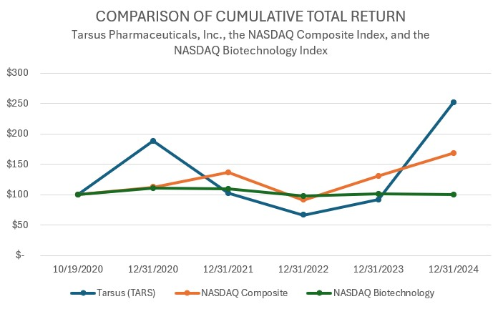
96

Recent Sales of Unregistered Securities

None.
Purchases of Equity Securities by the Issuer and Affiliated Purchases

None.
Other Information
None.

Item 6. [Reserved]

97
Table of Content
Item 7. Management's Discussion and Analysis of Financial Condition and Results of Operations
The following discussion and analysis of our financial condition and results of operations should be read in conjunction with our “Selected Financial Data” and our financial statements and the related notes to those statements included elsewhere in this Annual Report on Form 10-K. In addition to historical financial information, the following discussion and analysis contains forward-looking statements that involve risks, uncertainties and assumptions. Our actual results and timing of selected events may differ materially from those anticipated in these forward-looking statements as a result of many factors, including, but not limited to, those discussed under the section titled “Risk Factors” and elsewhere in this Annual Report on 10-K. See the section titled “Note Regarding Forward-Looking Statements” elsewhere in this Annual Report on Form 10-K.

Overview
Our Business

We are a commercial stage biopharmaceutical company focused on the development and commercialization of therapeutics, starting with eye care. We launched XDEMVY® (lotilaner ophthalmic solution) 0.25%, formerly known as TP-03, for the treatment of Demodex blepharitis, in August 2023 after receiving the U.S. Food and Drug Administration ("FDA") approval in July 2023. Demodex blepharitis is caused by the infestation of Demodex mites. Blepharitis (“Blephar” is a reference to eyelid and “itis” is a reference to inflammation) is an ophthalmic lid margin disease characterized by inflammation of the eyelid margin, redness and ocular irritation, including a specific type of eyelash dandruff called collarettes, which are pathognomonic for Demodex blepharitis. Poorly controlled and progressive blepharitis can lead to corneal damage over time and, in extreme cases, blindness. There may be as many as approximately 25 million people in the U.S. who suffer from Demodex blepharitis. XDEMVY is the first and only therapeutic approved by the FDA and we believe is the definitive standard of care for the treatment of Demodex blepharitis.

XDEMVY targets and eradicates the root cause of Demodex blepharitis – Demodex mite infestation. The active pharmaceutical ingredient ("API") of XDEMVY, lotilaner, paralyzes and eradicates mites and other parasites through the inhibition of parasite-specific gamma-aminobutyric acid-gated chloride ("GABA-Cl") channels with no GABA-Cl inhibition in humans.
To date, we have completed seven clinical trials that include a Phase 3 Saturn-2 trial, a Phase 2b/3 Saturn-1 trial, four Phase 2 trials, and a Phase 1 trial for XDEMVY in Demodex blepharitis, all of which met their primary, secondary and/or certain exploratory endpoints, with the drug well tolerated throughout each trial. We have also completed, and/or have ongoing clinical trials for the potential treatment of Demodex blepharitis in patients with Meibomian Gland Disease ("MGD"), including the Ersa clinical trial involving XDEMVY, and the Rhea clinical trial involving an XDEMVY vehicle; TP-04 for the potential treatment of Ocular Rosacea; and TP-05 for potential Lyme disease prophylaxis, among others.

We intend to further advance our pipeline with the lotilaner API to address several diseases in human medicine, including eye care, and infectious disease prevention. We are investigating the development of our product candidates to address targeted diseases with high unmet medical needs, which currently include TP-04, a novel gel formulation of lotilaner for the potential treatment of Ocular Rosacea, and TP-05, a novel investigational oral formulation of lotilaner, for potential Lyme disease prophylaxis and community malaria reduction.

Recent Business and Clinical Highlights

XDEMVY

•We recognized $66.4 million and $180.1 million in XDEMVY net product sales for the fourth quarter and full year 2024, respectively.

•We dispensed more than 58,500 and 163,000 bottles of XDEMVY to patients during the fourth quarter and full year 2024, respectively.

•We established broad Eye Care Professional ("ECP") utilization across more than 15,000 targets.

•The expanded sales force deployed in the third quarter 2024 started to deliver meaningfully to the increased ECP utilization and prescription volumes reported for the fourth quarter 2024.

•Broad commercial, Medicare, and Medicaid reimbursement of XDEMVY now extends to more than 90% of covered lives, as of February 25, 2025.
◦Recognized a gross-to-net discount of approximately 45% in the fourth quarter and full year 2024.
98
Table of Content
•We activated a memorable and action-oriented Direct-to-Consumer ("DTC") campaign on streamlining platforms in the fourth quarter 2024 and initiated a trial-run on network televisions in January 2025, including spots on the Golden Globes, the GRAMMYs and the National Football League playoffs.
◦The initial patient response from this campaign has been positive across multiple leading indicators, including the downloading of materials, taking the Demodex blepharitis quiz and utilizing the "find an eye doctor tool on the XDEMVY website.
◦DTC initiatives will continue on streamlining platforms and will meaningfully expand into a network television campaign beginning in the first quarter of 2025.

TP-03 Demodex blepharitis in patients with Meibomian Gland Disease, Ersa and Rhea Trials

In December 2023, we announced positive topline results of the Ersa trial evaluating XDEMVY administered twice daily ("BID") or three times a day ("TID") for 6 weeks and 12 weeks for the treatment of MGD in patients with Demodex mites. XDEMVY demonstrated statistically significant and clinically meaningful improvements compared to baseline in two objective measures of the disease: the presence and quality of liquid secretion as measured by the Meibomian Gland Secretion Score; and the number of glands secreting normal or clear liquid. In November 2024, additional positive data was presented from the Ersa trial as well as data from the Rhea trial, a pilot study evaluating XDEMVY vehicle for the treatment of MGD in patients with Demodex mites, at the American Academy of Optometry ("AAOpt") Annual Meeting 2024. The Rhea trial enrolled a similar patient population as the Ersa trial, and evaluated the same outcomes, with the same dosing regimens, except the Rhea trial participants received XDEMVY vehicle. Both the Ersa and Rhea trials also assessed patient reported outcomes for some of the most commonly reported patient symptoms in Demodex blepharitis and MGD, namely fluctuating vision, itching, redness, and burning.

The AAOpt presentation, which combined the Ersa and Rhea trials data in a pooled analysis, demonstrated that XDEMVY provided statistically significant and clinically meaningful improvements from baseline and when compared to vehicle. These improvements were shown across three objective measures of MGD: 1) the presence and quality of liquid secretion as measured by the Meibomian Gland Secretion Score; 2) the number of glands secreting normal or clear liquid; and 3) the number of glands yielding any liquid. Improvements were also demonstrated across certain patient reported outcomes, including fluctuating vision, itching and redness. Further, XDEMVY demonstrated statistically significant rates of collarette cure and lid margin erythema cure that are consistent with previous XDEMVY studies. No statistically significant differences were observed between the BID and TID treatment arms in both the Ersa and Rhea trials, respectively, and XDEMVY and the XDEMVY vehicle were well tolerated. Given the positive results of these trials, plus the FDA’s feedback that these patients are already covered under XDEMVY’s label for the treatment of Demodex blepharitis, our medical affairs team is moving forward with sharing this data with ECPs.
TP-04 Rosacea, Galatea Trial
In March 2023, we initiated the Galatea trial, a Phase 2a trial evaluating TP-04, a novel gel formulation of lotilaner, for the treatment of rosacea. In February 2024, we announced positive topline results from the Galatea trial evaluating TP-04 for the treatment of rosacea which demonstrated statistically significant improvements (p<0.05) in inflammatory lesions and Investigator's Global Assessment score (change in baseline and success rate) were observed compared to vehicle at week 12. TP-04 was generally well tolerated. After review of this data with the FDA and Key Opinion Leaders, we decided to pursue development of TP-04 for the potential treatment for Ocular Rosacea. In January 2025, we announced plans to initiate a Phase 2 study in the second half of 2025 for the potential treatment of Ocular Rosacea.
TP-05 Lyme Disease, Carpo Trial
In February 2024, we announced positive topline results from the Carpo trial, which demonstrated statistical significance in the mortality of ticks compared to vehicle (p<0.001), regardless of treatment arm, and was well tolerated. The Carpo trial is designed to evaluate TP-05, a novel investigational oral, non-vaccine pharmacological prophylactic for the potential prevention of Lyme disease in humans. The Carpo trial evaluated the efficacy of TP-05 in killing lab grown, non-disease carrying ticks after they have attached to the skin of healthy volunteers, as well as confirm the safety, tolerability, and blood concentration of TP-05.
In December 2024, we met with the FDA about our Lyme disease program. The FDA agreed to our proposed approach for a Phase 2b clinical trial, which would include several hundred subjects. Additionally, the FDA confirmed that a Phase 3 clinical study would require a disease prevention field study that would likely require the enrollment of thousands of patients. We continue to believe that the best approach to get this potential prophylactic therapy to patients is to partner this program either prior to the initiation of the Phase 2b study or after the completion of the study.

99
Table of Content
We believe TP-05 is currently the only non-vaccine, drug-based prophylaxis in development that targets ticks, and potentially prevents Lyme disease transmission. It is designed to rapidly and durably provide systemic blood levels of lotilaner potentially sufficient to kill infected ticks attached to the human body before they can transmit the Borrelia bacteria that causes Lyme disease.
Officer and Board Appointments
We expanded and strengthened our eye care leadership with two key appointments to our executive team and Board of Directors. Elizabeth Yeu, M.D. was appointed Chief Medical Officer in November 2024. Dr. Yeu is a distinguished ophthalmologist with more than two decades of experience who transitioned from her role as our Chief Medical Advisor and a member of our Board of Directors. Katherine H. Goodrich, M.D., MHS was appointed to our Board of Directors in November 2024. Dr. Goodrich is currently the Chief Medical Officer of Humana Inc., and brings decades of experience driving innovative and value-based initiatives designed to improve patient outcomes.

Additional Potential Growth Drivers in 2025 and Beyond

We are on track for potential European regulatory approval of a preservative-free formulation of XDEMVY for the potential treatment of Demodex blepharitis in 2027. We have initiated market development work, including Key Opinion Leader engagement, disease education and scientific presentations at major conferences.

In Japan, we expect to share results from a Demodex blepharitis prevalence study in the first half of 2025 and meet with Japanese regulatory authorities to help determine a regulatory path forward.

The Chinese regulatory agency, National Medical Products Administration, accepted the New Drug Application ("NDA") submitted by our partner, Grand Pharmaceutical Group Ltd., for TP-03 for Demodex blepharitis.

Corporate and Financial Overview
We were incorporated as a Delaware corporation in November 2016, and our headquarters are located in Irvine, California. Since our inception, we have devoted substantially all of our resources to organizing and staffing our company, acquiring intellectual property, clinical development of our product candidates, commercializing XDEMVY, building our research and development capabilities, raising capital, and enhancing our corporate infrastructure.
To date we have financed our operations through private placements of preferred stock, convertible promissory notes, net proceeds from issuance of common stock in our Initial Public Offering ("IPO"), our subsequent follow-on public offerings in May 2022 (the "May 2022 Public Offering"), August 2023 (the "August 2023 Public Offering"), and March 2024 (the "March 2024 Public Offering", collectively the "Follow-On Public Offerings"), and our Open Market Sale AgreementTM (the "2023 ATM Prospectus"), as well as proceeds from net product sales, our China Out-License, and drawdowns from the Credit Facilities.
We have incurred significant net operating losses ("NOLs") in every year since our inception and expect to continue to incur significant operating expenses as we commercialize XDEMVY for Demodex blepharitis, and, as we advance our other product candidates through clinical trials, regulatory submissions, and potential commercialization. Our net losses were $115.6 million, $135.9 million and $62.1 million for the years ended December 31, 2024, 2023, and 2022, respectively. Our net losses may fluctuate significantly from quarter to quarter and year to year and could be substantial. We anticipate that our operating expenses will increase significantly as we:
•continue to commercialize XDEMVY and our other product candidates for which we obtain regulatory approvals;
•maintain regulatory approval for XDEMVY and seek regulatory approval for our other product candidates that successfully complete clinical development, if any;
•advance the clinical development of TP-04 for the potential treatment of Ocular Rosacea and TP-05 for the potential Lyme disease prophylaxis;
•engage with contract manufacturers to ensure a sufficient supply chain capacity to provide commercial quantities of XDEMVY and any other products for which we may obtain marketing approval;
•maintain, expand and protect our intellectual property portfolio;
100
Table of Content
•hire additional staff, including clinical, scientific, technical, regulatory, marketing, sales, operations, financial, and other support personnel, to execute our business plan; and
•add information systems and personnel to support our product development and commercialization efforts, and to enable us to operate as a public company.
We began generating product sales during the year ended December 31, 2023, following the FDA approval of XDEMVY in July 2023 and our subsequent commercial launch in August 2023. Our reported revenue within license fees and collaboration revenue is from our China Out-License and clinical supply agreement; we expect to report additional revenue under this caption in future periods.
Until such time as we can generate significant revenue from product sales and achieve profitability, if ever, we expect to finance our operations through public equity or debt financings, or collaborations, strategic alliances, or licensing arrangements with third parties. Adequate funding may not be available to us when needed on acceptable terms, or at all. If we raise additional funds through collaborations, strategic alliances, or licensing arrangements with third parties, we may have to relinquish valuable rights to our intellectual property, future revenue streams, research programs or product candidates or grant licenses on terms that may not be favorable to us. If we are unable to raise additional capital or enter into such agreements as and when needed, we could be forced to significantly delay, scale back, or discontinue our product development and/or commercialization plans, which would negatively and adversely affect our financial condition.
Because of the numerous risks and uncertainties associated with drug product development and commercialization, we are unable to accurately predict the timing or amount of increased expenses or when or if we will be able to achieve or maintain profitability. Even if we are able to generate significant revenue from net product sales we may not become profitable. If we fail to become profitable or are unable to sustain profitability on a continuing basis, then we may be unable to continue our operations at planned levels.

As of December 31, 2024, our aggregate cash, cash equivalents and marketable securities was $291.4 million – see the section below titled "Management's Discussion and Analysis of Financial Condition and Results of Operations —
Liquidity and Capital Resources."

Impact of the Macroeconomic Environment
Recently, the economy has experienced downward pressure, and together with high rates of inflation and energy supply issues experienced in certain regions, war and geopolitical conflicts, have led to regional and/or global macroeconomic challenges, the effects of which may be of an extended duration.

In addition, we may be exposed to credit risk on deposits at financial institutions to the extent our account balances exceed the amount insured by the Federal Deposit Insurance Corporation (“FDIC”). We maintain cash held in deposit at financial institutions in the U.S. While these deposits are insured by the FDIC in an amount up to $250,000 for any depositor, to the extent we hold cash deposits in amounts that exceed the FDIC insurance limitation, we may incur a loss in the event of a failure of any of the financial institutions where we maintain deposits. We invest our excess cash in highly liquid investments, including money market fund accounts, that are readily convertible into cash without penalty. We believe the Company is not exposed to significant credit risk due to the financial position of the depository institutions and the types of accounts we hold, but we will continue to monitor regularly and adjust, if needed, to mitigate risk, including any ongoing or new events involving limited liquidity, defaults, non-performance or other adverse developments that affect financial institutions.

See the section titled "Risk Factors" for a further discussion of the potential adverse impact of unfavorable global and geopolitical economic conditions on our business, results of operations and financial condition.

Components of our Results of Operations
Product Sales, Net
We recognize product sales, net when a customer obtains control of promised goods or services, which occurs at a point in time, typically upon delivery of the Company's product to the customer. We record the amount of revenue that reflects the consideration we expect to receive in exchange for those goods or services. We apply the following five-step model in order to determine this amount: (i) identification of the promised goods in the contract; (ii) determination of whether the promised goods are performance obligations, including whether they are capable of being distinct; (iii) measurement of the transaction
101
Table of Content
price, including the constraint on variable consideration; (iv) allocation of the transaction price to the performance obligations; and (v) recognition of revenue as each performance obligation is satisfied.
We sell XDEMVY to customers in the U.S., which became available for commercial sale during the third quarter of 2023. We sell XDEMVY to a limited number of specialty pharmacies and distributors (i.e., its customers) who in turn sell it directly to clinics, hospitals, pharmacies and federal healthcare programs. Revenue from product sales is primarily recognized upon physical delivery of the product (when the customer obtains control of the product), in return for agreed-upon consideration. Shipping and handling activities are considered to be fulfillment activities rather than a separate performance obligation and are recorded within selling, general and administrative expenses in the Statements of Operations and Comprehensive Loss.
Revenues from product sales are recorded at the net sales price, or the transaction price, which may include fixed or variable consideration for (i) invoice discounts for prompt payment and distribution service fees, (ii) commercial and government rebates, chargebacks, discounts and fees, (iii) product returns and (iv) costs of co-pay assistance programs for patients, as well as other incentives. Estimates of variable consideration are calculated based on the actual product sales each reporting period and the nature of the variable consideration related to those sales. Where appropriate, we utilize the expected value method to determine the appropriate amount for estimates of variable consideration based on factors such as the current contractual and statutory requirements, specific known market events and trends, industry data and forecasted customer buying and payment patterns. The amount of variable consideration that is included in the transaction price may be constrained and is included in product sales, net only to the extent that it is probable that a significant reversal in the amount of the cumulative revenue recognized will not occur when the uncertainty associated with the variable consideration is subsequently resolved. These estimates reflect our best estimate of the amount of consideration to which we expect to be entitled based on the terms of the contract. Actual amounts of consideration ultimately received may differ materially from estimates. If actual results in the future vary from estimates, we will adjust these estimates, which would affect product sales, net and earnings in the period such variances are adjusted. We categorize product sales deduction estimates as follows:
Distribution Service Fees: We engage with wholesalers and specialty pharmacies to distribute our products to end customers. We pay the wholesalers and certain specialty pharmacies a fee for services such as: inventory management, chargeback administration, and service level commitments. We estimate the amount of distribution services fees to be paid to the customers and adjust the transaction price with the amount of such estimate at the time of sale to the customer. An accrued liability is recorded for unpaid distribution service fees.
Prompt Pay Discounts: We provide our customers with a percentage discount on their invoice if the customers pay within the agreed upon timeframe. We expect that our customers will earn prompt pay discounts. We estimate the probability of customers paying promptly based on the percentage of discount outlined in the purchase agreement between the two parties, and deduct the full amount of these discounts from gross product sales and accounts receivable at the time revenue is recognized.
Product Returns: Our customers are contractually permitted to return the product within the contractual allowable time before and after the applicable expiration date. In the initial sales period, we estimate a provision for returns based on industry data and adjust the transaction price at the time of the product sale to the customer. Once sufficient history has been collected for product returns, we will utilize that history to inform our returns estimate. Once the product is returned, it is destroyed since it cannot be resold.
Chargebacks: A chargeback is the difference between our invoice price to the wholesaler and the wholesaler’s customer's contract price. The wholesaler tracks these sales and charges us back for the difference between the negotiated prices paid between the wholesaler's customers and the wholesaler's acquisition cost. We estimate the percentage of goods sold that are eligible for chargeback and adjust the transaction price and accounts receivable at the time of sale of the product to the customer.
Co-payment Assistance: Patients who meet certain eligibility requirements may receive co-payment assistance funded by the Company. We record contra-revenue for co-payment assistance based on actual program participation and estimates of program redemption using data provided by third-party administrators. An accrued liability is recorded on unredeemed co-payment assistance related to products for which control has been transferred to the customer.
Rebates: We accrue rebates for contractually agreed-upon discounts with commercial payers and mandated discounts under government programs such as the Medicaid Drug Rebate Program, Medicare Part D Prescription Drug Program, and other government health care programs in the U.S. Our estimates for expected utilization of commercial payer rebates based on data received from our customers. The estimates for rebates under government programs are based on
102
Table of Content
statutory discount rates and expected utilization as well as historical data we have accumulated since product launch. We calculate the accruals for commercial and government rebates based on various assumptions, including payer mix, with actual rebates potentially requiring accrual adjustments affecting product sales, net. Rebates are generally invoiced and paid in arrears so that the accrual balance consists of an estimate of the amount expected to be incurred for the current period's activity, plus an accrual balance for known prior periods’ unpaid rebates. An accrued liability is recorded for unpaid rebates related to product for which control has transferred to the customer.
License Fees and Collaboration Revenue
License fees and collaboration revenue is primarily attributable to contractual milestones under the China Out-License. These amounts represent the contractual milestones achieved or allocated under the China Out-License that had been fully or partially completed by period end. These allocated amounts represented the satisfaction of the transfer of license rights to LianBio and GrandPharma and the completion of related performance obligations. License fees and collaboration revenue also includes the satisfaction of performance obligations under an existing clinical supply agreement.
We will recognize additional license fees and collaboration revenue under the China Out-License to the extent other events occur, specifically related to (i) milestone achievement of an additional drug supply agreement execution, (ii) milestone achievement of certain regulatory events in the China Territory, and (iii) royalties and milestones from our licensee's product sales of TP-03 in the China Territory. As of the date of this filing, it is uncertain if and when we will receive any royalties or future milestone consideration under the China Out-License, including but not limited to the milestone achievement of an additional drug supply agreement execution.
Cost of Sales
Cost of sales consists of direct and indirect costs related to the manufacturing and distribution of XDEMVY, including raw materials, third-party manufacturing costs, packaging services, freight-in, third-party royalties payable on our product sales, net and amortization of capitalized intangible assets associated with XDEMVY. Cost of sales may also include period costs related to certain inventory warehouse and distribution operations and inventory adjustment charges. Prior to FDA approval of XDEMVY, manufacturing and other inventory costs were recorded to research and development expenses in the Statements of Operations and Comprehensive Loss. As of December 31, 2024, we have sold materially all inventory that was recorded to research and development expense prior to FDA approval of XDEMVY.
Cost of License Fees and Collaboration Revenue
Cost of license fees and collaboration revenue includes the expense recognized under the terms of the China Out-License payable under the terms of our in-license agreement for lotilaner.
Research and Development Expenses
Research and development expenses consist of expenses incurred in connection with the development of our product candidates, including:
•fees paid to third parties to conduct certain research and development activities on our behalf, including under agreements with CROs;
•payments under licensing agreements, such as our upfront in-license fee for lotilaner;
•consulting costs and certain allocated payroll, employee benefit and other employee-related costs (including stock-based compensation, salaries, payroll taxes) for personnel engaged in research and development functions;
•costs related to compliance with clinical regulatory requirements;
•costs of procuring drug products for use in our preclinical studies and clinical trials; and
•facilities expenses, which include direct and allocated expenses for rent of our laboratory.
We expense both internal and external research and development expenses as incurred or as certain upfront or milestone payments become contractually due to licensors upon achievement of clinical or regulatory events. We recognize external research and development costs based on an evaluation of the progress-to-completion of (i) specific tasks performed or
103
Table of Content
deliverables provided by CROs and CMOs and (ii) patient visits for dosing or other follow-up. To estimate period expense for recognition, we use information provided to us by our service providers and we then apply the corresponding fee schedule.
We track our external research and development expenses on a program-by-program basis, such as fees paid to CROs, CMOs, and research laboratories in connection with our pre-clinical development, process development, manufacturing and clinical development activities. However, we do not currently track employee time on a program-by-program basis. Prior to commercialization of XDEMVY, the vast majority of our external and internal research and development expenses were attributable to the development of XDEMVY.
Selling, General and Administrative Expenses
Selling, general and administrative expenses consist of personnel-related costs including salaries, benefits, stock-based compensation and other personnel-related expenses for our executive, finance, sales and marketing, and other administrative functions. Selling, general and administrative expenses also include sales and marketing costs to support our commercial launch starting in August 2023, consulting fees, legal services, rent and other facilities costs, patient assistance donations, the U.S. healthcare reform federal excise fee on Branded Pharmaceutical Manufacturers and Importers, and other general operating expenses, not otherwise classified as research and development expenses.
We expect that our selling, general and administrative expenses will increase substantially in the future as a result of expanding our operations, including hiring personnel, continued commercialization of XDEMVY, preparing for potential commercialization of our other product candidates, and additional facility occupancy costs, as well as various incremental costs associated with being a public company, including: increased legal and accounting fees, regulatory costs associated with maintaining compliance with the rules of Nasdaq and SEC regulations, investor relations activities, directors and officers liability insurance premiums, and other accompanying compliance and governance costs.

Other Income, Net
Other income, net primarily consists of (i) interest income earned on our cash, cash equivalents, and marketable securities, (ii) interest expense on the Credit Facilities, and (iii) the change in estimated fair value of the LianBio equity warrants and LianBio common stock we received as part of the China Out-License.

104
Table of Content
Results of Operations
Comparison of the Years Ended December 31, 2024 and 2023
The following table summarizes our results of operations for the periods indicated:
Year Ended
December 31,
 |  |  | 2024 |  |  |  |  |  | 2023 |  |  |  |  |  | Change
 |  |  | (in thousands)
Revenues:
Product sales, net |  |  | $ | 180,059 |  |  |  |  | $ | 14,729 |  |  |  |  | $ | 165,330
License fees and collaboration revenue |  |  | 2,894 |  |  |  |  |  | 2,718 |  |  |  |  |  | 176
Total revenues |  |  | 182,953 |  |  |  |  |  | 17,447 |  |  |  |  |  | 165,506
Operating expenses:
Cost of sales |  |  | 12,826 |  |  |  |  |  | 1,593 |  |  |  |  |  | 11,233
Research and development |  |  | 53,386 |  |  |  |  |  | 50,312 |  |  |  |  |  | 3,074
Selling, general and administrative |  |  | 237,310 |  |  |  |  |  | 108,700 |  |  |  |  |  | 128,610
Total operating expenses |  |  | 303,522 |  |  |  |  |  | 160,605 |  |  |  |  |  | 142,917
Loss from operations |  |  | (120,569) |  |  |  |  |  | (143,158) |  |  |  |  |  | 22,589
Other income (expense):
Interest income |  |  | 15,014 |  |  |  |  |  | 10,337 |  |  |  |  |  | 4,677
Interest expense |  |  | (7,849) |  |  |  |  |  | (3,346) |  |  |  |  |  | (4,503)
Loss on debt extinguishment |  |  | (1,944) |  |  |  |  |  | — |  |  |  |  |  | (1,944)
Other income (expense), net |  |  | 586 |  |  |  |  |  | (102) |  |  |  |  |  | 688
Realized/unrealized (loss) gain on equity investments |  |  | (591) |  |  |  |  |  | 259 |  |  |  |  |  | (850)
Change in fair value of equity warrants issued by licensee |  |  | (201) |  |  |  |  |  | 117 |  |  |  |  |  | (318)
Total other income, net |  |  | 5,015 |  |  |  |  |  | 7,265 |  |  |  |  |  | (2,250)
Net loss |  |  | $ | (115,554) |  |  |  |  | $ | (135,893) |  |  |  |  | $ | 20,339
Product Sales, Net
Product sales, net increased by $165.3 million for the year ended December 31, 2024 to $180.1 million, as compared to the prior year period. This increase was primarily driven by more than 163,000 bottles of XDEMVY dispensed to patients, compared to 17,400 bottles dispensed to patients in the prior year period. XDEMVY was approved by the FDA in July 2023 and was commercially launched in August 2023.
License Fees and Collaboration Revenue
For the year ended December 31, 2024, we recognized $2.9 million of license fees and collaboration revenue including (i) $2.5 million for the Termination Payment related to the Novation Agreement, and (ii) $0.4 million for the Warrant Termination Payment. For the year ended December 31, 2023, we recognized $2.7 million related to (i) the achievement of a $2.5 million contractual milestone under the China Out-License, and (ii) $0.2 million from the satisfaction of performance obligations under an existing clinical supply agreement. These allocated amounts represented the satisfaction of the transfer of license rights to LianBio and the completion of related performance obligations.
We will recognize additional license fees and collaboration revenue under the China Out-License to the extent other events occur, specifically related to (i) milestone achievement of regulatory events and/or patent issuance in the China Territory, and (ii) royalties and milestones from our licensee's product sales of TP-03 in the China Territory.
Cost of Sales
Cost of sales increased by $11.2 million for the year ended December 31, 2024 to $12.8 million, as compared to the prior year period as a result of the increase in bottles of XDEMVY that were dispensed. Cost of sales consists of direct and indirect costs related to the manufacturing and distribution of XDEMVY, including raw materials, third-party manufacturing costs, packaging services, and freight-in, as well as third-party royalties payable on our product sales, net and amortization of capitalized intangible assets associated with XDEMVY.
105
Table of Content
Research and Development Expenses
 |  |  | December 31, |  |  |  |  |  |  |  |  |  |  |  | Change
 |  |  | 2024 |  |  |  |  |  | 2023
Direct external expenses:
TP-03 program |  |  | $ | 15,520 |  |  |  |  | $ | 14,311 |  |  |  |  | $ | 1,209
TP-04 program |  |  | 1,415 |  |  |  |  |  | 2,583 |  |  |  |  |  | (1,168)
TP-05 program |  |  | 2,602 |  |  |  |  |  | 5,261 |  |  |  |  |  | (2,659)
Other early-stage programs |  |  | 623 |  |  |  |  |  | 619 |  |  |  |  |  | 4
Indirect expenses:
Compensation and personnel-related |  |  | 27,591 |  |  |  |  |  | 24,129 |  |  |  |  |  | 3,462
Other |  |  | 3,135 |  |  |  |  |  | 2,409 |  |  |  |  |  | 726
Elanco milestone expenses |  |  | 2,500 |  |  |  |  |  | 1,000 |  |  |  |  |  | 1,500
Total research and development expenses |  |  | $ | 53,386 |  |  |  |  | $ | 50,312 |  |  |  |  | $ | 3,074

Research and development expenses increased by $3.1 million for the year ended December 31, 2024 to $53.4 million, as compared to the prior year period. The increase was primarily due to (i) $3.5 million of increased indirect expenses related to payroll and personnel-related costs (including increased stock-based compensation expense of $1.0 million) for employee additions to drive our product development initiatives, (ii) $0.7 million of increased other indirect expenses, (iii) a $1.5 million increase in milestone expense related to our in-license agreements (see Note 9), and (iv) $1.2 million of increased TP-03 program expenses. These increases were partially offset by (i) $2.7 million of decreased TP-05 program expenses including $1.5 million for the food effect study and $1.2 million for the Carpo trial, and (ii) a $1.2 million decrease in TP-04 program expenses related to completion of the Galatea trial.
Selling, General and Administrative Expenses

Selling, general and administrative expenses increased by $128.6 million for the year ended December 31, 2024, to $237.3 million as compared to the prior year period. The increase was primarily due to (i) $39.7 million of increased payroll and personnel-related costs (including increased stock-based compensation expense of $6.6 million) for commercial and corporate employee additions to support our business growth and commercial leadership hires for XDEMVY, (ii) $52.0 million of increased commercial and marketing costs as we continued our commercial expansion of XDEMVY, (iii) $36.8 million of increased information technology applications, legal, professional and other corporate expenses. Our field sales headcount and associated vendor expenses continued to increase during 2024 due to further growth and expansion of our commercial activities for XDEMVY. XDEMVY was approved by the FDA in July 2023 and was commercially launched in August 2023.
Other Income, Net
Other income, net decreased by $2.2 million for the year ended December 31, 2024 due to (i) $1.9 million of loss on debt extinguishment related to the termination of our 2022 Credit Facility (defined below), (ii) $4.5 million of increased interest expense related to the Credit Facilities, (iii) a $0.9 million decrease related to the change in fair value of the LianBio common stock sold in June, and (iv) a $0.3 million decrease related to the change in fair value related to the final mark-to-market adjustment on the unvested third tranche equity warrant. These decreases were partially offset by (i) $4.7 million of increased interest income earned on our cash, cash equivalents and marketable securities, and (ii) $0.7 million of dividend income from LianBio.
Comparison of the Years Ended December 31, 2023 and 2022
For a discussion of the year ended December 31, 2023 compared to the year ended December 31, 2022, please refer to Part II, Item 7, "Management's Discussion and Analysis of Financial Condition and Results of Operations" in our Annual Report on Form 10-K for the year ended December 31, 2023, filed with the SEC on February 27, 2024.

106
Table of Content
Liquidity and Capital Resources
Sources of Liquidity
Overview
Since our inception, we have financed our operations substantially through private placements of preferred stock, net proceeds from the issuance of common stock through our IPO, Follow-on Public Offerings, and the 2023 ATM Prospectus, as well as proceeds from product sales, net, the China Out-License, and drawdowns from our Credit Facilities. As of December 31, 2024, we had cash, cash equivalents and marketable securities of $291.4 million.
Follow-On Public Offerings
In August 2023, we completed the August 2023 Public Offering in which 5,714,285 shares of our common stock were sold at a public offering price of $17.50 per share. In September 2023, the underwriters partially exercised an option to purchase an additional 355,164 shares of common stock at the public offering price of $17.50 per share. After giving effect to the exercise of the underwriters' option, we sold a total of 6,069,449 shares and received aggregate net proceeds of $99.3 million, after deducting underwriting discounts, commissions, and other offering-related expenses.
In February 2024, we filed an automatic shelf registration statement on Form S-3 ASR (the "2024 Shelf Registration Statement"). In March 2024 we completed the March 2024 Public Offering. The 2024 Public Offering was an underwritten follow-on public offering under the 2024 Shelf Registration Statement, pursuant to which we sold 2,812,500 shares of our common stock, and, in lieu of common stock to a certain investor, pre-funded warrants to purchase 312,500 shares of our common stock. The price to the public was $32.00 per share and $31.9999 per pre-funded warrant, which was the price to the public of each share of common stock sold in the March 2024 Public Offering, minus the $0.0001 exercise price per pre-funded warrant. We also granted the underwriters a 30-day option to purchase up to 468,750 additional shares of its common stock at the public offering price of $32.00 per share, which the underwriters exercised in full in March 2024. We received $107.7 million in aggregate net proceeds, after deducting underwriting discounts, commissions, and other estimated offering-related expenses.
Open Market Sales Agreement
During the year ended December 31, 2023, we sold 1,000,000 shares of our common stock for $20.00 per share under a sales agreement prospectus filed in November 2023, pursuant to the 2023 Shelf Registration Statement (defined below) covering the sale of up to $100.0 million of our common stock pursuant to the 2023 ATM Prospectus with Jefferies LLC ("Jefferies"). This resulted in net proceeds of $19.2 million, after deducting broker commissions and offering related expenses.
During the year ended December 31, 2024, there were no sales of our common stock pursuant to the 2023 ATM Prospectus.
China Out-License
As of the date of this filing, we have received $86.1 million of total proceeds in connection with our China Out-License comprised of (i) $15.0 million of initial consideration, (ii) $67.5 million for the achievement of specified milestones, (iii) $0.7 million related to a special cash dividend, (iv) $2.5 million related to the Novation Agreement, and (v) $0.4 million related to the Warrant Termination Agreement.
As of December 31, 2024 we are eligible to receive further consideration from GrandPharma upon the achievement of additional TP-03 events, including: (i) $20.0 million of potential future regulatory and/or patent milestones; (ii) $100.0 million of potential future China-based TP-03 sales threshold milestones; and (iii) tiered low-to-high-teen royalties for China Territory TP-03 product sales.
Credit Facilities
In February 2022, we executed the Credit Facility with Hercules Capital, Inc. and SVB (the "2022 Credit Facility"). Concurrent with the execution of the 2022 Credit Facility we drew $20.0 million. The 2022 Credit Facility was amended in January 2023 and August 2023. The Credit Facility, as amended, set a maximum interest rate, updated the terms of prepayment and included an extended period to drawdown the tranche associated with the NDA submission. During 2023, we made two
107
Table of Content
separate draws for an aggregate of $10.0 million from the $25.0 million tranche associated with the NDA submission of TP-03. We did not incur lender fees as part of the 2022 Credit Facility.
In April 2024, we executed the 2024 Credit Facility with Pharmakon with maturity in April 2029 (collectively, with the 2022 Credit Facility, the “Credit Facilities”). The 2024 Credit Facility is collateralized by substantially all of the Company's presently existing and subsequently acquired assets. Upon execution, we made a $75.0 million draw from the initial tranche, a portion of which was utilized to repay all outstanding indebtedness associated with the 2022 Credit Facility, for total net proceeds of $39.6 million. The 2024 Credit Facility provides for three potential additional term loan tranches in principal amounts up to $25.0 million, $50.0 million, and $50.0 million, respectively, subject to customary conditions to funding and, in the case of the last two tranches, achieving minimum net sales milestones. The three additional tranches may be requested on or prior to December 31, 2024, June 30, 2025 and December 31, 2025, respectively.
The 2024 Credit Facility bears interest at a floating rate based upon the secured overnight financing rate (“SOFR”), plus a margin of 6.75% per annum. The SOFR is subject to a 3.75% floor. The 2024 Credit Facility contains representations and warranties, affirmative and negative covenants in each case. There is also no warrant coverage to the lenders and no financial covenants associated with the financing.
Funding Requirements
Liquidity
Our operating expenditures currently consist of cost of sales, research and development costs (including activities within our preclinical, clinical, regulatory, and drug manufacturing initiatives) and selling, general and administrative costs. Our use of cash is impacted by the timing and extent of payments for each of these activities and other business requirements. We have incurred significant losses and negative cash flows from operations since our inception and had an accumulated deficit of $360.2 million and $244.7 million as of December 31, 2024 and 2023, respectively.
We believe that our cash, cash equivalents and marketable securities of $291.4 million as of December 31, 2024 is sufficient to fund our current and planned operations for at least the next twelve months from the date of filing this Annual Report on Form 10-K. We also have additional availability from our 2024 Credit Facility of $100.0 million contingent on maintaining certain sales milestones. Our cash runway estimate is predicated on current assumptions for future revenue, operating expenses, and debt availability and may require future adjustments. Accordingly, we may be required to raise additional capital earlier than we currently expect based on our cash requirements and market dynamics.
Shelf Registration Statements
In February 2024, we filed the 2024 Shelf Registration Statement, which permits us to offer and sell from time to time, in one or more series of issuances and on terms that we will determine at the time of the offering, our common stock, preferred stock, debt securities, warrants, units or any combination of such securities.
In November 2023, we filed a shelf registration statement on Form S-3 that was declared effective by the SEC on November 21, 2023, (the "2023 Shelf Registration Statement"), which replaced the November 2021 Shelf Registration Statement, as defined below, and permits us to offer up to $300.0 million of common stock, preferred stock, debt securities and warrants in one or more offerings and in any combination, including in units from time to time.
As part of the 2023 Shelf Registration Statement, we concurrently filed the 2023 ATM Prospectus with Jefferies covering the sale of up to $100.0 million of our common stock pursuant to an Open Market Sales AgreementTM we entered into with Jefferies in 2021 (the "ATM Sales Agreement"). Under the terms of the 2023 ATM Prospectus and ATM Sales Agreement, Jefferies will act as the Company's sales agent and is entitled to compensation for its services equal to 3% of the gross proceeds of any shares of common stock sold. We have not sold any shares of our common stock under the 2023 ATM Prospectus during the year ended December 31, 2024. In December 2023, we sold 1,000,000 shares of our common stock under the 2023 ATM Prospectus for $20.00 per share and received net proceeds of $19.2 million, after deducting broker commission and offering-related expenses.
In November 2021, we filed a shelf registration statement on Form S-3 that was declared effective by the SEC on November 5, 2021 (the “2021 Shelf Registration Statement”), which permitted us to offer up to $300.0 million of common stock, preferred stock, debt securities and warrants in one or more offerings and in any combination, including in units from time to time. The 2023 Shelf Registration Statement replaced the 2021 Shelf Registration Statement.
108
Table of Content
Also, as part of the 2021 Shelf Registration Statement, we concurrently filed a sales agreement prospectus (the “2021 ATM Prospectus”) covering the sale of up to $100.0 million of our common stock pursuant to an Open Market Sale AgreementTM. We did not sell any shares of our common stock under the 2021 ATM Prospectus. In July 2023, in connection with the August 2023 Public Offering, we terminated the sales agreement prospectus relating to the 2021 ATM Prospectus.
Other Liquidity Risks
We expect to incur significant operating losses for the foreseeable future, and for these losses to further increase, as we expand our clinical development programs for our other product candidates and continue to commercialize XDEMVY. We may also encounter unforeseen expenses, difficulties, complications, delays and other currently unknown factors that could adversely affect our business.
We may require additional capital to fully develop our product candidates and to execute our business strategy. Our requirements of a future capital raise will depend on many factors, including:
•the amount of revenue received from commercial sales of XDEMVY or our product candidates, should any of our product candidates receive marketing approval;
•the cost and timing associated with commercializing XDEMVY or our product candidates, if they receive marketing approval;
•the scope, timing, rate of progress and costs of our drug discovery efforts, preclinical development activities, laboratory testing and clinical trials for our product candidates;
•the number and scope of clinical programs we decide to pursue;
•the cost, timing and outcome of preparing for and undergoing regulatory review of our product candidates;
•the scope and costs of development and commercial manufacturing activities;
•the achievement of milestones or occurrence of other developments that trigger payments under any collaboration agreements we might have at such time;
•the availability of our 2024 Credit Facility;
•the extent to which we acquire or in-license other product candidates and technologies;
•the costs of preparing, filing and prosecuting patent applications, maintaining and enforcing our intellectual property rights and defending intellectual property-related claims;
•our ability to establish and maintain collaborations on favorable terms, if at all;
•our efforts to enhance operational systems and our ability to attract, hire and retain qualified personnel, including personnel to support the development of our product candidates and, ultimately, the sale of our products, following FDA approval;
•our implementation of various computerized information systems;
•impact of health epidemics on our clinical development or operations; and
•the costs associated with being a public company.
A change in the outcome of any of these or other variables with respect to the development of any of our product candidates could significantly change the costs and timing associated with the development of that product candidate. Furthermore, our operating plans may change in the future, and we will continue to require additional capital to meet operational needs and capital requirements associated with such operating plans. If we raise additional funds by issuing equity securities, our stockholders may experience dilution. Any future debt financing into which we enter may impose upon us additional covenants that restrict our operations, including limitations on our ability to incur liens or additional debt, pay
109
Table of Content
dividends, repurchase our common stock, make certain investments or engage in certain merger, consolidation or asset sale transactions. Any debt financing or additional equity that we raise may contain terms that are not favorable to us or our stockholders.
Adequate funding may not be available to us on acceptable terms or at all. Our potential inability to raise capital when needed could have a negative impact on our financial condition and our ability to pursue our business strategies. If we are unable to raise additional funds as required, we may need to delay, reduce, or terminate some or all development programs and clinical trials. We may also be required to sell or license our rights to product candidates in certain territories or indications that we would otherwise prefer to develop and commercialize ourselves. If we are required to enter into collaborations and other arrangements to address our liquidity needs, we may have to give up certain rights that limit our ability to develop and commercialize our product candidates or may have other terms that are not favorable to us or our stockholders, which could materially and adversely affect our business and financial prospects. See the section of this Annual Report on Form 10-K titled “Risk Factors” for additional risks associated with our substantial capital requirements.
Contractual Obligations and Commitments
We have entered into arrangements that contractually obligate us to make payments that will affect our liquidity and cash flows in future periods. Such arrangements include those related to the contractual obligations described below:
Lease Commitments
Our operating lease commitments reflect payments due for our active lease agreements in Irvine, California, for adjacent office and laboratory suites. In December 2024, we entered into a lease agreement for office space located in Irvine, California for a 10-year lease term. The lease payments are expected to commence in late 2025 following the earlier of: (i) eleven months following the lease execution date, or (ii) the date the Company commences its regular business activities at the premises following completion of tenant improvements. The base rent for the first year of the lease will be approximately $2.5 million and is subject to annual increases of 3% thereafter. The Company is entitled to an abatement of base rent for the first five full calendar months from the beginning of the lease commencement date for an aggregate amount of $0.7 million. As of December 31, 2024, our contractual commitments for our leases were $0.8 million, which will be paid over the remaining lease term of 0.8 years.
Purchase Obligations
As of December 31, 2024, we have entered into manufacturing supply agreements for the commercial supply of XDEMVY. These amounts do not represent all of our anticipated purchases, but instead represent the contractually obligated minimum purchases or firm commitments of non-cancelable minimum amounts, as follows:
 |  |  |  |  |  | Amounts
2025 |  |  |  |  |  | $ | 1,943
2026 |  |  |  |  |  | 4,072
2027 |  |  |  |  |  | 3,744
2028 |  |  |  |  |  | 4,445
2029 |  |  |  |  |  | 4,534
Thereafter |  |  |  |  |  | —
Total |  |  |  |  |  | $ | 18,738
Milestone Obligations
The terms of our Eye and Derm Elanco Agreement, All Human Uses Elanco Agreement, and Other In-License Agreement requires us to make future development milestone payments aggregating up to $9.0 million and future commercial and sales-based milestone payments aggregating up to $249.0 million upon our achievement of the specified milestones. The amount and timing of such obligations are unknown or uncertain as of December 31, 2024.
Summary Statement of Cash Flows
The following table sets forth the primary sources and uses of cash and cash equivalents for each of the periods presented below:
110
Table of Content
Year Ended
December 31,
 |  |  | 2024 |  |  |  |  |  | 2023
 |  |  | (in thousands)
Net cash (used in) provided by:
Operating activities |  |  | $ | (83,027) |  |  |  |  | $ | (117,493)
Investing activities |  |  | (199,195) |  |  |  |  |  | 140,604
Financing activities |  |  | 154,656 |  |  |  |  |  | 130,176
Net (decrease) increase in cash and cash equivalents |  |  | $ | (127,566) |  |  |  |  | $ | 153,287
Net Cash Used in Operating Activities

Net cash used in operating activities was $83.0 million for the year ended December 31, 2024, which primarily consisted of our net loss of $115.6 million, partially offset by net increases in non-cash and other charges of $28.7 million and net operating assets and liabilities of $3.8 million. The increase in net non-cash and other charges were primarily related to stock-based compensation expense of $27.8 million and a loss on debt extinguishment of $1.9 million. The increase in net operating assets and liabilities was primarily due to cash increases in accounts payable and other accrued liabilities of $40.3 million and $2.6 million of accrued payroll and benefits, partially offset by cash decreases including $30.1 million of accounts receivable, $7.0 million of prepaid expenses, and $2.0 million of inventory.

Net cash used in operating activities was $117.5 million for the year ended December 31, 2023, which primarily consisted of our net loss of $135.9 million, partially offset by net increases in non-cash and other charges of $18.1 million and net operating assets and liabilities of $0.3 million. The increase in net non-cash and other charges primarily related to stock-based compensation of $19.8 million. The increase in net operating assets and liabilities was primarily due to cash increases in accounts payable and other accrued liabilities of $13.2 million, accrued payroll and benefits of $7.7 million, partially offset by cash decreases including $16.6 million of account receivables, $2.9 million of prepaid expenses, and $0.7 million of other non-current assets.
Net Cash (Used in) Provided by Investing Activities

Net cash used in investing activities was $199.2 million for the year ended December 31, 2024, and consisted of (i) $262.6 million of purchased marketable securities, (ii) $3.0 million of purchased long-term investments, (iii) $5.0 million of intangible asset additions, and (iv) $1.6 million of purchased property, plant and equipment. These cash decreases were partially offset by $73.0 million of proceeds from maturities of marketable securities.

Net cash provided by investing activities was $140.6 million for the year ended December 31, 2023, and consisted of $174.8 million of proceeds from maturities of marketable securities, partially offset by (i) $28.7 million of purchased marketable securities, (ii) $4.0 million of intangible asset additions, and (iii) $1.5 million of purchased property, plant and equipment.
Net Cash Provided by Financing Activities

Net cash provided by financing activities was $154.7 million for the year ended December 31, 2024, and consisted of (i) $98.3 million of net proceeds from the issuance of common stock from our March 2024 Public Offering, (ii) $9.4 million from the issuance of pre-funded warrants related to the March 2024 Public Offering, (iii) $75.0 million of proceeds from an initial draw against our 2024 Credit Facility, (iv) $5.6 million of proceeds from the exercise of vested employee stock options, and (v) $1.8 million of proceeds from our Employee Stock Purchase Plan ("ESPP"). These increases to cash were partially offset by $31.9 million of debt extinguishment payments on the 2022 Credit Facility and $3.5 million of cash paid for loan issuance costs on the 2024 Credit Facility.

Net cash provided by financing activities was $130.2 million for the year ended December 31, 2023, and consisted of (i) $99.4 million of net proceeds from the issuance of common stock from our August 2023 Public Offering, (ii) $19.2 million of net proceeds from common stock sold under the 2023 ATM Prospectus, (iii) $10.0 million of proceeds from our 2022 Credit Facility, (iv) $1.0 million of proceeds from our ESPP, and (v) $0.6 million of proceeds from the exercise of vested employee stock options.

For a discussion of the statement of cash flows for the year ended December 31, 2022, please refer to Part II, Item 7, "Management's Discussion and Analysis of Financial Condition and Results of Operations" in our Annual Report on Form 10-K for the year ended December 31, 2023, filed with the SEC on February 27, 2024.

111
Table of Content
Critical Accounting Policies, Significant Judgments and Use of Estimates
Our management’s discussion and analysis of financial condition and results of operations is based on our Financial Statements, which have been prepared in accordance with U.S. generally accepted accounting principles ("GAAP"). The preparation of these financial statements requires us to make estimates and assumptions that affect the reported amounts of assets and liabilities and the disclosure of contingent assets and liabilities at the date of the Financial Statements, as well as the reported revenue earned and expenses incurred during the reporting periods. Our estimates are based on our historical experience and on various other factors that we believe are reasonable under the circumstances, the results of which form the basis for making judgments about the carrying value of assets and liabilities that are not readily apparent from other sources. Actual results may differ materially from these estimates under different assumptions or conditions. Historically, revisions to our estimates have not resulted in a material change to the financial statements.
While our significant accounting policies are described in the notes to our financial statements also included in this Annual Report on Form 10-K, we believe this critical accounting policy is the most important to understanding and evaluating our reported financial results.
Rebates
We accrue rebates for contractually agreed-upon discounts with commercial payers and mandated discounts under government programs such as the Medicaid Drug Rebate Program, Medicare Part D Prescription Drug Program, and other government health care programs in the U.S. Our estimates for expected utilization of commercial payer rebates are based on data received from our customers. The estimates for rebates under government programs are based on statutory discount rates and expected utilization as well as historical data we have accumulated since product launch. We calculate the accruals for commercial and government rebates based on various assumptions, including payer mix, with actual rebates potentially requiring accrual adjustments affecting product sales, net. Rebates are generally invoiced and paid in arrears so that the accrual balance consists of an estimate of the amount expected to be incurred for the current period's activity, plus an accrual balance for known prior periods’ unpaid rebates. If actual rebates vary from estimates, we may need to adjust accruals, which would affect product sales, net in the period of adjustment. An accrued liability is recorded for unpaid rebates related to product for which control has transferred to the customer.

Recent Accounting Pronouncements
A description of recent accounting pronouncements that may potentially impact our financial position, results of operations or cash flows is disclosed in the notes to which they relate within our financial statements.

Indemnification Agreements
As permitted under Delaware law and in accordance with our bylaws, we indemnify our officers and directors for certain events or occurrences while the officer or director is or was serving in such capacity. We are also party to indemnification agreements with our officers and directors. We believe the fair value of the indemnification rights and agreements is minimal. Accordingly, we have not recorded any liabilities for these indemnification rights and agreements as of December 31, 2024.

112
Table of Content
Item 7A. Quantitative and Qualitative Disclosures About Market Risk

Interest Rate Risk

The market risk inherent in our financial instruments and in our financial position represents the potential loss arising from adverse changes in interest rates. As of December 31, 2024, we had cash, cash equivalents and marketable securities of $291.4 million, consisting of interest-bearing money market accounts, for which the fair market value would be affected by changes in the general level of United States interest rates. However, due to the short-term maturities and the low-risk profile of our investments, an immediate 100 basis point change in interest rates would not have a material effect on the fair market value of our cash, cash equivalents and marketable securities.

As of December 31, 2024, we had $75.0 million of debt principal outstanding. Our 2024 Credit Facility accrues interest at a floating rate based upon the secured overnight financing rate (“SOFR”), plus a margin of 6.75% per annum. The SOFR is subject to a 3.75% floor. As a result, we are exposed to risks related to our indebtedness from changes in interest rates. We do not believe that a hypothetical 100 basis point increase or decrease in the applicable interest rate would have had a significant impact on our interest expense for the year ended December 31, 2024.

Inflation, interest rate changes, and foreign currency exchange rate fluctuations did not have a significant impact on our results of operations for any periods presented herein. However, with further inflationary pressures, certain significant increased costs could have an adverse impact on the results of our operations.

113
Table of Content
Item 8. Financial Statements and Supplementary Data

TARSUS PHARMACEUTICALS, INC.
INDEX TO THE FINANCIAL STATEMENTS
 |  |  | Pages
Report of Independent Registered Public Accounting Firm (PCAOB ID: 42) |  |  | 115
Balance Sheets |  |  | 117
Statements of Operations and Comprehensive Loss |  |  | 118
Statements of Stockholders’ Equity |  |  | 119
Statements of Cash Flows |  |  | 120
Notes to Financial Statements |  |  | 121

114
Table of Content
Report of Independent Registered Public Accounting Firm

To the Stockholders and the Board of Directors of Tarsus Pharmaceuticals, Inc.

Opinion on the Financial Statements

We have audited the accompanying balance sheets of Tarsus Pharmaceuticals, Inc. (the Company) as of December 31, 2024 and 2023, the related statements of operations and comprehensive loss, stockholders' equity and cash flows for each of the three years in the period ended December 31, 2024, and the related notes (collectively referred to as the “financial statements”). In our opinion, the financial statements present fairly, in all material respects, the financial position of the Company at December 31, 2024 and 2023, and the results of its operations and its cash flows for each of the three years in the period ended December 31, 2024, in conformity with U.S. generally accepted accounting principles.

We also have audited, in accordance with the standards of the Public Company Accounting Oversight Board (United States) (PCAOB), the Company's internal control over financial reporting as of December 31, 2024, based on criteria established in Internal Control—Integrated Framework issued by the Committee of Sponsoring Organizations of the Treadway Commission (2013 framework), and our report dated February 25, 2025 expressed an unqualified opinion thereon.

Basis for Opinion

These financial statements are the responsibility of the Company's management. Our responsibility is to express an opinion on the Company’s financial statements based on our audits. We are a public accounting firm registered with the PCAOB and are required to be independent with respect to the Company in accordance with the U.S. federal securities laws and the applicable rules and regulations of the Securities and Exchange Commission and the PCAOB.

We conducted our audits in accordance with the standards of the PCAOB. Those standards require that we plan and perform the audit to obtain reasonable assurance about whether the financial statements are free of material misstatement, whether due to error or fraud. Our audits included performing procedures to assess the risks of material misstatement of the financial statements, whether due to error or fraud, and performing procedures that respond to those risks. Such procedures included examining, on a test basis, evidence regarding the amounts and disclosures in the financial statements. Our audits also included evaluating the accounting principles used and significant estimates made by management, as well as evaluating the overall presentation of the financial statements. We believe that our audits provide a reasonable basis for our opinion.

Critical Audit Matter

The critical audit matter communicated below is a matter arising from the current period audit of the financial statements that was communicated or required to be communicated to the audit committee and that: (1) relates to accounts or disclosures that are material to the financial statements and (2) involved our especially challenging, subjective or complex judgments. The communication of the critical audit matter does not alter in any way our opinion on the financial statements, taken as a whole, and we are not, by communicating the critical audit matter below, providing a separate opinion on the critical audit matter or on the accounts or disclosures to which it relates.
 |  |  |  |  |  | Accrued Commercial and Government Rebates Impacted by Estimated Payer Mix
Description of the Matter |  |  |  |  |  | As described in Note 2 to the financial statements, where appropriate, the Company utilizes the expected value method to estimate variable consideration based on factors such as current contractual and statutory requirements, specific known market events and trends, industry data and forecasted customer buying and payment patterns. The Company accrues variable consideration for rebates for contractually agreed-upon discounts with commercial payers and mandated discounts under government programs such as the Medicaid Drug Rebate Program, Medicare Part D Prescription Drug Program, and other government health care programs in the U.S. The Company calculates the accruals for commercial and government rebates based on various assumptions, including payer mix, with actual rebates potentially requiring accrual adjustments affecting net product sales.  Auditing the Company’s estimated payer mix used in the calculation of the accrued commercial and government rebates was especially challenging because it involved subjective management assumptions based on variability of rebates with commercial payers and government programs. Changes in the payer mix assumptions could have a material impact on the accrued commercial and government rebates.
115
Table of Content
How We Addressed the Matter in Our Audit |  |  |  |  |  | To test management’s payer mix assumptions, our audit procedures included, among others, comparing management’s estimate to our independently developed expectation based on historical results and inquiring of sales and marketing personnel. We performed a sensitivity analysis to evaluate the impact of changes in management’s estimated payer mix on the accrued commercial and government rebates. Additionally, we compared the accrued rebates, based on the estimated payer mix, to actual rebate invoices received in the subsequent period.
/s/ Ernst & Young LLP
We have served as the Company’s auditor since 2020.
Irvine, California

February 25, 2025

116
Table of Content
TARSUS PHARMACEUTICALS, INC.
BALANCE SHEETS
(In thousands, except share and par value amounts)

 |  |  | December 31,
 |  |  | 2024 |  |  |  |  |  | 2023
ASSETS
Current assets:
Cash and cash equivalents |  |  | $ | 94,819 |  |  |  |  | $ | 224,947
Marketable securities |  |  | 196,557 |  |  |  |  |  | 2,495
Accounts receivable, net |  |  | 46,760 |  |  |  |  |  | 16,621
Inventory |  |  | 2,620 |  |  |  |  |  | 3,107
Other receivables |  |  | 1,299 |  |  |  |  |  | 1,093
Prepaid expenses |  |  | 14,650 |  |  |  |  |  | 7,868
Total current assets |  |  | 356,705 |  |  |  |  |  | 256,131
Restricted cash, non-current |  |  | 2,562 |  |  |  |  |  | —
Inventory, non-current |  |  | 2,533 |  |  |  |  |  | —
Property and equipment, net |  |  | 2,314 |  |  |  |  |  | 1,468
Intangible assets, net |  |  | 8,326 |  |  |  |  |  | 3,867
Operating lease right-of-use assets |  |  | 552 |  |  |  |  |  | 1,880
Long-term investments |  |  | 3,000 |  |  |  |  |  | 631
Other assets |  |  | 999 |  |  |  |  |  | 1,514
Total assets |  |  | $ | 376,991 |  |  |  |  | $ | 265,491
LIABILITIES AND STOCKHOLDERS' EQUITY
Current liabilities:
Accounts payable and other accrued liabilities |  |  | $ | 64,789 |  |  |  |  | $ | 23,691
Accrued payroll and benefits |  |  | 15,823 |  |  |  |  |  | 13,245
Total current liabilities |  |  | 80,612 |  |  |  |  |  | 36,936
Long-term debt, net |  |  | 71,845 |  |  |  |  |  | 29,819
Other long-term liabilities |  |  | — |  |  |  |  |  | 1,748
Total liabilities |  |  | 152,457 |  |  |  |  |  | 68,503
Commitments and contingencies (Note 9)
Stockholders’ equity:
Preferred stock, $0.0001 par value; 10,000,000 shares authorized; no shares issued and outstanding |  |  | — |  |  |  |  |  | —
Common stock, $0.0001 par value; 200,000,000 shares authorized; 38,349,826 shares issued and outstanding at December 31, 2024; 34,211,190 shares issued and outstanding at December 31, 2023 |  |  | 6 |  |  |  |  |  | 5
Additional paid-in capital |  |  | 584,559 |  |  |  |  |  | 441,641
Accumulated other comprehensive income (loss) |  |  | 179 |  |  |  |  |  | (2)
Accumulated deficit |  |  | (360,210) |  |  |  |  |  | (244,656)
Total stockholders’ equity |  |  | 224,534 |  |  |  |  |  | 196,988
Total liabilities and stockholders’ equity |  |  | $ | 376,991 |  |  |  |  | $ | 265,491
See accompanying notes to financial statements.

117
Table of Content
TARSUS PHARMACEUTICALS, INC.
STATEMENTS OF OPERATIONS AND COMPREHENSIVE LOSS
(In thousands, except share and per share amounts)
 |  |  | Year Ended December 31,
 |  |  | 2024 |  |  |  |  |  | 2023 |  |  |  |  |  | 2022
Revenues:
Product sales, net |  |  | $ | 180,059 |  |  |  |  | $ | 14,729 |  |  |  |  | $ | —
License fees and collaboration revenue |  |  | 2,894 |  |  |  |  |  | 2,718 |  |  |  |  |  | 25,816
Total revenues |  |  | 182,953 |  |  |  |  |  | 17,447 |  |  |  |  |  | 25,816
Operating expenses:
Cost of sales |  |  | 12,826 |  |  |  |  |  | 1,593 |  |  |  |  |  | —
Cost of license fees and collaboration revenue |  |  | — |  |  |  |  |  | — |  |  |  |  |  | 955
Research and development |  |  | 53,386 |  |  |  |  |  | 50,312 |  |  |  |  |  | 42,624
Selling, general and administrative |  |  | 237,310 |  |  |  |  |  | 108,700 |  |  |  |  |  | 44,949
Total operating expenses |  |  | 303,522 |  |  |  |  |  | 160,605 |  |  |  |  |  | 88,528
Loss from operations |  |  | (120,569) |  |  |  |  |  | (143,158) |  |  |  |  |  | (62,712)
Other income (expense):
Interest income |  |  | 15,014 |  |  |  |  |  | 10,337 |  |  |  |  |  | 3,499
Interest expense |  |  | (7,849) |  |  |  |  |  | (3,346) |  |  |  |  |  | (2,199)
Loss on debt extinguishment |  |  | (1,944) |  |  |  |  |  | — |  |  |  |  |  | —
Other income (expense), net |  |  | 586 |  |  |  |  |  | (102) |  |  |  |  |  | 86
Realized/unrealized (loss) gain on equity investments |  |  | (591) |  |  |  |  |  | 259 |  |  |  |  |  | (268)
Change in fair value of equity warrants issued by licensee |  |  | (201) |  |  |  |  |  | 117 |  |  |  |  |  | (501)
Total other income, net |  |  | 5,015 |  |  |  |  |  | 7,265 |  |  |  |  |  | 617
Loss before income taxes |  |  | (115,554) |  |  |  |  |  | (135,893) |  |  |  |  |  | (62,095)
Benefit from income taxes |  |  | — |  |  |  |  |  | — |  |  |  |  |  | 4
Net loss |  |  | $ | (115,554) |  |  |  |  | $ | (135,893) |  |  |  |  | $ | (62,091)
Unrealized gain (loss) on marketable securities and cash equivalents |  |  | 181 |  |  |  |  |  | 72 |  |  |  |  |  | (74)
Comprehensive loss |  |  | $ | (115,373) |  |  |  |  | $ | (135,821) |  |  |  |  | $ | (62,165)
Net loss per share, basic and diluted |  |  | $ | (3.07) |  |  |  |  | $ | (4.62) |  |  |  |  | $ | (2.52)
Weighted-average shares outstanding, basic and diluted |  |  | 37,604,538 |  |  |  |  |  | 29,383,276 |  |  |  |  |  | 24,619,700

See accompanying notes to financial statements.

118
Table of Content
TARSUS PHARMACEUTICALS, INC.
STATEMENTS OF STOCKHOLDERS’ EQUITY
(In thousands, except share data)
 |  |  |  |  | Common Stock |  |  |  |  |  |  |  | Additional Paid-In Capital |  |  |  |  |  | Accumulated Other Comprehensive Income (Loss) |  |  |  |  |  | Accumulated  Deficit |  |  |  |  |  | Total  Stockholders’  Equity
 |  |  |  |  |  |  | Shares |  |  |  |  |  |  |  |  | Amount
Balance as of December 31, 2021 |  |  |  |  |  |  | 20,698,737 |  |  |  |  |  | $ | 4 |  |  |  |  | $ | 213,398 |  |  |  |  | $ | — |  |  |  |  | $ | (46,672) |  |  |  |  | $ | 166,730
Net loss |  |  |  |  |  |  | — |  |  |  |  |  | — |  |  |  |  |  | — |  |  |  |  |  | — |  |  |  |  |  | (62,091) |  |  |  |  |  | (62,091)
Recognition of stock-based compensation expense |  |  |  |  |  |  | — |  |  |  |  |  | — |  |  |  |  |  | 13,460 |  |  |  |  |  | — |  |  |  |  |  | — |  |  |  |  |  | 13,460
Issuance of common stock, net of issuance costs of $5.3 million |  |  |  |  |  |  | 5,889,832 |  |  |  |  |  | 1 |  |  |  |  |  | 74,233 |  |  |  |  |  | — |  |  |  |  |  | — |  |  |  |  |  | 74,234
Lapse of repurchase obligation for stock option exercises, prior to vesting |  |  |  |  |  |  | 27,840 |  |  |  |  |  | — |  |  |  |  |  | 56 |  |  |  |  |  | — |  |  |  |  |  | — |  |  |  |  |  | 56
Exercise of vested stock options |  |  |  |  |  |  | 40,979 |  |  |  |  |  | — |  |  |  |  |  | 123 |  |  |  |  |  | — |  |  |  |  |  | — |  |  |  |  |  | 123
Issuance of common stock upon the vesting of restricted stock units |  |  |  |  |  |  | 32,914 |  |  |  |  |  | — |  |  |  |  |  | — |  |  |  |  |  | — |  |  |  |  |  | — |  |  |  |  |  | —
Shares issued in connection with the employee stock purchase plan |  |  |  |  |  |  | 37,156 |  |  |  |  |  | — |  |  |  |  |  | 462 |  |  |  |  |  | — |  |  |  |  |  | — |  |  |  |  |  | 462
Other comprehensive loss |  |  |  |  |  |  | — |  |  |  |  |  | — |  |  |  |  |  | — |  |  |  |  |  | (74) |  |  |  |  |  | — |  |  |  |  |  | (74)
Balance as of December 31, 2022 |  |  |  |  |  |  | 26,727,458 |  |  |  |  |  | $ | 5 |  |  |  |  | $ | 301,732 |  |  |  |  | $ | (74) |  |  |  |  | $ | (108,763) |  |  |  |  | $ | 192,900
Net loss |  |  |  |  |  |  | — |  |  |  |  |  | — |  |  |  |  |  | — |  |  |  |  |  | — |  |  |  |  |  | (135,893) |  |  |  |  |  | (135,893)
Recognition of stock-based compensation expense |  |  |  |  |  |  | — |  |  |  |  |  | — |  |  |  |  |  | 19,830 |  |  |  |  |  | — |  |  |  |  |  | — |  |  |  |  |  | 19,830
Issuance of common stock, net of issuance costs of $6.9 million |  |  |  |  |  |  | 6,069,449 |  |  |  |  |  | — |  |  |  |  |  | 99,303 |  |  |  |  |  | — |  |  |  |  |  | — |  |  |  |  |  | 99,303
Issuance of common stock under an at-the-market sale agreement, net of issuance costs of $0.8 million |  |  |  |  |  |  | 1,000,000 |  |  |  |  |  | — |  |  |  |  |  | 19,199 |  |  |  |  |  | — |  |  |  |  |  | — |  |  |  |  |  | 19,199
Exercise of vested stock options |  |  |  |  |  |  | 136,310 |  |  |  |  |  | — |  |  |  |  |  | 592 |  |  |  |  |  | — |  |  |  |  |  | — |  |  |  |  |  | 592
Issuance of common stock upon the vesting of restricted stock units |  |  |  |  |  |  | 206,813 |  |  |  |  |  | — |  |  |  |  |  | — |  |  |  |  |  | — |  |  |  |  |  | — |  |  |  |  |  | —
Shares issued in connection with the employee stock purchase plan |  |  |  |  |  |  | 71,160 |  |  |  |  |  | — |  |  |  |  |  | 985 |  |  |  |  |  | — |  |  |  |  |  | — |  |  |  |  |  | 985
Other comprehensive income |  |  |  |  |  |  | — |  |  |  |  |  | — |  |  |  |  |  | — |  |  |  |  |  | 72 |  |  |  |  |  | — |  |  |  |  |  | 72
Balance as of December 31, 2023 |  |  |  |  |  |  | 34,211,190 |  |  |  |  |  | $ | 5 |  |  |  |  | $ | 441,641 |  |  |  |  | $ | (2) |  |  |  |  | $ | (244,656) |  |  |  |  | $ | 196,988
Net loss |  |  |  |  |  |  | — |  |  |  |  |  | — |  |  |  |  |  | — |  |  |  |  |  | — |  |  |  |  |  | (115,554) |  |  |  |  |  | (115,554)
Recognition of stock-based compensation expense |  |  |  |  |  |  | — |  |  |  |  |  | — |  |  |  |  |  | 27,818 |  |  |  |  |  | — |  |  |  |  |  | — |  |  |  |  |  | 27,818
Issuance of common stock, net of issuance costs of $6.7 million |  |  |  |  |  |  | 3,281,250 |  |  |  |  |  | 1 |  |  |  |  |  | 98,331 |  |  |  |  |  | — |  |  |  |  |  | — |  |  |  |  |  | 98,332
Issuance of pre-funded warrants, net of issuance costs of $0.6 million |  |  |  |  |  |  | — |  |  |  |  |  | — |  |  |  |  |  | 9,365 |  |  |  |  |  | — |  |  |  |  |  | — |  |  |  |  |  | 9,365
Exercise of vested stock options |  |  |  |  |  |  | 323,148 |  |  |  |  |  | — |  |  |  |  |  | 5,609 |  |  |  |  |  | — |  |  |  |  |  | — |  |  |  |  |  | 5,609
Issuance of common stock upon the vesting of restricted stock units |  |  |  |  |  |  | 440,746 |  |  |  |  |  | — |  |  |  |  |  | — |  |  |  |  |  | — |  |  |  |  |  | — |  |  |  |  |  | —
Shares issued in connection with the employee stock purchase plan |  |  |  |  |  |  | 93,492 |  |  |  |  |  | — |  |  |  |  |  | 1,795 |  |  |  |  |  | — |  |  |  |  |  | — |  |  |  |  |  | 1,795
Other comprehensive income |  |  |  |  |  |  | — |  |  |  |  |  | — |  |  |  |  |  | — |  |  |  |  |  | 181 |  |  |  |  |  | — |  |  |  |  |  | 181
Balance as of December 31, 2024 |  |  |  |  |  |  | 38,349,826 |  |  |  |  |  | $ | 6 |  |  |  |  | $ | 584,559 |  |  |  |  | $ | 179 |  |  |  |  | $ | (360,210) |  |  |  |  | $ | 224,534

See accompanying notes to financial statements.

119
Table of Content
TARSUS PHARMACEUTICALS, INC.
STATEMENTS OF CASH FLOWS
(In thousands)
 |  |  | Year Ended December 31,
 |  |  | 2024 |  |  |  |  |  | 2023 |  |  |  |  |  | 2022
Cash Flows From Operating Activities:
Net loss |  |  | $ | (115,554) |  |  |  |  | $ | (135,893) |  |  |  |  | $ | (62,091)
Adjustments to reconcile net loss to net cash used in operating activities:
Depreciation |  |  | 685 |  |  |  |  |  | 744 |  |  |  |  |  | 326
Amortization of intangible assets |  |  | 540 |  |  |  |  |  | 133 |  |  |  |  |  | —
Amortization/accretion of debt-related costs |  |  | 482 |  |  |  |  |  | 385 |  |  |  |  |  | 309
Stock-based compensation |  |  | 27,818 |  |  |  |  |  | 19,830 |  |  |  |  |  | 13,460
Loss on debt extinguishment |  |  | 1,944 |  |  |  |  |  | — |  |  |  |  |  | —
Non-cash lease expense |  |  | 635 |  |  |  |  |  | 541 |  |  |  |  |  | 464
Net amortization/accretion on marketable securities |  |  | (4,213) |  |  |  |  |  | (3,163) |  |  |  |  |  | (1,316)
Realized/unrealized loss (gain) on equity investments |  |  | 591 |  |  |  |  |  | (259) |  |  |  |  |  | 268
Change in fair value of equity warrants issued by licensee |  |  | 201 |  |  |  |  |  | (117) |  |  |  |  |  | 501
Changes in operating assets and liabilities:
Accounts receivable, net |  |  | (30,139) |  |  |  |  |  | (16,621) |  |  |  |  |  | —
Inventory |  |  | (2,046) |  |  |  |  |  | (3,107) |  |  |  |  |  | —
Other receivables |  |  | (206) |  |  |  |  |  | 2,490 |  |  |  |  |  | (3,490)
Prepaid expenses |  |  | (7,019) |  |  |  |  |  | (2,889) |  |  |  |  |  | (721)
Other non-current assets |  |  | 572 |  |  |  |  |  | (718) |  |  |  |  |  | (215)
Accounts payable and other accrued liabilities |  |  | 40,337 |  |  |  |  |  | 13,240 |  |  |  |  |  | 821
Accrued payroll and benefits |  |  | 2,578 |  |  |  |  |  | 7,726 |  |  |  |  |  | 2,721
Other long-term liabilities |  |  | (233) |  |  |  |  |  | 185 |  |  |  |  |  | (67)
Net cash used in operating activities |  |  | (83,027) |  |  |  |  |  | (117,493) |  |  |  |  |  | (49,030)
Cash Flows From Investing Activities:
Proceeds from sales and maturities of marketable securities |  |  | 73,000 |  |  |  |  |  | 174,770 |  |  |  |  |  | 5,315
Purchases of marketable securities |  |  | (262,628) |  |  |  |  |  | (28,664) |  |  |  |  |  | (149,438)
Purchases of long-term investments |  |  | (3,000) |  |  |  |  |  | — |  |  |  |  |  | —
Intangible asset additions |  |  | (5,000) |  |  |  |  |  | (4,000) |  |  |  |  |  | —
Purchases of property and equipment |  |  | (1,567) |  |  |  |  |  | (1,502) |  |  |  |  |  | (506)
Net cash (used in) provided by investing activities |  |  | (199,195) |  |  |  |  |  | 140,604 |  |  |  |  |  | (144,629)
Cash Flows From Financing Activities:
Proceeds from issuance of common stock, net of paid issuance costs |  |  | 98,287 |  |  |  |  |  | 99,355 |  |  |  |  |  | 74,352
Proceeds from issuance of pre-funded warrants, net of paid issuance costs |  |  | 9,365 |  |  |  |  |  | — |  |  |  |  |  | —
Proceeds from issuance of common stock under an at-the-market sales agreement, net of paid issuance costs |  |  | — |  |  |  |  |  | 19,244 |  |  |  |  |  | —
Proceeds from long-term debt |  |  | 75,000 |  |  |  |  |  | 10,000 |  |  |  |  |  | 20,000
Payment of debt issuance costs |  |  | (3,523) |  |  |  |  |  | — |  |  |  |  |  | (875)
Payments for debt extinguishment |  |  | (31,877) |  |  |  |  |  | — |  |  |  |  |  | —
Proceeds from sale of common stock under employee stock purchase plan |  |  | 1,795 |  |  |  |  |  | 985 |  |  |  |  |  | 462
Proceeds from exercise of stock options |  |  | 5,609 |  |  |  |  |  | 592 |  |  |  |  |  | 123
Payments of deferred offering costs |  |  | — |  |  |  |  |  | — |  |  |  |  |  | (75)
Net cash provided by financing activities |  |  | 154,656 |  |  |  |  |  | 130,176 |  |  |  |  |  | 93,987
Net (decrease) increase in cash, cash equivalents and restricted cash |  |  | (127,566) |  |  |  |  |  | 153,287 |  |  |  |  |  | (99,672)
Cash, cash equivalents and restricted cash at beginning of period |  |  | 224,947 |  |  |  |  |  | 71,660 |  |  |  |  |  | 171,332
Cash, cash equivalents and restricted cash at end of period |  |  | $ | 97,381 |  |  |  |  | $ | 224,947 |  |  |  |  | $ | 71,660
Supplemental Disclosures From Noncash, Investing and Financing Activities:
Operating lease right-of-use asset obtained in exchange for operating lease liability |  |  | $ | 384 |  |  |  |  | $ | 1,846 |  |  |  |  | $ | —
Operating lease modification |  |  | $ | 1,078 |  |  |  |  | $ | — |  |  |  |  | $ | —
Interest expense paid in cash |  |  | $ | 7,662 |  |  |  |  | $ | 2,880 |  |  |  |  | $ | 1,675
Additions of property and equipment included within accounts payable and other accrued liabilities |  |  | $ | 99 |  |  |  |  | $ | 134 |  |  |  |  | $ | 21
Offering costs included within accounts payable and other accrued liabilities |  |  | $ | 21 |  |  |  |  | $ | — |  |  |  |  | $ | —
See accompanying notes to financial statements.

120
Table of Contents
TARSUS PHARMACEUTICALS, INC.
NOTES TO THE FINANCIAL STATEMENTS
(all tabular amounts presented in thousands, except share, per share, per unit, and number of years)

1. DESCRIPTION OF BUSINESS AND PRESENTATION OF FINANCIAL STATEMENTS
Description of Business
Tarsus Pharmaceuticals, Inc. (“Tarsus” or the “Company”) is a commercial stage biopharmaceutical company focused on the development and commercialization of therapeutics, starting with eye care. The Company launched XDEMVY® (lotilaner ophthalmic solution) 0.25%, formerly known as TP-03, for the treatment of Demodex blepharitis, in August 2023, after receiving United States ("U.S.") Food and Drug Administration ("FDA") approval in July 2023.
Follow-On Public Offerings
In February 2024, the Company filed an automatic shelf registration on Form S-3 ASR (the "2024 Shelf Registration Statement"). In March 2024, the Company completed an underwritten follow-on public offering under the 2024 Shelf Registration Statement of 2,812,500 shares of the Company’s common stock, par value $0.0001 per share, and, in lieu of common stock to a certain investor, pre-funded warrants to purchase 312,500 shares of its common stock (the “March 2024 Public Offering”). The price to the public was $32.00 per share and $31.9999 per pre-funded warrant, which was the price to the public of each share of common stock sold in the March 2024 Public Offering, minus the $0.0001 exercise price per pre-funded warrant. The pre-funded warrants are exercisable, subject to certain beneficial ownership restrictions, at any time after their original issuance and will not expire; as of December 31, 2024, 312,500 of pre-funded warrants are exercisable. The Company also granted the underwriters a 30-day option to purchase up to 468,750 additional shares of its common stock at the public offering price of $32.00 per share, which the underwriters exercised in full and was completed in March 2024. The aggregate net proceeds received by the Company were $107.7 million, after deducting underwriting discounts, commissions, and other estimated offering-related expenses.
In August 2023, the Company completed a follow-on public offering under its shelf registration statement on Form S-3 (the "2021 Shelf Registration Statement") of 5,714,285 shares of common stock at a public offering price of $17.50 per share. In September 2023, the underwriters partially exercised the underwriters' option to purchase additional shares resulting in the Company's issuance of an additional 355,164 shares of common stock at the public offering price of $17.50 per share. The aggregate net proceeds received by the Company were $99.3 million, after deducting underwriting discounts, commissions, and other offering-related expenses.
In November 2023, the Company filed a shelf registration statement on Form S-3 that was declared effective by the Securities and Exchange Commission ("SEC") on November 21, 2023, (the "2023 Shelf Registration Statement"), which replaced the 2021 Shelf Registration Statement and permits the Company to offer up to $300.0 million of common stock, preferred stock, debt securities and warrants in one or more offerings and in any combination, including in units from time to time.
In May 2022, the Company completed a follow-on public offering under the 2021 Shelf Registration Statement for an initial underwritten sale of 5,600,000 shares of its common stock at the public offering price of $13.50 per share. The Company also granted the underwriters a 30-day option to purchase up to 840,000 additional shares of its common stock at the public offering price, which the underwriters partially exercised in June 2022 for an additional 289,832 shares at the public offering price of $13.50 per share. Total aggregate net proceeds received by the Company were $74.2 million, after deducting underwriting discounts, commissions, and other offering-related expenses.
Open Market Sales Agreement
As part of the 2023 Shelf Registration Statement, the Company concurrently filed a sales agreement prospectus covering the sale of up to $100.0 million of common stock pursuant to an Open Market Sale Agreement (the "2023 ATM Prospectus") with Jefferies LLC ("Jefferies"), which replaced the November 1, 2021 Open market Sale AgreementTM (the "2021 ATM Prospectus"). Under the terms of the 2023 ATM Prospectus, Jefferies will act as the Company's sales agent and is entitled to compensation for its services equal to 3% of the gross proceeds of any shares of common stock sold.
121
Table of Contents
TARSUS PHARMACEUTICALS, INC.
NOTES TO THE FINANCIAL STATEMENTS
(all tabular amounts presented in thousands, except share, per share, per unit, and number of years)
During the year ended December 31, 2024, there were no sales of the Company's common stock pursuant to the 2023 ATM Prospectus. During the year ended December 31, 2023, the Company sold 1,000,000 shares of common stock under the 2023 ATM Prospectus for net proceeds of $19.2 million, after deducting broker commissions and offering-related expenses. During the year ended December 31, 2022, there were no sales of the Company's common stock pursuant to the 2021 ATM Prospectus.
Liquidity
The Company has a limited operating history, limited history of product sales and has accumulated losses and negative cash flows from operations since inception. The Company has funded its inception-to-date operations through the Initial Public Offering ("IPO"), subsequent follow-on public offerings, and the 2023 ATM Prospectus, as well as from proceeds from product sales, the development and license agreement (the "China Out-License"), and draws on the current loan and security agreement (the "2024 Credit Facility") with Pharmakon Advisors, LP ("Pharmakon") and the previous loan and security agreement with Hercules Capital, Inc. ("Hercules") and Silicon Valley Bank, a division of First-Citizens Bank & Trust Company ("SVB") (collectively, the "Credit Facilities"). The Company estimates that its existing capital resources will be sufficient to meet projected operating expense requirements and other liquidity needs for at least 12 months from the issuance date of the accompanying Financial Statements that have been prepared on a going-concern basis.
The Company plans to fund its operations, capital funding and other liquidity needs using existing cash and investments and, to the extent available, cash generated from commercial operations. Management expects the Company to continue to incur operating losses for the foreseeable future and may be required to raise additional capital to fund its ongoing operations. However, no assurance can be given as to whether financing will be available on terms acceptable to the Company, or at all. If the Company is unable to raise additional funds as required, it may need to delay, reduce, or terminate some or all of its development programs and clinical trials. The Company may also be required to sell or license its rights to product candidates in certain territories or indications that it would otherwise prefer to develop and commercialize on its own and/or enter into collaborations and other arrangements to address its liquidity needs, which could materially and adversely affect its business and financial prospects, or even its ability to remain a going concern.

2. SUMMARY OF SIGNIFICANT ACCOUNTING POLICIES AND USE OF ESTIMATES
Basis of Presentation and Use of Estimates

The accompanying financial statements have been prepared in accordance with generally accepted accounting principles (“GAAP”) in the U.S. and with the rules and regulations of the SEC. The preparation of financial statements in conformity with GAAP and with the rules and regulations of the SEC requires management to make informed estimates and assumptions that affect the amounts reported in these accompanying Financial Statements and Notes. These estimates and assumptions are based upon historical experience, knowledge of current events and various other factors believed to be reasonable under the circumstances, the results of which form the basis for making judgments about the carrying values of assets and liabilities and the recording of expenses that are not readily apparent from other sources and involve judgments with respect to numerous factors that are difficult to predict and may materially differ from the amounts ultimately realized and reported due to the inherent uncertainty of any estimate or assumption. On an ongoing basis, management evaluates its estimates including those related to the recognition of revenue, clinical trial accruals, contract manufacturing accruals, expected demand for inventory, fair value of assets and liabilities, income taxes, and stock-based compensation. Management bases its estimates on historical experience and various other market-specific and relevant assumptions that management believes to be reasonable under the circumstances. Actual results could differ materially from those estimates and assumptions used in the preparation of the accompanying Financial Statements under different assumptions and conditions.

The Company’s Financial Statements as of and for the year ended December 31, 2024 reflect the Company’s estimates of the impact of the macroeconomic and geopolitical environment, including the impact of inflation, interest rates, and foreign exchange rate fluctuations. The duration and the scope of these conditions cannot be predicted; therefore, the extent to which these conditions will directly or indirectly impact the Company’s business, results of operations and financial condition, is uncertain. The Company is not aware of any specific event or circumstance that would require an update to its estimates, judgments and assumptions or a revision of the carrying value of the Company’s assets or liabilities as of the issuance date of the accompanying Financial Statements.
122
Table of Contents
TARSUS PHARMACEUTICALS, INC.
NOTES TO THE FINANCIAL STATEMENTS
(all tabular amounts presented in thousands, except share, per share, per unit, and number of years)
The accounting policies and estimates that most significantly impact the presented amounts within these accompanying Financial Statements are further described below:
Cash and Cash Equivalents
Cash and cash equivalents consist of bank deposits and highly liquid investments, including money market fund accounts, that are readily convertible into cash without penalty, with original maturities of three months or less from the purchase date. The carrying amounts reported in the accompanying Balance Sheets for cash and cash equivalents are valued at cost, which approximate their fair value.
Restricted Cash
As of December 31, 2024, the Company held $2.6 million of restricted cash as collateral for a letter of credit related to the Company's new office space lease that was executed in December 2024 (see Note 9). The restricted cash will be held for longer than one year and is reported in non-current assets on the accompanying Balance Sheet.
Marketable Securities and Long-Term Investments
Marketable securities consist primarily of short-term fixed income investments carried at estimated fair value as determined based upon quoted market prices or pricing models for similar securities (see Note 3). Management determines the appropriate classification of its investments in fixed income securities at the time of purchase. Available-for-sale securities with original maturities beyond three months at the date of purchase, including those that have maturity dates beyond one year from the balance sheet date, are classified as current assets on the accompanying Balance Sheets due to their highly liquid nature and availability for use in current operations.
Marketable securities are recorded at fair value with unrealized gains and losses reported as a component of accumulated other comprehensive income (loss) within the accompanying Statements of Stockholders' Equity until realized. The Company periodically evaluates whether declines in fair values of its available-for-sale securities below their book value are other-than-temporary. This evaluation consists of several qualitative and quantitative factors regarding the severity and duration of the unrealized loss as well as the Company’s ability and intent to hold the available-for-sale security until a forecasted recovery occurs. The cost of debt securities is adjusted for amortization of premiums and accretion of discounts to maturity. Such amortization and accretion, as well as interest and dividends, are included in interest income. Realized gains and losses as well as credit losses, if any, on marketable securities identified on a specific identification basis are included in other income (expense) in the accompanying Statements of Operations and Comprehensive Loss. The Company evaluates the underlying credit quality and credit ratings of the issuers during the period. To date, the Company has not identified any other-than-temporary declines in fair value of its investments and no credit losses associated with credit risk have occurred or have been recorded. Interest earned on marketable securities is included in interest income within the accompanying Statements of Operations and Comprehensive Loss.
In April 2024, the Company made a preferred stock investment in a privately-held eye care company which does not meet the criteria for in-substance common stock. This preferred stock investment is included in long-term investments in the accompanying Balance Sheet given the Company's intent to hold these securities for longer than one year. In accordance with the measurement alternative under the Accounting Standards Codification 321, Investments— Equity Securities, at each subsequent reporting period the Company records its preferred stock investment at cost, plus or minus changes resulting from observable price changes in orderly transactions for identical or similar equity financings at each subsequent reporting period. In addition, at each subsequent reporting period the Company will assess for possible impairment indicators. If the Company determines that the preferred stock fair value is less than its carrying value, it will recognize an impairment loss through other income (expense) on the Statements of Operations and Comprehensive Loss. As of December 31, 2024, there have been no observable transactions or impairment indicators that would result in a change to the fair value of the Company's preferred stock investment. As of December 31, 2023, there were no preferred stock investments.
As of December 31, 2023, the LianBio common stock was classified as long-term investments due to the Company's intent at that time to hold these shares for longer than one year. These equity securities were designated as
123
Table of Contents
TARSUS PHARMACEUTICALS, INC.
NOTES TO THE FINANCIAL STATEMENTS
(all tabular amounts presented in thousands, except share, per share, per unit, and number of years)
available-for-sale with associated unrealized gains or losses reported in other income (expense) within the Statements of Operations and Comprehensive Loss.
Accounts Receivable, Net
Accounts receivable generally consists of amounts due from the Company's customers, which includes pharmaceutical wholesalers and specialty pharmacy providers related to product sales of XDEMVY in the U.S. Payment terms are typically 30-60 days following delivery to customers. Accounts receivable are recorded net of discounts, chargebacks, allowances and other adjustments. The Company monitors the financial performance and creditworthiness of its customers so it can properly assess and respond to changes in their credit profile. The Company estimates the allowance for credit losses based on existing contractual payment terms, actual payment patterns of customers and individual customer circumstances. Amounts determined to be uncollectible are written off against the reserve when it is probable that the receivable will not be collected. The Company did not record a reserve for estimated credit losses as of and during the years ended December 31, 2024 and 2023.
Inventory
Inventories include the costs of material, third-party manufacturing costs, packaging services, and freight-in. Cost is determined on a first-in, first-out basis. Inventory is measured at the lower-of-cost and net realizable value, based on a number of factors including, but not limited to, damage, expiration, or changes in price level.
The Company capitalizes inventory costs associated with products following regulatory approval when future commercialization is considered probable and the future economic benefit is expected to be realized. Product that may be used in clinical development programs are excluded from inventory and the costs are charged to research and development expense in the Statements of Operations and Comprehensive Loss as incurred, as long as they do not have an alternative use. Prior to FDA approval of XDEMVY in July 2023, costs related to the production of such inventory were recorded as research and development expense on the Statements of Operations and Comprehensive Loss in the period incurred. The Company evaluates inventory levels that would be sold within one year. The portion of inventory that is not expected to be sold or used within one year is classified as inventory, non-current in the accompanying Balance Sheet.
Intangible Assets, Net
Intangible assets are measured at fair value as of the acquisition date or, in the case of commercial milestone payments, the date they become due. The evaluation of intangible assets includes assessing the amortization period for which the asset is expected to contribute to the future cash flows of the Company. Intangible assets with finite useful lives are amortized over their estimated useful lives, primarily on a straight-line basis when the Company is unable to reliably estimate the pattern of cash flow. The carrying value of intangible assets as a result of achieving certain commercial milestones was $8.3 million and $3.9 million as of December 31, 2024 and 2023, respectively. Intangible assets are amortized to cost of sales over the remaining useful life of 8.7 years as of December 31, 2024, with an initial useful life of 10 years from the date of first commercial sale (see Note 9). Amortization expense for the years ended December 31, 2024 and 2023 were $0.5 million and $0.1 million, respectively. Accumulated amortization was $0.7 million and $0.1 million as of December 31, 2024 and 2023, respectively. The Company had no intangible assets or amortization expense as of and during the year ended December 31, 2022.
124
Table of Contents
TARSUS PHARMACEUTICALS, INC.
NOTES TO THE FINANCIAL STATEMENTS
(all tabular amounts presented in thousands, except share, per share, per unit, and number of years)
As of December 31, 2024, the expected future amortization expense for the Company's intangible assets is as follows:
 |  |  |  |  |  | Amounts
2025 |  |  |  |  |  | $ | 961
2026 |  |  |  |  |  | 961
2027 |  |  |  |  |  | 961
2028 |  |  |  |  |  | 961
2029 |  |  |  |  |  | 961
Thereafter |  |  |  |  |  | 3,521
Total future amortization |  |  |  |  |  | $ | 8,326
Long-lived intangible assets are evaluated for impairment whenever events or changes in circumstances indicate that the carrying value of an asset might not be fully recoverable. To do so, the Company compares the carrying value of the intangible asset to the undiscounted net cash flows over its remaining useful life, and if not recoverable, will estimate the fair value of the asset. If the fair value is less than the carrying amount, an impairment loss is recognized in the Statements of Operations and Comprehensive Loss. There have been no impairments of intangible assets for the years ended December 31, 2024 and 2023.
Fair Value Measurements
Assets and liabilities recorded at fair value on a recurring basis in the balance sheets are categorized based upon the level of judgment associated with the inputs used to measure their fair values. Fair value is defined as the exchange price that would be received for an asset or an exit price that would be paid to transfer a liability in the principal or most advantageous market for the asset or liability in an orderly transaction between market participants on the measurement date. Valuation techniques used to measure fair value must maximize the use of observable inputs and minimize the use of unobservable inputs. The authoritative guidance on fair value measurements establishes a three-tier fair value hierarchy for disclosure of fair value measurements as follows:
•Level 1: Quoted prices (unadjusted) in active markets for identical assets or liabilities that are publicly accessible at the measurement date.
•Level 2: Observable prices that are based on inputs not quoted on active markets, but that are corroborated by market data. These inputs may include quoted prices for similar assets or liabilities or quoted market prices in markets that are not active to the general public.
•Level 3: Unobservable inputs that are supported by little or no market activity and that are significant to the fair value of the assets or liabilities.
The carrying amounts for financial instruments consisting of cash, cash equivalents, accounts receivable, net, accounts payable and accrued liabilities approximate fair value due to the short maturities for each. The Company's equity warrant holdings disclosed as other assets are carried at fair value based on unobservable market inputs (see Note 3).
Assets and liabilities are classified based on the lowest level of input that is significant to the fair value measurements. The Company reviews the fair value hierarchy classification on a quarterly basis. Changes in the ability to observe valuation inputs may result in a reclassification of levels for certain assets or liabilities within the fair value hierarchy. The Company did not have any transfers of assets and liabilities between the levels of the fair value hierarchy during the years presented.
Property and Equipment, Net

Property and equipment, net are stated at historical cost less accumulated depreciation. Depreciation is calculated using the straight-line method over the estimated useful lives of the assets that range from three to five years. Leasehold improvements are amortized on a straight-line basis over the shorter of the remaining lease term or the estimated useful lives of
125
Table of Contents
TARSUS PHARMACEUTICALS, INC.
NOTES TO THE FINANCIAL STATEMENTS
(all tabular amounts presented in thousands, except share, per share, per unit, and number of years)
related improvements. The Company evaluates the recoverability of its property and equipment, net whenever events or changes in circumstances of the business indicate that the asset’s carrying amount may not be recoverable. Recoverability of these assets is measured by a comparison of the carrying amounts to the sum of the future undiscounted cash flows the assets are expected to generate over the remaining useful lives of the assets. If a long-lived asset fails a recoverability test, the Company measures the amount by which the carrying value of the asset exceeds its fair value. There were no impairments recognized during the years ended December 31, 2024, 2023, and 2022.
Leases
The Company determines if an arrangement is or contains a lease at inception and evaluates each lease agreement to determine whether the lease is an operating or finance lease. Right-of-use assets (“ROU assets”) represent the Company’s right to control an underlying asset for the lease term and lease liabilities represent the Company’s obligation to make lease payments arising from the lease. ROU assets and liabilities are recognized at the lease commencement date based on the present value of lease payments over the initial non-cancelable lease term, unless there is a renewal option that is reasonably certain to be exercised. The Company uses its incremental borrowing rate at the lease commencement date in determining the discount rate utilized to present value the future minimum lease payments since an implicit interest rate in each at-market lease agreement was not determinable. Lease expense for the Company's operating leases are recognized on a straight-line basis over the lease term.
The Company's variable lease costs, consisting primarily of real estate taxes, insurance costs, and common area maintenance, are expensed as incurred and excluded from the reported ROU assets and lease liabilities amounts presented in the accompanying Balance Sheets. The current and noncurrent portion of the operating lease liability are included in accounts payable and other accrued liabilities and other long-term liabilities, respectively, in the accompanying Balance Sheets. Rent expense is allocated to research and development and general and administrative expenses in the accompanying Statements of Operations and Comprehensive Loss.
Concentration Risk
Credit Risk
Financial instruments that potentially subject the Company to significant concentrations of credit risk consist primarily of cash, cash equivalents, marketable securities and accounts receivable. The Company maintains cash held on deposit at financial institutions in the U.S. These deposits are insured by the Federal Deposit Insurance Corporation ("FDIC") in an amount up to $250,000 for any depositor. To the extent the Company holds cash deposits in amounts that exceed the FDIC insurance limitation, it may incur a loss in the event of a failure of any of the financial institutions where it maintains deposits. The Company invests its excess cash in highly liquid investments, including money market fund accounts, that are readily convertible into cash without penalty.
Management believes the Company is not exposed to significant credit risk due to the financial position of the depository institutions, but will continue to monitor regularly and adjust, if needed, to mitigate risk, including any ongoing or new events involving limited liquidity, defaults, non-performance or other adverse developments that affect financial institutions. The Company has established guidelines regarding diversification of its investments and their maturities, which are designed to maintain principal and maximize liquidity. To date, the Company has not experienced any losses associated with this credit risk and continues to assess that this exposure is not significant.
Major Customers
The Company enters into agreements with certain limited specialty pharmacies and specialty distributors for the sale of XDEMVY in the U.S. Major customers are defined as customers that individually accounted for greater than 10% of the
126
Table of Contents
TARSUS PHARMACEUTICALS, INC.
NOTES TO THE FINANCIAL STATEMENTS
(all tabular amounts presented in thousands, except share, per share, per unit, and number of years)
Company's revenue. The following table presents each major customer that accounted for more than 10% of its gross product sales:
 |  |  | December 31,
 |  |  | 2024 |  |  |  |  |  | 2023
Customer A |  |  | 47 |  | % |  |  |  | 13 |  | %
Customer B |  |  | 14 |  | % |  |  |  | 24 |  | %
Customer C |  |  | * |  |  |  |  |  | 37 |  | %
Customer D |  |  | * |  |  |  |  |  | 14 |  | %
Customer E |  |  | * |  |  |  |  |  | 11 |  | %
Total gross revenue from major customers |  |  | 61 |  | % |  |  |  | 99 |  | %
* Represents less than 10% of respective balance
The following table presents each major customer that accounted for more than 10% of its accounts receivable, net:
 |  |  | December 31,
 |  |  | 2024 |  |  |  |  |  | 2023
Customer A |  |  | 55 |  | % |  |  |  | 13 |  | %
Customer B |  |  | 14 |  | % |  |  |  | *
Customer C |  |  | * |  |  |  |  |  | 32 |  | %
Customer D |  |  | * |  |  |  |  |  | 21 |  | %
Customer E |  |  | * |  |  |  |  |  | 19 |  | %
Customer F |  |  | * |  |  |  |  |  | 15 |  | %
Total accounts receivable from major customers |  |  | 69 |  | % |  |  |  | 100 |  | %
* Represents less than 10% of respective balance
The Company believes that the concentration of credit risk in its accounts receivable is mitigated by its credit evaluation process, relatively short collection terms, and the level of credit worthiness of its customers.
Major Suppliers
The Company does not currently own manufacturing facilities and depends on an outsourced manufacturing strategy for the production of XDEMVY for commercial use and for the production of its other product candidates for clinical trials. The Company enters into agreements with third-party manufacturers that are approved for the commercial production of XDEMVY and third-party suppliers that are approved for XDEMVY's active pharmaceutical ingredient. Although there are potential sources of supply other than the Company's existing manufacturers and suppliers, any new supplier would be required to qualify under applicable regulatory requirements. The loss of certain manufacturers and third-party suppliers could result in a temporary disruption of the Company’s commercialization efforts.
Revenue Recognition
(i) Product Sales, Net
The Company recognizes product sales, net when a customer obtains control of promised goods or services, which occurs at a point in time, typically upon delivery of the Company's product to the customer. The Company records the amount of revenue that reflects the consideration that it expects to receive in exchange for those goods or services. The Company applies the following five-step model in order to determine this amount: (i) identification of the promised goods in the contract; (ii) determination of whether the promised goods are performance obligations, including whether they are capable of being distinct; (iii) measurement of the transaction price, including the constraint on variable consideration; (iv) allocation of the transaction price to the performance obligations; and (v) recognition of revenue as each performance obligation is satisfied.
The Company sells XDEMVY to customers in the U.S., which became available for commercial sale during the third quarter of 2023. The Company sells XDEMVY to a limited number of specialty pharmacies and distributors (i.e., its
127
Table of Contents
TARSUS PHARMACEUTICALS, INC.
NOTES TO THE FINANCIAL STATEMENTS
(all tabular amounts presented in thousands, except share, per share, per unit, and number of years)
customers) who in turn sell it directly to clinics, hospitals, pharmacies and federal healthcare programs. Revenue from product sales is primarily recognized upon physical delivery of the product (when the customer obtains control of the product), in return for agreed-upon consideration. Shipping and handling activities are considered to be fulfillment activities rather than a separate performance obligation and are recorded within selling, general and administrative expenses in the accompanying Statements of Operations and Comprehensive Loss.
Revenues from product sales are recorded at the net sales price, or the transaction price, which may include fixed or variable consideration for (i) invoice discounts for prompt payment and distribution service fees, (ii) commercial and government rebates, chargebacks, discounts and fees, (iii) product returns and (iv) costs of co-pay assistance programs for patients, as well as other incentives. Estimates of variable consideration are calculated based on the actual product sales each reporting period and the nature of the variable consideration related to those sales. Where appropriate, the Company utilizes the expected value method to determine the appropriate amount for estimates of variable consideration based on factors such as the current contractual and statutory discount rates, specific known market events and trends, industry data and forecasted customer buying and payment patterns. The amount of variable consideration that is included in the transaction price may be constrained and is included in product sales, net only to the extent that it is probable that a significant reversal in the amount of the cumulative revenue recognized will not occur when the uncertainty associated with the variable consideration is subsequently resolved. These estimates reflect the Company’s best estimate of the amount of consideration to which the Company expects to be entitled based on the terms of the contract. Actual amounts of consideration ultimately received may differ materially from estimates. If actual results in the future vary from estimates, the Company will adjust these estimates, which would affect product sales, net and earnings in the period such variances are adjusted. The Company categorizes product sales deduction estimates as follows:
Distribution Service Fees: The Company engages with wholesalers and specialty pharmacies to distribute its products to end customers. The Company pays the wholesalers and certain specialty pharmacies a fee for services such as: inventory management, chargeback administration, and service level commitments. The Company estimates the amount of distribution services fees to be paid to the customers and adjusts the transaction price with the amount of such estimate at the time of sale to the customer. An accrued liability is recorded for unpaid distribution service fees.
Prompt Pay Discounts: The Company provides its customers with a percentage discount on their invoice if the customers pay within the agreed upon timeframe. The Company expects that its customers will earn prompt pay discounts. The Company estimates the probability of customers paying promptly based on the percentage of discount outlined in the purchase agreement between the two parties, and deducts the full amount of these discounts from gross product sales and accounts receivable at the time revenue is recognized.
Product Returns: The Company's customers are contractually permitted to return the product within the contractual allowable time before and after the applicable expiration date. In the initial sales period, the Company estimates its provision for returns based on industry data and adjusts the transaction price at the time of the product sale to the customer. Once sufficient history has been collected for product returns, the Company will utilize that history to inform its returns estimate. Once the product is returned, it is destroyed since it cannot be resold.
Chargebacks: A chargeback is the difference between the Company's invoice price to the wholesaler and the wholesaler’s customer's contract price. The wholesaler tracks these sales and charges back the Company for the difference between the negotiated prices paid between the wholesaler's customers and the wholesaler's acquisition cost. The Company estimates the percentage of goods sold that are eligible for chargeback and adjusts the transaction price and accounts receivable at the time of sale of the product to the customer.
Co-payment Assistance: Patients who meet certain eligibility requirements may receive co-payment assistance funded by the Company. The Company records contra-revenue for co-payment assistance based on actual program participation and estimates of program redemption using data provided by third-party administrators. An accrued liability is recorded on unredeemed co-payment assistance related to products for which control has been transferred to the customer.
Rebates: The Company accrues rebates for contractually agreed-upon discounts with commercial payers and mandated discounts under government programs such as the Medicaid Drug Rebate Program, Medicare Part D Prescription Drug Program, and other government health care programs in the U.S. The Company's estimates for expected utilization of
128
Table of Contents
TARSUS PHARMACEUTICALS, INC.
NOTES TO THE FINANCIAL STATEMENTS
(all tabular amounts presented in thousands, except share, per share, per unit, and number of years)
commercial payer rebates are based on data received from its customers. The estimates for rebates under government programs are based on statutory discount rates and expected utilization as well as historical data the Company has accumulated since product launch. The Company calculates the accruals for commercial and government rebates based on various assumptions, including payer mix, with actual rebates potentially requiring accrual adjustments affecting product sales, net. Rebates are generally invoiced and paid in arrears so that the accrual balance consists of an estimate of the amount expected to be incurred for the current period's activity, plus an accrual balance for known prior periods’ unpaid rebates. If actual rebates vary from estimates, the Company may need to adjust accruals, which would affect product sales, net in the period of adjustment. An accrued liability is recorded for unpaid rebates related to product for which control has transferred to the customer.
(ii) License Fees and Collaboration Revenue
China Out-License
License fees and collaboration revenue in the accompanying Statements of Operations and Comprehensive Loss have historically related to the China Out-License that allows the third-party licensee to market the Company's TP-03 product candidate (representing functional intellectual property) in the People's Republic of China, Hong Kong, Macau, and Taiwan (the "China Territory")— see Note 10. The accounting and reporting of revenue for out-license arrangements requires significant judgment for: (a) identification of the number of performance obligations within the contract; (b) the contract’s transaction price for allocation (including variable consideration); (c) the stand-alone selling price for each identified performance obligation; and (d) the timing and amount of revenue recognition in each period.
The China Out-License was analyzed under GAAP to determine whether the promised goods or services are distinct or must be accounted for as part of a combined performance obligation. In making these assessments, the Company considers factors such as the stage of development of the underlying intellectual property and the capabilities of the customer to develop the intellectual property on their own, and/or whether the required expertise is readily available. If the license is not distinct, the license is combined with other promised goods or services as a combined performance obligation for revenue recognition.
The China Out-License arrangement included the following forms of consideration: (i) non-refundable upfront license payment; (ii) equity-based consideration; (iii) sales-based royalties; (iv) sales-based threshold milestones; (v) one-time payment for executing a drug supply agreement; (vi) development milestone payments; (vii) regulatory milestone payments and the issuance of a related patent; and (viii) a one-time termination payment to transition the rights to develop and commercialize TP-03 in China for the treatment of Demodex blepharitis and Meibomian Gland Disease ("MGD") to Xi An Grand Chang An Pharmaceutical Co., Ltd. ("GrandPharma"). Revenue is recognized in proportion to the allocated transaction price when (or as) the respective performance obligation is satisfied. The Company evaluates the progress related to each milestone at each reporting period and, if necessary, adjusts the probability of achievement and related revenue recognition. The measure of progress, and thereby periods over which revenue is recognized, is subject to estimates by management and may change over the course of the agreement.
Contractual Terms for Receipt of Payments
A performance obligation is a promise in a contract to transfer a distinct good or service and is the unit of accounting. A contract’s transaction price is allocated among each distinct performance obligation based on relative standalone selling price and recognized when, or as, the applicable performance obligation is satisfied.
The contractual terms that establish the Company’s right to collect specified amounts from its customers and that require contemporaneous evaluation and documentation under GAAP for the corresponding timing and amount of revenue recognition, are as follows:
Upfront License Fees: The Company determines whether non-refundable license fee consideration is recognized at the time of contract execution (i.e., when the license is transferred to the customer and the customer is able to use and benefit from the license) or over the actual (or implied) contractual period of the China Out-License. The Company also evaluates whether it has any other requirements to provide substantive services that are inseparable from the performance obligation of the license transfer to determine whether any combined performance obligation is satisfied over time or at a point in time.
129
Table of Contents
TARSUS PHARMACEUTICALS, INC.
NOTES TO THE FINANCIAL STATEMENTS
(all tabular amounts presented in thousands, except share, per share, per unit, and number of years)
Upfront payments may require deferral of revenue recognition to a future period until the Company performs obligations under these arrangements.
Development Milestones: The Company utilizes the most likely amount method to estimate the amount of consideration to which it will be entitled for achievement of development milestones as these represent variable consideration. For those payments based on development milestones (e.g., patient dosing in a clinical study or the achievement of statistically significant clinical results), the Company assesses the probability that the milestone will be achieved, including its ability to control the timing or likelihood of achievement, and any associated revenue constraint. Given the high degree of uncertainty around the occurrence of these events, the Company determines the milestone and other contingent amounts to be constrained until the uncertainty associated with these payments is resolved. At each reporting period, the Company re-evaluates this associated revenue recognition constraint. Any resulting adjustments are recorded to revenue on a cumulative catch-up basis, and reflected in the financial statements in the period of adjustment.
Regulatory Milestones: The Company utilizes the most likely amount method to estimate the consideration to which it will be entitled and recognizes revenue in the period regulatory approval occurs (the performance obligation is satisfied) as these represent variable consideration. Amounts constrained as variable consideration are included in the transaction price to the extent that it is probable that a significant reversal in the amount of cumulative revenue recognized will not occur when the uncertainty associated with the variable consideration is subsequently resolved. The Company evaluates whether the milestones are considered probable of being reached and not otherwise constrained. Accordingly, due to the inherent uncertainty of achieving regulatory approval, associated milestones are deemed constrained for revenue recognition until achievement.
Royalties: Under the sales-or-usage-based royalty exception the Company recognizes revenue based on the contractual percentage of the licensee’s sale of products to its customers at the later of (i) the occurrence of the related product sales or (ii) the date upon which the performance obligation to which some or all of the royalty has been allocated has been satisfied or partially satisfied. To date, the Company has not recognized any royalty revenue from the China Out-License.
Sales Threshold Milestones: Similar to royalties, applying the sales-or-usage-based royalty exception, the Company recognizes revenue from sales threshold milestones at the later of (i) the period the licensee achieves the one-time annual product sales levels in their territories for which the Company is contractually entitled to a specified lump-sum receipt, or (ii) the date upon which the performance obligation to which some or all of the milestone has been allocated has been satisfied or partially satisfied. To date, the Company has not recognized any sales threshold milestone revenue from the China Out-License.
The Company re-evaluates the measure of progress to each performance obligation in each reporting period as uncertain events are resolved and other changes in circumstances occur.
Cost of Sales
Cost of sales consists of direct and indirect costs related to the manufacturing and distribution of XDEMVY, including raw materials, third-party manufacturing costs, packaging services, freight-in, third-party royalties payable on the Company’s product sales, net and amortization of capitalized intangible assets associated with XDEMVY. Cost of sales also includes period costs related to certain inventory warehouse and distribution operations and inventory adjustment charges. The Company began capitalizing inventory costs upon FDA approval of XDEMVY in July 2023. Prior to FDA approval of XDEMVY, manufacturing and other inventory costs were recorded to research and development expenses in the Statements of Operations and Comprehensive Loss. As of December 31, 2024 the Company has sold materially all inventory that was recorded to research and development expenses prior to FDA approval of XDEMVY.
Selling, General and Administrative
Selling, general and administrative costs consist of salaries, benefits, stock-based compensation and other personnel-related costs for the Company's executive, finance, sales and marketing, and other administrative functions. Selling, general and administrative expenses also include sales and marketing costs to support the Company's commercial launch starting in August 2023, consulting fees, legal services, rent and other facilities costs, patient assistance donations, the U.S. healthcare reform federal excise fee on Branded Prescription Pharmaceutical Manufacturers and Importers, and other general
130
Table of Contents
TARSUS PHARMACEUTICALS, INC.
NOTES TO THE FINANCIAL STATEMENTS
(all tabular amounts presented in thousands, except share, per share, per unit, and number of years)
operating expenses not otherwise classified as research and development expenses. Advertising costs are expensed as incurred and were $29.8 million and $9.4 million for the years ended December 31, 2024 and 2023, respectively. There were no advertising costs incurred for the year ended December 31, 2022.
Research and Development Costs
Research and development costs are expensed as incurred or as certain upfront or milestone payments become contractually due to licensors upon the achievement of clinical or regulatory events. Research and development expenses include internal costs directly attributable to in-development programs, including the costs of salaries, payroll taxes, employee benefit and other employee-related costs (including stock-based compensation expense), license fees, materials, supplies, and the cost of services provided by outside contractors to conduct nonclinical studies, clinical trials and contract manufacturing activities. All costs associated with research and development are expensed as incurred. The Company accrues these costs based on factors such as estimates of the work completed and in accordance with agreements established with third-party service providers under the service agreements. As it relates to clinical trials, the financial terms of these contracts are subject to negotiations which vary from contract to contract and may result in payment flows that do not match the periods over which materials or services are provided under such contracts. Payments made prior to the receipt of goods or services to be used in research and development are capitalized until the goods or services are received. Such payments are evaluated for current or long-term classification based on when they will be realized. The Company's objective is to reflect the appropriate expense in its financial statements by matching those expenses with the period in which the services and efforts are expended. The Company accounts for these expenses according to the progress of the trial as measured by patient progression and the timing of various aspects of the trial taking into consideration discussions with applicable personnel and outside service providers. The clinical trial accrual is dependent in part upon the timely and accurate reporting of progress and efforts incurred from contract research organizations ("CROs"), contract manufacturers and other third-party vendors. Although estimates are expected to be materially consistent with actual amounts incurred, the Company's understanding of the status and timing of services performed relative to the actual status and timing of services performed can vary and may result in changes in estimates in any particular period. The Company makes significant judgments and estimates in determining the accrued liabilities balance at each reporting period. As actual costs become known, the Company adjusts its accrued liabilities. To date, there have been no material differences between estimates of such expenses and the amounts actually incurred.
The Company has entered into, and may continue to enter into, license agreements to access and utilize certain technology. In each case, the Company evaluates if the license agreement results in the acquisition of an asset or a business. To date, none of the Company's license agreements have been considered an acquisition of a business. For asset acquisitions, the upfront payments to acquire such licenses, as well as any future milestone payments made before product approval that do not meet the definition of a derivative, are immediately recognized as research and development expense in the Statements of Operations and Comprehensive Loss when paid or become payable, provided there is no alternative future use of rights in other research and development projects.
Stock-Based Compensation
The Company recognizes stock-based compensation expense for equity awards granted to employees, consultants, and members of its Board of Directors. Stock option awards are at an exercise price of not less than 100% of the fair market value of common stock on the respective date of grant. The grant date is the date the terms of the award are formally approved by the Company’s Board of Directors or its designee. The Company uses the Black-Scholes option pricing model to estimate the fair value of stock option awards as of the date of grant. The fair value of restricted stock units is representative of the closing market price of the Company's common stock on the date preceding the award grant-date.
Stock awards granted typically have one to four-year service conditions and a contractual term of 10 years. Any performance conditions for vesting are explicitly stated in each award agreement and are associated with clinical, business development, or operational milestones. For stock-based awards that vest subject to the satisfaction of a service requirement, the related expense is recognized on a straight-line basis over each award’s actual or implied vesting period. For stock-based awards that vest subject to a performance condition, the Company recognizes related expense on an accelerated attribution method, if and when it concludes that it is highly probable that the performance condition will be achieved. At each reporting period, the Company reassesses the probability of the achievement of the performance vesting conditions. As applicable, the Company reverses previously recognized expense for unvested awards in the same period of forfeiture.
131
Table of Contents
TARSUS PHARMACEUTICALS, INC.
NOTES TO THE FINANCIAL STATEMENTS
(all tabular amounts presented in thousands, except share, per share, per unit, and number of years)
The measurement of the fair value of stock option awards and recognition of stock-based compensation expense requires assumptions to be estimated by management that involve inherent uncertainties and the application of management’s judgment, including (i) the fair value of the Company’s common stock on the date of the option grant for all awards granted prior to the IPO, (ii) the expected term of the stock option until its exercise by the recipient, (iii) stock price volatility over the expected term, (iv) the prevailing risk-free interest rate over the expected term, and (v) expected dividend payments over the expected term.
All stock-based compensation expense is reported in the accompanying Statements of Operations and Comprehensive Loss within cost of sales, research and development expense or selling, general and administrative expense, based upon the assigned department of the award recipient. The measurement of the fair value of stock option awards and recognition of stock-based compensation expense requires assumptions to be estimated by management that involve inherent uncertainties and the application of management’s judgment, including:
Fair Value of Common Stock — The fair value of the Company’s common stock is based on the closing quoted market price of its common stock as reported by the Nasdaq Global Select Market on the date of the option grant.
Expected Term — The Company’s expected term represents the period that the Company’s stock option awards are expected to be outstanding. Management estimates the expected term of awarded stock options utilizing the simplified method (based on the mid-point between the vesting date and the end of the contractual term) to determine the expected term since the Company does not yet have sufficient exercise history.
Expected Volatility — Prior to 2023, the Company did not have sufficient trading history for its common stock to use its own historical volatility. Management estimated the expected volatility based on a designated peer-group of publicly-traded companies for a look-back period (from the date of grant) that corresponded with the expected term of the awarded stock option. Beginning in January 2023, the Company began using its own historical stock price for expected volatility.
Risk-Free Interest Rate — The Company estimates the risk-free interest rate based upon the U.S. Department of Treasury yield curve in effect at award grant date for the time period that corresponds with the expected term of the awarded stock option.
Dividend Yield — The Company’s expected dividend yield is zero because it has never paid cash dividends and does not expect to for the foreseeable future.
Income Taxes
Income taxes are accounted for using the asset and liability method. Deferred tax assets and liabilities are recorded based on the estimated future tax effects of temporary differences between the tax basis of assets and liabilities and amounts reported in the financial statements, as well as operating losses and tax credit carry forwards using enacted tax rates and laws that are expected to be in effect when the differences are expected to reverse. The effect on deferred tax assets and liabilities of a change in tax rates is recognized in income in the period of enactment. Realization of deferred tax assets is dependent upon future earnings, the timing and amount of which are uncertain due to the Company’s historical operating performance and recorded cumulative net losses in prior fiscal periods. A valuation allowance is recorded to reduce deferred tax assets, because based upon a weighting of positive and negative factors, it is more likely than not that these deferred tax assets will not be realized. If or when the Company were to determine that deferred tax assets are realizable, an adjustment to the corresponding valuation allowance would increase the net income in the period that such determination was made.
The Company’s income tax returns are based on calculations and assumptions that are subject to examination by the Internal Revenue Service and other tax authorities. In addition, the calculation of the Company’s tax liabilities involves dealing with uncertainties in the application of complex tax regulations. The Company recognizes liabilities for uncertain tax positions based on a two-step process. The first step is to evaluate the tax position for recognition by determining if the weight of available evidence indicates that it is more likely than not that the position will be sustained on audit, including resolution of related appeals or litigation processes, if any. The second step is to measure the tax benefit as the largest amount that is more than 50% likely of being realized upon settlement. While the Company believes it has appropriate support for the positions
132
Table of Contents
TARSUS PHARMACEUTICALS, INC.
NOTES TO THE FINANCIAL STATEMENTS
(all tabular amounts presented in thousands, except share, per share, per unit, and number of years)
taken on its tax returns, the Company regularly assesses the potential outcomes of examinations by tax authorities in determining the adequacy of its provision for income taxes. The Company continually assesses the likelihood and amount of potential revisions and adjusts the income tax provision, income taxes payable and deferred taxes in the period in which the facts that give rise to a revision become known.
Interest and penalties related to unrecognized tax benefits, if any, are recorded as a component of income tax expense.
Net Loss per Share
Basic net loss per share is calculated by dividing the net loss by the weighted-average number of shares of common stock outstanding for the period, without consideration for potential dilutive shares of common stock. Diluted net loss per share is computed by dividing the net loss by the weighted-average number of common stock equivalents outstanding for the period determined using the treasury-stock method and if-converted method as applicable.
Due to net losses in all periods presented, all otherwise potentially dilutive securities are antidilutive, and accordingly, the reported basic net loss per share equals diluted net loss per share.
Comprehensive Loss
Comprehensive loss represents (i) net loss for the periods presented, and (ii) unrealized gains or losses on the Company's reported marketable securities and cash equivalents.
Recently Issued or Effective Accounting Standards
Recently issued or effective accounting pronouncements that impact, or may have an impact, on the Company’s financial statements have been discussed within the footnote to which each relates. Outside of the pronouncements below, other recent accounting pronouncements not disclosed in these Financial Statements have been determined by the Company’s management to have no impact, or an immaterial impact, on its current financial position, results of operations, or cash flows.
In November 2023, the Financial Accounting Standards Board ("FASB") issued Accounting Standards Update ("ASU") No. 2023-07, Segment Reporting (Topic 280) - Improvements to Reportable Segment Disclosures. This requires publicly traded entities to provide enhanced disclosures about significant segment expenses regularly reviewed by the CODM, including publicly traded entities with a single reportable segment. The amendments in this ASU are effective for fiscal years beginning after December 15, 2023, and interim periods within fiscal years beginning after December 15, 2024. The Company adopted this standard during the year ended December 31, 2024. Refer to the Segment Reporting Footnote (Note 8) for related disclosures.
In December 2023, the FASB issued ASU No. 2023-09, Income Taxes (Topic 740): Improvements to Income Tax Disclosure ("ASU 2023-09"). ASU 2023-09 requires annual disclosures of specific categories in the rate reconciliation, additional information for reconciling items that meet a quantitative threshold and a disaggregation of income taxes paid, net of refunds. The standard also eliminates certain existing disclosure requirements related to uncertain tax positions and unrecognized deferred tax liabilities and is effective for the Company beginning with its Annual Report on Form 10-K for the year ending 2025. Early adoption is permitted. ASU 2023-09 should be applied prospectively. Retrospective adoption is permitted. The Company is currently assessing the impact this standard will have on its financial statements.

3. FAIR VALUE MEASUREMENTS
Financial assets and liabilities subject to fair value measurements on a recurring basis and the level of inputs used in such measurements by major security type are presented in the following table:
133
Table of Contents
TARSUS PHARMACEUTICALS, INC.
NOTES TO THE FINANCIAL STATEMENTS
(all tabular amounts presented in thousands, except share, per share, per unit, and number of years)
 |  |  | December 31, 2024
 |  |  | Level 1 |  |  |  |  |  | Level 2 |  |  |  |  |  | Level 3 |  |  |  |  |  | Total
Assets:
Money market funds(1) |  |  | $ | 89,822 |  |  |  |  | $ | — |  |  |  |  | $ | — |  |  |  |  | $ | 89,822
U.S. Treasury securities |  |  | 103,314 |  |  |  |  |  | — |  |  |  |  |  | — |  |  |  |  |  | 103,314
Commercial paper |  |  | — |  |  |  |  |  | 21,795 |  |  |  |  |  | — |  |  |  |  |  | 21,795
Corporate debt securities |  |  | — |  |  |  |  |  | 46,644 |  |  |  |  |  | — |  |  |  |  |  | 46,644
Government-related debt securities |  |  | — |  |  |  |  |  | 29,801 |  |  |  |  |  | — |  |  |  |  |  | 29,801
Total assets measured at fair value |  |  | $ | 193,136 |  |  |  |  | $ | 98,240 |  |  |  |  | $ | — |  |  |  |  | $ | 291,376
(1) This balance includes cash requirements settled on a nightly basis.
 |  |  | December 31, 2023
 |  |  | Level 1 |  |  |  |  |  | Level 2 |  |  |  |  |  | Level 3 |  |  |  |  |  | Total
Assets:
Money market funds(1) |  |  | $ | 224,947 |  |  |  |  | $ | — |  |  |  |  | $ | — |  |  |  |  | $ | 224,947
Government-related debt securities |  |  | — |  |  |  |  |  | 2,495 |  |  |  |  |  | — |  |  |  |  |  | 2,495
Common stock in LianBio |  |  | 631 |  |  |  |  |  | — |  |  |  |  |  | — |  |  |  |  |  | 631
Equity warrants (for LianBio shares) |  |  | — |  |  |  |  |  | — |  |  |  |  |  | 225 |  |  |  |  |  | 225
Total assets measured at fair value |  |  | $ | 225,578 |  |  |  |  | $ | 2,495 |  |  |  |  | $ | 225 |  |  |  |  | $ | 228,298
(1) This balance includes cash requirements settled on a nightly basis.
Money Market Funds and U.S. Treasury Securities
Money market funds and U.S. Treasury securities are highly liquid investments and are actively traded with readily-available market prices that are publicly observable and independently validated as of the measurement date. This approach results in the classification of these securities as Level 1 of the fair value hierarchy.
Commercial Paper, Corporate Debt Securities, and Government-related Debt Securities
Commercial paper, corporate debt securities and government-related debt securities were valued using Level 2 inputs that utilized industry standard valuation models, including both income and market-based approaches, for which all significant inputs are observable, either directly or indirectly, to estimate fair value. The Company reviews trading activity and pricing for these investments as of each measurement date.
LianBio Common Stock and Equity Warrants
In March 2021, contemporaneous with the China Out-License transaction, the Company and LianBio executed a warrant agreement for the Company to purchase, in three tranches, common shares in LianBio at an exercise price equal to common stock par value, which converted into warrants of the parent company of LianBio (a pharmaceutical company focused on the Greater China and other Asian markets; Nasdaq: LIAN; any references to common stock or warrants of LianBio shall refer to common stock or warrants of the publicly-traded parent of LianBio) in connection with LianBio's previous initial public offering. The first two tranches were vested, exercised, and converted into 156,746 shares of LianBio common stock as of December 31, 2022 and were recognized at fair value within long-term investments on the Balance Sheets as of December 31, 2023. As of December 31, 2023, LianBio common stock was classified within Level 1 of the fair value hierarchy, given its publicly reported price.
In February 2024, LianBio announced its plan to wind down its operations. In March 2024, LianBio's Board of Directors made a special cash dividend payment to the Company for $0.7 million (equivalent to $4.80 per share), which was recorded to other income (expense) in the Statements of Operations and Comprehensive Loss for the year ended December 31, 2024. LianBio was delisted from Nasdaq in March 2024 and trades on the over-the-counter markets. In June 2024, the Company sold its LianBio common stock and recognized a realized loss within other income (expense) in the Statements of Operations and Comprehensive Loss during the year ended December 31, 2024, which was not material.
134
Table of Contents
TARSUS PHARMACEUTICALS, INC.
NOTES TO THE FINANCIAL STATEMENTS
(all tabular amounts presented in thousands, except share, per share, per unit, and number of years)
The Company entered into an agreement with LianBio to terminate the unvested third tranche of the equity warrants related to the purchase of 78,373 shares of LianBio common stock (the "Warrant Termination Agreement") for a cancellation payment of $0.4 million (see Note 10). Upon execution of the Warrant Termination Agreement the Company recorded the final change in fair value of the equity warrant to other income (expense) in the Statements of Operations and Comprehensive Loss for the year ended December 31, 2024.

The fair value and amortized cost of cash equivalents, available-for-sale investments, and long-term investments by major security type are presented in the following table:
 |  |  | December 31, 2024
 |  |  | Amortized cost |  |  |  |  |  | Unrealized gains |  |  |  |  |  | Unrealized losses |  |  |  |  |  | Estimated fair value
Cash equivalents:
Money market funds(1) |  |  | $ | 89,822 |  |  |  |  | $ | — |  |  |  |  | $ | — |  |  |  |  | $ | 89,822
U.S. Treasury securities |  |  | 4,996 |  |  |  |  |  | 1 |  |  |  |  |  | — |  |  |  |  |  | 4,997
Total cash equivalents |  |  | $ | 94,818 |  |  |  |  | $ | 1 |  |  |  |  | $ | — |  |  |  |  | $ | 94,819
Marketable securities:
U.S. Treasury securities |  |  | $ | 98,247 |  |  |  |  | $ | 72 |  |  |  |  | $ | (2) |  |  |  |  | $ | 98,317
Commercial paper |  |  | 21,757 |  |  |  |  |  | 38 |  |  |  |  |  | — |  |  |  |  |  | 21,795
Corporate debt securities |  |  | 46,570 |  |  |  |  |  | 84 |  |  |  |  |  | (10) |  |  |  |  |  | 46,644
Government-related securities |  |  | 29,805 |  |  |  |  |  | 12 |  |  |  |  |  | (16) |  |  |  |  |  | 29,801
Total marketable securities |  |  | $ | 196,379 |  |  |  |  | $ | 206 |  |  |  |  | $ | (28) |  |  |  |  | $ | 196,557
(1) This balance includes cash requirements settled on a nightly basis.

 |  |  | December 31, 2023
 |  |  | Amortized cost |  |  |  |  |  | Unrealized gains |  |  |  |  |  | Unrealized losses |  |  |  |  |  | Estimated fair value
Cash equivalents:
Money market funds(1) |  |  | $ | 224,947 |  |  |  |  | $ | — |  |  |  |  | $ | — |  |  |  |  | $ | 224,947
Total cash equivalents |  |  | $ | 224,947 |  |  |  |  | $ | — |  |  |  |  | $ | — |  |  |  |  | $ | 224,947
Marketable securities:
Government-related securities |  |  | $ | 2,496 |  |  |  |  | $ | — |  |  |  |  | $ | (1) |  |  |  |  | $ | 2,495
Total marketable securities |  |  | $ | 2,496 |  |  |  |  | $ | — |  |  |  |  | $ | (1) |  |  |  |  | $ | 2,495
Long-term investments:
Common stock in LianBio |  |  | $ | 1,108 |  |  |  |  | $ | — |  |  |  |  | $ | (477) |  |  |  |  | $ | 631
Total long-term investments |  |  | $ | 1,108 |  |  |  |  | $ | — |  |  |  |  | $ | (477) |  |  |  |  | $ | 631
(1) This balance includes cash requirements settled on a nightly basis.

As of December 31, 2024, substantially all available-for-sale debt securities had a maturity of 12 months or less. Eight securities had a contractual maturity between one and five years, with an estimated fair market value of $19.0 million and amortized cost of $19.0 million. As of December 31, 2023, all available-for-sale debt securities had a maturity of 12 months or less.
As of December 31, 2024 and 2023, the Company had ten available-for-sale debt securities and one available-for-sale debt security, respectively, in a continuous gross unrealized loss position for less than one year. As of December 31, 2024 and 2023, unrealized credit losses on these securities were not material. Further, the Company does not intend to sell these investments prior to maturity and it is not more likely than not that the Company will be required to sell these investments before recovery of their amortized cost basis. Accordingly, the Company did not recognize any other-than-temporary impairment losses.

135
Table of Contents
TARSUS PHARMACEUTICALS, INC.
NOTES TO THE FINANCIAL STATEMENTS
(all tabular amounts presented in thousands, except share, per share, per unit, and number of years)
4. BALANCE SHEET ACCOUNT DETAIL
The composition of selected captions within the accompanying Balance Sheets are summarized below:

Inventory
Inventory consists of the following:
 |  |  | December 31,
 |  |  | 2024 |  |  |  |  |  | 2023
Current assets:
Raw materials |  |  | $ | — |  |  |  |  | $ | 2,533
Work in progress |  |  | 614 |  |  |  |  |  | 392
Finished goods |  |  | 2,006 |  |  |  |  |  | 182
Inventory |  |  | 2,620 |  |  |  |  |  | 3,107
Non-current assets:
Raw materials |  |  | 2,533 |  |  |  |  |  | —
Inventory, non-current |  |  | 2,533 |  |  |  |  |  | —
Total inventory |  |  | $ | 5,153 |  |  |  |  | $ | 3,107
Property and Equipment, Net
Property and equipment, net consists of the following:
 |  |  | December 31,
 |  |  | 2024 |  |  |  |  |  | 2023
Furniture and fixtures |  |  | $ | 1,598 |  |  |  |  | $ | 1,251
Office equipment |  |  | 1,127 |  |  |  |  |  | 660
Laboratory equipment |  |  | 167 |  |  |  |  |  | 167
Leasehold improvements |  |  | 794 |  |  |  |  |  | 680
Manufacturing equipment |  |  | 604 |  |  |  |  |  | —
Property and equipment, at cost |  |  | 4,290 |  |  |  |  |  | 2,758
(Less): Accumulated depreciation and amortization |  |  | (1,976) |  |  |  |  |  | (1,290)
Property and equipment, net |  |  | $ | 2,314 |  |  |  |  | $ | 1,468
Depreciation expense for the years ended December 31, 2024, 2023, and 2022 was $0.7 million, $0.7 million, and $0.3 million, respectively.

Accounts Payable and Other Accrued Liabilities
Accounts payable and other accrued liabilities consists of the following:
 |  |  | December 31,
 |  |  | 2024 |  |  |  |  |  | 2023
Trade accounts payable and other |  |  | $ | 27,739 |  |  |  |  | $ | 17,772
Accrued product sales deductions |  |  | 33,122 |  |  |  |  |  | 4,867
Accrued royalty payable |  |  | 3,320 |  |  |  |  |  | 654
Operating lease liability, current |  |  | 608 |  |  |  |  |  | 398
Accounts payable and other accrued liabilities |  |  | $ | 64,789 |  |  |  |  | $ | 23,691

136
Table of Contents
TARSUS PHARMACEUTICALS, INC.
NOTES TO THE FINANCIAL STATEMENTS
(all tabular amounts presented in thousands, except share, per share, per unit, and number of years)
5. STOCKHOLDERS’ EQUITY
2020 and 2016 Equity Incentive Plans
The Company's Board of Directors and stockholders adopted and approved the Company's 2020 Equity Incentive Plan (the “2020 Plan”) in October 2020. The 2020 Plan replaced the Company's 2016 Equity Incentive Plan that was earlier adopted in December 2016 (the "2016 Plan", collectively "the 2020 and 2016 Plans"). However, awards outstanding under the 2016 Plan will continue to be governed by its original terms. The number of shares of the Company's common stock that were initially available for issuance under the 2020 Plan equaled the initial sum of 9,000,000 shares plus 2,432,980 shares that were then available for issuance under the 2016 Plan. The 2020 Plan provides for the following types of awards: incentive and non-statutory stock options, stock appreciation rights, restricted shares, and restricted stock units.

The number of shares of common stock reserved for issuance under the 2020 Plan are increased automatically on the first business day of each fiscal year, commencing in 2021 and ending in 2030, by a number equal to the lesser of: (i) 4% of the shares of common stock outstanding on the last business day of the prior fiscal year; or (ii) the number of shares determined by the Company's Board of Directors. In general, to the extent that any awards under the 2020 Plan are forfeited, terminate, expire or lapse without the issuance of shares, or if the Company reacquires the shares subject to awards granted under the 2020 Plan, those shares will again become available for issuance under the 2020 Plan, as will shares applied to pay the exercise or purchase price of an award or to satisfy tax withholding obligations related to any award.
Employee Stock Purchase Plan

Under the terms of the Company's 2020 Employee Stock Purchase Plan ("ESPP"), eligible employees can purchase common stock through scheduled payroll deductions. The purchase price is equal to the closing price of the Company's common stock on the first or last day of the offering period (whichever is less), minus a 15% discount. To determine the value of ESPP expense to be recognized during each offering period, the Black-Scholes option-pricing model is used, in combination with the discounted employee price. A participant may purchase a maximum of 3,000 shares of common stock during a six-month offering period, not to exceed $25,000 at full market value on the offering date during each ESPP year.
Pursuant to the terms of the ESPP, the number of shares of common stock reserved for issuance under the ESPP are increased automatically on the first business day of each fiscal year, commencing in 2021 and ending in 2040, by an amount equal to the lesser of (i) one percent of the total number of shares of common stock outstanding on the last day of the year, (ii) 2.5 million shares, or (iii) a number determined by the Board of Directors.
Common Stock Outstanding and Reserves for Future Issuance
As of December 31, 2024 the Company had 38.3 million shares of common stock issued and outstanding, which excludes 312,500 of pre-funded warrants that remained exercisable at period end and are reserved for future issuance. As of December 31, 2023 the Company had 34.2 million shares of common stock issued and outstanding. Common stockholders have one vote for each share of common stock held and are entitled to receive dividends declared by the Company’s Board of Directors when legally available for distribution, then-subject to the dividend rights of the holders of preferred stock. For the years ended December 31, 2024, 2023, and 2022, no dividends were declared.
The Company's total shares reserved for future issuance under its 2020 and 2016 Equity Incentive Plans and 2020 Employee Stock Purchase Plan are summarized below:
137
Table of Contents
TARSUS PHARMACEUTICALS, INC.
NOTES TO THE FINANCIAL STATEMENTS
(all tabular amounts presented in thousands, except share, per share, per unit, and number of years)
 |  |  | December 31,
 |  |  | 2024 |  |  |  |  |  | 2023
Pre-funded warrants to purchase common stock |  |  | 312,500 |  |  |  |  |  | —
Equity award plans:
Common stock awards reserved for future issuance under the 2020 and 2016 Plans |  |  | 7,204,677 |  |  |  |  |  | 7,054,222
Common stock awards reserved for future issuance under the ESPP |  |  | 2,765,942 |  |  |  |  |  | 2,859,434
Stock options issued and outstanding (unvested and vested) under the 2020 and 2016 Plans |  |  | 5,007,908 |  |  |  |  |  | 4,760,366
Restricted stock units issued and outstanding (unvested) under the 2020 Plan |  |  | 1,915,281 |  |  |  |  |  | 1,708,725
Total shares of common stock reserved |  |  | 17,206,308 |  |  |  |  |  | 16,382,747

6. STOCK-BASED COMPENSATION
Stock-Based Compensation Expense
Stock-based compensation expense was recognized in the accompanying Statements of Operations and Comprehensive Loss as follows:
Year Ended
December 31,
 |  |  | 2024 |  |  |  |  |  | 2023 |  |  |  |  |  | 2022
Cost of sales |  |  | $ | 603 |  |  |  |  | $ | 190 |  |  |  |  | $ | —
Research and development |  |  | 6,804 |  |  |  |  |  | 5,833 |  |  |  |  |  | 3,736
Selling, general and administrative |  |  | 20,411 |  |  |  |  |  | 13,807 |  |  |  |  |  | 9,724
Total stock-based compensation |  |  | $ | 27,818 |  |  |  |  | $ | 19,830 |  |  |  |  | $ | 13,460
The fair value of granted stock options was estimated as of the date of grant using the Black-Scholes option-pricing model, based on the following inputs:
Year Ended
December 31,
 |  |  | 2024 |  |  |  |  |  | 2023 |  |  |  |  |  | 2022
Exercise price |  |  | $20.16 to $50.40 |  |  |  |  |  | $12.48 to $18.78 |  |  |  |  |  | $12.89 to $20.64
Expected term (in years) |  |  | 6.25 |  |  |  |  |  | 6.25 |  |  |  |  |  | 6.25
Risk-free interest rate |  |  | 3.57% to 4.65% |  |  |  |  |  | 3.38% to 4.83% |  |  |  |  |  | 1.63% to 4.21%
Expected volatility |  |  | 69.3% to 71.6% |  |  |  |  |  | 69.7% to 73.3% |  |  |  |  |  | 77.3% to 83.0%
Dividend yield rate |  |  | — |  |  |  |  |  | — |  |  |  |  |  | —
Weighted-average grant-date fair value per stock option |  |  | $ | 35.60 |  |  |  |  | $ | 15.49 |  |  |  |  | $ | 18.37
Stock Option Activity
Stock option activity during the year was as follows:
 |  |  | Number of  Shares |  |  |  |  |  | Weighted-Average  Exercise  Price |  |  |  |  |  | Weighted-Average  Remaining  Contractual  Term (Years) |  |  |  |  |  | Aggregate  Intrinsic  Value(1)
Outstanding - December 31, 2023 |  |  | 4,760,366 |  |  |  |  |  | $ | 16.62 |  |  |  |  | 7.53 |  |  |  |  |  | $ | 34,128
Granted |  |  | 784,036 |  |  |  |  |  | 35.60
Exercised |  |  | (323,148) |  |  |  |  |  | 17.34
Forfeited |  |  | (213,346) |  |  |  |  |  | 22.45
Outstanding - December 31, 2024 |  |  | 5,007,908 |  |  |  |  |  | $ | 19.29 |  |  |  |  | 6.91 |  |  |  |  |  | $ | 180,669
Vested - December 31, 2024 |  |  | 3,349,367 |  |  |  |  |  | $ | 16.15 |  |  |  |  | 6.10 |  |  |  |  |  | $ | 131,356
Unvested - December 31, 2024 |  |  | 1,658,541 |  |  |  |  |  | $ | 25.64 |  |  |  |  | 8.54 |  |  |  |  |  | $ | 49,313
138
Table of Contents
TARSUS PHARMACEUTICALS, INC.
NOTES TO THE FINANCIAL STATEMENTS
(all tabular amounts presented in thousands, except share, per share, per unit, and number of years)
____________
(1)The aggregate intrinsic value is calculated as the difference between the exercise price of the options and the fair value of the Company's common stock as of December 31, 2024.
The total grant-date fair value of options that vested during the years ended December 31, 2024, 2023, and 2022 was $13.5 million, $13.4 million, and $11.4 million, respectively. The total intrinsic value of options exercised during the years ended December 31, 2024, 2023, and 2022 was $7.0 million, $1.6 million, and $0.5 million, respectively.
For the years ended December 31, 2024, 2023, and 2022 the Company recorded stock-based compensation expense for stock options of $15.2 million, $13.0 million, and $10.7 million, respectively. As of December 31, 2024, there was approximately $24.2 million of unrecognized compensation expense related to unvested stock options, which the Company expects to recognize over a weighted average period of 2.3 years.
Restricted Stock Unit Activity
Restricted stock unit activity during the year was as follows:
 |  |  | Number of  Shares |  |  |  |  |  | Weighted-Average Grant Date  Fair Value
Outstanding - December 31, 2023 |  |  | 1,708,725 |  |  |  |  |  | $ | 16.31
Granted |  |  | 886,069 |  |  |  |  |  | 34.87
Vested |  |  | (440,746) |  |  |  |  |  | 16.48
Forfeited |  |  | (238,767) |  |  |  |  |  | 19.68
Outstanding - December 31, 2024 |  |  | 1,915,281 |  |  |  |  |  | $ | 24.41
The total grant date fair value of RSUs that vested during the years ended December 31, 2024, 2023, and 2022 was $7.3 million, $3.7 million, and $0.6 million, respectively. For the years ended December 31, 2024, 2023, and 2022 the Company recorded stock-based compensation expense for restricted stock units of $11.8 million, $6.5 million, and $2.5 million, respectively. As of December 31, 2024, there was approximately $37.6 million of unrecognized compensation expense related to unvested restricted stock units, which the Company expects to recognize over a weighted average period of 3.0 years.
Employee Stock Purchase Plan
Stock-based compensation expense related to the ESPP was $0.8 million, $0.3 million, and $0.3 million, respectively, for the years ended December 31, 2024, 2023, and 2022.

7. NET LOSS PER SHARE
The following table sets forth the computation of basic and diluted net loss per share:
 |  |  | Year Ended December 31,
 |  |  | 2024 |  |  |  |  |  | 2023 |  |  |  |  |  | 2022
Net loss |  |  | $ | (115,554) |  |  |  |  | $ | (135,893) |  |  |  |  | $ | (62,091)
Weighted-average shares — basic and diluted(1) |  |  | 37,604,538 |  |  |  |  |  | 29,383,276 |  |  |  |  |  | 24,619,700
Net loss per share — basic and diluted |  |  | $ | (3.07) |  |  |  |  | $ | (4.62) |  |  |  |  | $ | (2.52)
(1) Weighted-average shares outstanding includes pre-funded warrants issued on March 5, 2024.
139
Table of Contents
TARSUS PHARMACEUTICALS, INC.
NOTES TO THE FINANCIAL STATEMENTS
(all tabular amounts presented in thousands, except share, per share, per unit, and number of years)
The following outstanding and potentially dilutive securities were excluded from the calculation of diluted net loss per share because their impact under the treasury stock method and if-converted method would have been anti-dilutive for each period presented:
 |  |  | Year Ended December 31,
 |  |  | 2024 |  |  |  |  |  | 2023 |  |  |  |  |  | 2022
Stock options, unexercised — vested and unvested |  |  | 5,007,908 |  |  |  |  |  | 4,760,366 |  |  |  |  |  | 3,899,342
Restricted stock units — unvested |  |  | 1,915,281 |  |  |  |  |  | 1,708,725 |  |  |  |  |  | 551,258
Total |  |  | 6,923,189 |  |  |  |  |  | 6,469,091 |  |  |  |  |  | 4,450,600

8. SEGMENT REPORTING
The Company manages business activities on an aggregated basis and operates in one reportable segment: therapeutics. The therapeutics segment derives revenue primarily through sales of XDEMVY to specialty pharmacies and distributors in the U.S, who in turn sell it directly to clinics, hospitals, pharmacies and federal healthcare programs. The segment also generates license fees and collaboration revenue related to the China Out-License arrangement (see Note 10). The accounting policies of the therapeutics segment are the same as those described in the summary of significant accounting policies (see Note 2).
The Company’s chief operating decision-maker ("CODM") is its Chief Executive Officer. The CODM uses net loss, as reported in the accompanying Statements of Operations and Comprehensive Loss, to assess performance of the therapeutics segment and in deciding whether to allocate resources into the therapeutics segment or outside the segment, such as for acquisitions or new in-license agreements. The CODM uses net loss to regularly monitor budget versus actual results which are used in assessing performance of the segment and in establishing management’s compensation. The CODM does not review assets in evaluating the results of the therapeutics segment, and therefore, such information is not presented.
The following table provides the operating financial results of the therapeutics segment:
 |  |  | Year Ended December 31,
 |  |  | 2024 |  |  |  |  |  | 2023 |  |  |  |  |  | 2022
Revenues:
Product sales, net |  |  | $ | 180,059 |  |  |  |  | $ | 14,729 |  |  |  |  | $ | —
License fees and collaboration revenue |  |  | 2,894 |  |  |  |  |  | 2,718 |  |  |  |  |  | 25,816
Total revenues |  |  | 182,953 |  |  |  |  |  | 17,447 |  |  |  |  |  | 25,816
Operating expenses:
Cost of sales |  |  | 12,826 |  |  |  |  |  | 1,593 |  |  |  |  |  | —
Cost of license fees and collaboration revenue |  |  | — |  |  |  |  |  | — |  |  |  |  |  | 955
Research and development |  |  | 53,386 |  |  |  |  |  | 50,312 |  |  |  |  |  | 42,624
Selling and marketing |  |  | 140,482 |  |  |  |  |  | 63,301 |  |  |  |  |  | 20,893
General and administrative |  |  | 96,828 |  |  |  |  |  | 45,399 |  |  |  |  |  | 24,056
Total operating expenses |  |  | 303,522 |  |  |  |  |  | 160,605 |  |  |  |  |  | 88,528
Loss from operations |  |  | (120,569) |  |  |  |  |  | (143,158) |  |  |  |  |  | (62,712)
Other reconciliation items |  |  | 5,015 |  |  |  |  |  | 7,265 |  |  |  |  |  | 621
Net loss |  |  | $ | (115,554) |  |  |  |  | $ | (135,893) |  |  |  |  | $ | (62,091)
 |  |  | Year Ended December 31,
 |  |  | 2024 |  |  |  |  |  | 2023 |  |  |  |  |  | 2022
Other segment disclosures:
Interest income |  |  | $ | 15,014 |  |  |  |  | $ | 10,337 |  |  |  |  | $ | 3,499
Interest expense |  |  | $ | (7,849) |  |  |  |  | $ | (3,346) |  |  |  |  | $ | (2,199)
Depreciation and amortization expense |  |  | $ | 1,225 |  |  |  |  | $ | 877 |  |  |  |  | $ | 326

140
Table of Contents
TARSUS PHARMACEUTICALS, INC.
NOTES TO THE FINANCIAL STATEMENTS
(all tabular amounts presented in thousands, except share, per share, per unit, and number of years)
9. COMMITMENTS & CONTINGENCIES
Lease Agreements
Current Lease Agreement

In the ordinary course of business, the Company enters into lease agreements with unaffiliated third parties for its facilities and office equipment. As of December 31, 2024, 2023, and 2022, the Company had six, five, and four active leases, respectively, for adjacent office and laboratory suites in Irvine, California.

In March 2024, the Company executed an amendment for an additional office suite. This amendment was accounted for as a lease modification and resulted in the recognition of an operating lease ROU asset valued at $0.4 million as of the execution date.

In December 2024, the Company entered into an agreement to terminate its existing facility lease agreements (the "Current Lease") and entered into a new lease agreement (the "New Lease"), both with the same landlord, to relocate its corporate headquarters. The Current Lease will terminate upon the earlier of the substantial completion of tenant improvements at the New Lease premises or the commencement of the Company's regular business activities at the New Lease premises, which the Company expects to begin occupying in late 2025, as discussed in more detail below.
The components of total lease expense for the Current Lease is as follows:
 |  |  | Year Ended December 31,
 |  |  | 2024 |  |  |  |  |  | 2023 |  |  |  |  |  | 2022
Operating lease expense |  |  | $ | 835 |  |  |  |  | $ | 705 |  |  |  |  | $ | 569
Variable lease expense |  |  | 472 |  |  |  |  |  | 391 |  |  |  |  |  | 244
Total lease expense |  |  | $ | 1,307 |  |  |  |  | $ | 1,096 |  |  |  |  | $ | 813
Other information related to the Current Lease is as follows:
 |  |  | Year Ended December 31,
 |  |  | 2024 |  |  |  |  |  | 2023 |  |  |  |  |  | 2022
Cash paid for operating leases |  |  | $ | 799 |  |  |  |  | $ | 884 |  |  |  |  | $ | 680
Remaining lease term (years) |  |  | 0.8 |  |  |  |  |  | 3.1 |  |  |  |  |  | 1.1
Discount rate |  |  | 11.0 |  | % |  |  |  | 10.0 |  | % |  |  |  | 10.0 |  | %
The below table summarizes as of December 31, 2024 the (i) minimum lease payments over the next five years and thereafter, (ii) lease arrangement imputed interest, and (iii) present value of future lease payments for the Current Lease as follows:
141
Table of Contents
TARSUS PHARMACEUTICALS, INC.
NOTES TO THE FINANCIAL STATEMENTS
(all tabular amounts presented in thousands, except share, per share, per unit, and number of years)
 |  |  |  |  |  | Amounts
2025 |  |  |  |  |  | $ | 800
2026 |  |  |  |  |  | —
2027 |  |  |  |  |  | —
2028 |  |  |  |  |  | —
2029 |  |  |  |  |  | —
Total future lease payments, undiscounted |  |  |  |  |  | $ | 800
(Less): Imputed interest |  |  |  |  |  | (30)
(Less): Tenant improvement allowance |  |  |  |  |  | (162)
Present value of operating lease payments |  |  |  |  |  | $ | 608
Operating lease liability, current |  |  |  |  |  | 608
Operating lease liability, noncurrent |  |  |  |  |  | —
Total operating lease liability |  |  |  |  |  | $ | 608
New Lease Agreement

In December 2024, the Company entered into the New Lease agreement for 59,626 square feet of office space located in Irvine, California for a 10-year lease term. The lease payments are expected to commence in late 2025 following the earlier of: (i) eleven months following the lease execution date, or (ii) the date the Company commences its regular business activities at the premises following completion of tenant improvements. The base rent for the first year of the lease will be $2.5 million and is subject to annual increases of 3% thereafter. The Company is entitled to an abatement of base rent for the first five full calendar months from the beginning of the lease commencement date for an aggregate amount of $0.7 million. The lease also provides for a tenant improvement allowance, not to exceed $6.0 million, to be applied to the construction costs of the premises. The tenant improvement allowance must be used within one year of the Company commencing its regular business activities otherwise it will be forfeited with no further obligation by the landlord. As of December 31, 2024, no rent payments were made and the landlord had not provided any of the tenant improvement allowance.

Upon lease execution, the Company provided the landlord a letter of credit for $2.6 million to serve as a security deposit. Provided that no defaults occur, and the Company meets certain financial milestones for certain time periods, the security deposit can be subsequently be reduced.
In-License Agreements
Elanco In-License Agreement for Skin and Eye Disease or Conditions in Humans

In January 2019, the Company executed a license agreement with Elanco Tiergesundheit AG (“Elanco”) for exclusive worldwide rights to certain intellectual property for the development and commercialization of lotilaner in the treatment or cure of any eye or skin disease or condition in humans, as amended in June 2022 (the "Eye and Derm Elanco Agreement"). The Company has sole financial responsibility for related development, regulatory, and commercialization activities.
In March 2023, a clinical milestone was triggered to Elanco under the Eye and Derm Elanco Agreement upon enrollment of the first patient in the Phase 2a Galatea trial, evaluating the potential treatment of rosacea. The related milestone payment of $1.0 million was included in research and development expense in the accompanying Statements of Operations and Comprehensive Loss for the year ended December 31, 2023.
The Company made cash payments to Elanco under the Eye and Derm Agreement comprised of $1.0 million upfront upon contract execution in January 2019 and a total of $4.0 million for three specified clinical milestone achievements in September 2020, April 2021, and March 2023, which were all recorded in research and development expense in the Statements of Operations and Comprehensive Loss. During 2023, a milestone of $4.0 million was achieved and paid to Elanco upon the first commercial sale of XDEMVY in the U.S., which was recorded to intangible assets, net in the accompanying Balance Sheets as of December 31, 2024 and 2023. In September 2024, a $5.0 million sales-based milestone obligation to Elanco was triggered for the achievement of reaching $100 million in net product sales of XDEMVY, which was recorded to intangible assets, net in the accompanying Balance Sheet as of December 31, 2024.
142
Table of Contents
TARSUS PHARMACEUTICALS, INC.
NOTES TO THE FINANCIAL STATEMENTS
(all tabular amounts presented in thousands, except share, per share, per unit, and number of years)
The Company is obligated to make further cash payments to Elanco of $2.0 million under the Eye and Derm Elanco Agreement upon achievement of the last clinical milestone in the treatment of human skin diseases using lotilaner and a maximum of $70.0 million for various commercial and sales threshold milestones for the treatment of human skin diseases and the treatment of blepharitis in humans using lotilaner.
In addition, the Company is obligated to pay tiered contractual royalties to Elanco in the mid to high single digits of its net sales. If the Company receives certain types of payments from its sublicensees, it will be obligated to pay Elanco a variable percentage in the low to mid double-digits of such proceeds, until achievement of the first applicable regulatory approval of a product covered under the license, which occurred in July 2023 with the FDA approval of XDEMVY. As a result of the commercialization of XDEMVY, the Company began accruing royalties payable to Elanco during the third quarter of 2023, which are recorded to cost of sales in the accompanying Statements of Operations and Comprehensive Loss for the years ended December 31, 2024 and 2023 and accounts payable and other accrued liabilities in the accompanying Balance Sheets as of December 31, 2024 and 2023. Royalty expense during the years ended December 31, 2024 and 2023 was $9.0 million, and $0.7 million, respectively. There was no royalty expense recorded during the year ended December 31, 2022.
Elanco In-License Agreement for All Other Diseases or Conditions in Humans
In September 2020, the Company executed a license agreement with Elanco granting it a worldwide license to certain intellectual property for the development and commercialization of lotilaner for the treatment, palliation, prevention, or cure of all other diseases and conditions in humans (i.e., beyond that of the eye or skin), as amended in June 2022 (the "All Human Uses Elanco Agreement").
The Company made cash payments under the All Human Uses Elanco Agreement of $0.5 million related to a clinical milestone that was triggered in December 2022 upon enrollment of the first patient in the Phase 2a Carpo trial, for the potential treatment of Lyme disease. The Company is required to make further cash payments under this agreement upon the achievement of various clinical milestones up to an aggregate maximum of $4.0 million and various commercial and sales threshold milestones for an aggregate maximum of $77.0 million. In addition, the Company will be obligated to pay contractual royalties to Elanco in the single digits of its product sales, net. If the Company receives certain types of payments from its sublicensees, it will also be obligated to pay Elanco a variable percentage in the low to mid double-digits of such proceeds, until achievement of the first applicable regulatory approval of a product covered under the license.
Other In-License Agreement for All Ophthalmic Uses in Humans
In October 2024, the Company executed a new in-license agreement for the exclusive worldwide rights to develop, manufacture, and commercialize a compound for all ophthalmic uses. The Company made an upfront payment of $2.5 million upon contract execution in October 2024, which was recorded to research and development expense in the accompanying Statements of Operations for the year ended December 31, 2024. As of December 31, 2024, the Company is obligated to make potential future cash payments under this in-license agreement of $3.0 million upon the achievement of an event-based development milestone and up to $102.0 million for various commercial and sales threshold milestones. Future annual worldwide net sales of products developed from the compound will also be subject to incremental royalty rates in the range of mid to high single digits.
Employment Agreements
The Company has entered into employment agreements, including severance and change in control agreements, with seven of its executive officers. These agreements provide for the payment of certain benefits upon separation of employment under specified circumstances, such as termination without cause, or termination in connection with a change in control event.
Litigation Contingencies
From time to time, the Company may be subject to various litigation and related matters arising in the ordinary course of business. The Company is currently not aware of any such matters where there is at least a reasonable probability that a material loss, if any, has been or will be incurred for financial statement recognition.
143
Table of Contents
TARSUS PHARMACEUTICALS, INC.
NOTES TO THE FINANCIAL STATEMENTS
(all tabular amounts presented in thousands, except share, per share, per unit, and number of years)
Indemnities and Guarantees
The Company has certain indemnity commitments, under which it may be required to make payments to its officers and directors in relation to certain transactions to the maximum extent permitted under applicable laws. The duration of these indemnities varies, and in certain cases, are indefinite and do not provide for any limitation of maximum payments. The Company has not been obligated to make any such payments to date and no liabilities have been recorded for this contingency in the accompanying Balance Sheets.

10. OUT-LICENSE AGREEMENT
Out-License of TP-03 Commercial Rights in the China Territory in March 2021
In March 2021, the Company entered into the China Out-License agreement with LianBio for its exclusive development and commercialization rights of TP-03 (lotilaner ophthalmic solution) 0.25% in the China Territory for the treatment of Demodex blepharitis and Meibomian Gland Disease. LianBio is contractually responsible for all clinical development and commercialization activities and costs within the China Territory.
The Company assessed this arrangement and identified the following material promises under the arrangement: (i) the exclusive license to research, develop, manufacture, commercialize, make, offer for sale, sell, and import TP-03 in the China Territory; and (ii) the research and development services in the form of clinical study materials for the respective Phase 2b/3 trial (Saturn-1) and Phase 3 (Saturn-2) TP-03 trials. The promises to provide research and development services for Saturn-1 and Saturn-2 clinical trials were evaluated and determined to be distinct promises in the contract and each of the two clinical trials are separate performance obligations apart from the promise to provide the license.
The assessment of the initial transaction price for the China Out-License included an analysis of amounts the Company expected to receive, which at contract inception consisted of: (i) the upfront cash payment of $15.0 million; (ii) a second cash payment of $10.0 million; (iii) a $10.0 million milestone that was determined to be within the control of the Company; and (iv) $1.2 million representing the initial fair value of the equity warrant.
The Company accounted for each performance obligation as follows:
Out-License
The Company determined that this license was distinct based on an evaluation of the delivery of the functional license that was in the later stages of development, and it met the criteria for being distinct from the research and development services required under the China Out-License. The Company determined the standalone selling price of this license using a discounted projected sales model and recognized as license fees and collaboration revenue the total allocated transaction price at contract inception, upon delivery of the license.
Research and Development Services
The standalone selling price of these performance obligations was determined using the adjusted market assessment approach. The Company analyzed costs expected to be incurred for each of the clinical trials through completion to estimate the price that a customer would be willing to pay for these services in order to benefit from the clinical trials. The Company determined that LianBio simultaneously benefited from the research and development services that are satisfied over time, as they were able to request and access the clinical trial data at any point through the trial completion. Therefore, the Company recognized the amounts allocated to the respective research and development performance obligations for the Saturn-1 and Saturn-2 clinical trials within license fees and collaboration revenue as the research and development services were provided using an input method, based on the costs incurred for each clinical trial and the total costs expected to be incurred to satisfy each performance obligation. The Company believes this method most faithfully depicted its performance in transferring the promised services during the expected period of time that each clinical trial was ongoing. The Company monitored the expected completion dates for each clinical trial and updated its estimated time to completion at each reporting period, as necessary.
144
Table of Contents
TARSUS PHARMACEUTICALS, INC.
NOTES TO THE FINANCIAL STATEMENTS
(all tabular amounts presented in thousands, except share, per share, per unit, and number of years)
In February 2023, a specified milestone event was triggered based upon the signing of an agreement for which the Company has no ongoing obligations, resulting in $2.5 million recognized as license fees and collaboration revenue in the accompanying Statements of Operations for the year ended December 31, 2023.
In February 2024, LianBio announced its plan to wind down its operations and in March 2024 made a special cash dividend payment to the Company of $0.7 million (equivalent to $4.80 per share - see Note 3). In March 2024, the Company executed the Novation Agreement and upon execution of the Novation Agreement, the China Out-License agreement with LianBio was assigned to GrandPharma and a one-time payment of $2.5 million (the "Termination Payment") was made to the Company from LianBio in April 2024. This Termination Payment was recorded as license fees and collaboration revenue in the Statements of Operations and Comprehensive Loss for the year ended December 31, 2024. The Novation Agreement amended the $15.0 million future development milestone payable on China regulatory approval of the China Out-License agreement with a combined condition of patent issuance related to TP-03 in China.
Simultaneous with the execution of the Novation Agreement, the Company entered into the Warrant Termination Agreement for a total cancellation payment of $0.4 million (the "Warrant Cancellation Payment"). This Warrant Cancellation Payment was recorded as license fees and collaboration revenue in the Statements of Operations and Comprehensive Loss for the year ended December 31, 2024.
Through December 31, 2024, the Company received aggregate payments from LianBio totaling $86.1 million, comprised of (i) initial consideration of $15.0 million, (ii) $67.5 million for the achievement of specified milestones, (iii) $2.5 million upon execution of the Novation Agreement, (iv) $0.4 million upon execution of the Warrant Termination Agreement, and (v) $0.7 million related to a special cash dividend.
As of December 31, 2024 the Company is eligible to receive further consideration from GrandPharma upon the achievement of additional TP-03 events, including: (i) additional regulatory approval and/or patent issuance milestones and one-time payments of up to an aggregate of $20.0 million; (ii) China-based TP-03 sales threshold milestone payments of up to an aggregate of $100.0 million; and (iii) tiered low-to-high-teen royalties for China Territory TP-03 product sales. The variable consideration related to the remaining milestone payments was fully constrained as of December 31, 2024.

11. CREDIT FACILITY AGREEMENTS
In February 2022, the Company executed the Credit Facility with Hercules and SVB (the "2022 Credit Facility") and concurrently made a $20.0 million draw. The 2022 Credit Facility was amended in January 2023 and August 2023. As amended, the 2022 Credit Facility set a maximum interest rate, updated the terms of prepayment and extended the period for the Company to drawdown the $25.0 million tranche associated with the submission of the New Drug Application ("NDA") for T0-03. During 2023, the Company made two separate draws totaling $10.0 million from this $25.0 million tranche associated with the NDA submission of TP-03. The Company did not incur any lender fees as part of the 2022 Credit Facility.
In April 2024, the Company executed a loan and security agreement (the "2024 Credit Facility") with Pharmakon with maturity in April 2029. The 2024 Credit Facility is collateralized by substantially all of the Company's presently existing and subsequently acquired assets. Upon execution, the Company made a $75.0 million draw from the initial tranche of the 2024 Credit Facility, a portion of which was utilized to repay all outstanding indebtedness on the 2022 Credit Facility, resulting in total net proceeds of $39.6 million. The 2024 Credit Facility provides for three potential additional term loan tranches in principal amounts up to $25.0 million, $50.0 million, and $50.0 million, respectively, subject to customary conditions to funding and, in the case of the last two tranches, achieving minimum net product sales milestones. The three potential additional tranches may be requested on or prior to December 31, 2024, June 30, 2025, and December 31, 2025, respectively. The Company did not draw on the first additional tranche of $25.0 million prior to December 31, 2024.
Under the 2024 Credit Facility, the outstanding principal draws accrue interest at a floating rate based upon the secured overnight financing rate (“SOFR”), plus a margin of 6.75% per annum. The SOFR is subject to a 3.75% floor. Under the First Amendment of the 2022 Credit Facility, the outstanding principal draws accrued interest at a floating interest rate per annum equal to the greater of either (i) The Wall Street Journal ("WSJ") prime rate plus 4.45% with an aggregate cap of 11.45%, or (ii) 8.45%. At the execution date of the 2022 Credit Facility, the WSJ prime rate was 3.25% and increased to 8.50% as of the date of its extinguishment.
145
Table of Contents
TARSUS PHARMACEUTICALS, INC.
NOTES TO THE FINANCIAL STATEMENTS
(all tabular amounts presented in thousands, except share, per share, per unit, and number of years)
The Company was required to pay a specified fee upon the earlier of (i) February 2, 2027, or (ii) the date the Company prepays, in full or in part, the outstanding principal balance of the 2022 Credit Facility ("End of Term Charge"). As the 2022 Credit Facility was paid in full upon the signing of the 2024 Credit Facility, the End of Term Charge of $1.4 million was paid in April 2024, which was derived by multiplying 4.75% by the $30.0 million outstanding principal balance. Prior to being paid, the End of Term Charge was accreted to interest expense over the expected maturity date. The Company recognized a loss on debt extinguishment of $1.9 million during the year ended December 31, 2024 in the Statement of Operations and Comprehensive Loss.
As of December 31, 2024, 2023 and 2022, the effective interest rate for the full term of the Credit Facilities was 12.61%, 11.96%, and 13.61%, respectively. The Company recognized interest expense in the accompanying Statements of Operations and Comprehensive Loss in connection with the Credit Facilities as follows:
 |  |  | Year Ended December 31,
 |  |  | 2024 |  |  |  |  |  | 2023 |  |  |  |  |  | 2022
Interest expense for long-term debt |  |  | $ | 7,367 |  |  |  |  | $ | 2,961 |  |  |  |  | $ | 1,890
Accretion of end of term charge |  |  | 80 |  |  |  |  |  | 264 |  |  |  |  |  | 174
Amortization of debt issuance costs |  |  | 402 |  |  |  |  |  | 121 |  |  |  |  |  | 135
Total interest expense |  |  | $ | 7,849 |  |  |  |  | $ | 3,346 |  |  |  |  | $ | 2,199
The carrying value of the Credit Facilities consists of principal outstanding less legal and administrative issuance costs that were recorded as a debt discount to the long-term debt, net and will continue to be accreted to interest expense using the effective interest method during its term. The principal balance of the Credit Facilities and related accretion and amortization are reported on a combined basis as long-term debt, net in the accompanying Balance Sheets as follows:
 |  |  | December 31,
 |  |  | 2024 |  |  |  |  |  | 2023
Long-term debt, gross |  |  | $ | 75,000 |  |  |  |  | $ | 30,000
Debt issuance costs |  |  | (3,523) |  |  |  |  |  | (875)
Accretion of end of term charge |  |  | — |  |  |  |  |  | 438
Accumulated amortization of debt issuance costs |  |  | 368 |  |  |  |  |  | 256
Long-term debt, net |  |  | $ | 71,845 |  |  |  |  | $ | 29,819

12. INCOME TAXES
The components of loss from operations before benefit from income taxes were as follows:
 |  |  | Year Ended December 31,
 |  |  | 2024 |  |  |  |  |  | 2023 |  |  |  |  |  | 2022
United States |  |  | $ | (115,554) |  |  |  |  | $ | (135,893) |  |  |  |  | $ | (62,095)
Total |  |  | $ | (115,554) |  |  |  |  | $ | (135,893) |  |  |  |  | $ | (62,095)
The federal and state income tax provision (benefit) is summarized as follows:
146
Table of Contents
TARSUS PHARMACEUTICALS, INC.
NOTES TO THE FINANCIAL STATEMENTS
(all tabular amounts presented in thousands, except share, per share, per unit, and number of years)
 |  |  | Year Ended December 31,
 |  |  | 2024 |  |  |  |  |  | 2023 |  |  |  |  |  | 2022
Current:
Federal |  |  | $ | — |  |  |  |  | $ | — |  |  |  |  | $ | (4)
State |  |  | — |  |  |  |  |  | — |  |  |  |  |  | —
Total current income tax benefit |  |  | $ | — |  |  |  |  | $ | — |  |  |  |  | $ | (4)
Deferred:
Federal |  |  | — |  |  |  |  |  | — |  |  |  |  |  | —
State |  |  | — |  |  |  |  |  | — |  |  |  |  |  | —
Total deferred income tax benefit |  |  | — |  |  |  |  |  | — |  |  |  |  |  | —
Total income tax benefit |  |  | $ | — |  |  |  |  | $ | — |  |  |  |  | $ | (4)
A reconciliation of income taxes was computed by applying the federal statutory income tax rate in each period to the pretax loss for the years ended December 31, 2024, 2023 and 2022, and adjusted for certain classes of transactions, as summarized below:
 |  |  | Year Ended December 31,
 |  |  | 2024 |  |  |  |  |  | 2023 |  |  |  |  |  | 2022
Expected tax benefit at statutory rate |  |  | $ | (24,266) |  |  |  |  | $ | (28,537) |  |  |  |  | $ | (13,040)
State income tax, net of federal benefit |  |  | (4,292) |  |  |  |  |  | (4,403) |  |  |  |  |  | (212)
Permanent items |  |  | 69 |  |  |  |  |  | 501 |  |  |  |  |  | (22)
Stock-based compensation |  |  | (1,290) |  |  |  |  |  | 579 |  |  |  |  |  | 606
Executive compensation |  |  | 2,679 |  |  |  |  |  | 1,484 |  |  |  |  |  | 988
Research and development credits |  |  | (237) |  |  |  |  |  | (2,878) |  |  |  |  |  | (1,753)
State rate adjustment |  |  | (516) |  |  |  |  |  | (1,815) |  |  |  |  |  | 86
Change in fair value of equity warrants and equity securities |  |  | 42 |  |  |  |  |  | (30) |  |  |  |  |  | 91
Other |  |  | 37 |  |  |  |  |  | 12 |  |  |  |  |  | 126
Change in valuation allowance |  |  | 27,774 |  |  |  |  |  | 35,087 |  |  |  |  |  | 13,126
Income tax benefit |  |  | $ | — |  |  |  |  | $ | — |  |  |  |  | $ | (4)
147
Table of Contents
TARSUS PHARMACEUTICALS, INC.
NOTES TO THE FINANCIAL STATEMENTS
(all tabular amounts presented in thousands, except share, per share, per unit, and number of years)
The tax effects of significant items comprising the Company's deferred tax assets and liabilities were as follows:
 |  |  | Year Ended December 31,
 |  |  | 2024 |  |  |  |  |  | 2023
Deferred tax assets:
Net operating loss carry forwards |  |  | $ | 33,677 |  |  |  |  | $ | 25,881
Research and development credit carryforwards |  |  | 8,642 |  |  |  |  |  | 7,601
Capitalized research and development |  |  | 21,734 |  |  |  |  |  | 15,892
Charitable contributions |  |  | 8,842 |  |  |  |  |  | 1,360
Intangible assets |  |  | 3,658 |  |  |  |  |  | 3,442
Stock-based compensation |  |  | 4,760 |  |  |  |  |  | 3,747
Accruals |  |  | 6,764 |  |  |  |  |  | 2,598
Other, net |  |  | 320 |  |  |  |  |  | 482
Total deferred tax assets before valuation allowance |  |  | 88,397 |  |  |  |  |  | 61,003
(Less): Valuation allowance |  |  | (88,043) |  |  |  |  |  | (60,270)
Total deferred tax assets |  |  | $ | 354 |  |  |  |  | $ | 733
Deferred tax liabilities, net:
Operating lease right-of-use assets |  |  | (137) |  |  |  |  |  | (473)
Fixed assets |  |  | (217) |  |  |  |  |  | (260)
Net deferred tax asset |  |  | $ | — |  |  |  |  | $ | —
Deferred income taxes reflect the net tax effects of temporary differences between the carrying amount of assets and liabilities for financial reporting purposes and the amounts used for income tax purposes. The Company maintains a valuation allowance against its net deferred tax assets due to the uncertainty that such assets will be realized and evaluates the recoverability of its deferred tax assets on at least an annual basis. The Company has determined that its deferred tax assets, with the exception of amounts supported by the reversal of taxable temporary differences, are not realizable. Consequently, the Company has recorded a valuation allowance on deferred tax assets of $88.0 million and $60.3 million at December 31, 2024 and 2023, respectively.
At December 31, 2024, the Company has federal and state NOL carryforwards of approximately $138.5 million and $111.5 million, respectively. As a result of the Tax Cuts and Jobs Act of 2017 (the "Tax Act"), for U.S. income tax purposes, NOLs generated prior to December 31, 2017 can be carried forward for up to 20 years, while NOLs generated after December 31, 2017 can be carried forward indefinitely, but are limited to 80% utilization against taxable income. The Company’s total federal NOL of $138.5 million will not expire but will only be able to offset 80% of future taxable income within each year. The other state NOLs will begin to expire in 2029. At December 31, 2024, the Company had federal and other state research and development tax credits of $8.4 million and $3.0 million, respectively. The federal research and development tax credits begin to expire in 2040 unless previously utilized, and of the other state credit carryforwards $0.2 million begin to expire in 2037 while the remaining $2.8 million do not expire.

The Internal Revenue Code ("IRC") Sections 382 and 383 limit annual use of NOL and research and development credit carryforwards in the event a cumulative change in ownership of more than 50% occurs within a three-year period. The Company has completed an ownership change analysis, which resulted in some ownership changes. Of the total federal and state NOLs of $138.5 million and $111.5 million respectively, $80.1 million and $53.7 million are available as of December 31, 2024 and $136.9 million and $110.5 million are available as of December 31, 2025 to offset future taxable income. The remaining $1.6 million and $1.0 million will become available in future years. If a requisite ownership change occurs in the future, the amount of remaining tax attribute carryforwards available to offset taxable income and income tax expense in future years may be restricted or eliminated. If eliminated, the related asset would be removed from deferred tax assets with a corresponding reduction in the valuation allowance. Due to the existence of the valuation allowance, limitations created by future ownership changes, if any, will not impact the Company’s effective tax rate.
Uncertain tax positions are evaluated based upon the facts and circumstances that exist at each reporting period. Subsequent changes in judgement based upon new information may lead to changes in recognition, derecognition, and
148
Table of Contents
TARSUS PHARMACEUTICALS, INC.
NOTES TO THE FINANCIAL STATEMENTS
(all tabular amounts presented in thousands, except share, per share, per unit, and number of years)
measurement. Adjustment may result, for example, upon resolution of an issue with the taxing authorities or expiration of a statute of limitations barring an assessment for an issue. The Company recognizes a tax benefit from an uncertain tax position when it is more-likely-than-not that it will be sustained upon examination by tax authorities. As of December 31, 2024, the Company had gross unrecognized tax benefits of $4.8 million, none of which would affect the effective tax rate if recognized. The Company does not anticipate any significant changes in its unrecognized tax benefits over the next 12 months. The Company's policy is to recognize the interest expense and/or penalties related to income tax matters as a component of income tax expense. The Company had no accrual for interest or penalties in the accompanying Balance Sheets at December 31, 2024 and has not recognized interest and/or penalties in the accompanying Statements of Operations for the years ended December 31, 2024, or 2023.
The following table summarizes the changes to the gross unrecognized tax benefits:
Year Ended
December 31,
 |  |  | 2024 |  |  |  |  |  | 2023 |  |  |  |  |  | 2022
Balance at beginning of year |  |  | $ | 3,928 |  |  |  |  | $ | 3,393 |  |  |  |  | $ | 3,045
Additions related to current year positions |  |  | 986 |  |  |  |  |  | 468 |  |  |  |  |  | 349
Additions related to prior year positions |  |  | — |  |  |  |  |  | 67 |  |  |  |  |  | —
Decreases related to prior year positions |  |  | (164) |  |  |  |  |  | — |  |  |  |  |  | (1)
Balance at end of year |  |  | $ | 4,750 |  |  |  |  | $ | 3,928 |  |  |  |  | $ | 3,393
The Company is subject to taxation in the U.S. Federal jurisdiction and various states. All tax years from inception are subject to examination by federal and state tax authorities. Further, the Company is not currently under examination by any federal, state, or local tax authority.

13. RELATED PARTY TRANSACTIONS
Equity Investment in Privately-Held Eye Care Company
In April 2024, the Company participated in an equity funding round of an early clinical-stage private eye care company. Pursuant to the terms of a Preferred Stock Purchase Agreement the Company purchased $3.0 million of preferred stock. Drs. Azamian (the Company's CEO) and Link (a director of the Company) are board members of this private company and the Company's former director, Michael Ackermann, is an executive and board member of this private company. The Company owns a small minority of this private company.
Consulting Agreements
The Company had a preexisting consulting agreement with a board member who was appointed in December 2021. This consulting agreement provided for annual cash compensation of approximately $0.2 million and option grants to purchase 45,134 shares of the Company’s common stock, with exercise prices ranging from $2.01 to $34.72 per share.
In January 2024, this consulting agreement with the board member was amended to provide for annual cash compensation of approximately $0.4 million and an additional option grant to purchase 10,000 shares of the Company’s common stock, with an exercise price of $27.49 per share. This amended consulting agreement was mutually terminated due to the board member's resignation from their seat on the board and appointment as the Company's Chief Medical Officer in November 2024.
During the year ended December 31, 2024, 2023, and 2022, the Company recorded $0.5 million, $0.3 million and $0.3 million, respectively, of selling, general and administrative expenses in the accompanying Statements of Operations and Comprehensive Loss related to this consulting agreement.
149
Table of Contents
TARSUS PHARMACEUTICALS, INC.
NOTES TO THE FINANCIAL STATEMENTS
(all tabular amounts presented in thousands, except share, per share, per unit, and number of years)
Sponsorship Activities
In May 2023, a board member of the Company was appointed president of the American Society of Cataract and Refractive Surgery ("ASCRS"), a society dedicated to meeting the needs of anterior segment ophthalmic surgeons. In April 2024, this board member's term as president ended with ASCRS.
The accompanying Statements of Operations and Comprehensive Loss includes selling, general, and administrative expenses for sponsorship and event-related activities associated with ASCRS as follows:
 |  |  | Year Ended December 31,
 |  |  | 2024 |  |  |  |  |  | 2023
ASCRS expenses |  |  | $ | 393 |  |  |  |  | $ | 404
There were no selling, general, and administrative expenses for sponsorship and event-related activities associated with ASCRS for the year ended December 31, 2022.

14. EMPLOYEE BENEFIT PLAN
The Company has a 401(k) tax-deferred savings plan which permits participants to make contributions by salary deduction pursuant to Section 401(k) of the IRC. The Company has elected to make discretionary matching contributions of 4% of employee contributions up to a maximum annual compensation limit of $345,000. For the years ended December 31, 2024, 2023, and 2022, the Company's matching contributions were $2.2 million, $1.1 million, and $0.5 million, respectively, as reported in the accompanying Statements of Operations and Comprehensive Loss.

150

Item 9. Changes in and Disagreements with Accountants on Accounting and Financial Disclosure

None.

Item 9A. Controls and Procedures

Conclusions Regarding the Effectiveness of Disclosure Controls and Procedures

We maintain a system of disclosure controls and procedures that are designed to provide reasonable assurance that information required to be disclosed in the reports that we file or submit under the Securities Exchange Act of 1934, as amended (the "Exchange Act"), is processed, recorded, summarized and reported within the time periods specified in the Securities and Exchange Commission’s rules and forms. These disclosure controls and procedures include, among other processes, controls and procedures designed to ensure that information required to be disclosed in the reports that we file or submit under the Exchange Act is accumulated and communicated to management, including our Chief Executive Officer and Chief Financial Officer (our principal executive officer and principal financial officer, respectively), as appropriate, to allow for timely decisions regarding required disclosure.

Our management carried out an evaluation, under the supervision and with the participation of our Chief Executive Officer and Chief Financial Officer, of the effectiveness of the design and operation of our disclosure controls and procedures (as defined in Rules 13a-15(e) under the Exchange Act) as of December 31, 2024. Based upon that evaluation, our Chief Executive Officer and Chief Financial Officer have concluded that as of December 31, 2024, the Company’s disclosure controls and procedures were effective to provide reasonable assurance that information we are required to disclose in reports that we file or submit under the Exchange Act is recorded, processed, summarized, and reported within the time periods specified in SEC rules and forms, and that such information is accumulated and communicated to our management, including our Chief Executive Officer and Chief Financial Officer, as appropriate, to allow timely decisions regarding required disclosure.

Management’s Report on Internal Control Over Financial Reporting

Our management is responsible for establishing and maintaining adequate internal control over financial reporting, as defined in Exchange Act Rules 13a-15(f) and 15d-15(f). We maintain internal control over financial reporting designed to provide reasonable assurance regarding the reliability of financial reporting and the preparation of financial statements for external purposes in accordance with generally accepted accounting principles.

Under the supervision and with the participation of our Chief Executive Officer and our Chief Financial Officer, our management conducted an evaluation of the effectiveness of our internal control over financial reporting based on the criteria set forth in “Internal Control—Integrated Framework” issued by the Committee of Sponsoring Organizations of the Treadway Commission (2013 framework). Based on this assessment, our management concluded that our internal control over financial reporting was effective at the reasonable assurance level as of December 31, 2024. The effectiveness of the Company’s internal control over financial reporting has been audited by Ernst & Young LLP, an independent registered public accounting firm, as stated in their attestation report appearing below, which expresses an unqualified opinion on the effectiveness of the Company’s internal control over financial reporting as of December 31, 2024.

Changes in Internal Control over Financial Reporting

There was no change in our internal controls over financial reporting during the three months ended December 31, 2024, covered by this Annual Report on Form 10-K that has materially affected, or is reasonably likely to materially affect, our internal controls over financial reporting.

On June 28, 2024, the last business day of the second quarter in 2024, the aggregate market value of the shares of our common stock held by non-affiliates exceeded $700 million. As such, during the year ended December 31, 2024, we formally implemented certain internal controls over all business and information technology processes in order to comply with Section 404(b) of the Sarbanes-Oxley Act. Additionally, we will no longer (i) qualify as an emerging growth company, (ii) qualify as a smaller reporting company, and (iii) be exempt from providing an auditor's attestation report on internal control over financial reporting.

Inherent Limitations on Effectiveness of Controls

Our management, including our Chief Executive Officer and Chief Financial Officer, do not expect that our disclosure controls or our internal control over financial reporting will prevent all errors and all fraud. A control system, no matter how well conceived and operated, can provide only reasonable, not absolute, assurance that the objectives of the control
151

system are met. Further, the design of a control system must reflect the fact that there are resource constraints, and the benefits of controls must be considered relative to their costs. Because of the inherent limitations in all control systems, no evaluation of controls can provide absolute assurance that all control issues and instances of fraud, if any, have been detected. These inherent limitations include the realities that judgments in decision-making can be faulty, and that breakdowns can occur because of a simple error or mistake. Additionally, controls can be circumvented by the individual acts of some persons, by collusion of two or more people or by management override of the controls. The design of any system of controls is also based in part on certain assumptions about the likelihood of future events, and there can be no assurance that any design will succeed in achieving its stated goals under all potential future conditions. Over time, controls may become inadequate because of changes in conditions, or the degree of compliance with policies or procedures may deteriorate. Because of the inherent limitations in a cost-effective control system, misstatements due to error or fraud may occur and not be detected.

152

Report of Independent Registered Public Accounting Firm

To the Stockholders and the Board of Directors of Tarsus Pharmaceuticals, Inc.

Opinion on Internal Control Over Financial Reporting

We have audited Tarsus Pharmaceuticals, Inc.’s internal control over financial reporting as of December 31, 2024, based on criteria established in Internal Control—Integrated Framework issued by the Committee of Sponsoring Organizations of the Treadway Commission (2013 framework) (the COSO criteria). In our opinion, Tarsus Pharmaceuticals, Inc. (the Company) maintained, in all material respects, effective internal control over financial reporting as of December 31, 2024, based on the COSO criteria.

We also have audited, in accordance with the standards of the Public Company Accounting Oversight Board (United States) (PCAOB), the balance sheets of the Company as of December 31, 2024 and 2023, the related statements of operations and comprehensive loss, stockholders’ equity and cash flows for each of the three years in the period ended December 31, 2024, and the related notes and our report dated February 25, 2025 expressed an unqualified opinion thereon.

Basis for Opinion

The Company’s management is responsible for maintaining effective internal control over financial reporting and for its assessment of the effectiveness of internal control over financial reporting included in the accompanying Management’s Report on Internal Control Over Financial Reporting. Our responsibility is to express an opinion on the Company’s internal control over financial reporting based on our audit. We are a public accounting firm registered with the PCAOB and are required to be independent with respect to the Company in accordance with the U.S. federal securities laws and the applicable rules and regulations of the Securities and Exchange Commission and the PCAOB.

We conducted our audit in accordance with the standards of the PCAOB. Those standards require that we plan and perform the audit to obtain reasonable assurance about whether effective internal control over financial reporting was maintained in all material respects.

Our audit included obtaining an understanding of internal control over financial reporting, assessing the risk that a material weakness exists, testing and evaluating the design and operating effectiveness of internal control based on the assessed risk, and performing such other procedures as we considered necessary in the circumstances. We believe that our audit provides a reasonable basis for our opinion.

Definition and Limitations of Internal Control Over Financial Reporting

A company’s internal control over financial reporting is a process designed to provide reasonable assurance regarding the reliability of financial reporting and the preparation of financial statements for external purposes in accordance with generally accepted accounting principles. A company’s internal control over financial reporting includes those policies and procedures that (1) pertain to the maintenance of records that, in reasonable detail, accurately and fairly reflect the transactions and dispositions of the assets of the company; (2) provide reasonable assurance that transactions are recorded as necessary to permit preparation of financial statements in accordance with generally accepted accounting principles, and that receipts and expenditures of the company are being made only in accordance with authorizations of management and directors of the company; and (3) provide reasonable assurance regarding prevention or timely detection of unauthorized acquisition, use, or disposition of the company’s assets that could have a material effect on the financial statements.

Because of its inherent limitations, internal control over financial reporting may not prevent or detect misstatements. Also, projections of any evaluation of effectiveness to future periods are subject to the risk that controls may become inadequate because of changes in conditions, or that the degree of compliance with the policies or procedures may deteriorate.

/s/ Ernst & Young LLP

Irvine, California

February 25, 2025

153

Item 9B. Other Information.
Securities Trading Plans of Directors and Executive Officers
In December 2024, Bobak Azamian, our Chief Executive Officer, adopted a Rule 10b5-1 trading plan to satisfy the affirmative defense of Rule 10b5-1(c) under the Exchange Act. The plan provides for the sale of up to 24,000 shares of common stock held by Dr. Azamian between March 24, 2025, and March 23, 2026.
During the quarter ended December 31, 2024, none of our other officers or directors, as defined in Rule 16a-1(f), informed us of the adoption or termination of a Rule 10b5-1 trading arrangement or a non-Rule 10b5-1 trading arrangement, each as defined in Regulation S-K Item 408.

Item 9C. Disclosure Regarding Foreign Jurisdictions that Prevent Inspections.
Not applicable.

154

Part III

Item 10. Directors, Executive Officers and Corporate Governance
The information required by this item will be contained in our definitive proxy statement to be filed with the SEC in connection with the Annual Meeting of Stockholders within 120 days after December 31, 2024 (the "Proxy Statement"), and is incorporated in this Annual Report on Form 10-K by reference.

Item 11. Executive Compensation
The information required by this item will be contained in our Proxy Statement and is incorporated in this Annual Report on Form 10-K by reference.

Item 12. Security Ownership of Certain Beneficial Owners and Management and Related Stockholder Matters
The information required by this item will be contained in our Proxy Statement and is incorporated in this Annual Report on Form 10-K by reference.

Item 13. Certain Relationships and Related Transactions, and Director Independence
The information required by this item will be contained in our Proxy Statement and is incorporated in this Annual Report on Form 10-K by reference.

Item 14. Principal Accountant Fees and Services
The information required by this item will be contained in our Proxy Statement and is incorporated in this Annual Report on Form 10-K by reference.

155

Part IV

Item 15. Exhibits, Financial Statement Schedules
(a) The following documents are filed as part of this report:

(1) Financial Statements (included in Part II of this Annual Report on Form 10-K):

•Report of Independent Registered Public Accounting Firm
•Balance Sheets
•Statements of Operations and Comprehensive Loss
•Statements of Stockholder's Equity
•Statements of Cash Flows
•Notes to Financial Statements

(2) Financial Statement Schedules:
All financial statement schedules are omitted because the information is inapplicable or presented in the notes to the financial statements
(b) The following exhibits are included herein or incorporated herein by reference:

156

INDEX TO EXHIBITS
 |  |  |  |  |  |  |  |  | Incorporated by Reference
Exhibit Number |  |  |  |  |  | Description |  |  | Form |  |  | File No. |  |  | Exhibit |  |  | Filing Date |  |  | Filed Herewith
3.1 |  |  |  |  |  | Amended and Restated Certificate of Incorporation of Registrant. |  |  | 8-K |  |  | 001-39614 |  |  | 3.1 |  |  | October 20, 2020
3.2 |  |  |  |  |  | Amended and Restated Bylaws of Registrant. |  |  | 8-K |  |  | 001-39614 |  |  | 3.2 |  |  | October 20, 2020
4.1 |  |  |  |  |  | Form of Registrant’s common stock certificate. |  |  | S-1/A |  |  | 333-249076 |  |  | 4.1 |  |  | October 9, 2020
4.2 |  |  |  |  |  | Description of the Registrant’s securities registered pursuant to Section 12 of the Securities Exchange Act of 1934. |  |  | 10-K |  |  | 001-39614 |  |  | 4.2 |  |  | March 14, 2022
4.3 |  |  |  |  |  | Amended and Restated Investors’ Rights Agreement, dated September 24, 2020, by and among the Registrant and the other parties thereto. |  |  | S-1/A |  |  | 333-249076 |  |  | 4.2 |  |  | October 9, 2020
4.4 |  |  |  |  |  | Form of Pre-Funded Warrant. |  |  | 8-K |  |  | 001-39614 |  |  | 4.1 |  |  | March 1, 2024
10.1# |  |  |  |  |  | Form of Indemnification Agreement between the Registrant and each of its directors and executive officers. |  |  | S-1/A |  |  | 333-249076 |  |  | 10.1 |  |  | October 9, 2020
10.2# |  |  |  |  |  | Tarsus Pharmaceuticals, Inc. 2016 Stock Plan, as amended and forms of agreements thereunder. |  |  | S-1 |  |  | 333-249076 |  |  | 10.2 |  |  | September 25, 2020
10.3# |  |  |  |  |  | Tarsus Pharmaceuticals, Inc. 2020 Equity Incentive Plan and form of agreements thereunder. |  |  | S-8 |  |  | 333-249571 |  |  | 99.2 |  |  | October 20, 2020
10.4# |  |  |  |  |  | Tarsus Pharmaceuticals, Inc. 2020 Employee Stock Purchase Plan. |  |  | S-8 |  |  | 333-249571 |  |  | 99.3 |  |  | October 20, 2020
10.5# |  |  |  |  |  | Amended and Restated Offer Letter, dated October 8, 2020, between the Registrant and Bobak Azamian, M.D., Ph.D. |  |  | S-1/A |  |  | 333-249076 |  |  | 10.5 |  |  | October 9, 2020
10.6# |  |  |  |  |  | Offer Letter, dated March 15, 2020, between the Registrant and Leonard M. Greenstein. |  |  | S-1 |  |  | 333-249076 |  |  | 10.6 |  |  | September 25, 2020
10.7# |  |  |  |  |  | Offer Letter, dated June 4, 2020, between the Registrant and Seshadri Neervannan, Ph.D. |  |  | S-1 |  |  | 333-249076 |  |  | 10.7 |  |  | September 25, 2020
10.8# |  |  |  |  |  | Offer Letter, dated June 22, 2020, between the Registrant and Aziz Mottiwala. |  |  | S-1 |  |  | 333-249076 |  |  | 10.9 |  |  | September 25, 2020
10.9# |  |  |  |  |  | Office Lease, dated May 28, 2020, between the Registrant and Discovery Business Center LLC. |  |  | S-1 |  |  | 333-249076 |  |  | 10.13 |  |  | September 25, 2020
10.10^* |  |  |  |  |  | Sublease Agreement, dated May 29, 2020, between the Registrant and Avent, Inc., as amended by First Amendment to Sublease Agreement, dated July 30, 2020, between the Registrant and Avent, Inc. |  |  | S-1 |  |  | 333-249076 |  |  | 10.14 |  |  | September 25, 2020
10.11# |  |  |  |  |  | Management Cash Incentive Plan. |  |  | S-1/A |  |  | 333-249076 |  |  | 10.15 |  |  | October 9, 2020
10.12† |  |  |  |  |  | Development and License Agreement, dated March 26, 2021, between the Registrant and LianBio Ophthalmology Limited. |  |  | 10-Q |  |  | 001-39614 |  |  | 10.1 |  |  | May 11, 2021
10.13 |  |  |  |  |  | Loan and Security Agreement, dated February 2, 2022, by and among Registrant, Hercules Capital, Inc. and Silicon Valley Bank. |  |  | 10-Q |  |  | 001-39614 |  |  | 10.1 |  |  | May 11, 2022
10.14# |  |  |  |  |  | Consulting Agreement, dated August 1, 2020, between the Registrant and Elizabeth Yeu-Lin, M.D., as amended. |  |  | 10-Q |  |  | 001-39614 |  |  | 10.2 |  |  | May 11, 2022
10.15† |  |  |  |  |  | Amended and Restated License Agreement, dated June 3, 2022, between the Registrant and Elanco Tiergesundheit AG. |  |  | 10-Q |  |  | 001-39614 |  |  | 10.1 |  |  | August 11, 2022
10.16^ |  |  |  |  |  | Amended and Restated License Agreement, dated June 3, 2022,between the Registrant and Elanco Tiergesundheit AG. |  |  | 10-Q |  |  | 001-39614 |  |  | 10.2 |  |  | August 11, 2022
10.17 |  |  |  |  |  | First Amendment to Loan and Security Agreement, dated January 5, 2023, among Registrant Hercules Capital, Inc. and Silicon Valley Bank. |  |  | 10-K |  |  | 001-39614 |  |  | 10.18 |  |  | March 17, 2023
10.18 |  |  |  |  |  | Second Amendment to Loan and Security Agreement, dated August 28, 2023, among Registrant, Hercules Capital, Inc. and First-Citizens Bank & Trust Company. |  |  | 10-Q |  |  | 001-39614 |  |  | 10.1 |  |  | November 9, 2023
10.19# |  |  |  |  |  | Offer Letter, dated March 6, 2023 by and between the Registrant and Jeffrey Farrow. |  |  | 10-K |  |  | 001-39614 |  |  | 10.19 |  |  | February 27, 2024
10.20# |  |  |  |  |  | Separation Agreement, dated May 4, 2023, between the Registrant and Leonard M. Greenstein. |  |  | 10-Q |  |  | 001-39614 |  |  | 10.1 |  |  | August 10, 2023
157

10.21# |  |  |  |  |  | Form of Executive Severance and Change in Control Agreement. |  |  | 10-Q |  |  | 001-39614 |  |  | 10.2 |  |  | August 10, 2023
10.22 |  |  |  |  |  | Loan and Security Agreement, dated April 19, 2024, among Registrant and Biopharma Credit PLC, Biopharma Credit Investments V (Master) LP, and BPCR Limited Partnership. |  |  | 10-Q |  |  | 001-39614 |  |  | 10.1 |  |  | August 8, 2024
10.23 |  |  |  |  |  | Separation Agreement, dated February 21, 2024, between the Registrant and Jose M. Trevejo. |  |  | 10-Q |  |  | 001-39614 |  |  | 10.1 |  |  | May 8, 2024
10.24 |  |  |  |  |  | Office Lease Termination Agreement, dated December 16, 2024, between the Registrant and Discovery Business Center LLC. |  |  |  |  |  |  |  |  |  |  |  |  |  |  | X
10.25† |  |  |  |  |  | Office Lease Agreement, dated December 16, 2024, between the Registrant and Spectrum Terrace III LLC. |  |  |  |  |  |  |  |  |  |  |  |  |  |  | X
10.26#† |  |  |  |  |  | Offer Letter, dated October 31, 2024, between the Registrant and Elizabeth Yeu. |  |  |  |  |  |  |  |  |  |  |  |  |  |  | X
10.27† |  |  |  |  |  | Novation and Termination Agreement, dated March 26, 2024, by and among the Registrant, LianBio Development (HK) Limited, LianBio, Shanghai LianBio Development Co., Ltd., Xi An Grand Chang An Pharmaceutical Co., Ltd., and Grand Pharmaceutical Group Limited. |  |  |  |  |  |  |  |  |  |  |  |  |  |  | X
19.1^ |  |  |  |  |  | Tarsus Pharmaceuticals, Inc. Insider Trading Policy |  |  |  |  |  |  |  |  |  |  |  |  |  |  | X
23.1 |  |  |  |  |  | Consent of Independent Registered Public Accounting Firm. |  |  |  |  |  |  |  |  |  |  |  |  |  |  | X
24.1 |  |  |  |  |  | Power of Attorney (included in the signature page to this Annual Report on Form 10-K). |  |  |  |  |  |  |  |  |  |  |  |  |  |  | X
31.1 |  |  |  |  |  | Certification of Principal Executive Officer Pursuant to Rules 13a-14(a) and 15d-14(a) under the Securities Exchange Act of 1934, as Adopted Pursuant to Section 302 of the Sarbanes-Oxley Act of 2002. |  |  |  |  |  |  |  |  |  |  |  |  |  |  | X
31.2 |  |  |  |  |  | Certification of Principal Financial Officer Pursuant to Rules 13a-14(a) and 15d-14(a) under the Securities Exchange Act of 1934, as Adopted Pursuant to Section 302 of the Sarbanes-Oxley Act of 2002. |  |  |  |  |  |  |  |  |  |  |  |  |  |  | X
32.1* |  |  |  |  |  | Certification of Principal Executive Officer Pursuant to 18 U.S.C. Section 1350, as Adopted Pursuant to Section 906 of the Sarbanes-Oxley Act of 2002. |  |  |  |  |  |  |  |  |  |  |  |  |  |  | X
32.2* |  |  |  |  |  | Certification of Principal Financial Officer Pursuant to 18 U.S.C. Section 1350, as Adopted Pursuant to Section 906 of the Sarbanes-Oxley Act of 2002. |  |  |  |  |  |  |  |  |  |  |  |  |  |  | X
97.1 |  |  |  |  |  | Tarsus Pharmaceuticals, Inc. Policy for the Recovery of Erroneously Awarded Compensation. |  |  | 10-K |  |  | 001-39614 |  |  | 97.1 |  |  | February 27, 2024
101.INS |  |  |  |  |  | XBRL Instance Document - The instance document does not appear in the interactive data file because its XBRL tags are embedded within the inline XBRL document. |  |  |  |  |  |  |  |  |  |  |  |  |  |  | X
101.SCH |  |  |  |  |  | Inline XBRL Taxonomy Extension Schema With Embedded Linkbase Documents. |  |  |  |  |  |  |  |  |  |  |  |  |  |  | X
104 |  |  |  |  |  | Cover Page Interactive Data File (formatted as Inline XBRL and contained in Exhibit 101). |  |  |  |  |  |  |  |  |  |  |  |  |  |  | X
^ |  |  | Pursuant to Item 601(a)(5) of Regulation S-K, certain exhibits and schedules have been omitted. The Registrant hereby undertakes to furnish supplementally a copy of any omitted exhibit or schedule upon request by the SEC.
† |  |  | Pursuant to Item 601(b)(10) of Regulation S-K, certain confidential portions of this exhibit have been omitted by means of marking such portions with asterisks as the identified confidential portions (i) are not material and (ii) is the type that the Registrant treats as private or confidential.
# |  |  | Indicates a management contract or compensatory plan.
* |  |  | The certifications attached as Exhibits 32.1 and 32.2 that accompany this Annual Report on Form 10-K are not deemed  filed with the SEC and are not to be incorporated by reference into any filing of the Registrant under the Securities Act of 1933, as amended, or the Securities Exchange Act of 1934, as amended, whether made before or after the date of this Annual Report on Form 10-K, irrespective of any general incorporation language contained in such filing.
(c) Financial Statement Schedules. All schedules have been omitted because the information required to be presented in them is not applicable or is shown in the financial statements or related notes.

Item 16. Form 10-K Summary
158

None.

159

SIGNATURES
Pursuant to the requirements of the Securities Exchange Act of 1934, as amended, the registrant has duly caused this Annual Report on Form 10-K to be signed on its behalf by the undersigned, thereunto duly authorized, in the City of Irvine, State of California, on February 25, 2025.
Tarsus Pharmaceuticals, Inc.
/s/ Bobak Azamian, M.D., Ph.D.
Bobak Azamian, M.D., Ph.D.
President, Chief Executive Officer and Chairman

KNOW ALL PERSONS BY THESE PRESENTS, that each person whose signature appears below constitutes and appoints Bobak Azamian, M.D., Ph.D., Jeffrey Farrow, and Bryan Wahl, M.D., and each of them, as his or her true and lawful attorney-in-fact and agent, with full power of substitution and resubstitution, for him or her and in his or her name, place and stead, in any and all capacities, to sign any and all amendments to this Annual Report on Form 10-K, and to file the same, with all exhibits thereto, and other documents in connection therewith, with the Securities and Exchange Commission, granting unto said attorneys-in-fact and agents, and each of them, full power and authority to do and perform each and every act and thing requisite and necessary to be done in connection therewith, as fully to all intents and purposes as he or she might or could do in person, hereby ratifying and confirming all that said attorneys-in-fact and agents, or any of them, or their or his substitutes, may lawfully do or cause to be done by virtue thereof.
Pursuant to the requirements of the Securities Exchange Act of 1934, as amended, this Annual Report on Form 10-K has been signed by the following persons on behalf of the registrant and in the capacities and on the dates indicated.
Signature |  |  | Title |  |  | Date
/s/ Bobak Azamian, M.D., Ph.D. |  |  | President, Chief Executive Officer and Chairman |  |  | February 25, 2025
Bobak Azamian, M.D., Ph.D. |  |  | (Principal Executive Officer)
/s/ Jeffrey Farrow |  |  | Chief Financial Officer and Chief Strategy Officer |  |  | February 25, 2025
Jeffrey Farrow |  |  | (Principal Financial Officer and Principal Accounting Officer)
/s/ Scott Morrison |  |  | Director |  |  | February 25, 2025
Scott Morrison
/s/ Bhaskar Chaudhuri, Ph.D. |  |  | Director |  |  | February 25, 2025
Bhaskar Chaudhuri, Ph.D.
/s/ Andrew Goldberg, M.D. |  |  | Director |  |  | February 25, 2025
Andrew Goldberg, M.D.
/s/ William J. Link, Ph.D. |  |  | Director |  |  | February 25, 2025
William J. Link, Ph.D.
/s/ Wendy Yarno |  |  | Director |  |  | February 25, 2025
Wendy Yarno
/s/ Katherine Goodrich |  |  | Director |  |  | February 25, 2025
Katherine Goodrich
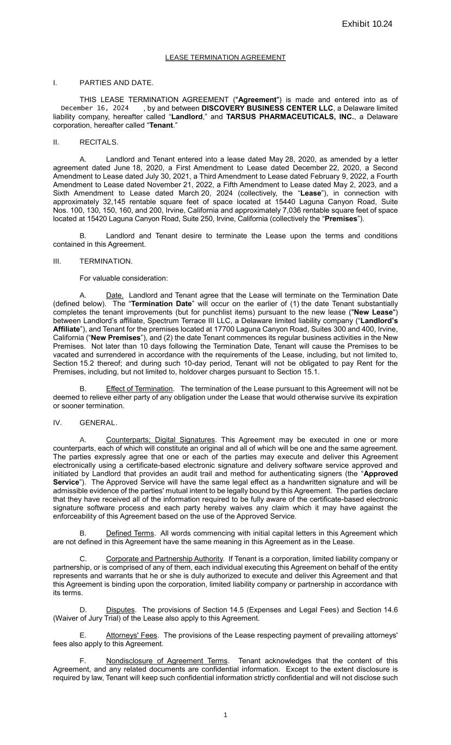
160
TARSUS PHARMACEUTICALS, INC. 15420 Laguna Canyon Road-STE 250 and 15440 Laguna Canyon Rd-STES 100, 130, 150 and 200-T5 12/9/24-OPP-049812 1 LEASE TERMINATION AGREEMENT I. PARTIES AND DATE. THIS LEASE TERMINATION AGREEMENT ("Agreement") is made and entered into as of \fed\ __________________, by and between DISCOVERY BUSINESS CENTER LLC, a Delaware limited liability company, hereafter called “Landlord,” and TARSUS PHARMACEUTICALS, INC., a Delaware corporation, hereafter called “Tenant.” II. RECITALS. A. Landlord and Tenant entered into a lease dated May 28, 2020, as amended by a letter agreement dated June 18, 2020, a First Amendment to Lease dated December 22, 2020, a Second Amendment to Lease dated July 30, 2021, a Third Amendment to Lease dated February 9, 2022, a Fourth Amendment to Lease dated November 21, 2022, a Fifth Amendment to Lease dated May 2, 2023, and a Sixth Amendment to Lease dated March 20, 2024 (collectively, the “Lease”), in connection with approximately 32,145 rentable square feet of space located at 15440 Laguna Canyon Road, Suite Nos. 100, 130, 150, 160, and 200, Irvine, California and approximately 7,036 rentable square feet of space located at 15420 Laguna Canyon Road, Suite 250, Irvine, California (collectively the “Premises”). B. Landlord and Tenant desire to terminate the Lease upon the terms and conditions contained in this Agreement. III. TERMINATION. For valuable consideration: A. Date. Landlord and Tenant agree that the Lease will terminate on the Termination Date (defined below). The “Termination Date” will occur on the earlier of (1) the date Tenant substantially completes the tenant improvements (but for punchlist items) pursuant to the new lease ("New Lease") between Landlord’s affiliate, Spectrum Terrace III LLC, a Delaware limited liability company (“Landlord’s Affiliate”), and Tenant for the premises located at 17700 Laguna Canyon Road, Suites 300 and 400, Irvine, California (“New Premises”), and (2) the date Tenant commences its regular business activities in the New Premises. Not later than 10 days following the Termination Date, Tenant will cause the Premises to be vacated and surrendered in accordance with the requirements of the Lease, including, but not limited to, Section 15.2 thereof; and during such 10-day period, Tenant will not be obligated to pay Rent for the Premises, including, but not limited to, holdover charges pursuant to Section 15.1. B. Effect of Termination. The termination of the Lease pursuant to this Agreement will not be deemed to relieve either party of any obligation under the Lease that would otherwise survive its expiration or sooner termination. IV. GENERAL. A. Counterparts; Digital Signatures. This Agreement may be executed in one or more counterparts, each of which will constitute an original and all of which will be one and the same agreement. The parties expressly agree that one or each of the parties may execute and deliver this Agreement electronically using a certificate-based electronic signature and delivery software service approved and initiated by Landlord that provides an audit trail and method for authenticating signers (the “Approved Service”). The Approved Service will have the same legal effect as a handwritten signature and will be admissible evidence of the parties' mutual intent to be legally bound by this Agreement. The parties declare that they have received all of the information required to be fully aware of the certificate-based electronic signature software process and each party hereby waives any claim which it may have against the enforceability of this Agreement based on the use of the Approved Service. B. Defined Terms. All words commencing with initial capital letters in this Agreement which are not defined in this Agreement have the same meaning in this Agreement as in the Lease. C. Corporate and Partnership Authority. If Tenant is a corporation, limited liability company or partnership, or is comprised of any of them, each individual executing this Agreement on behalf of the entity represents and warrants that he or she is duly authorized to execute and deliver this Agreement and that this Agreement is binding upon the corporation, limited liability company or partnership in accordance with its terms. D. Disputes. The provisions of Section 14.5 (Expenses and Legal Fees) and Section 14.6 (Waiver of Jury Trial) of the Lease also apply to this Agreement. E. Attorneys' Fees. The provisions of the Lease respecting payment of prevailing attorneys' fees also apply to this Agreement. F. Nondisclosure of Agreement Terms. Tenant acknowledges that the content of this Agreement, and any related documents are confidential information. Except to the extent disclosure is required by law, Tenant will keep such confidential information strictly confidential and will not disclose such Docusign Envelope ID: A9ED51EE-1FB3-40A6-B597-7032AA8C6657 December 16, 2024

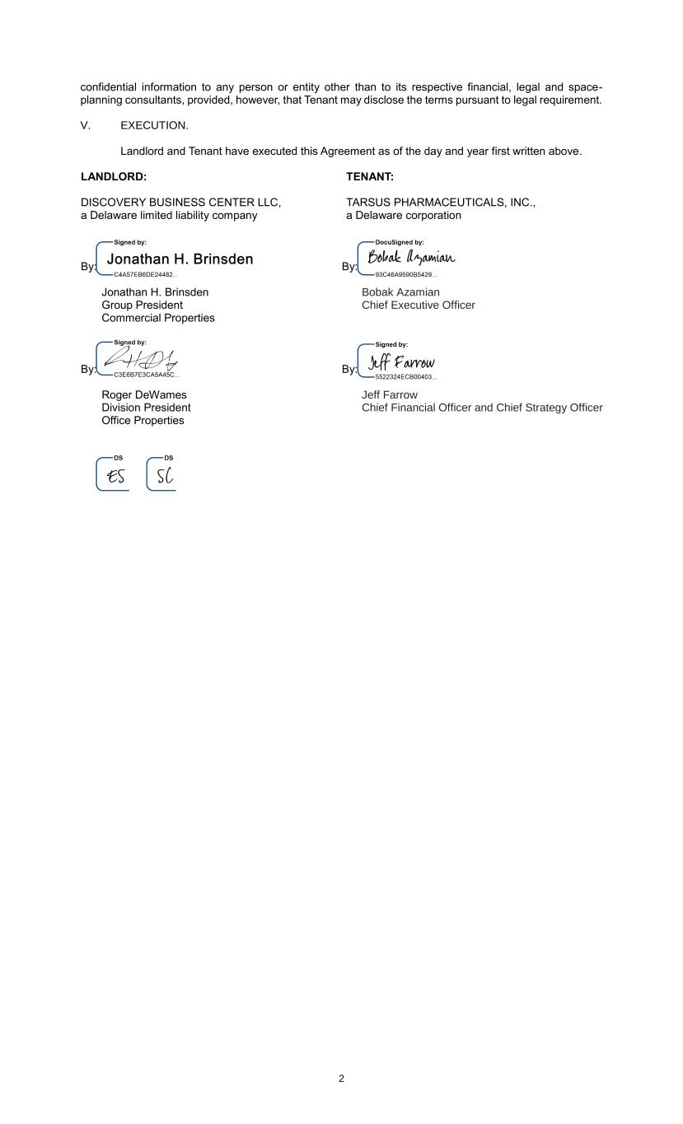
TARSUS PHARMACEUTICALS, INC. 15420 Laguna Canyon Road-STE 250 and 15440 Laguna Canyon Rd-STES 100, 130, 150 and 200-T5 12/9/24-OPP-049812 2 confidential information to any person or entity other than to its respective financial, legal and space- planning consultants, provided, however, that Tenant may disclose the terms pursuant to legal requirement. V. EXECUTION. Landlord and Tenant have executed this Agreement as of the day and year first written above. LANDLORD: DISCOVERY BUSINESS CENTER LLC, a Delaware limited liability company By: \si6\ Jonathan H. Brinsden Group President Commercial Properties By: \si5\ Roger DeWames Division President Office Properties \in9\ TENANT: TARSUS PHARMACEUTICALS, INC., a Delaware corporation By: \si1\ Bobak Azamian Chief Executive Officer By: \si2\ Jeff Farrow Chief Financial Officer and Chief Strategy Officer Docusign Envelope ID: A9ED51EE-1FB3-40A6-B597-7032AA8C6657

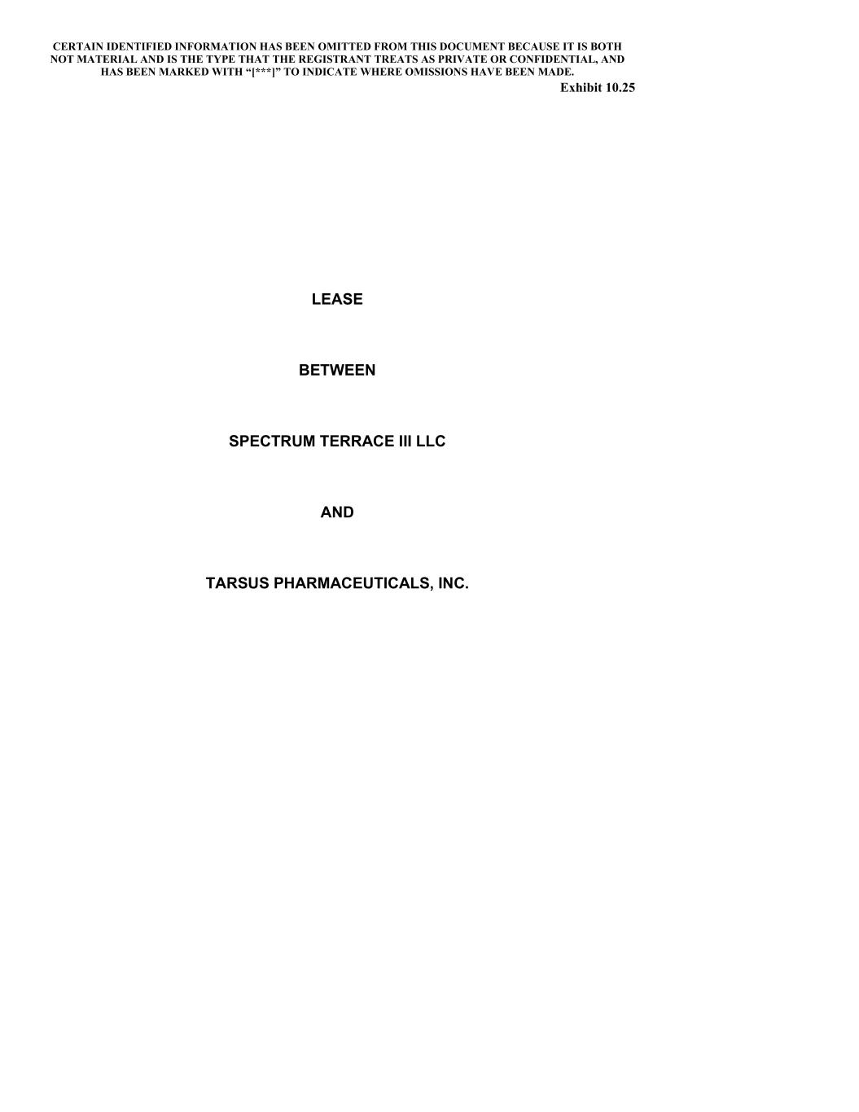

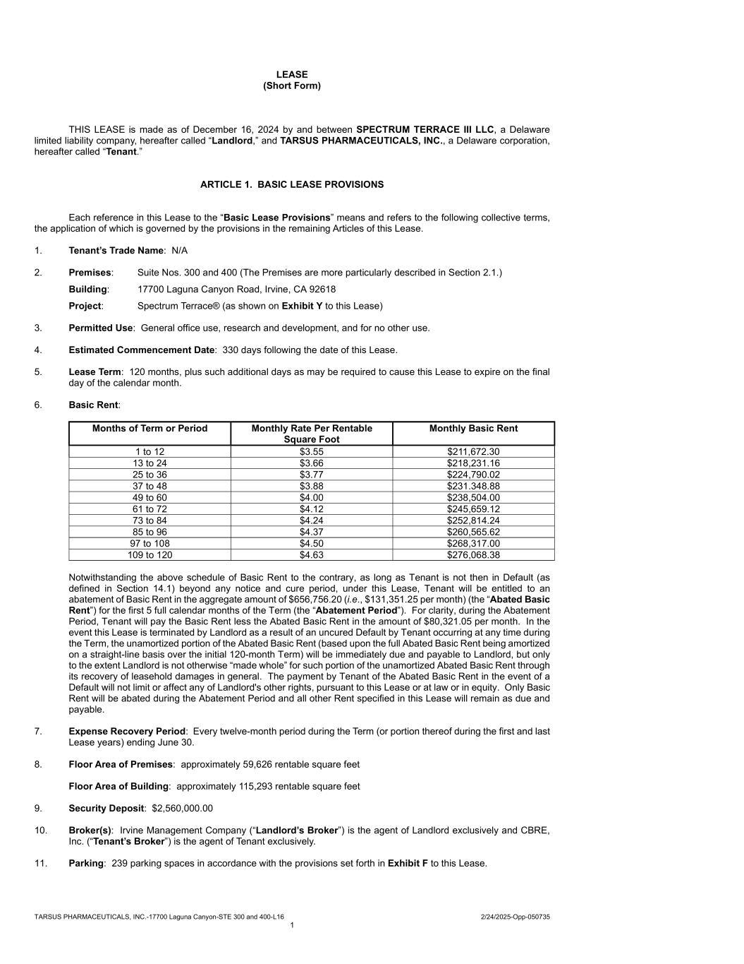

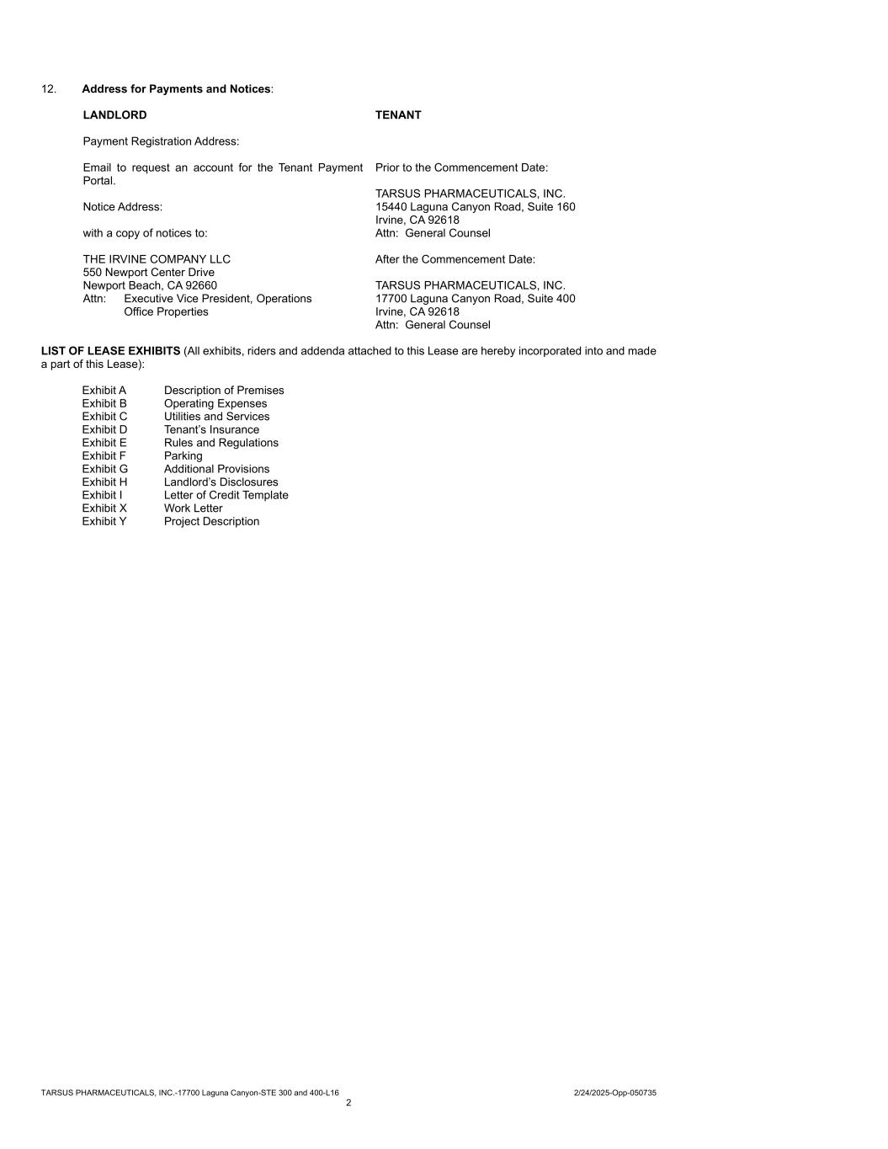

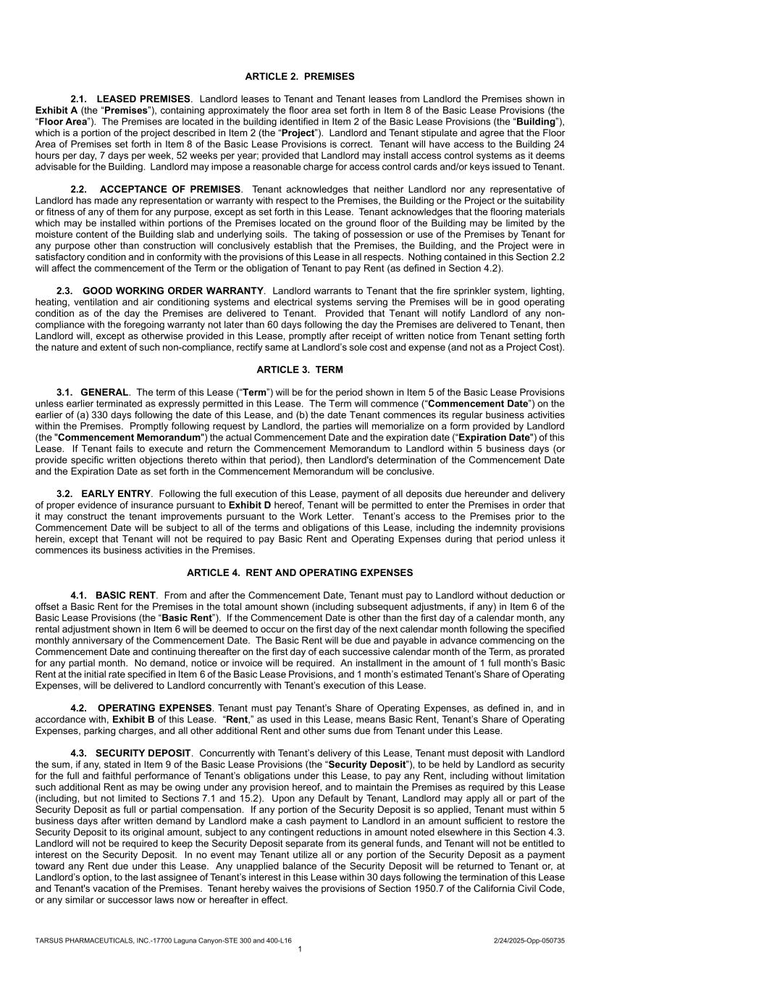

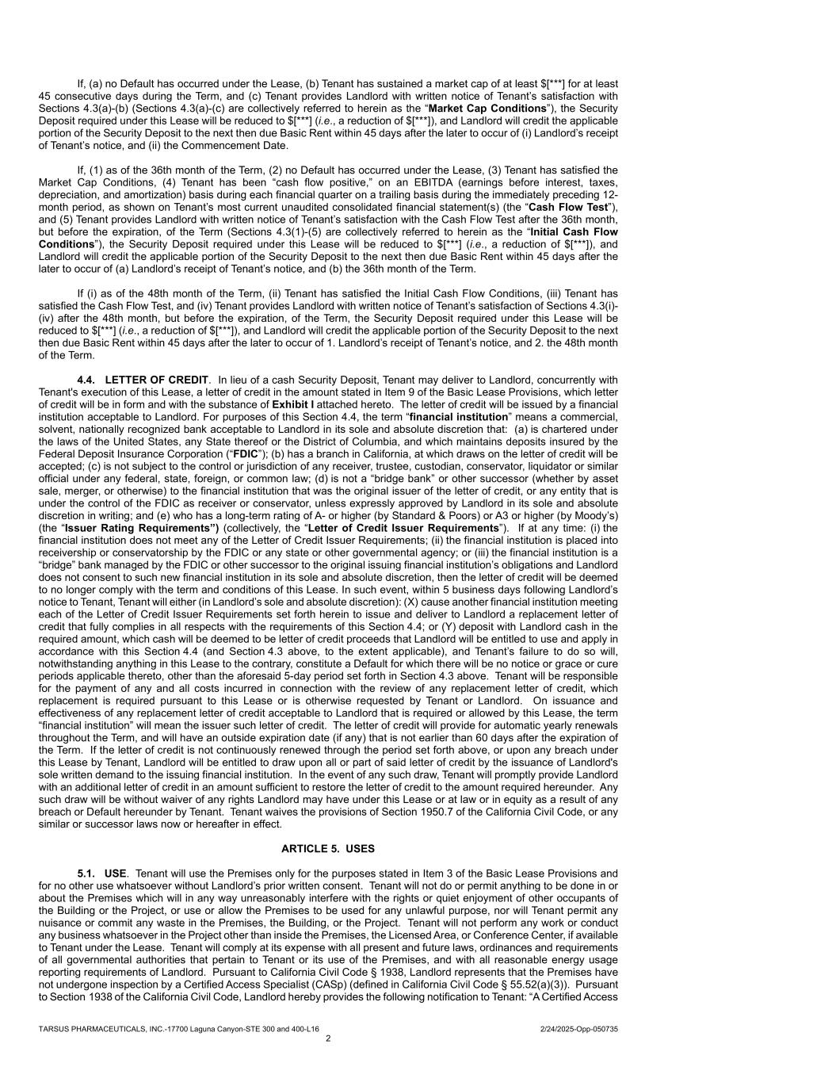

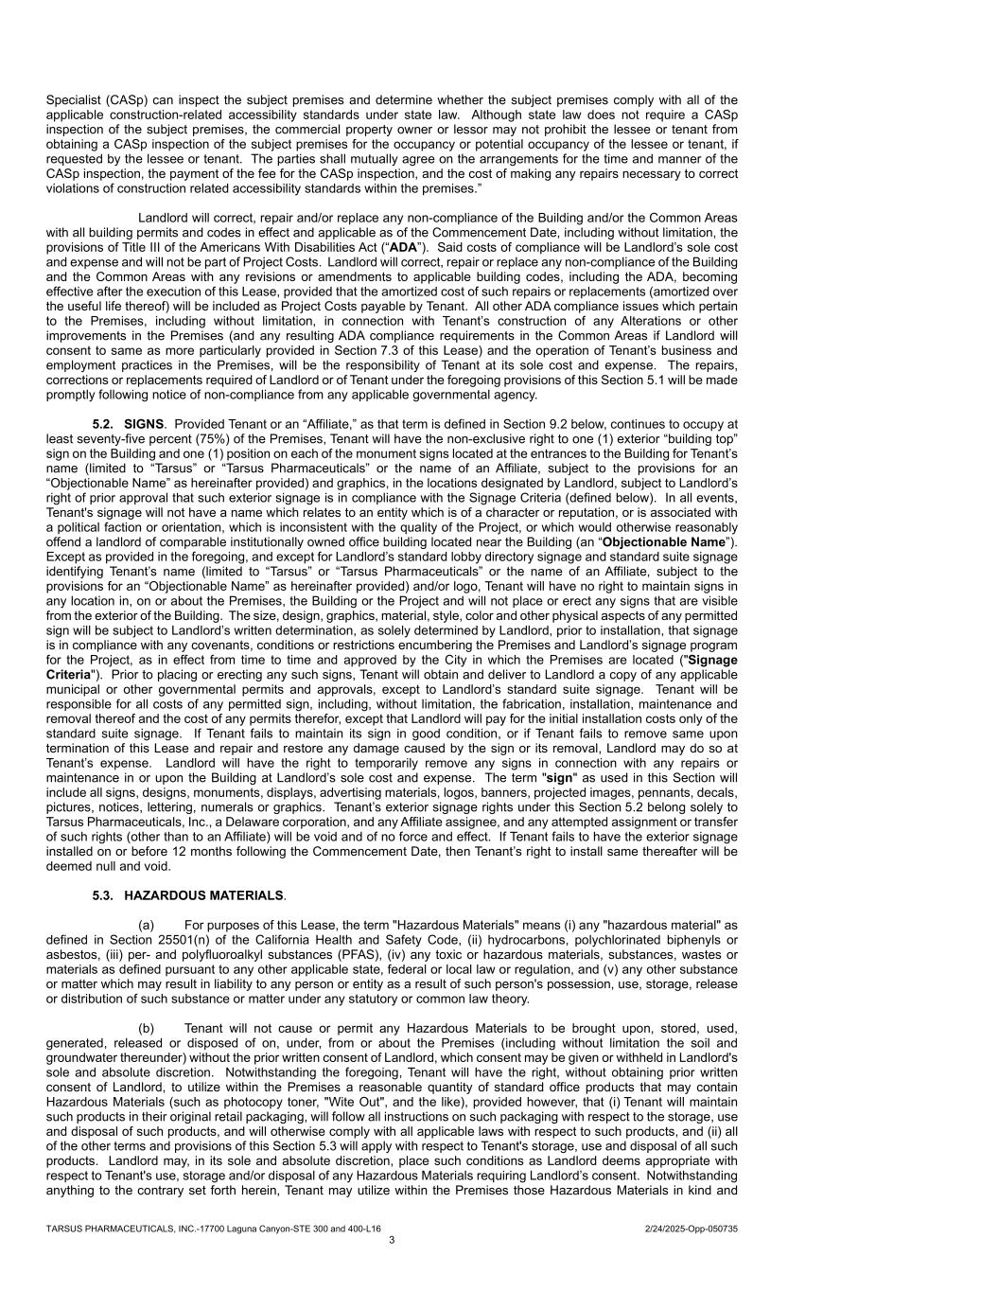

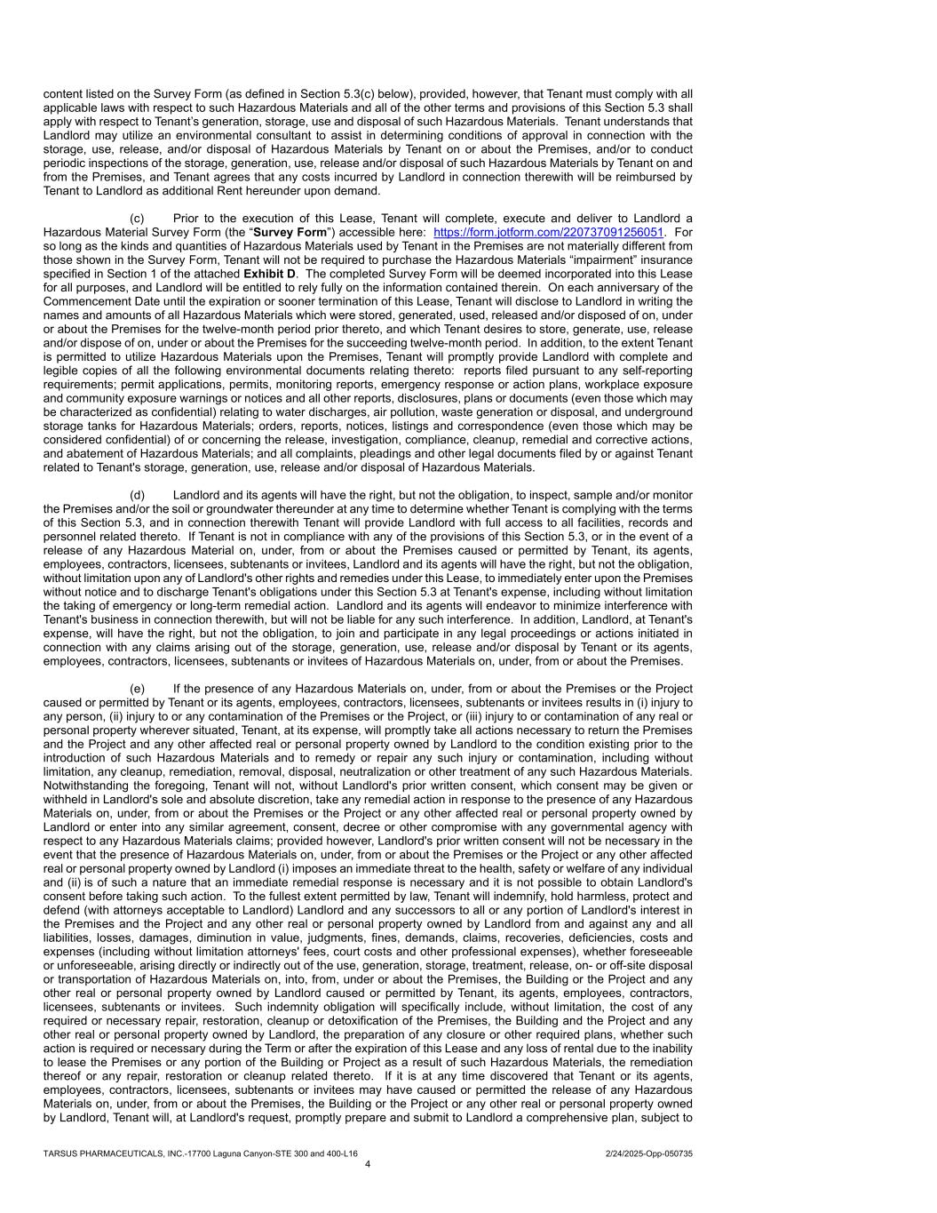

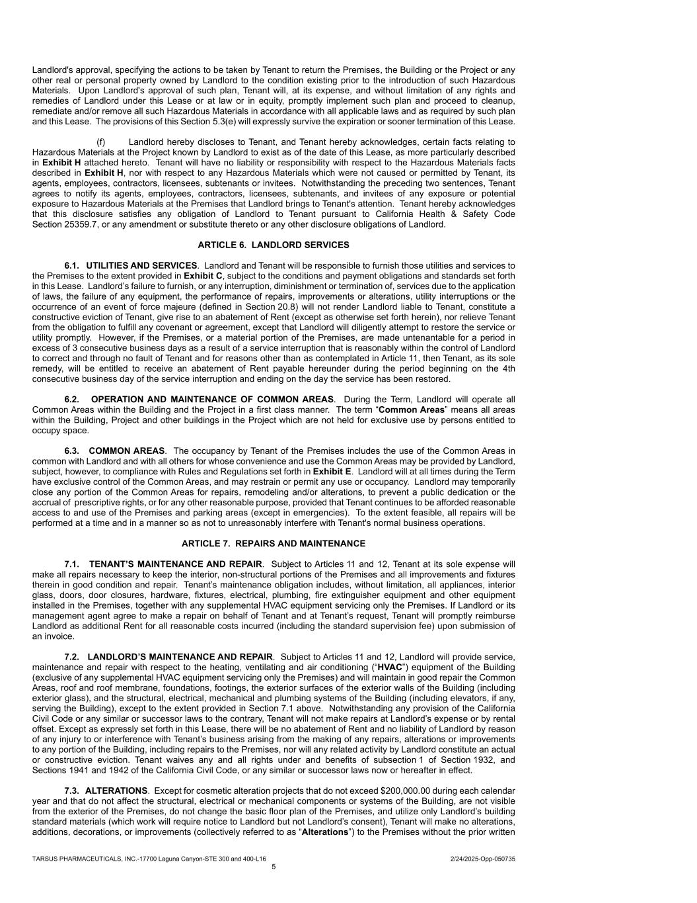

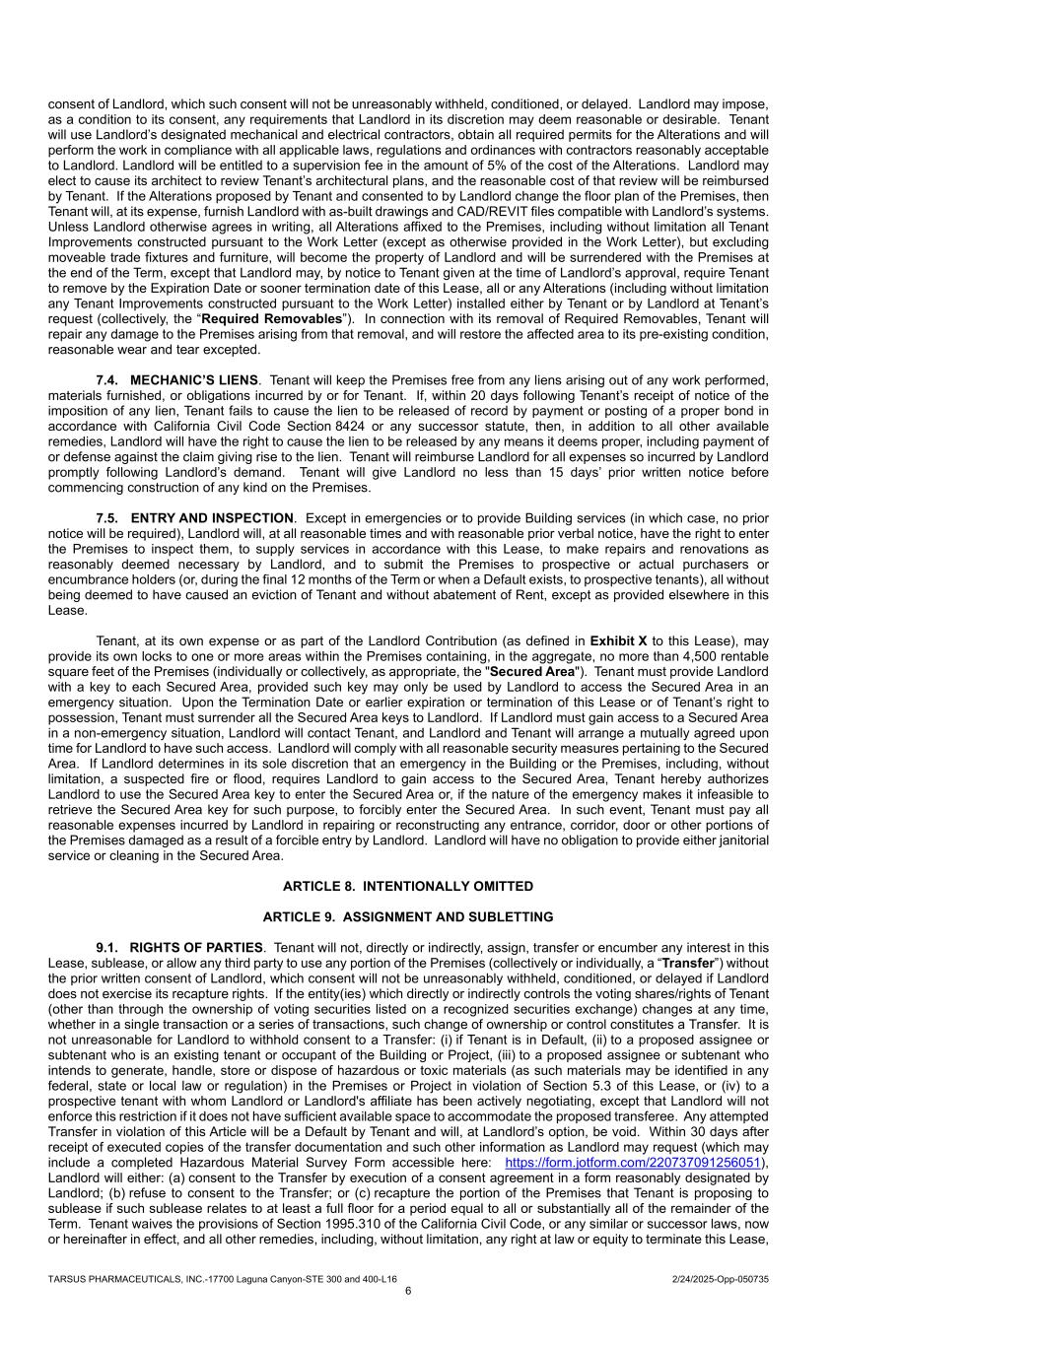

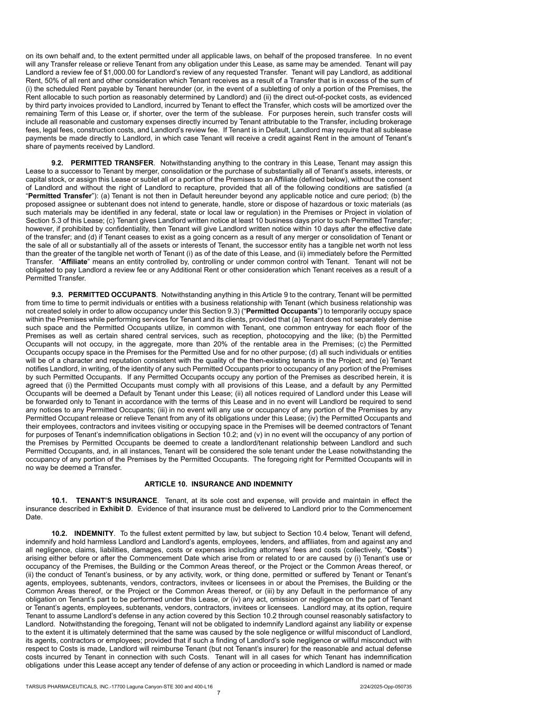

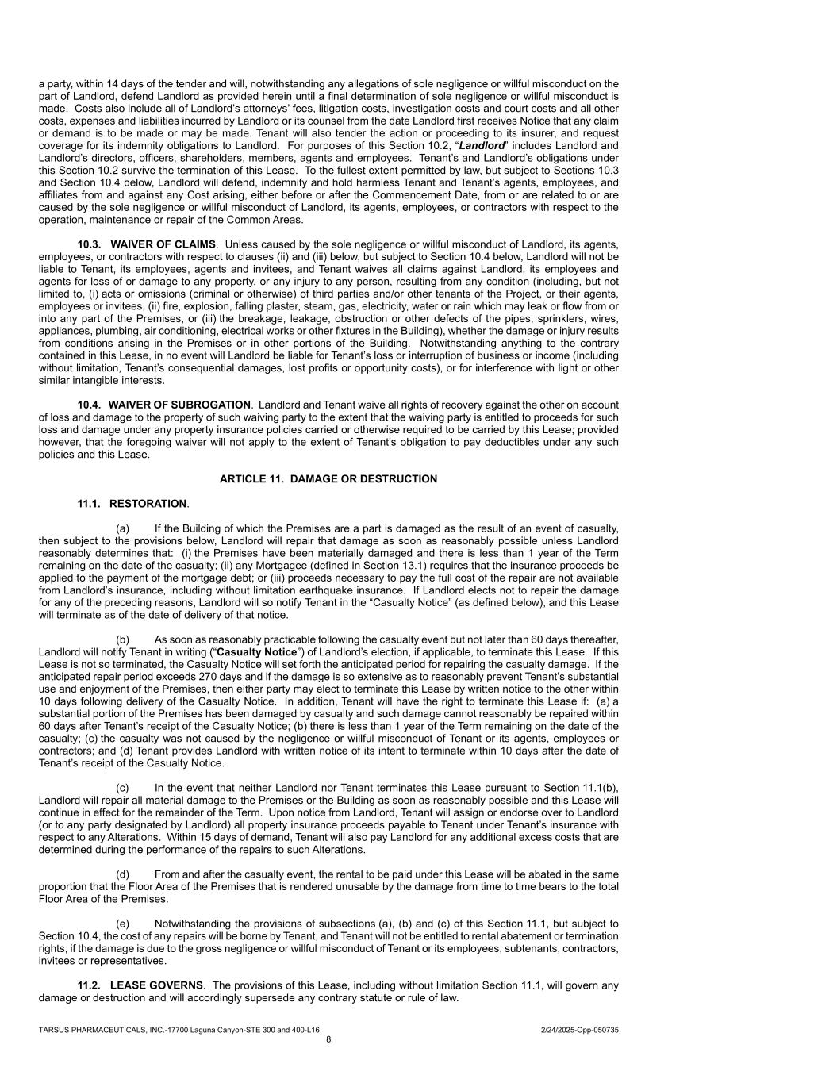

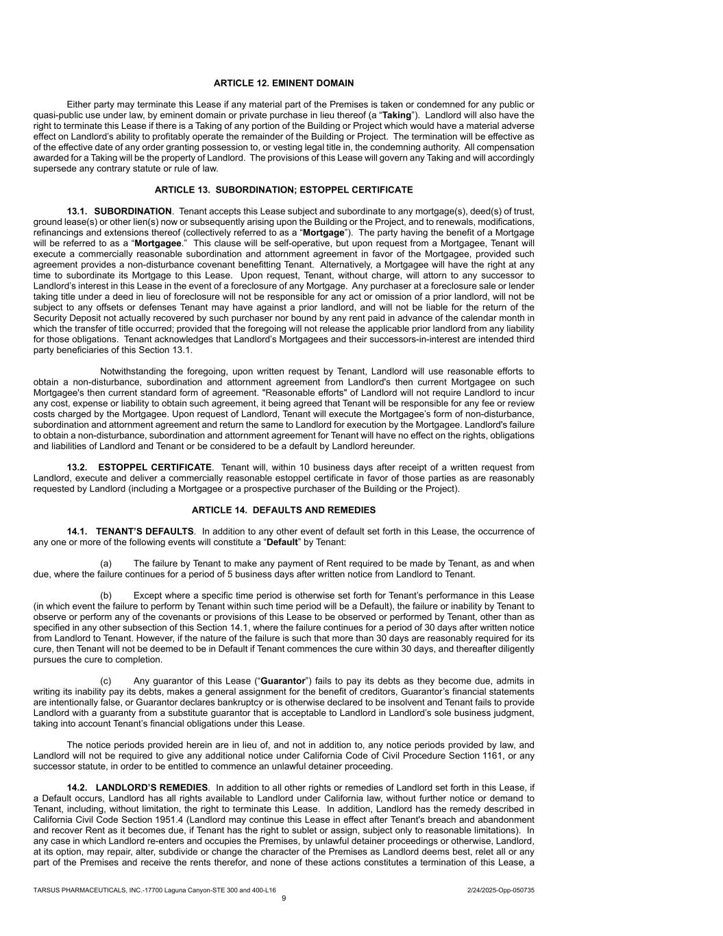

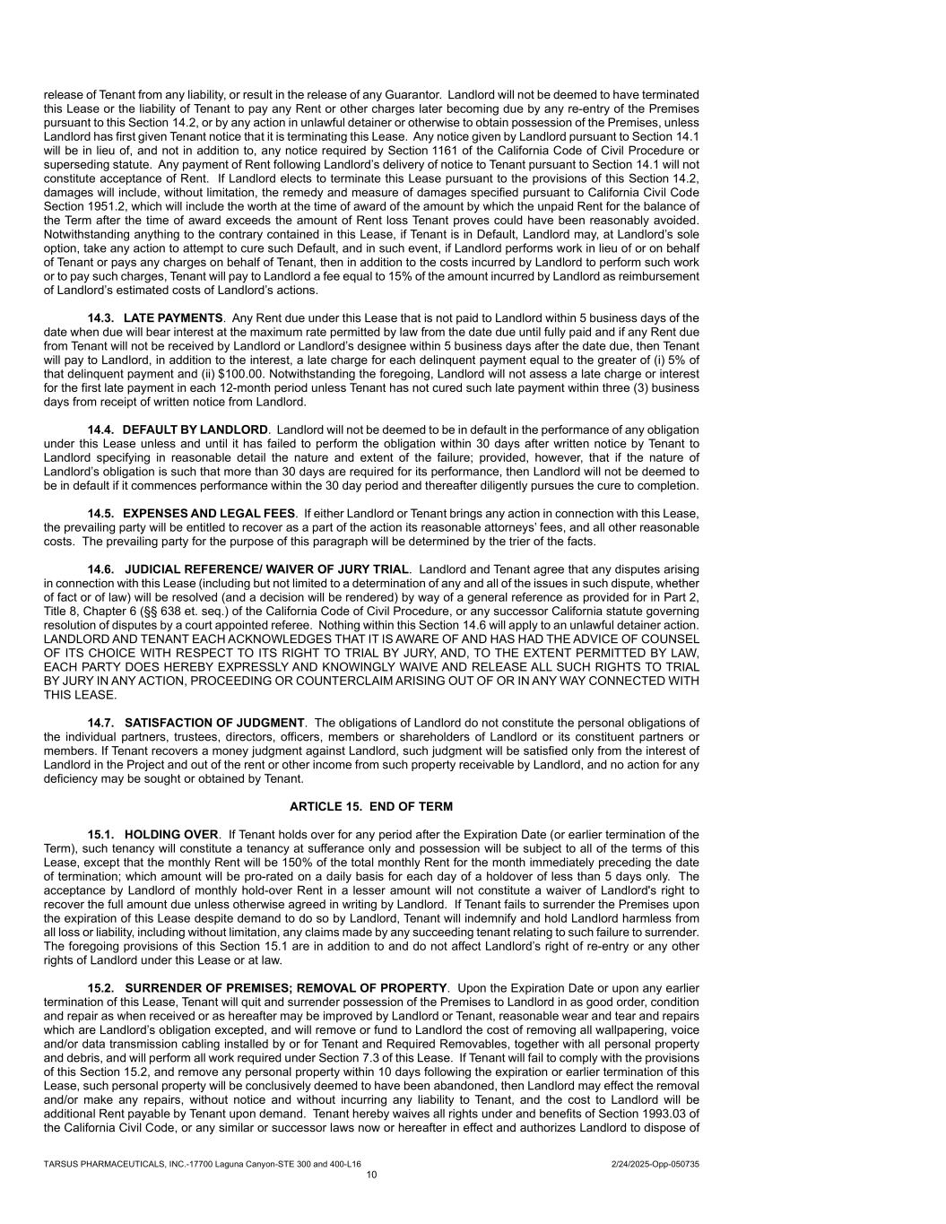

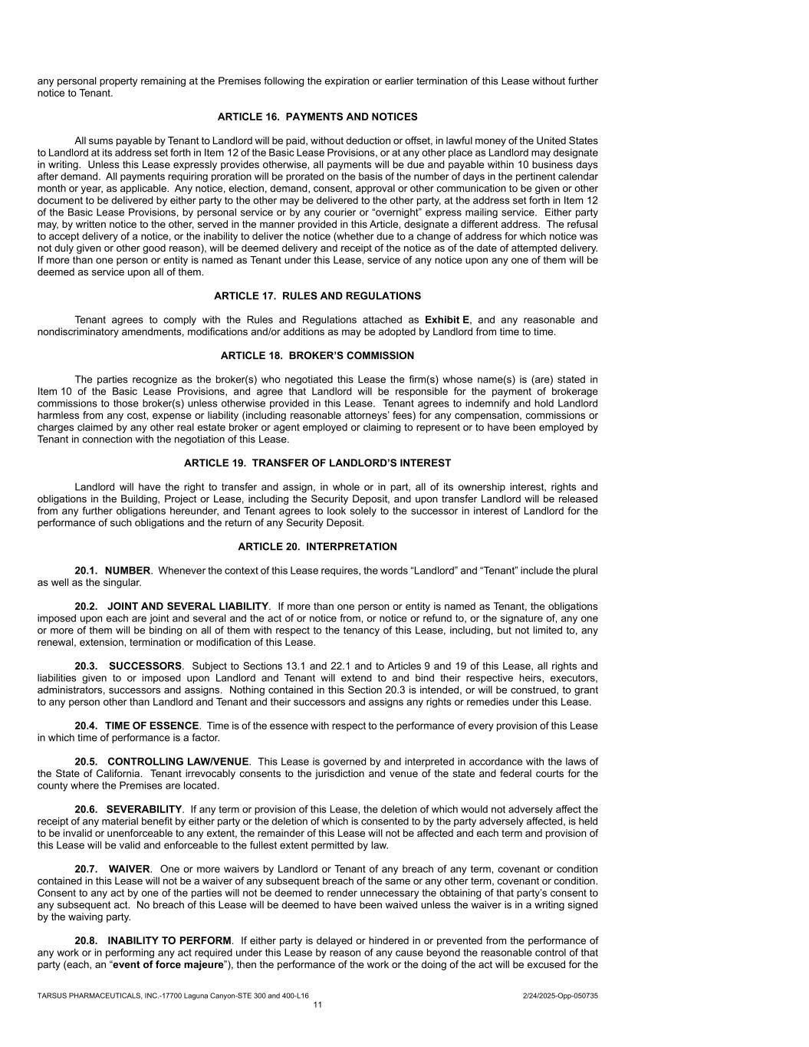

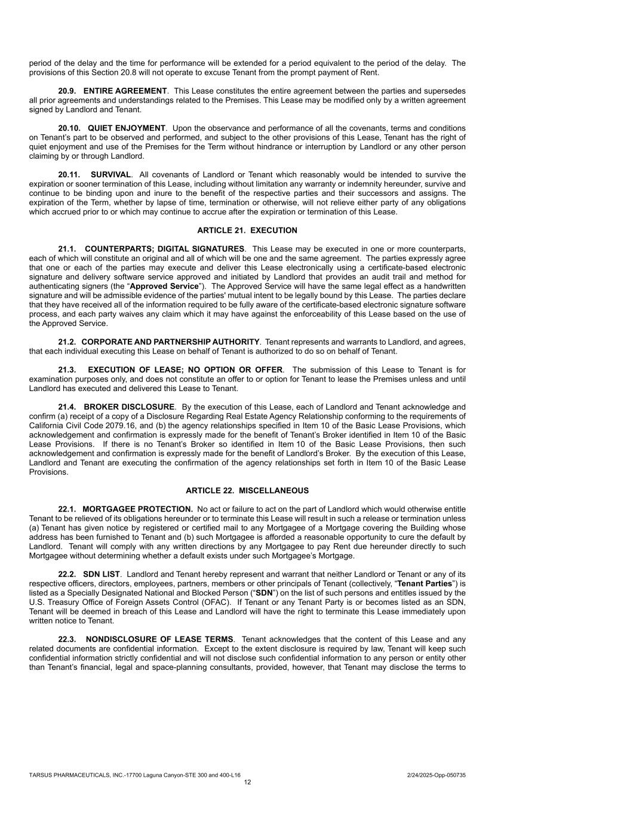

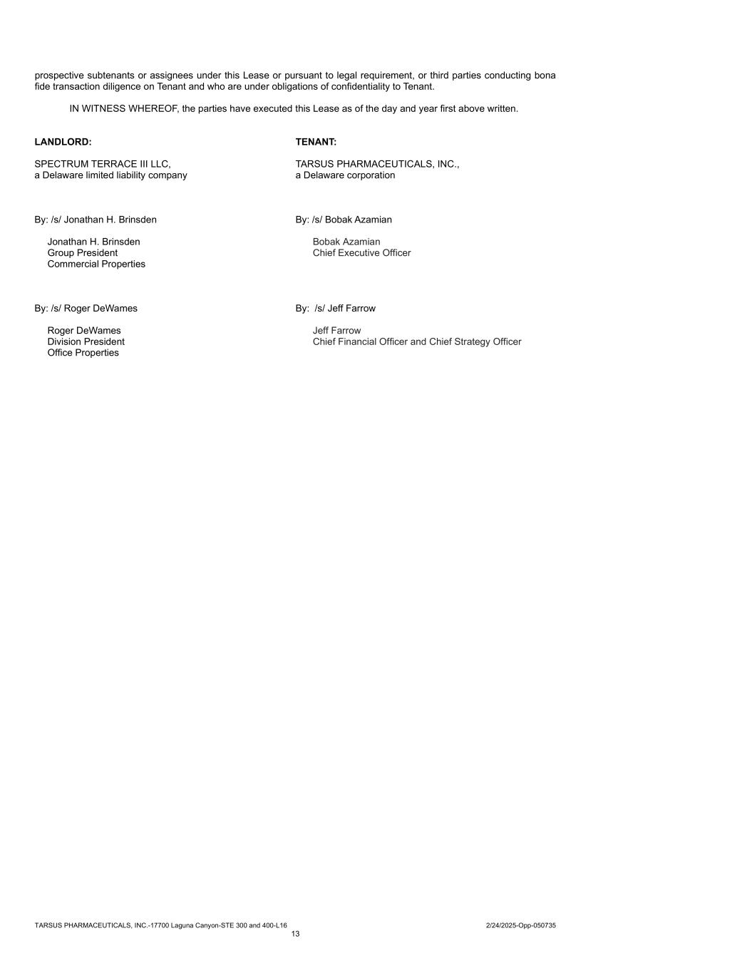

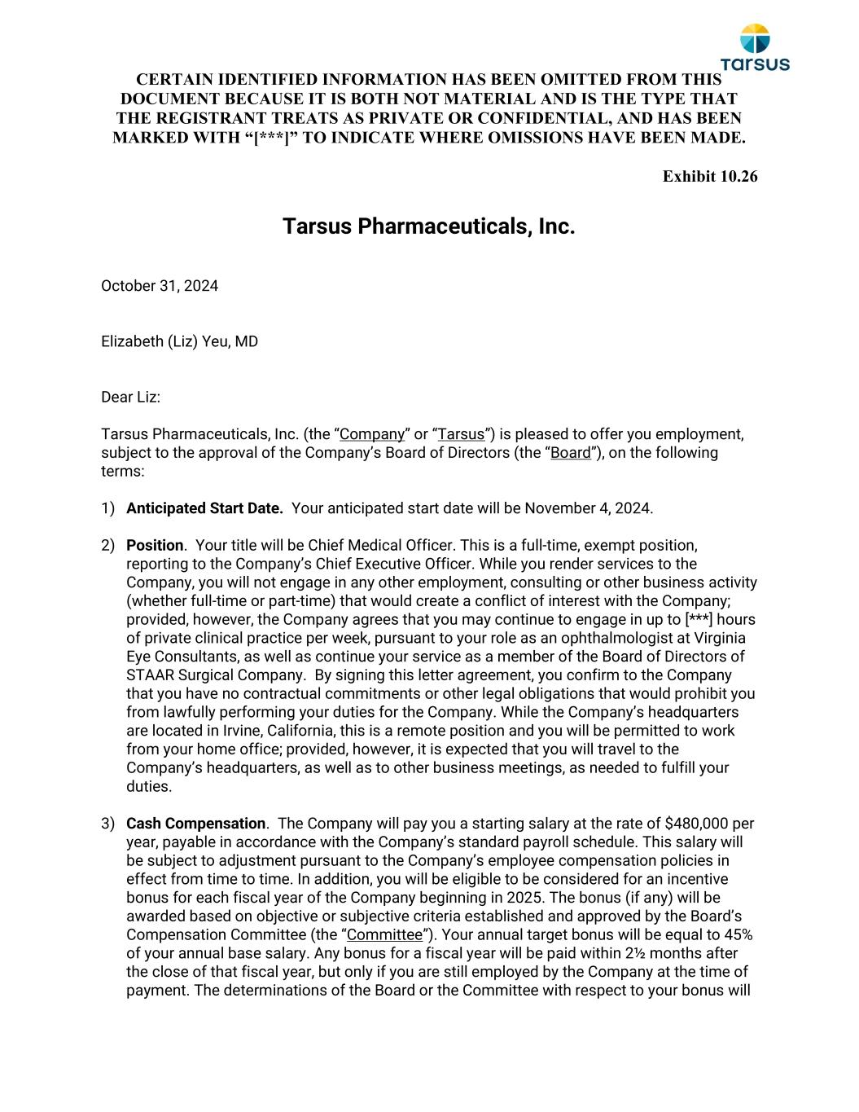
CERTAIN IDENTIFIED INFORMATION HAS BEEN OMITTED FROM THIS DOCUMENT BECAUSE IT IS BOTH NOT MATERIAL AND IS THE TYPE THAT THE REGISTRANT TREATS AS PRIVATE OR CONFIDENTIAL, AND HAS BEEN MARKED WITH “[***]” TO INDICATE WHERE OMISSIONS HAVE BEEN MADE. Exhibit 10.26 Tarsus Pharmaceuticals, Inc. October 31, 2024 Elizabeth (Liz) Yeu, MD Dear Liz: Tarsus Pharmaceuticals, Inc. (the “Company” or “Tarsus”) is pleased to offer you employment, subject to the approval of the Company’s Board of Directors (the “Board”), on the following terms: 1) Anticipated Start Date. Your anticipated start date will be November 4, 2024. 2) Position. Your title will be Chief Medical Officer. This is a full-time, exempt position, reporting to the Company’s Chief Executive Officer. While you render services to the Company, you will not engage in any other employment, consulting or other business activity (whether full-time or part-time) that would create a conflict of interest with the Company; provided, however, the Company agrees that you may continue to engage in up to [***] hours of private clinical practice per week, pursuant to your role as an ophthalmologist at Virginia Eye Consultants, as well as continue your service as a member of the Board of Directors of STAAR Surgical Company. By signing this letter agreement, you confirm to the Company that you have no contractual commitments or other legal obligations that would prohibit you from lawfully performing your duties for the Company. While the Company’s headquarters are located in Irvine, California, this is a remote position and you will be permitted to work from your home office; provided, however, it is expected that you will travel to the Company’s headquarters, as well as to other business meetings, as needed to fulfill your duties. 3) Cash Compensation. The Company will pay you a starting salary at the rate of $480,000 per year, payable in accordance with the Company’s standard payroll schedule. This salary will be subject to adjustment pursuant to the Company’s employee compensation policies in effect from time to time. In addition, you will be eligible to be considered for an incentive bonus for each fiscal year of the Company beginning in 2025. The bonus (if any) will be awarded based on objective or subjective criteria established and approved by the Board’s Compensation Committee (the “Committee”). Your annual target bonus will be equal to 45% of your annual base salary. Any bonus for a fiscal year will be paid within 2½ months after the close of that fiscal year, but only if you are still employed by the Company at the time of payment. The determinations of the Board or the Committee with respect to your bonus will

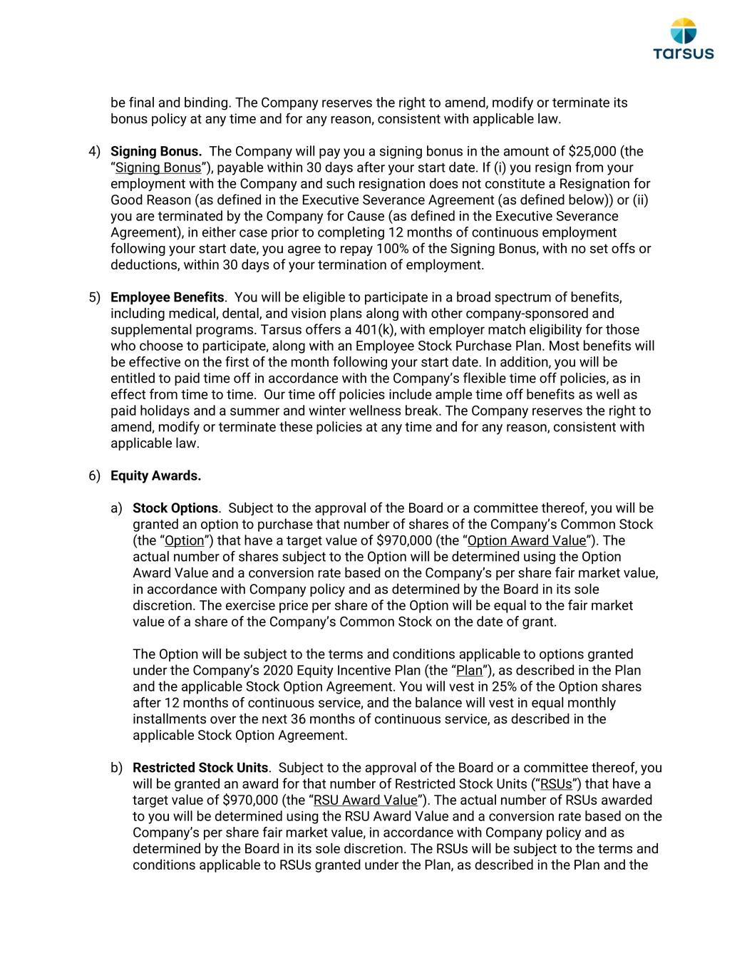
be final and binding. The Company reserves the right to amend, modify or terminate its bonus policy at any time and for any reason, consistent with applicable law. 4) Signing Bonus. The Company will pay you a signing bonus in the amount of $25,000 (the “Signing Bonus”), payable within 30 days after your start date. If (i) you resign from your employment with the Company and such resignation does not constitute a Resignation for Good Reason (as defined in the Executive Severance Agreement (as defined below)) or (ii) you are terminated by the Company for Cause (as defined in the Executive Severance Agreement), in either case prior to completing 12 months of continuous employment following your start date, you agree to repay 100% of the Signing Bonus, with no set offs or deductions, within 30 days of your termination of employment. 5) Employee Benefits. You will be eligible to participate in a broad spectrum of benefits, including medical, dental, and vision plans along with other company-sponsored and supplemental programs. Tarsus offers a 401(k), with employer match eligibility for those who choose to participate, along with an Employee Stock Purchase Plan. Most benefits will be effective on the first of the month following your start date. In addition, you will be entitled to paid time off in accordance with the Company’s flexible time off policies, as in effect from time to time. Our time off policies include ample time off benefits as well as paid holidays and a summer and winter wellness break. The Company reserves the right to amend, modify or terminate these policies at any time and for any reason, consistent with applicable law. 6) Equity Awards. a) Stock Options. Subject to the approval of the Board or a committee thereof, you will be granted an option to purchase that number of shares of the Company’s Common Stock (the “Option”) that have a target value of $970,000 (the “Option Award Value”). The actual number of shares subject to the Option will be determined using the Option Award Value and a conversion rate based on the Company’s per share fair market value, in accordance with Company policy and as determined by the Board in its sole discretion. The exercise price per share of the Option will be equal to the fair market value of a share of the Company’s Common Stock on the date of grant. The Option will be subject to the terms and conditions applicable to options granted under the Company’s 2020 Equity Incentive Plan (the “Plan”), as described in the Plan and the applicable Stock Option Agreement. You will vest in 25% of the Option shares after 12 months of continuous service, and the balance will vest in equal monthly installments over the next 36 months of continuous service, as described in the applicable Stock Option Agreement. b) Restricted Stock Units. Subject to the approval of the Board or a committee thereof, you will be granted an award for that number of Restricted Stock Units (“RSUs”) that have a target value of $970,000 (the “RSU Award Value”). The actual number of RSUs awarded to you will be determined using the RSU Award Value and a conversion rate based on the Company’s per share fair market value, in accordance with Company policy and as determined by the Board in its sole discretion. The RSUs will be subject to the terms and conditions applicable to RSUs granted under the Plan, as described in the Plan and the

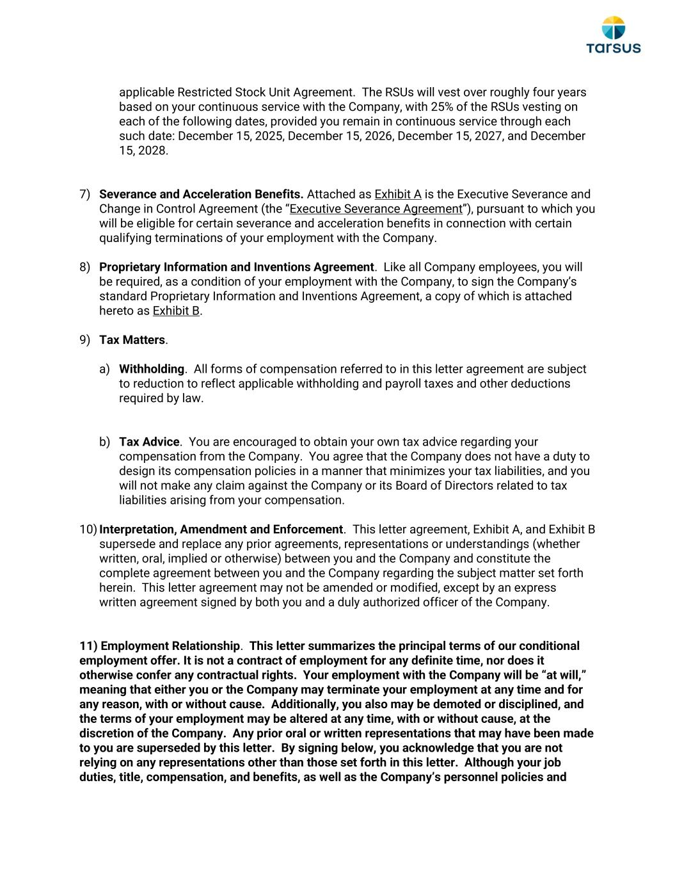
applicable Restricted Stock Unit Agreement. The RSUs will vest over roughly four years based on your continuous service with the Company, with 25% of the RSUs vesting on each of the following dates, provided you remain in continuous service through each such date: December 15, 2025, December 15, 2026, December 15, 2027, and December 15, 2028. 7) Severance and Acceleration Benefits. Attached as Exhibit A is the Executive Severance and Change in Control Agreement (the “Executive Severance Agreement”), pursuant to which you will be eligible for certain severance and acceleration benefits in connection with certain qualifying terminations of your employment with the Company. 8) Proprietary Information and Inventions Agreement. Like all Company employees, you will be required, as a condition of your employment with the Company, to sign the Company’s standard Proprietary Information and Inventions Agreement, a copy of which is attached hereto as Exhibit B. 9) Tax Matters. a) Withholding. All forms of compensation referred to in this letter agreement are subject to reduction to reflect applicable withholding and payroll taxes and other deductions required by law. b) Tax Advice. You are encouraged to obtain your own tax advice regarding your compensation from the Company. You agree that the Company does not have a duty to design its compensation policies in a manner that minimizes your tax liabilities, and you will not make any claim against the Company or its Board of Directors related to tax liabilities arising from your compensation. 10) Interpretation, Amendment and Enforcement. This letter agreement, Exhibit A, and Exhibit B supersede and replace any prior agreements, representations or understandings (whether written, oral, implied or otherwise) between you and the Company and constitute the complete agreement between you and the Company regarding the subject matter set forth herein. This letter agreement may not be amended or modified, except by an express written agreement signed by both you and a duly authorized officer of the Company. 11) Employment Relationship. This letter summarizes the principal terms of our conditional employment offer. It is not a contract of employment for any definite time, nor does it otherwise confer any contractual rights. Your employment with the Company will be “at will,” meaning that either you or the Company may terminate your employment at any time and for any reason, with or without cause. Additionally, you also may be demoted or disciplined, and the terms of your employment may be altered at any time, with or without cause, at the discretion of the Company. Any prior oral or written representations that may have been made to you are superseded by this letter. By signing below, you acknowledge that you are not relying on any representations other than those set forth in this letter. Although your job duties, title, compensation, and benefits, as well as the Company’s personnel policies and

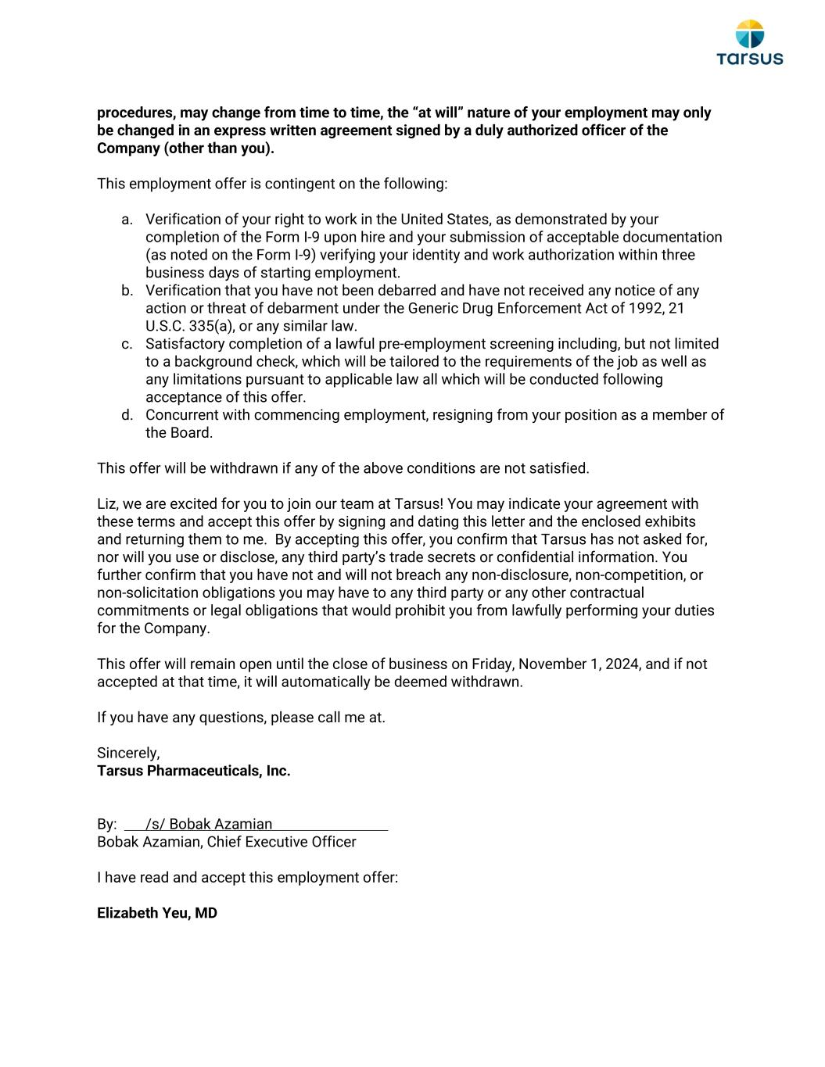
procedures, may change from time to time, the “at will” nature of your employment may only be changed in an express written agreement signed by a duly authorized officer of the Company (other than you). This employment offer is contingent on the following: a. Verification of your right to work in the United States, as demonstrated by your completion of the Form I-9 upon hire and your submission of acceptable documentation (as noted on the Form I-9) verifying your identity and work authorization within three business days of starting employment. b. Verification that you have not been debarred and have not received any notice of any action or threat of debarment under the Generic Drug Enforcement Act of 1992, 21 U.S.C. 335(a), or any similar law. c. Satisfactory completion of a lawful pre-employment screening including, but not limited to a background check, which will be tailored to the requirements of the job as well as any limitations pursuant to applicable law all which will be conducted following acceptance of this offer. d. Concurrent with commencing employment, resigning from your position as a member of the Board. This offer will be withdrawn if any of the above conditions are not satisfied. Liz, we are excited for you to join our team at Tarsus! You may indicate your agreement with these terms and accept this offer by signing and dating this letter and the enclosed exhibits and returning them to me. By accepting this offer, you confirm that Tarsus has not asked for, nor will you use or disclose, any third party’s trade secrets or confidential information. You further confirm that you have not and will not breach any non-disclosure, non-competition, or non-solicitation obligations you may have to any third party or any other contractual commitments or legal obligations that would prohibit you from lawfully performing your duties for the Company. This offer will remain open until the close of business on Friday, November 1, 2024, and if not accepted at that time, it will automatically be deemed withdrawn. If you have any questions, please call me at. Sincerely, Tarsus Pharmaceuticals, Inc. By: /s/ Bobak Azamian Bobak Azamian, Chief Executive Officer I have read and accept this employment offer: Elizabeth Yeu, MD

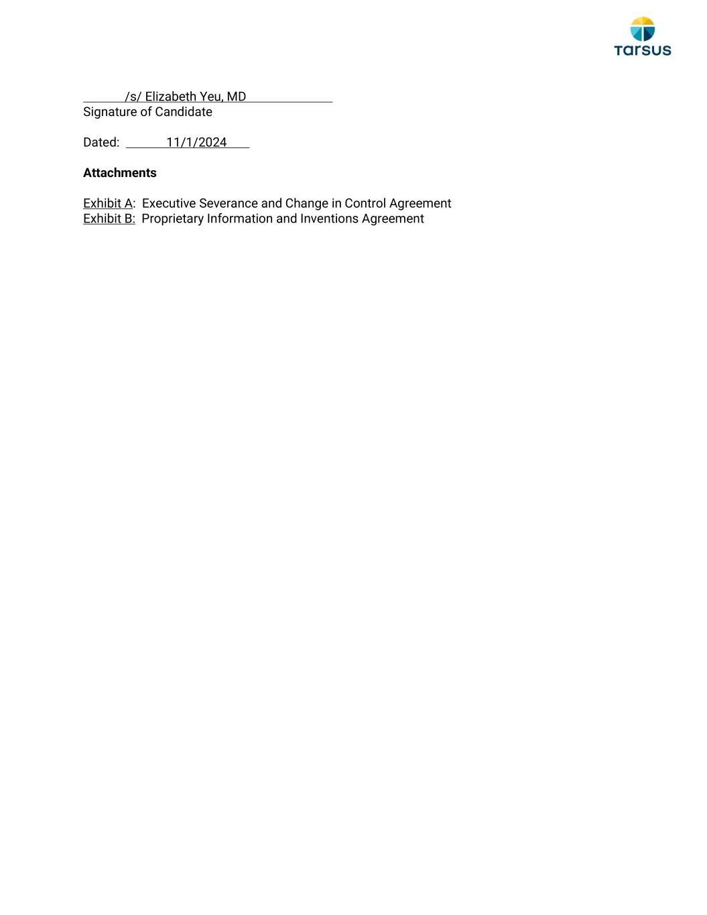
/s/ Elizabeth Yeu, MD Signature of Candidate Dated: 11/1/2024 Attachments Exhibit A: Executive Severance and Change in Control Agreement Exhibit B: Proprietary Information and Inventions Agreement

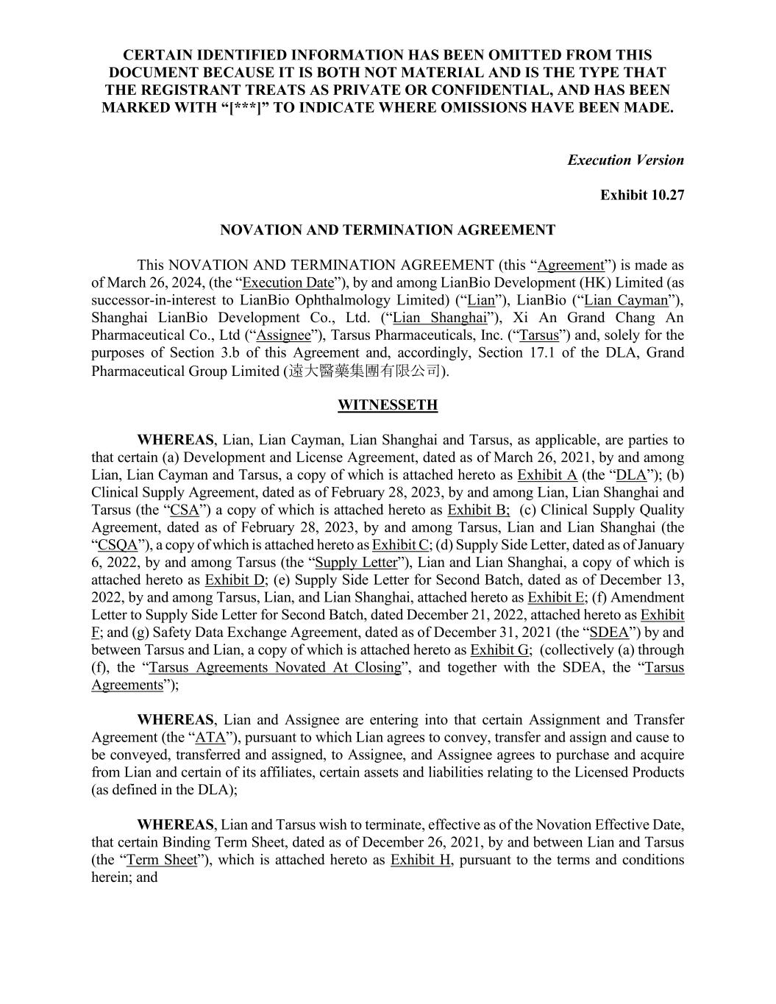
CERTAIN IDENTIFIED INFORMATION HAS BEEN OMITTED FROM THIS DOCUMENT BECAUSE IT IS BOTH NOT MATERIAL AND IS THE TYPE THAT THE REGISTRANT TREATS AS PRIVATE OR CONFIDENTIAL, AND HAS BEEN MARKED WITH “[***]” TO INDICATE WHERE OMISSIONS HAVE BEEN MADE. Execution Version Exhibit 10.27 NOVATION AND TERMINATION AGREEMENT This NOVATION AND TERMINATION AGREEMENT (this “Agreement”) is made as of March 26, 2024, (the “Execution Date”), by and among LianBio Development (HK) Limited (as successor-in-interest to LianBio Ophthalmology Limited) (“Lian”), LianBio (“Lian Cayman”), Shanghai LianBio Development Co., Ltd. (“Lian Shanghai”), Xi An Grand Chang An Pharmaceutical Co., Ltd (“Assignee”), Tarsus Pharmaceuticals, Inc. (“Tarsus”) and, solely for the purposes of Section 3.b of this Agreement and, accordingly, Section 17.1 of the DLA, Grand Pharmaceutical Group Limited (遠大醫藥集團有限公司). WITNESSETH WHEREAS, Lian, Lian Cayman, Lian Shanghai and Tarsus, as applicable, are parties to that certain (a) Development and License Agreement, dated as of March 26, 2021, by and among Lian, Lian Cayman and Tarsus, a copy of which is attached hereto as Exhibit A (the “DLA”); (b) Clinical Supply Agreement, dated as of February 28, 2023, by and among Lian, Lian Shanghai and Tarsus (the “CSA”) a copy of which is attached hereto as Exhibit B; (c) Clinical Supply Quality Agreement, dated as of February 28, 2023, by and among Tarsus, Lian and Lian Shanghai (the “CSQA”), a copy of which is attached hereto as Exhibit C; (d) Supply Side Letter, dated as of January 6, 2022, by and among Tarsus (the “Supply Letter”), Lian and Lian Shanghai, a copy of which is attached hereto as Exhibit D; (e) Supply Side Letter for Second Batch, dated as of December 13, 2022, by and among Tarsus, Lian, and Lian Shanghai, attached hereto as Exhibit E; (f) Amendment Letter to Supply Side Letter for Second Batch, dated December 21, 2022, attached hereto as Exhibit F; and (g) Safety Data Exchange Agreement, dated as of December 31, 2021 (the “SDEA”) by and between Tarsus and Lian, a copy of which is attached hereto as Exhibit G; (collectively (a) through (f), the “Tarsus Agreements Novated At Closing”, and together with the SDEA, the “Tarsus Agreements”); WHEREAS, Lian and Assignee are entering into that certain Assignment and Transfer Agreement (the “ATA”), pursuant to which Lian agrees to convey, transfer and assign and cause to be conveyed, transferred and assigned, to Assignee, and Assignee agrees to purchase and acquire from Lian and certain of its affiliates, certain assets and liabilities relating to the Licensed Products (as defined in the DLA); WHEREAS, Lian and Tarsus wish to terminate, effective as of the Novation Effective Date, that certain Binding Term Sheet, dated as of December 26, 2021, by and between Lian and Tarsus (the “Term Sheet”), which is attached hereto as Exhibit H, pursuant to the terms and conditions herein; and

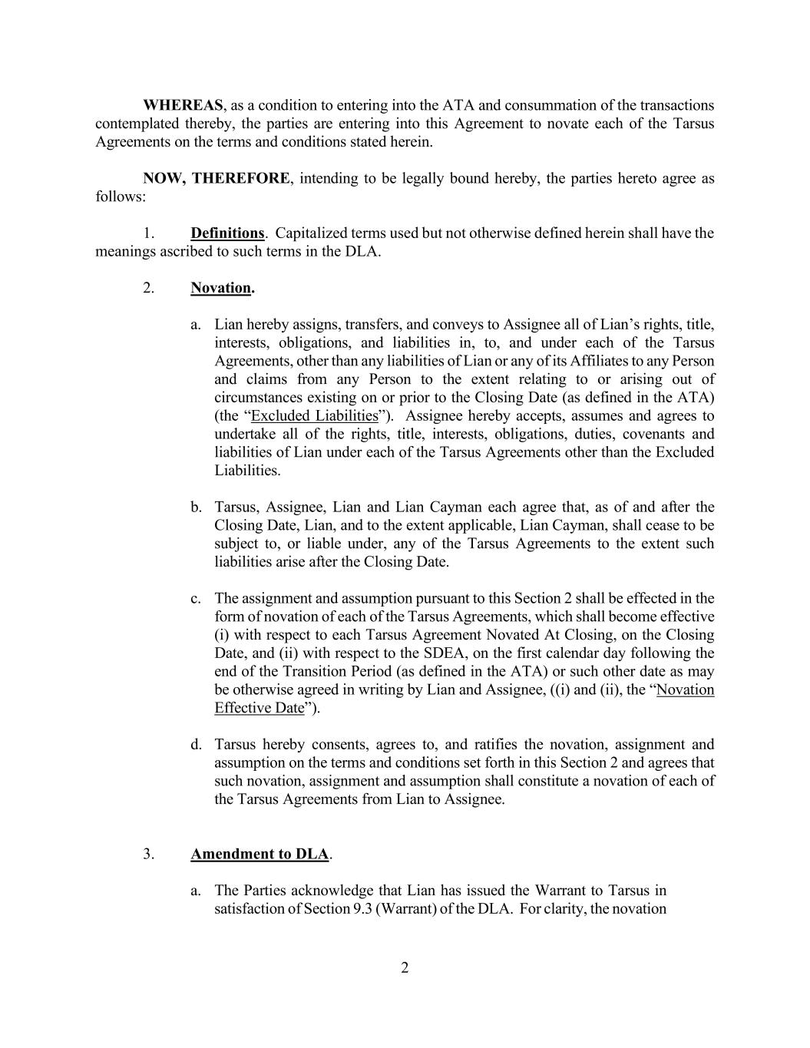
2 WHEREAS, as a condition to entering into the ATA and consummation of the transactions contemplated thereby, the parties are entering into this Agreement to novate each of the Tarsus Agreements on the terms and conditions stated herein. NOW, THEREFORE, intending to be legally bound hereby, the parties hereto agree as follows: 1. Definitions. Capitalized terms used but not otherwise defined herein shall have the meanings ascribed to such terms in the DLA. 2. Novation. a. Lian hereby assigns, transfers, and conveys to Assignee all of Lian’s rights, title, interests, obligations, and liabilities in, to, and under each of the Tarsus Agreements, other than any liabilities of Lian or any of its Affiliates to any Person and claims from any Person to the extent relating to or arising out of circumstances existing on or prior to the Closing Date (as defined in the ATA) (the “Excluded Liabilities”). Assignee hereby accepts, assumes and agrees to undertake all of the rights, title, interests, obligations, duties, covenants and liabilities of Lian under each of the Tarsus Agreements other than the Excluded Liabilities. b. Tarsus, Assignee, Lian and Lian Cayman each agree that, as of and after the Closing Date, Lian, and to the extent applicable, Lian Cayman, shall cease to be subject to, or liable under, any of the Tarsus Agreements to the extent such liabilities arise after the Closing Date. c. The assignment and assumption pursuant to this Section 2 shall be effected in the form of novation of each of the Tarsus Agreements, which shall become effective (i) with respect to each Tarsus Agreement Novated At Closing, on the Closing Date, and (ii) with respect to the SDEA, on the first calendar day following the end of the Transition Period (as defined in the ATA) or such other date as may be otherwise agreed in writing by Lian and Assignee, ((i) and (ii), the “Novation Effective Date”). d. Tarsus hereby consents, agrees to, and ratifies the novation, assignment and assumption on the terms and conditions set forth in this Section 2 and agrees that such novation, assignment and assumption shall constitute a novation of each of the Tarsus Agreements from Lian to Assignee. 3. Amendment to DLA. a. The Parties acknowledge that Lian has issued the Warrant to Tarsus in satisfaction of Section 9.3 (Warrant) of the DLA. For clarity, the novation

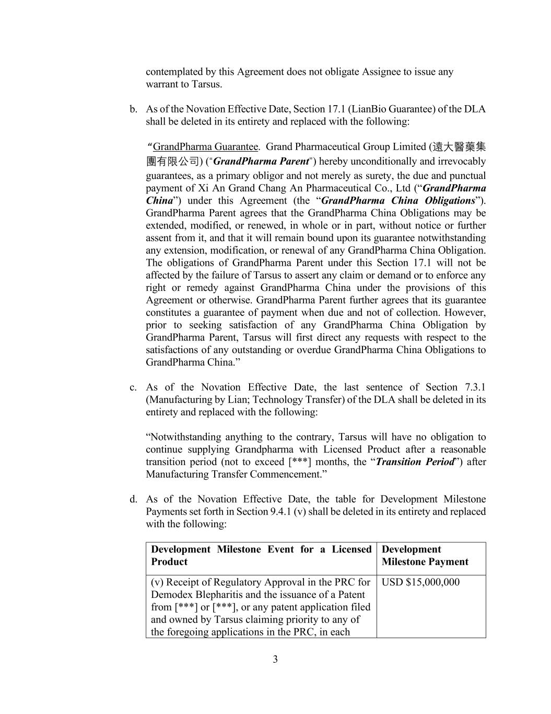
3 contemplated by this Agreement does not obligate Assignee to issue any warrant to Tarsus. b. As of the Novation Effective Date, Section 17.1 (LianBio Guarantee) of the DLA shall be deleted in its entirety and replaced with the following: “ GrandPharma Guarantee. Grand Pharmaceutical Group Limited (遠大醫藥集 團有限公司) (“GrandPharma Parent”) hereby unconditionally and irrevocably guarantees, as a primary obligor and not merely as surety, the due and punctual payment of Xi An Grand Chang An Pharmaceutical Co., Ltd (“GrandPharma China”) under this Agreement (the “GrandPharma China Obligations”). GrandPharma Parent agrees that the GrandPharma China Obligations may be extended, modified, or renewed, in whole or in part, without notice or further assent from it, and that it will remain bound upon its guarantee notwithstanding any extension, modification, or renewal of any GrandPharma China Obligation. The obligations of GrandPharma Parent under this Section 17.1 will not be affected by the failure of Tarsus to assert any claim or demand or to enforce any right or remedy against GrandPharma China under the provisions of this Agreement or otherwise. GrandPharma Parent further agrees that its guarantee constitutes a guarantee of payment when due and not of collection. However, prior to seeking satisfaction of any GrandPharma China Obligation by GrandPharma Parent, Tarsus will first direct any requests with respect to the satisfactions of any outstanding or overdue GrandPharma China Obligations to GrandPharma China.” c. As of the Novation Effective Date, the last sentence of Section 7.3.1 (Manufacturing by Lian; Technology Transfer) of the DLA shall be deleted in its entirety and replaced with the following: “Notwithstanding anything to the contrary, Tarsus will have no obligation to continue supplying Grandpharma with Licensed Product after a reasonable transition period (not to exceed [***] months, the “Transition Period”) after Manufacturing Transfer Commencement.” d. As of the Novation Effective Date, the table for Development Milestone Payments set forth in Section 9.4.1 (v) shall be deleted in its entirety and replaced with the following: Development Milestone Event for a Licensed Product Development Milestone Payment (v) Receipt of Regulatory Approval in the PRC for Demodex Blepharitis and the issuance of a Patent from [***] or [***], or any patent application filed and owned by Tarsus claiming priority to any of the foregoing applications in the PRC, in each USD $15,000,000

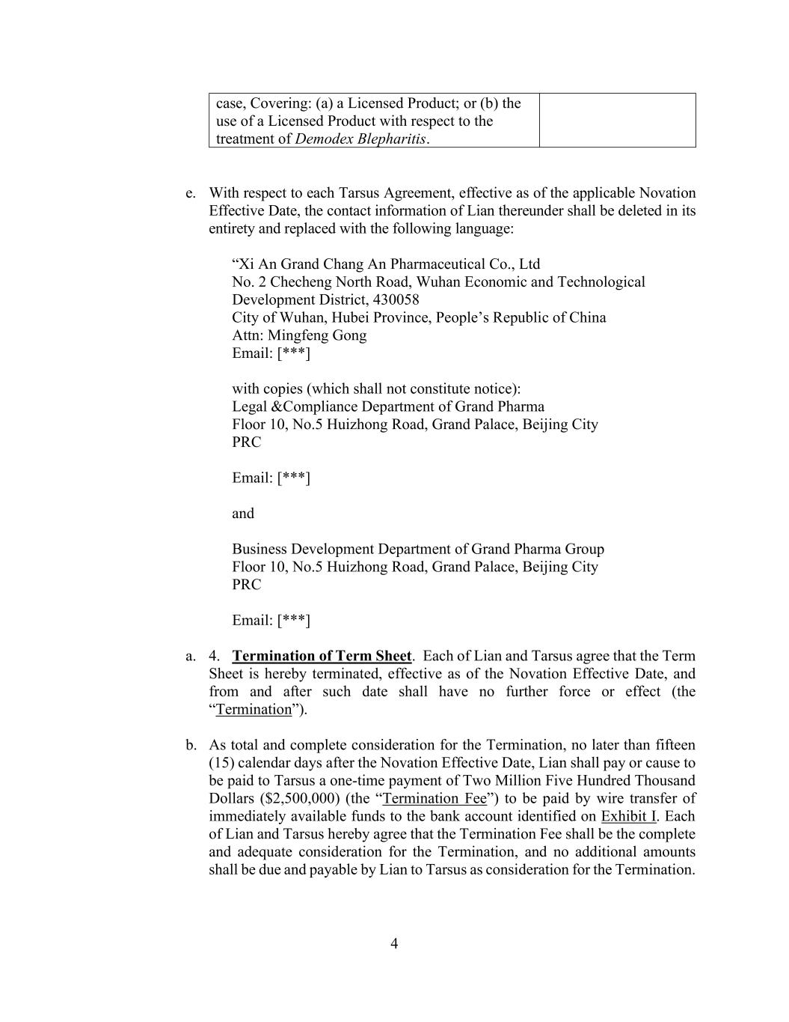
4 case, Covering: (a) a Licensed Product; or (b) the use of a Licensed Product with respect to the treatment of Demodex Blepharitis. e. With respect to each Tarsus Agreement, effective as of the applicable Novation Effective Date, the contact information of Lian thereunder shall be deleted in its entirety and replaced with the following language: “Xi An Grand Chang An Pharmaceutical Co., Ltd No. 2 Checheng North Road, Wuhan Economic and Technological Development District, 430058 City of Wuhan, Hubei Province, People’s Republic of China Attn: Mingfeng Gong Email: [***] with copies (which shall not constitute notice): Legal &Compliance Department of Grand Pharma Floor 10, No.5 Huizhong Road, Grand Palace, Beijing City PRC Email: [***] and Business Development Department of Grand Pharma Group Floor 10, No.5 Huizhong Road, Grand Palace, Beijing City PRC Email: [***] a. 4. Termination of Term Sheet. Each of Lian and Tarsus agree that the Term Sheet is hereby terminated, effective as of the Novation Effective Date, and from and after such date shall have no further force or effect (the “Termination”). b. As total and complete consideration for the Termination, no later than fifteen (15) calendar days after the Novation Effective Date, Lian shall pay or cause to be paid to Tarsus a one-time payment of Two Million Five Hundred Thousand Dollars ($2,500,000) (the “Termination Fee”) to be paid by wire transfer of immediately available funds to the bank account identified on Exhibit I. Each of Lian and Tarsus hereby agree that the Termination Fee shall be the complete and adequate consideration for the Termination, and no additional amounts shall be due and payable by Lian to Tarsus as consideration for the Termination.

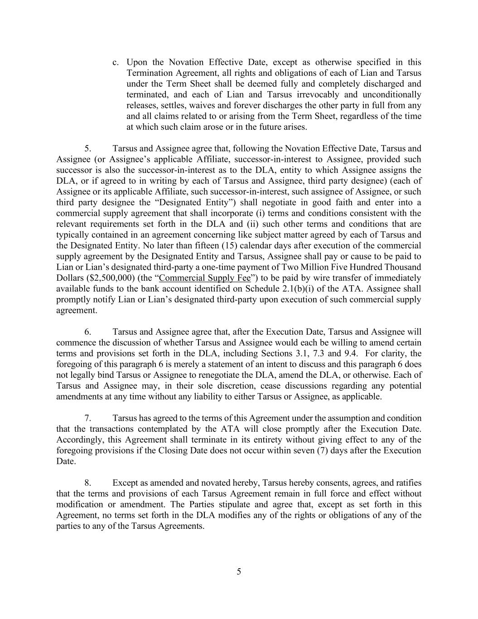
5 c. Upon the Novation Effective Date, except as otherwise specified in this Termination Agreement, all rights and obligations of each of Lian and Tarsus under the Term Sheet shall be deemed fully and completely discharged and terminated, and each of Lian and Tarsus irrevocably and unconditionally releases, settles, waives and forever discharges the other party in full from any and all claims related to or arising from the Term Sheet, regardless of the time at which such claim arose or in the future arises. 5. Tarsus and Assignee agree that, following the Novation Effective Date, Tarsus and Assignee (or Assignee’s applicable Affiliate, successor-in-interest to Assignee, provided such successor is also the successor-in-interest as to the DLA, entity to which Assignee assigns the DLA, or if agreed to in writing by each of Tarsus and Assignee, third party designee) (each of Assignee or its applicable Affiliate, such successor-in-interest, such assignee of Assignee, or such third party designee the “Designated Entity”) shall negotiate in good faith and enter into a commercial supply agreement that shall incorporate (i) terms and conditions consistent with the relevant requirements set forth in the DLA and (ii) such other terms and conditions that are typically contained in an agreement concerning like subject matter agreed by each of Tarsus and the Designated Entity. No later than fifteen (15) calendar days after execution of the commercial supply agreement by the Designated Entity and Tarsus, Assignee shall pay or cause to be paid to Lian or Lian’s designated third-party a one-time payment of Two Million Five Hundred Thousand Dollars ($2,500,000) (the “Commercial Supply Fee”) to be paid by wire transfer of immediately available funds to the bank account identified on Schedule 2.1(b)(i) of the ATA. Assignee shall promptly notify Lian or Lian’s designated third-party upon execution of such commercial supply agreement. 6. Tarsus and Assignee agree that, after the Execution Date, Tarsus and Assignee will commence the discussion of whether Tarsus and Assignee would each be willing to amend certain terms and provisions set forth in the DLA, including Sections 3.1, 7.3 and 9.4. For clarity, the foregoing of this paragraph 6 is merely a statement of an intent to discuss and this paragraph 6 does not legally bind Tarsus or Assignee to renegotiate the DLA, amend the DLA, or otherwise. Each of Tarsus and Assignee may, in their sole discretion, cease discussions regarding any potential amendments at any time without any liability to either Tarsus or Assignee, as applicable. 7. Tarsus has agreed to the terms of this Agreement under the assumption and condition that the transactions contemplated by the ATA will close promptly after the Execution Date. Accordingly, this Agreement shall terminate in its entirety without giving effect to any of the foregoing provisions if the Closing Date does not occur within seven (7) days after the Execution Date. 8. Except as amended and novated hereby, Tarsus hereby consents, agrees, and ratifies that the terms and provisions of each Tarsus Agreement remain in full force and effect without modification or amendment. The Parties stipulate and agree that, except as set forth in this Agreement, no terms set forth in the DLA modifies any of the rights or obligations of any of the parties to any of the Tarsus Agreements.

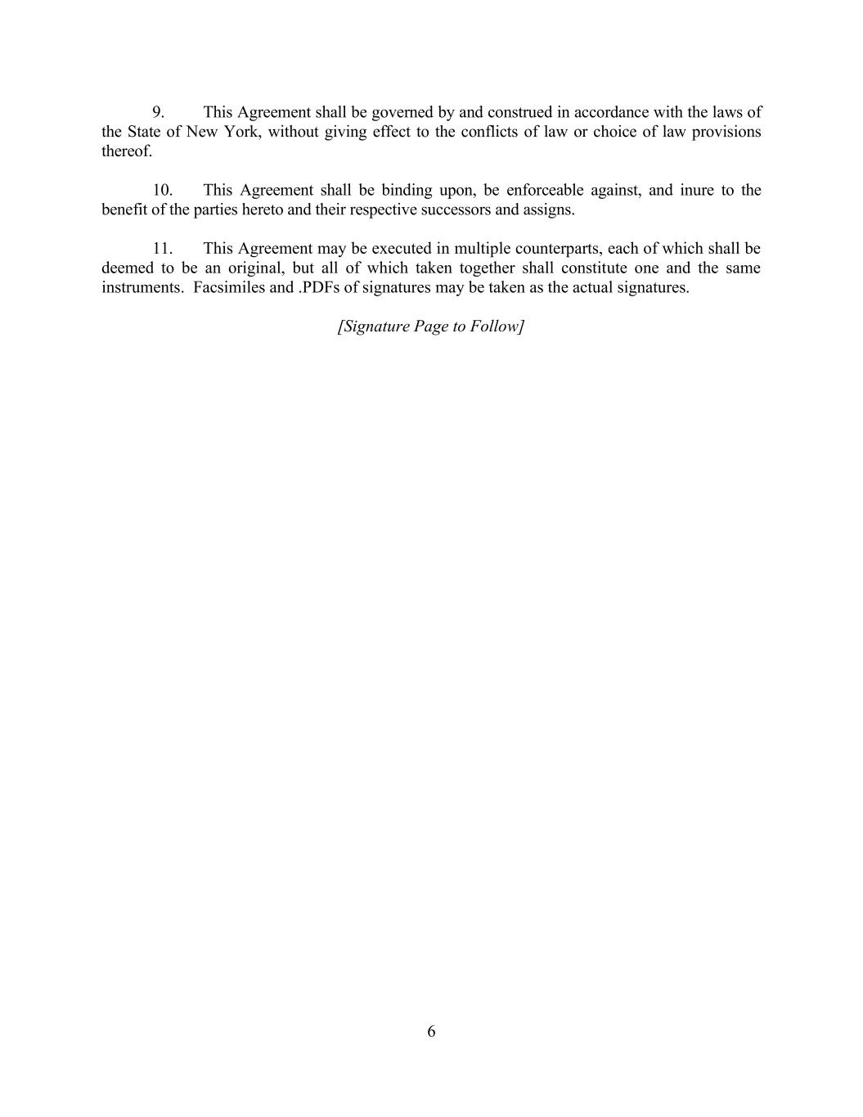
6 9. This Agreement shall be governed by and construed in accordance with the laws of the State of New York, without giving effect to the conflicts of law or choice of law provisions thereof. 10. This Agreement shall be binding upon, be enforceable against, and inure to the benefit of the parties hereto and their respective successors and assigns. 11. This Agreement may be executed in multiple counterparts, each of which shall be deemed to be an original, but all of which taken together shall constitute one and the same instruments. Facsimiles and .PDFs of signatures may be taken as the actual signatures. [Signature Page to Follow]

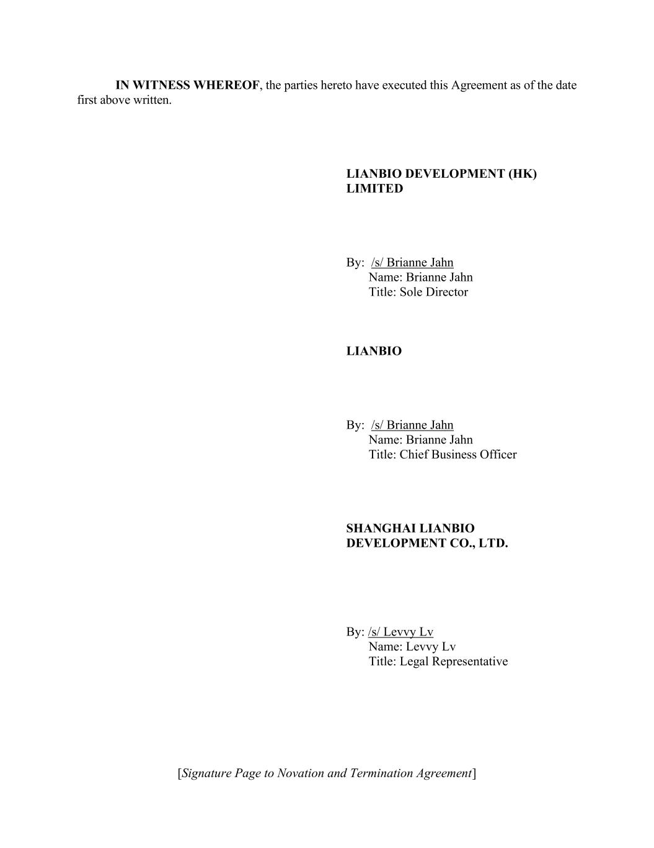
[Signature Page to Novation and Termination Agreement] IN WITNESS WHEREOF, the parties hereto have executed this Agreement as of the date first above written. LIANBIO DEVELOPMENT (HK) LIMITED By: /s/ Brianne Jahn Name: Brianne Jahn Title: Sole Director LIANBIO By: /s/ Brianne Jahn Name: Brianne Jahn Title: Chief Business Officer SHANGHAI LIANBIO DEVELOPMENT CO., LTD. By: /s/ Levvy Lv Name: Levvy Lv Title: Legal Representative

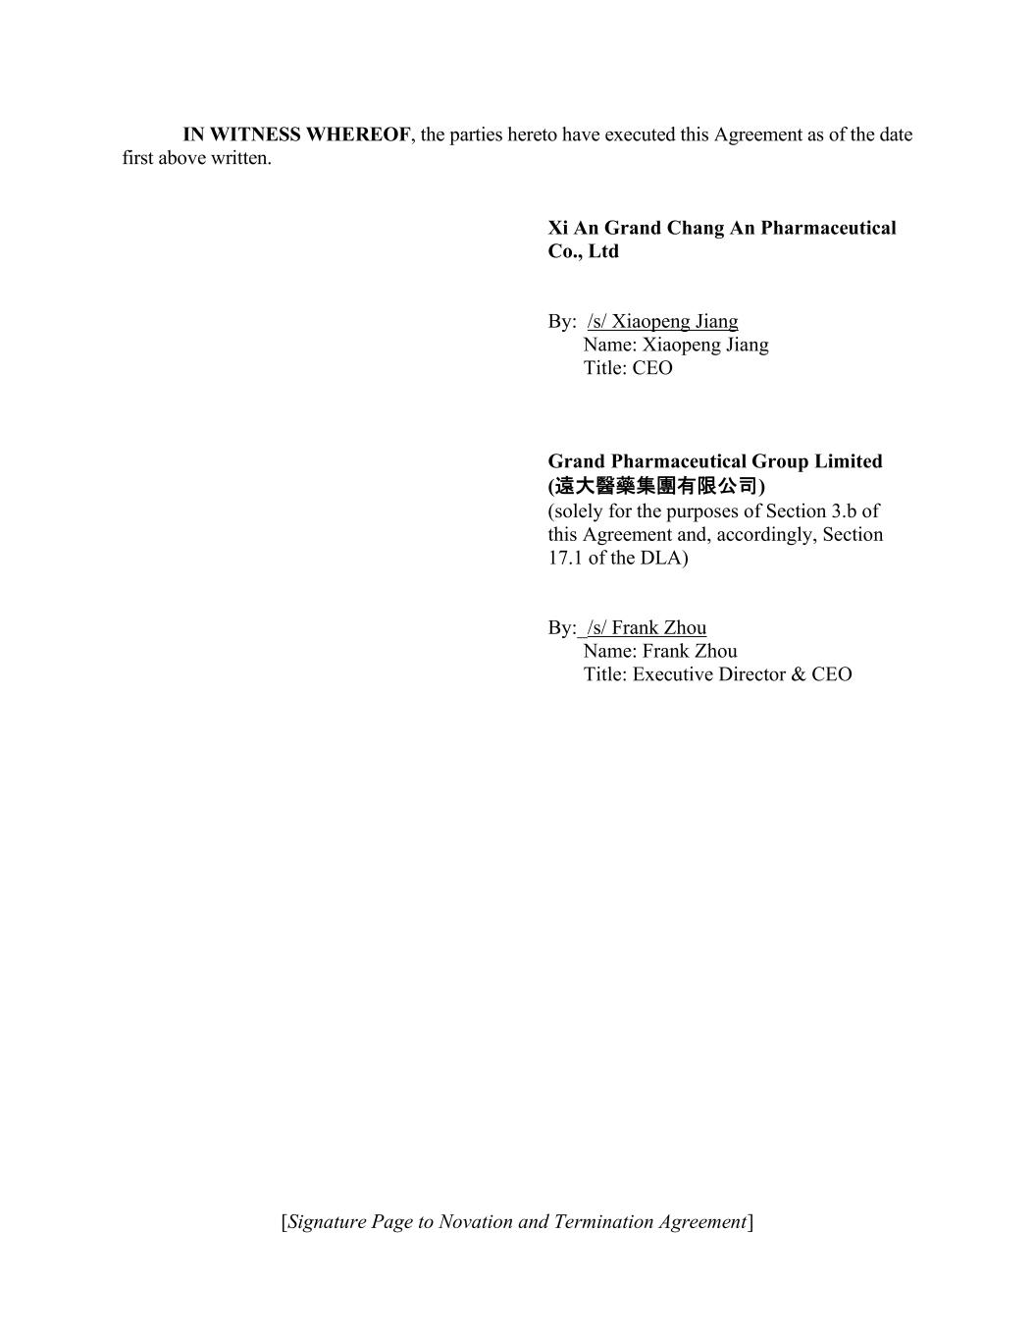
[Signature Page to Novation and Termination Agreement] IN WITNESS WHEREOF, the parties hereto have executed this Agreement as of the date first above written. Xi An Grand Chang An Pharmaceutical Co., Ltd By: /s/ Xiaopeng Jiang Name: Xiaopeng Jiang Title: CEO Grand Pharmaceutical Group Limited (遠大醫藥集團有限公司) (solely for the purposes of Section 3.b of this Agreement and, accordingly, Section 17.1 of the DLA) By:_/s/ Frank Zhou Name: Frank Zhou Title: Executive Director & CEO

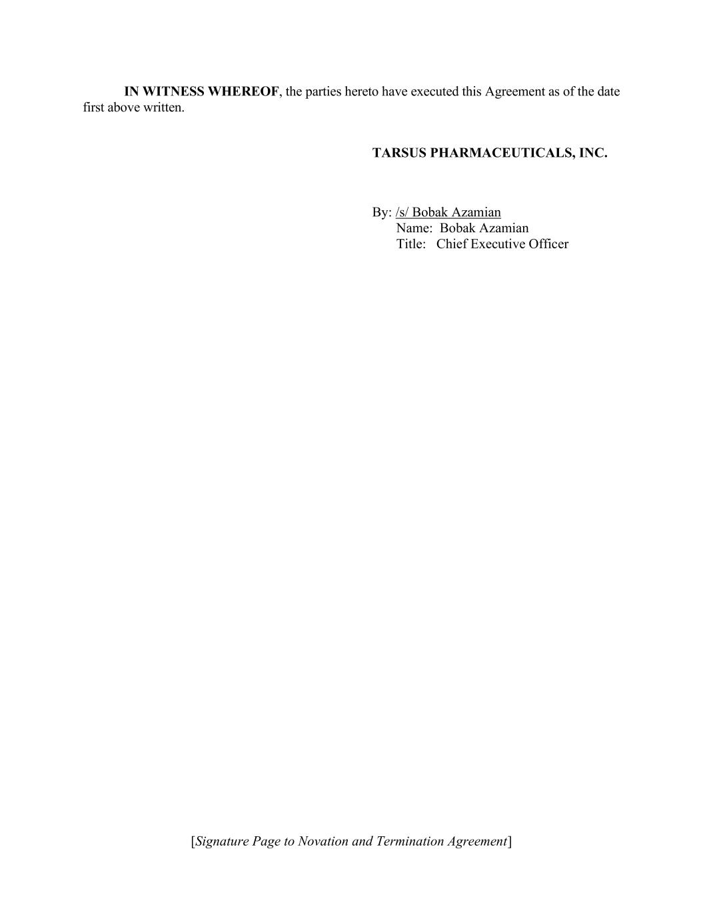
[Signature Page to Novation and Termination Agreement] IN WITNESS WHEREOF, the parties hereto have executed this Agreement as of the date first above written. TARSUS PHARMACEUTICALS, INC. By: /s/ Bobak Azamian Name: Bobak Azamian Title: Chief Executive Officer


EXHIBIT A Development and License Agreement [See attached.] [***]


EXHIBIT B Clinical Supply Agreement [See attached.] [***]


EXHIBIT C Clinical Supply Quality Agreement [See attached] [***]


EXHIBIT D Supply Side Letter [See attached.] [***]


EXHIBIT E Supply Side Letter for Second Batch [See attached.] [***]


EXHIBIT F Amendment Letter to Supply Side Letter for Second Batch [See attached.] [***]


EXHIBIT G Safety Data Exchange Agreement [See attached.] [***]


EXHIBIT H Binding Term Sheet [See attached.] [***]


EXHIBIT I Tarsus Wire Information [***]

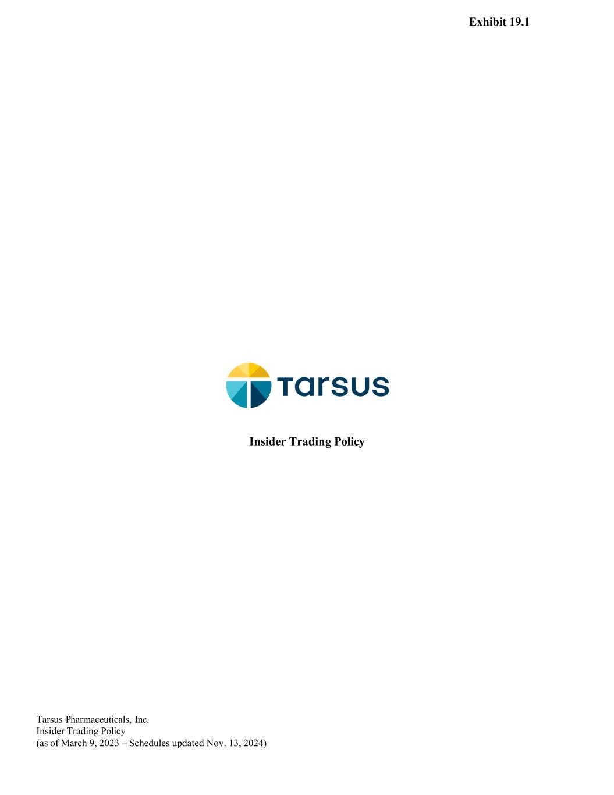
Tarsus P harmaceuticals, Inc. Insider Trading Policy (as of March 9, 2023 – Schedules updated Nov. 13, 2024) Insider Trading Policy Exhibit 19.1

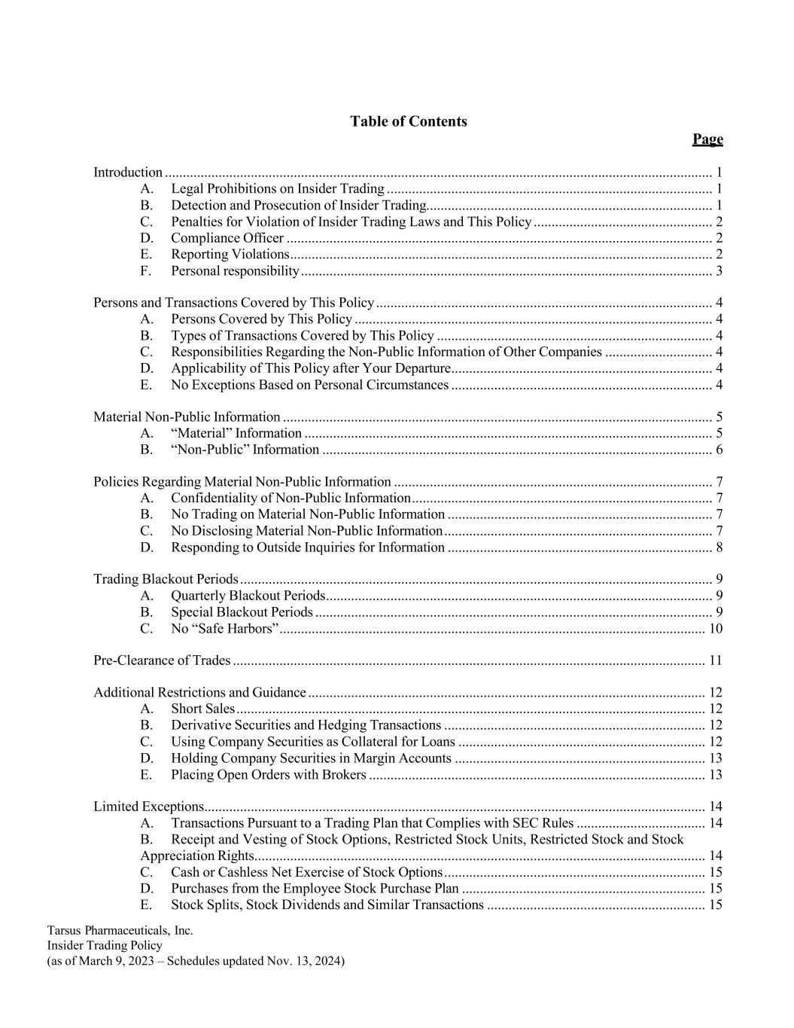
Tarsus P harmaceuticals, Inc. Insider Trading Policy (as of March 9, 2023 – Schedules updated Nov. 13, 2024) Table of Contents Page Introduction ......................................................................................................................................................... 1 A. Legal Prohibitions on Insider Trading ........................................................................................... 1 B. Detection and Prosecution of Insider Trading................................................................................ 1 C. Penalties for Violation of Insider Trading Laws and This Policy .................................................. 2 D. Compliance Officer ....................................................................................................................... 2 E. Reporting Violations ...................................................................................................................... 2 F. Personal responsibility ................................................................................................................... 3 Persons and Transactions Covered by This Policy .............................................................................................. 4 A. Persons Covered by This Policy .................................................................................................... 4 B. Types of Transactions Covered by This Policy ............................................................................. 4 C. Responsibilities Regarding the Non-Public Information of Other Companies .............................. 4 D. Applicability of This Policy after Your Departure ......................................................................... 4 E. No Exceptions Based on Personal Circumstances ......................................................................... 4 Material Non-Public Information ........................................................................................................................ 5 A. “Material” Information .................................................................................................................. 5 B. “Non-Public” Information ............................................................................................................. 6 Policies Regarding Material Non-Public Information ......................................................................................... 7 A. Confidentiality of Non-Public Information .................................................................................... 7 B. No Trading on Material Non-Public Information .......................................................................... 7 C. No Disclosing Material Non-Public Information ........................................................................... 7 D. Responding to Outside Inquiries for Information .......................................................................... 8 Trading Blackout Periods .................................................................................................................................... 9 A. Quarterly Blackout Periods ............................................................................................................ 9 B. Special Blackout Periods ............................................................................................................... 9 C. No “Safe Harbors” ....................................................................................................................... 10 Pre-Clearance of Trades .................................................................................................................................... 11 Additional Restrictions and Guidance ............................................................................................................... 12 A. Short Sales ................................................................................................................................... 12 B. Derivative Securities and Hedging Transactions ......................................................................... 12 C. Using Company Securities as Collateral for Loans ..................................................................... 12 D. Holding Company Securities in Margin Accounts ...................................................................... 13 E. Placing Open Orders with Brokers .............................................................................................. 13 Limited Exceptions ............................................................................................................................................ 14 A. Transactions Pursuant to a Trading Plan that Complies with SEC Rules .................................... 14 B. Receipt and Vesting of Stock Options, Restricted Stock Units, Restricted Stock and Stock Appreciation Rights .............................................................................................................................. 14 C. Cash or Cashless Net Exercise of Stock Options ......................................................................... 15 D. Purchases from the Employee Stock Purchase Plan .................................................................... 15 E. Stock Splits, Stock Dividends and Similar Transactions ............................................................. 15

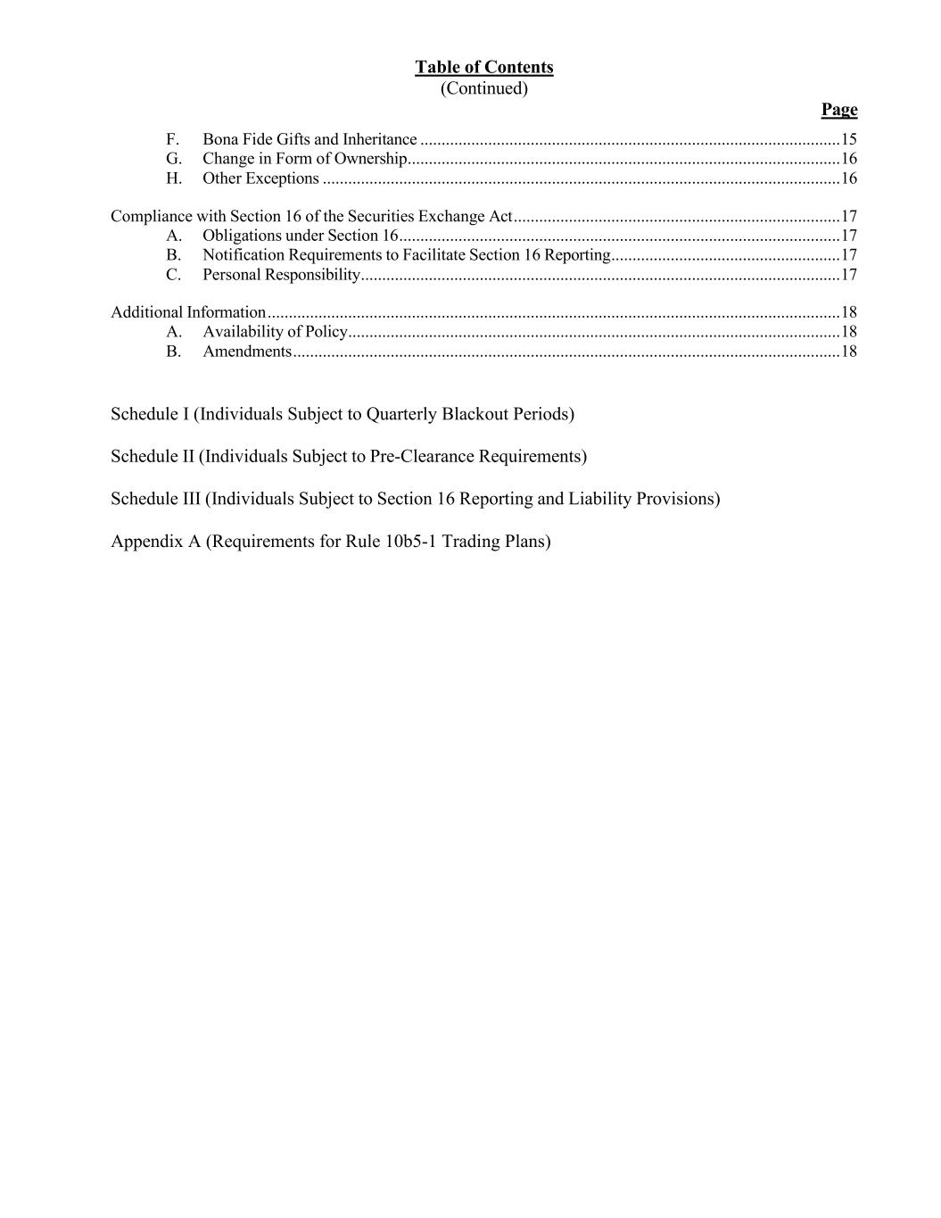
Table of Contents (Continued) Page F. Bona Fide Gifts and Inheritance ................................................................................................... 15 G. Change in Form of Ownership ...................................................................................................... 16 H. Other Exceptions .......................................................................................................................... 16 Compliance with Section 16 of the Securities Exchange Act ............................................................................. 17 A. Obligations under Section 16 ........................................................................................................ 17 B. Notification Requirements to Facilitate Section 16 Reporting ...................................................... 17 C. Personal Responsibility ................................................................................................................. 17 Additional Information ....................................................................................................................................... 18 A. Availability of Policy .................................................................................................................... 18 B. Amendments ................................................................................................................................. 18 Schedule I (Individuals Subject to Quarterly Blackout Periods) Schedule II (Individuals Subject to Pre-Clearance Requirements) Schedule III (Individuals Subject to Section 16 Reporting and Liability Provisions) Appendix A (Requirements for Rule 10b5-1 Trading Plans)

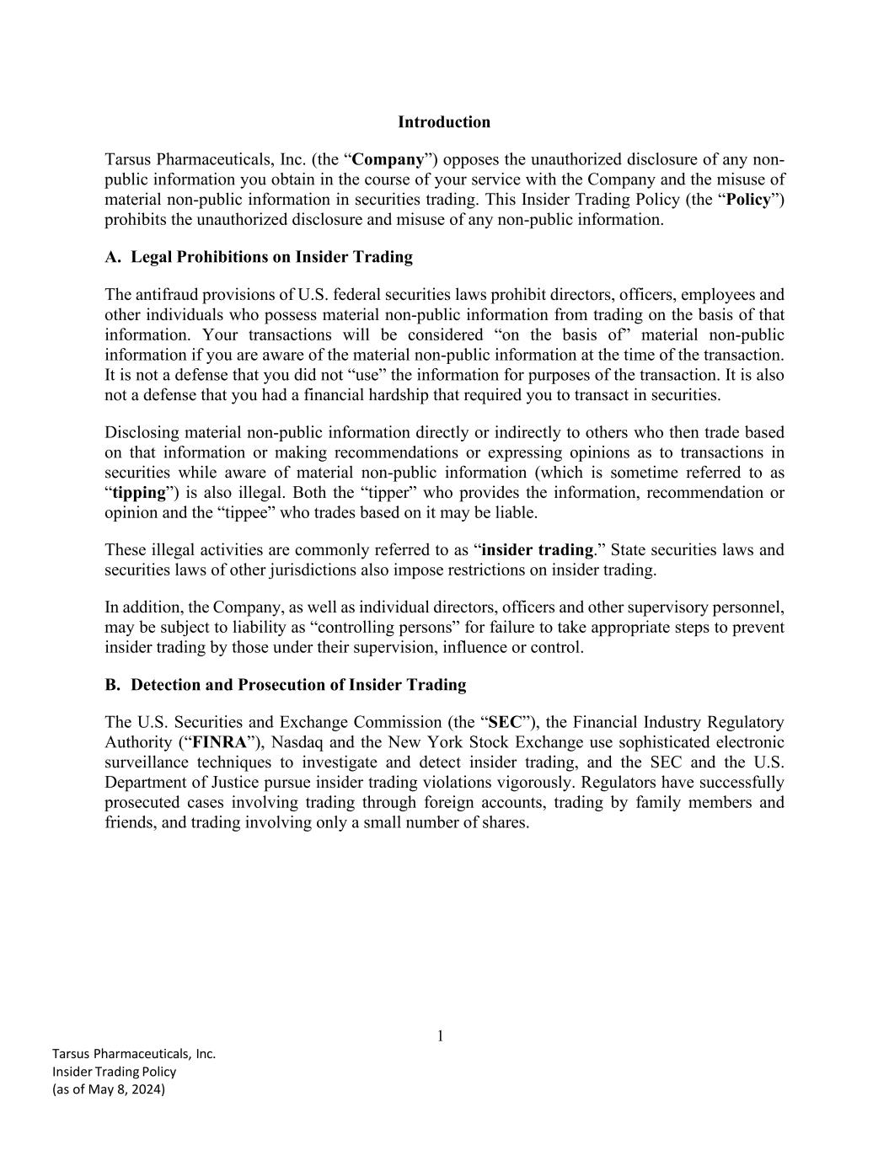
1 Tarsus Pharmaceuticals, Inc. Insider Trading Policy (as of May 8, 2024) Introduction Tarsus Pharmaceuticals, Inc. (the “Company”) opposes the unauthorized disclosure of any non- public information you obtain in the course of your service with the Company and the misuse of material non-public information in securities trading. This Insider Trading Policy (the “Policy”) prohibits the unauthorized disclosure and misuse of any non-public information. A. Legal Prohibitions on Insider Trading The antifraud provisions of U.S. federal securities laws prohibit directors, officers, employees and other individuals who possess material non-public information from trading on the basis of that information. Your transactions will be considered “on the basis of” material non-public information if you are aware of the material non-public information at the time of the transaction. It is not a defense that you did not “use” the information for purposes of the transaction. It is also not a defense that you had a financial hardship that required you to transact in securities. Disclosing material non-public information directly or indirectly to others who then trade based on that information or making recommendations or expressing opinions as to transactions in securities while aware of material non-public information (which is sometime referred to as “tipping”) is also illegal. Both the “tipper” who provides the information, recommendation or opinion and the “tippee” who trades based on it may be liable. These illegal activities are commonly referred to as “insider trading.” State securities laws and securities laws of other jurisdictions also impose restrictions on insider trading. In addition, the Company, as well as individual directors, officers and other supervisory personnel, may be subject to liability as “controlling persons” for failure to take appropriate steps to prevent insider trading by those under their supervision, influence or control. B. Detection and Prosecution of Insider Trading The U.S. Securities and Exchange Commission (the “SEC”), the Financial Industry Regulatory Authority (“FINRA”), Nasdaq and the New York Stock Exchange use sophisticated electronic surveillance techniques to investigate and detect insider trading, and the SEC and the U.S. Department of Justice pursue insider trading violations vigorously. Regulators have successfully prosecuted cases involving trading through foreign accounts, trading by family members and friends, and trading involving only a small number of shares.

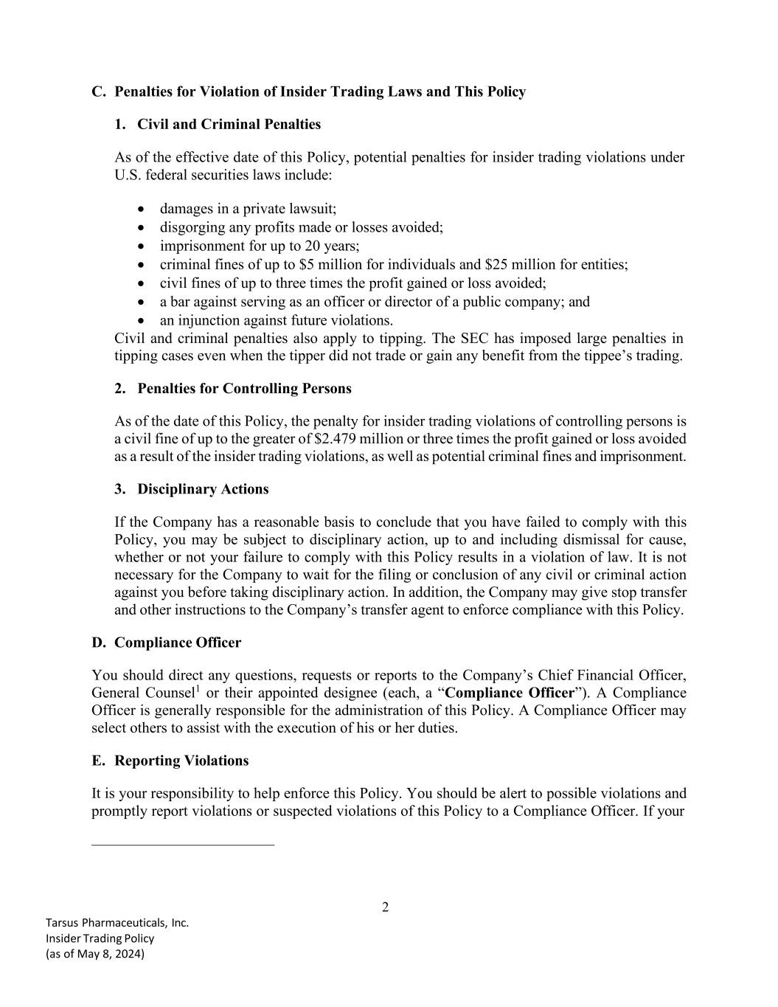
2 Tarsus Pharmaceuticals, Inc. Insider Trading Policy (as of May 8, 2024) C. Penalties for Violation of Insider Trading Laws and This Policy 1. Civil and Criminal Penalties As of the effective date of this Policy, potential penalties for insider trading violations under U.S. federal securities laws include: • damages in a private lawsuit; • disgorging any profits made or losses avoided; • imprisonment for up to 20 years; • criminal fines of up to $5 million for individuals and $25 million for entities; • civil fines of up to three times the profit gained or loss avoided; • a bar against serving as an officer or director of a public company; and • an injunction against future violations. Civil and criminal penalties also apply to tipping. The SEC has imposed large penalties in tipping cases even when the tipper did not trade or gain any benefit from the tippee’s trading. 2. Penalties for Controlling Persons As of the date of this Policy, the penalty for insider trading violations of controlling persons is a civil fine of up to the greater of $2.479 million or three times the profit gained or loss avoided as a result of the insider trading violations, as well as potential criminal fines and imprisonment. 3. Disciplinary Actions If the Company has a reasonable basis to conclude that you have failed to comply with this Policy, you may be subject to disciplinary action, up to and including dismissal for cause, whether or not your failure to comply with this Policy results in a violation of law. It is not necessary for the Company to wait for the filing or conclusion of any civil or criminal action against you before taking disciplinary action. In addition, the Company may give stop transfer and other instructions to the Company’s transfer agent to enforce compliance with this Policy. D. Compliance Officer You should direct any questions, requests or reports to the Company’s Chief Financial Officer, General Counsel1 or their appointed designee (each, a “Compliance Officer”). A Compliance Officer is generally responsible for the administration of this Policy. A Compliance Officer may select others to assist with the execution of his or her duties. E. Reporting Violations It is your responsibility to help enforce this Policy. You should be alert to possible violations and promptly report violations or suspected violations of this Policy to a Compliance Officer. If your

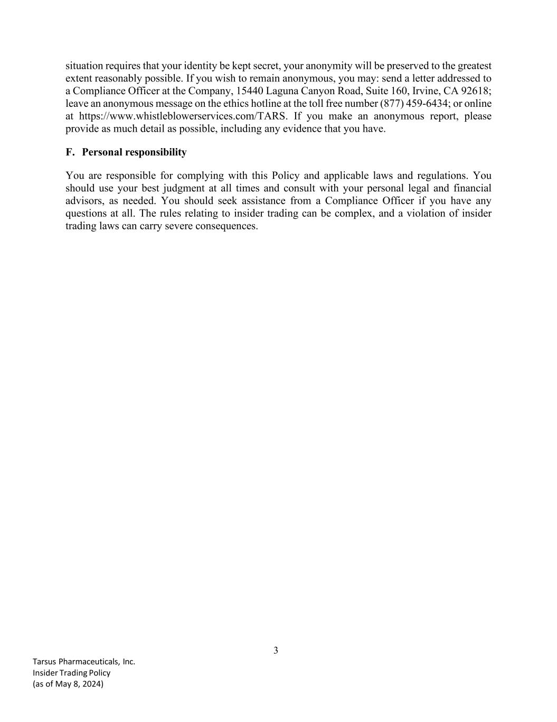
3 Tarsus Pharmaceuticals, Inc. Insider Trading Policy (as of May 8, 2024) situation requires that your identity be kept secret, your anonymity will be preserved to the greatest extent reasonably possible. If you wish to remain anonymous, you may: send a letter addressed to a Compliance Officer at the Company, 15440 Laguna Canyon Road, Suite 160, Irvine, CA 92618; leave an anonymous message on the ethics hotline at the toll free number (877) 459-6434; or online at https://www.whistleblowerservices.com/TARS. If you make an anonymous report, please provide as much detail as possible, including any evidence that you have. F. Personal responsibility You are responsible for complying with this Policy and applicable laws and regulations. You should use your best judgment at all times and consult with your personal legal and financial advisors, as needed. You should seek assistance from a Compliance Officer if you have any questions at all. The rules relating to insider trading can be complex, and a violation of insider trading laws can carry severe consequences.

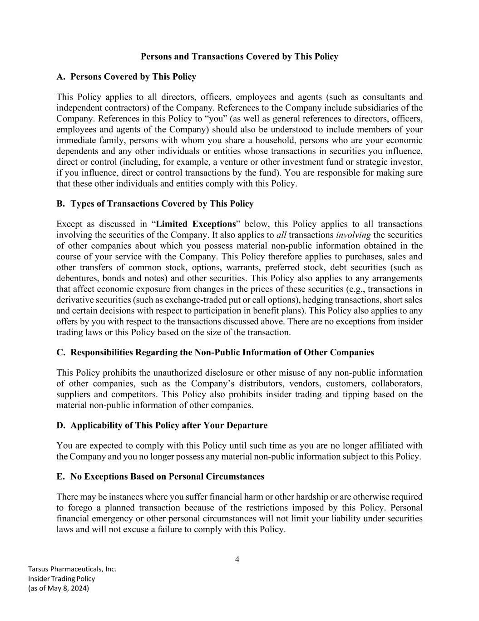
4 Tarsus Pharmaceuticals, Inc. Insider Trading Policy (as of May 8, 2024) Persons and Transactions Covered by This Policy A. Persons Covered by This Policy This Policy applies to all directors, officers, employees and agents (such as consultants and independent contractors) of the Company. References to the Company include subsidiaries of the Company. References in this Policy to “you” (as well as general references to directors, officers, employees and agents of the Company) should also be understood to include members of your immediate family, persons with whom you share a household, persons who are your economic dependents and any other individuals or entities whose transactions in securities you influence, direct or control (including, for example, a venture or other investment fund or strategic investor, if you influence, direct or control transactions by the fund). You are responsible for making sure that these other individuals and entities comply with this Policy. B. Types of Transactions Covered by This Policy Except as discussed in “Limited Exceptions” below, this Policy applies to all transactions involving the securities of the Company. It also applies to all transactions involving the securities of other companies about which you possess material non-public information obtained in the course of your service with the Company. This Policy therefore applies to purchases, sales and other transfers of common stock, options, warrants, preferred stock, debt securities (such as debentures, bonds and notes) and other securities. This Policy also applies to any arrangements that affect economic exposure from changes in the prices of these securities (e.g., transactions in derivative securities (such as exchange-traded put or call options), hedging transactions, short sales and certain decisions with respect to participation in benefit plans). This Policy also applies to any offers by you with respect to the transactions discussed above. There are no exceptions from insider trading laws or this Policy based on the size of the transaction. C. Responsibilities Regarding the Non-Public Information of Other Companies This Policy prohibits the unauthorized disclosure or other misuse of any non-public information of other companies, such as the Company’s distributors, vendors, customers, collaborators, suppliers and competitors. This Policy also prohibits insider trading and tipping based on the material non-public information of other companies. D. Applicability of This Policy after Your Departure You are expected to comply with this Policy until such time as you are no longer affiliated with the Company and you no longer possess any material non-public information subject to this Policy. E. No Exceptions Based on Personal Circumstances There may be instances where you suffer financial harm or other hardship or are otherwise required to forego a planned transaction because of the restrictions imposed by this Policy. Personal financial emergency or other personal circumstances will not limit your liability under securities laws and will not excuse a failure to comply with this Policy.

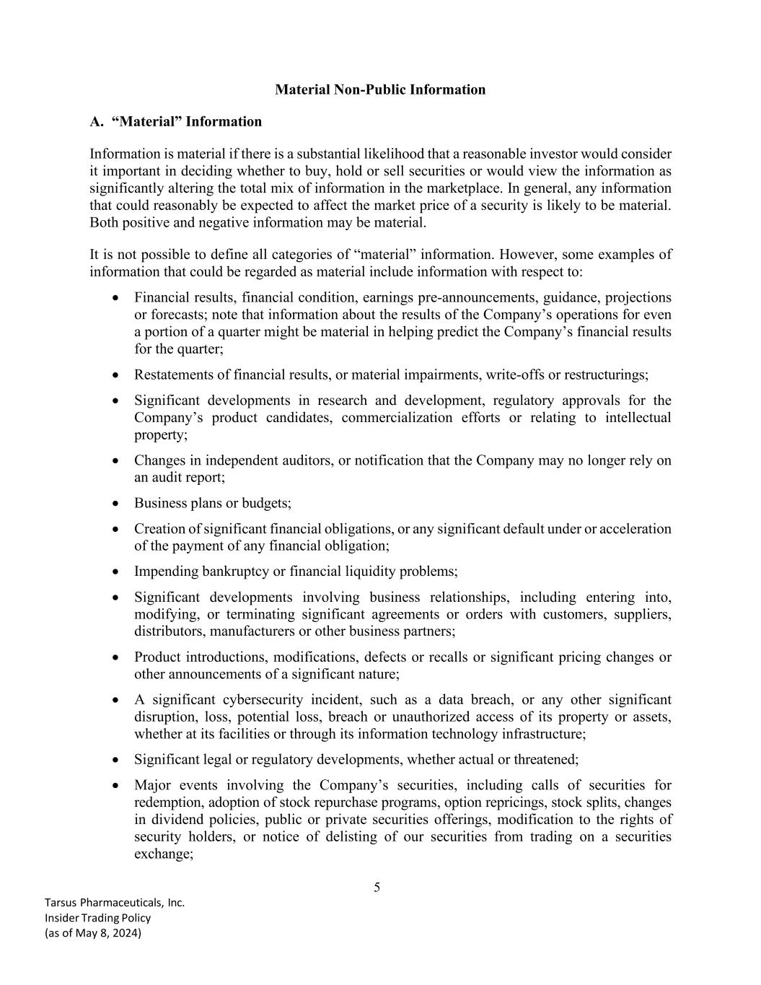
5 Tarsus Pharmaceuticals, Inc. Insider Trading Policy (as of May 8, 2024) Material Non-Public Information A. “Material” Information Information is material if there is a substantial likelihood that a reasonable investor would consider it important in deciding whether to buy, hold or sell securities or would view the information as significantly altering the total mix of information in the marketplace. In general, any information that could reasonably be expected to affect the market price of a security is likely to be material. Both positive and negative information may be material. It is not possible to define all categories of “material” information. However, some examples of information that could be regarded as material include information with respect to: • Financial results, financial condition, earnings pre-announcements, guidance, projections or forecasts; note that information about the results of the Company’s operations for even a portion of a quarter might be material in helping predict the Company’s financial results for the quarter; • Restatements of financial results, or material impairments, write-offs or restructurings; • Significant developments in research and development, regulatory approvals for the Company’s product candidates, commercialization efforts or relating to intellectual property; • Changes in independent auditors, or notification that the Company may no longer rely on an audit report; • Business plans or budgets; • Creation of significant financial obligations, or any significant default under or acceleration of the payment of any financial obligation; • Impending bankruptcy or financial liquidity problems; • Significant developments involving business relationships, including entering into, modifying, or terminating significant agreements or orders with customers, suppliers, distributors, manufacturers or other business partners; • Product introductions, modifications, defects or recalls or significant pricing changes or other announcements of a significant nature; • A significant cybersecurity incident, such as a data breach, or any other significant disruption, loss, potential loss, breach or unauthorized access of its property or assets, whether at its facilities or through its information technology infrastructure; • Significant legal or regulatory developments, whether actual or threatened; • Major events involving the Company’s securities, including calls of securities for redemption, adoption of stock repurchase programs, option repricings, stock splits, changes in dividend policies, public or private securities offerings, modification to the rights of security holders, or notice of delisting of our securities from trading on a securities exchange;

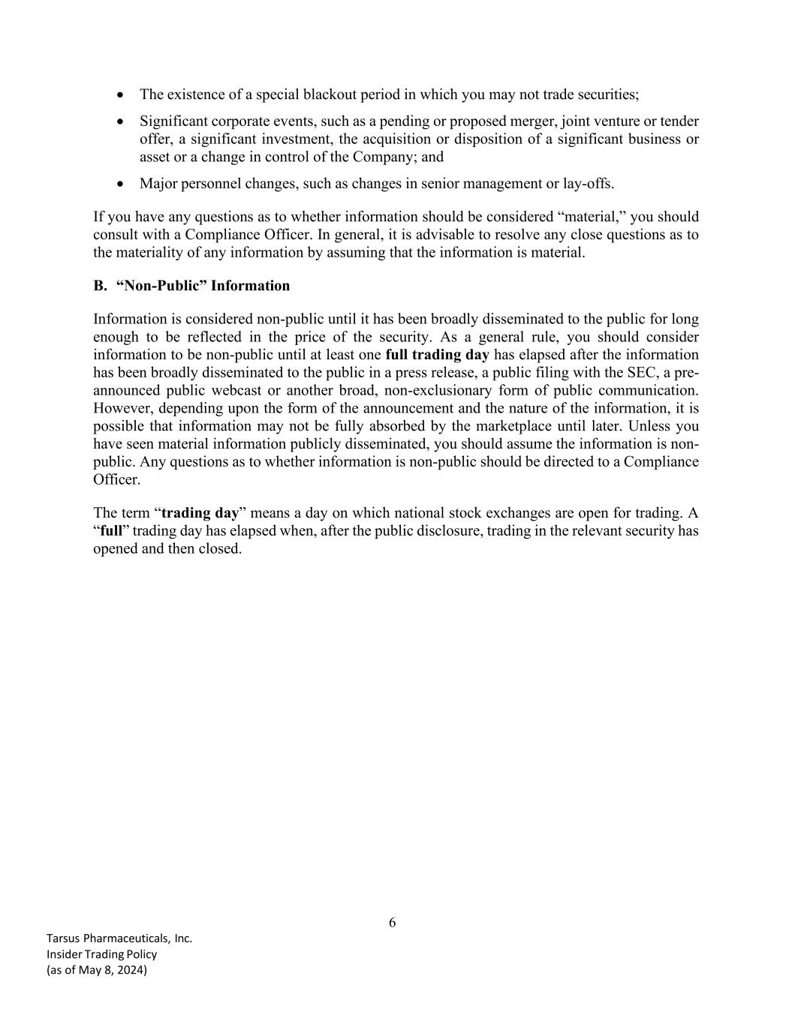
6 Tarsus Pharmaceuticals, Inc. Insider Trading Policy (as of May 8, 2024) • The existence of a special blackout period in which you may not trade securities; • Significant corporate events, such as a pending or proposed merger, joint venture or tender offer, a significant investment, the acquisition or disposition of a significant business or asset or a change in control of the Company; and • Major personnel changes, such as changes in senior management or lay-offs. If you have any questions as to whether information should be considered “material,” you should consult with a Compliance Officer. In general, it is advisable to resolve any close questions as to the materiality of any information by assuming that the information is material. B. “Non-Public” Information Information is considered non-public until it has been broadly disseminated to the public for long enough to be reflected in the price of the security. As a general rule, you should consider information to be non-public until at least one full trading day has elapsed after the information has been broadly disseminated to the public in a press release, a public filing with the SEC, a pre- announced public webcast or another broad, non-exclusionary form of public communication. However, depending upon the form of the announcement and the nature of the information, it is possible that information may not be fully absorbed by the marketplace until later. Unless you have seen material information publicly disseminated, you should assume the information is non- public. Any questions as to whether information is non-public should be directed to a Compliance Officer. The term “trading day” means a day on which national stock exchanges are open for trading. A “full” trading day has elapsed when, after the public disclosure, trading in the relevant security has opened and then closed.

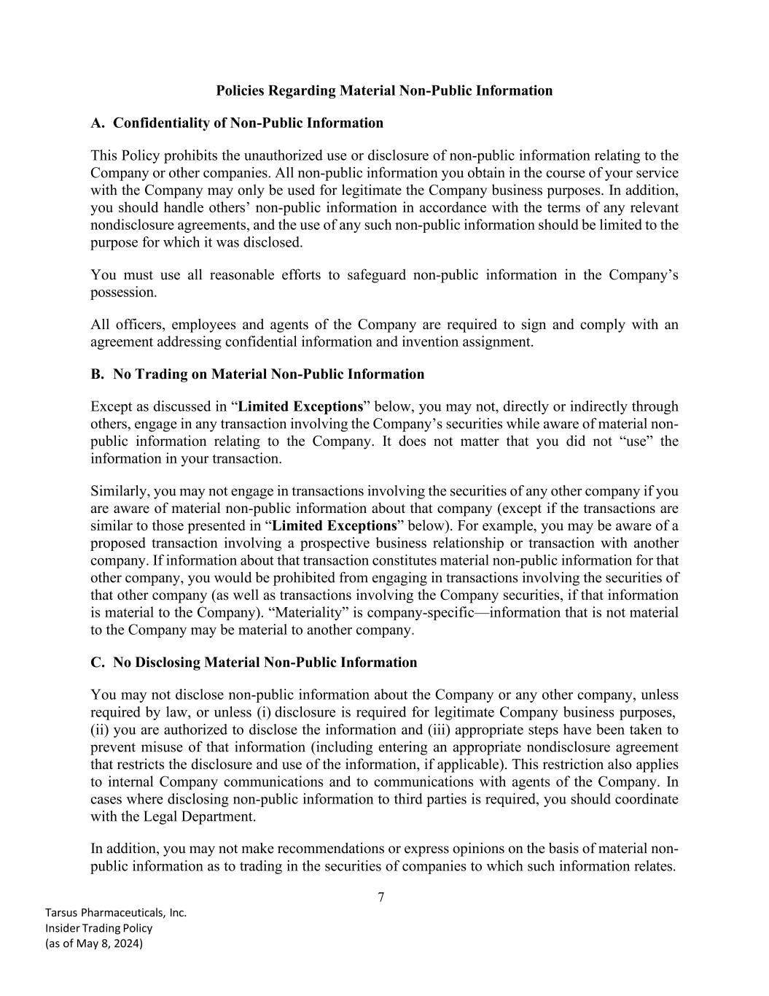
7 Tarsus Pharmaceuticals, Inc. Insider Trading Policy (as of May 8, 2024) Policies Regarding Material Non-Public Information A. Confidentiality of Non-Public Information This Policy prohibits the unauthorized use or disclosure of non-public information relating to the Company or other companies. All non-public information you obtain in the course of your service with the Company may only be used for legitimate the Company business purposes. In addition, you should handle others’ non-public information in accordance with the terms of any relevant nondisclosure agreements, and the use of any such non-public information should be limited to the purpose for which it was disclosed. You must use all reasonable efforts to safeguard non-public information in the Company’s possession. All officers, employees and agents of the Company are required to sign and comply with an agreement addressing confidential information and invention assignment. B. No Trading on Material Non-Public Information Except as discussed in “Limited Exceptions” below, you may not, directly or indirectly through others, engage in any transaction involving the Company’s securities while aware of material non- public information relating to the Company. It does not matter that you did not “use” the information in your transaction. Similarly, you may not engage in transactions involving the securities of any other company if you are aware of material non-public information about that company (except if the transactions are similar to those presented in “Limited Exceptions” below). For example, you may be aware of a proposed transaction involving a prospective business relationship or transaction with another company. If information about that transaction constitutes material non-public information for that other company, you would be prohibited from engaging in transactions involving the securities of that other company (as well as transactions involving the Company securities, if that information is material to the Company). “Materiality” is company-specific—information that is not material to the Company may be material to another company. C. No Disclosing Material Non-Public Information You may not disclose non-public information about the Company or any other company, unless required by law, or unless (i) disclosure is required for legitimate Company business purposes, (ii) you are authorized to disclose the information and (iii) appropriate steps have been taken to prevent misuse of that information (including entering an appropriate nondisclosure agreement that restricts the disclosure and use of the information, if applicable). This restriction also applies to internal Company communications and to communications with agents of the Company. In cases where disclosing non-public information to third parties is required, you should coordinate with the Legal Department. In addition, you may not make recommendations or express opinions on the basis of material non- public information as to trading in the securities of companies to which such information relates.

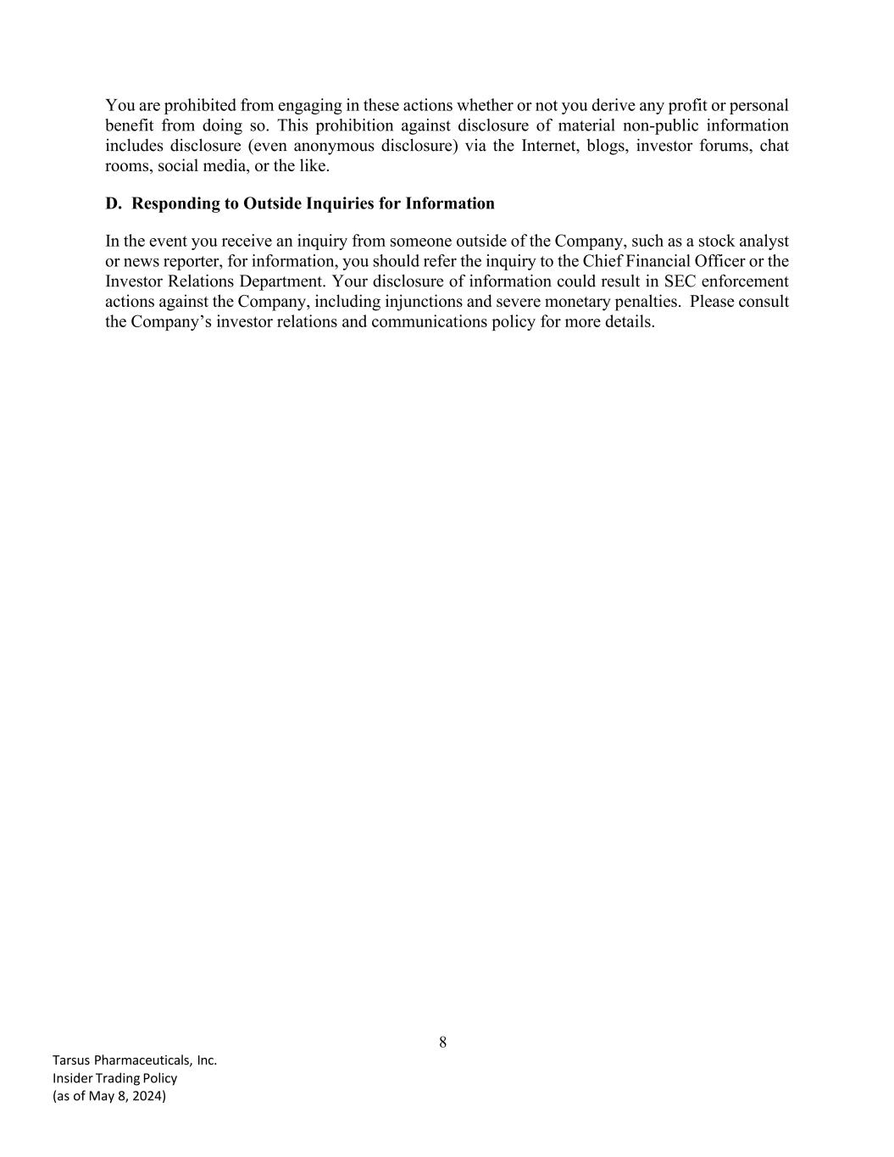
8 Tarsus Pharmaceuticals, Inc. Insider Trading Policy (as of May 8, 2024) You are prohibited from engaging in these actions whether or not you derive any profit or personal benefit from doing so. This prohibition against disclosure of material non-public information includes disclosure (even anonymous disclosure) via the Internet, blogs, investor forums, chat rooms, social media, or the like. D. Responding to Outside Inquiries for Information In the event you receive an inquiry from someone outside of the Company, such as a stock analyst or news reporter, for information, you should refer the inquiry to the Chief Financial Officer or the Investor Relations Department. Your disclosure of information could result in SEC enforcement actions against the Company, including injunctions and severe monetary penalties. Please consult the Company’s investor relations and communications policy for more details.

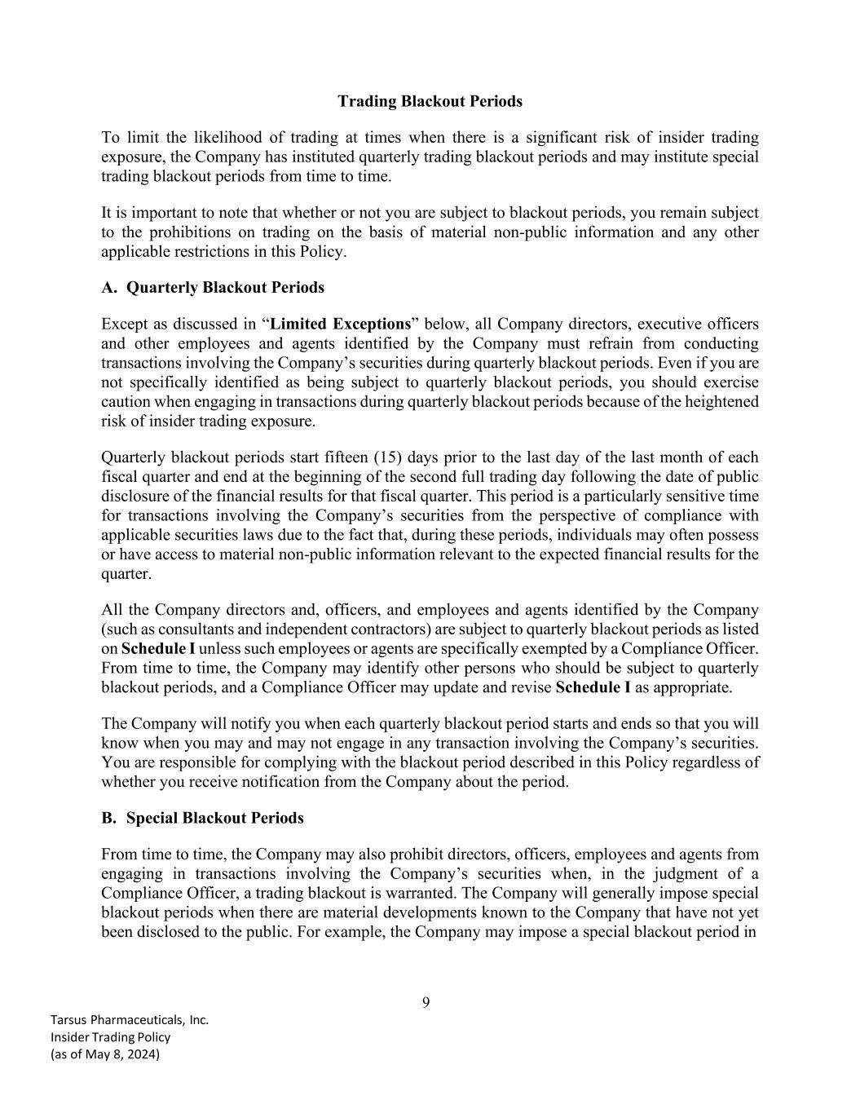
9 Tarsus Pharmaceuticals, Inc. Insider Trading Policy (as of May 8, 2024) Trading Blackout Periods To limit the likelihood of trading at times when there is a significant risk of insider trading exposure, the Company has instituted quarterly trading blackout periods and may institute special trading blackout periods from time to time. It is important to note that whether or not you are subject to blackout periods, you remain subject to the prohibitions on trading on the basis of material non-public information and any other applicable restrictions in this Policy. A. Quarterly Blackout Periods Except as discussed in “Limited Exceptions” below, all Company directors, executive officers and other employees and agents identified by the Company must refrain from conducting transactions involving the Company’s securities during quarterly blackout periods. Even if you are not specifically identified as being subject to quarterly blackout periods, you should exercise caution when engaging in transactions during quarterly blackout periods because of the heightened risk of insider trading exposure. Quarterly blackout periods start fifteen (15) days prior to the last day of the last month of each fiscal quarter and end at the beginning of the second full trading day following the date of public disclosure of the financial results for that fiscal quarter. This period is a particularly sensitive time for transactions involving the Company’s securities from the perspective of compliance with applicable securities laws due to the fact that, during these periods, individuals may often possess or have access to material non-public information relevant to the expected financial results for the quarter. All the Company directors and, officers, and employees and agents identified by the Company (such as consultants and independent contractors) are subject to quarterly blackout periods as listed on Schedule I unless such employees or agents are specifically exempted by a Compliance Officer. From time to time, the Company may identify other persons who should be subject to quarterly blackout periods, and a Compliance Officer may update and revise Schedule I as appropriate. The Company will notify you when each quarterly blackout period starts and ends so that you will know when you may and may not engage in any transaction involving the Company’s securities. You are responsible for complying with the blackout period described in this Policy regardless of whether you receive notification from the Company about the period. B. Special Blackout Periods From time to time, the Company may also prohibit directors, officers, employees and agents from engaging in transactions involving the Company’s securities when, in the judgment of a Compliance Officer, a trading blackout is warranted. The Company will generally impose special blackout periods when there are material developments known to the Company that have not yet been disclosed to the public. For example, the Company may impose a special blackout period in

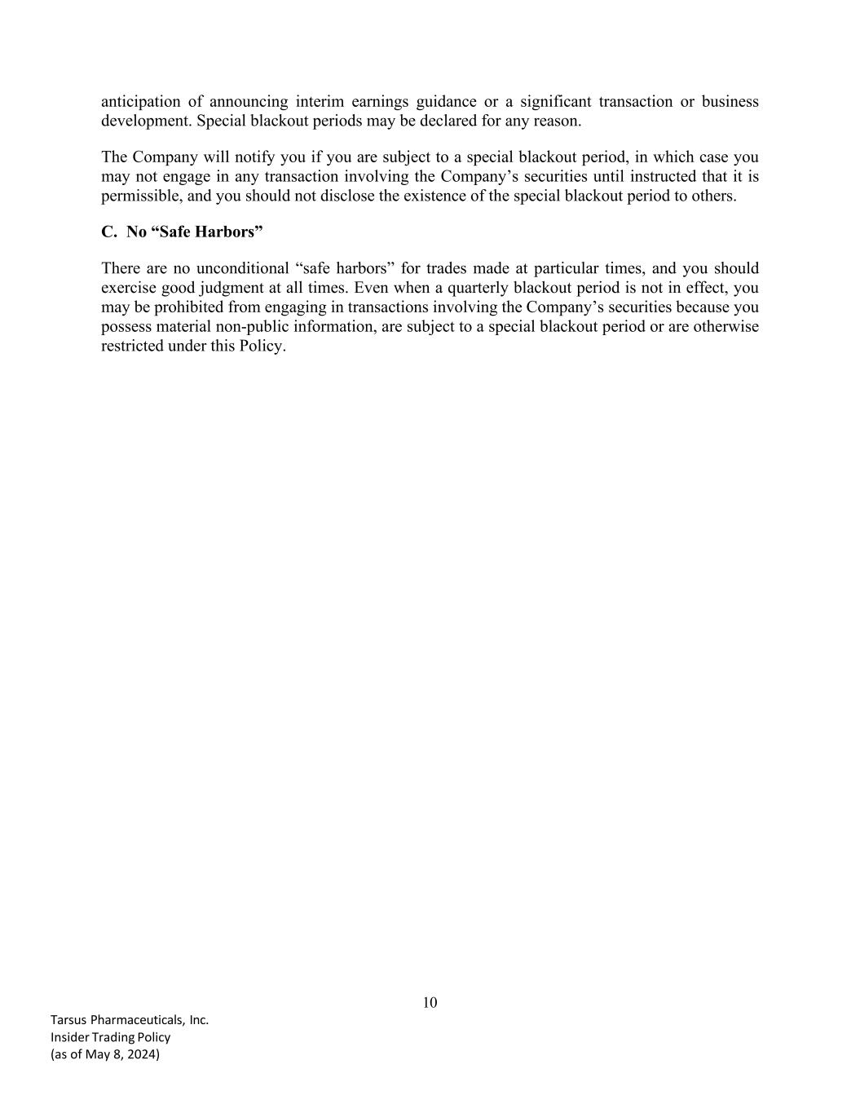
10 Tarsus Pharmaceuticals, Inc. Insider Trading Policy (as of May 8, 2024) anticipation of announcing interim earnings guidance or a significant transaction or business development. Special blackout periods may be declared for any reason. The Company will notify you if you are subject to a special blackout period, in which case you may not engage in any transaction involving the Company’s securities until instructed that it is permissible, and you should not disclose the existence of the special blackout period to others. C. No “Safe Harbors” There are no unconditional “safe harbors” for trades made at particular times, and you should exercise good judgment at all times. Even when a quarterly blackout period is not in effect, you may be prohibited from engaging in transactions involving the Company’s securities because you possess material non-public information, are subject to a special blackout period or are otherwise restricted under this Policy.

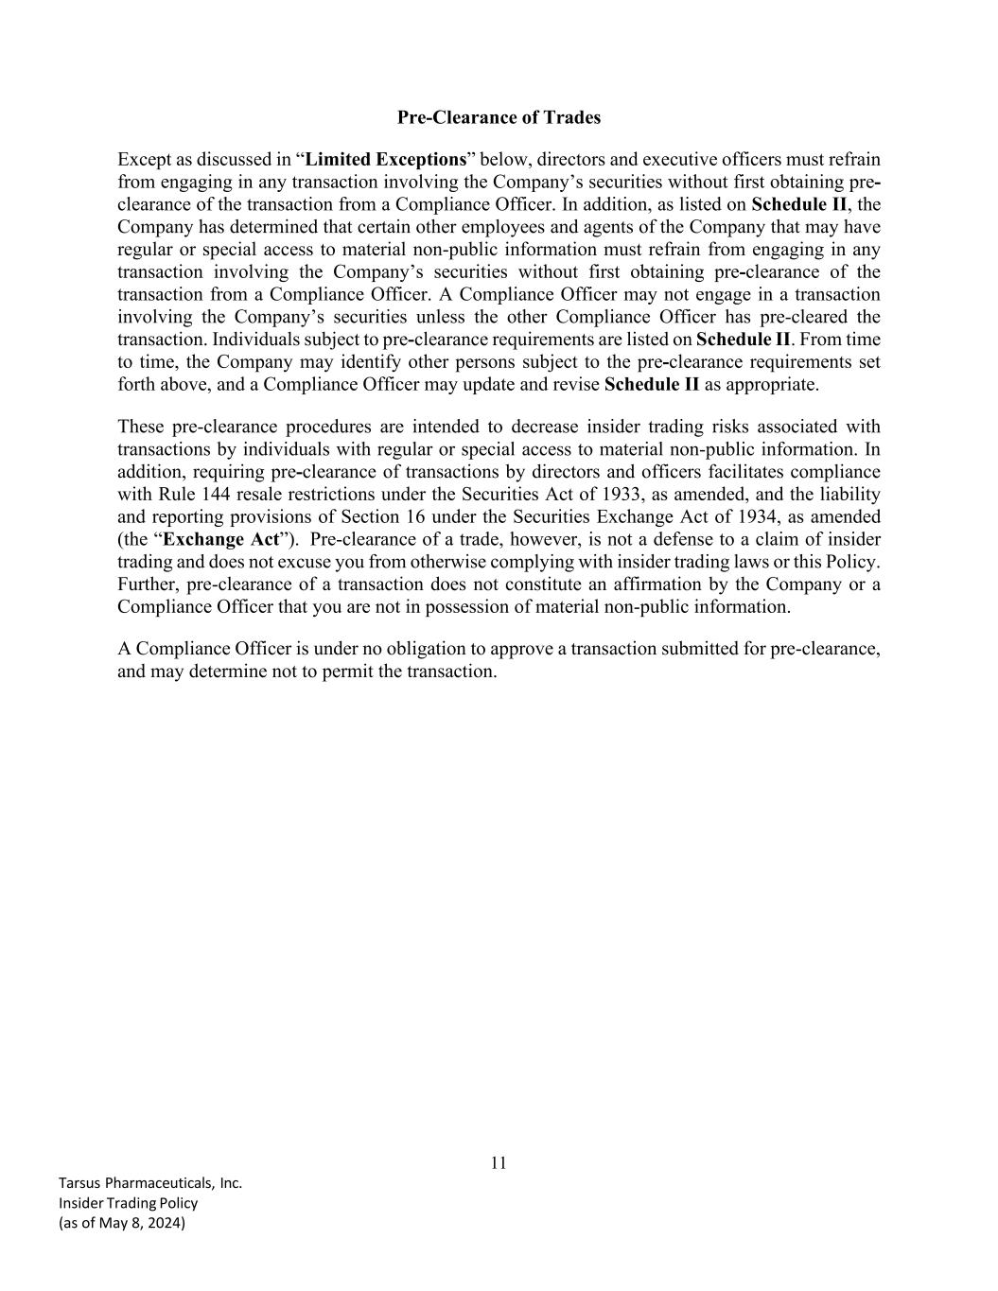
11 Tarsus Pharmaceuticals, Inc. Insider Trading Policy (as of May 8, 2024) Pre-Clearance of Trades Except as discussed in “Limited Exceptions” below, directors and executive officers must refrain from engaging in any transaction involving the Company’s securities without first obtaining pre- clearance of the transaction from a Compliance Officer. In addition, as listed on Schedule II, the Company has determined that certain other employees and agents of the Company that may have regular or special access to material non-public information must refrain from engaging in any transaction involving the Company’s securities without first obtaining pre-clearance of the transaction from a Compliance Officer. A Compliance Officer may not engage in a transaction involving the Company’s securities unless the other Compliance Officer has pre-cleared the transaction. Individuals subject to pre-clearance requirements are listed on Schedule II. From time to time, the Company may identify other persons subject to the pre-clearance requirements set forth above, and a Compliance Officer may update and revise Schedule II as appropriate. These pre-clearance procedures are intended to decrease insider trading risks associated with transactions by individuals with regular or special access to material non-public information. In addition, requiring pre-clearance of transactions by directors and officers facilitates compliance with Rule 144 resale restrictions under the Securities Act of 1933, as amended, and the liability and reporting provisions of Section 16 under the Securities Exchange Act of 1934, as amended (the “Exchange Act”). Pre-clearance of a trade, however, is not a defense to a claim of insider trading and does not excuse you from otherwise complying with insider trading laws or this Policy. Further, pre-clearance of a transaction does not constitute an affirmation by the Company or a Compliance Officer that you are not in possession of material non-public information. A Compliance Officer is under no obligation to approve a transaction submitted for pre-clearance, and may determine not to permit the transaction.

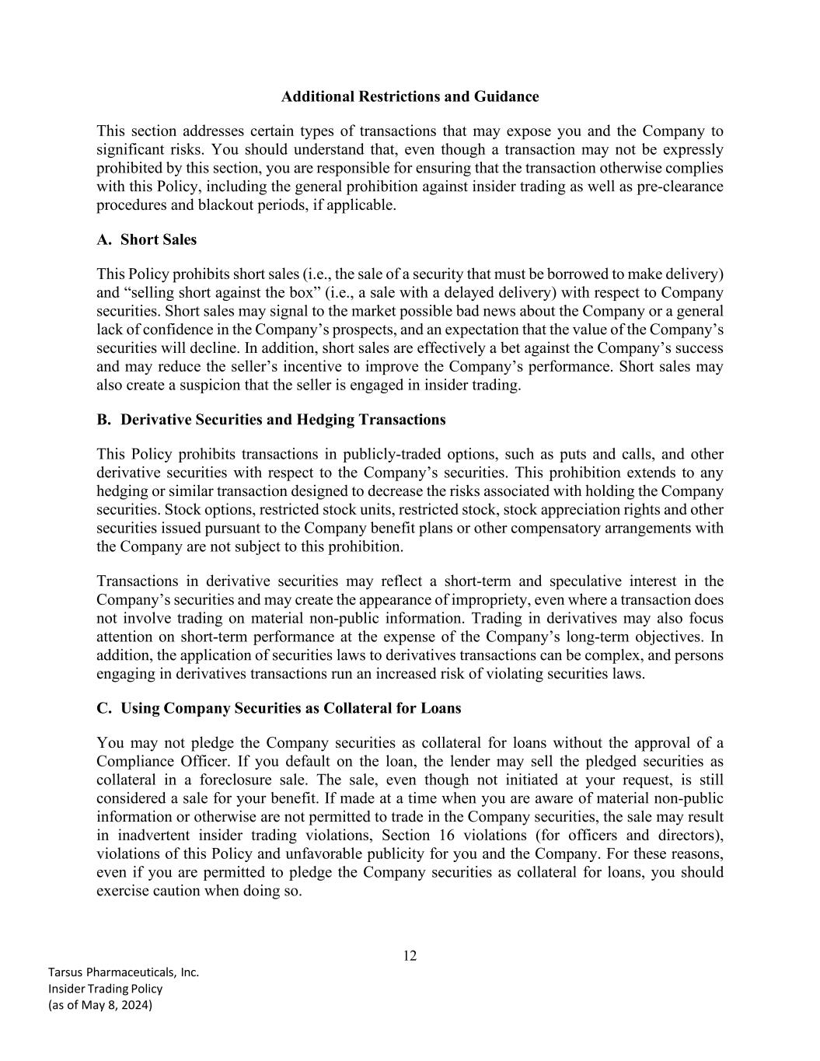
12 Tarsus Pharmaceuticals, Inc. Insider Trading Policy (as of May 8, 2024) Additional Restrictions and Guidance This section addresses certain types of transactions that may expose you and the Company to significant risks. You should understand that, even though a transaction may not be expressly prohibited by this section, you are responsible for ensuring that the transaction otherwise complies with this Policy, including the general prohibition against insider trading as well as pre-clearance procedures and blackout periods, if applicable. A. Short Sales This Policy prohibits short sales (i.e., the sale of a security that must be borrowed to make delivery) and “selling short against the box” (i.e., a sale with a delayed delivery) with respect to Company securities. Short sales may signal to the market possible bad news about the Company or a general lack of confidence in the Company’s prospects, and an expectation that the value of the Company’s securities will decline. In addition, short sales are effectively a bet against the Company’s success and may reduce the seller’s incentive to improve the Company’s performance. Short sales may also create a suspicion that the seller is engaged in insider trading. B. Derivative Securities and Hedging Transactions This Policy prohibits transactions in publicly-traded options, such as puts and calls, and other derivative securities with respect to the Company’s securities. This prohibition extends to any hedging or similar transaction designed to decrease the risks associated with holding the Company securities. Stock options, restricted stock units, restricted stock, stock appreciation rights and other securities issued pursuant to the Company benefit plans or other compensatory arrangements with the Company are not subject to this prohibition. Transactions in derivative securities may reflect a short-term and speculative interest in the Company’s securities and may create the appearance of impropriety, even where a transaction does not involve trading on material non-public information. Trading in derivatives may also focus attention on short-term performance at the expense of the Company’s long-term objectives. In addition, the application of securities laws to derivatives transactions can be complex, and persons engaging in derivatives transactions run an increased risk of violating securities laws. C. Using Company Securities as Collateral for Loans You may not pledge the Company securities as collateral for loans without the approval of a Compliance Officer. If you default on the loan, the lender may sell the pledged securities as collateral in a foreclosure sale. The sale, even though not initiated at your request, is still considered a sale for your benefit. If made at a time when you are aware of material non-public information or otherwise are not permitted to trade in the Company securities, the sale may result in inadvertent insider trading violations, Section 16 violations (for officers and directors), violations of this Policy and unfavorable publicity for you and the Company. For these reasons, even if you are permitted to pledge the Company securities as collateral for loans, you should exercise caution when doing so.

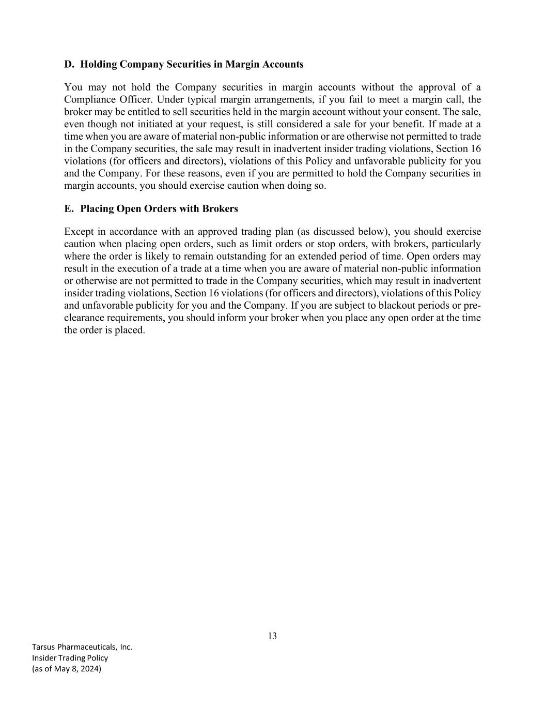
13 Tarsus Pharmaceuticals, Inc. Insider Trading Policy (as of May 8, 2024) D. Holding Company Securities in Margin Accounts You may not hold the Company securities in margin accounts without the approval of a Compliance Officer. Under typical margin arrangements, if you fail to meet a margin call, the broker may be entitled to sell securities held in the margin account without your consent. The sale, even though not initiated at your request, is still considered a sale for your benefit. If made at a time when you are aware of material non-public information or are otherwise not permitted to trade in the Company securities, the sale may result in inadvertent insider trading violations, Section 16 violations (for officers and directors), violations of this Policy and unfavorable publicity for you and the Company. For these reasons, even if you are permitted to hold the Company securities in margin accounts, you should exercise caution when doing so. E. Placing Open Orders with Brokers Except in accordance with an approved trading plan (as discussed below), you should exercise caution when placing open orders, such as limit orders or stop orders, with brokers, particularly where the order is likely to remain outstanding for an extended period of time. Open orders may result in the execution of a trade at a time when you are aware of material non-public information or otherwise are not permitted to trade in the Company securities, which may result in inadvertent insider trading violations, Section 16 violations (for officers and directors), violations of this Policy and unfavorable publicity for you and the Company. If you are subject to blackout periods or pre- clearance requirements, you should inform your broker when you place any open order at the time the order is placed.

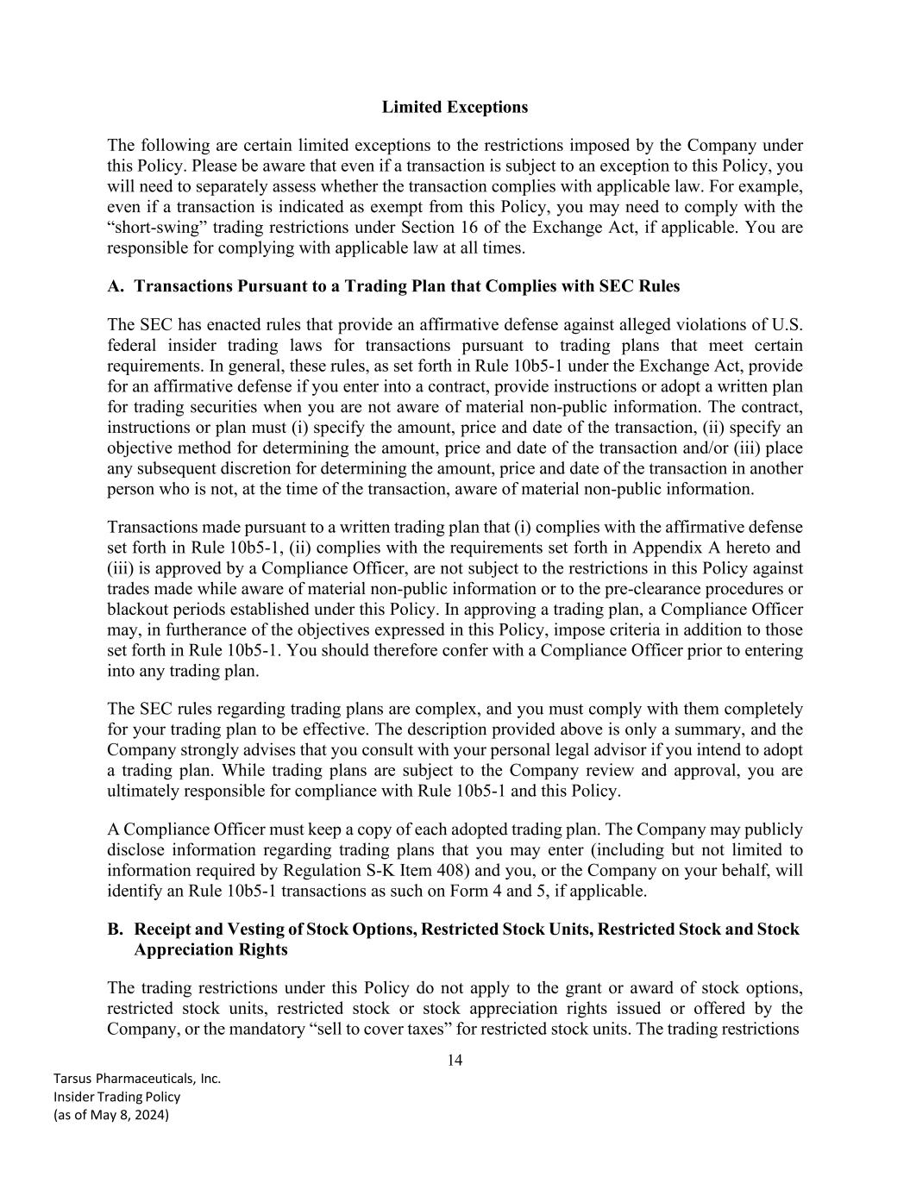
14 Tarsus Pharmaceuticals, Inc. Insider Trading Policy (as of May 8, 2024) Limited Exceptions The following are certain limited exceptions to the restrictions imposed by the Company under this Policy. Please be aware that even if a transaction is subject to an exception to this Policy, you will need to separately assess whether the transaction complies with applicable law. For example, even if a transaction is indicated as exempt from this Policy, you may need to comply with the “short-swing” trading restrictions under Section 16 of the Exchange Act, if applicable. You are responsible for complying with applicable law at all times. A. Transactions Pursuant to a Trading Plan that Complies with SEC Rules The SEC has enacted rules that provide an affirmative defense against alleged violations of U.S. federal insider trading laws for transactions pursuant to trading plans that meet certain requirements. In general, these rules, as set forth in Rule 10b5-1 under the Exchange Act, provide for an affirmative defense if you enter into a contract, provide instructions or adopt a written plan for trading securities when you are not aware of material non-public information. The contract, instructions or plan must (i) specify the amount, price and date of the transaction, (ii) specify an objective method for determining the amount, price and date of the transaction and/or (iii) place any subsequent discretion for determining the amount, price and date of the transaction in another person who is not, at the time of the transaction, aware of material non-public information. Transactions made pursuant to a written trading plan that (i) complies with the affirmative defense set forth in Rule 10b5-1, (ii) complies with the requirements set forth in Appendix A hereto and (iii) is approved by a Compliance Officer, are not subject to the restrictions in this Policy against trades made while aware of material non-public information or to the pre-clearance procedures or blackout periods established under this Policy. In approving a trading plan, a Compliance Officer may, in furtherance of the objectives expressed in this Policy, impose criteria in addition to those set forth in Rule 10b5-1. You should therefore confer with a Compliance Officer prior to entering into any trading plan. The SEC rules regarding trading plans are complex, and you must comply with them completely for your trading plan to be effective. The description provided above is only a summary, and the Company strongly advises that you consult with your personal legal advisor if you intend to adopt a trading plan. While trading plans are subject to the Company review and approval, you are ultimately responsible for compliance with Rule 10b5-1 and this Policy. A Compliance Officer must keep a copy of each adopted trading plan. The Company may publicly disclose information regarding trading plans that you may enter (including but not limited to information required by Regulation S-K Item 408) and you, or the Company on your behalf, will identify an Rule 10b5-1 transactions as such on Form 4 and 5, if applicable. B. Receipt and Vesting of Stock Options, Restricted Stock Units, Restricted Stock and Stock Appreciation Rights The trading restrictions under this Policy do not apply to the grant or award of stock options, restricted stock units, restricted stock or stock appreciation rights issued or offered by the Company, or the mandatory “sell to cover taxes” for restricted stock units. The trading restrictions

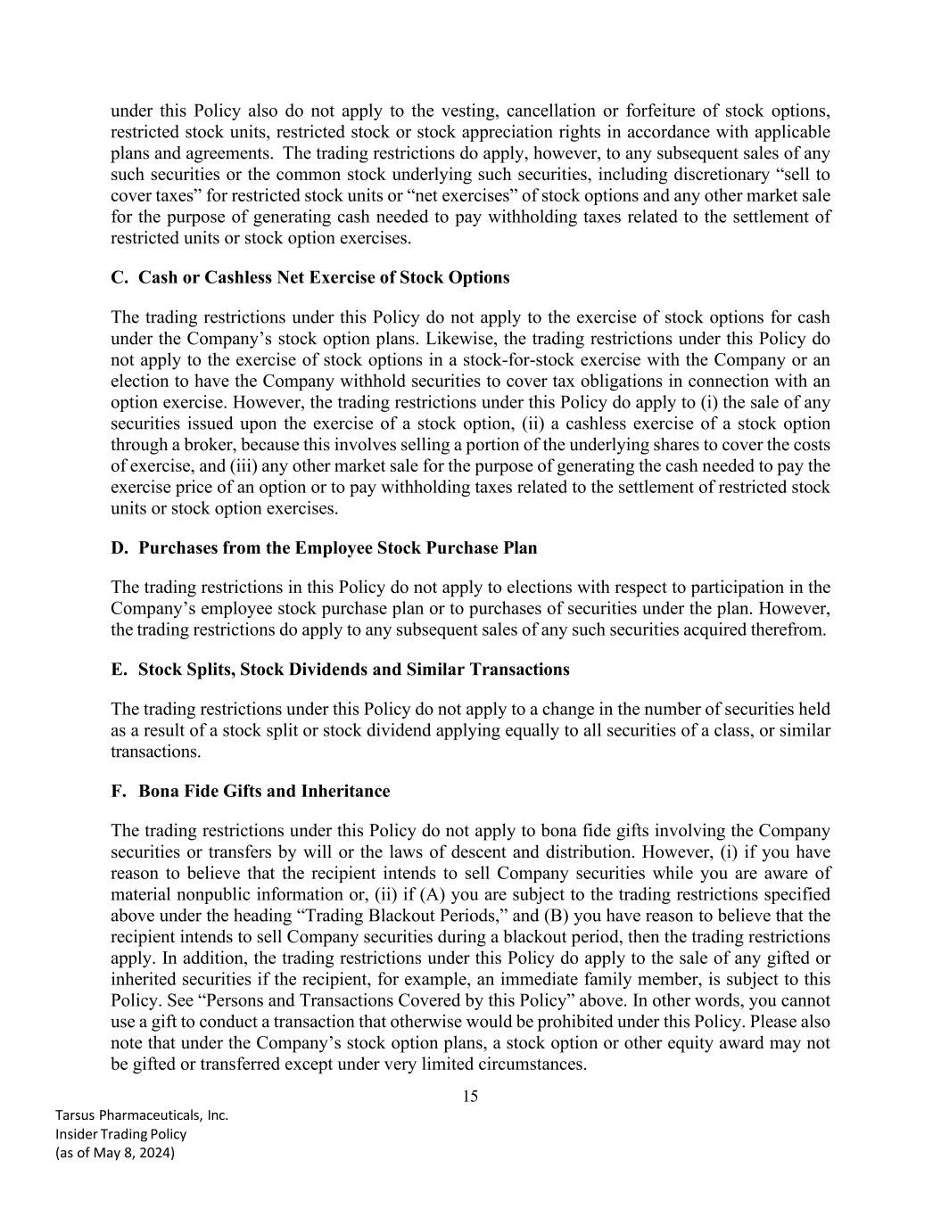
15 Tarsus Pharmaceuticals, Inc. Insider Trading Policy (as of May 8, 2024) under this Policy also do not apply to the vesting, cancellation or forfeiture of stock options, restricted stock units, restricted stock or stock appreciation rights in accordance with applicable plans and agreements. The trading restrictions do apply, however, to any subsequent sales of any such securities or the common stock underlying such securities, including discretionary “sell to cover taxes” for restricted stock units or “net exercises” of stock options and any other market sale for the purpose of generating cash needed to pay withholding taxes related to the settlement of restricted units or stock option exercises. C. Cash or Cashless Net Exercise of Stock Options The trading restrictions under this Policy do not apply to the exercise of stock options for cash under the Company’s stock option plans. Likewise, the trading restrictions under this Policy do not apply to the exercise of stock options in a stock-for-stock exercise with the Company or an election to have the Company withhold securities to cover tax obligations in connection with an option exercise. However, the trading restrictions under this Policy do apply to (i) the sale of any securities issued upon the exercise of a stock option, (ii) a cashless exercise of a stock option through a broker, because this involves selling a portion of the underlying shares to cover the costs of exercise, and (iii) any other market sale for the purpose of generating the cash needed to pay the exercise price of an option or to pay withholding taxes related to the settlement of restricted stock units or stock option exercises. D. Purchases from the Employee Stock Purchase Plan The trading restrictions in this Policy do not apply to elections with respect to participation in the Company’s employee stock purchase plan or to purchases of securities under the plan. However, the trading restrictions do apply to any subsequent sales of any such securities acquired therefrom. E. Stock Splits, Stock Dividends and Similar Transactions The trading restrictions under this Policy do not apply to a change in the number of securities held as a result of a stock split or stock dividend applying equally to all securities of a class, or similar transactions. F. Bona Fide Gifts and Inheritance The trading restrictions under this Policy do not apply to bona fide gifts involving the Company securities or transfers by will or the laws of descent and distribution. However, (i) if you have reason to believe that the recipient intends to sell Company securities while you are aware of material nonpublic information or, (ii) if (A) you are subject to the trading restrictions specified above under the heading “Trading Blackout Periods,” and (B) you have reason to believe that the recipient intends to sell Company securities during a blackout period, then the trading restrictions apply. In addition, the trading restrictions under this Policy do apply to the sale of any gifted or inherited securities if the recipient, for example, an immediate family member, is subject to this Policy. See “Persons and Transactions Covered by this Policy” above. In other words, you cannot use a gift to conduct a transaction that otherwise would be prohibited under this Policy. Please also note that under the Company’s stock option plans, a stock option or other equity award may not be gifted or transferred except under very limited circumstances.

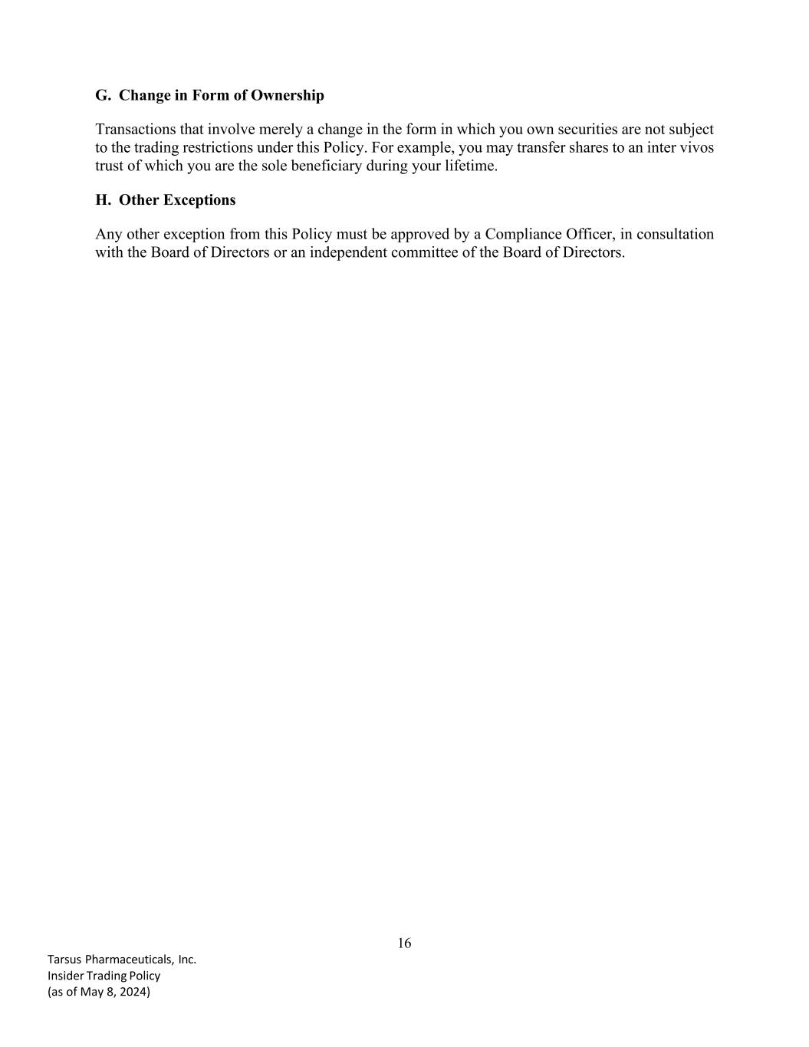
16 Tarsus Pharmaceuticals, Inc. Insider Trading Policy (as of May 8, 2024) G. Change in Form of Ownership Transactions that involve merely a change in the form in which you own securities are not subject to the trading restrictions under this Policy. For example, you may transfer shares to an inter vivos trust of which you are the sole beneficiary during your lifetime. H. Other Exceptions Any other exception from this Policy must be approved by a Compliance Officer, in consultation with the Board of Directors or an independent committee of the Board of Directors.

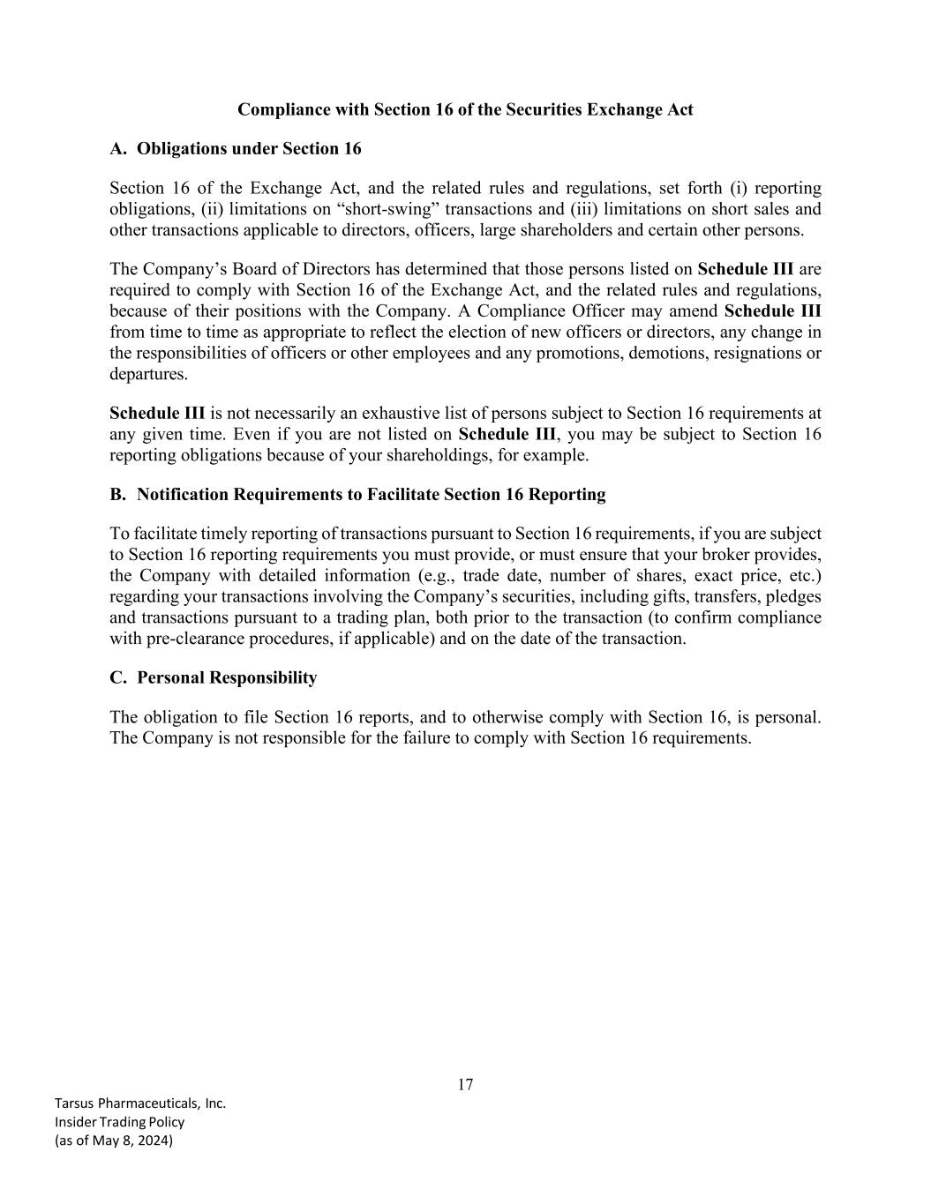
17 Tarsus Pharmaceuticals, Inc. Insider Trading Policy (as of May 8, 2024) Compliance with Section 16 of the Securities Exchange Act A. Obligations under Section 16 Section 16 of the Exchange Act, and the related rules and regulations, set forth (i) reporting obligations, (ii) limitations on “short-swing” transactions and (iii) limitations on short sales and other transactions applicable to directors, officers, large shareholders and certain other persons. The Company’s Board of Directors has determined that those persons listed on Schedule III are required to comply with Section 16 of the Exchange Act, and the related rules and regulations, because of their positions with the Company. A Compliance Officer may amend Schedule III from time to time as appropriate to reflect the election of new officers or directors, any change in the responsibilities of officers or other employees and any promotions, demotions, resignations or departures. Schedule III is not necessarily an exhaustive list of persons subject to Section 16 requirements at any given time. Even if you are not listed on Schedule III, you may be subject to Section 16 reporting obligations because of your shareholdings, for example. B. Notification Requirements to Facilitate Section 16 Reporting To facilitate timely reporting of transactions pursuant to Section 16 requirements, if you are subject to Section 16 reporting requirements you must provide, or must ensure that your broker provides, the Company with detailed information (e.g., trade date, number of shares, exact price, etc.) regarding your transactions involving the Company’s securities, including gifts, transfers, pledges and transactions pursuant to a trading plan, both prior to the transaction (to confirm compliance with pre-clearance procedures, if applicable) and on the date of the transaction. C. Personal Responsibility The obligation to file Section 16 reports, and to otherwise comply with Section 16, is personal. The Company is not responsible for the failure to comply with Section 16 requirements.

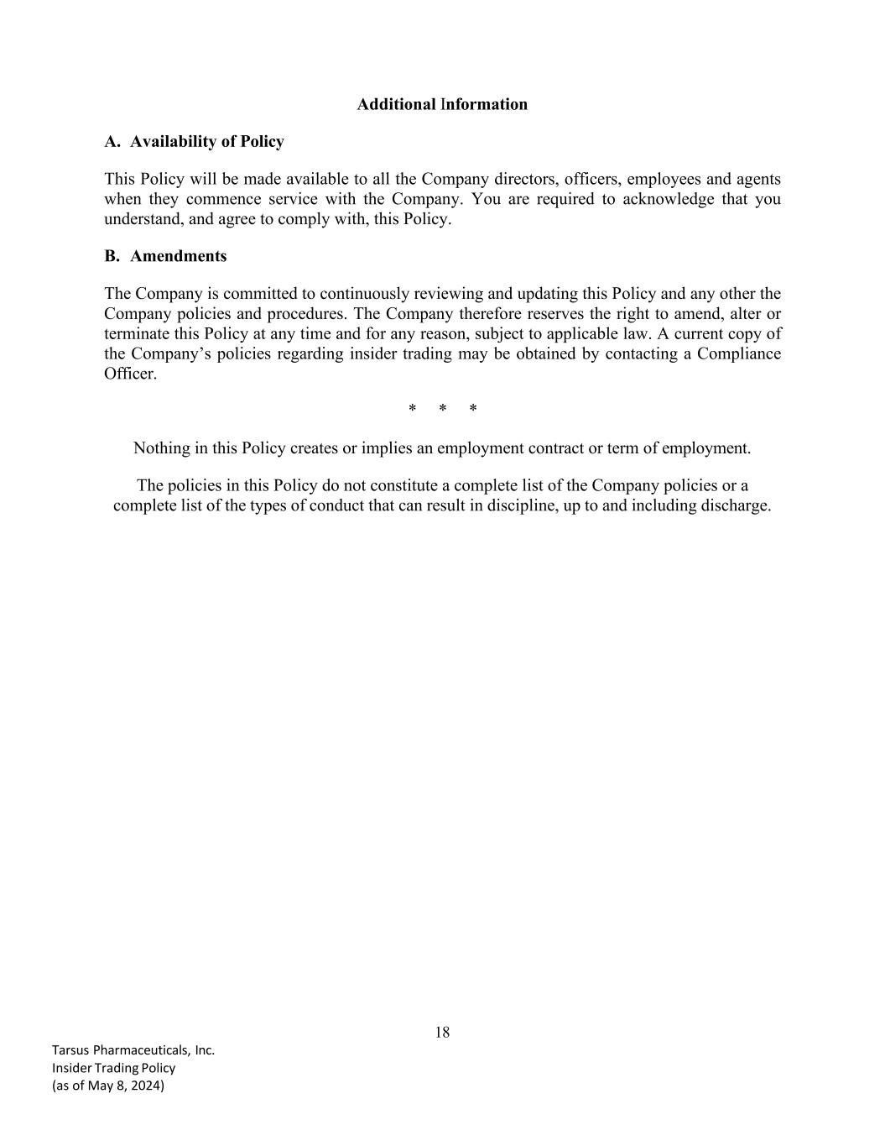
18 Tarsus Pharmaceuticals, Inc. Insider Trading Policy (as of May 8, 2024) Additional Information A. Availability of Policy This Policy will be made available to all the Company directors, officers, employees and agents when they commence service with the Company. You are required to acknowledge that you understand, and agree to comply with, this Policy. B. Amendments The Company is committed to continuously reviewing and updating this Policy and any other the Company policies and procedures. The Company therefore reserves the right to amend, alter or terminate this Policy at any time and for any reason, subject to applicable law. A current copy of the Company’s policies regarding insider trading may be obtained by contacting a Compliance Officer. * * * Nothing in this Policy creates or implies an employment contract or term of employment. The policies in this Policy do not constitute a complete list of the Company policies or a complete list of the types of conduct that can result in discipline, up to and including discharge.

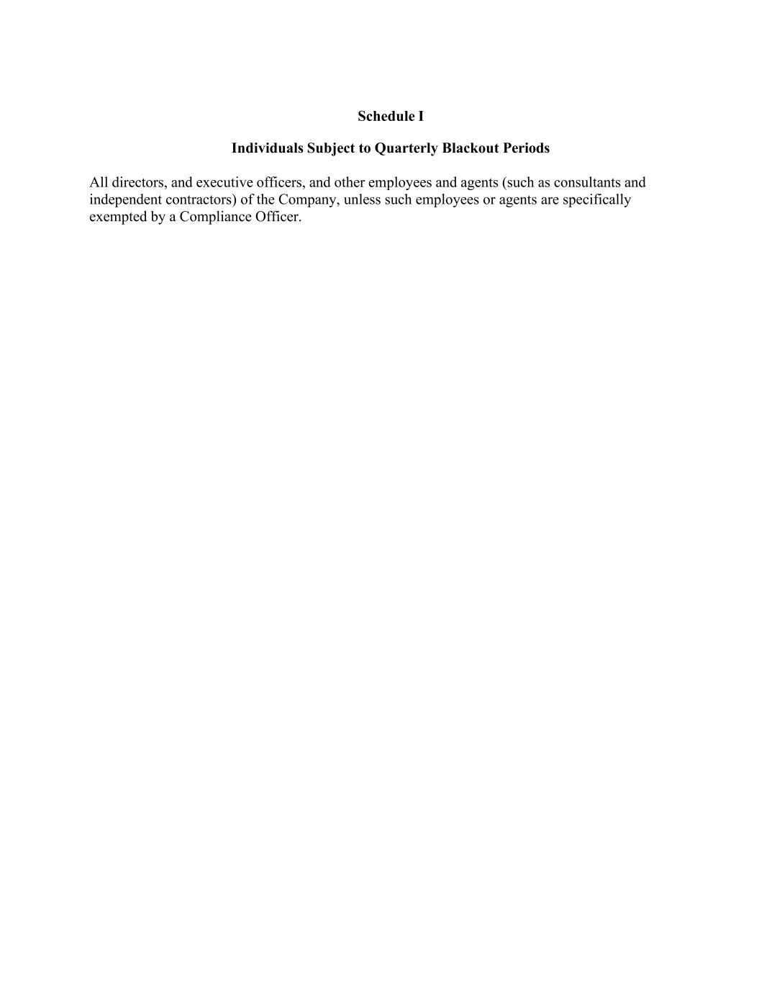
Schedule I Individuals Subject to Quarterly Blackout Periods All directors, and executive officers, and other employees and agents (such as consultants and independent contractors) of the Company, unless such employees or agents are specifically exempted by a Compliance Officer.

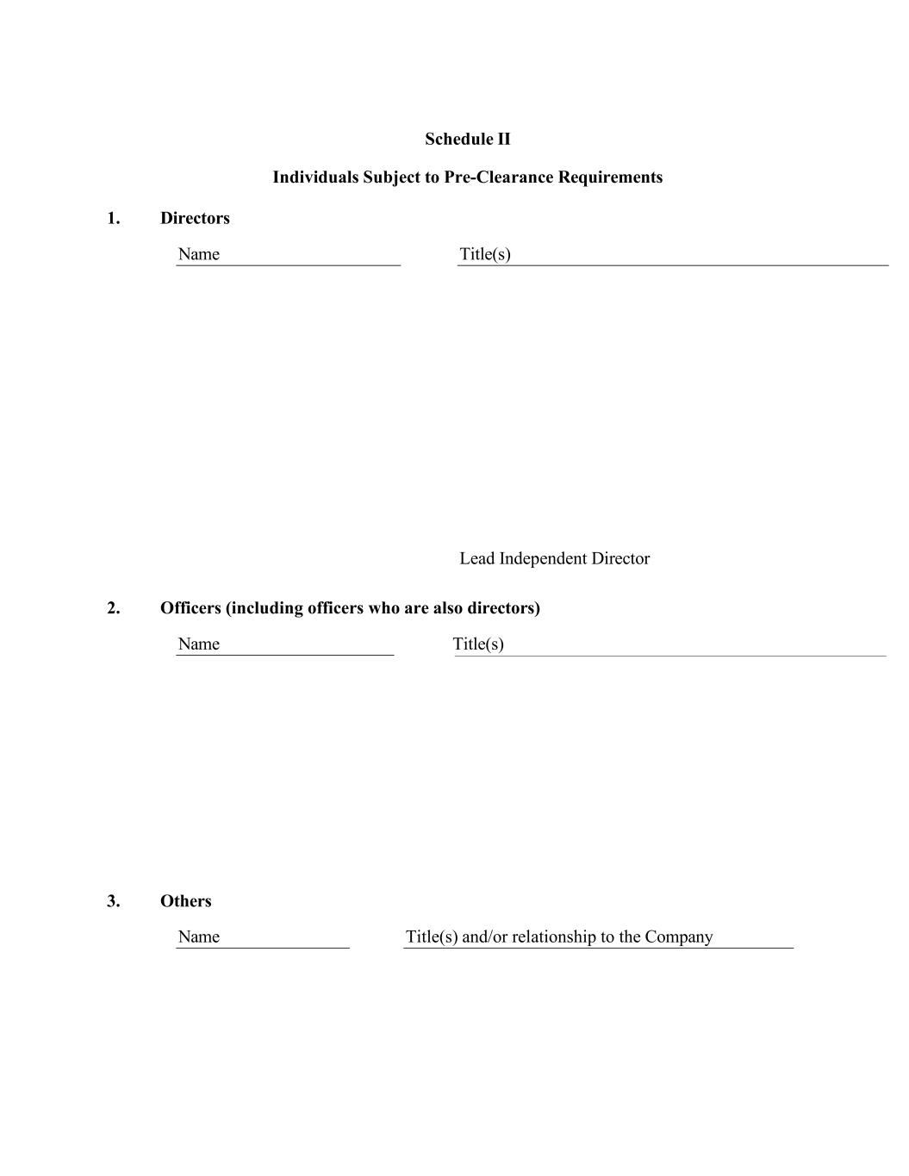
Schedule II Individuals Subject to Pre-Clearance Requirements 1. Directors Name Title(s) Lead Independent Director 2. Officers (including officers who are also directors) Name Title(s) 3. Others Name Title(s) and/or relationship to the Company

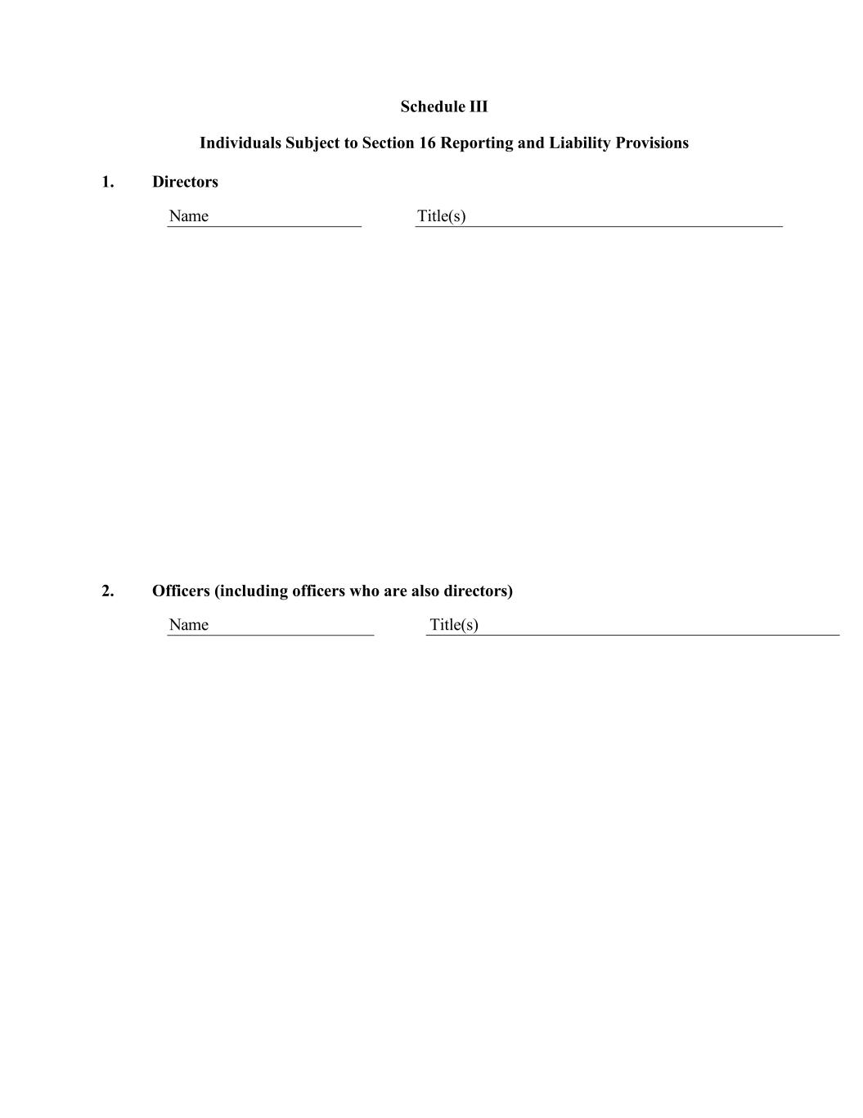
Schedule III Individuals Subject to Section 16 Reporting and Liability Provisions 1. Directors Name Title(s) 2. Officers (including officers who are also directors) Name Title(s)

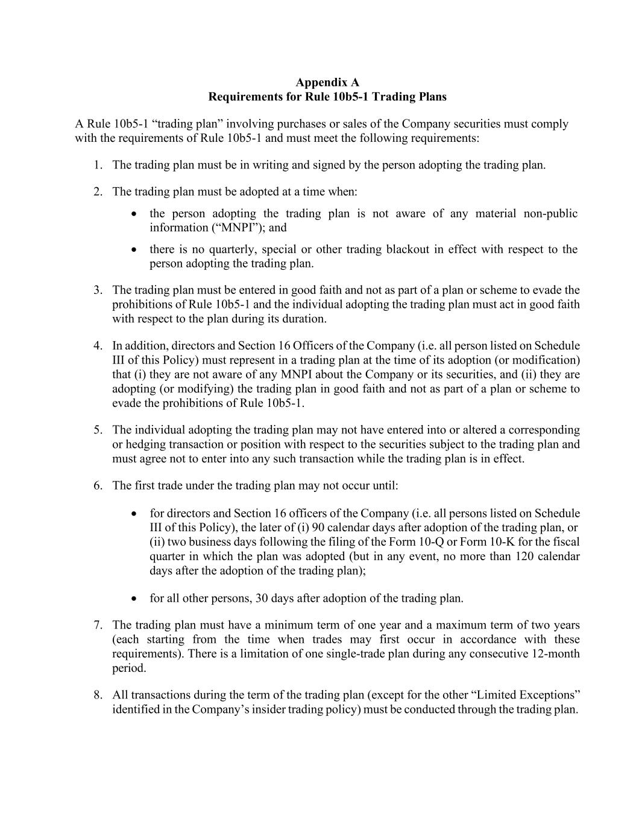
Appendix A Requirements for Rule 10b5-1 Trading Plans A Rule 10b5-1 “trading plan” involving purchases or sales of the Company securities must comply with the requirements of Rule 10b5-1 and must meet the following requirements: 1. The trading plan must be in writing and signed by the person adopting the trading plan. 2. The trading plan must be adopted at a time when: • the person adopting the trading plan is not aware of any material non-public information (“MNPI”); and • there is no quarterly, special or other trading blackout in effect with respect to the person adopting the trading plan. 3. The trading plan must be entered in good faith and not as part of a plan or scheme to evade the prohibitions of Rule 10b5-1 and the individual adopting the trading plan must act in good faith with respect to the plan during its duration. 4. In addition, directors and Section 16 Officers of the Company (i.e. all person listed on Schedule III of this Policy) must represent in a trading plan at the time of its adoption (or modification) that (i) they are not aware of any MNPI about the Company or its securities, and (ii) they are adopting (or modifying) the trading plan in good faith and not as part of a plan or scheme to evade the prohibitions of Rule 10b5-1. 5. The individual adopting the trading plan may not have entered into or altered a corresponding or hedging transaction or position with respect to the securities subject to the trading plan and must agree not to enter into any such transaction while the trading plan is in effect. 6. The first trade under the trading plan may not occur until: • for directors and Section 16 officers of the Company (i.e. all persons listed on Schedule III of this Policy), the later of (i) 90 calendar days after adoption of the trading plan, or (ii) two business days following the filing of the Form 10-Q or Form 10-K for the fiscal quarter in which the plan was adopted (but in any event, no more than 120 calendar days after the adoption of the trading plan); • for all other persons, 30 days after adoption of the trading plan. 7. The trading plan must have a minimum term of one year and a maximum term of two years (each starting from the time when trades may first occur in accordance with these requirements). There is a limitation of one single-trade plan during any consecutive 12-month period. 8. All transactions during the term of the trading plan (except for the other “Limited Exceptions” identified in the Company’s insider trading policy) must be conducted through the trading plan.

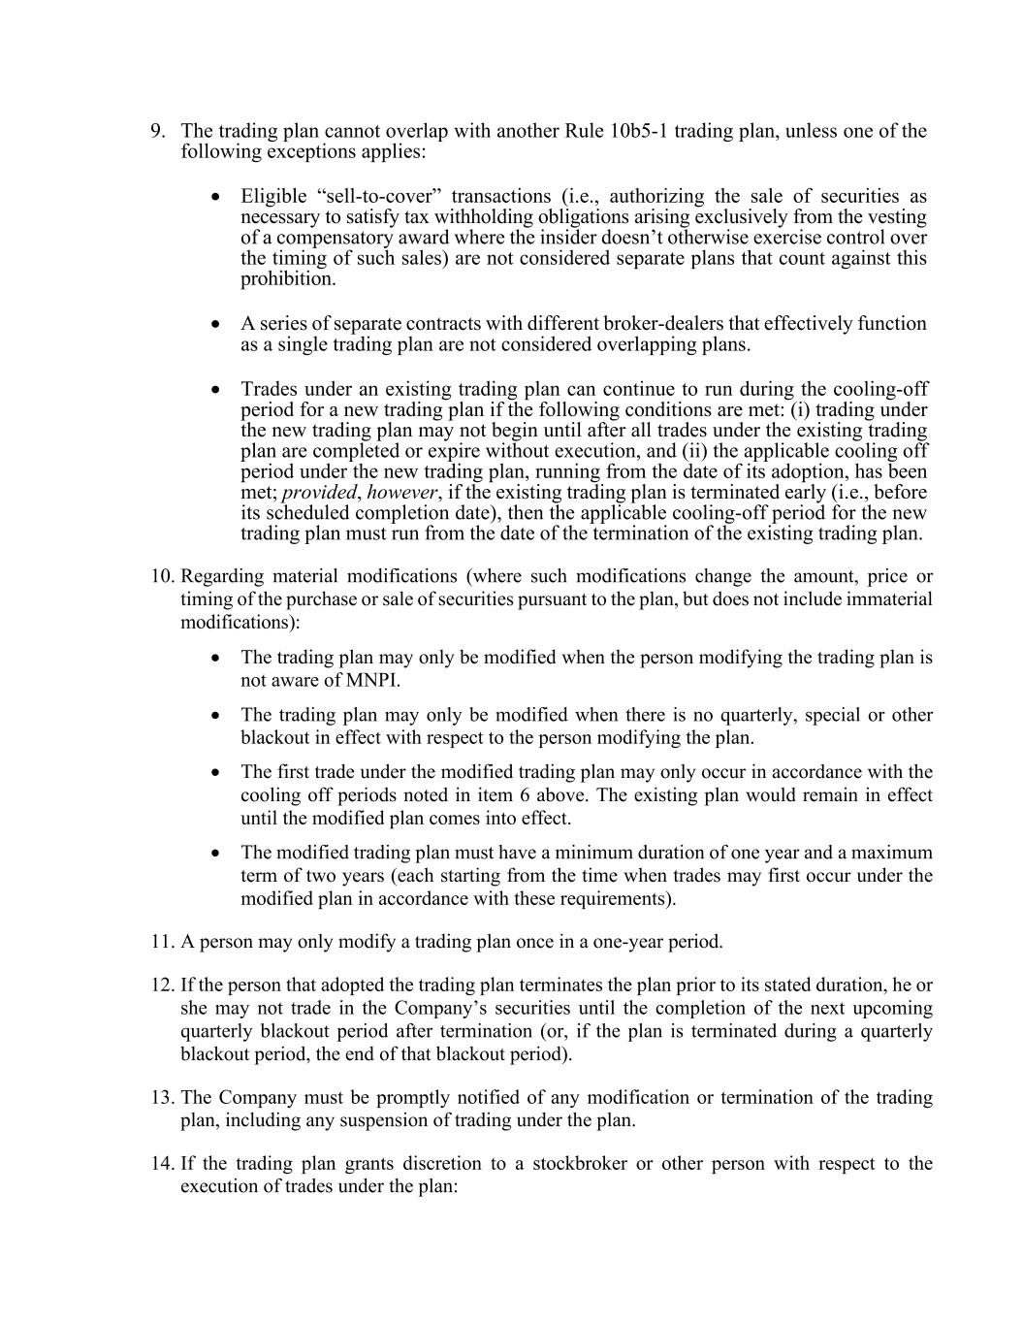
9. The trading plan cannot overlap with another Rule 10b5-1 trading plan, unless one of the following exceptions applies: • Eligible “sell-to-cover” transactions (i.e., authorizing the sale of securities as necessary to satisfy tax withholding obligations arising exclusively from the vesting of a compensatory award where the insider doesn’t otherwise exercise control over the timing of such sales) are not considered separate plans that count against this prohibition. • A series of separate contracts with different broker-dealers that effectively function as a single trading plan are not considered overlapping plans. • Trades under an existing trading plan can continue to run during the cooling-off period for a new trading plan if the following conditions are met: (i) trading under the new trading plan may not begin until after all trades under the existing trading plan are completed or expire without execution, and (ii) the applicable cooling off period under the new trading plan, running from the date of its adoption, has been met; provided, however, if the existing trading plan is terminated early (i.e., before its scheduled completion date), then the applicable cooling-off period for the new trading plan must run from the date of the termination of the existing trading plan. 10. Regarding material modifications (where such modifications change the amount, price or timing of the purchase or sale of securities pursuant to the plan, but does not include immaterial modifications): • The trading plan may only be modified when the person modifying the trading plan is not aware of MNPI. • The trading plan may only be modified when there is no quarterly, special or other blackout in effect with respect to the person modifying the plan. • The first trade under the modified trading plan may only occur in accordance with the cooling off periods noted in item 6 above. The existing plan would remain in effect until the modified plan comes into effect. • The modified trading plan must have a minimum duration of one year and a maximum term of two years (each starting from the time when trades may first occur under the modified plan in accordance with these requirements). 11. A person may only modify a trading plan once in a one-year period. 12. If the person that adopted the trading plan terminates the plan prior to its stated duration, he or she may not trade in the Company’s securities until the completion of the next upcoming quarterly blackout period after termination (or, if the plan is terminated during a quarterly blackout period, the end of that blackout period). 13. The Company must be promptly notified of any modification or termination of the trading plan, including any suspension of trading under the plan. 14. If the trading plan grants discretion to a stockbroker or other person with respect to the execution of trades under the plan:

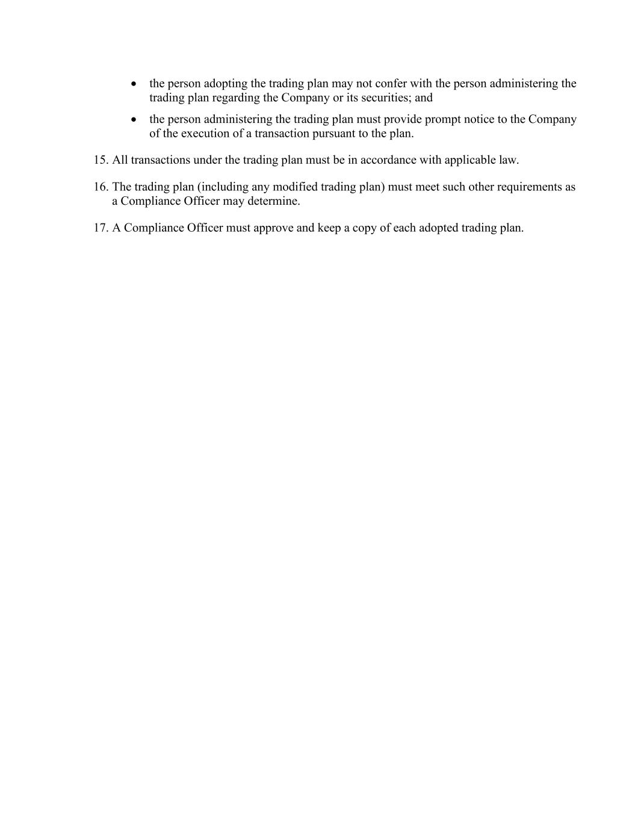
• the person adopting the trading plan may not confer with the person administering the trading plan regarding the Company or its securities; and • the person administering the trading plan must provide prompt notice to the Company of the execution of a transaction pursuant to the plan. 15. All transactions under the trading plan must be in accordance with applicable law. 16. The trading plan (including any modified trading plan) must meet such other requirements as a Compliance Officer may determine. 17. A Compliance Officer must approve and keep a copy of each adopted trading plan.

Exhibit 23.1
Consent of Independent Registered Public Accounting Firm

We consent to the incorporation by reference in the following Registration Statements:
(1) Registration Statement (Form S-8 No. 333-249571) pertaining to the Tarsus Pharmaceuticals, Inc. 2020 Equity Incentive Plan, the Tarsus Pharmaceuticals, Inc. 2020 Employee Stock Purchase Plan, and the Tarsus Pharmaceuticals, Inc. 2016 Stock Plan of Tarsus Pharmaceuticals, Inc.,
(2) Registration Statement (Form S-8 No. 333-254932) pertaining to the Tarsus Pharmaceuticals, Inc. 2020 Equity Incentive Plan, and the Tarsus Pharmaceuticals, Inc. 2020 Employee Stock Purchase Plan of Tarsus Pharmaceuticals, Inc.,
(3) Registration Statement (Form S-8 No. 333-263537) pertaining to the Tarsus Pharmaceuticals, Inc. 2020 Equity Incentive Plan and the Tarsus Pharmaceuticals, Inc. 2020 Employee Stock Purchase Plan of Tarsus Pharmaceuticals, Inc.,
(4) Registration Statement (Form S-8 No. 333-270644) pertaining to the Tarsus Pharmaceuticals, Inc. 2020 Equity Incentive of Tarsus Pharmaceuticals, Inc.,
(5) Registration Statement (Form S-8 No. 333-277400) pertaining to the Tarsus Pharmaceuticals, Inc. 2020 Equity Incentive Plan of Tarsus Pharmaceuticals, Inc.,
(6) Registration Statement (Form S-3 No. 333-275439) of Tarsus Pharmaceuticals, Inc., and;
(7) Registration Statement (Form S-3ASR No. 333-277523) of Tarsus Pharmaceuticals, Inc.;

of our reports dated February 25, 2025 with respect to the financial statements of Tarsus Pharmaceuticals, Inc. and the effectiveness of internal control over financial reporting of Tarsus Pharmaceuticals, Inc. included in this Annual Report (Form 10-K) of Tarsus Pharmaceuticals, Inc. for the year ended December 31, 2024.
/s/ Ernst & Young LLP

Irvine, California

February 25, 2025

Exhibit 31.1
CERTIFICATION PURSUANT TO
RULES 13a-14(a) AND 15d-14(a) UNDER THE SECURITIES EXCHANGE ACT OF 1934,
AS ADOPTED PURSUANT TO SECTION 302 OF THE SARBANES-OXLEY ACT OF 2002

I, Bobak Azamian, M.D., Ph.D., certify that:

1. I have reviewed this Annual Report on Form 10-K of Tarsus Pharmaceuticals, Inc;
2. Based on my knowledge, this report does not contain any untrue statement of a material fact or omit to state a material fact necessary to make the statements made, in light of the circumstances under which such statements were made, not misleading with respect to the period covered by this report;
3. Based on my knowledge, the financial statements, and other financial information included in this report, fairly present in all material respects the financial condition, results of operations and cash flows of the registrant as of, and for, the periods presented in this report;
4. The registrant's other certifying officer(s) and I are responsible for establishing and maintaining disclosure controls and procedures (as defined in Exchange Act Rules 13a-15(e) and 15d-15(e)) and internal control over financial reporting (as defined in Exchange Act Rules 13a-15(f) and 15d-15(f)) for the registrant and have:
(a) Designed such disclosure controls and procedures, or caused such disclosure controls and procedures to be designed under our supervision, to ensure that material information relating to the registrant, including its consolidated subsidiaries, is made known to us by others within those entities, particularly during the period in which this report is being prepared;
(b) Designed such internal control over financial reporting, or caused such internal control over financial reporting to be designed under our supervision, to provide reasonable assurance regarding the reliability of financial reporting and the preparation of financial statements for external purposes in accordance with generally accepted accounting principles;
(c) Evaluated the effectiveness of the registrant's disclosure controls and procedures and presented in this report our conclusions about the effectiveness of the disclosure controls and procedures, as of the end of the period covered by this report based on such evaluation; and
(d) Disclosed in this report any change in the registrant's internal control over financial reporting that occurred during the registrant's most recent fiscal quarter (the registrant's fourth fiscal quarter in the case of an annual report) that has materially affected, or is reasonably likely to materially affect, the registrant's internal control over financial reporting; and
5. The registrant's other certifying officer(s) and I have disclosed, based on our most recent evaluation of internal control over financial reporting, to the registrant's auditors and the audit committee of the registrant's board of directors (or persons performing the equivalent functions):
(a) All significant deficiencies and material weaknesses in the design or operation of internal control over financial reporting which are reasonably likely to adversely affect the registrant's ability to record, process, summarize and report financial information; and
(b) Any fraud, whether or not material, that involves management or other employees who have a significant role in the registrant's internal control over financial reporting.
Date: |  |  | February 25, 2025 |  |  | By: |  |  | /s/ Bobak Azamian, M.D., Ph.D.
President, Chief Executive Officer and Board Chairman
(Principal Executive Officer)

Exhibit 31.2
CERTIFICATION PURSUANT TO
RULES 13a-14(a) AND 15d-14(a) UNDER THE SECURITIES EXCHANGE ACT OF 1934,
AS ADOPTED PURSUANT TO SECTION 302 OF THE SARBANES-OXLEY ACT OF 2002

I, Jeffrey S. Farrow, certify that:

1. I have reviewed this Annual Report on Form 10-K of Tarsus Pharmaceuticals, Inc;
2. Based on my knowledge, this report does not contain any untrue statement of a material fact or omit to state a material fact necessary to make the statements made, in light of the circumstances under which such statements were made, not misleading with respect to the period covered by this report;
3. Based on my knowledge, the financial statements, and other financial information included in this report, fairly present in all material respects the financial condition, results of operations and cash flows of the registrant as of, and for, the periods presented in this report;
4. The registrant's other certifying officer(s) and I are responsible for establishing and maintaining disclosure controls and procedures (as defined in Exchange Act Rules 13a-15(e) and 15d-15(e)) and internal control over financial reporting (as defined in Exchange Act Rules 13a-15(f) and 15d-15(f)) for the registrant and have:
(a) Designed such disclosure controls and procedures, or caused such disclosure controls and procedures to be designed under our supervision, to ensure that material information relating to the registrant, including its consolidated subsidiaries, is made known to us by others within those entities, particularly during the period in which this report is being prepared;
(b) Designed such internal control over financial reporting, or caused such internal control over financial reporting to be designed under our supervision, to provide reasonable assurance regarding the reliability of financial reporting and the preparation of financial statements for external purposes in accordance with generally accepted accounting principles;
(c) Evaluated the effectiveness of the registrant's disclosure controls and procedures and presented in this report our conclusions about the effectiveness of the disclosure controls and procedures, as of the end of the period covered by this report based on such evaluation; and
(d) Disclosed in this report any change in the registrant's internal control over financial reporting that occurred during the registrant's most recent fiscal quarter (the registrant's fourth fiscal quarter in the case of an annual report) that has materially affected, or is reasonably likely to materially affect, the registrant's internal control over financial reporting; and
5. The registrant's other certifying officer(s) and I have disclosed, based on our most recent evaluation of internal control over financial reporting, to the registrant's auditors and the audit committee of the registrant's board of directors (or persons performing the equivalent functions):
(a) All significant deficiencies and material weaknesses in the design or operation of internal control over financial reporting which are reasonably likely to adversely affect the registrant's ability to record, process, summarize and report financial information; and
(b) Any fraud, whether or not material, that involves management or other employees who have a significant role in the registrant's internal control over financial reporting.
Date: |  |  | February 25, 2025 |  |  | By: |  |  | /s/ Jeffrey S. Farrow
Jeffrey S. Farrow
Chief Financial Officer and Chief Strategy Officer
(Principal Financial Officer and Principal Accounting Officer)

Exhibit 32.1

CERTIFICATION OF PRINCIPAL EXECUTIVE OFFICER
PURSUANT TO
18 U.S.C. SECTION 1350, AS ADOPTED PURSUANT TO
SECTION 906 OF THE SARBANES-OXLEY ACT OF 2002

In connection with the Annual Report of Tarsus Pharmaceuticals, Inc. (the “Company”) on Form 10-K for the period ended December 31, 2024 as filed with the Securities and Exchange Commission on the date hereof (the “Report”), I, Bobak Azamian, as Principal Executive Officer of the Company, hereby certify, pursuant to 18 U.S.C. § 1350, as adopted pursuant to § 906 of the Sarbanes-Oxley Act of 2002, that:
 |  |  |  |  |  |  |  |  | (1) |  |  |  |  |  |  |  |  | The Report fully complies with the requirements of Section 13(a) or 15(d) of the Securities Exchange Act  of 1934, as amended; and
 |  |  |  |  |  |  |  |  | (2) |  |  |  |  |  |  |  |  | The information contained in the Report fairly presents, in all material respects, the financial condition and results of operations of the Company.
Date: |  |  | February 25, 2025 |  |  | By: |  |  | /s/ Bobak Azamian, M.D., Ph.D.
 |  |  |  |  |  |  |  |  | Bobak Azamian, M.D., Ph.D.
 |  |  |  |  |  |  |  |  | President, Chief Executive Officer and Board Chairman
 |  |  |  |  |  |  |  |  | (Principal Executive Officer)

Exhibit 32.2

CERTIFICATION OF PRINCIPAL FINANCIAL OFFICER
PURSUANT TO
18 U.S.C. SECTION 1350, AS ADOPTED PURSUANT TO
SECTION 906 OF THE SARBANES-OXLEY ACT OF 2002

In connection with the Annual Report of Tarsus Pharmaceuticals, Inc. (the “Company”) on Form 10-K for the period ended December 31, 2024 as filed with the Securities and Exchange Commission on the date hereof (the “Report”), I, Jeffrey S. Farrow, as Principal Financial Officer of the Company, hereby certify, pursuant to 18 U.S.C. § 1350, as adopted pursuant to § 906 of the Sarbanes-Oxley Act of 2002, that:
 |  |  |  |  |  |  |  |  | (1) |  |  |  |  |  |  |  |  | The Report fully complies with the requirements of Section 13(a) or 15(d) of the Securities Exchange Act  of 1934, as amended; and
 |  |  |  |  |  |  |  |  | (2) |  |  |  |  |  |  |  |  | The information contained in the Report fairly presents, in all material respects, the financial condition and results of operations of the Company.
Date: |  |  | February 25, 2025 |  |  | By: |  |  | /s/ Jeffrey S. Farrow
 |  |  |  |  |  |  |  |  | Jeffrey S. Farrow
 |  |  |  |  |  |  |  |  | Chief Financial Officer and Chief Strategy Officer
 |  |  |  |  |  |  |  |  | (Principal Financial Officer and Principal Accounting Officer)

