SEC Form 4

FORM 4

Check this box if no longer subject to Section
- Form 4 or Form 5 obligations may continue. See Instruction 1(b).

UNITED STATES SECURITIES AND EXCHANGE COMMISSION
Washington, D.C. 20549
Washington, D.C. 20549 |  | OMB APPROVAL
STATEMENT OF CHANGES IN BENEFICIAL OWNERSHIP
STATEMENT OF CHANGES IN BENEFICIAL OWNERSHIP |  | OMB Number: | 3235-0287
 |  | Estimated average burden
Filed pursuant to Section 16(a) of the Securities Exchange Act of 1934 |  | hours per response: | 0.5
or Section 30(h) of the Investment Company Act of 1940
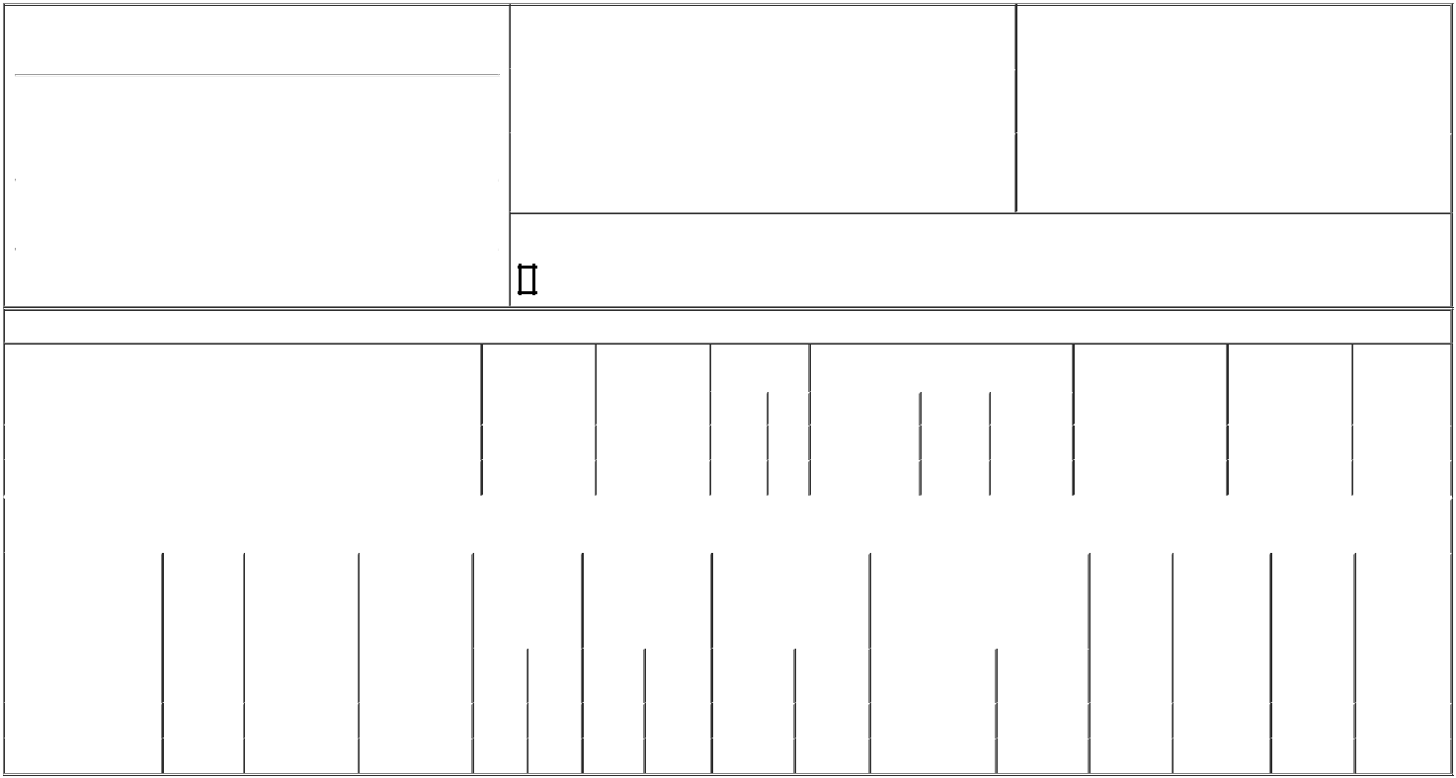

1. Name and Address of Reporting Person*
Neervannan Seshadri

 | (Last) | (First) | (Middle)
 | C/O TARSUS PHARMACEUTICALS, INC.
 | 15440 LAGUNA CANYON ROAD, SUITE 160
(Street)
 | IRVINE | CA | 92618
 | (City) | (State) | (Zip)

2. |  | Issuer Name and Ticker or Trading Symbol |  | 5. Relationship of Reporting Person(s) to Issuer
Tarsus Pharmaceuticals, Inc. [ TARS ] |  |  |  | (Check all applicable)
 |  |  |  |  | Director | 10% Owner
 |  |  |  | X | Officer (give title | Other (specify below)
3. |  | Date of Earliest Transaction (Month/Day/Year) |  | X | Officer (give title | Other (specify below)
 |  |  |  | X | below) | Other (specify below)
03/15/2024 |  |  |  |  | Chief Operating Officer
4. |  | If Amendment, Date of Original Filed (Month/Day/Year) |  | 6. Individual or Joint/Group Filing (Check Applicable Line)
 |  |  |  | X | Form filed by One Reporting Person
 |  |  |  |  | Form filed by More than One Reporting Person

Rule 10b5-1(c) Transaction Indication

Check this box to indicate that a transaction was made pursuant to a contract, instruction or written plan that is intended to satisfy the affirmative defense conditions of Rule 10b5-1(c). See Instruction 10.

Table I - Non-Derivative Securities Acquired, Disposed of, or Beneficially Owned

 | 1. Title of Security (Instr. 3) |  |  |  | 2. Transaction | 2A. Deemed |  | 3. Transaction |  | 4. Securities Acquired (A) or Disposed Of |  |  |  | 5. Amount of Securities |  |  | 6. Ownership |  | 7. Nature of
 |  |  |  |  | Date | Execution Date, |  | Code (Instr. 8) |  | (D) (Instr. 3, 4 and 5) |  |  |  | Beneficially Owned |  |  | Form: Direct (D) or |  | Indirect
 |  |  |  |  | (Month/Day/Year) | if any |  |  |  |  |  |  |  | Following Reported |  |  | Indirect (I) (Instr. 4) |  | Beneficial
 |  |  |  |  |  | (Month/Day/Year) |  | Code | V | Amount |  | (A) or (D) | Price | Transaction(s) (Instr. 3 |  |  |  |  | Ownership
 |  |  |  |  |  |  |  | Code | V | Amount |  | (A) or (D) | Price | and 4) |  |  |  |  | (Instr. 4)
 | Common Stock |  |  |  | 03/15/2024 |  |  | M |  | 13,245 |  | A | (1) | 69,646⁽²⁾ |  |  |  | D
 | Common Stock |  |  |  | 03/18/2024 |  |  | _{S}(3) |  | 4,879 |  | D | $30.6 | 64,767 |  |  |  | D
 |  |  |  | Table II - Derivative Securities Acquired, Disposed of, or Beneficially Owned
 |  |  |  |  | (e.g., puts, calls, warrants, options, convertible securities)
 | 1. Title of Derivative | 2. | 3. Transaction | 3A. Deemed | 4. Transaction | 5. Number of |  | 6. Date Exercisable and |  |  | 7. Title and Amount of Securities |  |  |  | 8. Price of | 9. Number of |  | 10. | 11. Nature of
 | Security (Instr. 3) | Conversion | Date | Execution Date, | Code (Instr. 8) | Derivative |  | Expiration Date |  |  | Underlying Derivative Security |  |  |  | Derivative | derivative |  | Ownership | Indirect
 |  | or Exercise | (Month/Day/Year) | if any |  | Securities Acquired |  | (Month/Day/Year) |  |  | (Instr. 3 and 4) |  |  |  | Security | Securities |  | Form: | Beneficial
 |  | Price of |  | (Month/Day/Year) |  | (A) or Disposed of |  |  |  |  |  |  |  |  | (Instr. 5) | Beneficially |  | Direct (D) or | Ownership
 |  | Derivative |  |  |  | (D) (Instr. 3, 4 and |  |  |  |  |  |  |  |  |  | Owned |  | Indirect (I) | (Instr. 4)
 |  | Security |  |  |  | 5) |  |  |  |  |  |  |  |  |  | Following |  | (Instr. 4)
 |  |  |  |  |  |  |  |  |  |  |  |  |  |  |  | Reported
 |  |  |  |  |  |  |  |  |  |  |  |  | Amount or |  |  | Transaction(s)
 |  |  |  |  |  |  |  | Date |  | Expiration |  |  | Number of |  |  | (Instr. 4)
 |  |  |  |  | Code V | (A) | (D) | Exercisable |  | Date | Title |  | Shares
 | Restricted Stock Units | (4) | 03/15/2024 |  | M |  | 5,097 | (5) |  | (5) |  | Common Stock | 5,097 | $0 |  | 10,194 |  | D
 | Restricted Stock Units | (4) | 03/15/2024 |  | M |  | 8,148 | (6) |  | (6) |  | Common Stock | 8,148 | $0 |  | 24,444 |  | D

Explanation of Responses:

- The shares were issued pursuant to settlement of vested Restricted Stock Units ("RSUs").

- Includes 1,705 shares acquired under the Issuer's Employee Stock Purchase Plan on June 30, 2023.

- The sale reported on this Form 4 represents shares sold by the Reporting Person to cover tax withholding obligations in connection with the vesting and settlement of RSUs. The sale is mandated by the Issuer's election to require the satisfaction of tax withholding obligations to be funded by a "sell to cover" transaction and does not represent a discretionary transaction by the Reporting Person.

- Each RSU represents a contingent right to receive one share of the Issuer's common stock.

- RSUs granted on March 9, 2022, under the Tarsus Pharmaceuticals, Inc. 2020 Stock Plan. 25% of the RSUs will vest on March 15th of each of 2023, 2024, 2025, and 2026, subject to the Reporting Person's continuous service.

- RSUs granted on March 8, 2023, under the Tarsus Pharmaceuticals, Inc. 2020 Stock Plan. 25% of the RSUs will vest on March 15th of each of 2024, 2025, 2026 and 2027, subject to the Reporting Person's continuous service.

Remarks:

Exhibit 24 - Power of Attorney

 | /s/ Jeffrey Farrow, Attorney-in-Fact |  | 03/19/2024
 | ** Signature of Reporting Person |  | Date
Reminder: Report on a separate line for each class of securities beneficially owned directly or indirectly.
* If the form is filed by more than one reporting person, see Instruction 4 (b)(v).
** Intentional misstatements or omissions of facts constitute Federal Criminal Violations See 18 U.S.C. 1001 and 15 U.S.C. 78ff(a).
Note: File three copies of this Form, one of which must be manually signed. If space is insufficient, see Instruction 6 for procedure.
Persons who respond to the collection of information contained in this form are not required to respond unless the form displays a currently valid OMB Number.



