SEC Form 4

FORM 4

Check this box if no longer subject to Section
- Form 4 or Form 5 obligations may continue. See Instruction 1(b).

UNITED STATES SECURITIES AND EXCHANGE COMMISSION
Washington, D.C. 20549
Washington, D.C. 20549 |  | OMB APPROVAL
STATEMENT OF CHANGES IN BENEFICIAL OWNERSHIP
STATEMENT OF CHANGES IN BENEFICIAL OWNERSHIP |  | OMB Number: | 3235-0287
 |  | Estimated average burden
Filed pursuant to Section 16(a) of the Securities Exchange Act of 1934 |  | hours per response: | 0.5
or Section 30(h) of the Investment Company Act of 1940
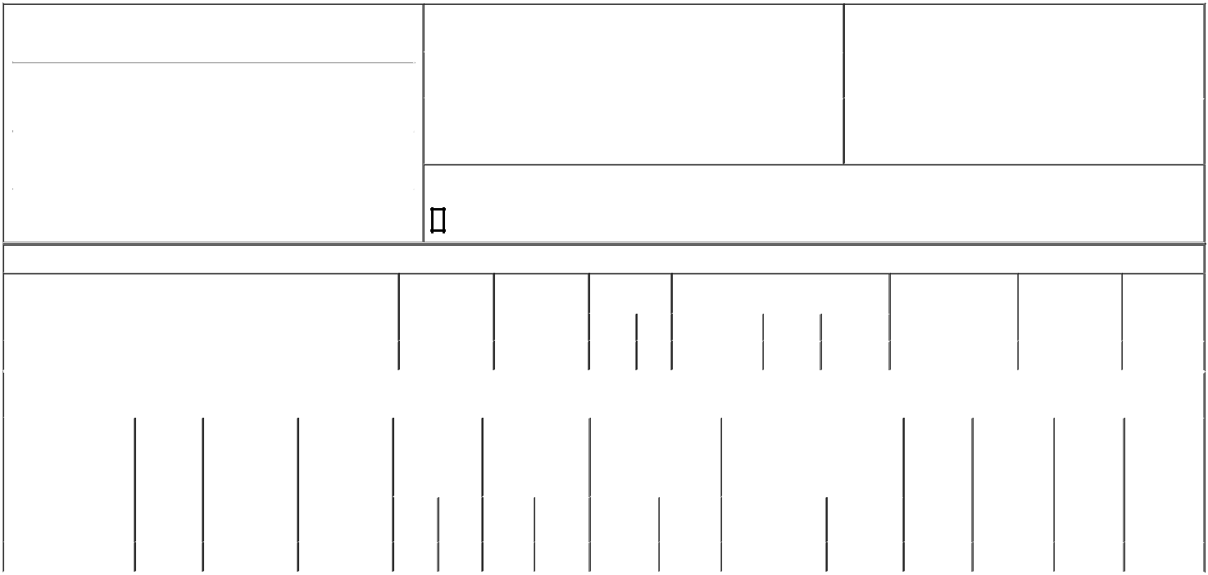

1. Name and Address of Reporting Person*
Morrison Scott W

 | (Last) | (First) | (Middle)
 | 15440 LAGUNA CANYON ROAD, SUITE 160
(Street)
 | IRVINE | CA | 92673
 | (City) | (State) | (Zip)

2. |  | Issuer Name and Ticker or Trading Symbol |  | 5. Relationship of Reporting Person(s) to Issuer
 | Tarsus Pharmaceuticals, Inc. [ TARS ] |  |  | (Check all applicable)
 |  |  |  | X | Director | 10% Owner
3. |  | Date of Earliest Transaction (Month/Day/Year) |  |  | Officer (give title | Other (specify below)
09/15/2023 |  |  |  |  | below) | Other (specify below)
4. |  | If Amendment, Date of Original Filed (Month/Day/Year) |  | 6. Individual or Joint/Group Filing (Check Applicable Line)
 |  |  |  | X | Form filed by One Reporting Person
 |  |  |  |  | Form filed by More than One Reporting Person

Rule 10b5-1(c) Transaction Indication

Check this box to indicate that a transaction was made pursuant to a contract, instruction or written plan that is intended to satisfy the affirmative defense conditions of Rule 10b5-1(c). See Instruction 10.

Table I - Non-Derivative Securities Acquired, Disposed of, or Beneficially Owned

 | 1. Title of Security (Instr. 3) |  |  |  | 2. Transaction | 2A. Deemed |  | 3. Transaction |  | 4. Securities Acquired (A) or Disposed Of |  |  |  | 5. Amount of Securities |  |  |  |  | 6. Ownership |  |  | 7. Nature of
 |  |  |  |  | Date | Execution Date, |  | Code (Instr. 8) (D) (Instr. 3, 4 and 5) |  |  |  |  |  | Beneficially Owned |  |  |  |  | Form: Direct (D) or |  |  | Indirect
 |  |  |  |  | (Month/Day/Year) | if any |  |  |  |  |  |  |  | Following Reported |  |  |  |  | Indirect (I) (Instr. 4) |  |  | Beneficial
 |  |  |  |  |  | (Month/Day/Year) |  | Code | V | Amount |  | (A) or (D) | Price | Transaction(s) (Instr. 3 |  |  |  |  |  |  |  | Ownership
 |  |  |  |  |  |  |  | Code | V | Amount |  | (A) or (D) | Price | and 4) |  |  |  |  |  |  |  | (Instr. 4)
 | Common Stock |  |  |  | 09/15/2023 |  |  | _{M}(1) |  | 1,333 |  | A | (1) | 1,333 |  |  |  |  |  |  | D
 |  |  |  | Table II - Derivative Securities Acquired, Disposed of, or Beneficially Owned
 |  |  |  |  | (e.g., puts, calls, warrants, options, convertible securities)
 | 1. Title of Derivative | 2. | 3. Transaction | 3A. Deemed | 4. Transaction | 5. Number of |  | 6. Date Exercisable and |  |  | 7. Title and Amount of Securities |  |  |  | 8. Price of |  |  | 9. Number of |  |  | 10. | 11. Nature of
 | Security (Instr. 3) | Conversion | Date | Execution Date, | Code (Instr. 8) | Derivative |  | Expiration Date |  |  | Underlying Derivative Security |  |  |  | Derivative |  |  | derivative |  |  | Ownership | Indirect
 |  | or Exercise | (Month/Day/Year) | if any |  | Securities Acquired |  | (Month/Day/Year) |  |  | (Instr. 3 and 4) |  |  |  | Security |  |  | Securities |  |  | Form: | Beneficial
 |  | Price of |  | (Month/Day/Year) |  | (A) or Disposed of |  |  |  |  |  |  |  |  | (Instr. 5) |  |  | Beneficially |  |  | Direct (D) or | Ownership
 |  | Derivative |  |  |  | (D) (Instr. 3, 4 and |  |  |  |  |  |  |  |  |  |  |  | Owned |  |  | Indirect (I) | (Instr. 4)
 |  | Security |  |  |  | 5) |  |  |  |  |  |  |  |  |  |  |  | Following |  |  | (Instr. 4)
 |  |  |  |  |  |  |  |  |  |  |  |  |  |  |  |  |  | Reported
 |  |  |  |  |  |  |  |  |  |  |  |  | Amount or |  |  |  |  | Transaction(s)
 |  |  |  |  |  |  |  | Date |  | Expiration |  |  | Number of |  |  |  |  | (Instr. 4)
 |  |  |  |  | Code V | (A) | (D) | Exercisable |  | Date | Title |  | Shares
 | Restricted Stock Units | (1) | 09/15/2023 |  | M |  | 1,333 | (2) |  | (2) |  | Common Stock | 1,333 | $0 |  |  | 2,667 |  |  |  | D
 | Explanation of Responses:
 | 1. The shares were issued pursuant to settlement of vested Restricted Stock Units ("RSUs"). Each RSU represents a contingent right to receive one share of the Company's common stock.
 | 2. The RSUs vest in three equal annual installments on September 15th of 2023, 2024, and 2025, subject to the Reporting Person's continuous service.
 | Remarks:
 | Exhibit 24 - Power of Attorney
 |  |  |  |  |  |  |  |  |  |  | /s/ Jeffrey Farrow, Attorney-in-Fact |  |  |  |  |  |  | 09/19/2023
 |  |  |  |  |  |  |  |  |  |  | ** Signature of Reporting Person |  |  |  |  |  | Date
 | Reminder: Report on a separate line for each class of securities beneficially owned directly or indirectly.
 | * If the form is filed by more than one reporting person, see Instruction 4 (b)(v).

** Intentional misstatements or omissions of facts constitute Federal Criminal Violations See 18 U.S.C. 1001 and 15 U.S.C. 78ff(a).

Note: File three copies of this Form, one of which must be manually signed. If space is insufficient, see Instruction 6 for procedure.

Persons who respond to the collection of information contained in this form are not required to respond unless the form displays a currently valid OMB Number.



