UNITED STATES
SECURITIES AND EXCHANGE COMMISSION
Washington, D.C. 20549
_______________
FORM 8-K
CURRENT REPORT
Pursuant to Section 13 OR 15(d) of The Securities Exchange Act of 1934
Date of Report (date of earliest event reported) July 6, 2026
_______________
TARSUS PHARMACEUTICALS, INC.
(Exact name of registrant as specified in its charter)
_______________
Delaware |  |  | 001-39614 |  |  |  |  |  | 81-4717861
(State or other jurisdiction of incorporation) |  |  | (Commission File Number) |  |  |  |  |  | (I.R.S. Employer Identification No.)
17700 Laguna Canyon Road, Floor 4
Irvine, CA 92618
(Address of principal executive offices, including Zip Code)
Registrant's telephone number, including area code: (949) 418-1801
Check the appropriate box below if the Form 8-K filing is intended to simultaneously satisfy the filing obligation of the registrant under any of the following provisions:
☐ |  |  | Written communications pursuant to Rule 425 under the Securities Act (17 CFR 230.425)
☐ |  |  | Soliciting material pursuant to Rule 14a-12 under the Exchange Act (17 CFR 240.14a-12)
☐ |  |  | Pre-commencement communications pursuant to Rule 14d-2(b) under the Exchange Act (17 CFR 240.14d-2(b))
☐ |  |  | Pre-commencement communications pursuant to Rule 13e-4(c) under the Exchange Act (17 CFR 240.13e-4(c))
Securities registered pursuant to Section 12(b) of the Act:
Title of each class |  |  | Trading Symbol(s) |  |  | Name of each exchange on which registered
Common Stock, $0.0001 par value per share |  |  | TARS |  |  | The Nasdaq Global Market LLC  (Nasdaq Global Select Market)
Indicate by check mark whether the registrant is an emerging growth company as defined in Rule 405 of the Securities Act of 1933 (§230.405 of this chapter) or Rule 12b-2 of the Securities Exchange Act of 1934 (§240.12b-2 of this chapter). Emerging growth company ☐
If an emerging growth company, indicate by check mark if the registrant has elected not to use the extended transition period for complying with any new or revised financial accounting standards provided pursuant to Section 13(a) of the Exchange Act. ☐

Item 1.01 Entry into a Material Definitive Agreement.

On July 6, 2026, Tarsus Pharmaceuticals, Inc. (the “Company”) entered into an Agreement and Plan of Merger (the “Merger Agreement”) with iRenix Medical, Inc., a Delaware corporation (“iRenix”), Dolores Merger Sub, Inc., a Delaware corporation and wholly-owned subsidiary of the Company (“Merger Sub”) and Fortis Advisors LLC, as the securityholders’ representative (the “Securityholders’ Representative”). Pursuant to the Merger Agreement, on July 6, 2026, Merger Sub merged with and into iRenix (the “Merger”), with iRenix surviving the Merger as a wholly-owned subsidiary of the Company. The aggregate up-front consideration (the “Up-front Consideration”) paid by the Company for the transactions contemplated by the Merger Agreement (the “Acquisition”) was (i) an amount in cash equal to $37,500,000, subject to customary adjustments and a post-closing purchase price adjustment, and (ii) 607,093 shares of common stock, par value $0.0001 per share, of the Company. In addition to the Up-front Consideration, the equityholders of iRenix will be entitled to receive: (i) milestone payments up to an aggregate amount equal to $490,000,000 in the event certain regulatory approval and/or commercial sales milestones are achieved and (ii) revenue sharing payments in the low-to-mid single digits of future net sales of certain products.

In connection with the Merger Agreement, the Company and the Securityholders’ Representative entered into an escrow agreement pursuant to which the Company has deposited certain funds for purposes of securing the indemnification obligations of the former securityholders of iRenix and for purposes of securing any Merger Consideration adjustments.

The Merger Agreement contains customary representations, warranties and covenants for a transaction of this nature.

The foregoing description of the Merger Agreement is not complete and is qualified in its entirety by reference to the full text of the Merger Agreement, which will be filed as an exhibit with the Company’s Quarterly Report on Form 10-Q for the quarter ended September 30, 2026.

Item 3.02 Unregistered Sales of Equity Securities.

To the extent required by this Item, the information included in Item 1.01 of this Current Report on Form 8-K is incorporated herein by reference.

The Stock Consideration was issued in private placements exempt from registration under Section 4(a)(2) of the Securities Act of 1933, as amended (the “Securities Act”), and/or Regulation D promulgated thereunder, because the offer and sale of such securities did not involve a “public offering” as defined in Section 4(a)(2) of the Securities Act, and other applicable requirements were met. The issuance of the Stock Consideration was made only to those stockholders of iRenix determined to be “accredited investors” as defined pursuant to Rule 501(a) of Regulation D promulgated under the Securities Act.

Item 8.01 Other Events.

On July 8, 2026, the Company issued a press release announcing the completion of the Acquisition. A copy of the press release is attached hereto as Exhibit 99.1 and is incorporated herein by reference.

Item 9.01 Financial Statements and Exhibits.

(d) Exhibits.
Exhibit No. |  |  |  |  |  |  |  |  | Description
99.1 |  |  |  |  |  |  |  |  | Press Release issued by the Company, dated July 8, 2026.
 |  |  | 104 |  |  |  |  |  | Cover Page Interactive Data File (embedded within XBRL document)

SIGNATURES

Pursuant to the requirements of the Securities Exchange Act of 1934, as amended, the registrant has duly caused this report to be signed on its behalf by the undersigned hereunto duly authorized.

 |  |  |  |  |  |  |  |  |  |  |  |  |  |  | Tarsus Pharmaceuticals, Inc.
Date: |  |  | July 8, 2026 |  |  |  |  |  |  |  |  | By: |  |  | /s/ Jeffrey Farrow
 |  |  |  |  |  |  |  |  |  |  |  |  |  |  | Jeffrey Farrow
 |  |  |  |  |  |  |  |  |  |  |  |  |  |  | Chief Financial Officer and Chief Strategy Officer
 |  |  |  |  |  |  |  |  |  |  |  |  |  |  | (Principal Financial Officer and Principal Accounting Officer)
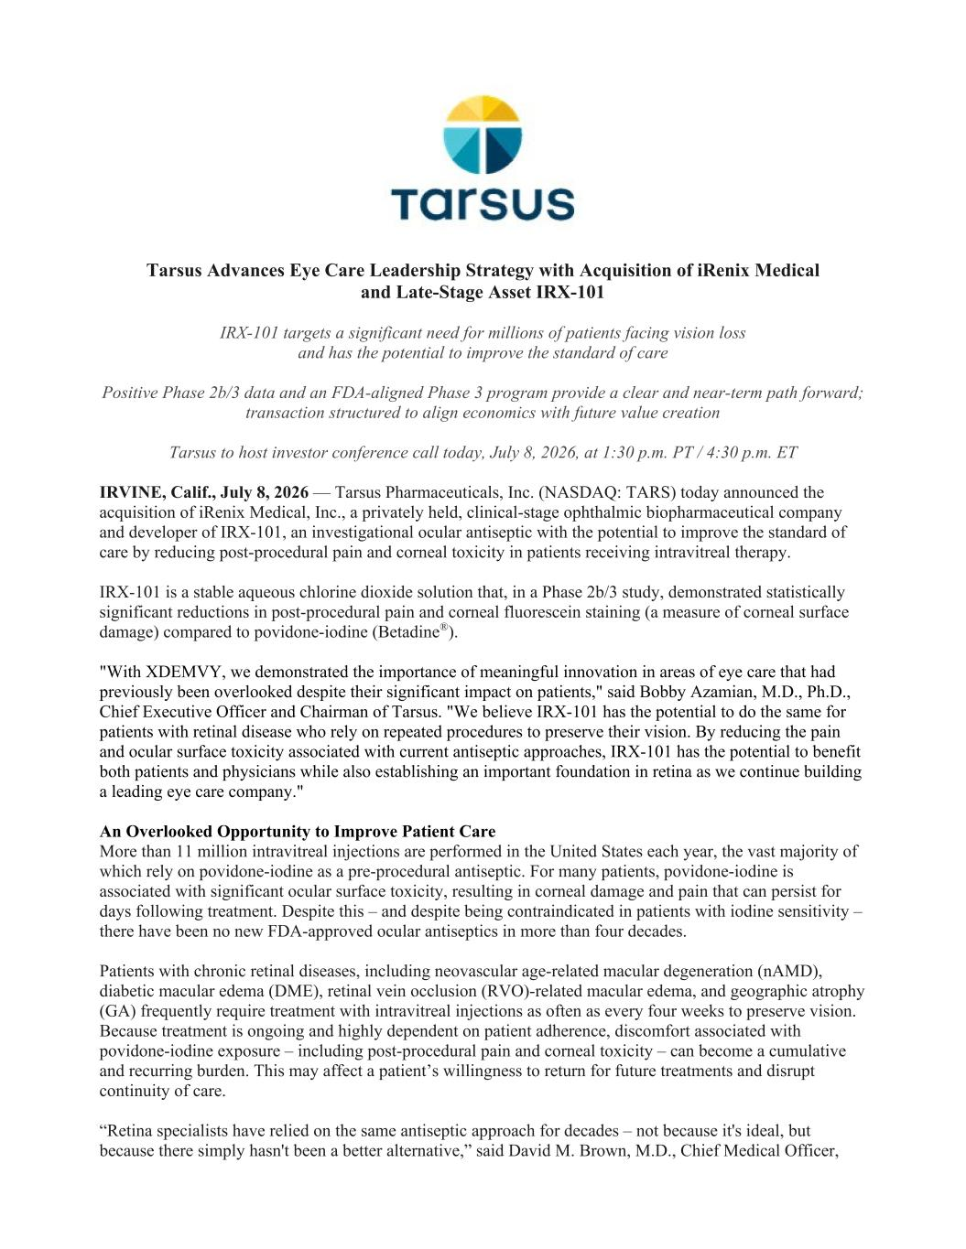

Tarsus Advances Eye Care Leadership Strategy with Acquisition of iRenix Medical and Late-Stage Asset IRX-101 IRX-101 targets a significant need for millions of patients facing vision loss and has the potential to improve the standard of care Positive Phase 2b/3 data and an FDA-aligned Phase 3 program provide a clear and near-term path forward; transaction structured to align economics with future value creation Tarsus to host investor conference call today, July 8, 2026, at 1:30 p.m. PT / 4:30 p.m. ET IRVINE, Calif., July 8, 2026 — Tarsus Pharmaceuticals, Inc. (NASDAQ: TARS) today announced the acquisition of iRenix Medical, Inc., a privately held, clinical-stage ophthalmic biopharmaceutical company and developer of IRX-101, an investigational ocular antiseptic with the potential to improve the standard of care by reducing post-procedural pain and corneal toxicity in patients receiving intravitreal therapy. IRX-101 is a stable aqueous chlorine dioxide solution that, in a Phase 2b/3 study, demonstrated statistically significant reductions in post-procedural pain and corneal fluorescein staining (a measure of corneal surface damage) compared to povidone-iodine (Betadine®). "With XDEMVY, we demonstrated the importance of meaningful innovation in areas of eye care that had previously been overlooked despite their significant impact on patients," said Bobby Azamian, M.D., Ph.D., Chief Executive Officer and Chairman of Tarsus. "We believe IRX-101 has the potential to do the same for patients with retinal disease who rely on repeated procedures to preserve their vision. By reducing the pain and ocular surface toxicity associated with current antiseptic approaches, IRX-101 has the potential to benefit both patients and physicians while also establishing an important foundation in retina as we continue building a leading eye care company." An Overlooked Opportunity to Improve Patient Care More than 11 million intravitreal injections are performed in the United States each year, the vast majority of which rely on povidone-iodine as a pre-procedural antiseptic. For many patients, povidone-iodine is associated with significant ocular surface toxicity, resulting in corneal damage and pain that can persist for days following treatment. Despite this – and despite being contraindicated in patients with iodine sensitivity – there have been no new FDA-approved ocular antiseptics in more than four decades. Patients with chronic retinal diseases, including neovascular age-related macular degeneration (nAMD), diabetic macular edema (DME), retinal vein occlusion (RVO)-related macular edema, and geographic atrophy (GA) frequently require treatment with intravitreal injections as often as every four weeks to preserve vision. Because treatment is ongoing and highly dependent on patient adherence, discomfort associated with povidone-iodine exposure – including post-procedural pain and corneal toxicity – can become a cumulative and recurring burden. This may affect a patient’s willingness to return for future treatments and disrupt continuity of care. “Retina specialists have relied on the same antiseptic approach for decades – not because it's ideal, but because there simply hasn't been a better alternative,” said David M. Brown, M.D., Chief Medical Officer,

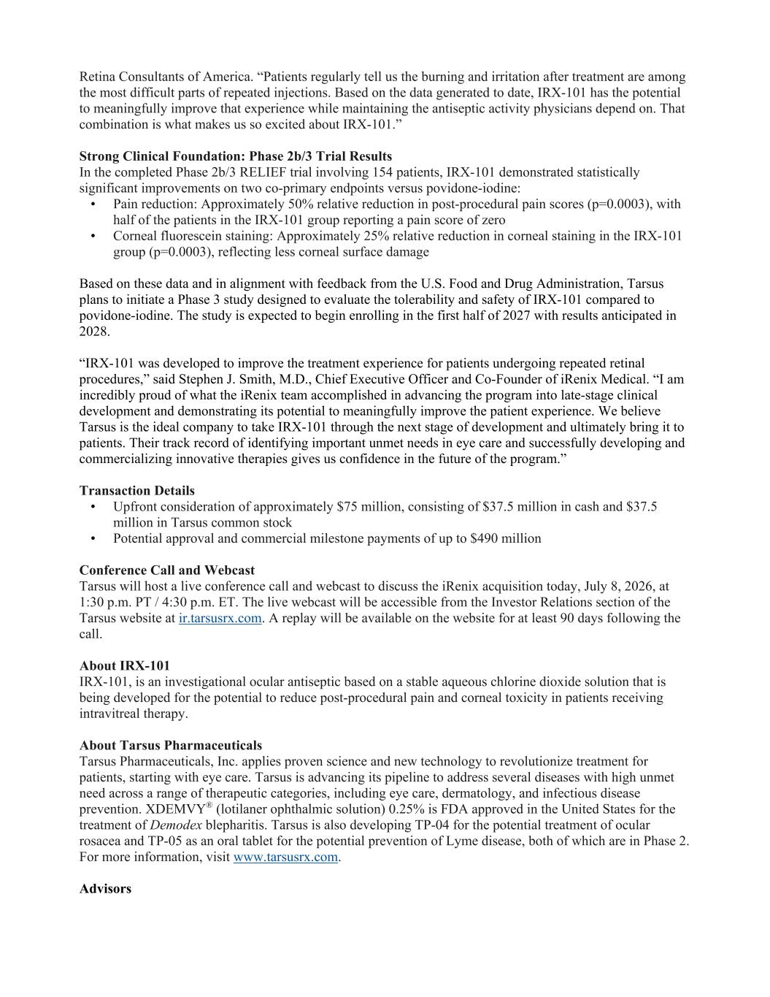
Retina Consultants of America. “Patients regularly tell us the burning and irritation after treatment are among the most difficult parts of repeated injections. Based on the data generated to date, IRX-101 has the potential to meaningfully improve that experience while maintaining the antiseptic activity physicians depend on. That combination is what makes us so excited about IRX-101.” Strong Clinical Foundation: Phase 2b/3 Trial Results In the completed Phase 2b/3 RELIEF trial involving 154 patients, IRX-101 demonstrated statistically significant improvements on two co-primary endpoints versus povidone-iodine: • Pain reduction: Approximately 50% relative reduction in post-procedural pain scores (p=0.0003), with half of the patients in the IRX-101 group reporting a pain score of zero • Corneal fluorescein staining: Approximately 25% relative reduction in corneal staining in the IRX-101 group (p=0.0003), reflecting less corneal surface damage Based on these data and in alignment with feedback from the U.S. Food and Drug Administration, Tarsus plans to initiate a Phase 3 study designed to evaluate the tolerability and safety of IRX-101 compared to povidone-iodine. The study is expected to begin enrolling in the first half of 2027 with results anticipated in 2028. “IRX-101 was developed to improve the treatment experience for patients undergoing repeated retinal procedures,” said Stephen J. Smith, M.D., Chief Executive Officer and Co-Founder of iRenix Medical. “I am incredibly proud of what the iRenix team accomplished in advancing the program into late-stage clinical development and demonstrating its potential to meaningfully improve the patient experience. We believe Tarsus is the ideal company to take IRX-101 through the next stage of development and ultimately bring it to patients. Their track record of identifying important unmet needs in eye care and successfully developing and commercializing innovative therapies gives us confidence in the future of the program.” Transaction Details • Upfront consideration of approximately $75 million, consisting of $37.5 million in cash and $37.5 million in Tarsus common stock • Potential approval and commercial milestone payments of up to $490 million Conference Call and Webcast Tarsus will host a live conference call and webcast to discuss the iRenix acquisition today, July 8, 2026, at 1:30 p.m. PT / 4:30 p.m. ET. The live webcast will be accessible from the Investor Relations section of the Tarsus website at ir.tarsusrx.com. A replay will be available on the website for at least 90 days following the call. About IRX-101 IRX-101, is an investigational ocular antiseptic based on a stable aqueous chlorine dioxide solution that is being developed for the potential to reduce post-procedural pain and corneal toxicity in patients receiving intravitreal therapy. About Tarsus Pharmaceuticals Tarsus Pharmaceuticals, Inc. applies proven science and new technology to revolutionize treatment for patients, starting with eye care. Tarsus is advancing its pipeline to address several diseases with high unmet need across a range of therapeutic categories, including eye care, dermatology, and infectious disease prevention. XDEMVY® (lotilaner ophthalmic solution) 0.25% is FDA approved in the United States for the treatment of Demodex blepharitis. Tarsus is also developing TP-04 for the potential treatment of ocular rosacea and TP-05 as an oral tablet for the potential prevention of Lyme disease, both of which are in Phase 2. For more information, visit www.tarsusrx.com. Advisors

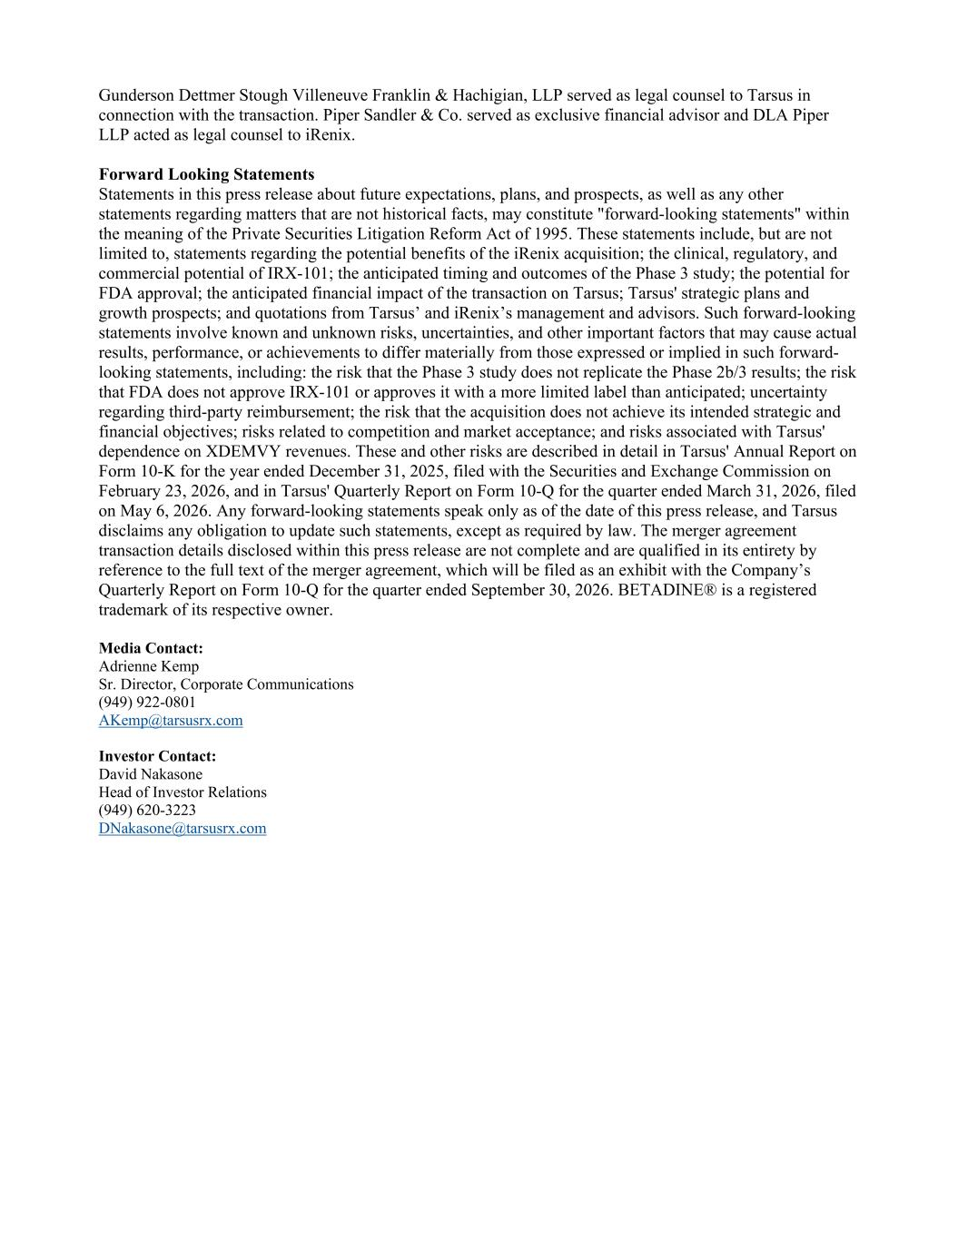
Gunderson Dettmer Stough Villeneuve Franklin & Hachigian, LLP served as legal counsel to Tarsus in connection with the transaction. Piper Sandler & Co. served as exclusive financial advisor and DLA Piper LLP acted as legal counsel to iRenix. Forward Looking Statements Statements in this press release about future expectations, plans, and prospects, as well as any other statements regarding matters that are not historical facts, may constitute "forward-looking statements" within the meaning of the Private Securities Litigation Reform Act of 1995. These statements include, but are not limited to, statements regarding the potential benefits of the iRenix acquisition; the clinical, regulatory, and commercial potential of IRX-101; the anticipated timing and outcomes of the Phase 3 study; the potential for FDA approval; the anticipated financial impact of the transaction on Tarsus; Tarsus' strategic plans and growth prospects; and quotations from Tarsus’ and iRenix’s management and advisors. Such forward-looking statements involve known and unknown risks, uncertainties, and other important factors that may cause actual results, performance, or achievements to differ materially from those expressed or implied in such forward- looking statements, including: the risk that the Phase 3 study does not replicate the Phase 2b/3 results; the risk that FDA does not approve IRX-101 or approves it with a more limited label than anticipated; uncertainty regarding third-party reimbursement; the risk that the acquisition does not achieve its intended strategic and financial objectives; risks related to competition and market acceptance; and risks associated with Tarsus' dependence on XDEMVY revenues. These and other risks are described in detail in Tarsus' Annual Report on Form 10-K for the year ended December 31, 2025, filed with the Securities and Exchange Commission on February 23, 2026, and in Tarsus' Quarterly Report on Form 10-Q for the quarter ended March 31, 2026, filed on May 6, 2026. Any forward-looking statements speak only as of the date of this press release, and Tarsus disclaims any obligation to update such statements, except as required by law. The merger agreement transaction details disclosed within this press release are not complete and are qualified in its entirety by reference to the full text of the merger agreement, which will be filed as an exhibit with the Company’s Quarterly Report on Form 10-Q for the quarter ended September 30, 2026. BETADINE® is a registered trademark of its respective owner. Media Contact: Adrienne Kemp Sr. Director, Corporate Communications (949) 922-0801 AKemp@tarsusrx.com Investor Contact: David Nakasone Head of Investor Relations (949) 620-3223 DNakasone@tarsusrx.com

