UNITED STATES
SECURITIES AND EXCHANGE COMMISSION
Washington, D.C. 20549
_______________
FORM 8-K
CURRENT REPORT
Pursuant to Section 13 OR 15(d) of The Securities Exchange Act of 1934
Date of Report (date of earliest event reported) July 31, 2026
_______________
TARSUS PHARMACEUTICALS, INC.
(Exact name of registrant as specified in its charter)
_______________
Delaware |  |  | 001-39614 |  |  |  |  |  | 81-4717861
(State or other jurisdiction of incorporation) |  |  | (Commission File Number) |  |  |  |  |  | (I.R.S. Employer Identification No.)
17700 Laguna Canyon Road, Floor 4
Irvine, CA 92618
(Address of principal executive offices, including Zip Code)
Registrant's telephone number, including area code: (949) 418-1801
Check the appropriate box below if the Form 8-K filing is intended to simultaneously satisfy the filing obligation of the registrant under any of the following provisions:
☐ |  |  | Written communications pursuant to Rule 425 under the Securities Act (17 CFR 230.425)
☐ |  |  | Soliciting material pursuant to Rule 14a-12 under the Exchange Act (17 CFR 240.14a-12)
☐ |  |  | Pre-commencement communications pursuant to Rule 14d-2(b) under the Exchange Act (17 CFR 240.14d-2(b))
☐ |  |  | Pre-commencement communications pursuant to Rule 13e-4(c) under the Exchange Act (17 CFR 240.13e-4(c))
Securities registered pursuant to Section 12(b) of the Act:
Title of each class |  |  | Trading Symbol(s) |  |  | Name of each exchange on which registered
Common Stock, $0.0001 par value per share |  |  | TARS |  |  | The Nasdaq Global Market LLC  (Nasdaq Global Select Market)
Indicate by check mark whether the registrant is an emerging growth company as defined in Rule 405 of the Securities Act of 1933 (§230.405 of this chapter) or Rule 12b-2 of the Securities Exchange Act of 1934 (§240.12b-2 of this chapter). Emerging growth company ☐
If an emerging growth company, indicate by check mark if the registrant has elected not to use the extended transition period for complying with any new or revised financial accounting standards provided pursuant to Section 13(a) of the Exchange Act. ☐

Item 1.01 Entry into a Material Definitive Agreement.

Merger Agreement

On July 31, 2026, Tarsus Pharmaceuticals, Inc. (the “Company”) entered into an Agreement and Plan of Merger (the “Merger Agreement”) with Alkeus Pharmaceuticals, Inc., a Delaware corporation (“Alkeus”), Apex 2026 Merger Sub, Inc., a Delaware corporation and wholly-owned subsidiary of the Company (“Merger Sub”), and Shareholder Representative Services LLC, as the securityholders’ representative. Pursuant to the Merger Agreement, and subject to the satisfaction or waiver of the conditions specified therein, Merger Sub will be merged with and into Alkeus (the “Merger”), with Alkeus surviving the Merger as a wholly-owned subsidiary of the Company (the “Acquisition”).

Upon the closing of the Acquisition, and subject to the terms and conditions of the Merger Agreement, the Company has agreed to pay up-front consideration (the “Up-front Consideration”) consisting of (i) an amount in cash equal to $270,000,000, subject to customary adjustments and a post-closing purchase price adjustment, and (ii) $180,000,000 of shares of common stock, par value $0.0001 per share (“Common Stock”), of the Company valued at $61.38 per share (the “Up-front Stock Consideration”). In addition to the Up-front Consideration, the Company has agreed to pay the equityholders of Alkeus: (i) milestone payments up to an aggregate amount equal to $350,000,000, $250,000,000 of which is payable in cash and/or shares of the Company’s Common Stock in such proportions as the Company may determine in its sole discretion, subject to certain limitations, upon achievement of regulatory approval of an Alkeus product in the United States (any such shares of Common Stock that the Company may elect to issue, the “Contingent Stock Consideration” and, together with the Up-front Stock Consideration, the “Stock Consideration”) and $100,000,000 of which is payable in cash upon first sale of an Alkeus product in the United States and (ii) tiered revenue sharing payments in the low-to-mid single digits as a percentage of annual worldwide gildeuretinol net sales, subject to certain reductions.

The Merger Agreement contains customary representations, warranties and covenants for a transaction of this nature.
The closing of the Acquisition is subject to customary closing conditions, including the expiration or termination of the applicable waiting period under the Hart-Scott-Rodino Antitrust Improvements Act. The Merger Agreement contains customary termination rights for the Company and Alkeus, including the right of either party to terminate the Merger Agreement if the Acquisition has not been consummated on or before 11:59 p.m. Eastern Time on October 31, 2026, subject to certain limitations and as such date may be extended to 11:59 p.m. Eastern Time on January 31, 2027, pursuant to the terms of the Merger Agreement (as such date may be so extended, the “Outside Date”). The Company expects that the Acquisition will be completed in 2026, subject to satisfaction of the closing conditions described above. There can be no assurances that the Acquisition will be consummated on the terms and in the timing described herein or at all.

Registration Rights Agreement

In connection with the Merger Agreement, on July 31, 2026, the Company entered into a Registration Rights Agreement (the “Registration Rights Agreement”) with certain stockholders of Alkeus, which will become effective as of and contingent upon the closing of the Acquisition. The Registration Rights Agreement requires the Company to take commercially reasonable efforts to (i) as soon as practicable, but in any event within the later of (x) 30 calendar days after the closing of the Acquisition and (y) 40 calendar days after the receipt by the Company of the financial statements that Alkeus is required to deliver to the Company pursuant to the Merger Agreement (the “Target Financials”), prepare and file with the Securities and Exchange Commission (the “SEC”) a shelf registration statement (the “Initial Resale Shelf”) covering the resale of the shares of Company Common Stock that will be issued to equityholders of Alkeus in connection with the closing of the Acquisition that constitute registrable securities under the Registration Rights Agreement and (ii) if the Initial Resale Shelf does not become effective immediately upon filing, cause the Initial Resale Shelf to become effective as soon as practicable after filing and in no event later than the date that is the later of (x) 90 calendar days after the closing of the Acquisition and (y) 100 calendar days after the receipt by the Company of the Target Financials. In addition, the Registration Rights Agreement requires the Company to take commercially reasonable efforts to (i) as soon as practicable, but in any event within 30 calendar days of the Company issuing any Contingent Stock Consideration, to file with the SEC a registration statement or post-effective amendment to the Initial Resale Shelf (the “Milestone Resale Shelf” and, together with the Initial Resale Shelf, the “Resale Shelf Registration Statements”) covering the resale of the Contingent Stock Consideration, and (ii) if the Milestone Resale Shelf does not become effective immediately upon filing, cause the Milestone Resale Shelf to become effective as soon as practicable after filing and in no event later than the date that is 90 calendar days after the date of issuance of the applicable Contingent Stock Consideration.

The Company has agreed to use commercially reasonable efforts to keep the Resale Shelf Registration Statements continuously effective until there are no longer any registrable securities outstanding, subject to certain delay rights. The Registration Rights Agreement also grants the Alkeus stockholders party thereto the right, subject to specified conditions, to require the Company to effect underwritten shelf take-downs of the Stock Consideration. The Company is required to bear all

expenses incurred in connection with the filing of the Resale Shelf Registration Statements and any such offerings, other than any underwriting discounts, selling commissions or stock transfer taxes relating to the resale of the Stock Consideration.

In the event that the Merger Agreement is terminated or the Acquisition does not close by the Outside Date, then the Registration Rights Agreement will terminate and shall automatically be void ab initio.

Joinder and Lock-Up Agreements

In connection with the Merger Agreement, on July 31, 2026, certain stockholders of Alkeus entered into joinders to the Merger Agreement (the “Joinder and Lock-Up Agreements”). Pursuant to these Joinder and Lock-Up Agreements, the Alkeus stockholders party thereto agreed, among other things, not to, directly or indirectly, sell, offer or agree to sell, or otherwise transfer, loan or pledge, through swap or hedging transactions, grant any option to purchase, make any short sale of or otherwise dispose of any of their Up-front Stock Consideration without the prior written consent of the Company for a period of two months following the closing of the Acquisition (the “Lock-up Period”), subject to certain customary exceptions. Notwithstanding the foregoing, to the extent the Company grants an early release or waiver from the lock-up provisions (a “Triggering Release”) to any Alkeus stockholder (except (i) if the aggregate number of shares released pursuant to all Triggering Releases is less than or equal to 1.0% of the total number of shares issued as Up-front Stock Consideration or (ii) if due to circumstances of an emergency or hardship, as determined by the Company in its sole discretion), the other Alkeus stockholders shall also be released from the lock-up provisions on a pro rata basis.

In addition, certain stockholders of Alkeus that will receive more than $7.0 million in Up-front Stock Consideration upon the closing of the Acquisition have agreed to certain selling limitations related to the Company’s average trading volume for a period of three months following the end of the Lock-up Period.

The foregoing descriptions of the Merger Agreement, the Registration Rights Agreement and the Joinder and Lock-Up Agreements are not complete and are qualified in their entirety by reference to the full text of the Merger Agreement, the Registration Rights Agreement and the Joinder and Lock-Up Agreements, which will be filed as exhibits with the Company’s Quarterly Report on Form 10-Q for the quarter ended September 30, 2026.
Item 3.02 Unregistered Sales of Equity Securities.
To the extent required by this Item, the information included in Item 1.01 of this Current Report on Form 8-K is incorporated herein by reference.

The Up-front Stock Consideration and the Contingent Stock Consideration, if any, will be issued, in private placements exempt from registration under Section 4(a)(2) of the Securities Act of 1933, as amended (the “Securities Act”), and/or Regulation D promulgated thereunder, because the offer and sale of such securities did not or will not involve a “public offering” as defined in Section 4(a)(2) of the Securities Act, and other applicable requirements were met. The issuance of the Up-front Stock Consideration, and the Contingent Stock Consideration, if any, will be, made only to those stockholders of Alkeus determined to be “accredited investors” as defined pursuant to Rule 501(a) of Regulation D promulgated under the Securities Act.
Item 8.01 Other Events.

On August 6, 2026, the Company issued a press release announcing the Merger Agreement. A copy of the press release is attached hereto as Exhibit 99.1 and is incorporated herein by reference.

Forward-Looking Statements

Statements in this Current Report on Form 8-K about future expectations, plans and prospects, as well as any other statements regarding matters that are not historical facts, may constitute “forward-looking statements.” These statements include, but are not limited to, statements relating to the closing of the Acquisition; the anticipated strategic and financial benefits of the Acquisition; the potential achievement of the milestones and the timing and amount of any milestone payments or royalty payments; and the timing of filing and effectiveness of the Resale Shelf Registration Statements under the Registration Rights Agreement. The words, without limitation, “believe,” “contemplate,” “continue,” “could,” “estimate,” “expect,” “intend,” “may,” “might,” “plan,” “potential,” “predict,” “project,” “should,” “target,” “will” or “would” or the negative of these terms or other similar expressions are intended to identify forward-looking statements, although not all forward-looking statements contain these or similar identifying words. Actual results may differ materially from those indicated by such forward-looking statements as a result of various important factors, including the factors discussed in the “Risk Factors” section of the Company’s filings with the SEC. Any forward-looking statements contained in this Current Report on

Form 8-K are based on the current expectations of the Company’s management team and speak only as of the date hereof, and the Company specifically disclaims any obligation to update any forward-looking statement, whether as a result of new information, future events or otherwise, except as required by law.

Item 9.01 Financial Statements and Exhibits.

(d) Exhibits.
Exhibit No. |  |  |  |  |  |  |  |  | Description
99.1 |  |  |  |  |  |  |  |  | Press Release issued by the Company, dated August 6, 2026.
104 |  |  |  |  |  |  |  |  | Cover Page Interactive Data File (embedded within XBRL document)

SIGNATURES

Pursuant to the requirements of the Securities Exchange Act of 1934, as amended, the registrant has duly caused this report to be signed on its behalf by the undersigned hereunto duly authorized.

 |  |  |  |  |  |  |  |  |  |  |  |  |  |  | TARSUS PHARMACEUTICALS, INC.
Date: |  |  | August 6, 2026 |  |  |  |  |  |  |  |  | By: |  |  | /s/ Jeffrey Farrow
 |  |  |  |  |  |  |  |  |  |  |  |  |  |  | Jeffrey Farrow
 |  |  |  |  |  |  |  |  |  |  |  |  |  |  | Chief Financial Officer and Chief Strategy Officer
 |  |  |  |  |  |  |  |  |  |  |  |  |  |  | (Principal Financial Officer and Principal Accounting Officer)
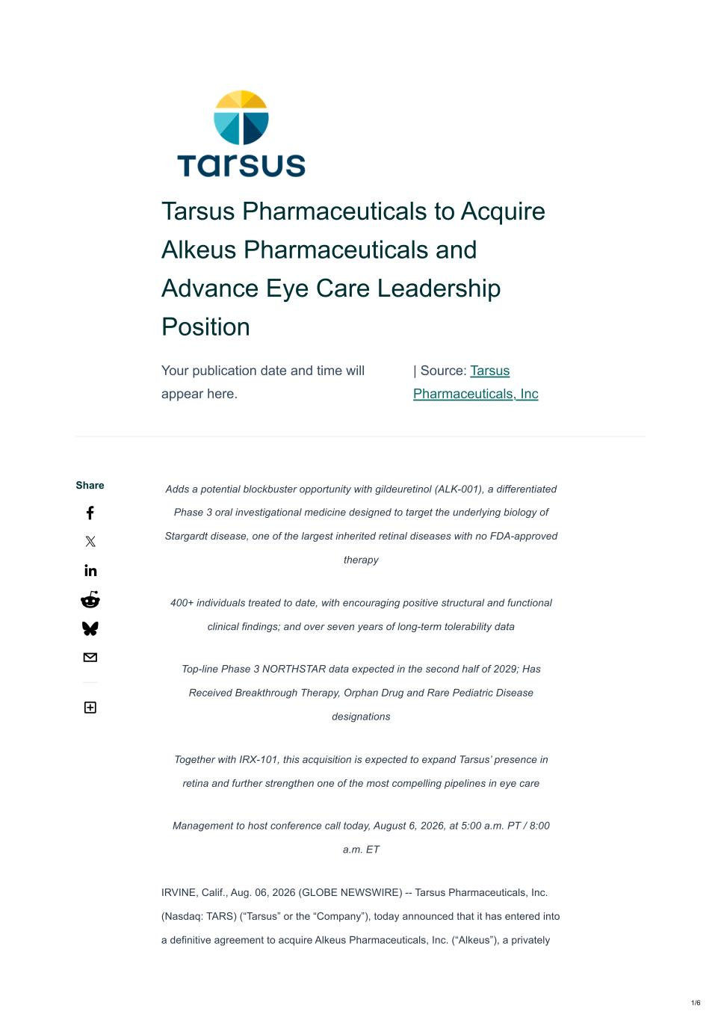

Tarsus Pharmaceuticals to Acquire Alkeus Pharmaceuticals and Advance Eye Care Leadership Position Your publication date and time will appear here. | Source: Tarsus Pharmaceuticals, Inc Adds a potential blockbuster opportunity with gildeuretinol (ALK-001), a differentiated Phase 3 oral investigational medicine designed to target the underlying biology of Stargardt disease, one of the largest inherited retinal diseases with no FDA-approved therapy 400+ individuals treated to date, with encouraging positive structural and functional clinical findings; and over seven years of long-term tolerability data Top-line Phase 3 NORTHSTAR data expected in the second half of 2029; Has Received Breakthrough Therapy, Orphan Drug and Rare Pediatric Disease designations Together with IRX-101, this acquisition is expected to expand Tarsus’ presence in retina and further strengthen one of the most compelling pipelines in eye care Management to host conference call today, August 6, 2026, at 5:00 a.m. PT / 8:00 a.m. ET IRVINE, Calif., Aug. 06, 2026 (GLOBE NEWSWIRE) -- Tarsus Pharmaceuticals, Inc. (Nasdaq: TARS) (“Tarsus” or the “Company”), today announced that it has entered into a definitive agreement to acquire Alkeus Pharmaceuticals, Inc. (“Alkeus”), a privately Share 1/6

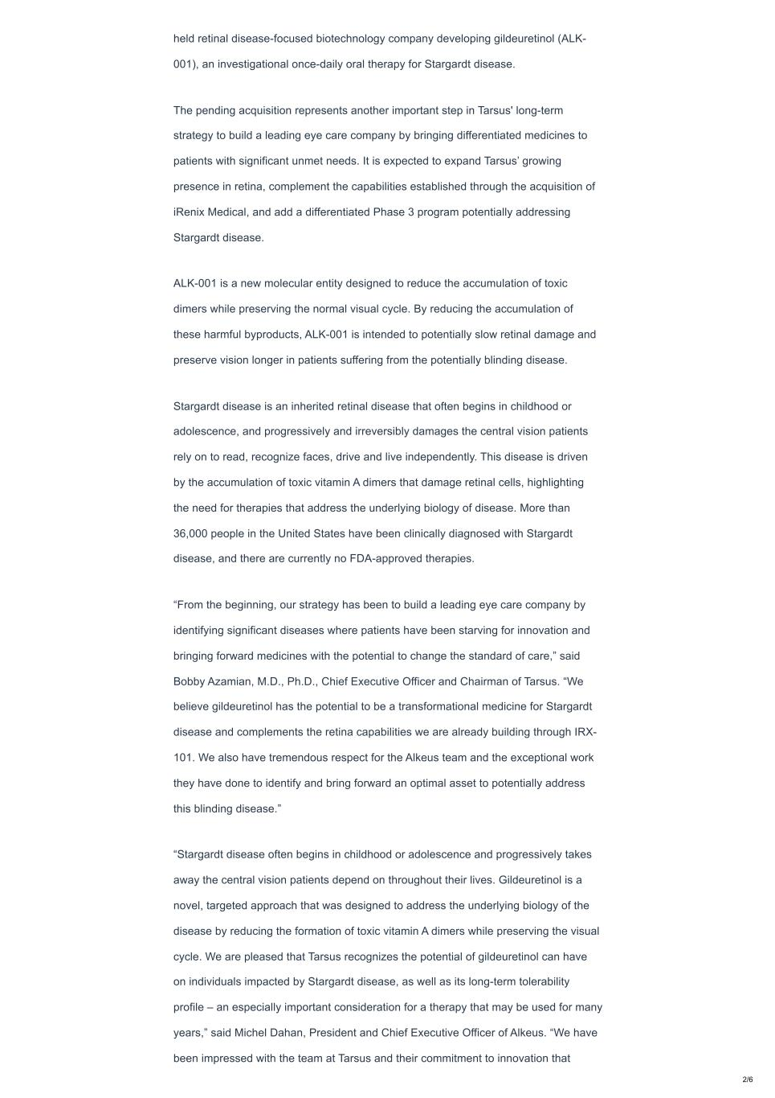
held retinal disease-focused biotechnology company developing gildeuretinol (ALK- 001), an investigational once-daily oral therapy for Stargardt disease. The pending acquisition represents another important step in Tarsus' long-term strategy to build a leading eye care company by bringing differentiated medicines to patients with significant unmet needs. It is expected to expand Tarsus’ growing presence in retina, complement the capabilities established through the acquisition of iRenix Medical, and add a differentiated Phase 3 program potentially addressing Stargardt disease. ALK-001 is a new molecular entity designed to reduce the accumulation of toxic dimers while preserving the normal visual cycle. By reducing the accumulation of these harmful byproducts, ALK-001 is intended to potentially slow retinal damage and preserve vision longer in patients suffering from the potentially blinding disease. Stargardt disease is an inherited retinal disease that often begins in childhood or adolescence, and progressively and irreversibly damages the central vision patients rely on to read, recognize faces, drive and live independently. This disease is driven by the accumulation of toxic vitamin A dimers that damage retinal cells, highlighting the need for therapies that address the underlying biology of disease. More than 36,000 people in the United States have been clinically diagnosed with Stargardt disease, and there are currently no FDA-approved therapies. “From the beginning, our strategy has been to build a leading eye care company by identifying significant diseases where patients have been starving for innovation and bringing forward medicines with the potential to change the standard of care,” said Bobby Azamian, M.D., Ph.D., Chief Executive Officer and Chairman of Tarsus. “We believe gildeuretinol has the potential to be a transformational medicine for Stargardt disease and complements the retina capabilities we are already building through IRX- 101. We also have tremendous respect for the Alkeus team and the exceptional work they have done to identify and bring forward an optimal asset to potentially address this blinding disease.” “Stargardt disease often begins in childhood or adolescence and progressively takes away the central vision patients depend on throughout their lives. Gildeuretinol is a novel, targeted approach that was designed to address the underlying biology of the disease by reducing the formation of toxic vitamin A dimers while preserving the visual cycle. We are pleased that Tarsus recognizes the potential of gildeuretinol can have on individuals impacted by Stargardt disease, as well as its long-term tolerability profile – an especially important consideration for a therapy that may be used for many years,” said Michel Dahan, President and Chief Executive Officer of Alkeus. “We have been impressed with the team at Tarsus and their commitment to innovation that 2/6

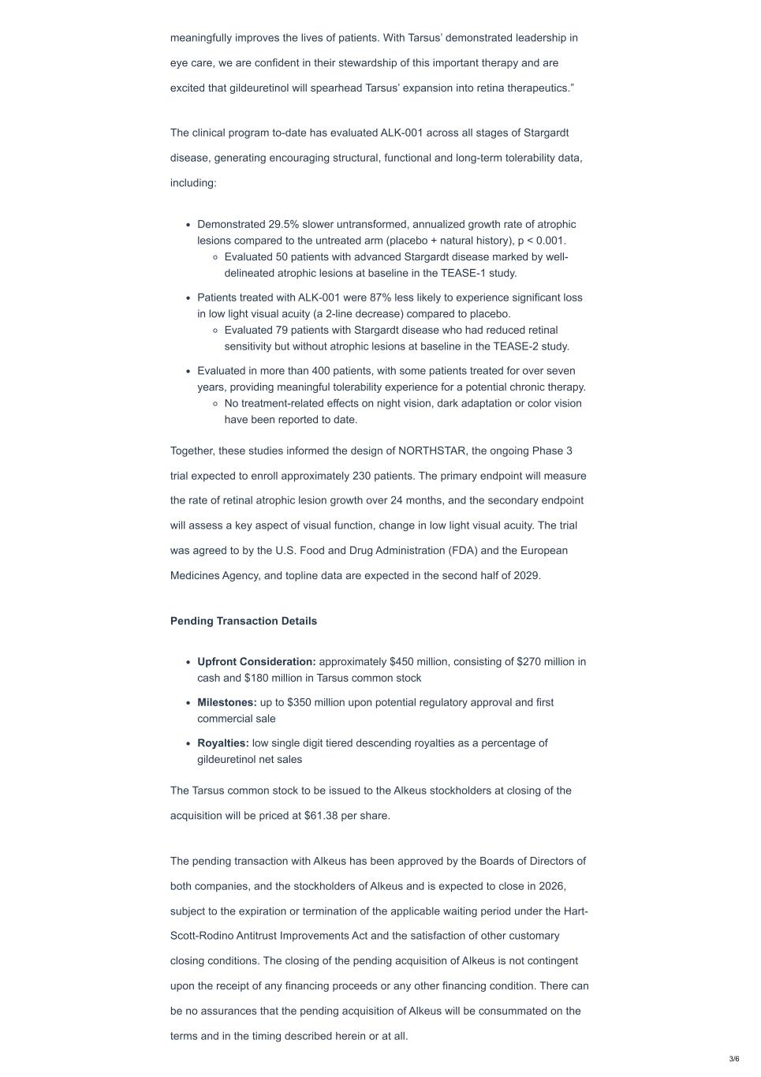
meaningfully improves the lives of patients. With Tarsus’ demonstrated leadership in eye care, we are confident in their stewardship of this important therapy and are excited that gildeuretinol will spearhead Tarsus’ expansion into retina therapeutics.” The clinical program to-date has evaluated ALK-001 across all stages of Stargardt disease, generating encouraging structural, functional and long-term tolerability data, including: Demonstrated 29.5% slower untransformed, annualized growth rate of atrophic lesions compared to the untreated arm (placebo + natural history), p < 0.001. Evaluated 50 patients with advanced Stargardt disease marked by well- delineated atrophic lesions at baseline in the TEASE-1 study. Patients treated with ALK-001 were 87% less likely to experience significant loss in low light visual acuity (a 2-line decrease) compared to placebo. Evaluated 79 patients with Stargardt disease who had reduced retinal sensitivity but without atrophic lesions at baseline in the TEASE-2 study. Evaluated in more than 400 patients, with some patients treated for over seven years, providing meaningful tolerability experience for a potential chronic therapy. No treatment-related effects on night vision, dark adaptation or color vision have been reported to date. Together, these studies informed the design of NORTHSTAR, the ongoing Phase 3 trial expected to enroll approximately 230 patients. The primary endpoint will measure the rate of retinal atrophic lesion growth over 24 months, and the secondary endpoint will assess a key aspect of visual function, change in low light visual acuity. The trial was agreed to by the U.S. Food and Drug Administration (FDA) and the European Medicines Agency, and topline data are expected in the second half of 2029. Pending Transaction Details Upfront Consideration: approximately $450 million, consisting of $270 million in cash and $180 million in Tarsus common stock Milestones: up to $350 million upon potential regulatory approval and first commercial sale Royalties: low single digit tiered descending royalties as a percentage of gildeuretinol net sales The Tarsus common stock to be issued to the Alkeus stockholders at closing of the acquisition will be priced at $61.38 per share. The pending transaction with Alkeus has been approved by the Boards of Directors of both companies, and the stockholders of Alkeus and is expected to close in 2026, subject to the expiration or termination of the applicable waiting period under the Hart- Scott-Rodino Antitrust Improvements Act and the satisfaction of other customary closing conditions. The closing of the pending acquisition of Alkeus is not contingent upon the receipt of any financing proceeds or any other financing condition. There can be no assurances that the pending acquisition of Alkeus will be consummated on the terms and in the timing described herein or at all. 3/6

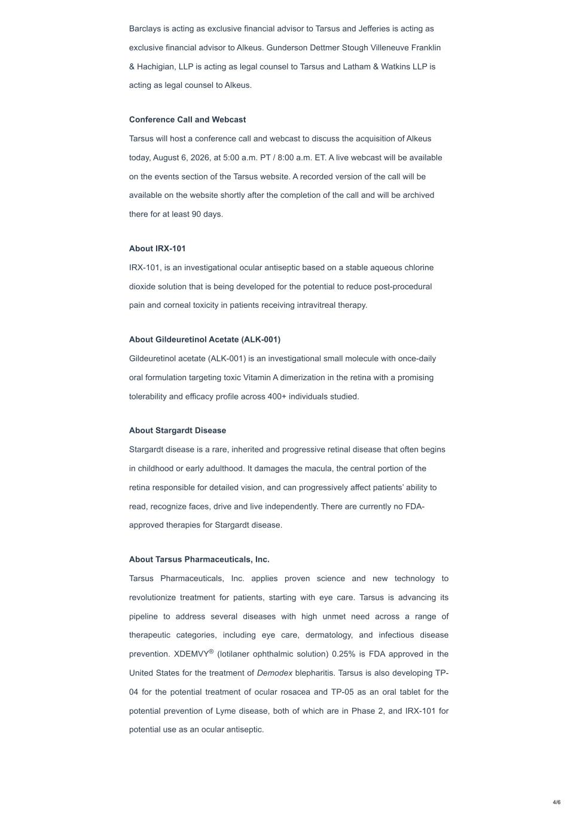
Barclays is acting as exclusive financial advisor to Tarsus and Jefferies is acting as exclusive financial advisor to Alkeus. Gunderson Dettmer Stough Villeneuve Franklin & Hachigian, LLP is acting as legal counsel to Tarsus and Latham & Watkins LLP is acting as legal counsel to Alkeus. Conference Call and Webcast Tarsus will host a conference call and webcast to discuss the acquisition of Alkeus today, August 6, 2026, at 5:00 a.m. PT / 8:00 a.m. ET. A live webcast will be available on the events section of the Tarsus website. A recorded version of the call will be available on the website shortly after the completion of the call and will be archived there for at least 90 days. About IRX-101 IRX-101, is an investigational ocular antiseptic based on a stable aqueous chlorine dioxide solution that is being developed for the potential to reduce post-procedural pain and corneal toxicity in patients receiving intravitreal therapy. About Gildeuretinol Acetate (ALK-001) Gildeuretinol acetate (ALK-001) is an investigational small molecule with once-daily oral formulation targeting toxic Vitamin A dimerization in the retina with a promising tolerability and efficacy profile across 400+ individuals studied. About Stargardt Disease Stargardt disease is a rare, inherited and progressive retinal disease that often begins in childhood or early adulthood. It damages the macula, the central portion of the retina responsible for detailed vision, and can progressively affect patients’ ability to read, recognize faces, drive and live independently. There are currently no FDA- approved therapies for Stargardt disease. About Tarsus Pharmaceuticals, Inc. Tarsus Pharmaceuticals, Inc. applies proven science and new technology to revolutionize treatment for patients, starting with eye care. Tarsus is advancing its pipeline to address several diseases with high unmet need across a range of therapeutic categories, including eye care, dermatology, and infectious disease prevention. XDEMVY (lotilaner ophthalmic solution) 0.25% is FDA approved in the United States for the treatment of Demodex blepharitis. Tarsus is also developing TP- 04 for the potential treatment of ocular rosacea and TP-05 as an oral tablet for the potential prevention of Lyme disease, both of which are in Phase 2, and IRX-101 for potential use as an ocular antiseptic. ® 4/6

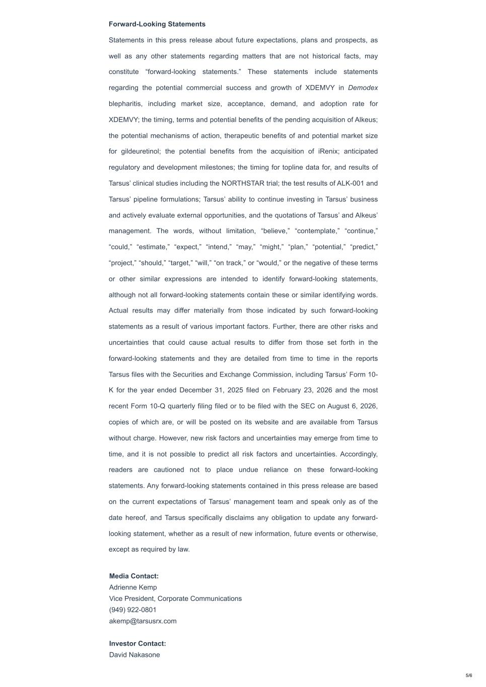
Forward-Looking Statements Statements in this press release about future expectations, plans and prospects, as well as any other statements regarding matters that are not historical facts, may constitute “forward-looking statements.” These statements include statements regarding the potential commercial success and growth of XDEMVY in Demodex blepharitis, including market size, acceptance, demand, and adoption rate for XDEMVY; the timing, terms and potential benefits of the pending acquisition of Alkeus; the potential mechanisms of action, therapeutic benefits of and potential market size for gildeuretinol; the potential benefits from the acquisition of iRenix; anticipated regulatory and development milestones; the timing for topline data for, and results of Tarsus’ clinical studies including the NORTHSTAR trial; the test results of ALK-001 and Tarsus’ pipeline formulations; Tarsus’ ability to continue investing in Tarsus’ business and actively evaluate external opportunities, and the quotations of Tarsus’ and Alkeus’ management. The words, without limitation, “believe,” “contemplate,” “continue,” “could,” “estimate,” “expect,” “intend,” “may,” “might,” “plan,” “potential,” “predict,” “project,” “should,” “target,” “will,” “on track,” or “would,” or the negative of these terms or other similar expressions are intended to identify forward-looking statements, although not all forward-looking statements contain these or similar identifying words. Actual results may differ materially from those indicated by such forward-looking statements as a result of various important factors. Further, there are other risks and uncertainties that could cause actual results to differ from those set forth in the forward-looking statements and they are detailed from time to time in the reports Tarsus files with the Securities and Exchange Commission, including Tarsus’ Form 10- K for the year ended December 31, 2025 filed on February 23, 2026 and the most recent Form 10-Q quarterly filing filed or to be filed with the SEC on August 6, 2026, copies of which are, or will be posted on its website and are available from Tarsus without charge. However, new risk factors and uncertainties may emerge from time to time, and it is not possible to predict all risk factors and uncertainties. Accordingly, readers are cautioned not to place undue reliance on these forward-looking statements. Any forward-looking statements contained in this press release are based on the current expectations of Tarsus’ management team and speak only as of the date hereof, and Tarsus specifically disclaims any obligation to update any forward- looking statement, whether as a result of new information, future events or otherwise, except as required by law. Media Contact: Adrienne Kemp Vice President, Corporate Communications (949) 922-0801 akemp@tarsusrx.com Investor Contact: David Nakasone 5/6


Head of Investor Relations (949) 620-3223 DNakasone@tarsusrx.com 6/6

