SEC Form 3
FORM 3 | UNITED STATES SECURITIES AND EXCHANGE COMMISSION  Washington, D.C. 20549  INITIAL STATEMENT OF BENEFICIAL OWNERSHIP OF SECURITIES  Filed pursuant to Section 16(a) of the Securities Exchange Act of 1934  or Section 30(h) of the Investment Company Act of 1940
  OMB APPROVAL
  OMB Number: | 3235-0104
  Estimated average burden
  hours per response: | 0.5
1. Name and Address of Reporting Person*  (Street) | 2. Date of Event Requiring Statement (Month/Day/Year)  04/24/2023 | 3. Issuer Name and Ticker or Trading Symbol  Tarsus Pharmaceuticals, Inc. [ TARS ]
  Farrow Jeffrey S
  (Last) | (First) | (Middle)
  C/O TARSUS PHARMACEUTICALS, INC.
  15440 LAGUNA CANYON ROAD, SUITE 160
  IRVINE | CA | 92618
  (City) | (State) | (Zip)
 |  | 4. Relationship of Reporting Person(s) to Issuer  (Check all applicable) | 5. If Amendment, Date of Original Filed (Month/Day/Year)
   | Director |  | 10% Owner
  X | Officer (give title below) |  | Other (specify below)
  See Remarks
6. Individual or Joint/Group Filing (Check Applicable Line)
X | Form filed by One Reporting Person
 | Form filed by More than One Reporting Person

Table I - Non-Derivative Securities Beneficially Owned
1. Title of Security (Instr. 4) | 2. Amount of Securities Beneficially Owned (Instr. 4) | 3. Ownership Form: Direct (D) or Indirect (I) (Instr. 5) | 4. Nature of Indirect Beneficial Ownership (Instr. 5)
Table II - Derivative Securities Beneficially Owned
(e.g., puts, calls, warrants, options, convertible securities)
1. Title of Derivative Security (Instr. 4) | 2. Date Exercisable and Expiration Date (Month/Day/Year) |  | 3. Title and Amount of Securities Underlying Derivative Security (Instr. 4) |  | 4. Conversion or Exercise Price of Derivative Security | 5. Ownership Form: Direct (D) or Indirect (I) (Instr. 5) | 6. Nature of Indirect Beneficial Ownership (Instr. 5)
1. Title of Derivative Security (Instr. 4) | Date Exercisable | Expiration Date | Title | Amount or Number of Shares | 4. Conversion or Exercise Price of Derivative Security | 5. Ownership Form: Direct (D) or Indirect (I) (Instr. 5) | 6. Nature of Indirect Beneficial Ownership (Instr. 5)
Explanation of Responses:
Remarks:
Chief Financial Officer and Chief Strategic Officer Exhibit 24 - Power of Attorney
No securities are beneficially owned.
 | /s/ Jeffrey Farrow | 04/26/2023
 | ** Signature of Reporting Person | Date
Reminder: Report on a separate line for each class of securities beneficially owned directly or indirectly.
* If the form is filed by more than one reporting person, see Instruction 5 (b)(v).
** Intentional misstatements or omissions of facts constitute Federal Criminal Violations See 18 U.S.C. 1001 and 15 U.S.C. 78ff(a).
Note: File three copies of this Form, one of which must be manually signed. If space is insufficient, see Instruction 6 for procedure.
Persons who respond to the collection of information contained in this form are not required to respond unless the form displays a currently valid OMB Number.
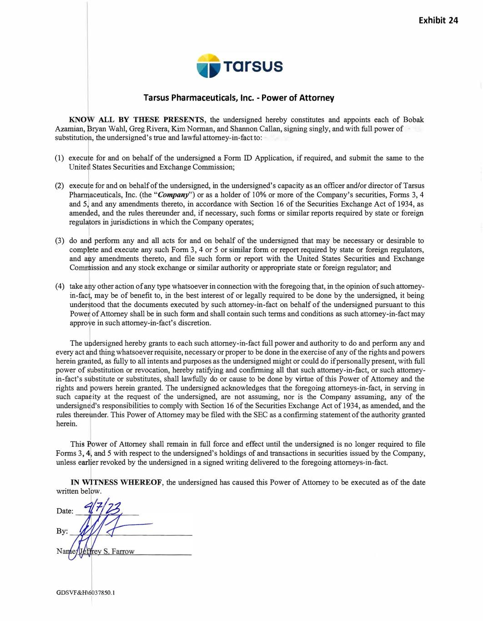
Tarsus Pharmaceuticals, Inc. - Power of Attorney KNO ALL BY THESE PRESENTS, the undersigned hereby constitutes and appoints each of Bobak Azamian, Bryan Wahl, Greg Rivera, Kirn Norman, and Shannon Callan, signing singly, and with full power of substitution, the undersigned's true and lawful attorney-in-fact to: (1) execu e for and on behalf of the undersigned a Form ID Application, if required, and submit the same to the Unite , States Securities and Exchange Commission; (2) execu e for and on behalf of the undersigned, in the undersigned's capacity as an officer and/or director of Tarsus Pha ] aceuticals, Inc. (the "Company") or as a holder of 10% or more of the Company's securities, Forms 3, 4 and 5 and any amendments thereto, in accordance with Section 16 of the Securities Exchange Act of 1934, as amen ed, and the rules thereunder and, if necessary, such forms or similar reports required by state or foreign regulalt:ors in jurisdictions in which the Company operates; (3) do an� petlorm any and all acts fo, and on behalf of the unden;igned that may be necessary m desirnble to comp�ete and execute any such Form 3, 4 or 5 or similar form or report required by state or foreign regulators, and atJ.y amendments thereto, and file such form or report with the United States Securities and Exchange Co ! ission and any stock exchange or similar authority or appropriate state or foreign regulator; and ( 4) take a y other action of any type whatsoever in connection with the foregoing that, in the opinion of such attorney in-fac , may be of benefit to, in the best interest of or legally required to be done by the undersigned, it being under tood that the documents executed by such attorney-in-fact on behalf of the undersigned pursuant to this Powe of Attorney shall be in such form and shall contain such terms and conditions as such attorney-in-fact may appro e in such attorney-in-fact's discretion. The undersigned hereby grants to each such attorney-in-fact full power and authority to do and perform any and every act 1 1 d thing whatsoever requisite, necessary or proper to be done in the exercise of any of the rights and powers herein gr ted, as fully to all intents and purposes as the undersigned might or could do if personally present, with full power of bstitution or revocation, hereby ratifying and confirming all that such attorney-in-fact, or such attorney in-fact's s bstitute or substitutes, shall lawfully do or cause to be done by virtue of this Power of Attorney and the rights and owers herein granted. The undersigned acknowledges that the foregoing attorneys-in-fact, in serving in such capa, ity at the request of the undersigned, are not assuming, nor is the Company assuming, any of the undersign d's responsibilities to comply with Section 16 of the Securities Exchange Act of 1934, as amended, and the rules there der. This Power of Attorney may be filed with the SEC as a confirming statement of the authority granted herein. Thi � Bower of Attorney shall remain in full force and effect until the undersigned is no longer required to file Forms 3, 4 and 5 with respect to the undersigned's holdings of and transactions in securities issued by the Company, unless earl er revoked by the undersigned in a signed writing delivered to the foregoing attorneys-in-fact. IN TNESS WHEREOF, the undersigned has caused this Power of Attorney to be executed as of the date written bel 1 w. Date: � 1-, h N GDSVF&H\6\037850.1 Exhibit 24

