SEC Form 4

FORM 4

Check this box if no longer subject to Section 16. Form 4 or Form 5 obligations may continue. See Instruction 1(b).

UNITED STATES SECURITIES AND EXCHANGE COMMISSION
Washington, D.C. 20549
Washington, D.C. 20549 |  | OMB APPROVAL
STATEMENT OF CHANGES IN BENEFICIAL OWNERSHIP
STATEMENT OF CHANGES IN BENEFICIAL OWNERSHIP |  | OMB Number: | 3235-0287
 |  | Estimated average burden
Filed pursuant to Section 16(a) of the Securities Exchange Act of 1934 |  | hours per response: | 0.5
or Section 30(h) of the Investment Company Act of 1940
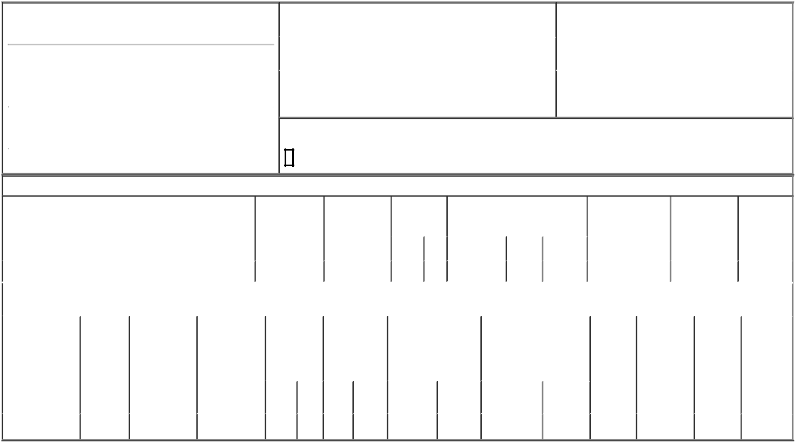

1. Name and Address of Reporting Person*
LINK WILLIAM J PHD

 | (Last) | (First) | (Middle)
 | C/O TARSUS PHARMACEUTICALS, INC.
 | 15440 LAGUNA CANYON ROAD, SUITE 160
(Street)
 | IRVINE | CA | 92618
 | (City) | (State) | (Zip)

2. |  | Issuer Name and Ticker or Trading Symbol |  | 5. | Relationship of Reporting Person(s) to Issuer
 | Tarsus Pharmaceuticals, Inc. [ TARS ] |  |  | (Check all applicable)
 |  |  |  |  | X | Director | 10% Owner
3. |  | Date of Earliest Transaction (Month/Day/Year) |  |  |  | Officer (give title | Other (specify
06/16/2023 |  |  |  |  |  | below) | below)
4. |  | If Amendment, Date of Original Filed (Month/Day/Year) |  | 6. | Individual or Joint/Group Filing (Check Applicable Line)
 |  |  |  |  | X | Form filed by One Reporting Person
 |  |  |  |  |  | Form filed by More than One Reporting Person

Rule 10b5-1(c) Transaction Indication

Check this box to indicate that a transaction was made pursuant to a contract, instruction or written plan that is intended to satisfy the affirmative defense conditions of Rule 10b5-1(c). See Instruction 10.

Table I - Non-Derivative Securities Acquired, Disposed of, or Beneficially Owned

1. Title of Security (Instr. 3) |  |  |  | 2. Transaction |  | 2A. Deemed |  | 3. | 4. Securities Acquired (A) or |  |  |  |  | 5. Amount of |  | 6. Ownership |  | 7. Nature of
 |  |  |  | Date |  | Execution Date, |  | Transaction | Disposed Of (D) (Instr. 3, 4 and 5) |  |  |  |  | Securities |  | Form: Direct (D) |  | Indirect
 |  |  |  | (Month/Day/Year) |  | if any |  | Code (Instr. |  |  |  |  |  | Beneficially Owned |  | or Indirect (I) |  | Beneficial
 |  |  |  |  |  | (Month/Day/Year) |  | 8) |  |  |  |  |  | Following Reported |  | (Instr. 4) |  | Ownership
 |  |  |  |  |  |  |  |  |  |  |  |  |  | Transaction(s) (Instr. |  |  |  | (Instr. 4)
 |  |  |  |  |  |  |  |  |  |  | (A) or |  |  |  |  |  |  | (Instr. 4)
 |  |  |  |  |  |  |  | Code V | Amount |  | (A) or | Price |  | 3 and 4)
 |  |  |  |  |  |  |  | Code V | Amount |  | (D)
Common Stock |  |  |  | 06/16/2023 |  |  |  | _{M}(1) | 2,000 |  | A | (1) |  | 136,632 |  |  | D
 |  |  | Table II - Derivative Securities Acquired, Disposed of, or Beneficially Owned
 |  |  | (e.g., puts, calls, warrants, options, convertible securities)
1. Title of Derivative | 2. | 3. Transaction | 3A. Deemed |  | 4. Transaction | 5. Number of |  | 6. Date Exercisable and |  | 7. Title and Amount of |  |  |  | 8. Price of | 9. Number of |  | 10. | 11. Nature
Security (Instr. 3) | Conversion | Date | Execution Date, |  | Code (Instr. 8) | Derivative |  | Expiration Date |  | Securities Underlying |  |  |  | Derivative | derivative |  | Ownership | of Indirect
 | or Exercise | (Month/Day/Year) | if any |  |  | Securities |  | (Month/Day/Year) |  | Derivative Security (Instr. 3 |  |  |  | Security | Securities |  | Form: | Beneficial
 | Price of |  | (Month/Day/Year) |  |  | Acquired (A) or |  |  |  | and 4) |  |  |  | (Instr. 5) | Beneficially |  | Direct (D) | Ownership
 | Derivative |  |  |  |  | Disposed of (D) |  |  |  |  |  |  |  |  | Owned |  | or Indirect | (Instr. 4)
 | Security |  |  |  |  | (Instr. 3, 4 and |  |  |  |  |  |  |  |  | Following |  | (I) (Instr. 4)
 |  |  |  |  |  | 5) |  |  |  |  |  |  |  |  | Reported
 |  |  |  |  |  |  |  |  |  |  |  |  |  |  | Transaction(s)
 |  |  |  |  |  |  |  |  |  |  |  | Amount or
 |  |  |  |  |  |  |  | Date | Expiration |  |  |  |  |  | (Instr. 4)
 |  |  |  |  | Code V | (A) | (D) | Date | Expiration | Title |  | Number of
 |  |  |  |  | Code V | (A) | (D) | Exercisable | Date | Title |  | Shares
Restricted Stock | (2) | 06/16/2023 |  |  | M |  | 2,000 | (3) | (3) | Common Stock |  | 2,000 |  | $0 | 0 |  | D
Units | (2) | 06/16/2023 |  |  | M |  |  |  |  |  |  |  |  | $0 | 0 |  | D

Explanation of Responses:

- The shares were issued pursuant to settlement of vested Restricted Stock Units ("RSUs"). Each RSU represents a contingent right to receive one share of the Company's common stock.

- Each RSU represents a contingent right to receive one share of the Company's common stock.

- RSUs granted on June 16, 2022, in connection with the Reporting Person's service as a non-employee director as of the Company's 2022 annual meeting of stockholders. The RSUs vest in full on the one-year anniversary of the date of grant, subject to the non-employee director's continuous service.

Remarks:

Exhibit 24 - Power of Attorney

/s/ Jeffrey Farrow, Attorney-in-Fact |  | 06/21/2023
** Signature of Reporting Person |  | Date

Reminder: Report on a separate line for each class of securities beneficially owned directly or indirectly.

* If the form is filed by more than one reporting person, see Instruction 4 (b)(v).

- Intentional misstatements or omissions of facts constitute Federal Criminal Violations See 18 U.S.C. 1001 and 15 U.S.C. 78ff(a). Note: File three copies of this Form, one of which must be manually signed. If space is insufficient, see Instruction 6 for procedure.
Persons who respond to the collection of information contained in this form are not required to respond unless the form displays a currently valid OMB Number.



