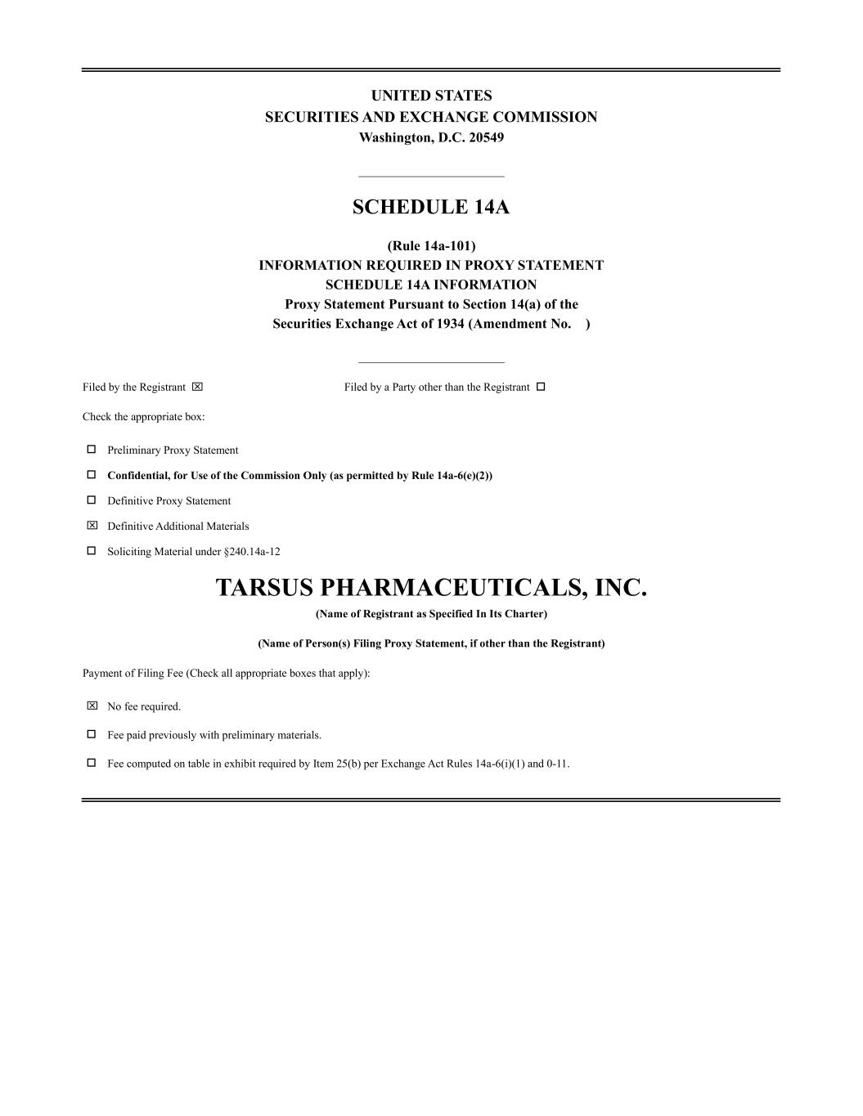
UNITED STATES SECURITIES AND EXCHANGE COMMISSION Washington, D.C. 20549 _______________________ SCHEDULE 14A (Rule 14a-101) INFORMATION REQUIRED IN PROXY STATEMENT SCHEDULE 14A INFORMATION Proxy Statement Pursuant to Section 14(a) of the Securities Exchange Act of 1934 (Amendment No. ) _______________________ Filed by the Registrant ☒ Filed by a Party other than the Registrant □ Check the appropriate box: □ Preliminary Proxy Statement □ Confidential, for Use of the Commission Only (as permitted by Rule 14a-6(e)(2)) □ Definitive Proxy Statement ☒ Definitive Additional Materials □ Soliciting Material under §240.14a-12 TARSUS PHARMACEUTICALS, INC. (Name of Registrant as Specified In Its Charter) (Name of Person(s) Filing Proxy Statement, if other than the Registrant) Payment of Filing Fee (Check all appropriate boxes that apply): ☒ No fee required. □ Fee paid previously with preliminary materials. □ Fee computed on table in exhibit required by Item 25(b) per Exchange Act Rules 14a-6(i)(1) and 0-11.

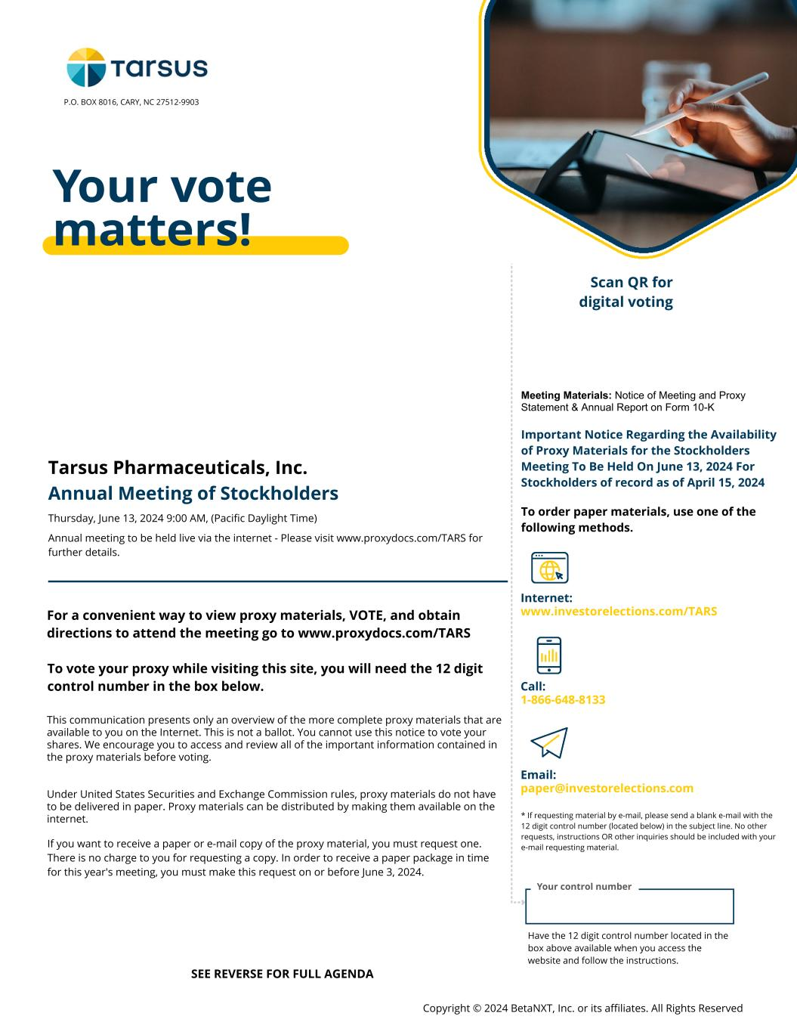
Your control number Your vote matters! Meeting Materials: Notice of Meeting and Proxy Statement & Annual Report on Form 10-K Important Notice Regarding the Availability of Proxy Materials for the Stockholders Meeting To Be Held On June 13, 2024 For Stockholders of record as of April 15, 2024 To order paper materials, use one of the following methods. Internet: www.investorelections.com/TARS Call: 1-866-648-8133 Email: paper@investorelections.com * If requesting material by e-mail, please send a blank e-mail with the 12 digit control number (located below) in the subject line. No other requests, instructions OR other inquiries should be included with your e-mail requesting material. Have the 12 digit control number located in the box above available when you access the website and follow the instructions. Copyright © 2024 BetaNXT, Inc. or its affiliates. All Rights Reserved Tarsus Pharmaceuticals, Inc. Annual Meeting of Stockholders Thursday, June 13, 2024 9:00 AM, (Pacific Daylight Time) Annual meeting to be held live via the internet - Please visit www.proxydocs.com/TARS for further details. For a convenient way to view proxy materials, VOTE, and obtain directions to attend the meeting go to www.proxydocs.com/TARS To vote your proxy while visiting this site, you will need the 12 digit control number in the box below. This communication presents only an overview of the more complete proxy materials that are available to you on the Internet. This is not a ballot. You cannot use this notice to vote your shares. We encourage you to access and review all of the important information contained in the proxy materials before voting. Under United States Securities and Exchange Commission rules, proxy materials do not have to be delivered in paper. Proxy materials can be distributed by making them available on the internet. If you want to receive a paper or e-mail copy of the proxy material, you must request one. There is no charge to you for requesting a copy. In order to receive a paper package in time for this year's meeting, you must make this request on or before June 3, 2024. styleINA P.O. BOX 8016, CARY, NC 27512-9903 SEE REVERSE FOR FULL AGENDA Scan QR for digital voting

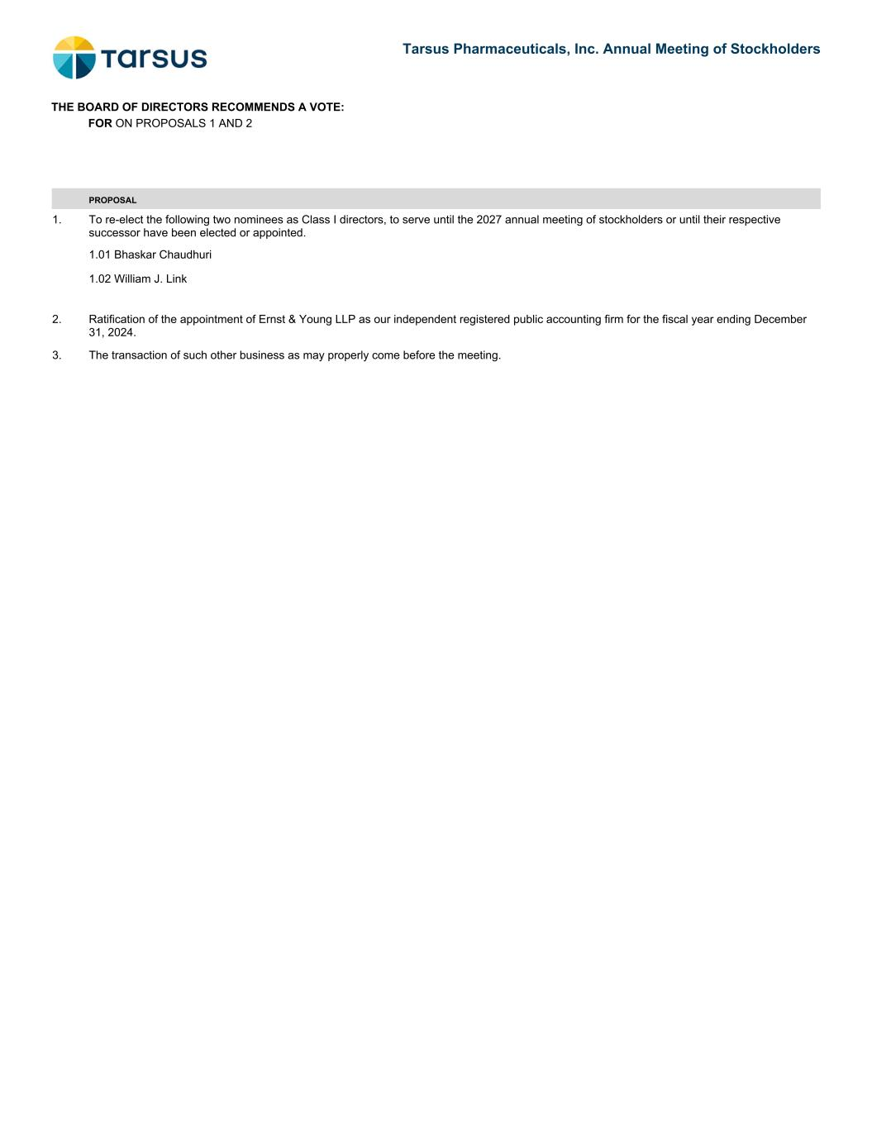
PROPOSAL 1. To re-elect the following two nominees as Class I directors, to serve until the 2027 annual meeting of stockholders or until their respective successor have been elected or appointed. 1.01 Bhaskar Chaudhuri 1.02 William J. Link 2. Ratification of the appointment of Ernst & Young LLP as our independent registered public accounting firm for the fiscal year ending December 31, 2024. 3. The transaction of such other business as may properly come before the meeting. THE BOARD OF DIRECTORS RECOMMENDS A VOTE: FOR ON PROPOSALS 1 AND 2 Tarsus Pharmaceuticals, Inc. Annual Meeting of Stockholders

